EVALUATION OF THE MICROBIOLOGICAL QUALITY OF ANAGO BAKA PORRIDGE USED AS A SUPPLEMENT TO MATERNAL MILK IN ABIDJAN (Côte d’Ivoire)

.
ABSTRACT

Aims: Infant flour "Custard," commonly known in Ivory Coast as "Anago Baka," is primarily made from corn. It is one of the most popular local infant flours in Ivory Coast, marketed both in artisanal and industrial forms. This study aimed to evaluate the microbiological quality of infant porridge prepared from this flour.
Place and Duration of Study: The study was conducted in the municipality of Yopougon (Latitude: 5.31667; Longitude: -4.06667; 5° 19′ 0″ North, 4° 4′ 0″ West), specifically in the neighborhoods of Koweït, Toit Rouge, and Wassakara between May and July 2024. Yopougon is the largest municipality in the Autonomous District of Abidjan, covering an area of 8,500 hectares, with an estimated population of 1,571,065 inhabitants,
Methodology: First, a survey was conducted among mothers attending consultations at the dietary counseling units of three Community Urban Health Facilities in the Yopougon municipality. 78 mothers of children under 2 years of age randomly selected from health centers were interviewed. Subsequently, microbiological analyses were performed on 36 samples of Anago Baka porridge according to international norms and standards.
Results: The survey showed that porridge was introduced into infants' diets before 6 months in 65.4% of cases, contrary to WHO recommendations, and mothers preferred local infant flours (72%). Microbiological analyses revealed polycontamination of samples by Aerobic Mesophilic Germs, coliforms, staphylococci, yeast and molds. The presence of these germs indicated problems with hygiene, quality and preservation. Over 91.7% of porridges prepared with Côte d’Ioire-origin Anago Baka flour and Nigerian-origin flour, and 75% of porridges obtained with artisanal Anago Baka flour, showed satisfactory microbiological quality.
Conclusion: The presence of potentially pathogenic germs poses a risk to young children. Therefore, efforts must continue to promote good hygiene practices.

Keywords: Porridge, infant, Anago Baka, microbiological quality

1. INTRODUCTION
Infant nutrition is an important public health issue. Proper breastfeeding practices and the introduction of complementary foods to children after six months are vital in fighting microelement deficiency in infants and young children (Salle, 2009; N’Zi et al., 2023). The World Health Organisation (WHO) recommends exclusive breastfeeding for up to 6 months, except in cases of medical contraindication. After the first 6 months, complementary foods should be gradually introduced while decreasing the duration and frequency of breastfeeding (Dupon, 2005; WHO, 2015). At this age, breast milk alone cannot meet all the nutritional needs of a growing infant (Colin et al., 2017; Salle, 2009). This transitional phase in infant feeding is crucial. Poor management of this transition can have consequences for the child's health and growth. Indeed, it is during this period that the first signs of protein-energy malnutrition may appear. Therefore, the choice and quality of flour used as complementary foods during this period is very important (Brou-Tanoh et al., 2010; Tchoko-Zannou et al., 2011; Euphrasie et al., 2019).
The vast majority of infant flours that meet WHO requirements in Africa are industrial and imported. They are inaccessible to a large part of the population due to their prices (Coulibaly et al., 2014; Kagambega et al., 2019). In light of this situation, the majority of the African population, especially in sub-Saharan Africa, rely on traditional porridges as a supplement to breast milk. Consequently, health and early childhood care facilities propose the preparation of child flours based on locally available products as a solution. These porridges are made from simple or composite flours derived from cereals or tubers (Coulibaly et al., 2014; Sika et al., 2019).
Coverage of infant flours in the Ivorian market is wide. There are options for all tastes and budgets, produced industrially, semi-industrially and artisanally. The most consumed low-cost infant flours in Ivory Coast are branded Custard Powder and are commonly referred to as "Anango baka" (Bamba et al., 2018). Those produced in Ivory Coast are sold in white boxes, while those from Nigeria are sold in yellow boxes. The term "Anango" is used in Côte d’Ivoire to refer to Nigerian nationals, and "baka" means porridge in a local Ivorian language (Yapo et al., 2019). Some of these local flours often fail to meet all the nutritional needs of young children due to their quality and composition. The quality of the water used, hygienic conditions during preparation, and the storage of the porridges are very important. Additionally, the traditional or semi-industrial nature, insufficient health controls, the diversity of suppliers, the unknown origins of raw materials, and the conditions of processing, storage, and transportation of these flours are all sources of concern among some mothers regarding the health risks for their babies (Drabo et al., 2009; Sika et al., 2019; N’Zi et al., 2023).
Moreover, studies have reported the presence of molds such as Aspergillus flavus and Mucor sp. in Anango Baka flour (Yapo et al., 2019). Additionally, Bacillus cereus, salmonella, and other pathogens may be present in infant flours and can even persist in cooked porridge, causing harm to children (Lee et al., 2012; Jessim et al., 2017). According to WHO estimates, unfortunately, more than 125,000 children out of approximately 420,000 die each year from foodborne illnesses (WHO & FAO, 2015). The common concern of both public authorities and mothers is to ensure that the market offers dietary supplements that guarantee sanitary quality and compliance with manufacturing and storage standards (WHO & FAO, 2005; Sika et al., 2019).
It thus becomes important to evaluate the microbiological quality of "Anango Baka," an infant porridge widely used as a complement to breast milk in Abidjan, Côte d’Ivoire. This study aims to contribute to the sanitary quality of this porridge as a complementary food for young children.

2. material and methods
2.1 Study Area
The study was conducted in the municipality of Yopougon (Latitude: 5.31667; Longitude: -4.06667; 5° 19′ 0″ North, 4° 4′ 0″ West), specifically in the neighborhoods of Koweït, Toit Rouge, and Wassakara. Yopougon is the largest municipality in the Autonomous District of Abidjan, covering an area of 8,500 hectares, with an estimated population of 1,571,065 inhabitants (INS, 2021).
2.2 Biological Material
Prepared 'Anango baka' mixtures based on artisanal flour (AA), industrial flour of Ivorian origin (AII), and industrial flour of Nigerian origin (AIN) were used as biological matrices for the study (Fig. 1).
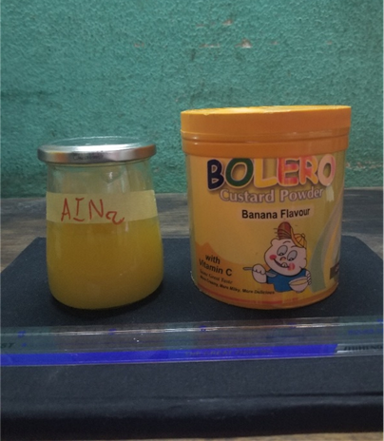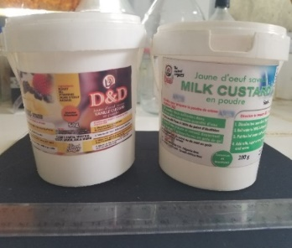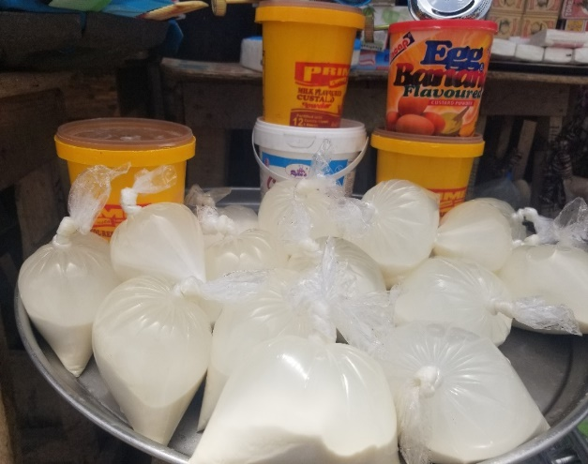
A
B
C
D
A : "Industrial Anago Baka Flour from Nigeria (AIN) ; B : "Industrial Anago Baka Flour from Ivory Coast (AII) C : Artisanal Anago Baka Flour (AA) et D : sample of Anago Baka porridge.
Fig. 1. Photographs of biological materials
2.3 Survey of Mothers of infants
The survey was conducted using a questionnaire with Kobo toolbox through the Kob collect application in the Urban Community Health Facilities (UCHF) of Toit-Rouge, Koweït, and Wassakara-Attié. A total of 78 voluntary mothers were interviewed. The mothers of children aged 0 to 2 years had come to these centers for vaccination sessions or to receive dietary advice for their children.
Sampling
The samples consisted of porridge prepared from 'Anango Baka' flour: industrially sourced from Nigeria (AIN) and Ivory Coast (AII), as well as artisanal production (AA). They were collected using a small sterile ladle and placed in sterile glass jars of 450 ml. The jars were labeled, placed in a cooler containing ice, and then transported to the laboratory. In total, 36 samples were collected, consisting of 12 AIN, 12 AII, and 12 AA.
2.4 Microbiological Analyses
The operations were carried out under aseptic conditions near the flame of a Bunsen burner and in accordance with international standards.
2.4.1 Preparation of stock solutions and decimal dilutions
10 ml of porridge was added to 90 ml of buffered peptone water (BPW). The homogenized mixture consisted of the stock suspension. This served as decimal dilutions according to ISO 6887/2017 standard. 1 ml of the stock suspension was taken and placed in a test tube containing 9 ml of BPW. After homogenizing the mixture by vortexing for 20 to 30 seconds, the resulting suspension constituted the 10^{–1} dilution. 1 ml of the 10^{–1} dilution was taken and placed in another test tube containing 9 ml of BPW to constitute the 10^{–2} dilution. The same operation was performed under the same conditions to obtain the desired dilutions.
2.4.2 Inoculation, Incubation and Enumeration
Aerobic Mesophilic Germs (AMG) were sought on Plate Count Agar (PCA) (BIOKAR, France) at 37°C for 72 hours according to the NF ISO 4833 :2003 method. Counting was done on successive dilutions that had given the most readable colonies between 30 and 300.
Staphylococci enumeration was performed on Baird Parker medium (BP OXOID CM0275) according to NF EN ISO 6888-1:1999. A volume of 0.1 ml of the stock suspension and dilutions were spread on the surface of Petri dishes and incubated at 37°C for 24 to 48 hours. A well-isolated presumptive colony (black, shiny with clear halo) was replated on a new Petri dish to obtain pure strains. These strains were replated on Dnase agar and incubated at 37°C for 24 hours. After incubation, a solution of hydrochloric acid (1 M) was poured over the different isolates. Staphylococcus aureus strains were revealed by a clear ring around the isolates.
Coliform enumeration was performed according to ISO 4832-1:2006 with VRBL agar (BIO-RAD, France). 1 ml of the stock suspension and different dilutions were aseptically placed in Petri dishes, then 10 to 15 ml of VRBL agar melted and cooled to 45°C was poured into each dish. After solidification of the agar, about 4 ml of VRBL medium was poured onto the surface of the inoculated medium. After solidification of the second layer, the dishes were incubated at 37°C for total coliforms and at 44°C for thermotolerant coliforms for 24-48 hours.
Mold enumeration was performed according to NF V08-059 :2002 on Sabouraud medium with chloramphenicol (BIOKAR, France). After inoculation, the dishes were incubated at 30°C for 48 hours. Macroscopic observation was mainly based on growth rate, colony texture, color of the front and back of the culture, consistency and size (Diguta, 2010). Microscopic identification of molds was performed by observation under an optical microscope at X40 and X100 magnification. For this purpose, well-isolated mold colonies were taken and placed on a slide moistened with distilled water and gently covered with a coverslip. The observed characteristics included mycelium (color, size, septa), the presence of sporangium (color, shape, size), spores (color, shape, size, grouping). An identification key for molds allowed naming the observed molds (Diguta, 2010 ; Gacem et al., 2012).
2.5 Expression of bacterial loads
The bacterial load corresponding to the number of colony-forming units per mL of product (N) was determined according to ISO 7218 using the following formula:
N=$∑c/V.d(n1+0,1n2)$

ΣC : sum of colonies on all plates of the two successive dilutions ; V : volume of the inoculum ; n1 and n2 : number of plates respectively for the 1st and 2nd dilution retained ; d : dilution rate of the 1st plate that produced countable colonies (low dilution) ; N : expressed in CFU/mL (Colony Forming Units per mL)
2.6 Statistical Analysis
Statistical analysis of the results was performed using Statistica version 7.1 software. The software allowed for the calculation of means, standard deviations of different microbial loads, comparison of means at the significance level of P = 0.05, and the evaluation of normalized principal component analysis.
3. results
3.1 Survey

3.1.1 Sociodemographic characteristics of the surveyed mothers
More than half of the surveyed mothers (58%) were aged between 25 and 35 years. Mothers in the age groups of 15 to 17 years, 18 to 25 years, and over 35 years represented 1%, 26%, and 14%, respectively. Regarding level of education, 13.16% had primary education, 38.16% had secondary education and 23.68% had higher education. Approximately 25% reported being uneducated. They held various professions, with 7.89% being homemakers, 22.37% being traders, 10.53% being school students, 18.42% being university students, and 39.47% being in other professions (Table 1).

Table 1. Sociodemographic characteristics of the surveyed mothers
Parameters |  | Number (n=78) | Percentages (%)
Age groups (years) | 15-17 | 1 | 1
Age groups (years) | 18-25 | 20 | 26
Age groups (years) | 25-35 | 45 | 58
Age groups (years) | 35 and above | 12 | 15
Level of Education | Uneducated | 20 | 25
Level of Education | Primary | 10 | 13.2
Level of Education | Secondary | 30 | 38.2
Level of Education | Higher education | 18 | 23.6
Profession | Housewife | 7 | 7.9
Profession | Business person | 17 | 22.4
Profession | Student | 14 | 18.4
Profession | Pupil | 8 | 10.5
Profession | Civil Servant | 32 | 39.5

3.1.2 Periods for introducing porridge into the child's diet
Table 2 shows the periods for introducing porridge into the child's diet by the surveyed mothers. More than half of the mothers (65.4%) fed their children porridge before 6 months, contrary to the WHO recommendations. Porridge was introduced by 26.9% between 6 and 9 months, and by 7.7% starting at 9 months.
Table 2. Time of Introduction of Infant Porridge into the Diet of Infants
UCHF | Before 6 months | 6 to 9 months | 9 and above
Wassakara Attié (n=28) | 19 (67.9) | 7 (25) | 2 (7.1)
Toit rouge (n=22) | 17 (77.3) | 5 (22.7) | 00 (00)
Koweit (n=28) | 15 (53.6) | 09 (32.1) | 4 (14.2)
Total (n=78) | 51 (65.4) | 21 (26.9) | 6 (7.7)

3.1.3 Types of flour used
72% of the mothers interviewed used local flours more compared to imported infant flours from developed countries, 28%, for preparing porridge for their infants. Anago Baka flours accounted for 27%, with 23% being industrially processed and 4% being artisanally processed. Other local flours represented 45% (Fig. 2).

Fig. 2. Types of flours used for the preparation of infant porridges
For the preparation of the porridge, the mothers indicated that they follow the manufacturer's instructions written on the packaging or according to the recommendations of the vendors in the case of homemade flour. The preparation procedure for Anago Baka porridge is schematized in Fig. 3.

Portable water brought to boil
Mix the boiling water with the dissolved flour mixture
Anango baka porridge
Dissolve flour in potable (drinking) water
Homogenize the mixture until cooked (for about 5 minutes)

Fig. 3. Preparation Diagram for the "Anango baka" Infant Porridge

3.2 Contamination level of the analysed porridge
The microbiological analysis of the different samples of porridges indicated the presence of many germs (Table 3). The average loads in Aerobic Mesophilic Germs (AMG) were 1.7x10 ⁴ CFU/mL, 1.5x10⁴ CFU/mL and 1.3x10³ CFU/mL, respectively for the porridge samples prepared with the Ivorian industrial Anango baka flours (AII), Nigerian (AIN) and artisanal flour (AA). The average Coliform loads varied between 1.2x10² and 1.4x10¹ CFU/mL for the AII porridges, 1x10² and 1.1x10¹ CFU/mL for the AIN porridge samples, and 2.1x10² and 1.1x10¹ CFU/mL for the AA samples, respectively for total and thermotolerant coliforms. As for the average Staphylococcus loads, they ranged from 1.10x10² CFU/mL for the AA, 1.6x10³ CFU/mL for the AII and 1.7x10³ CFU/mL for the AIN. The average mold loads varied from 7 CFU/mL to 76 CFU/mL. A significant difference at the α (0.05) level was observed between the AA and AI (Ivorian and Nigerian) porridge samples for the contamination levels of AMG, coliforms and Staphylococci. However, no significant difference was observed between the AII and AIN porridges.
A principal normalized component analysis (NPCA) was carried out to highlight the possible relationships between the microbiological loads and the types of porridges (Fig. 4).
Table 3. Average microbial loads in CFU/mL of the analyzed porridge samples according to the type of porridge
Microbes | Types of Porridge
Microbes | AA | AII | AIN | threshold
AMG | 1.3x10³ ± 4.0x10^{2 b} | 1.7x10⁴ ± 1.7x10⁴ ª | 1.5x10⁴ ± 1x10⁴ ª | 1x10⁵
CT | 2.1x10² ± 7.2x10⁰ ^{b} | 1.2x10² ± 7.9x10¹ ª | 1x10² ± 1.2x10² ª | 1000
CTh | 1.1x10¹ ± 2 x 10¹ ^{b} | 1.4x10¹ ± 2x10¹ ª | 1.1x10¹± 8.3x10¹ ^{b} | 100
Staph | 1x10² ± 4.8x10¹ ^{b} | 1.6x10³ ± 1.7x10³ ª | 1.7x10³ ± 2.8x10³ ª | 1000
Mold | 18 | 7 | 76 | 1000
AMG : Mesophilic Germs; CT : Total Coliform; Cth : Thermotolerant Coliform ; Staph : Staphylococcus ; AA : porridge made from Artisanal Anango baka flour ; AIN : porridge made from Nigerian Industrial Anango baka; AII : porridge made from Ivorian Industrial Anango baka flour



Fig. 4. Correlation between types of porridges and the microbial loads
3.3 Microbiological quality of the analyzed porridges

Table 4 provides a detailed presentation of the microbiological quality of the samples analyzed in terms of germs. The porridge prepared with AII and AIN flours were of satisfactory quality for MAG, coliforms and molds. For the porridges based on AA, three were of unsatisfactory microbiological quality for total coliforms and one sample was of unsatisfactory quality for MAG. For Staphylococci, two samples of AA porridge and one sample of AII and AIN porridge were of unsatisfactory microbiological quality.
The overall microbiological quality according to the type of porridge is presented in Fig. 5. More than 91.7% of the porridge prepared with AII and AIN flours and 75% of the porridges made with AA flour were of satisfactory microbiological quality.

Table 4. Microbiological quality of porridge samples analyzed according to germs
 | AA (n=12) |  | AII (n=12) |  | AIN (n=12)
 | Satisfactory (%) | Unsatisfactory (%) | Satisfactory (%) | Unsatisfactory (%) | Satisfactory (%) | Unsatisfactory (%)
AMG | 11 (91.7) | 01 (8.3) | 12 (100) | 00 (00) | 12 (100) | 00 (00)
CT | 9 (75) | 03 (25) | 12 (100) | 00 (00) | 12 (100) | 00 (00)
Cth | 12 (100) | 00 (00) | 12(100) | 00 (00) | 12 (100) | 00 (00)
Staph | 10 (83.3) | 02 (16.6) | 11 (91.7) | 01 (8.3) | 11 (91.7) | 01 (8.3)
Mold | 12 (100) | 00 (00) | 12 (100) | 00 (00) | 12 (100) | 00 (00)

S : satisfactory, NS : unsatisfactory
Fig. 5. Microbiological Quality according to the Type of Porridge

3.4 Morphological identification of Isolated fungal flora
Based on the macroscopic and microscopic observations described in the methodology, four presumptive fungal species (Penicillium sp., Aspergillus sp.1, Aspergillus sp.2, and Aspergillus sp.3) belonging to two genera were identified using the identification key of Diguta (2010) and Gacem et al. (2012) (Table 5).

Table 5. Photographs of macroscopic and microscopic observations
Macroscopic Observation | Microscopic Observation
 | 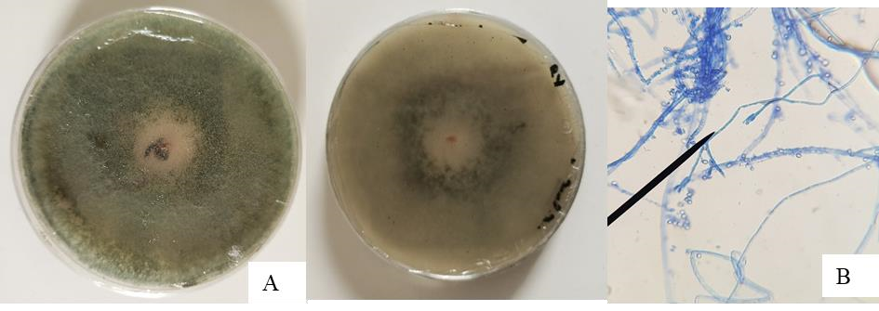 | Penicillium sp.
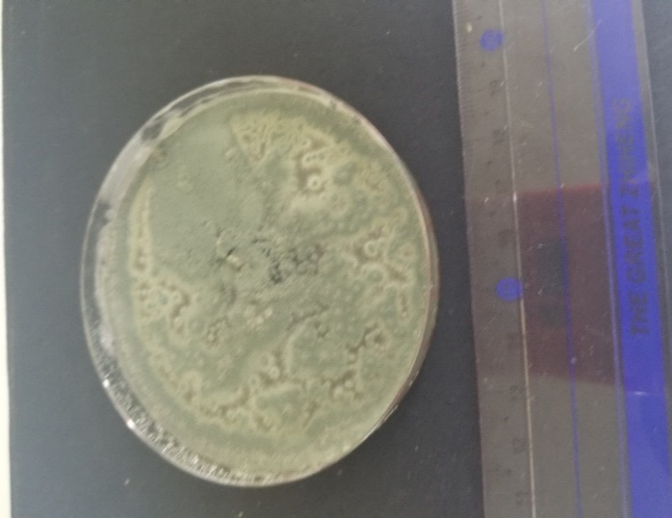 |  | Aspergillus sp.1
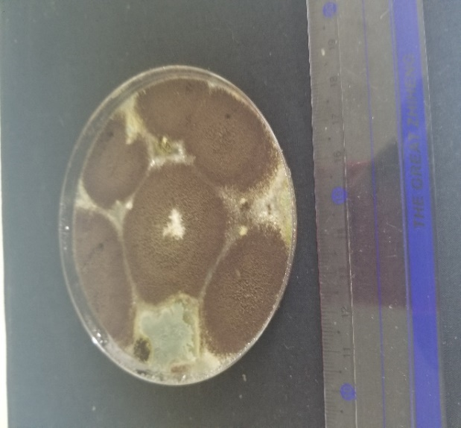 |  | Aspergillus sp.2
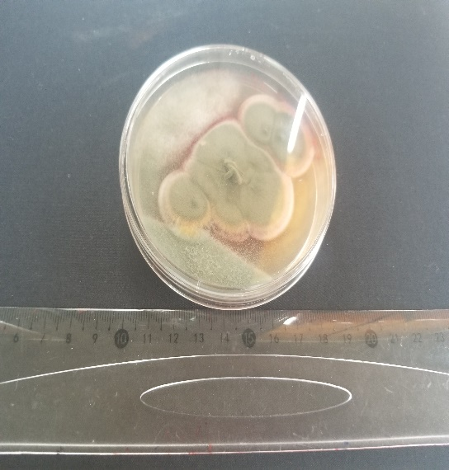 | 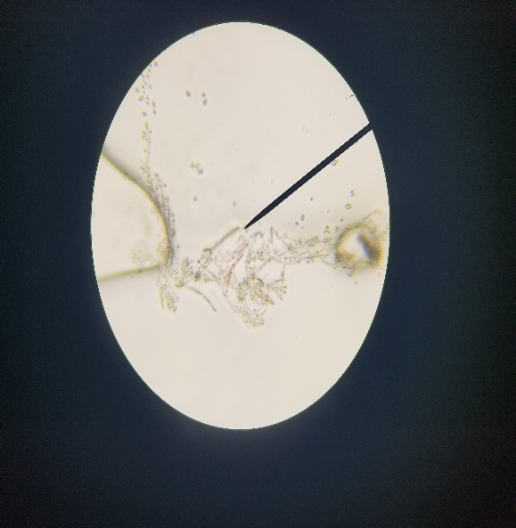 | Aspergillus sp.3

4. DISCUSSION
A survey of mothers of infants established a diverse sociodemographic profile. The age of the mothers varied from 15 to over 35 years, with a strong representation of the 25-35 age group at 58%. They had various professions: homemakers (7.9%), traders (22.4%), civil servants (39.5%), etc. Their levels of education: 13.2% had attended primary school, 38.2% secondary school and 23.6% had higher education. Non-schooled mothers represented 25%. These results are similar to those of N’Zi et al. (2023), which showed that more than 1/3 of the respondents had not attended school, 27.33% had attended secondary school and 18.22% had higher education. The survey also revealed some infant feeding practices by their mothers. The survey results indicated that more than half of the interviewed mothers (65.4%) gave porridge to their child before six months of age, 25% between six and nine months and 7.1% after nine months. However, the WHO recommends exclusive breastfeeding until six months of age (WHO, 2021). In a similar study, authors indicated that 71.56%, 12%, and 15% of mothers introduced complementary food from six months, before, and after that age, respectively (N’Zi et al., 2023). Several reasons could explain the early introduction of porridge into children's diets, including mothers' professional occupations, prejudices about the negative impact of breastfeeding on breast firmness and advice from their entourage. For many mothers, breastfeeding until six months makes the breasts “flabby” and gives them the feeling of aging (Brou-Tanoh et al., 2010). This practice can have detrimental effects on the young child's health, including protein-energy diseases, malnutrition, delayed brain growth, decreased IQ, and behavioral problems (Elenga et al., 2009; Mengistu et al., 2013; Darsene et al., 2017). A study conducted by UNICEF indicated that only 30% of children under six months are exclusively breastfed in West and Central Africa. Based on this observation, UNICEF and the Alive and Thrive initiative launched the regional and national campaign "Stronger with Breast Milk Only" in 2019 in Abidjan, Côte d’Ivoire (Fanny et al., 2020).
The survey also showed that local infant flours (72%), particularly industrial Anango Baka flour (23%), were the most used by mothers. A survey conducted in Abidjan on infant flours indicated a 62% use of local flours by mothers (N’Zi, 2023). This preference for local flour by mothers could be explained by the trust they have in this flour, its availability in the markets, and also the quantity-price ratio (400g for 1000 Francs CFA). These results confirm several previous studies on the availability and selling prices of infant flours. Most industrial complementary flours for children sold in pharmacies, supermarkets and large commercial outlets are inaccessible to a significant portion of the population due to high costs (Coulibaly et al., 2014; Kagambega et al., 2019).
The analyzed samples of "Anango baka" were contaminated by Mesophilic Aerobic Germs (MAG), Total Coliforms, Fecal Coliforms, Staphylococci and molds. The presence of these germs in the samples can be explained by the initial contamination of the flour, the quality of the water used and the hygiene practices during the preparation of the porridge. According to N’zi et al. (2023), the methods adopted by mothers during porridge preparation are often insufficient to ensure the quality of the final product. Moreover, mothers and traders have no knowledge of the nutritional and sanitary quality of these products (Yapo et al., 2019).
The contamination level of porridges by mesophilic aerobic germs ranged between 1.3 x 10³ and 1.7 x 10⁴ CFU/mL. These load levels are similar to those obtained in a previous study by Yapo et al. (2019) on Anango Baka flour, which showed a variation of MAG from 5 x 10² to 10 x 10³ CFU/g. The presence of MAG in a food product provides an idea of the hygienic quality of that product. MAG indicates general hygiene or the ineffectiveness of preservation (Sanogo et al., 2022). The coliform loads varied between 1.2 x 10² and 1.4 x 10¹ CFU/mL for AII porridges, 1 x 10² and 1.1 x 10¹ CFU/mL for AIN porridge samples, and 2.1 x 10² and 1.1 x 10¹ CFU/mL for AA samples, respectively for total coliforms and thermotolerant coliforms. Total coliform loads ranged between 1 x 10² and 2.1 x 10² CFU/mL, while thermotolerant coliform loads ranged between 11 and 14 CFU/mL. In a study on Anango Baka infant flour conducted in Ivory Coast, authors obtained coliform loads lower than 20 CFU/g (Yapo et al., 2019). In another similar study conducted in Burkina Faso, authors found loads ranging between 0 and 2.8 x 10³ CFU/g for total coliforms and 0 and 5.3 x 10² for fecal coliforms (Sanogo et al., 2022). Coliforms are fecal contamination germs. Their presence in porridge can be explained by improper hand hygiene and the quality of water used, as mentioned earlier during the preparation of porridges. This contamination by coliforms could pose a health problem. Indeed, enterobacteria, which include coliforms, cause several diseases whose severity varies according to the level of pathogenicity (Kagambega et al., 2019). Another health risk related to coliforms is their ability to produce biogenic amines (Santos, 1996). High doses of biogenic amines, especially histamine, in food exposure could cause nausea, headaches and skin rashes (Oyelakin et al., 2016). The staphylococci load ranged between 1 x 10² and 1.7 x 10³ CFU/mL. Contrary to our results, Yapo et al. (2019) found no Staphylococcus strains after analyzing several types of industrial Anango Baka flours. This difference can be explained by the nature of the samples. Staphylococci are ubiquitous germs. They were probably introduced into the porridge by the mothers, the utensils and the containers used during preparation. According to Tankoano et al. (2016), the presence of staphylococci in infant porridges indicates poor hygiene conditions adopted after cooking. Staphylococcus aureus strains were identified from the staphylococci found in the porridges. This species is of paramount interest in food microbiology because its presence can be dangerous for infants. Indeed, S. aureus can secrete enterotoxins, which are responsible for severe food poisoning symptoms such as nausea, vomiting, diarrhea, etc. Moreover, these toxins are heat-resistant (Elkhal et al., 2024). Generally, AA porridges had a lower contamination level compared to the other two types of porridges (AII and AIN). During the production of AA flour, the flour is first roasted and then undergoes fermentation before being packaged. According to N’zi et al. (2023), fermentation and cooking strongly inhibit the growth of vegetative microorganisms but do not destroy those that form spores, including pathogens.
A significant difference at the threshold of α = 0.05 was observed between the microbial loads of mesophilic aerobic germs (MAG), total and fecal coliforms, and staphylococci in the porridge samples made from artisanal "Anango baka" flour and those made with industrial "Anango baka" flours (Ivorian and Nigerian). However, no significant difference was observed between the different microbial loads for the porridges made from Ivorian and Nigerian industrial "Anango baka" flours. No correlation could be established between the three types of porridge and the germs sought. Microbiological contamination would rather be controlled by the composition of the internal flora and handling during preparation. A principal normalized component analysis (NPCA) confirms the absence of correlation between the level of contamination and the type of porridge. AA porridge is minimally contaminated compared to other types of porridge.
Four mold strains were isolated. These were Aspergillus sp.1, Aspergillus sp.2, Aspergillus sp.3, and Penicillium sp. Our results corroborate those of Yapo et al. (2019); Sanogo et al. (2022). These authors isolated Aspergillus flavus and Mucor sp. from "Anango baka" flours sold in Abidjan. Like these authors, several others mentioned the presence of mold strains such as Aspergillus and Penicillium in cereal-based flours used for preparing infant porridges (Shah et al., 2010). The presence of such fungal flora suggests probable contamination of the maize grains (raw material). Some species of these molds are capable of producing mycotoxins such as aflatoxins and ochratoxins. Aflatoxins produced by A. flavus have carcinogenic, hepatotoxic, teratogenic, and immunotoxic properties. Ochratoxins are equally dangerous and are produced by the Penicillium and Aspergillus genera. These Aspergillus and Penicillium species typically contaminate cereals and their derivatives (Tangni, 2013). The presence of toxin-producing molds in food does not necessarily mean it is dangerous; it is the quantity and dose of the toxin that determines its safety. However, there is need for increased vigilance because it concerns infants (Gauthier, 2016).
The evaluation of microbiological quality showed that only one AA porridge sample had unsatisfactory total aerobic flora compared to the threshold. The evaluation of total coliform load showed that 25% of AA porridge samples were of unsatisfactory quality. Regarding Staphylococci, 16.6% of AA porridges and 8.3% of AII and AIN porridges were of unsatisfactory microbiological quality. Researchers in Burkina Faso found 100% of infant flours satisfactory for total flora, Escherichia coli, and Salmonella; 64.71% and 94.12% of infant flours were satisfactory for fecal coliforms and molds, respectively (Sanogo et al., 2022). These results indicate that efforts are still needed to apply good hygiene practices both during the manufacture of infant flours and during their preparation.

5. Conclusion
This study aimed to evaluate the microbiological quality of Anago Baka infant porridge used as a complementary food for young children. The preliminary survey showed that porridges are introduced into the infant's diet before the age of six months, which is contrary to WHO recommendations that advocate exclusive breastfeeding until six months. The use of local infant flours by mothers represents about 72%. The different types of infant flours (AII, AIN, and AA) of the Custard brand are highly appreciated and used by mothers. Several germs were found in the analyzed samples. All porridge samples based on AII and AIN presented loads of mesophilic aerobic germs (MAG), coliforms, and molds below the thresholds set by the standards. For porridges based on AA, 91.7% presented satisfactory MAG loads and 75% satisfactory total coliforms. Regarding Staphylococci, 83.3% of AA porridge samples and 91.7% were of satisfactory quality. Efforts are still needed since it concerns vulnerable individuals. Also, some isolated germs, such as molds and S. aureus, are potentially pathogenic. The state must guarantee the quality of local and imported food intended for children. Mothers, first and foremost, must be well-informed and trained on hygiene and dietary measures.

CONSENT
As per international standards or university standards, Participants’ written consent has been collected and preserved by the author(s).

DISCLAIMER (ARTIFICIAL INTELLIGENCE)

Author(s) hereby declare that NO generative AI technologies such as Large Language Models (ChatGPT, COPILOT, etc.) and text-to-image generators have been used during the writing or editing of this manuscript.

COMPETING INTERESTS DISCLAIMER:
Authors have declared that they have no known competing financial interests OR non-financial interests OR personal relationships that could have appeared to influence the work reported in this paper.

References
Abel Tankoano, A. (2013). Study of the Process and Microbiological Quality of Gappal, a Fermented Food from Burkina Faso Based on Milk and Millet Dough. International Journal of Multidisciplinary and Current Research. https://doi.org/10.14741/ijmcr/v.5.1.18

Acem, M. A., Ould El Hadj Khelil, A., & Gacemi, B. (2011). Study of the Physicochemical and Mycological Quality of Local and Imported Soft Wheat Stored at the Algerian Interprofessional Cereals Office (OAIC) ​​in Saida, Algeria. Algerian Journal of Arid Environment “AJAE,” 1(2), 67-76. https://asjp.cerist.dz/en/article/594

Bamba, M. S., Gbogouri, G. A., Agbo, E. A., Digbeu, D. Y., & Brou, K. (2018). Infant feeding practices using local flours in relation to nutritional status of Children aged 6 to 24 months surveyed in Maternal and Child protection centers of Abidjan (Côte d’Ivoire). International Journal of Child Health and Nutrition, 7(3), 102–108. https://doi.org/10.6000/1929-4247.2018.07.03.2

Brou-Tanoh, A.M., Etiegne, M. S., Bosso, P., Kourouma, R., Boa, A., Amalaman, K., Angaman, E., & Nancy, K. (2010). Infant and young child feeding practices in Côte d'Ivoire: Complementary feeding for children aged 6-24 months. Public Health Journal, 9(2): 69-82.

Colin, B., Boulle, M. C., Traore, T., Soma, A., Lankoande, R., Kabore, C., & Mouquet-Rivier, C. (2017). Distribution, perception, and consumption of infant flours in Ouagadougou and Gnagna province, Burkina Faso. GRET-IRD technical report: 63.

Coulibaly, A., Ake Tano, O., Bénie Bi Vroh, J., Traoré, Y., & Dagnan, N. S. (2014). Socio-professional factors and the practice of exclusive breastfeeding among primiparous mothers in Abidjan (Côte d'Ivoire). Public Health, Vol. 26(4), 555–562. https://doi.org/10.3917/spub.144.0555

Darsene, H., Geleto, A., Gebeyehu, A., & Meseret, S. (2017). Magnitude and predictors of undernutrition among children aged six to fifty nine months in Ethiopia: a cross sectional study. Archives of Public Health, 75(1). https://doi.org/10.1186/s13690-017-0198-4

Diguta, C.F. (2010). Ecology of molds present on grape berries. Doctoral thesis from the University of Burgundy in Food Sciences. p. 194. https://hal.science/REVV/tel-00597399v1

Drabo, K. M., Zongo, A. N., Zeba, Pare-Toe, L., Tarnagda, Z., Rouamba, N., Rouamba, J., Toe, A., Ouedraogo, D., & Ouedraogo, J. B. (2009). Main characteristics of the street food sector in Bobo-Dioulasso, Burkina Faso. Bulletin of the Society of Exotic Pathology 102(1):36-40, DOI: 10.3185/pathexo3267

Dupont, C. (2005). Dietary diversification. Nutrition and Dietetics Journal, 40(5), 250–253. https://doi.org/10.1016/s0007-9960(05)80495-x

Elenga, M., Massamba, J., Kobawila, S., Makosso, V., & Silou, T. (2010). Evaluation and improvement of the nutritional quality of fermented corn pasta and porridge in Congo. International Journal of Biological and Chemical Sciences, 3(6). https://doi.org/10.4314/ijbcs.v3i6.53146

Elkhal, A., Chibani, A., Dahou, B., Sadek, S., Rkhaila, A., Auajjar, N., & Attarassi, B. (2024). Investigation of a collective food poisoning in the province of Kenitra, Morocco from 2019 to 2023: A study to determine the epidemiological profile and the effectiveness of the management measures implemented. Bangladesh Journal of Medical Science, 23(4), 1020–1029. https://doi.org/10.3329/bjms.v23i4.76511

Euphrasie, L. S., Jean Brice, G., Appolinaire, K. K., Albarin, G. G., & Kouakou, B. (2019). Mixed Flour Formulations, One Based on Rice (Oryza Sativa) and the Other Based on Corn (Zea Mays) for Weaning Children. European Scientific Journal "ESJ", 15(33). https://doi.org/10.19044/esj.2019.v15n33p100

N’zi Fabienne, A. J. A., Florent K. N’G., Clémentine, A. K. K., Corinne, T., & Didier, M. (2023). Production, preparation, and storage practices of artisanal infant flours in Côte d’Ivoire. Journal of Applied Biosciences. Vol: 183. https://doi.org/10.35759/JABs.183.8

Fanny, O., Mouquet-Rivier, C., Fioroni, N., Bichard, A., Boulle-Martinaud, C., Kaboré, C., Denizeau, M., Zagré, N. M., Le Dain, A. S., Ndiaye, N. F., Tou, El H. K. P., & Aho, A. (2020). The locally produced infant formula sector in six Sahelian countries: Burkina Faso, Mali, Mauritania, Niger, Senegal, and Chad. UNICEF-IRD Study Report: 164. https://www.documentation.ird.fr/hor/fdi:010080274/https://www.unicef.org/wca/media/6946/file/Rapport%20IRD%20&%20UNICEF.pdf

Gauthier, A. (2016). Mycotoxins in Food and Their Impact on Health. Doctoral Dissertation. University of Bordeaux: 132. https://dumas.ccsd.cnrs.fr/dumas-01315198

National Institute of Statistics (INS). (2021). General Population and Housing Census. Report of the National Institute of Statistics, Côte d'Ivoire: 68. https://www.caidp.ci/uploads/7113b93cc641ba78c591e9f79a4e729c.pdf

Jessim, A. I. , Fakhry , S. S. , & Alwash , S. J. (2017). Detection and Determination of Bacillus cereus in Cooked Rice and Some Types of Spices with Ribosomal 16SrRNA Gene Selected from Iraqi Public Restaurants. International Journal of Bio-Resource and Stress Management, 8(3), 382–387. https://doi.org/10.23910/ijbsm/2017.8.3.1814a

Kagambega , B. , Cisse , H. , Tapsoba , F. , Sawadoga , A. , Zongo , C. , Traore , Y. & Savadogo , A. (2019). Traditional cereal-based fermented porridges in Burkina Faso: diversity, production technologies and microorganisms with associated probiotic potential. Science Technology Review, 25(2) : 12-24.

Karimou , R. , Noumavo , A. D. P. , Aboudou , K. , Boya , B. , Assouma , F. F. , Salami , H. A. , Konmy , B. B. S. , Houngbo , H. Y. , Adjanohoun , A. , Baba-Moussa , L. , & Sina , H. (2024). Nutritional and Microbial Qualities of Fermented Cereal-Based Porridges Produced in Northern Benin. Journal of Food Quality, 1–12. https://doi.org/10.1155/2024/7

Lee , N. , Sun , J. M. , Kwon , K. Y. , Kim , H. J. , Koo , M. , & Chun , H. S. (2012). Genetic Diversity, Antimicrobial Resistance, and Toxigenic Profiles of Bacillus cereus Strains Isolated from Sunsik. Journal of Food Protection, 75(2), 225–230. https://doi.org/10.4315/0362-028x.jfp-11-317

Mengistu , K. , & Alemu , K. (2013). Prevalence of Malnutrition and Associated Factors Among Children Aged 6-59 Months at Hidabu Abote District, North Shewa, Oromia Regional State. Journal of Nutritional Disorders & Therapy, 01(T1). https://doi.org/10.4172/2161-0509-3-t1-001

http://dx.doi.org/10.1037/0021-843X.102.2.210 Teyssier, C., & Montet, D. (2023). Production, preparation and storage practices of artisanal infant flours in Côte d’Ivoire. Journal of Applied Biosciences. Vol: 183. https://doi.org/10.35759/JABs.183.8

Oyelakin , O. , Traore , M. , Mbaye , E. H. B. , Conte , A. , Cisse , L. , Faye , A. N. , Faye , O. , Faye , M. , Kital , K. , Seye , G. , Coly , A. , Tine , A. , & Delattre , F. (2016). Spectrofluorometric Determination of Putrescine Using Orthophthaldehyde as a Fluorophore: A Novel Method. Journal of AOAC INTERNATIONAL, 99(1), 170–173. https://doi.org/10.5740/jaoacint.15-0212

Salle , B. , Bourre , M. M. S. , Duhamel , Durand , S. , Dupont , M. M. C. , & Lapillonne , A. (2009). Nutrition of the newborn and infant. Bulletin of the National Academy of Medicine, 193(2), 431–446. https://doi.org/10.1016/s0001-4079(19)32593-2

Sanogo , B. , Oboulbiga , E. B. , Tarnagda , B. , Zongo , O. , Kabore , B. , Ouedraogo , H. S. , Songre-Ouattara , L. T. , & Savadogo , A. (2022). Evaluation of the physico-chemical and microbiological quality of some local baby flours sold in Ouagadougou, Burkina Faso. PAMJ - One Health, 9. https://doi.org/10.11604/pamj-oh.2022.9.25.37566

Shah , H. U. , Simpson , T. J. , Alam , S. , Khattak , K. F. , & Perveen , S. (2010). Mold incidence and mycotoxin contamination in maize kernels from Swat Valley, North West Frontier Province of Pakistan. Food and Chemical Toxicology, 48(4), 1111–1116. https://doi.org/10.1016/j.fct.2010.02.004

Sika , A. E. , Kadji , B. R. L. , Dje , K. M. , Cone , Fanchroma Thierry Martial , Dabonne , S. , & Koffi-Nevry , A. R. (2019). Nutritional, microbiological and organoleptic quality of maize (Zea mays) and safou (Dacryodes edulis) based composite flours produced in Côte d’Ivoire. International Journal of Biological and Chemical Sciences, 13(1), 325. https://doi.org/10.4314/ijbcs.v13i1.26

Tangni , E. K. , Pussemier , L. , Schneider , Y.-J. , & Larondelle , Y. (2013). Mycotoxins in organic and conventional cereals and derived products from Europe: A review. Agricultural Notebooks, 22(3), 152–164. https://doi.org/10.1684/agr.2013.0623

http://dx.doi.org/10.1037/0021-843X.111.2.202 Tchoko-Zannou, V. J., Bouaffou, K. G. M., Kouame, K. G., & Konan, B. A. (2011). A study of the nutritional value of cassava and soybean based infant flours for weanling age child. Bulletin of the Royal Society of Science of Liege , 80 : 748 – 758 .

World Health Organization (WHO). (2003). Global Strategy for Infant and Young Child Feeding. 37P ISBN: 92-4-256221-1. https://www.who.int/fr/publications/i/item/9241562218

World Health Organization (WHO). (2015). Diseases of food origin: nearly a third of deaths occur in children under 5 years of age. https://www.who.int/fr/news/item/

World Health Organization (WHO). (2021). Malnutrition. https://www.who.int/fr/news-room/fact-sheets/detail/malnutrition

World Health Organization (WHO) & Food and Agriculture Organization (FAO). (2005). The informal sector of food product distribution (food sold on public street): importance and stake. Excerpt from Regional Conference for Africa on Food Safety Harare Zimbabwe: 11. https://www.fao.org/4/a0215f/A0215F02.htm

Yapo-Crezoit , C. C. A. , Kpan , S. E. , Boni , A. , Bonouman , I. , Kalpy , J. , N'guessan , J. D. , Djaman , A. J. , & Dosso , M. (2019). Evaluation of the Allergenic Potential of Marketed Anagobaka Infant Flours i n the Markets of the District of Abidjan. Advances in Research, 1–13. https://doi.org/10.9734/air/2019/v19i230118

