Original Research Article
HPTLC PROFILING OF HYDROCOTYLE VULGARIS L. LEAVES FOR IDENTIFICATION OF BIOACTIVE COMPOUNDS
ABSTRACT`
Hydrocotyle vulgaris L., commonly known as marsh pennywort, is a perennial herbaceous plant from the family Araliaceae, traditionally used for various medicinal purposes. The present study aimed to investigate the pharmacognostic and phytochemical properties of H. vulgaris leaf extracts, with a focus on identifying bioactive compounds through preliminary phytochemical screening, fluorescence analysis, and High-Performance Thin Layer Chromatography (HPTLC).
The leaves of H. vulgaris were collected, shade-dried, and powdered for extraction using three solvents—distilled water, ethanol, and chloroform. Preliminary phytochemical analysis revealed the presence of alkaloids, flavonoids, phenolics, steroids, quinones, glycosides, saponins, tannins, and terpenoids, with ethanol being the most effective solvent for extracting a wide range of phytochemicals. Fluorescence analysis of the leaf powder demonstrated distinct color changes under UV light when treated with various reagents, assisting in the authentication and standardization of the plant material.
HPTLC analysis was performed on the ethanolic extract of the leaves, revealing a total of 10 peaks at 254 nm and 13 peaks at 366 nm, which were associated with various bioactive compounds. Five peaks at 254 nm were identified as an alkaloid (Rf = 0.16), ferulic acid (Rf = 0.53), vanillic acid (Rf = 0.63), flavonoids (Rf = 0.87), and quercetin (Rf = 0.99). At 366 nm, four peaks were identified as ferulic acid (Rf = 0.58), alkaloid (Rf = 0.63), flavonoid (Rf = 0.88), and quercetin (Rf = 0.97). These compounds are known for their antioxidant, anti-inflammatory, and antimicrobial properties, supporting the traditional medicinal uses of the plant.
The findings of this study confirm that H. vulgaris is rich in bioactive compounds with significant pharmacological potential. These results provide a chemical basis for the plant's therapeutic applications and highlight its potential as a source of natural bioactive agents. Further research is needed to explore the isolated compounds' pharmacological mechanisms and their applications in modern medicine.
Keywords: Hydrocotyle vulgaris L., Phytochemistry, Fluorescent analysis, HPTLC, Bioactive Compounds.
INTRODUCTION
Over the past century, the field of phytochemistry has undergone significant transformation—not only in terms of the sheer number of identified compounds, but also in the conceptual framework that defines phytochemistry itself. Central to this evolution has been the refinement and diversification of methodologies used in the study of plant-derived secondary metabolites. These developments have raised fundamental questions about the evolutionary, biochemical, physiological, and ethnobotanical significance of secondary metabolites in plants and other organisms.
Secondary metabolites, while not essential for the immediate survival of the plant, play pivotal roles in ecological interactions, including defense mechanisms against herbivores and pathogens, attraction of pollinators, and adaptation to environmental stressors. The energetic and metabolic investment plants make in synthesizing these compounds suggests their importance in long-term fitness and survival. Furthermore, many of these metabolites exhibit significant bioactivities with potential therapeutic applications in humans.
Phytochemicals—naturally occurring bioactive compounds in plants—are largely responsible for the color, flavor, and organoleptic properties of plants. Although they are not classified as essential nutrients, they contribute to disease prevention and overall health, particularly through their antioxidant and anti-inflammatory properties. Their benefits are most effectively realized through the consumption of whole plant materials rather than isolated supplements.
Among the wide variety of medicinal plants, Hydrocotyle vulgaris L. (commonly known as marsh pennywort) has gained research interest due to its traditional use and bioactive constituents. Native to Europe, Asia, and parts of North America, H. vulgaris is a creeping perennial herb found predominantly in wetland environments. It is recognized not only for its ecological role—such as stabilizing soil and providing habitat in marsh ecosystems, but also for its traditional medicinal applications in treating skin disorders, inflammation, and gastrointestinal issues.
Within the genus Hydrocotyle, several species have been identified to possess pharmacological activities, including H. sibthorpioides and H. maritima, which demonstrate hemostatic and antitumor properties. Essential oils and flavonoids such as quercetin 3-O-galactopyranoside have been isolated from H. vulgaris, and preliminary studies suggest their potential cytotoxic effects on cancer cell lines such as RD (rhabdomyosarcoma), Hep-G2 (liver cancer), and LU (lung cancer). These bioactive compounds have been characterized using techniques such as nuclear magnetic resonance (NMR), mass spectrometry (MS), and gas chromatography-mass spectrometry (GC-MS) (Huong et al., 2009).
The oxidative stress theory of aging, particularly the Free Radical Theory proposed by Denham Harman, highlights the role of reactive oxygen species (ROS) in cellular damage and the aging process. Skin, being the outermost barrier of the human body, is particularly vulnerable to oxidative damage from environmental and endogenous sources. Factors such as UV radiation, pollution, stress, and poor nutrition exacerbate free radical formation, leading to cellular damage and aging. Although a variety of commercial products claim to mitigate oxidative stress, many may introduce additional irritants or toxins, aggravating the condition rather than alleviating it (Romnick and Siegfried, 2018).
Plant-derived antioxidants—particularly flavonoids, phenols, and other secondary metabolites—have shown promise in countering oxidative stress and enhancing immune resilience. In recent years, a renewed focus has been placed on ethnopharmacological knowledge to identify plant-based compounds effective against antibiotic-resistant bacterial strains (Mercelin and Johnsi, 2023).
Given the ecological, pharmacological, and biochemical significance of Hydrocotyle vulgaris, this study aims to investigate its phytochemical profile, with an emphasis on its bioactive constituents. The goal is to assess its potential therapeutic applications, particularly its antioxidant and anticancer properties, thereby contributing to the growing body of evidence supporting the medicinal utility of traditionally used plants.
MATERIALS AND METHODS
Collection of Plant Material
Hydrocotyle vulgaris L., a species belonging to the family Araliaceae, was collected in its entirety from the Akola region of Maharashtra, India. The plant was taxonomically identified using flora of Marathwada (Naik, 1998). The collected plant material was thoroughly washed with distilled water to remove soil and surface contaminants. It was then air-dried under shade conditions at ambient temperature for approximately 10 days to preserve phytoconstituents. Once completely dried, the leaves were pulverized into a fine powder using a sterile household electric blender. The resulting powder was stored in an airtight container for subsequent phytochemical and fluorescent analyses.
Preparation of Plant Extracts
The powdered plant material (approximately 10 g) was subjected to maceration using three different solvents: distilled water, methanol, and chloroform. Each solvent (50 mL) was added to the powdered material in a sterile, closed beaker and allowed to stand for 24 hours at room temperature with intermittent shaking. Following incubation, the mixtures were filtered through Whatman No. 1 filter paper. All precautions were taken to prevent solvent evaporation or degradation of bioactive compounds during filtration. The filtrates were stored at 4°C until further analysis.
Fluorescent Analysis
Fluorescence characteristics of the powdered leaf material were observed under visible and ultraviolet light (365 nm) after treatment with various standard laboratory reagents. The analysis was performed following the methods described by Shirsat and Suradkar (2017), and Jagtap and Koche. (2023). This analysis aids in preliminary identification of plant constituents based on color changes and fluorescence behavior under different lighting conditions.
Preliminary Phytochemical Screening
Qualitative phytochemical screening of aqueous, methanolic, and chloroform extracts was conducted to detect the presence of key secondary metabolites using standard protocols (Harborne, 1998; Koche et al., 2010). The following phytochemical tests were carried out:
- Test for Alkaloids: 1 mL of extract was treated with 2 mL of Mayer’s reagent. Formation of a dull white precipitate indicated the presence of alkaloids.
- Test for Flavonoids: 1 mL of extract was mixed with 1 mL of neutral ferric chloride solution. A brown coloration signified the presence of flavonoids.
- Test for Steroids: The extract was dissolved in 2 mL of chloroform; 10 drops of acetic acid and 5 drops of concentrated sulfuric acid were added. A transition from red to blue or green indicated steroidal content.
- Test for Terpenoids: 5 mL of extract was mixed with 2 mL of chloroform. Concentrated sulfuric acid (3 mL) was then carefully added to form a layer. A reddish-brown interface suggested the presence of terpenoids.
- Test for Quinones: A few drops of concentrated hydrochloric acid were added to 1 mL of extract. A yellowish-brown color denoted the presence of quinone compounds.
- Test for Phenols: 1 mL of extract was treated with lead acetate solution. The formation of a precipitate confirmed the presence of phenolic compounds.
- Test for Glycosides: 2 mL of 3.5% ferric chloride solution was added to the extract and allowed to stand for one minute. This was followed by the addition of 2 mL of concentrated sulfuric acid down the side of the test tube to form a separate layer. The appearance of a brown ring at the interface indicated glycosides.
- Test for Saponins: 5 mL of extract was vigorously shaken with 5 mL of distilled water. Persistent frothing confirmed the presence of saponins.
- Test for Tannins: A few drops of 5% ferric chloride solution were added to 2–3 mL of the extract. The development of a dark blue or greenish-black coloration indicated tannins.

High-Performance Thin Layer Chromatography (HPTLC)
For HPTLC profiling, the ethanolic extract of Hydrocotyle vulgaris leaves was sent to Qualichem Laboratory Ltd., Nagpur (Maharashtra, India). The chromatographic analysis was conducted under standardized laboratory conditions. The results obtained were compared and interpreted based on available literature and recent phytochemical studies to identify the presence of specific compounds.
OBSERVATIONS AND RESULTS
The plant species selected for the present study is Hydrocotyle vulgaris L., commonly known as marsh pennywort. The collected plant material was cleaned, shade-dried, and powdered for subsequent pharmacognostic and phytochemical analyses. The powdered sample was utilized for preliminary phytochemical screening using three different solvents—distilled water, ethanol, and chloroform. Additionally, the same powdered material was subjected to High-Performance Thin Layer Chromatography (HPTLC) for compound profiling.
- Scientific Name: Hydrocotyle vulgaris L.
- Family: Araliaceae
- Vernacular Name: Marsh Pennywort
Hydrocotyle vulgaris L. is a small, herbaceous, perennial plant that typically reaches a height of 5 to 20 cm. It is characterized by creeping stems that root at the nodes, allowing it to form dense mats in moist environments. The leaves are simple, rounded to kidney-shaped, and serrated along the margins. They are borne on long petioles and can reach up to 4 cm in diameter, although smaller sizes are more commonly observed. The plant is primarily found in wetland habitats, including marshes, ditches, and the margins of water bodies.
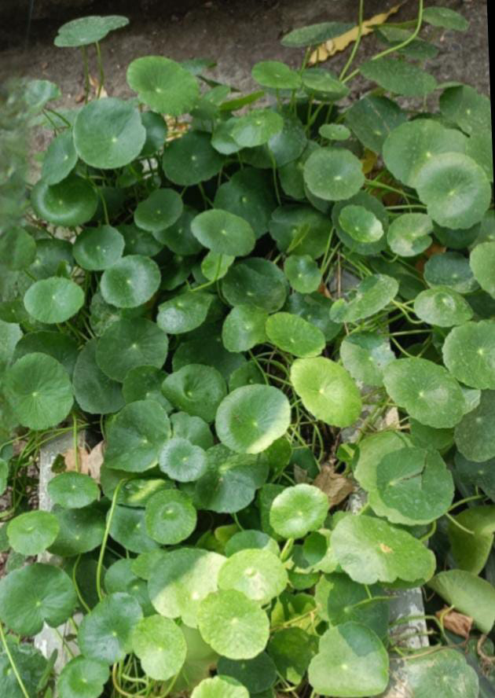

Fig. 1: Plant Hydrocotyl vulgaris L. in its habitat
Ethnomedicinal and Therapeutic Uses
Hydrocotyle vulgaris L. has a long history of use in traditional medicine across various cultures. Its medicinal applications are attributed to its diverse phytochemical constituents and observed pharmacological activities (Smitha et al., 2013; Kumar et al., 2016; Perez et al., 2020):
- Wound Healing: The plant has been traditionally applied topically to promote wound healing, likely due to its anti-inflammatory and tissue-regenerating properties.
- Treatment of Skin Disorders: Extracts from H. vulgaris have been used in the management of skin conditions such as eczema, psoriasis, and dermatitis. Its soothing and anti-inflammatory effects are thought to play a key role in these treatments.
- Diuretic Activity: The plant has been used as a natural diuretic, promoting urinary output. It is believed to assist in flushing out toxins and may be beneficial in treating urinary tract infections and preventing kidney stone formation.
- Cognitive Support: In some traditional medicinal systems, Hydrocotyle vulgaris has been used to enhance memory and cognitive function. Although the mechanisms are not fully elucidated, the plant is believed to exert neuroprotective effects.
- Anti-inflammatory Potential: The plant has demonstrated potential anti-inflammatory properties, suggesting its possible utility in the management of chronic inflammatory conditions such as arthritis.
Preliminary Phytochemical Analysis
The results of the preliminary phytochemical analysis of Hydrocotyle vulgaris L. leaf extracts are summarized in Table 1. Qualitative screening was performed to detect the presence of nine major classes of phytoconstituents, including alkaloids, phenolics, flavonoids, steroids, quinones, glycosides, saponins, tannins, and terpenoids. The analysis was conducted using three different solvent systems: distilled water, ethanol, and chloroform.
The aqueous extract (distilled water) revealed the presence of a broad spectrum of phytochemicals, including alkaloids, flavonoids, terpenoids, quinones, steroids, phenols, glycosides, and saponins. The ethanolic extract also tested positive for multiple constituents such as alkaloids, flavonoids, steroids, phenols, saponins, and tannins, indicating ethanol's high efficacy in extracting a diverse range of secondary metabolites. In contrast, the chloroform extract showed a limited presence of phytochemicals, with only flavonoids, terpenoids, steroids, and saponins being detected.
These results suggest that ethanol is the most effective solvent among the three tested for extracting a wide range of phytochemicals from the powdered leaves of H. vulgaris. The high polarity and solvation capacity of ethanol likely contribute to its superior extraction efficiency for both polar and moderately non-polar compounds.
Table 1: Preliminary phytochemical test of Hydrocotyle vulgaris L. leaf extracts
Sr. no. | Test | Distilled water | Ethanol | Chloroform
1 | Alkaloid | + | + | -
2 | Flavonoid | + | + | +
3 | Terpenoids | + | + | +
4 | Quinones | - | - | -
5 | Steroids | + | + | +
6 | Phenol | + | + | -
7 | Glycosides | - | - | -
8 | Saponin | + | + | +
9 | Tannin | - | + | -
Note: The results are the average of triplicate analyses.
Fluorescence Analysis of Leaf Powder
Fluorescence analysis of the powdered leaf material of Hydrocotyle vulgaris L. was carried out to support the authentication of the crude drug and to detect any possible adulteration. This technique is widely employed in pharmacognostic studies, as many phytoconstituents exhibit characteristic fluorescence under ultraviolet (UV) light when treated with specific chemical reagents.
In the present study, the powdered leaf sample was observed both in its natural state and after treatment with various laboratory reagents. Observations were recorded under visible daylight and UV light (365 nm) to evaluate any changes in color and fluorescence behavior.
- Untreated Powder: Appeared green under daylight and exhibited a dark green fluorescence under UV light.
- With Concentrated Hydrochloric Acid (HCl): The powder appeared brown in daylight and dark brown under UV light.
- With 50% HCl: Exhibited a yellow coloration in daylight, which shifted to light brown under UV light.
- With Concentrated Sulfuric Acid (H₂SO₄): The powder turned reddish in daylight and dark brown under UV light.
- With 50% H₂SO₄: Appeared light green under daylight and transformed to blackish-green under UV exposure.
- With Sodium Hydroxide (NaOH): Displayed a yellow hue in daylight, changing to light yellow under UV light.
- With Ferric Chloride (FeCl₃): Showed a dark yellow color under daylight and a light green fluorescence under UV light.
- With 50% Nitric Acid (HNO₃): Appeared pale yellow in daylight and changed to blackish-green under UV light.
These fluorescence characteristics serve as a useful tool for the identification and standardization of H. vulgaris in its powdered form. The distinct color changes observed under UV light in the presence of different reagents provide preliminary phytochemical insight and help ensure the authenticity of the plant material.
The High-Performance Thin Layer Chromatography (HPTLC) analysis of the leaf extract of Hydrocotyle vulgaris L. was carried out at Qualichem Laboratories Pvt. Ltd., Nagpur (Maharashtra, India). The objective of the analysis was to obtain a phytochemical fingerprint of the ethanolic extract to aid in compound identification and standardization of the plant material.
Experimental Conditions
The analysis was conducted using a standard glass tank chamber (10 × 10 cm), with the mobile phase composed of Toluene: Ethyl Acetate: Formic Acid in the ratio 5:4:0.2 (v/v/v). The development of the chromatogram was performed up to a solvent front position of 70.00 mm. After development, the TLC plate was dried in an oven at 60°C for 5 minutes.
Detection and scanning were performed using a CAMAG TLC Scanner (Model: Scanner_171005, Serial No. 171005, Software Version: 2.01.02). The scanning was conducted at a speed of 20 mm/s with a data resolution of 100 μm/step. Chromatographic visualization and peak detection were carried out at two wavelengths: 254 nm and 366 nm, corresponding to short-wave and long-wave UV, respectively.
HPTLC Profile at 254 nm
At 254 nm, the HPTLC chromatogram of the ethanolic extract of H. vulgaris revealed 10 distinct peaks, each representing a unique phytoconstituent (Figure 2). Corresponding to these peaks, 10 well-resolved bands were visualized on the TLC plate under UV light at 254 nm (Figure 2). Detailed information for each peak—such as peak number, Rf value (start, maximum), peak height, and peak area—is summarized in Table 2.
This phytochemical fingerprint serves as a valuable reference for the identification and comparison of bioactive constituents present in H. vulgaris, facilitating both quality control and future analytical studies. Each peak may potentially correspond to known or novel secondary metabolites and can be further investigated using advanced spectroscopic techniques.
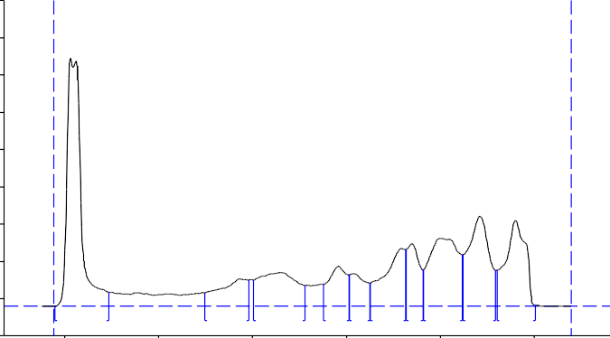
1
9
10
8
7
6
4
3
5
2

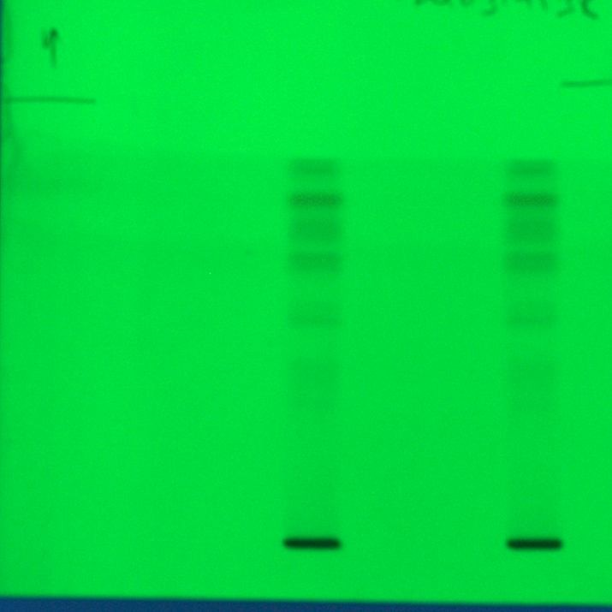
Fig. 2. HPTLC chromatogram of H. vulgaris leaf extract at 254 nm
Fig. 3. HPTLC Bands for H. vulgaris leaf extract at 254 nm
Table 2: Details of HPTLC chromatogram of H. vulgaris leaf extract at 254 nm.
Peak | Start Rf | Start Height | Max Rf | Max Height | Max  % | End Rf | End Height | Area | Area  % | Assigned substance
1 | -0.02 | 0.7 | 0.01 | 666.3 | 33.25 | 0.10 | 38.4 | 14473.0 | 24.40 | unknown
2 | 0.30 | 36.9 | 0.37 | 73.4 | 3.66 | 0.39 | 70.8 | 3273.2 | 5.52 | unknown
3 | 0.40 | 71.0 | 0.46 | 90.6 | 4.52 | 0.51 | 56.2 | 5418.1 | 9.13 | Alkaloid
4 | 0.55 | 59.6 | 0.58 | 107.5 | 5.37 | 0.61 | 85.2 | 2952.3 | 4.98 | Ferulic acid
5 | 0.61 | 85.4 | 0.62 | 88.0 | 4.39 | 0.65 | 62.9 | 2140.4 | 3.61 | unknown
6 | 0.65 | 63.3 | 0.72 | 155.3 | 7.75 | 0.73 | 152.6 | 4900.4 | 8.26 | unknown
7 | 0.73 | 153.3 | 0.74 | 167.8 | 8.37 | 0.76 | 98.0 | 3262.2 | 5.50 | Vanilic acid
8 | 0.77 | 98.5 | 0.81 | 183.1 | 9.13 | 0.85 | 139.1 | 8188.9 | 13.80 | unknown
9 | 0.85 | 139.3 | 0.89 | 242.1 | 12.08 | 0.92 | 96.8 | 7658.6 | 12.91 | Flavonoid
10 | 0.92 | 97.6 | 0.96 | 230.0 | 11.48 | 1.00 | 4.0 | 7052.0 | 11.89 | Quercetin

From the HPTLC chromatogram of the ethanolic leaf extract of Hydrocotyle vulgaris L. observed at 254 nm, a total of 10 distinct peaks were recorded, indicating the presence of multiple phytochemical constituents. Out of these, five peaks—specifically peak numbers 3, 4, 7, 9, and 10—were successfully identified based on their maximum Rf values and comparison with reference standards.
The identified peaks correspond to the following phytoconstituents:
Peak 3 (Rf = 0.16): Identified as an alkaloid
Peak 4 (Rf = 0.53): Identified as ferulic acid
Peak 7 (Rf = 0.63): Identified as vanillic acid
Peak 9 (Rf = 0.87): Identified as a flavonoid
Peak 10 (Rf = 0.99): Identified as quercetin
These compounds are known to possess significant pharmacological activities such as antioxidant, anti-inflammatory, and antimicrobial properties. Their presence in the leaf extract of H. vulgaris supports the traditional medicinal applications of the plant and provides a chemical basis for its therapeutic potential.
HPTLC Analysis of Hydrocotyle vulgaris Leaf Extract at 366 nm
The HPTLC analysis of the ethanolic leaf extract of Hydrocotyle vulgaris L. was further examined at a wavelength of 366 nm to detect additional phytoconstituents, particularly those with natural fluorescence under long-wave UV light. The chromatographic profile obtained at this wavelength revealed 13 distinct peaks, each corresponding to a unique compound (Figure 4). The TLC visualization under UV light at 366 nm similarly displayed 13 well-resolved fluorescent bands (Figure 5), consistent with the peaks recorded in the chromatogram.
Comprehensive data for each peak—including peak number, start Rf, maximum Rf, peak height, and peak area—are detailed in Table 3. This information is essential for the tentative identification and characterization of bioactive compounds present in the extract. Comparative analysis with reference standards may allow for further confirmation of compound identity, supporting the chemotaxonomic profiling and standardization of H. vulgaris.
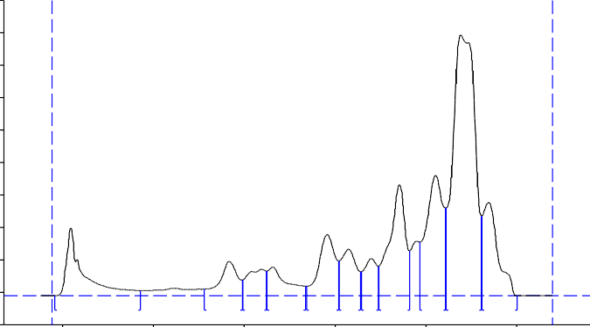

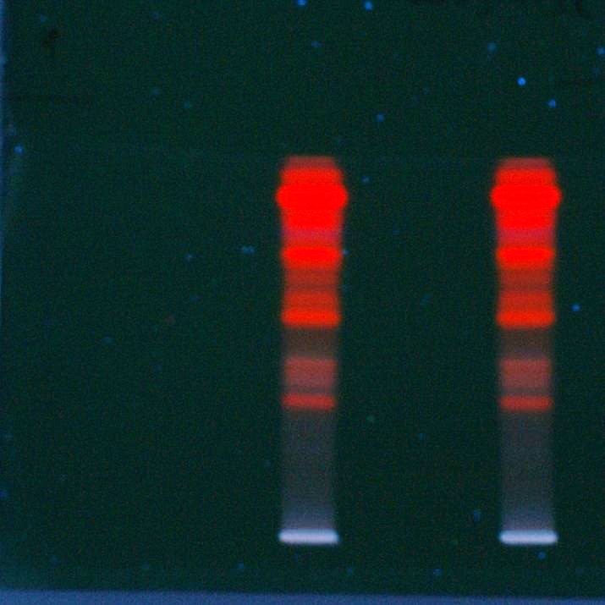
Fig. 4. HPTLC chromatogram of H. vulgaris leaf extract at 366 nm
Fig. 5. HPTLC band visualization of H. vulgaris leaf extract at 366
Table 3: Details of HPTLC chromatogram of H. vulgaris leaf extract at 366 nm.
Peak | Start Rf | Start Height | Max Rf | Max Height | Max  % | End Rf | End Height | Area | Area  % | Assigned substance
1 | -0.02 | 0.2 | 0.02 | 210.1 | 7.66 | 0.17 | 16.0 | 5666.7 | 7.25 | unknown
2 | 0.31 | 20.9 | 0.37 | 106.5 | 3.88 | 0.40 | 48.4 | 2953.8 | 3.78 | Unknown
3 | 0.40 | 49.2 | 0.44 | 81.8 | 2.98 | 0.45 | 76.8 | 2369.2 | 3.03 | unknown
4 | 0.45 | 76.8 | 0.46 | 89.6 | 3.26 | 0.54 | 30.1 | 2751.8 | 3.52 | unknown
5 | 0.54 | 30.2 | 0.58 | 189.1 | 6.89 | 0.61 | 107.2 | 4920.7 | 6.30 | Ferulic acid
6 | 0.61 | 107.7 | 0.63 | 144.5 | 5.26 | 0.66 | 74.3 | 3452.4 | 4.42 | Alkaloid
7 | 0.66 | 74.6 | 0.68 | 115.0 | 4.19 | 0.70 | 91.2 | 2345.7 | 3.00 | unknown
8 | 0.70 | 92.3 | 0.74 | 342.9 | 12.49 | 0.77 | 138.1 | 8687.0 | 11.12 | unknown
9 | 0.79 | 165.5 | 0.82 | 371.7 | 13.54 | 0.85 | 271.6 | 9995.1 | 12.80 | unknown
10 | 0.85 | 271.9 | 0.88 | 805.1 | 29.33 | 0.92 | 245.1 | 28093.6 | 35.97 | Flavonoid
11 | 0.93 | 246.2 | 0.97 | 288.4 | 10.51 | 1.00 | 0.8 | 6872.4 | 8.80 | Quercetin

At 366 nm, the HPTLC chromatogram of the ethanolic leaf extract of Hydrocotyle vulgaris L. displayed a total of 11 distinct peaks, indicating the presence of multiple UV-fluorescent phytoconstituents. Out of these, four peaks—specifically peak numbers 5, 6, 10, and 11—were tentatively identified based on their maximum Rf values and comparison with known reference standards.
The identified compounds and their corresponding peak characteristics are as follows:
Peak 5 (Rf = 0.58): Identified as ferulic acid
Peak 6 (Rf = 0.63): Identified as an alkaloid
Peak 10 (Rf = 0.88): Identified as a flavonoid
Peak 11 (Rf = 0.97): Identified as quercetin
These bioactive constituents are well-documented for their pharmacological properties, including antioxidant, anti-inflammatory, and antimicrobial activities. Their presence further substantiates the therapeutic potential of H. vulgaris and supports its traditional medicinal applications.
DISCUSSION
The present study was undertaken to investigate the phytochemical composition of Hydrocotyle vulgaris L., a medicinally important plant belonging to the family Araliaceae. The leaves of H. vulgaris were collected from the Akola region, authenticated, shade-dried, and powdered for use as crude drug material. The study focused on the preliminary phytochemical screening, fluorescence analysis, and HPTLC profiling of the leaf powder to establish a phytochemical fingerprint and support the pharmacognostic evaluation of the species.
Phytochemical Screening
The preliminary qualitative phytochemical analysis revealed the presence of several bioactive constituents including alkaloids, phenolics, flavonoids, steroids, quinones, glycosides, saponins, tannins, and terpenoids (Table 1). Among the three solvents tested (ethanol, distilled water, and chloroform), ethanol was found to be the most efficient in extracting a broad spectrum of phytoconstituents, followed by aqueous and chloroform extracts. These findings are in agreement with earlier reports indicating that ethanol serves as an optimal solvent for the extraction of both polar and moderately polar compounds from plant materials (Patel et al., 2020; Kumari et al., 2021).
Fluorescence Analysis
Fluorescence analysis of the powdered leaf material, both untreated and treated with various reagents, was performed under visible and UV light to aid in crude drug identification and detection of adulterants. Characteristic fluorescence responses were observed under UV light at 365 nm, with distinct color changes upon treatment with hydrochloric acid, sulfuric acid, sodium hydroxide, ferric chloride, and nitric acid. These findings provide a valuable tool for the quality control and authentication of H. vulgaris as part of routine pharmacognostic analysis (Shirsat and Suradkar, 2017; Jagtap and Koche., 2023).
HPTLC Analysis
High-Performance Thin Layer Chromatography (HPTLC) profiling at 254 nm revealed 10 distinct peaks, out of which five were tentatively identified based on their Rf values and comparison with reference standards. These included alkaloids (Rf = 0.16), ferulic acid (Rf = 0.53), vanillic acid (Rf = 0.63), flavonoids (Rf = 0.87), and quercetin (Rf = 0.99).
At 366 nm, 11 peaks were observed, and four compounds were identified: ferulic acid (Rf = 0.58), alkaloid (Rf = 0.63), flavonoid (Rf = 0.88), and quercetin (Rf = 0.97). These phytochemicals, particularly flavonoids and phenolic acids, are well-documented for their antioxidant, anti-inflammatory, antimicrobial, and cardioprotective activities (Smitha et al., 2013; Jasutkar et al., 2018; Pandey et al., 2022 and Mercelin and Johnsi, 2023).
CONCLUSION
The findings of this study confirm that Hydrocotyle vulgaris L. is a rich source of pharmacologically active phytoconstituents, especially phenolic compounds and flavonoids, which likely contribute to its traditional therapeutic applications. The presence of quercetin, ferulic acid, vanillic acid, and other bioactive compounds underscores the plant’s potential in the development of natural antioxidant and antimicrobial agents.
Previous studies have similarly highlighted the medicinal value of H. vulgaris and related species for their antimicrobial, antioxidant, anti-inflammatory, and neuroprotective properties (Ramnick et al., 2018; Mercelin and Johnsi, 2023; Bhandari et al., 2023).
Based on the results, it is concluded that H. vulgaris holds significant promise as a source of natural bioactive molecules. However, further pharmacological and toxicological evaluations, along with compound isolation and structural elucidation, are essential to validate its medicinal potential and facilitate its development into a standardized herbal therapeutic agent.
REFERENCES
Bhandari, P. R., Patel, S. M., Sharma, R. K., and Verma, A. (2023). Phytochemical and therapeutic perspectives of medicinal plants: A global review. Journal of Herbal Medicine, 41: 100631.
Harborne, J. B. (1998). Phytochemical Methods: A guide to modern techniques of plant analysis. Edition: 3, Springer. Germany.
Huong, T. N. L., Phung, N. K. P. and Suong, N. N. (2009). Contribution to the Chemical constituents study of Hydrocotyl vulgaris (L.) Apiaceae. Trang, 12(10): 29-34.
Jagtap, T., and Koche, D. (2023). Powder microscopy, fluorescence, qualitative phytochemistry, and GC-MS analysis of a neglected ethnomedicinal weed - Ruellia brittoniana Leonard. Soudi Journal of Life Sciences, 8(5): 71-77.
Jasutkar, J. M., Shirsat, R. P., and Koche, D. K. (2018). Pharmacognostic Study, Chemical Analysis and Antioxidant Potential of Leucas indica L. (R. Br.). Journal of Herbal Drugs, 9 (1): 1- 5.
Koche, D. K., Shirsat, R. P., Imran, S., and Bhadange, D. G. (2010). Phytochemical screening of eight folk medicinal plants from Akola District (MS) India. International Journal Pharma and Bioscience, 1(4): 256-261.
Koche, D., Shirsat, R. and Kawale, M. (2016) An overview of major classes of Phytochemicals: Types and role in disease prevention. Hislopia Journal, 9(1/2): 1-11.
Kumar, R., Singh, P., Mehta, V., and Gupta, A. (2016). Ethnopharmacological review of Hydrocotyle species: A valuable medicinal plant. Journal of Ethnopharmacology, 187: 13–32.
Kumari, N., Singh, S., Mehta, V., & Gupta, A. (2021). Solvent extraction in phytochemistry: A comparative study of solvent efficacy for phytoconstituent recovery. Pharmacognosy Journal, 13(3): 712–716.
Mercelin, B. M., and Johnsi, M. L. (2023). Phytochemical analysis and antimicrobial activity of medicinal plants used in traditional systems. Journal of Ethnopharmacology, 298: 115639.
Naik, V. N. (1998). Flora of Marathwada, Amrut Prakashan, Aurangabad (MS).
Pandey, R., Kumar, A., Singh, P., Verma, R., and Sharma, S. (2022). Bioactive compounds of traditional medicinal plants and their therapeutic potential. Phytotherapy Research, 36(2): 799–815.
Patel, D. K., Gupta, S., Mehta, A., and Sharma, A. (2020). Ethanolic extraction in phytochemical studies: Benefits and challenges. Journal of Pharmacognosy and Phytochemistry, 9(2): 550–556.
Pérez, J. L., García, R. C., Martínez, F. A., and Rodríguez, E. M. (2020). Phytochemical and pharmacological activities of Hydrocotyle species. Phytomedicine, 76: 153273.
Ramnick, S., and Siegfried, H. (2018). Oxidative stress and role of herbal antioxidants in skin aging. Journal of Dermatological Science, 92(3): 223–230.
Shirsat, R. P., and Suradkar, S. S. (2017). Macroscopic, phytochemical and fluorescent analysis of Colebrookea oppositifolia Smith. International Journal of Applied Research. Special Issue, 288-89.
Smitha, G. R., Suresh, R., Radhakrishnan, K., and Sivaraj, P. (2013). Biological activities and phytochemical profile of Hydrocotyle species: A review. International Journal of Pharmaceutical Sciences and Research, 4(6): 2137–2142.

