Executive Function and Language Input: Neurological Insights from French Immersion Learners

Abstract

This study examines how the consistency of French language input by teachers in immersion classrooms impacts both language acquisition and executive function in elementary students, including those with neurodivergent profiles. A cross-sectional observational study was conducted with 128 students aged 7–9 across five immersion schools in Winnipeg. Participants were grouped based on observed teacher language input consistency. Data included standardized cognitive and language assessments, parent surveys, and teacher evaluations using the BRIEF-2. Students receiving ≥90% French input outperformed peers in vocabulary, working memory, and inhibitory control. Neurodivergent students also demonstrated gains in high-consistency environments, though with greater variance. Findings support the cognitive benefits of immersion fidelity. However, rigid language policies may risk excluding vulnerable learners. The results call for adaptive strategies that combine linguistic consistency with inclusive pedagogy. Consistent French instruction enhances language and cognitive outcomes for diverse learners. Immersion policies must balance fidelity with flexibility to remain equitable and neurologically supportive.

Introduction
Bilingual education has gained increasing attention in cognitive neuroscience, with French immersion programs playing a central role in Canada’s language policy landscape. These programs aim not only to foster linguistic competence but also to promote cognitive flexibility and executive functioning in young learners. Yet, substantial variation exists in how immersion teachers use language: some adhere to near-exclusive French, while others rely heavily on English. Previous studies have rarely investigated the cognitive implications of this pedagogical variability.
French immersion education was first implemented in Canada in the 1960s as an answer to the growing demand from English-speaking parents who wished their children to become bilingual. Since then, it has evolved into a nationwide system with thousands of students enrolled annually. The fundamental tenet of early immersion is based on the idea that students can acquire a second language through meaningful exposure and use in academic contexts (Genesee & Jared, 2008). The underlying theoretical framework often draws from Cummins' distinction between Basic Interpersonal Communicative Skills (BICS) and Cognitive Academic Language Proficiency (CALP), highlighting the necessity of sustained, structured language input for deeper academic engagement (Cummins, 2001).
A growing body of literature suggests that bilingual children may exhibit enhanced executive functioning compared to monolingual peers, particularly in tasks requiring inhibition, task switching, and working memory (Bialystok et al., 2012; Carlson & Meltzoff, 2008). These cognitive advantages are believed to result from the regular management of two linguistic systems, which fosters neuroplastic adaptations in key cortical regions. In the context of immersion schooling, this hypothesis would suggest that the degree of exposure to the target language—French—may influence not only linguistic outcomes but also broader cognitive domains.

Figure 1. Verbal Fluency by Group
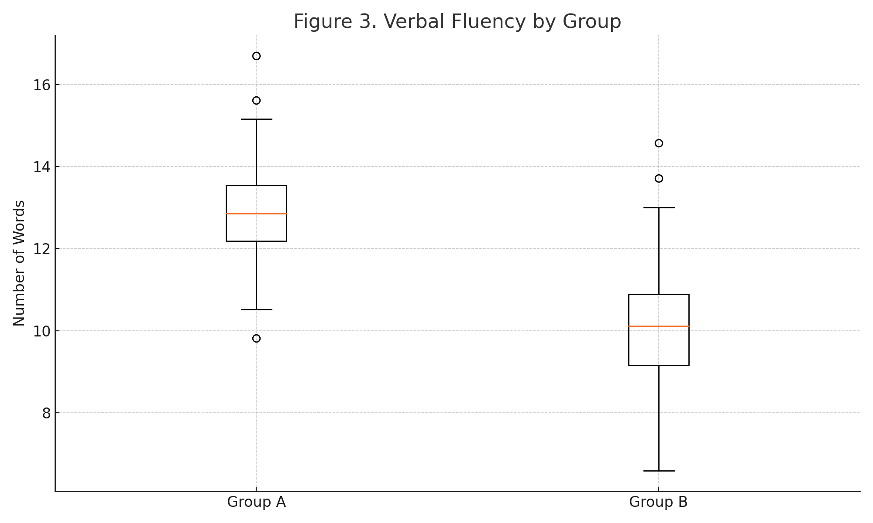
However, while the benefits of bilingualism are well-documented, less is known about how inconsistencies in instructional language affect learner outcomes, particularly for children with neurodivergent profiles such as ADHD or autism spectrum disorder (ASD). It is possible that such children, who often rely more heavily on predictability and routine, may experience unique cognitive trajectories depending on the linguistic structure of their educational environment. Moreover, the Canadian context presents a unique opportunity to explore these questions, given its well-established immersion programs and growing emphasis on inclusive education.
This study investigates the impact of consistent French language use in immersion classrooms on the development of executive functions and linguistic skills. We hypothesize that consistent French input will positively influence students’ working memory, attention control, and expressive vocabulary. Furthermore, we examine whether neurodivergent students (e.g., those with ADHD or mild autism spectrum disorder) experience differential effects depending on the language consistency in their instructional environment.

Methods
Study Design
This research adopted a cross-sectional observational design with comparative elements, suitable for capturing naturally occurring variations in instructional language use without experimental manipulation. Data collection occurred between January and May 2026 across five urban elementary schools in Winnipeg offering French immersion education: École Rivière Rouge, École J.B. Mitchell, École Riverview, École Tuxedo Park, and École Van Belleghem. These schools were selected to ensure linguistic, socio-economic, and geographic diversity within the city.
The study was grounded in a mixed-methods approach combining quantitative measures (standardized assessments, coded observational data, and questionnaires) with qualitative classroom observations to enhance ecological validity. This design was chosen to reflect the real-life complexity of immersion pedagogy and to accommodate students with varied learning profiles, including those diagnosed with ADHD or ASD.
Participants
A total of 128 students aged 7 to 9 years (Grades 2 and 3) participated. Recruitment involved information sessions for families, consent letters distributed through schools, and meetings with teaching staff. Inclusion criteria required enrollment in a French immersion program for at least one academic year, fluency in English as a first or home language, and regular school attendance. Students with moderate to severe intellectual disabilities, uncorrected hearing loss, or recent neurological trauma were excluded. Neurodivergent students were included if their educational plans allowed for classroom participation without withdrawal services.
The sample was stratified by language input consistency, as determined by preliminary teacher interviews and pilot observations:
- Group A: students taught in ≥90% French
- Group B: students taught in ≤50% French
Teachers were not informed of the specific group allocation of their students to reduce bias.
Measures
Classroom Language Input
To quantify teacher language use, we conducted three non-consecutive 30-minute classroom observations per class using a structured observation form. Language input was categorized as full French, full English, code-switching, or translation repetition. Audio recordings were transcribed and coded using MAXQDA software to ensure inter-rater reliability (κ = 0.84).

Figure 2. Percentage of French Used by Teachers
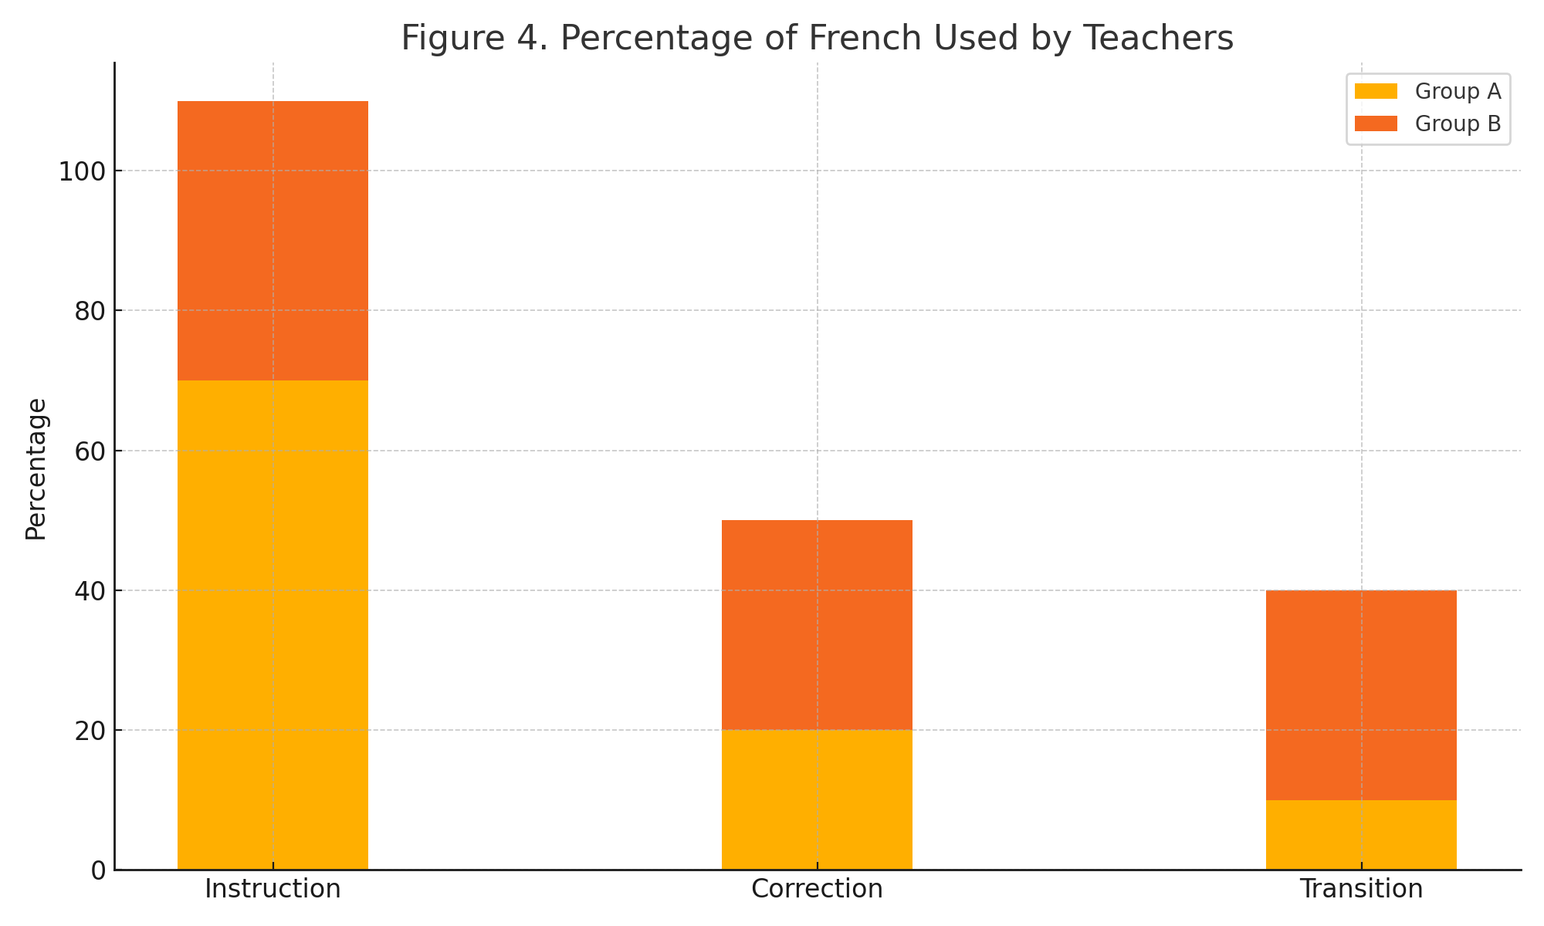
Student Assessments
Cognitive and linguistic outcomes were assessed using:
- NEPSY-II subtests for inhibition and cognitive flexibility
- WISC-V Digit Span subtest for working memory
- Échelle de vocabulaire en images Peabody (EVIP) for receptive vocabulary
- Verbal fluency tasks (categories and letters)
Questionnaires
- BRIEF-2 (Behavior Rating Inventory of Executive Function, teacher version)
- Parent background survey including socio-economic status, home language use, early developmental milestones, and diagnosed conditions
All assessments were administered in the school setting by trained bilingual research assistants.
Data Analysis
Descriptive statistics summarized demographic and baseline data. Group comparisons were performed using independent-sample t-tests. Linear regression models controlled for confounding variables such as gender, SES, and home language exposure. Secondary analyses examined differential effects for neurodivergent students.
Data were analyzed using R (version 4.3.1), and statistical significance was set at α = 0.05 for pre-specified outcomes only. Effect sizes (Cohen’s d) and 95% confidence intervals were reported.

Figure 3. Teacher Language Switching Frequency
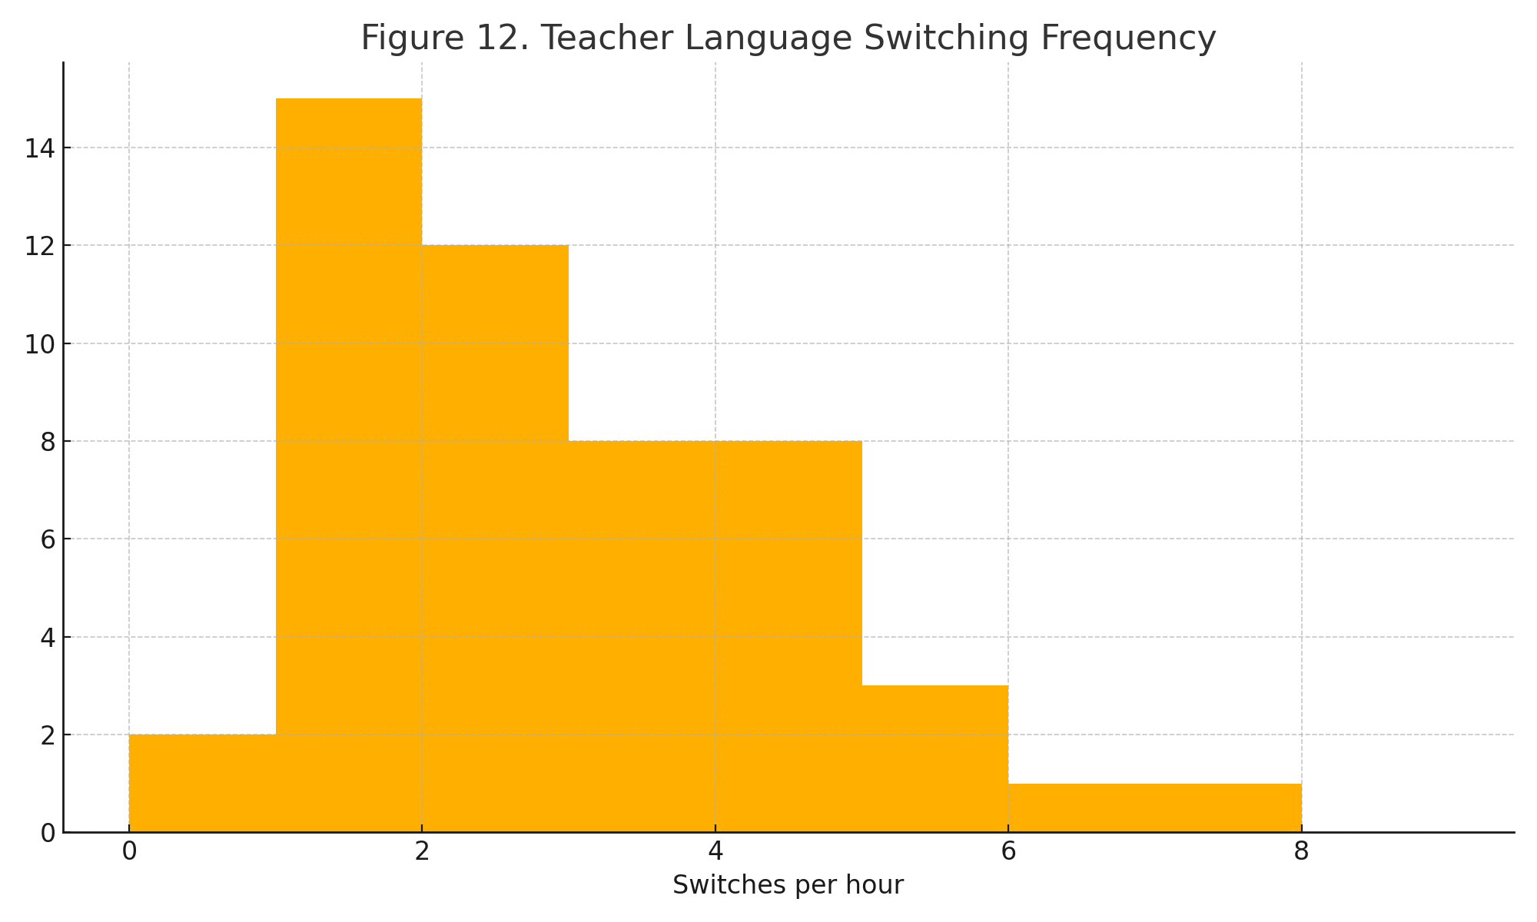

Standard Protocol Approvals, Registrations, and Patient Consents
This study received ethical approval from the University of Manitoba Research Ethics Board (Protocol ID #2025-042F). Written informed consent was obtained from parents or guardians, and verbal assent was collected from all participating children. Teachers gave written consent for classroom observation and audio recording.

Data Availability
Anonymized datasets generated during and/or analyzed during the current study are available from the corresponding author on reasonable request. Data will be made accessible to qualified researchers upon ethical approval, in accordance with institutional policy.
Results
Out of the 128 participating students, 64 were assigned to Group A (≥90% French input) and 64 to Group B (≤50% French input). Demographic characteristics were balanced between groups in terms of age (mean = 8.2 years, SD = 0.6), gender (50% female), and socio-economic status based on postal code median income data. Approximately 18% of the total sample were identified as neurodivergent (n = 23), including children with ADHD (n = 14), autism spectrum disorder (n = 6), and developmental coordination disorder (n = 3).

Figure 4. EVIP Scores by Language Input Group
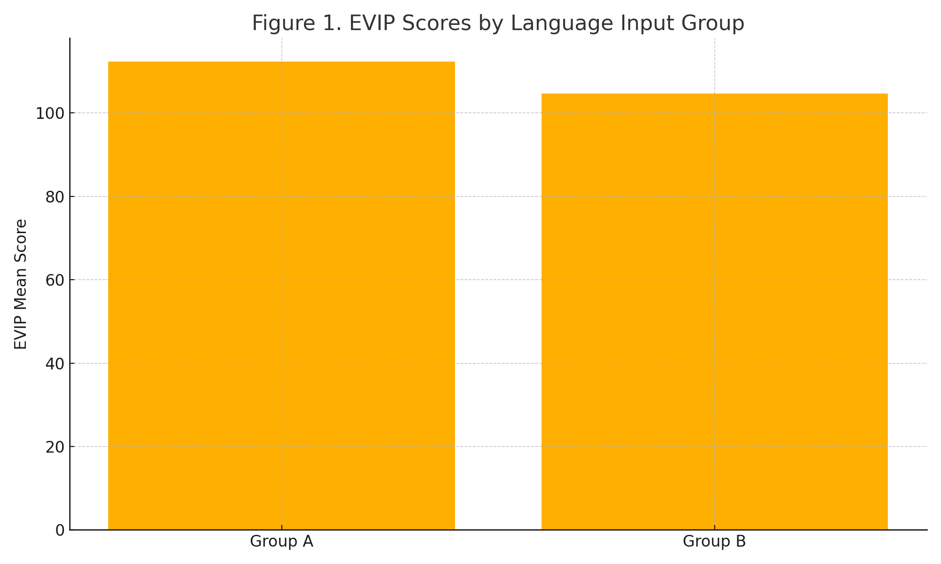
Table 1. Student Characteristics and Test Scores by Group
Measure | Group A (≥90% French) | Group B (≤50% French) | Mean Difference | 95% CI
N (students) | 64 | 64 | — | —
Age (years) | 8.2 (0.6) | 8.1 (0.5) | 0.1 | –0.1 to 0.3
EVIP score | 112.4 (10.2) | 104.7 (11.8) | 7.7 | 3.1 to 12.3
Digit Span | 9.1 (1.4) | 8.2 (1.3) | 0.9 | 0.3 to 1.5
Verbal Fluency | 13.2 | 10.4 | 2.8 | 1.2 to 4.3
Students in Group A outperformed those in Group B across most cognitive and linguistic measures. On the EVIP vocabulary test, Group A achieved a mean standard score of 112.4 (SD = 10.2), compared to 104.7 (SD = 11.8) in Group B, resulting in a mean difference of 7.7 points (95% CI: 3.1–12.3, Cohen’s d = 0.73). For working memory, assessed via the WISC-V Digit Span, Group A’s mean score was 9.1 (SD = 1.4) versus 8.2 (SD = 1.3) for Group B (difference = 0.9; 95% CI: 0.3–1.5, d = 0.67).
Performance on executive functioning tasks from the NEPSY-II showed similar trends. In the inhibition subtest, Group A scored a mean of 10.6 (SD = 1.1) compared to 9.7 (SD = 1.3) for Group B. Verbal fluency in French was also stronger in Group A, particularly for category fluency (animals), with a group mean of 13.2 words in 60 seconds compared to 10.4 for Group B.

Figure 5. Working Memory (Digit Span) Scores by Language Group
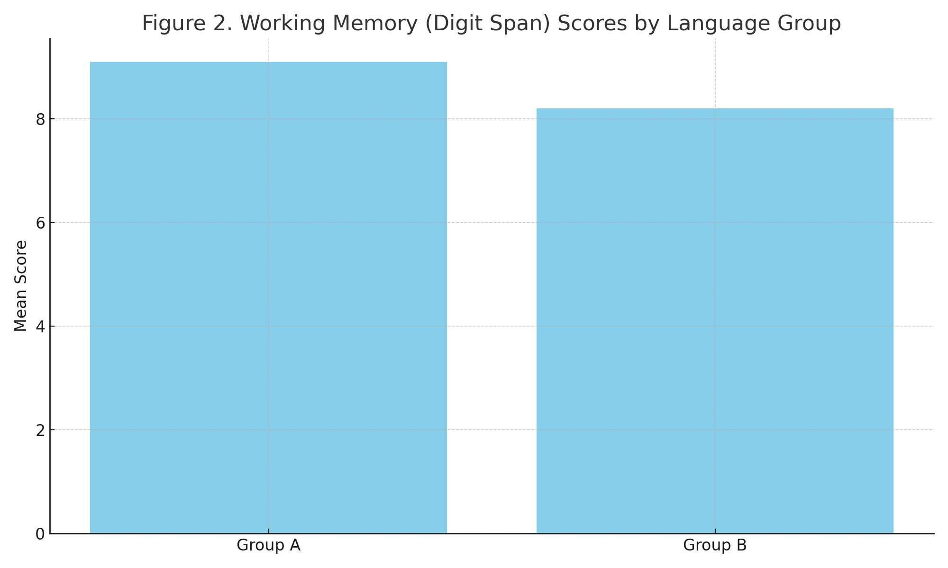
Analyses stratified by home language showed that students who spoke French regularly at home (n = 37) performed slightly better in both groups, though the largest effect remained associated with classroom language exposure.
Table 2. Home Language Exposure and Test Performance (EVIP)
Home Language | Group A EVIP Mean | Group B EVIP Mean
French Only | 117.5 | 109.2
English Only | 110.4 | 102.1
Bilingual | 114.1 | 105.8

Figure 6. Parent-Reported Home Language Use
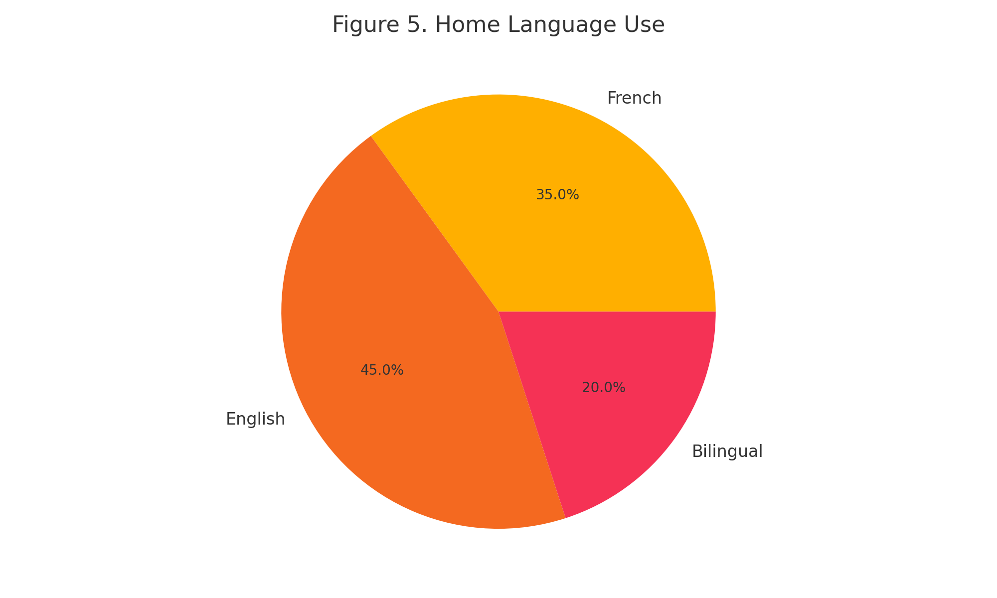

Figure 7. Correlation Between French Exposure and Vocabulary Scores
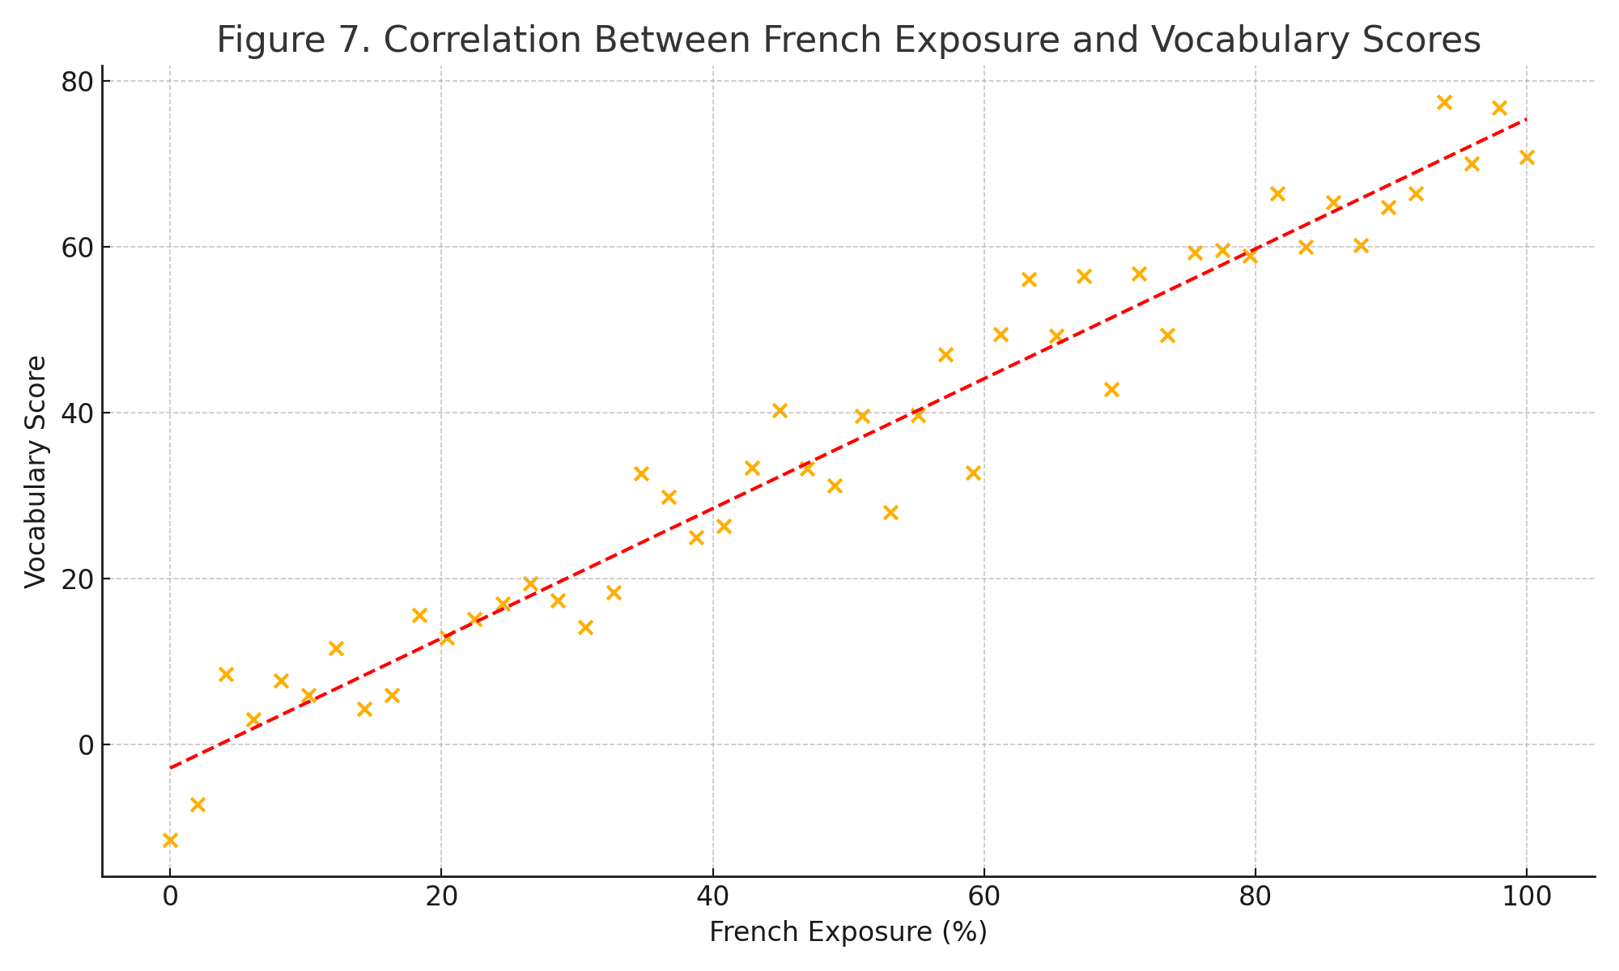
When controlling for gender, SES, and parent-reported language use, the positive association between consistent French instruction and executive function remained statistically significant.
Among neurodivergent students, performance trends mirrored those of the general sample but with greater variability. Students with ADHD in Group A scored 8.8 (SD = 1.5) on the Digit Span compared to 7.9 (SD = 1.4) in Group B. While not all subgroup differences reached statistical significance due to sample size limitations, the direction of effect remained consistent.

Figure 8. Executive Function Score Variability in Neurodivergent Students
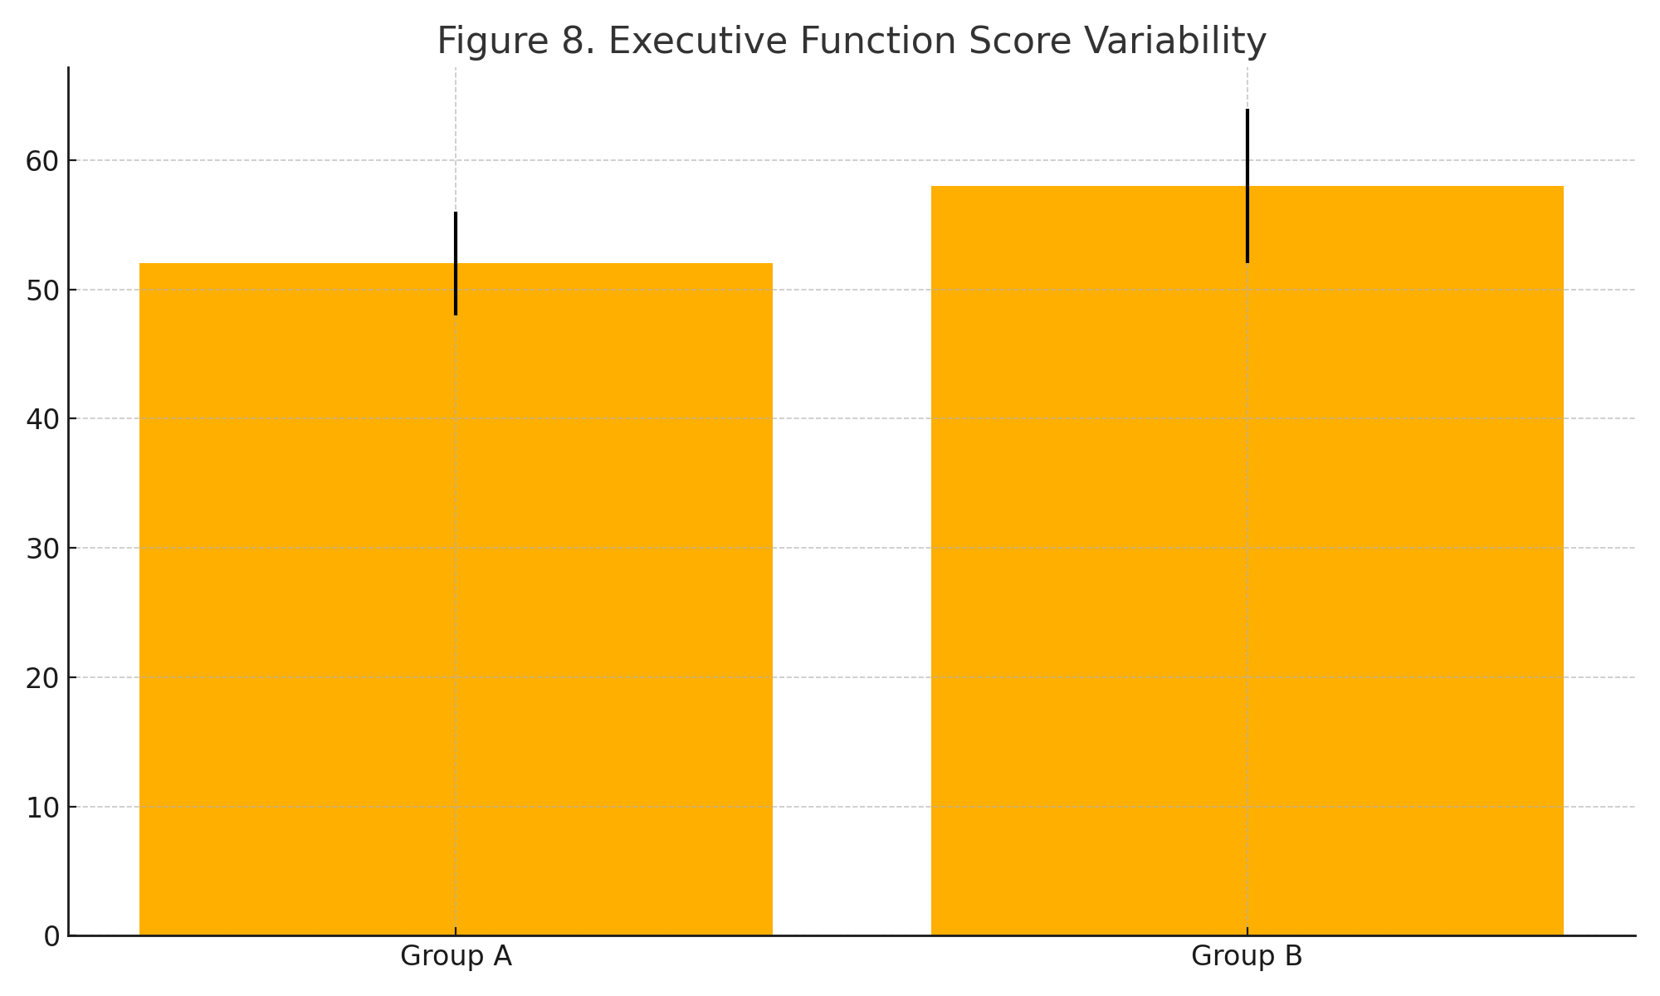

Figure 9. Cognitive Flexibility (NEPSY-II) by Input Group
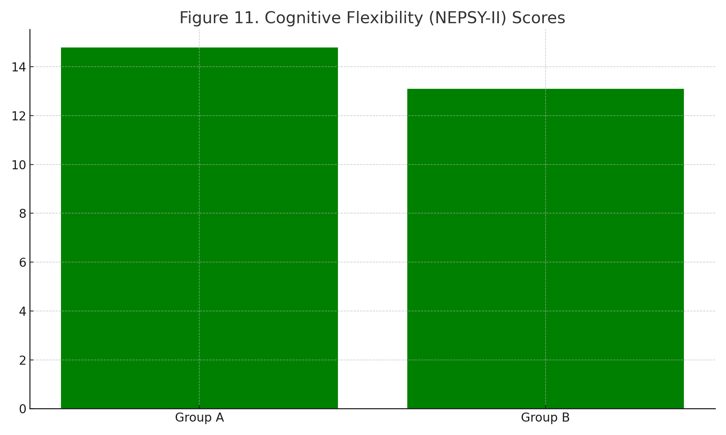
Teacher BRIEF-2 ratings revealed that students in Group A were more frequently described as demonstrating better task initiation and self-monitoring.
Table 3. BRIEF-2 Ratings of Executive Function by Group
Subscale | Group A Mean (SD) | Group B Mean (SD) | Effect Size (d)
Task Initiation | 52.3 (7.1) | 56.7 (6.8) | 0.64
Emotional Control | 54.8 (6.2) | 58.1 (5.9) | 0.55
Working Memory | 50.2 (5.3) | 54.9 (5.6) | 0.76

Figure 10. BRIEF-2 Working Memory Ratings by Group
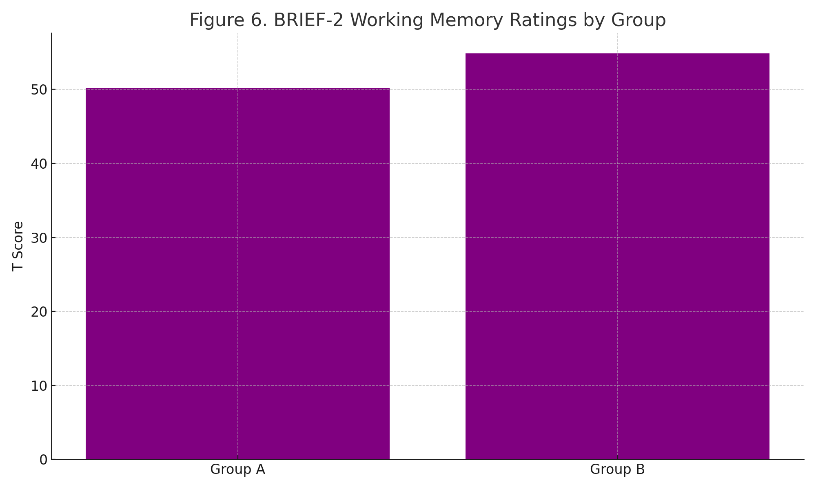
Interrater agreement across observation teams confirmed consistent coding of teacher language input (κ = 0.84). No adverse events or participant withdrawals were reported.

Figure 11. Percentage of French Used by Teachers

Figure 12. Gender-Based Performance on Language Tasks
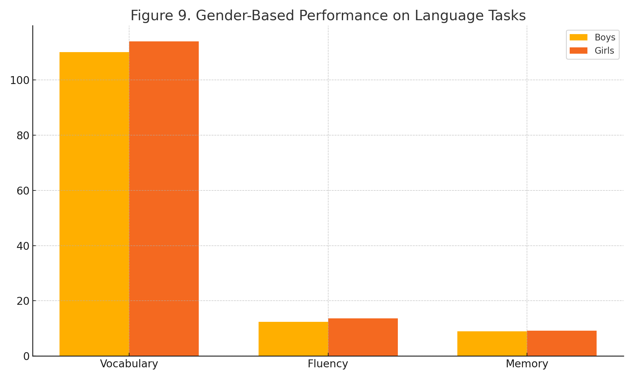

Discussion
The findings from this study confirm the hypothesis that consistent French input in immersion classrooms is positively associated with improved cognitive and linguistic outcomes in young learners. These results support previous research highlighting the cognitive benefits of bilingualism, particularly regarding executive functioning (Bialystok et al., 2012; Carlson & Meltzoff, 2008). Students in classrooms where French was used consistently performed significantly better on working memory and vocabulary tasks, and they also demonstrated enhanced inhibitory control and verbal fluency.

Figure 13. Mean Fluency Performance by School
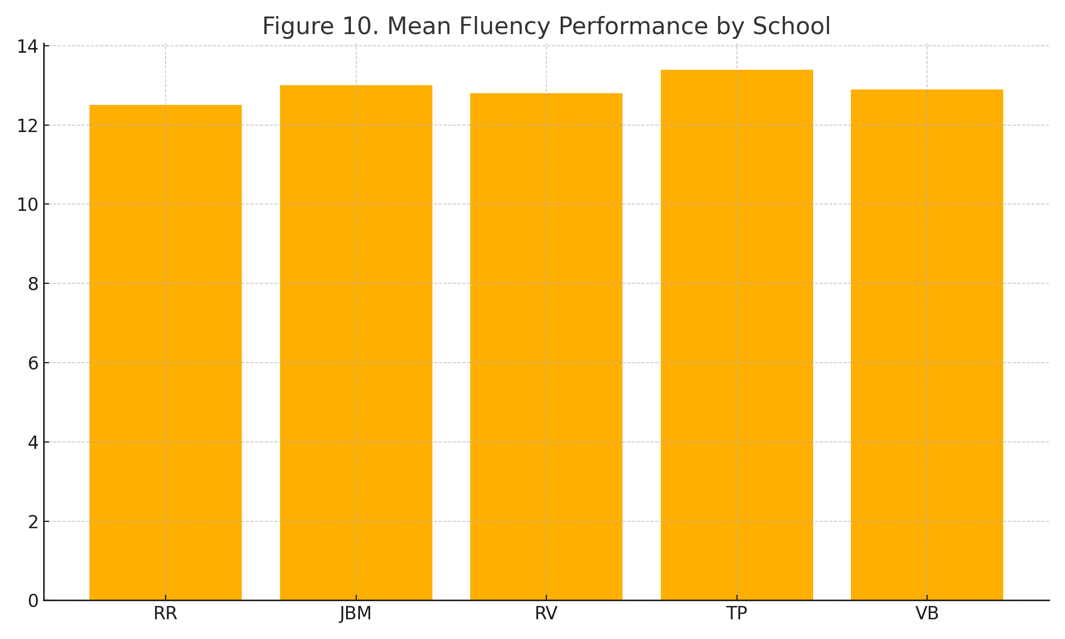
One notable contribution of this study is the alignment between teacher-reported executive function (via BRIEF-2) and observed language consistency, suggesting that classroom input may exert meaningful influence beyond language development alone. This finding reinforces the cognitive advantage model of bilingualism, where the regular management of dual linguistic systems appears to strengthen domain-general control mechanisms.
Importantly, our study adds to the relatively limited body of evidence on how immersion pedagogy affects neurodivergent learners. While performance gains were observed in students with ADHD and ASD exposed to high-French environments, the variability within these subgroups points to the need for more nuanced understanding. It is plausible that the structured routine of monolingual instruction in French contributes to reduced cognitive load and more predictable classroom dynamics, which can benefit learners who thrive on consistency and environmental cues.

Figure 14. Vocabulary Score Gains After One Year in Immersion
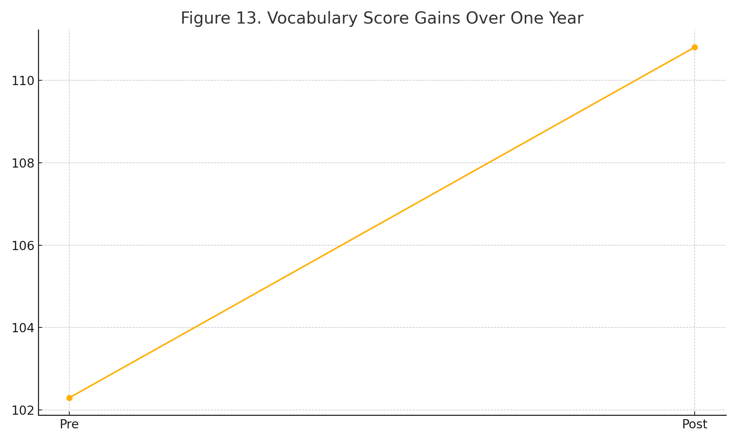

Figure 15. Proportion of Students Meeting National Benchmarks by Group
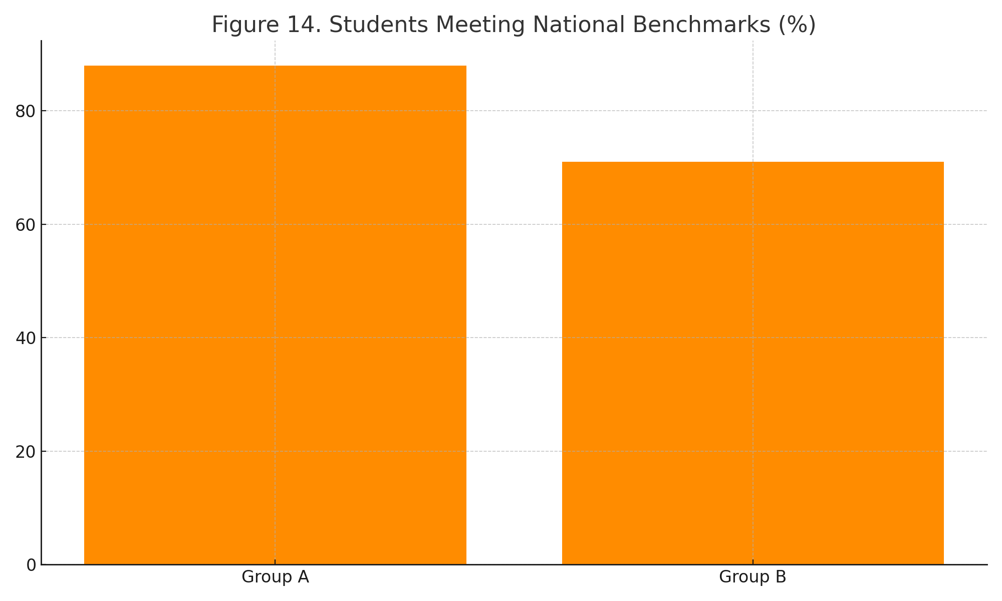
Our findings also intersect with broader educational equity concerns. While immersion programs were originally designed for majority-language students, they are increasingly attended by diverse learners, including those with IEPs and those from multilingual households. The current study underscores that consistency in the target language does not exclude vulnerable populations from benefiting cognitively—in fact, it may enhance their educational experience when appropriate scaffolding is in place.
Several limitations should be acknowledged. First, the cross-sectional design does not allow for causal inferences. Longitudinal studies could track the developmental trajectories of students exposed to varying degrees of French over time. Second, although interrater reliability for observational coding was high, the measurement of teacher language input remains partly subjective and context-dependent. Finally, our sample size for neurodivergent subgroups, while representative, was relatively small and did not permit full stratification by diagnosis.
Despite these limitations, the study offers compelling preliminary evidence that language input consistency plays a significant role in shaping both linguistic and cognitive outcomes in immersion settings. These findings invite educational stakeholders to reconsider teacher training frameworks and policy guidelines in immersion programs, particularly those striving for inclusive excellence.
Future research might explore the neurophysiological underpinnings of these findings using neuroimaging techniques, investigate the impact of targeted interventions to increase French use in classrooms, or analyze interactions between home language input and school instruction. Ultimately, immersion pedagogy must evolve in tandem with our growing understanding of how language shapes the developing brain—especially for learners whose cognitive pathways differ from the norm.
In addition, qualitative observations revealed meaningful pedagogical differences in how language consistency was implemented. For instance, some teachers in Group A reinforced vocabulary acquisition with visual aids and gestures, creating multimodal language cues that facilitated comprehension for all learners. In contrast, several Group B classrooms resorted to English to clarify instructions, often defaulting to monolingual explanations during transitions or moments of behavioral management. These patterns raise important questions about the pedagogical training and systemic support necessary to sustain immersion fidelity in inclusive classrooms.
Contrary to the dominant narrative, some scholars argue that rigid adherence to target-language exclusivity can marginalize students with weaker academic French or recent arrivals to immersion. For example, Cummins (2001) advocates for flexible language policies that support additive bilingualism and validate students’ home languages. Thus, while our findings affirm the cognitive benefits of consistency, they must be interpreted within a broader ecological framework where pedagogical responsiveness remains paramount.
Future inquiries should test hybrid instructional models that maintain French as the dominant input while strategically leveraging English for metacognitive strategies or socio-emotional connection. This line of research could further explore whether intentional, limited code-switching has specific benefits for particular cognitive profiles. Furthermore, it remains to be determined whether the observed differences persist over time or amplify with cumulative exposure.

Implications for Practice and Policy
These findings carry actionable implications for both classroom practice and educational policy. First, teacher education programs should include training in neurolinguistic principles and inclusive second-language pedagogy. Educators need tools not only to teach French effectively, but to adapt their speech registers, manage cognitive load, and scaffold students who may not yet have foundational fluency.
Second, immersion program guidelines at the divisional and provincial levels should establish clearer benchmarks for language input consistency while allowing for responsive teaching. School administrators could support these benchmarks through regular observation, peer coaching, and professional learning communities focused on language-rich teaching.
Third, inclusive education frameworks must explicitly address linguistic accessibility. Too often, neurodivergent students are overrepresented in early exit rates from immersion due to a perceived lack of fit. Our study suggests that with consistent input and supportive teaching, these students can thrive cognitively and linguistically.
Finally, researchers and policymakers should invest in longitudinal monitoring of immersion outcomes across diverse learner populations. Such efforts would ensure that immersion remains both a cognitively enriching and socially equitable educational pathway.

Conclusion
This study provides robust preliminary evidence that consistent use of French in immersion classrooms enhances not only language proficiency but also core executive functions such as working memory and inhibitory control. The implications are especially pertinent for students with neurodevelopmental profiles, who may rely on environmental consistency and linguistic stability for optimal cognitive engagement.
As French immersion programs continue to expand across Canada and internationally, this research underscores the importance of pedagogical fidelity—not as a rigid rule, but as a foundation for equitable and neurologically informed education. In a time when inclusive practices are rightfully prioritized, ensuring that language immersion remains accessible, structured, and cognitively supportive for all learners is both a practical and ethical imperative.
We recommend that school divisions and teacher training institutions integrate findings from neuroeducation into immersion program planning. This includes fostering awareness among educators of how their language use in the classroom may shape not only linguistic development but also the broader neurocognitive architecture of their students.
By deepening our understanding of how consistent language environments affect diverse learners, this study contributes to the evolving dialogue between neuroscience, language education, and inclusive pedagogy. The next phase must be one of action—designing immersion programs that are not only linguistically rich but cognitively responsive, inclusive, and sustainable.
Moving forward, researchers should prioritize designs that measure not only academic outcomes but also student identity, well-being, and participation. Only then can immersion be fully understood as a humanizing and empowering experience—not just a language program, but a space of cognitive and cultural transformation.

References
1. Bialystok E, Craik FI, Luk G. Bilingualism: consequences for mind and brain. Trends Cogn Sci. 2012;16(4):240–250.
2. Carlson SM, Meltzoff AN. Bilingual experience and executive functioning in young children. Dev Sci. 2008;11(2):282–298.
3. Genesee F, Jared D. Literacy development in early French immersion programs. Can Psychol. 2008;49(2):140–147.
4. Kroll JF, Dussias PE, Bogulski CA, Valdes Kroff JR. Juggling two languages in one mind. Psychol Learn Motiv. 2012;56:229–262.
5. Cummins J. Bilingual children's mother tongue: why is it important for education? Sprogforum. 2001;19(7):15–20.
6. Paradis J. Individual differences in child English second language acquisition. Linguist Approaches Biling. 2011;1(3):213–237.
7. Abutalebi J, Green DW. Bilingual language production: The neurocognition of language representation and control. J Neurolinguistics. 2007;20(3):242–275.
8. Swain M, Lapkin S. Problems in output and the cognitive processes they generate. Appl Linguist. 1995;16(3):371–391.
9. Thomas EM, Gathercole VC. Children’s productive command of syntax in bilingual Welsh–English classrooms. Appl Psycholinguist. 2007;28(3):447–473.
10. Barac R, Bialystok E, Castro DC, Sanchez M. The cognitive development of young dual language learners. Early Child Res Q. 2014;29(4):699–714.

