Smart Firefighting Robot: An IoT-Based Solution for Real-Time Fire Detection and Control

Abstract: Fire outbreaks have long posed significant threats to human life, property, and the environment, often resulting in substantial economic and social losses. In this study, we present the design and implementation of an Internet of Things (IoT)-based fire-fighting robot developed to enhance early fire detection and automated suppression. The system is built around a microcontroller unit and integrates a suite of sensors for autonomous operation, enabling real-time fire detection. A motor driver controls the robot’s mobility, while a relay circuit manages the actuation of a direct current (DC) pump connected to a water jet spray mechanism for extinguishing fires. The robot also supports manual override functionality through a web-based interface accessible via smartphones or personal computers, incorporating a live camera feed for remote navigation and control. The prototype design will increase response time by 30%, significantly improving the speed of fire suppression interventions. This improvement directly translates to a higher chance of containing fires before they escalate, reducing potential damage and increasing safety for occupants and first responders. It is recommended that future developments expand the system's capabilities to address other classes of fires (e.g., Class B and C), beyond the current focus on Class A fires. Additionally, incorporating cloud-based infrastructure can improve real-time data processing, storage, analytics, and multi-location deployment, enabling smarter and more coordinated fire management.

Keywords: Camera, DC pumping machine, Motor driver (L298n), Raspberry pi 3b, Sensors, Web page

Introduction
Fire is a classical element that has been an equalizer on earth before the start of written history. It has many positive attributes (heat, energy, cleansing) but is hazardous outside control [1]. A robotic fire firefight system is designed with specific tasks in mind. These include analyzing and locating fires, conducting search and rescue monitoring hazardously, and the primary task of fire control and suppression [2]. Mobile robotic firefighting systems are another type, mainly in remote-controlled vehicles affixed with fire suppression tools like water hoses. These can travel into an unsafe area for people through an array of sensors, visual cameras, and more technology that transmits information for navigation to a remote operation [3]. The “Internet of Things” (IoT) is the ability for things that contain embedded technologies to sense, communicate, interact, and collaborate with other things, thus creating a network of physical objects. IoT applications can be found in every industry with various applications for smart homes, smart buildings, travel and transportation, health and personal care, retail, agriculture, construction, etc.
Detecting fire and extinguishing it is a dangerous job that puts the life of a firefighter at risk. Although there are many fire accidents with lost lives in the line of duty every year globally, firefighters have dedicated their lives to protecting others from disaster that can occur due to myriad reasons anywhere at any time. Unfortunately, a firefighter is the only human who can succumb to injury or death. Besides, they also have to face life-threatening situations like explosions and collapsed buildings.
According to the report of IAFF, in 2000, 1.9 firefighters in every 100,000 burned structures lost their lives annually in the USA [6]. However, this rate was increased to 3 per 100,000 structure fires. The causes of Line of Duty Deaths (LODD) are smoke inhalation, burns, crushing injuries, and related trauma.
The project is based on the design and construction of an IoT base firefighter robot that will work independently with firefighters to improve response times to fires, serve as advanced equipment for extinguishing fires, can be controlled anywhere in the world any place and reduce the risk of firefighter injury, and protect lives and property.
Swati Deshmukh [7] has developed a Wireless firefighting robot. It is a combination of machines that can detect fire and extinguish it. This firefighting robot can move forward and reverse and rotate in the right and left directions. So, firefighting can operate the robot over a long distance. This robot does not require any human handling, so there is no need for a human to stay near the fire area. That firefighting can also save others and their own life in fire disasters. She uses light-dependent resistors to detect fire, a susceptible device that can detect tiny fires. This robot can provide security at home, buildings, factories, and laboratories. It is an intelligent multi-sensor-based fire security system as a fire alarm and contains a firefighting system for daily life. [8].
Phyo Wai Aung [9] developed a Remote-Controlled Fire Fighting Robot. It is one of the best inventions and examples of remote-controlled firefighting robots. It has two main parts, namely transmitter and receiver. In these parts, RF module sets are used. One RF module is used to transmit data to the motor driver, and another RF module is used to know the fire condition. To operate the whole system of the robot, the Microcontroller PIC16F887 is used. L298 and ULN2003 drivers are added to this system to drive the motors. Since this robot cannot detect the fire and follow the path itself, it consists of a wireless camera mounted on the robot. With the help of this camera, humans/firefighters can see where the fire source is and where the robot is going? It consists of an alarm that rings when the robot goes under a temperature of more than 40 degrees Celsius. If the temperature of the fire.

Methodology
This section explains the materials and methodologies for developing an IoT base firefighter robot. It comprises two modules which are the hardware and the software. The hardware consists of the equipment required for the development of the proposed project:
- Hardware materials.
- Raspberry Pi 3b
- Flame sensor
- Ultrasonic sensor
- Raspberry Pi Camera module
- Servo motor
- Motor driver (L298n)
- Power supply (5v)
- DC Pumping machine
- Water tank
- Robotic chassis
- Hosepipe
- Jumper wire
- Temperature sensor (LM35)
- SD card
- Buzzer
- Smoke sensor

- Software applications are the programs and other operating information used for the proposed project.
- Eclipse Kepler
- HTML5(Hypertext markup language)
- CSS3(Cascading style sheet)
- C++ Programming
- SERVLET/JSP(Java server pages)
- Apache Tomcat
- Putty client.
- Debian Raspberry PI Language

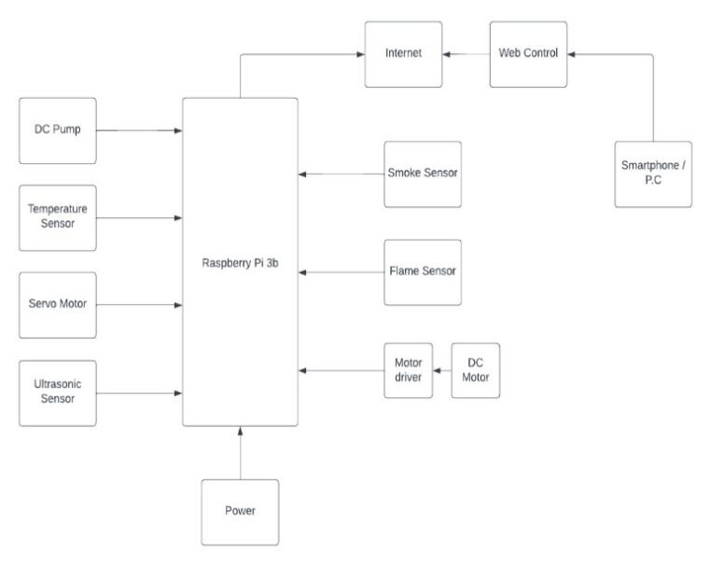
Figure 1: System block diagram of an IoT based firefighter Robot
The Raspberry Pi 3b is a microprocessor that allows the integration of various units, Raspberry Pi 3b serves as the controller. This is the system's brain, which connects all the units and aids in processing the various functionalities implemented in the system. The control unit houses the motor drivers, web control or manual control, and automatic control, linked to a Raspberry Pi 3b. First, the robot moves by using a motor driver and ultrasonic sensors to determine the distance between the robot and obstacles. Web control via a personal computer, tablet, or smartphone directs the moto driver toward the fire for a short period of time, after which the pump ejects water from the water storage.

2.1 Manual mode
In manual mode, a web control is used to control the robot's movement; this is designed in such a way that the robot can be controlled from a different location; the robot is controlled via a smartphone with a python programming backend through which we can send commands to the motor GPIO pin of the Raspberry Pi 3b, and it moves in the required direction with the following control.
- Forward
- Backwards
- Right
- Left
- Stop
- Camera tilt

2.2 Automatic mode
The first process in automatic mode is the sensors. Once the flame sensor, smoke sensor and temperature sensor detects the fire, the Ultrasonic sensor is used to detect an object or change in its environment, and the distance of the events is sent to raspberry pi 3b, which gives the command to the motor driver to run the motor toward the fire for a short time, then the pump ejects water from the water storage.

2.3 System hardware design

Testing of all modules and sensors
Before we mount all of the sensors, we want to test them individually. Using their respective programs, test a module such as raspberry pi, raspberry pi camera, dc motor with L298n driver, ultrasonic sensor, smoke sensor, flame sensor, temperature sensor and servo motor.

2.4 Robot Movement
The subjective robot is a simple four-wheeled robot with two wheels on each side and a front and back castor wheel for support. The robot is propelled by two direct currents (DC) motors. The angular velocities are of identical magnitude and direction, indicating that both wheels are driven at the same speed and in the same direction. One of the most significant advantages of the personal robot is its ability to turn completely. If one of the wheels rotates while the other remains stationary, the robot can make a 90-degree turn and is more likely to follow the left or right path. The robot moves using two standard robot wheels on the side that can run forward and backwards. The center of the wheel is fixed to the robot’s frame, whereas the angle between the robot frame and the wheel remains constant. The wheels have a radius of 3.5 cm.

2.5 Robot Manipulation
The cloud oversees controlling the personal robot. The physical buttons provided on the web page are used to control the robot. In addition, manipulation of other objects in the environment is possible using the onboard Pi-Camera.

2.6 Robot Energy
The personal robot is powered by a DC battery, which is the primary energy source. Two DC batteries are used, one for driving the motors and the other for powering the primary circuit.

2.7 Robot Intelligence
The concept of robots freely moving around in the same environment as humans is only now becoming a reality; the personal robot can make decisions about moving safely in the environment. In conjunction with an ultrasonic sensor, the Pi-Camera serves as a vision for the robot, assisting the user in selecting a safe path.

2.8 Robot Sensing
With the help of attached sensors, the personal robot can determine the environmental quality. The temperature sensor, smoke sensor, and flame sensor assist the user in determining the quality of the surrounding environment, which aids in classifying the location as pleasant or unpleasant for humans or other living organisms.

2.9 Sensors Connection and Circuit Diagram
Connecting and programming all the modules and sensors to raspberry pi

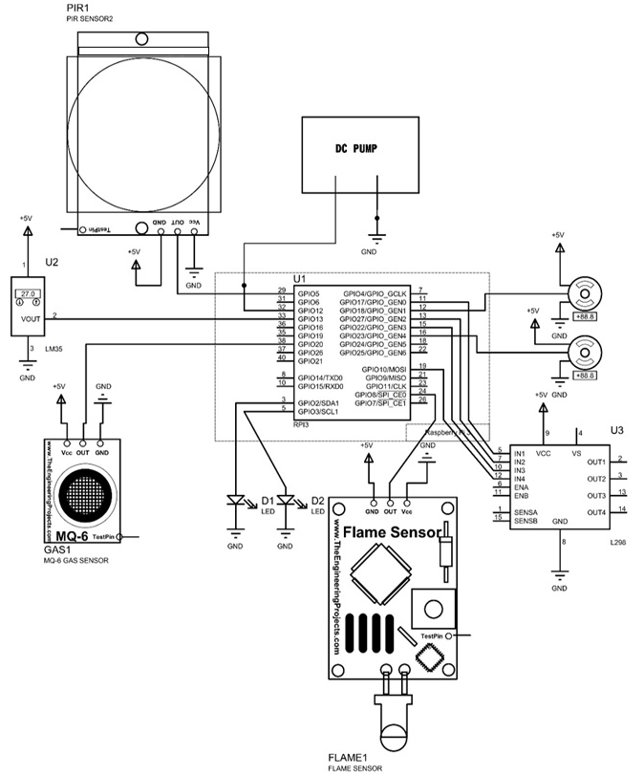
Figure 2: Complete Circuit diagram

2.10 System Software Design

2.10.1 Installing Raspbian Main OS
Start installing the raspberry pi, raspbian, the main operating system on which the raspberry pi will operate. Then, the Filezilla for securely transferring files on raspberry pi. Etc.

2.10.2 Installing Webserver (Lighttpd) on Raspberry Pi
To install the Lighttpd web server, type the following commands in the terminal.
Step 1 : sudo apt−get install lighttpd
Step 2 : sudo lighttpd−enable−mod cgI // To enabling CGI
Step 3 : sudo lighttpd−enable−mod fastcgI // To fast enabling CGI
Step4: sudo server.document−root=”/var/www/” // To change the default location of html in web-directory.

2.10.3 Installing Other Needed Software
Start the installation of other software needed on the raspberry pi like Filezilla for securely transferring files on raspberry pi. etc.

2.10.4 Setting up MySQL Database on Raspberry Pi
Before getting started, we need to install the MySQL server on Raspberry Pi. For installing the MySQL server, do the following.
Step 1: sudo apt−get install mysql−server
Step 2: sudo apt−get install php7−mysql
The php7-mysql install adds the mysql libraries to allow PHP to access the mysql database.
Creating Tables in a database: “CREATE TABLE sensors ( S/N I n t ( 5 ),
Temperature Int(5), Humidity Int(5), Date & Time Varchar(20) )”;

2.10.5 Setting up Pi Camera Software
Execute this instruction on the command line to download and install the latest kernel, GPU firmware, and applications. “sudo apt−get upgrade” We need an internet connection for this to work correctly. First, we must enable camera support using the raspi-config program “sudo raspi−config”. Select 'enable' from the camera option using the cursor keys. When you exit raspi-config, it will prompt you to reboot. The enable option ensures that when the camera reboots, the correct GPU firmware is installed with the camera driver and tuning and that the GPU memory split is sufficient for the camera to acquire enough memory to function correctly.

2.10.6 Designing a web page on a cloud
The main component of our project to control robots from any remote location is creating a web page. We must create a single platform from which we will access our robot. I can control the motor's direction and the camera's position from the web page and monitor the video feedback. It will be essential to protect our website from cyber-attacks and unauthorized access. To ensure security, we will keep IP addresses strictly confidential. When authorized, we shall build a single platform from which we can control our robots. We may use the web page to control the motor's direction and the camera's position and monitor the video feedback. It will be essential to protect our website from cyber-attacks. If the user wants to gain access to the robot, he will log in to that page and enter the static IP address of the raspberry pi, and the authorized user will gain access to the robot.

Mathematical models
Flame detector $C=A÷d2$
A = Area, d = distance
For the same flame detector and same flame, the maximum distance or the minimum fire area be calculated.
$A=cd2$
d=$\frac{\sqrt{A}}{C}$
A more exact relation valid when the distance between the flame and flame detector is small between the radiation density E, at the distance D between the detector and a flame of effective radius R, emitting energy density, M.
E= $\frac{2π{MR}^{2}}{\left(R^{2}+D^{2}\right)}$
Where R<<D then relation reduces to the (inverse) square law
E=$\frac{2πMR^{2}}{D^{2}}$
Ultrasonic sensor
The distance can be determined with the accompanying recipe:
Distance L $=½×T×C$
L is the distance, T is the time between the discharge and gathering, and C is the sonic speed. C varies depending on temperature and humidity.
Temperature sensor
Linear +10-mV/$℃$ scale factor
+10 millsvolts per degree
Power
$P=IV$
I is the current, V is the voltage
Dc pumping machine
Pump power P$=q×p×h$
q is rate of flow, p is fluid density, pump differential

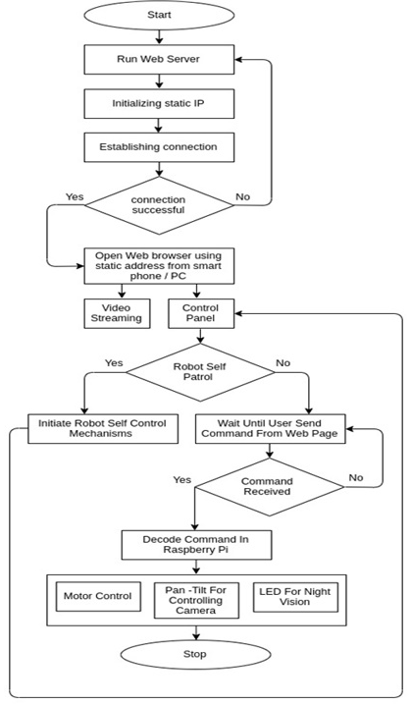
Figure 3: System flowchart

Results and Discussion
This section analyzes and discusses the results of the implemented circuit concerning the subject matter and its relevance to the project's aim.
Testing
The activities performed to determine the reliability of a system are referred to as testing. It entails logical analysis of system components and methods of the interconnectivity of individual units to achieve the set goals.
This project's tests include the Functional and Continuity test on the project circuit implementation, the Extinguisher test, and the Remote-control test.
A. Continuity Test: Continuity testing entails checking the circuit for connection failures. The system passed this test because all of the different units performed well when tested. This test was performed with a multimeter in the continuity mode.
B. Functional Test: The system also passed the functional test, allowing video to be streamed on a web page.
C. Extinguisher Test: This involves Class A; this test was carried out on wood, paper and plastic; it successfully extinguished the fire in both classes of fire.
D. Remote-control test: On the web page, a manual control test indicates Forward, Backward, Right, Left, Camera tilt, and Stop.

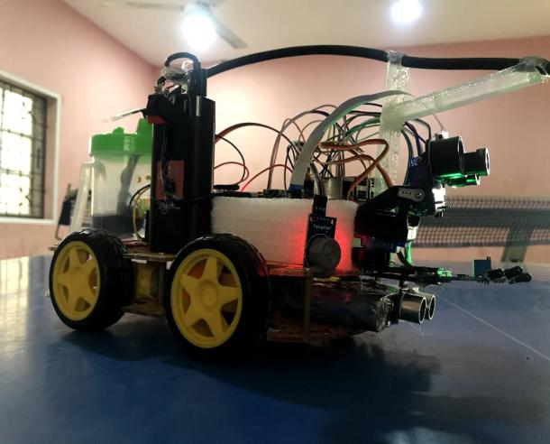
Plates 1: An IoT base firefighter robot
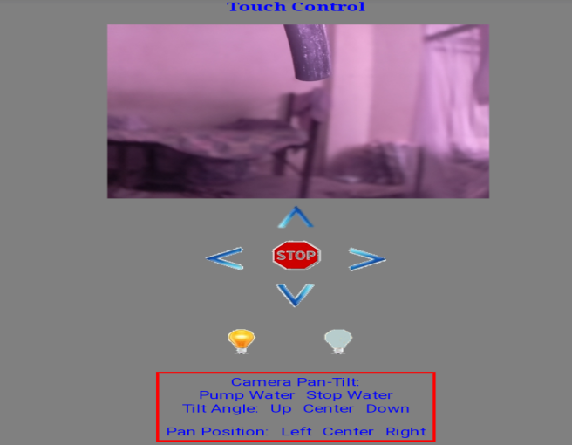
Plates 1.1: An IoT base firefighter robot web page control

The experiment demonstrates the relationship between distance and time to extinguish fire. This projection shows how the robot could function at a different distance and time to extinguish fire in a room of 5.5 m by 4.7 m with a stopwatch. Time is one of the most critical factors in putting out a fire.
Speed is the rate of change of distance with time.
$speed=distance(m)÷time(s)$
SI unit ($m/s$)

Table 1: Extinguishing Fire Based on the Distance and Time Relationship.
S/N | Distance (m) | Time (s) | Value
1 | 5.5 | 12 | 0.458 $m/s$
2 | 4.5 | 10 | 0.450 $m/s$
3 | 3.5 | 8 | 0.438 $m/s$
4 | 2.5 | 6 | 0.417 $m/s$
5 | 1.5 | 3 | 0.500 $m/s$

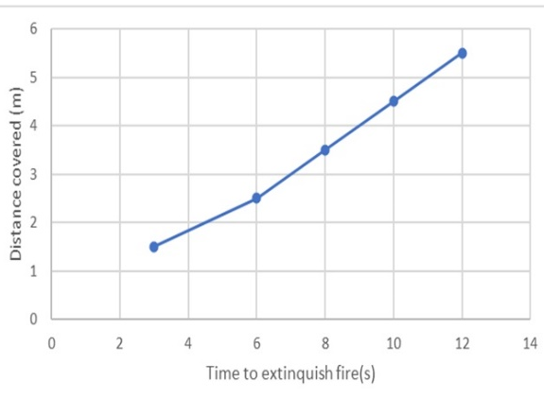
Figure 5: Output response of distance and time to extinguish fire graph

4. Conclusion
The fire fighter robot, as a repaid response to fire accident, covered a long distance to extinguish fire rapidly to save lives and mitigate the risk of property and live damages. More research can be done in protocol development, energy efficiency, sensor integration, and integration of long wireless communication modules in the coming years to fully exploit the potential of advanced technology, Further improvements to the project can be done on the extinguisher on more classes of fire.

COMPETING INTERESTS DISCLAIMER:
Authors have declared that they have no known competing financial interests OR non-financial interests OR personal relationships that could have appeared to influence the work reported in this paper.

Reference
[1] Tiwari, S.; Bandopadhaya, S. "IoT based fire alarm and monitoring system," International Journal of Innovations & Advancement in Computer Science, IJIACS 2017, 6(9).
[2] Priyanka, D.; Karthik, V. "Wireless Surveillance Robot with Motion Detection and Live Video Transmission and Gas Detection," International Journal of Scientific Engineering and Technology Research, 2015, 4(17), 3099-3106.
[3] RutujaJadkar, R. W., Khatade, S., Dugane, S.; Kini, S. "A Survey on Fire Fighting Robot Controlled Using Android Application." 2016
[4] BVaKS, K. D. "A Surveillance Robot For Real Time Monitoring and Capturing Controlled Using Android Mobile," Middle-East Journal of Scientific Research,2016, 24(1)155-166.
[5] Suganthi, N.; Arun, R.; Saranya,D.; Vignesh,N.; Nadu, T. "Smart Security Surveillance Rover," International Journal of Pure and Applied Mathematics 2017, 116(12) ,67-75.
[6] Rambabu, K., Siriki, S., Chupernechit, D.; Pooja, C. "Monitoring and controlling of firefighting robot using IoT," International Journal of Engineering Technology Science and Research, 2018, 5(3), 552-557.
[7] Swati A. D.; Karishma A. M.; Rashmi A. P. “Wireless Fire Fighting Robot”, International Journal For Research In Emerging Science and Technology, 2015
[8] Ahmad, S., and Shanmugasundaram, M. "Manually controlled enhanced wireless intelligent Firefighting robot," Asian Journal of Engineering and Applied Sciences,2018, 12(21).
[9]

