Evaluation of the antimicrobial activity of the two extracts (aqueous and lipidic) of P. aquilinum of cross plant

Abstract
Ferns have been living with human beings for a long time. Various biological activities have been reported, such as dietary, antioxidant and others. In our case, the focus was on antimicrobial activity. The aim was to demonstrate the activity of two extracts (aqueous and lipidic) of P. aquilinum fronds. The methodology adopted consisted in extracting the total oil from fiddleheads using a sohlext device, with hexane as the solvent. The aqueous extract was also prepared using water as the extraction solvent. Five strains were selected and used, namely three strains of the Shigella genus: boydii, flexneri and sonnei, and two strains of the Pseudomonas genus: aeruginosa, clinical strain, and aeruginosa, spontaneous flora strain. At a concentration of 250 mg/mL, the lipid extract inhibited the growth of all three Shigella strains, with a mean zone of inhibition of 6.5 mm, 11 mm and 16 mm for Shigella sonnei, Shigella boydii and Shigella flexneri respectively. On the other hand, no activity was revealed against Pseudomonas. On the other hand, for both Shigella and Pseudomonas, the aqueous extract showed no activity at the same concentration of 250 mg/mL.
Keys worlds: Antibacterial activity, Evaluation, Extracts, Purification, Pteridium aquilinum

- Introduction
The use of plants for the treatment of human diseases is very ancient and has evolved with the history of mankind (Soldata, 1997).
The search for new pharmacologically active agents via chemical screening of natural sources has led to the discovery of a large number of drugs. These drugs are useful and play a major role in the treatment of many diseases (Awe, 2015). The medicinal and aromatic plants that are sources of these substances are widespread in nature (Benjilali. B., 2005).
The Congo's geographical position means it abounds in important and varied plant species (P & M, 1988). This abundance bears witness to an undeniable wealth of flora. As a result, the study of Congolese flora is of “fundamental” scientific interest in terms of ethnobotany and pharmacopoeia, but also of “applied” scientific interest in terms of the valorization of natural substances. The use of plant extracts and compounds of plant origin is a valuable source of traditional medicine, particularly for infectious diseases (Al-Bayati. A. F., 2007).
It's a well-known fact that modern medicines (antibiotics) can be used to treat various infections caused by pathogenic microbes. However, microbial resistance to antibiotics has led researchers to turn increasingly to the plant world, and particularly medicinal and alicamentary plants, in search of effective molecules devoid of any adverse effects (Bahorun, 1997). For this reason, the investigation of plants represents an invaluable potential for the discovery of new substances with antimicrobial and antioxidant power (Lamiae Bachiri 1, 2015; Harzallah H.J., 2012).
Today, several studies have isolated and/or identified interesting bioactive natural molecules in the crude extracts of numerous plants (Mabika ABM, et al. 2023; Arnaud, W.G. Tamba Sompila et al. 2021). These include Pteridium aquilinum L. Kuhn (Arnaud, W.G. Tamba Sompila et al. 2022).
Eagle fern [Pteridium aquilinum L. Kuhn] is a member of the Dennstaedtiaceae family, a cosmopolitan terrestrial pteridophyte with an underground rhizome (Aké Assi L., 1984). It is also a heliophilous and highly invasive plant (Adjanohoun E. & Aké Assi L., 1979). Around 170 species of the genus Pteridium have been recorded to date [Yildirim . et al. (2013)]. The plant can grow up to 2 m high, with a thick, creeping rhizome and a deltoid frond 0.5-1.5 m long, cut into pinnae and subdivided into pinnules. The very long petiole can reach 55 cm [Adou. L.M.D., Ipou Ipou. J. (2007); Yan. Y et al, (2013); BOUCHEKOUK et al, 2018].
In the Congo, and particularly in certain localities, this eagle fern is known in the vernacular as makoungou or fesi. This plant contributes significantly to the balance of rural food rations, where various edible parts of it are used directly or after processing (Arnaud, W.G. Tamba Sompila et al., 2019). Similarly, little work has been devoted to studying the chemical profile of Pteridium aquilinum L. Kuhn plant extracts. Moreover, to our knowledge, the antibacterial and anti-oxidant activity of its extracts has not previously been studied in Congo.
The aim of this study is to evaluate the antimicrobial activity of two extracts (aqueous and lipid) from the fronds or butts of the Congo eagle fern (Pteridium aquilinum), with a view to proposing a new alternative in the fight against infectious diseases.

2. Materials and methods
2.1. Plant material
2.1.1. Plant material
The fern plant was purchased in the local market (the tsieme) in one of the northwestern districts of Brazzaville. The part used in this study is made up of fronds (Figure 1) maintained in the shelter of the light and at room temperature (25˚C) during approximately five (05) days. The dry matter was then crushed with an apparatus of type IKA-WERKE Gmbh-CO-KG, D-79219 Staufen, equipped with a sieve of granulometry 0.25 mm.
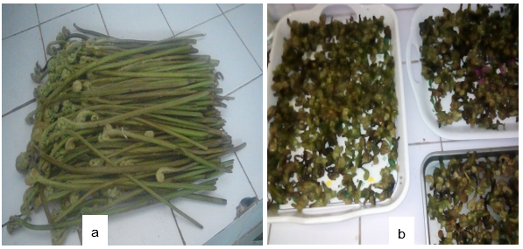
Figure 1. (a) Rhizome with fronds. (b) P. aquilinum fronds
2.1.2. Microorganisms studied
Five (5) bacterial strains known for their high frequency of contaminating foodstuffs and for their pathogenicity were used to carry out this study. These strains were supplied by the Laboratoire de Recherche en Microbiologie of the Institut Nationale de Recherche en Sciences Exactes et Naturelles (IRSEN). They include three species of the same Shigella genus: boydii, flexneri, sonnei and two other strains of the same Pseudomonas genus: aeruginosa (clinical isolates) and aeruginosa (environmental).
2.2.1. Preparation of aqueous and lipid extracts
Aqueous extract
10 g of P. aquilinum plant powder was weighed and placed in a beaker, to which 200 mL of distilled water was added. The mixture was macerated at room temperature for 12 to 24 hours. After maceration, the mixture was filtered to separate the liquid from the plant material. The filtrate obtained was kept cool in the refrigerator at +4°C.
Lipid extract
Extraction was carried out using the AOAC (1995) soxhlet method. 20 g of plant powder, wrapped in a cartridge, were placed in the soxhlet extractor. Hexane extraction took place over 6 hours. The extracted oil was collected in a flask and evaporated using a brand-name rotavapor for 1 hour.
2.2.2. Verification of strain purity
The purity of the strains was verified by inoculating them in agar-treated EMB medium. To this end, 7.5 g of agar EMB was weighed and placed in a 250 mL flask, to which 200 mL of distilled water was added. The whole mixture was then homogenized using a magnetic stirrer (Fisherbrand, hotplate & magnetic stirrer, basic serie, Germany) and placed in a microwave oven to melt the agar using heat and pressure.
The medium was then autoclaved at 121°C and 1.5 bar for 15 minutes. The medium was then poured hot into petri dishes to avoid contamination, and allowed to solidify before inoculation and incubation at 37°C for 24 hours in a Memmert incubator.
Catalase test
A catalase is an enzyme which allows the dismutation of hydrogen peroxide (hydrogen peroxide) into water and oxygen. This test was carried out using hydrogen peroxide. A drop of hydrogen peroxide was placed on a clean, sterile slide. Next, a portion of the 24-hour colony was removed and mixed into the drop of hydrogen peroxide. A few minutes later, the appearance of air bubbles (effervescence) was observed. When effervescence occurs, the colony is said to be catalase plus; when effervescence does not occur, the colony is said to be catalase minus.
Oxidase test
Oxidase testing is a fundamental test for identifying Gram bacilli. This test was carried out using an oxidase test strip. A colony of the strain to be tested was placed on the appropriate part of the strip using a pasteur pipette sterilized by flaming. After 30 seconds, the colony's color changes. The presence of violet coloration means that the bacterium is oxidase plus (+) and possesses cytochrome oxidase. If the coloration does not change, it means that the bacterium is oxidase minus (-) and does not possess the respiratory enzyme.

Gram test
For this test, a drop of 3% KOH solution (i.e. 0.03 g/mL water) was used, which was placed on a clean, sterile slide. After sampling a colony portion of the test strain, the drop of KOH was mixed with the test colony. The mixture was then transferred to a magnetic stirrer. During agitation, if a filament appeared, the strain was marked Gram (-); if it did not, it was marked Gram (+).
Aromatogram test
The principle involves placing 25 g of Mueller Hinton in 1 L of distilled water, and sterilizing at 121°C for 15 minutes. Depending on the quantity required, we weighed 3.13 g of MH agar culture medium per 125 mL of distilled water, which we mixed in a 250 mL flask and homogenized using a magnetic stirrer, then placed in a microwave oven for 2 minutes to melt the agar. The medium was then sterilized at 121°C for 15 minutes.
With the purity of the strains verified, we proceeded to evaluate the activity of the two P. aquilinum plant extracts.
2.2.3. Evaluation of the aqueous extract on the five (5) strains
The disc diffusion method on solid media was used to evaluate the aqueous extract, as described below:
Inoculation was performed using the dial technique. Using a clean buttoned Pasteur pipette, sterilized by flaming with a Bensen nozzle, parallel streaks were introduced into the bacterial suspension, made as tightly as possible on the surface of a Petri dish previously poured with Mueller-Hinton agar.
The operation was repeated twice, rotating the Petri dish at 60° and turning the pipette on itself. Filter paper discs were prepared and sterilized. They were then placed on the surface of the seeded Petri dish. Four discs were placed on the dish, two of which were immersed in aqueous extract at a concentration of 250 mg/mL, a single disc and a tetracelyne disc used as negative and positive controls respectively. The Petri dishes were then placed on the bench for 30 minutes for pre-diffusion of the extract, before being incubated at 37°C for 24 h.
Results were read by measuring the diameter of the zone of inhibition formed around the disc using a graduated ruler.

2.2.4. Evaluation of lipid extract on bacterial strains
This test was made possible by using the solid-state well diffusion method, described as follows:
To 1 mL of inoculum previously prepared with nutrient broth in a Petri dish, was poured 20 mL of Mueller Hinton agar medium at a temperature of around 47°C, as agar solidifies at less than 45°C. The mixture was then shaken to homogenize it and allowed to cool and solidify. Antibacterial activity was then assessed using the well-seeding method. Three (3) wells 5 mm in diameter and 1 mm deep were made in each Petri dish, into which we filled the lipid extract with a concentration of 250 mg/mL in two wells, and in the third, we deposited the tween 80 which was considered as a control because we had to use it to melt our lipid extract.
Petri dishes were left on the bench for 30 minutes to pre-diffuse the extract before incubating at 37°C. Results were read after 24 hours, using a graduated ruler to measure the diameter of the zone of inhibition formed around the well for each strain.

3. Results and discussion
3.1. Yield of different extracts
Yields of both extracts (aqueous and lipid) after reconstitution were 250 mg/mL.
Antibacterial activity
All Pteridium aquilinum extracts were subjected to an antibacterial test against Shigella: boydii, flexneri, sonnei and two other strains of the same Pseudomonas genus: aeruginosa (clinical isolates) and aeruginosa.
The activity of Pteridium aquilinum extract was assessed by the presence or absence of inhibition of bacterial growth. The presence of antibacterial activity is indicated by the appearance of clear zones around the discs or wells filled with the plant extract, while the absence of inhibition is indicated by the absence of halos around the wells. The diameter of the zones of inhibition varies according to the strain tested.
3.1.1. Activity of the aqueous extract
Table I shows the results of the antimicrobial activity of the aqueous extract of P. aquilinum fronds. It can be seen that the aqueous extract of P. aquilinum fronds did not exert antibacterial activity at the inhibition concentration of 250 mg/mL on all selected bacterial strains.

Table I. Microbial activity of aqueous extract on selected strains

Strains | Microbial activity at 250 mg/mL
Shigella boydii | -
Shigella flexneri | -
Shigella sonnei | -
Clinical Pseudomonas aeruginosa | -
Environmental Pseudomonas aeruginosa | -
Tween 80 (control) | -
Legend: (+) : presence of activity; (-) : absence of activity
These results do not allow us to certify that the aqueous extract contains no antimicrobial activity. For the simple reason that we did not check with other concentrations than those we had used. These results are illustrated in Figure 2:
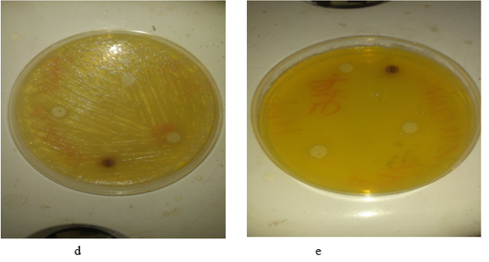
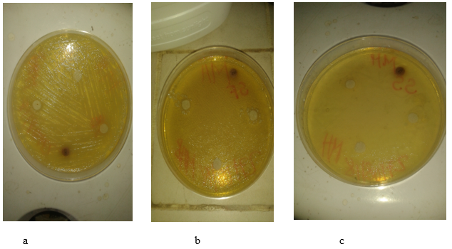

Figure 2. Antibacterial activity of aqueous extract : (a), S. boydii;(b), S. flexneri; (c), S. sonnei; (d and e) P. aeruginosa (clinical and environmental).

3.1.2. Activity of lipid extract
Total oil extracted from Pteridium aquilinum frond powder showed inhibitory activity on three species of five selected strains, while no activity was observed on the two types of strains of the same genus (Table II).
Table II. Antimicrobial activity of oil extract against various microorganisms

Strains | Microbial activity at 250 mg/mL
Shigella boydii | +
Shigella flexneri | +
Shigella sonnei | +
Clinical Pseudomonas aeruginosa | -
Environmental Pseudomonas aeruginosa | -
Tween 80 (control) | -

Legend: (+) : presence of activity; (-) : absence of activity
The greatest inhibition was obtained with the Shigella flexneri strain, with an average inhibition zone of 16 mm in diameter (figure 3a and table III). The second strain of the same genus (Shigella boydii) produced an average inhibition zone of 11 mm in diameter (figure 3b and table III), while the last strain, Shigella sonnei, produced an inhibition zone of 6.5 mm in diameter (figure 3c and table III). All zones of inhibition were obtained at a concentration of 250 mg/mL. The inhibition aureoles did not exceed 1.4 cm in diameter in the other tests (higher value of the average of the two perpendicular values we determined).
In the case of both Pseudomonas aeruginosa (clinical strain) and Pseudomonas aeruginosa (environmental strain), the lack of antimicrobial activity is reflected in the absence of an inhibitory zone (figure 3.d; figure 3.e and Table III).

Table III. Diameters of inhibition zones
Strains | Diameter 1 (mm) | Diameter 2 (mm) | Average diameter (mm)
Shigella boydii | 13 | 9 | 11
Shigella flexneri | 17 | 15 | 16
Shigella sonnei | 13 | 0 | 6.5
Clinical P. aeruginosa | 0 | 0 | 0
Environmental P. aeruginosa | 0 | 0 | 0
Tween 80 (control) | 0 | 0 | 0
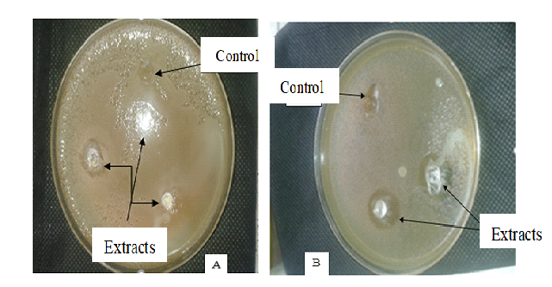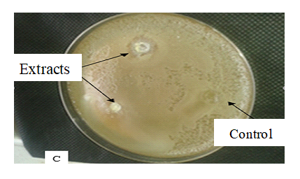
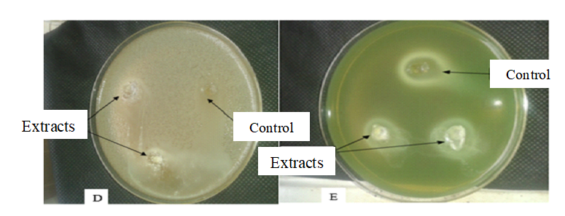
Figure 3. Antibacterial activity of oil extract: (A), S. boydii;(B), S. flexneri;(C), S. sonnei; (D and E) P. aeruginosa (clinical and environmental)

In the end, the presence of activity revealed only in fern frond oil could be a prospect for solving the problem linked to the Sighella strain.

4. Conclusion
Medicinal plants remain a reliable source of active ingredients with known therapeutic properties. It can be argued that the Congolese flora can constitute an important reserve of interesting plant species, whose active principles can be used in several fields such as the agri-food (alicaments) and pharmaceutical industries, hence the interest in their exploitation.
The results of this study, which evaluated the antimicrobial activity of two extracts (aqueous and lipid), showed that the lipid extract was active against all three (3) Shigella strains (16, 11 and 6.5 mm), with a predominance of the S. flexneri strain. With the latter strain, an average inhibition zone of 16 mm was clearly observed at a concentration of 250 mg/mL. On the other hand, no zone of inhibition was observed with Pseudomonas species. The aqueous extract showed no activity on the five (5) strains tested. Given the inactivity observed in this work, and despite the high composition of antibacterial compounds in this plant's extracts, it would be advisable to revise the extract concentrations in order to verify the activity of both the aqueous and lipid extracts.

Références
1. Al-Bayati, A. F., K. D. (2007). In vitro antimicrobial activity of Salvadora persica L., Mosul, Iraq.
2. Awe, S. A. (2015, October). Antibacterial, Phytochemical, and Proximate Analysis of Pteridium aquilinum. International Journal of Research in Pharmacy and Biosciences, 2(9), 1-7.
3. Bahorun, T. (1997). Active Natural Substances: The Mauritian Flora.
4. Benjilali, B., Z. S. (2005). Aromatic and Medicinal Plants: Sector Assets and Requirements for Sustainable Development. Actes Editions, Rabat, 346 p. (Actes Editions ed.). Rabat.
5. Harzallah, H.J., N. E. (2012). Chemical composition, antibacterial and antifungal properties of Tunisian Nigella sativa fixed oil. African Journal of Microbiology Research, 6 (22): 4675-4679, 6(22), 4675-4679.
6. Lamiae Bachiri 1, A. D. (2015). Floristic study of the Ifrane valley "Watershed of Oued Tizguit." Journal of Animal Plant Sciences, 26(1), 3977-4006. Retrieved September 2018, from http://www.m.elewa.org/JAPS
7. P., S., & M, M. J. (1988). Catalogue of vascular plants of Congo (Vol. 2). Brazzaville, Brazzaville, Congo: Cerve, Botanical Laboratory. Retrieved September 02, 2018
8. Soldata, J. v. (1997). Medicinal Plants, Tenth Edition (10th Edition).
9. Adjanohoun E. & Aké Assi L., 1979. Contribution to the Census of Medicinal Plants of Côte d'Ivoire. National Center of Floristry, Faculty of Sciences, University of Abidjan, Vol. 1; 357 p.
10. Aké Assi L., 1984. Flora of Côte d'Ivoire. Descriptive and Biogeographical Study with Some Ethnobotanical Notes. Doctoral Thesis, National University of Côte d'Ivoire, Abidjan. 3 volumes and 6 volumes
11. Yildirim E., Emsen B., Kordali S. (2013). Insecticidal effects of monoterpenes on Sitophilus zeamais Motschulsky (Coleoptera: Curculionidae). Journal of Applied Botany and Food Quality 86: 198 - 204.
12. Adou. L.M.D., Ipou Ipou. J. (2007). Pteridium aquilinum, an invasive pteridophyte of perennial crops in southern Côte d'Ivoire: some ethnobotanical notes. Tropicultura 25(4): 232-234.
13.Yan. Y., Qi. X., Liao. L., Xing. F., Ding. Mr., Wang. F., Zhang. X., Wu. Z., Serizawa. S., Prado. J., Funston. A., Gilbert. Mr., Nooteboom. H. (2013). Dennstaedtiaceae. Flora of China 2(3): 147-168
14. Bouchekouk Cheïmaâ, Kara Fatima Zohra, Tail Ghania, Saidi Fairouz and Lazar Mohammed (2018). Bio-aphicidal potential of the essential oil of Algerian pteridium aquilinum linné on aphis fabae (hemiptera: aphididae). Revue Agrobiologia, 8 (1): 896-901
15. Arnaud, W.G. Tamba Sompila, J.E. Moussounga, A.B. Madiélé Mabika, N.P.G. Pambou-Tobi1, P. Diakabana, B.D.E. Miakayizila, M. Dzondo-Gadet and Silou, T. 2019. Conservation and Analysis of the Physicochemical Parameters of a Congo Food Plant Alicamentary [Pteridium aquilinum (L.) Kuhn]. Int.J.Curr.Microbiol.App.Sci. 8(09): 247-256.
doi: https://doi.org/10.20546/ijcmas.2019.809.030
16. Mabika ABM, Sompila AWGT, Ndinga AME, Agnaniet H, Thiery V, et al. Elucidation ofAlkaloids Contained in the Fec5 Fraction of Bark of Annickia Chlorantha. Austin J Anal PharmChem. 2023; 10(2): 1162
17. Sompila, A.W.G.T., Mabika, A.B.M., Pambou-Tobi, N.P.G., Gou-ollaly, T., Moussounga, J.E., N’simba, G.L.-L.B., Nguie, R. and Matos, L. (2021) Evaluation of Some Secondary Metabolites andDetermination of the Antioxidant Potential of Different Extracts from the Plant of Pteridium aquilinum. American Journal of Analytical Chemistry, 12, 506-519. https://doi.org/10.4236/ajac.2021.1212032

