EVALUATION OF THE SENSITIVITY OF STRAINS OF Phytophthora spp , THE CAUSE OF BROWN ROT OF COCOA ( Theobroma cacao L. ) , TO LIMOCIDE 60 ME, AN EXTRACT OF SWEET ORANGE ESSENTIAL OIL

Abstract
Ivory Coast produces nearly 2 million tons, which represents 15% of the Gross Domestic Product (GDP), more than 50% of exports and provides seven million jobs to Ivorians. However, its production is severely limited by the brown rot disease of cocoa pods. In order to increase production and improve public health and environmental problems, sweet orange essential oil extract was used to combat cocoa brown rot disease caused by Phytophthora spp . A morphological description of the pathogen was carried out. The effectiveness of Limocide was tested at doses of 100, 200, 400, 800 ppm and compared to NECO and Callomil super. Limocide , Callomil super and NECO significantly inhibited the in vitro mycelial growth of Phytophthora spp with 29.76, 89.41 and 100% respectively after six days of incubation. The minimum concentrations that inhibit 50% (IC ₅₀ ) the growth of the fungus were, respectively, 929, 1521 and 348 ppm for Limocide , Callomil super and NECO. The biofungicide Limocide has proven its ability to control brown rot of cocoa pods under controlled conditions.
Keywords : biofungicide , Phytophthora spp , inoculation, brown pod rot.

INTRODUCTION
The cocoa tree ( Theobroma cacao L. ) is a perennial plant that belongs to the mallow family, cultivated in several tropical countries ( Motamayor et al ., 2008 ). Native to the Amazon rainforest of America, the cocoa tree constitutes the only species of the Genus Theobroma widely cultivated because of the use of its beans in the manufacture of chocolate ( Braudeau , 1969 ). First, the cultivation spread to Central America, South America and the Caribbean islands towards the end of the 16th century, then to Asia in the 17th century. In Africa, cocoa cultivation was introduced to Ghana towards the end of the 19th century. The first cocoa farms were established in Ivory Coast between 1895 and 1905, but the intensification of this cultivation began in 1912 in the east of the country on the border with Ghana ( Burle, 1962 ). The world's leading producer of cocoa ahead of Ghana and Nigeria, Ivory Coast supplies nearly 2 million tonnes which represent 15% of the Gross Domestic Product (GDP), more than 50% of exports and provides employment to 7 million Ivorians ( ADB, 2020 ). However, these important socio-economic achievements linked to cocoa production in Côte d'Ivoire are faced with numerous constraints capable of causing a significant decrease in cocoa production. The constraints of cocoa production in Côte d'Ivoire are diverse depending on their origin. These are, on the one hand, constraints linked to climate change, fluctuations in market prices and the scarcity of forests ( Freud et al., 2000 ). On the other hand, biotic constraints marked by diseases, insect pests of the cocoa tree and the effects of the intensive and uncontrolled use of synthetic products supposed to fight against diseases including brown pod rot ( Fofana et al., 2020 ). Brown rot of cocoa pods is the most important, widespread and damaging fungal disease in the world with a loss of production estimated at 30% on a global scale ( Lass and Wood, 1985 ) and 30 to 40% according to the International Cocoa Organization ( ICCO, 2015 ). In Ivory Coast, brown rot of cocoa pods is caused by fungi of the genus Phytophthora spp (P. palmivora and P. megakarya ), which are the most significant pests of cocoa trees in terms of the damage caused. In response to these biological pests, an integrated, environmentally friendly pest management method can reasonably limit their action ( Kebé et al., 2005; Tahi et al., 2006; Assiri , 2007 ). This is the context in which the present study is conducted, which aims to evaluate the sensitivity of Phytophthora strains spp , agents responsible for brown rot of cocoa against Limocide 60 ME, an extract of sweet orange essential oil. The general objective of this study is to contribute to sustainable cocoa production by implementing biological control methods against cocoa brown rot ( Theobroma cacao L.) . More specifically, it involves: (i) performing the morphological characterization of Phytophthora spp strains; (ii) testing the pathogenicity of Phytophthora spp strains on pods and (iii) evaluating the in vitro effect of limocide 60 ME, an extract of sweet orange essential oil. This thesis devoted to this study is structured around three parts. In addition to the introduction, the conclusion, perspectives and bibliographical references. The first part addresses the generalities on the cocoa tree, diseases and other cocoa pests. The second part presents the materials and methods used in conducting the study. Finally, the results obtained are presented and then discussed in the third part.

2.1. Material

2.1.1. Study area
The study site is located in the southwest of Ivory Coast, in the department of Soubré , more precisely in the sub-prefecture of Grand- Zattry at 6.6°16'98'' North latitude and 6.23°04'11'' West longitude. The climate is subequatorial with four rainy seasons including two dry seasons and two rainy seasons. Average annual temperatures vary between 24 and 29°C and annual rainfall varies between 1600 and 1800 mm of rain ( Brou, 2010 ). The soils are ferralitic types.

2.1.2. Plant material
The plant material consisted of pods naturally affected by brown rot from organic plantations in Grand- Zattry and healthy green pods susceptible to Phytophthora spp used for pathogenicity tests ( Figure 1 ) .
2.1.3. Fungal material
The fungal material consists of Phytophthora spp strains isolated from organic pods affected by brown rot ( Mpika , 2009). These strains were isolated and purified in the conduct of the experiment ( Figure 1 C ).

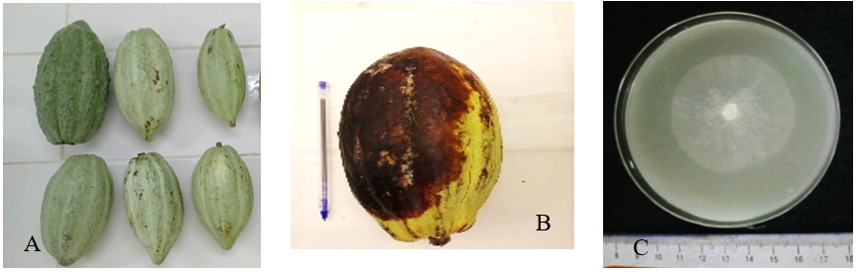
Figure 1: Cocoa pods used in the study
A: Healthy green pods; B: Pods affected by brown rot
C: Strain of Phytophthora spp used for the study

2.1.4. Fungal control equipment
The fungal control equipment used in the experiment consisted of Limocide , NECO and Callomil super ( Figure 2 ). Limocide is a microemulsion fungicide, insecticide and acaricide used at a dose of 1l/ha, the active ingredient of which is an extract of sweet orange essential oil. NECO is a concentrated emulsion fungicide, used at a dose of one litre per hectare. Its active ingredient is composed of essential oils obtained by hydrodistillation of the leaves. of Ocimum gratissimum . Callomil super is a wettable powder used at a dose of 200g/ha, whose active ingredient is composed of copper oxide and Metalaxyl -M). The characteristics of the different products used during the study are presented in Table I.
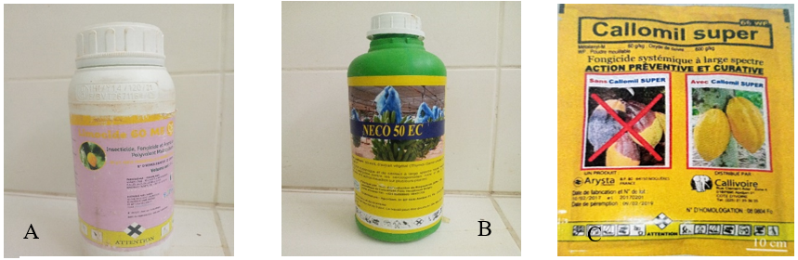
Figure 2 : Fungicides used in the study
A: Limocide biofungicide; B: NECO biofungicide; C: Callomil super synthetic fungicide.
Table I : Characteristics of the fungicides used in the study
Chemical family | Active ingredient | Trade name | Formulation type | Dose/ha
Biofungicide | Sweet orange essential oil | Limocide | 60 ME | 1.5 to 2 L / ha
Biofungicide | Ocimum essential oil gratissimum | NECO | EC 50 | 1 L / ha
Broad-spectrum systemic fungicide | Metalaxyl -M (60g/kg); copper oxide (600g/kg) | Callomil super | 66 WP | 200 g / ha

2.2. Methods

2.2.1. Preparation of the pea agar culture medium
Pea agar culture medium was used in this experiment for the evaluation of mycelial growth. The preparation of the culture medium was carried out in two (02) steps:
The first step is to obtain a 1.5 liter pea filtrate, from 1.5 liters of distilled water and 200g of peas. To do this, 200g of peas were boiled in 500 ml of distilled water for 45 minutes. After cooking, the peas are ground in a blender and filtered with percal. The volume of the pea filtrate obtained is made up to 1.5 liters with distilled water. The second step is to prepare 500 ml of the pea agar culture medium. 11g of agar was dissolved in 500 ml of pea filtrate to obtain the culture medium ( Fofana et al. , 2020 ). The technique consists of introducing a mixture of the product to be tested into a culture medium after autoclaving at 121°C, at a pressure of 1 bar for 30 minutes, then the medium is distributed at a rate of 20 ml in Petri dishes of 90 mm diameter maintained in supercooling at 45°C.

2.2.2. Preparation of the carrot culture medium
Carrot culture medium was used in this experiment to carry out the pathogenicity test. This culture medium aims to promote the sporulation of the fungus. The preparation of the culture medium was also carried out in two (02) steps. The first step consisted of obtaining a one-liter carrot filtrate, from one liter of distilled water and 200g of carrot. To do this, 200g of carrot were boiled in 500 ml of distilled water for 45 minutes. After cooking, the carrot slurry (200g) is ground in a blender and filtered with percal. The carrot filtrate obtained is completed to a volume of one liter with distilled water. The second step consists of preparing 500 ml of carrot culture medium. To obtain the carrot culture medium, 22g of agar was dissolved in 500ml of carrot filtrate ( Fofana et al. , 2020 ).

2.2.3.Phytophthora spp strains
In conducting the experiment, the preparation of the plant material was essential. The infected pods were isolated in plastics to avoid contamination. They were washed individually with tap water, then the necrotic part was cleaned with 90% alcohol. Phytophthora spp strains were isolated from pods showing symptoms of brown rot on a water agar culture medium. Cubical-shaped fragments were taken from the growth front of the brown rot. These fragments were placed on the water agar culture medium, then the cultures were incubated at 26 °C in the dark for 4 days ( Fofana et al. , 2020 ). After thallus formation, a mycelial fragment was taken from the growth front and placed on the pea agar culture medium for strain purification.

2.2.4. Preparation of the 1500 ppm stock solution of the synthetic fungicide
The mother solution of the Callomil super (600 g/kg copper oxide; 60 g/kg Metalaxyl -M) was obtained by weighing, using an electronic balance, 0.375 grams. This mass is added to 250 ml with sterilized distilled water and homogenized by stirring.

2.2.5. Obtaining doses of biofungicides
To obtain a pea agar medium at 100 ppm, 20 μl of the biofungicide Limocide were placed in 125ml of pea agar medium contained in an Erlenmeyer flask. Thus, the media at 200; 400; 800 ppm, were respectively obtained by putting in each of the 125 ml of pea agar medium 40 μl ; 80 μl and 160 μl of the essential oil. By the same process, to obtain the pea agar medium of 125 ml at 100; 200; 400; 800 ppm , the respective volumes of 25; 50; 100; 200 μl of NECO were poured into the medium. The media thus amended were distributed in Petri dishes, at a rate of 25 ml per Petri dish. For a sample to be analyzed, 5 Petri dishes were used per dose.

2.2.6. Morphological characterizations of Phytophthora spp isolates.

2.2.6.1. Macroscopic characterization
Macroscopic description of Phytophthora spp isolates obtained from the collected samples. The isolates were inoculated on carrot medium in Petri dishes and then incubated in the dark for 7 days at room temperature of 26°C. Observations focused on morphological criteria for classification of Phytophthora spp species proposed by Gallegly et al ., (2008) .

2.2.6.2. Microscopic characterization
Mycelial fragments 7 mm in diameter were taken from the growth front of a pure culture of Phytophthora spp aged 5 days on a pea-based medium. These fragments were subcultured onto carrot medium. Incubation is carried out in the dark at 26°C for 7 days. Then, the culture is exposed to light for 48 hours at a temperature of 26°C. A fragment of thallus is removed using a lanceolate needle and placed on a slide covered with a coverslip in a drop of sterile distilled water ( Coulibaly et al. , 2013 ). An optical microscope was used to observe the sporangia at x 400 magnification.

2.2.7. Cultivation of mushrooms
Using a 7 mm diameter punch, mycelium fragments were taken from 7-day-old cultures and placed in the center of the Petri dish containing the pea agar culture media and the fungicide-pea agar mixture. The cultures were sealed using stretch film and then incubated at 27°C ( Neri And al., 2006 ). Five (05) Petri dishes were replanted per concentration. This experiment was repeated three (03) times over time.

2.2.8. In vitro evaluation of mycelial growth of Phytophthora spp. strains.
Mycelial growth was assessed daily by measuring the diameter of the colonies until the control petri dishes were filled. Using a graduated ruler, the mycelial growth diameter of each colony was measured on two perpendicular diameters, drawn across the petri dish that intersect at a point. This point is the midpoint of the mycelial discs ( Figure 3 ). Measurements were stopped when mycelial colonies filled the control Petri dishes. When no fungal growth was observed in a Petri dish, the mycelial disc was transplanted into a Petri dish containing pea agar medium without the addition of fungicide ( Fofana et al. , 2020 ). The average colony diameter of each Petri dish was calculated by averaging the two diameters.
Dm (cm) = (d1 + d2) /2
E: explant of known average diameter (7 mm) at time t0 (origin of E and (X))
d1: diameter of explant E on the ordinate axis (diameter 1) at time t1
d2: diameter of the explant E on the ordinate axis (diameter 2) at time t1 ( Camara, 2011 )
With these measurements, the percentage of growth inhibition (Pic) compared to the control was calculated according to the following formula ( Leroux and Gredet , 1978 ):
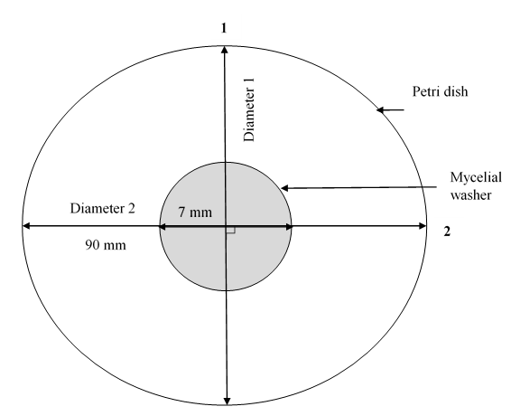
Figure 3 : Illustrative diagram of the method for measuring radial growth of fungal strains from two perpendicular axes drawn through the petri dish
Pic (%) = (Do – Dc / Do) ×100

Peak: percentage of inhibition of mycelial growth.
Do: growth diameter of the mycelium on the medium without fungicide (control colonies).
Dc : Growth diameter of the mycelium on the medium containing a concentration c of the synthetic fungicide or biofungicide.
The mycelial growth inhibition rates are transformed into probit values. According to the Paranagama transformed formula et al ( 2003 ), the regression lines are established according to the following equation:
y = a log x + b

a : regression coefficient ; b : constancy ; x : fungicide concentration ; log : decimal logarithm.
The equations of these regression lines made it possible to determine the CI ₅₀ and CI ₉₀ which are the concentrations of fungicides reducing the mycelial growth of the fungus by 50 and 90% ( Oxenham et al., 2005 ).

2.2.9. Assessment of pathogenicity Phytophthora spp .

2.2.9.1. Harvesting and preparing healthy green pods
Mature, healthy green pods were harvested from the field using a sterilized blade and transported to the laboratory, avoiding friction between them. In the laboratory, the pods were washed with tap water, cleaned with alcohol, and placed on water-soaked foam one day before inoculation to create the humid conditions necessary for infection.

2.2.9.2. Inoculation of pods
The inoculum of Phytophthora ssp was obtained from zoospores produced by the fungus. Specifically, the spores were obtained from a seven-day-old culture in Petri dishes on carrot medium in the dark. The culture was then exposed to light for 48 hours at a temperature of 25 °C ( Coulibaly et al ., 2013) . The inoculation was carried out under controlled conditions, two (02) types of inoculations were tested, namely by mycelial washer (IR) and by zoospores (IS) according to Figure 4. Regarding the inoculation by mycelial washer, small wounds were made on pods using the punch and the explants were deposited. As for the inoculation by zoospores, a spore solution was prepared at 3.10 ⁵ spores/ml and the inoculation was carried out by a syringe at the level of the peduncle. A non-inoculated control was used. The pods were incubated in a tray for ten (10) days, during which evaluations were carried out. Four cocoa pods were used for each type of inoculation. Small wounds were made on control pods using the punch. The uninoculated controls also consisted of four pods. The inoculated pods and the controls were incubated at room temperature in the laboratory ( Fofana et al. , 2020 ).
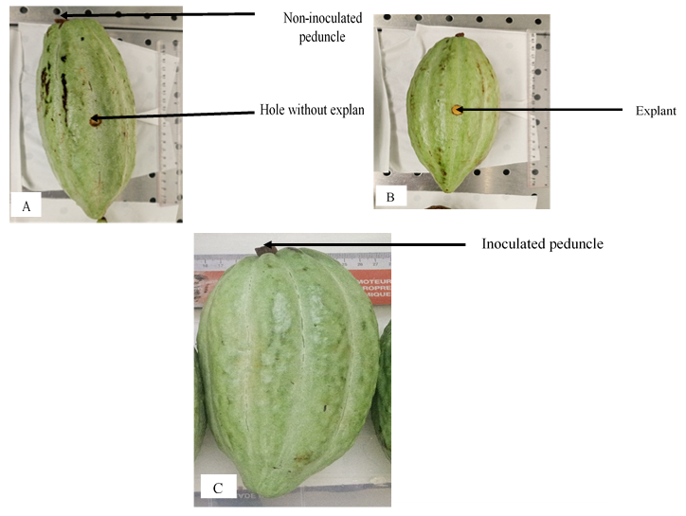

Figure 4 : Cocoa pod inoculation site
A : Control; B : Inoculation with mycelial disc (IR); C : Inoculation with zoospore suspension (IS)

Table II : Rating scale Iwaro modified and adapted from the severity of symptoms of

Table II : Echelle de notation d’Iwaro modifiée et adaptée de la sévérité des symptômes de la pourriture brune de cacao
Notes | Interpretation of the note
1 | no visible brown rot
2 | 1 to 5% of the browned pod
3 | 6 to 15% of the browned pod
4 | 16 to 30% of the browned pod
5 | 31 to 50% of the browned pod
6 | 51 to 65% of the browned pod
7 | 66 to 75% of the browned pod
8 | ˃ 76% of the browned pod

2.2.9.3. Data collection
Regular observations were made during incubation and the incubation time was noted. The proportions of brown rot infection were noted every 24 hours (24H) following the Iwaro grading scale . et al ., (2000) modified and adapted which ranges from 1 (no visible brown rot) to 8 (˃ of 76% of the pod browned). The rating scale has been summarized in Table II. The incidence of brown rot was assessed on the tenth day of incubation. The number of affected pods was recorded and the incidence was calculated using the following formula:
I (%) = (cabosses brunies/cabosse total) ×100

2.2.10. Statistical analysis
The data collected during this experiment were subjected to an analysis of variance (ANOVA) with STATISTICA software version 7.1. In case of a significant effect of the factor studied, the Newman- Keuls test was used at the 5% threshold for the comparison of means.

3.1. Results

3.1.1. Phytophthora spp isolates
After purification of the fungus in this study, the morphological description of Phytophthora spp showed a single morphotype. The strain presented white mycelial colonies with a cottony appearance on the face and radial, compact growth without clear margin, after seven (07) days of culture on carrot medium. The strains Phytophthora spp obtained presented a thallus with a radiate, striated and stellate facies with a regular and scalloped growth front (Figure 5 a). On the back of the boxes, the fungus appeared as a white color on the culture medium (Figure 5 b). Microscopic observation showed four forms of sporangia. These sporangia were deciduous with prominent papilla and carried a short pedicel. The shape of the sporangia was obpyriform , ovoid- obpyriform , ovoid, spherical which is a chlamidospore ( Figure 6 a, b, c and d ).
3.1.2. Evaluation of the pathogenic power of Phytophthora spp strains .

3.1.2.1. Incubation period of brown rot disease on cocoa pods
Cocoa pods inoculated with Phytophthora mycelial discs spp showed the first symptoms of brown rot after two days of incubation. On the other hand, those inoculated with zoospore suspension on the peduncle, the symptoms were evident on the fourth day (Figure 7).

3.1.2.2. Evolution of the severity of Phytophthora spp
The severity evolution curves according to the types of inoculation varied according to time. The curve of inoculation with mycelial discs (IR) was largely above the others. It showed a strong growth between D1 (1) and D7 (8). On the other hand, the control (T0), showed no evolution during the ten (10) days ( Figure 7 and 8 ) . Regarding inoculation with a zoospore suspension (IS), the severity index showed three levels of evolution ( Figure 7 and 8 ). Between D1 and D3, the curve showed a weak evolution going from 1 to 2. From D4 to D7, the curve experienced a growth ranging from 2 to 3.5. Then a strong evolution was noted between D7 and D10. The severity index went from 3.5 to 8 ( Figure 7 and 8 ) .
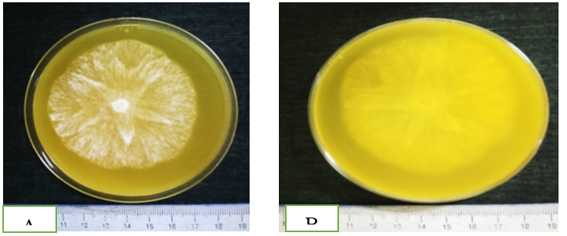
Figure 5 : macroscopic characteristics of Phytophthora spp isolates
A- thallus with a radiate, striate and stellate facies with a regular, scalloped growth front, B- thallus with a whitish reverse.

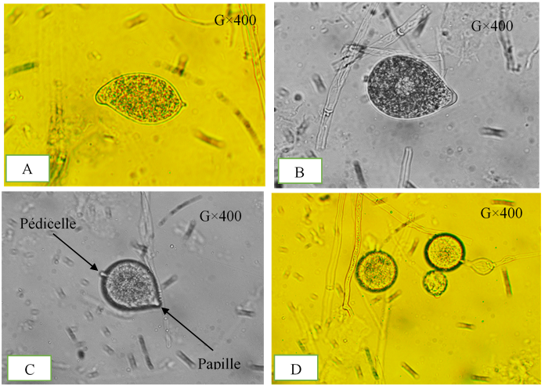
Figure 6: microscopic characteristics of Phytophthora spp isolates (G×400)
Shape of sporangia: A- obpyriform; B- ovoid-obpyriform; C- ovoid; D- spherical
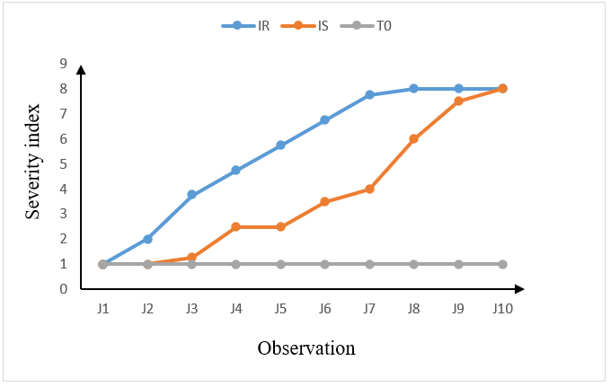
Figure 7 : Evolution of the severity of Phytophthora spp according to the type of inoculation 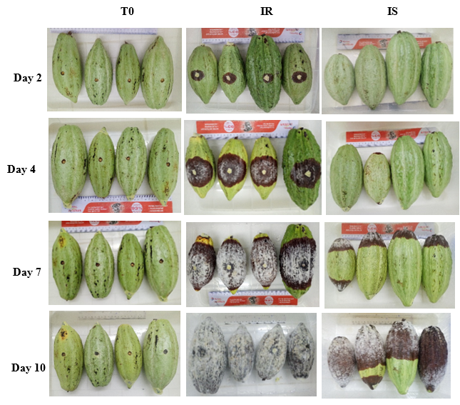

Figure 8: Incidence and severity of brown rot disease on inoculated pods according to inoculation type

T0: Control without inoculation IR: Inoculation with mycelial rings IS: Inoculation with a suspension of zoospores T0 : Témoin sans inoculation

3.1.2.3. Average severity index
Statistical analysis revealed a significant difference between the two types of inoculation presented. The pods inoculated with mycelial discs (IR) recorded a high average severity index of 5.5. On the other hand, the control recorded a low average severity index. As for the inoculation with the zoospore suspension (IS), the average severity index is intermediate with a value of 3.5 ( Figure 9 ).

3.1.2.4. Average incidence
The significance test showed a significant difference between the control, the pods inoculated with mycelial discs and those inoculated with the zoospore suspension ( Figure 10 ) . The inoculation with mycelial discs showed a high average incidence of 80%. On the other hand, the control recorded a zero average incidence. Regarding the inoculation with the zoospore suspension (IS), the average incidence was 60% ( Figure 10 ).

In vitro inhibition of mycelial growth of the fungus by fungicides

3.1.3.1. Effect of products on mycelial growth in vitro
The products had different levels on the mycelial growth of Phytophthora strains spp .
With Callomil super, the 100 ppm dose showed an inhibition rate that remained below the others and gave a decrease from day 2 (80%) to day 6 (60%). The inhibition rate of the 800 ppm dose remained well above the others. It was constant at 100% until day 5, before decreasing to 80% on day 6. The 200 ppm and 400 ppm doses had intermediate inhibition rates of 90% on day 2 to 80% on day 6 ( Figure 11 ). Regarding NECO, the inhibition rate of the four doses showed three (03) different levels of effects. The inhibition rate of the 800 ppm dose remained constant at 100% for six (06) days. On the other hand, the inhibition rate of the 100 ppm dose remained below the others and experienced a decrease from 60% on day 1 to 40% on day 6. The doses of 200 ppm and 400 ppm had similar effects and their rate remained intermediate between 800 ppm and 100 ppm ( Figure 12 ) . As for Limocide , the inhibition rates showed a strong decrease for all doses evaluated. They remained between 50% on day 1 and 2% on day 2 ( Figure 13 ) .
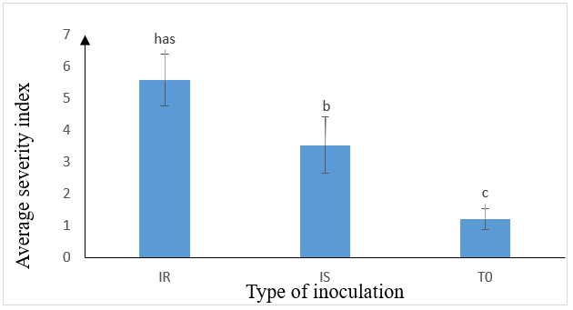
Figure 9 : Severity index according to type of inoculation

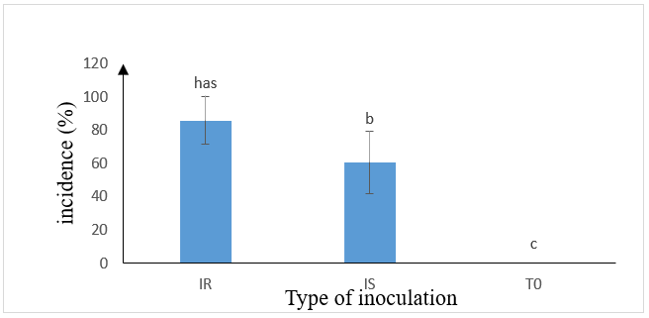

Figure 10 : Incidence according to type of inoculation

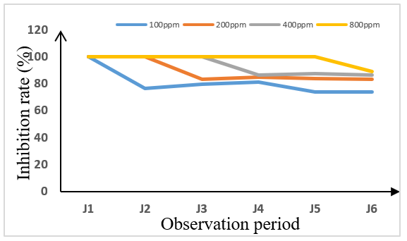
Figure 11: Changes in inhibition rates of the four doses of Callomil super as a function of time
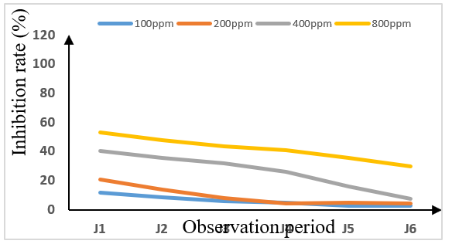
Figure 12 : Changes in inhibition rates of the four doses of Limocide as a function of time

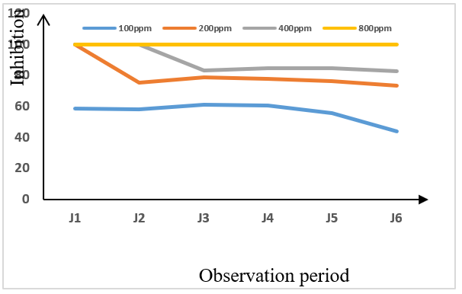
Figure 13: Changes in inhibition rates of the four doses of NECO as a function of time

3.1.3.2. Average inhibition rate of products on Phytophthora spp in vitro
Data analysis showed a significant difference between the doses for the three products ( Limocide , Callomil super and NECO). The inhibition rates observed with Limocide were low. They ranged from 29.76% to 2.71%. The dose of 800 ppm had the highest inhibition rate of 29.76%. The lowest rate was noted with the concentrations of 100, 200, 400 ppm having obtained inhibition rates of 2.71%, 4.24% and 7.53% respectively ( Figure 14 ). Callomil super showed high inhibition rates ( Table III ). The doses of 200, 400, 800 ppm had the highest inhibition rates of 83.65%, 86.82% and 89.41% respectively. On the other hand, the dose of 100 ppm showed the lowest inhibition rate which is 74.24% ( Table III ). NECO, on the other hand, totally (100%) inhibited mycelial growth at the dose of 800 ppm. The dose of 100 ppm had a low inhibition rate which is 43.88%. The doses of 200 ppm and 400 ppm had statistically identical rates which are respectively 73.53% and 82.71% ( Table III ).

3.1.4. 50 and 90% inhibitory concentration (IC ₅₀ and IC ₉₀ ) of fungicides
50 and 90% inhibitory concentrations of Phytophthora mycelial growth spp differ depending on the products (Table IV ). The inhibitory concentration for NECO was 348.82 ppm which inhibits 50% of the mycelial growth of the pathogen and 536.48 ppm for the IC ₉₀ . The synthetic fungicide Callomil super recorded -1521.18 ppm which inhibits 50% of the pathogen and -221.30 ppm for the IC ₉₀ . As for Limocide, it obtained 929.01 ppm as CI ₅₀ and 1689.61 ppm as CI ₉₀ .
Table III : In vitro inhibition rates of Phytophthora spp as a function of the concentrations of fungicides tested
Concentrations | Limocide | Callomil super | NECO
100 ppm | 2.71±0.30b | 74.24±1.36b | 43.88±3.21b
200 ppm | 4.24±0.71b | 83.65±1.38a | 73.53±1.50ab
400 ppm | 7.53±1.24b | 86.82±0.14a | 82.71±0.30ab
800ppm | 29.76±1.01a | 89.41±0.00a | 100.00±0.00a
F | 46.5 | 46.5 | 46.5
P | 0.00 | 0.00 | 0.00
Table IV : 50 and 90% inhibitory concentration (IC ₅₀ and IC ₉₀ ) of fungicides
Products | CI ₅₀ ppm | CI ₉₀ ppm
Limocide | 929.01 | 1689.61
Callomil super | -1521.18 | -221.30
NECO | 348.82 | 536.48

Figure 14 : Diameter of inhibition of mycelial growth

3.2. Discussion
Morphological characterization (macroscopic and microscopic) of isolates
Macroscopic study of the purified isolates allowed the observation of a morphotype, namely a clear fungal colony that grows radially, compactly without a clear margin. The thallus of Phytophthora spp isolates presented a radiate, striated and stellate facies with a regular and scalloped growth front. Microscopic observation showed a diversity of sporangia that varies from ovoid to ovoid-obpyriform. These comments are consistent with those of Coulibaly et al . (2013) who showed on culture medium, a thallus with a radiate and stellate facies, with moderately abundant aerial mycelium and a regular or scalloped growth front. The work of Semangun (2000) and Coulibaly et al . (2013 ) noted a great diversity of the shape of the sporangia in Phytophthora spp .
Symptoms of pod brown rot disease were observed four days after inoculation with zoospore suspension. Fofana et al . (2020) showed that inoculation of the pod with a zoospore suspension induced brown rot lesions after four days of incubation. Our results showed aggressiveness of Phytophthora spp depending on the inoculation area and the type of inoculum. Pods inoculated with mycelial discs showed symptoms on the second day of incubation. The study carried out by Pohé et al ., (2013) in the South-East of Côte d'Ivoire showed the aggressiveness of Phytophthora spp on cocoa trees.
In vitro results of this study showed that the biological fungicide NECO has an effective inhibitory activity against Phytophthora spp responsible for brown rot of cocoa pods and compared to that of the synthetic fungicide Callomil super based on copper oxide and metalaxyl-M on pea medium. On the one hand, Gadji et al . (2015) showed the sensitivity of Phytophthora spp. to biological products. On the other hand, the antifungal, antibacterial and insecticidal activity of biological fungicides was approved by the work of Camara et al. (2007) . NECO and Callomil super significantly reduced the radial mycelial growth of Phytophtora spp . Concentrations of 800 ppm recorded the highest inhibition rates . Our results corroborate those obtained by Fofana et al . (2020) with the biofungicides NECO, ASTOUN and Ferca against Phytophthora palmivora , responsible for brown rot of cocoa pods. Furthermore, the biofungicide NECO was more effective compared to the biological fungicide Limocide. This difference in antifungal activity would be due to the chemical composition of Ocimum gratissimum . Indeed, the work of Kobenan et al . ( 2018 ) showed that the essential oil of Ocimum gratissimum is composed mainly of oxygenated monoterpenes and hydrocarbon monoterpenes. However, the essential oil of Citrus sinensis is composed mainly of limonenes. The inhibitory effect of these products would be due to the presence of the majority compounds that enter into the composition of essential oils. Sweet orange essential oil extract reduced radial mycelial growth in vitro of Phytophthora spp. Our results converge in particular with the results of the work of Gadji et al . (2015) showed the sensitivity of Phytophthora spp to biological products

Conclusion
Cocoa farming occupies an important place in the economic system of Côte d'Ivoire. Acquiring information on cocoa tree pathologies is crucial to identify pathogens and propose more environmentally friendly control methods. It is in this context that this work was conducted. The aim of this work was to test a biological control method, based on a biofungicide extracted from sweet orange essential oil in the fight against cocoa brown rot ( Theobroma cacao L.). This study allowed on the one hand the characterization of the pathogen ( Phytophthora spp) responsible for cocoa brown rot and on the other hand, the in vitro evaluation of the effect of the biofungicide Limocide at different concentrations on the mycelial growth of the fungus. However, further work is possible to evaluate the in vivo effect of the biofungicide Limocide on cocoa brown rot disease by carrying out field tests.

References
Assiri AA 2007. Identification of peasant practices in the management of cocoa orchards in Côte d'Ivoire. DEA thesis. Department of Earth Sciences and Mineral Resources. University of Cocody, Abidjan. 62 p.
AfDB. 2020. Annual Review of Development Effectiveness. 81 p.
Braudeau, J. 1969. The cocoa tree. Agricultural techniques and tropical production. Ed. Maisonneuve et Larose, Paris, 304 p.
Burle L. 1962. The cocoa tree. Volume two. GP. Maisonneuve et Larose, Paris, pp. 486-491.cocoa using cloned DNA of cacao swollen shoot virus and particle bombardment. Mol . Plant. Pathol , 84, pp: 1239–1243.
Camara B. , Kone D., Kango C., Anno A & Ake S. 2007. Antifungal activity of essential oils of Ocimum gratissimum L. of Monodora myristica (Gaaertn) dunal and two synthetic products (impulse and folicur), on mycelial growth and spore production in vitro of Deightoniella torulosa (Syd) ellis. Ivorian Journal of Sciences and Technologies , 9: 187-201
Camara B. 2011. Contribution to the characterization of foliar and soil-borne fungal parasites in the Ivory Coast in banana ( Musa spp) and research into control methods. Doctoral thesis, University of Cocody, Abidjan, Ivory Coast. 231 p.
Coulibaly K., Kebe IB, Koffi NK, Mpika J., Daouda K. 2013. Characterization of phytophthora spp isolates from cocoa orchards in Ivory Coast. Journal of applied Bioscience , 77: 5567–5579 ISSN 1997–5902.
Fofana B., Soro S., Kassy F., Silué N., Zouzou M. & Kone D. 2020. Valorization of plant-derived biofungicides for eco-efficient management of cocoa pod brown rot caused by Phytophthora palmivora . Journal of Animal & Plant Sciences , vol 44, issue 2: 7654-7676.
Freud EH, Petithuguenin P. & Richard J. 2000. Cocoa fields: a competitive challenge in Africa and Asia. Editions Karthala and CIRAD, Paris, 207 p.
Gadji AAG, Yapo OB, Abo K., Coulibaly K., Kébé BI, Gnepe JR & Tyagi RD 2015 . In vitro assessment of biopesticide bacillus thuringiensis var. Kurstaki hd- 1 effectiveness on Phytophthora palmivora , agent of cocoa black pod rot in Ivory Coast. European Scientific Journal vol.11, No.21 ISSN: 1857 – 7881 (Print) e - ISSN 1857- 7431.
Gallegly, ME, and Hong, C. 2008. Phytophthora : Identifying species by morphology and DNA fingerprints. APS Press, St. Paul, MN.
ICCO. 2015. What are the effects of intensive commercial production of cocoa on the environment? Westgate House W5 1YY, United Kingdom. ICCO Annual Report. 25p.
Iwaro AD, Sreenivasan TN, Butler DR, Thevénin JM, Mooleedhar V., Bekele F., Sounigo O. and Umaharan P. 2000. Rapid screening for Phytophthora pod rot resistance by means of detached pod inoculation. In : Eskes AB & Efron Y. Eds. Proceedings of the CFI/ICCO/IPGRI Project Workshop on Workin procedures for cocoa germplasm evaluation and selection. 1-6 February 1998. Montpellier (France). pp. 109-111.
Kébé BI, N'Goran K., Ahoutou K., N'Guessan F., Kohi NJ & Zahouli BI 2005. Cultivating cocoa trees successfully in Côte d'Ivoire. Report of the National Center for Agricultural Research (CNRA).
Kobenan KC, Tia EV, Ochou CEG, Bini N., Dagnogo M., Dick EA & Ochou GO 2018. Comparison of the insecticidal potential of Ocimum essential oils gratissimum L. and Ocimum canum Sims on Pectinophora gossypiella Saunders (Lepidoptera: Gelechiidae), a cotton pest in Ivory Coast. European Scientific Journal , vol.14, n°21 ISSN: 1857 – 7881 (Print) e - ISSN 1857- 7431.
Lass RA & Wood GAR 1985. Cocoa Production presents constraints and priorities for research. World Bank Technical Paper 1985.pp 95.
Leroux P., 1987. Resistance of fungi to fungicides. Phytoma . March 1987. 9 p.
Motamayor JC, Lachenaud P., Wallace S., Mota J., Loor R., Kuhn DN, Steven Brown J. & Schnell RJ 2008. Geographic and Genetic Population Differentiation of the Amazonian Chocolate Tree ( Theobroma cacao L.). PLoS ONE, 3 (10): e3311. Page consulted on 07/22/2011.
Mpika J., Kébé IB, Druzhinina IS, Komon-Zélazowska M., Kubicek CP, & Aké S. 2009. Inhibition of Phytophthora palmivora , the agent of brown rot of cocoa pods in Ivory Coast, by Trichoderma sp. Sciences et Nature Vol. 6 N°1: 49 – 62.
Neri F., Mari M. & Brigati S. 2006. Control of Penicillium expansum by plant volatile compounds. Plant pathology 55:100-105.
Oxenham SK, Svoboda KPN & Walters DR 2005. Antifungal activity of essential oil Basil ( Ocimum basilicum ). Phtopathology , 153: 174 – 180.
Paranagama PA, Abeysekera KHT, Abeywickrama K. & Nugaliyadde L. 2003. Fungicidal and anti-aflatoxigenic effects of the essential oil of Cymbopogon citrates (DC.) Stapt. (Lemongrass) against Aspergillus flavusLink. Isolated from stored rice. Letter in Applied Microbio . 37: 86–90.
Pohé J. & AGneroh TA 2013. Neem seed oil, an alternative fungicide to copper oxide in the control of brown rot of cocoa pods in Côte d'Ivoire. Journal of Applied Biosciences 62: 4644-4652.
Semangun, H. 2000 . Penyakit-Penyakit Tanaman Perkebunan di Indonesia. Yogyakarta, Gadjah Mada University Press
Tahi GM, Kébé BI, Cilas C. & Eskes AB 2006 . Factors affecting foliar resistance of cocoa ( Theobroma cacao L.) to Phytophthora palmivora and its correlation with pod resistance. Presentation at the 14th International Conference on Cocoa Research. San José, Costa Rica. October 2006.

