Original Research Article
Development of a Three-Dimensional Gel Culture Model Using Acoustic Levitation to Simulate Microgravity-Induced Muscle Atrophy in Caenorhabditis elegans

.
ABSTRACT

Aims: This study aimed to establish an acoustic levitation-based microgravity simulation model and investigate its effects on the locomotor function and muscle protein expression of Caenorhabditis elegans.
Methodology: L4-stage N2 nematodes were assessed on gel ball and on culture plate after 3, 6, 9, and 12 hours post-inoculation. The acoustic levitation system was developed using the standing wave principle, with a three-dimensional gel ball culture system serving as the suspension carrier. Locomotor behavior including head swing frequency, bending frequency and swimming ability were observed after suspended for 9 hours, as well as muscle protein expression of RW1596 nematodes.
Results: Nematodes were suspended for 9 hours, during which significant reductions were observed in head swing frequency (41.67 to 21.87 times/min, a 47.52% decrease), bending frequency (19.33 to 9.4 times/min, a 51.38% decrease), and swimming frequency (38.88 to 32.19 times/min, a 17.2% decrease) (all P < 0.01). Additionally, MYO-3 protein fluorescence intensity declined by 17.87% (P < 0.0001).
Conclusion: These findings demonstrate that acoustic levitation can induce a muscle atrophy phenotype analogous to that seen in true microgravity within a short time frame. This approach avoids mechanical contact interference and provides a novel ground-based simulation platform for aerospace medical research.

Keywords: Caenorhabditis elegans; acoustic levitation; gel ball; locomotor behavior

1. INTRODUCTION

Skeletal muscle atrophy induced by microgravity in space has emerged as a major health risk limiting the feasibility of long-term space missions. However, its molecular mechanisms remain incompletely understood [1,2]. Previous studies have shown that microgravity can lead to pathological changes such as a shift toward slow-twitch muscle fibers and a reduction in metabolic rate [3]. Nevertheless, current on-orbit experiments on space stations pose challenges for conducting systematic, molecular-level research. While mainstream ground-based simulation devices—such as the rotating wall vessel (RWV) [4], random positioning machine (RPM) [5,6], and three-dimensional clinostat (3D clinostat) [7,8]—can simulate short-term microgravity, they are limited by technical constraints including contact-induced mechanical stress and a narrow range of suspension densities [9,10].
In this study, we employed acoustic levitation (AL) technology to develop a novel microgravity simulation platform. This technique utilizes the principle of standing acoustic waves to simulate microgravity and achieve container-free suspension within a density range of 1.1–8 g/cm³, effectively avoiding the mechanical contact issues associated with developed method [11,12]. The model organism Caenorhabditis elegans was selected due to its highly conserved muscle system and ease of genetic manipulation [13,14]. By constructing a three-dimensional gel bead culture system, we investigated nematode locomotion and muscle-related gene expression profiles under simulated microgravity. This approach aims to simulate microgravity-induced muscle atrophy and provide a theoretical foundation for developing astronaut countermeasures.
2. materials and methods

2.1 Nematode Strains

Nematode strains used in this study included wild-type N2 and the transgenic strain RW1596 (myo-3p::GFP), both obtained from the Caenorhabditis Genetics Center (CGC).
2.2 Evaluation of Growth Platform Adaptability

N2 nematodes were synchronized to the L1 stage and cultured at 20 °C until reaching the L4 stage [15]. The nematodes were then divided into two groups: (1) Gel ball group: NGM gel balls were prepared using a 3 mm pore mold (Figure 1A). Each ball was loaded with 10 μL of 5× concentrated OP50 bacterial solution, followed by inoculation with 10 μL of L4-stage nematode suspension. (2) Plate control group: Nematodes were inoculated onto standard NGM agar plates. After 3, 6, 9, and 12 hours post-inoculation, 50 nematodes were randomly selected from each group to assess locomotor activity.

2.3 Acoustic Suspension Treatment

L4-stage N2 nematodes were allocated to a control group (CK) and an acoustic levitation treatment group (AL). The AL group was subjected to acoustic suspension in the designated device (Figure 1B) for 9 hours. Ten nematodes were randomly selected from each group (n=3) to assess locomotor behavior.
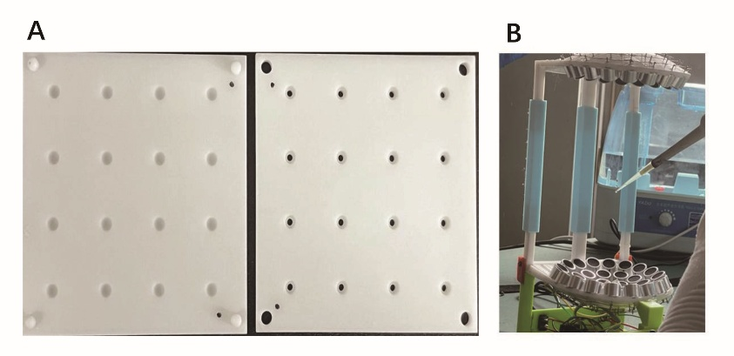
Fig. 1. Circular hole mold (A) and acoustic levitation device(B).

2.4 Locomotion Analysis

Locomotor behavior including head swing frequency, bending frequency and swimming ability were conducted as described by Ye et al [16]. Briefly, after stabilizing on NGM medium for 1 minute, head swings were counted over 60 seconds. The number of complete sinusoidal waveforms generated in 1 minute was recorded as bending frequency. After 10 seconds of stabilization in M9 buffer, the number of body bends within 60 seconds was recorded as swimming ability.

2.5 Muscle Protein Expression Analysis

RW1596 nematodes were synchronized to the L4 stage and subjected to a 9-hour acoustic levitation treatment in the AL group. Nematodes were immobilized on 1.5% agarose pads using 10 mM levamisole hydrochloride and imaged under a fluorescence microscope with fixed magnification and exposure settings to observe MYO-3::GFP expression. Fluorescence intensity was analyzed using ImageJ software. Ten nematodes were randomly selected from each group (n=3).
2.6 Statistical Analysis

Statistical analysis was conducted using GraphPad Prism 9.0. Group comparisons were performed using an unpaired t-test. Data are presented as mean ± standard deviation (SD). Statistical significance is denoted as: *P < 0.05, **P < 0.01, ****P < 0.0001; ns indicates no significant difference.

3. results

3.1 Evaluation of Growth Platform Adaptability

The head swing frequency, bending frequency, and swimming frequency of nematodes in the gel ball group and the control group after 3, 6, 9, and 12 hours of culture are shown in Figures 2, 3, and 4, respectively. As illustrated, there were no significant differences in locomotor ability between the gel ball and control (plate) groups across the four culture periods (P > 0.05), except at 3 hours, when the head swing frequency was significantly different (P < 0.05). Based on this, 10 μL of OP50 was added to each 3 mm diameter NGM gel ball for subsequent acoustic suspension experiments.
Fig. 2. Head swing frequency of C. elegans cultured on gel balls and NGM plates at 3 h (A), 6 h (B), 9 h (C), and 12 h (D). “ns” indicates no significant difference (P > 0.05); * indicates P < 0.05.

Fig. 3. Bending frequency of C. elegans cultured on gel balls and NGM plates at 3 h (A), 6 h (B), 9 h (C), and 12 h (D). “ns” indicates no significant difference (P > 0.05).

Fig. 4. Swimming frequency of C. elegans cultured on gel balls and NGM plates at 3 h (A), 6 h (B), 9 h (C), and 12 h (D). “ns” indicates no significant difference (P > 0.05).

Further statistical analysis (Figure 5) showed no significant differences in head swing frequency beyond 6 hours of culture (P > 0.05). Significant differences were observed only in the gel ball group at 3 and 6 hours (Figure 5A, P < 0.01), while the plate group exhibited no significant time-dependent changes (Figure 5B).
Similarly, bending frequency (Figure 6) followed the same pattern, with significant changes observed only at 3 and 6 hours (P < 0.01), and no differences detected beyond 6 hours (P > 0.05).
Swimming frequency displayed more distinct variations between the gel ball and plate groups (Figure 7). In the gel ball group (Figure 7A), swimming ability remained stable, showing no significant change at 6 and 9 hours (P > 0.05). In contrast, the plate group (Figure 7B) showed a progressive decline in swimming ability over time (P < 0.05). In summary, 9 hours of culture in NGM gel balls did not significantly impact the locomotor indices of C. elegans, indicating good adaptability to the gel ball platform.
Fig. 5. Changes in head swing frequency of C. elegans over different culture durations. (A) Gel ball group; (B) Plate group. “ns” indicates no significant difference (P > 0.05); ** indicates P < 0.01.

Fig. 6. Changes in bending frequency of C. elegans over different culture durations. (A) Gel ball group; (B) Plate group. “ns” indicates no significant difference (P > 0.05); ** indicates P < 0.01.

Fig. 7. Changes in swimming frequency of C. elegans over different culture durations. (A) Gel ball group; (B) Plate group. “ns” indicates no significant difference (P > 0.05); ** indicates P < 0.01.

3.2 Effect of Acoustic Suspension Treatment on Locomotor Activity

As shown in Figure 8, acoustic suspension (AL) significantly reduced locomotor indices. Head swing frequency decreased from 41.67 ± 7.77 to 21.87 ± 5.95, a decrease of 47.52% (P＜0.0001), bending frequency dropped from 19.33 ± 6.91 to 9.40 ± 8.28, a decrease of 51.38% (P＜0.01), and swimming frequency declined from 38.88 ± 6.97 to 32.19 ± 5.82, a decrease of 17.2% (P＜0.01).
Fig. 8. Changes in locomotor indicators of C. elegans following 9 h of acoustic levitation. (A) Head swing frequency; (B) Bending frequency; (C) Swimming frequency. ** indicates P < 0.01; **** indicates P < 0.0001.

3.3 Effect of Acoustic Suspension Treatment on Muscle Protein Expression

RW1596 (myo-3p::GFP) nematodes were subjected to AL treatment for 9 hours. As shown in Figure 9, the fluorescence intensity of MYO-3::GFP in the AL group was significantly reduced to 82.13 ± 0.20%, a decrease of 17.87% compared to the control (CK) group (P < 0.0001). These findings suggest that acoustic suspension may downregulate myo-3 gene expression, potentially impairing muscle function and reducing motility in C. elegans.

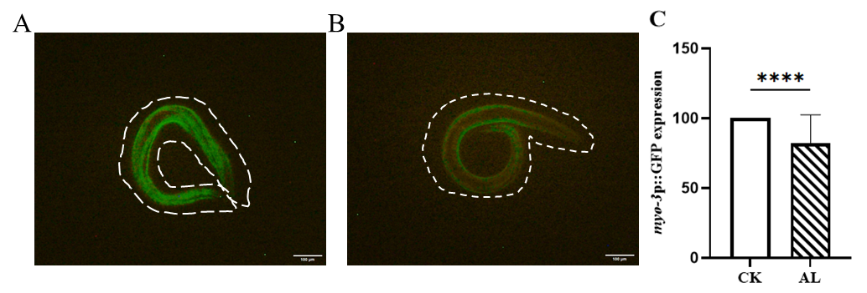
Fig. 9. Effects of acoustic levitation on myo-3p::GFP expression in C. elegans. (A) Control (CK) group; (B) Acoustic levitation (AL) group; (C) Semi-quantitative analysis of myo-3p::GFP fluorescence intensity using ImageJ software. **** indicates P < 0.0001.

4. discussion

Compared to other microgravity simulation techniques, the application of acoustic levitation in biological research remains relatively underexplored [17]. Sundvik et al. [18] utilized a traditional acoustic levitation device to simulate microgravity in zebrafish embryos, observing their growth and development under acoustic levitation treatment. Their results demonstrated that exposing zebrafish embryos to a single-axis acoustic levitation field for 2000 seconds had no adverse effects on embryonic development, with normal formation of auricles and neuromasts. Similarly, Li et al. [19] applied acoustic levitation to zebrafish embryos and found that the acoustic standing wave field significantly affected early developmental stages. They also reported that acoustic levitation inhibited hatching rates and assessed the biosafety of zebrafish embryos in a simulated space environment. These studies provide a theoretical foundation for the use of acoustic levitation in microgravity simulation research.
In this study, we used acoustic levitation to simulate microgravity conditions and exposed C. elegans to these conditions for 9 hours to evaluate its impact on locomotor function. Our findings confirmed that NGM gel balls can serve as a suitable suspension medium for nematode culture. No significant differences in locomotor indices were observed between nematodes cultured on gel balls and those on standard NGM plates. Although liquid culture methods for nematodes using S Medium have been previously reported [20], the long duration of space experiments can lead to droplet volume reduction due to evaporation under acoustic levitation. Therefore, gel balls were chosen as a more stable suspension carrier.
Movement index measurements after 3, 6, 9, and 12 hours of culture revealed that a 9-hour culture period significantly reduced nematode locomotor performance. Considering factors such as droplet evaporation rate, nematode viability, and levitation stability, we selected 9 hours as the optimal exposure duration. Nematode locomotion depends on coordinated synaptic activity between muscles and neurons, mediated by neurotransmitters. Body wall muscles are located dorsally and ventrally and coordinate to generate movement [21]. Head swing frequency is associated with feeding and spatial perception, while bending frequency and swimming frequencies are commonly used indicators of neural function [22]. Our findings suggest that acoustic levitation may impair muscle and neural function in C. elegans.
Previous studies have reported that microgravity can suppress nematode locomotion, reduce muscle fiber area, and downregulate genes related to muscle proteins and transcription factors [23]. Compared with a 14-day rotating wall vessel (RCCS) simulation study [24], our results show that acoustic levitation induces comparable locomotor impairment within a shorter timeframe (9 hours, P < 0.01). This contrasts with Sundvik’s findings [18] on the safety of acoustic levitation in zebrafish embryos, suggesting that invertebrates like nematodes may be more sensitive to acoustic forces. Moreover, the observed decline in MYO-3 expression aligns with known mechanisms of muscle atrophy under microgravity [23], and the inhibition rate under acoustic levitation was 3.2 times faster than that observed in real space microgravity.
Actually, this study has only a single treatment duration (9 hours) was tested, limiting the ability to assess dose-response effects. In addition, neurotransmitter levels were not measured, restricting insights into neuromuscular regulation; and the gel matrix may have buffered mechanical effects of acoustic levitation, potentially reducing the accuracy of microgravity simulation.

5. Conclusion

This study successfully established a novel microgravity simulation model using acoustic levitation and demonstrated, for the first time, that a 9-hour acoustic levitation treatment significantly impairs the locomotor ability of C. elegans—as evidenced by a 47.52% reduction in head swing frequency (P < 0.0001)—and downregulates the expression of the muscle protein MYO-3 by 17.87% (P < 0.0001). The observed pathological features closely resemble those induced by real microgravity conditions. These findings suggest that acoustic loads may affect motor function via neuromuscular regulatory pathways and offer a novel methodological platform for investigating the mechanisms underlying microgravity-induced muscle atrophy. Despite certain limitations, including the use of a single treatment duration and the absence of neurotransmitter data, the developed three-dimensional gel-based culture system, combined with its rapid response capabilities, presents a promising and reliable short-term ground-based simulation model for advancing aerospace medical countermeasures.

Disclaimer (Artificial intelligence)

Author(s) hereby declare that NO generative AI technologies such as Large Language Models (ChatGPT, COPILOT, etc.) and text-to-image generators have been used during the writing or editing of this manuscript.

.

References

- Lang T, LeBlanc A, Evans H, Lu Y, Genant H, Yu A. Cortical and trabecular bone mineral loss from the spine and hip in long-duration spaceflight. J Bone Miner Res. 2004;19(6):1006-12. doi: 10.1359/JBMR.040307.
- Jillings S, Van Ombergen A, Tomilovskaya E, Rumshiskaya A, Litvinova L, Nosikova I, Pechenkova E, Rukavishnikov I, Kozlovskaya IB, Manko O, Danilichev S, Sunaert S, Parizel PM, Sinitsyn V, Petrovichev V, Laureys S, Zu Eulenburg P, Sijbers J, Wuyts FL, Jeurissen B. Macro- and microstructural changes in cosmonauts' brains after long-duration spaceflight. Sci Adv. 2020;6(36):eaaz9488. doi: 10.1126/sciadv.aaz9488.
- Trappe S, Costill D, Gallagher P, Creer A, Peters JR, Evans H, Riley DA, Fitts RH. Exercise in space: human skeletal muscle after 6 months aboard the International Space Station. J Appl Physiol (1985). 2009;106(4):1159-68. doi: 10.1152/japplphysiol.91578.2008.
- Hammond TG, Hammond JM. Optimized suspension culture: the rotating-wall vessel. Am J Physiol Renal Physiol. 2001;281(1):F12-25. doi: 10.1152/ajprenal.2001.281.1.F12.
- van Loon J.J.W.A. Some history and use of the random positioning machine, RPM, in gravity related research. Adv Space Res, 2007;39(7):1161-1165. doi: 10.1016/j.asr.2007.02.016
- Herranz R, Anken R, Boonstra J, Braun M, Christianen PC, de Geest M, Hauslage J, Hilbig R, Hill RJ, Lebert M, Medina FJ, Vagt N, Ullrich O, van Loon JJ, Hemmersbach R. Ground-based facilities for simulation of microgravity: organism-specific recommendations for their use, and recommended terminology. Astrobiology. 2013;13(1):1-17. doi: 10.1089/ast.2012.0876.
- Hoson T, Kamisaka S, Masuda Y, Yamashita M, Buchen B. Evaluation of the three-dimensional clinostat as a simulator of weightlessness. Planta. 1997;203 Suppl:S187-97. doi: 10.1007/pl00008108.
- Zhang Y, Richards JT, Hellein JL, Johnson CM, Woodall J, Sorenson T, Neelam S, Ruby AMJ, Levine HG. NASA's Ground-Based Microgravity Simulation Facility. Methods Mol Biol. 2022;2368:281-299. doi: 10.1007/978-1-0716-1677-2_18.
- Drinkwater BW. Dynamic-field devices for the ultrasonic manipulation of microparticles. Lab Chip. 2016;16(13):2360-75. doi: 10.1039/c6lc00502k.
- Ma Z, Holle AW, Melde K, Qiu T, Poeppel K, Kadiri VM, Fischer P. Acoustic Holographic Cell Patterning in a Biocompatible Hydrogel. Adv Mater. 2020;32(4):e1904181. doi: 10.1002/adma.201904181.
- Marzo A, Barnes A, Drinkwater BW. TinyLev: A multi-emitter single-axis acoustic levitator. Rev Sci Instrum. 2017;88(8):085105. doi: 10.1063/1.4989995.
- Wang YH, Zhang K, Wang NJ, et al. Acoustic suspension type biological incubator capable of simulating microgravity and application of acoustic suspension type biological incubator. CN115322898 (B)- 2024-10-01
- C. elegans Sequencing Consortium. Genome sequence of the nematode C. elegans: a platform for investigating biology. Science. 1998;282(5396):2012-8. doi: 10.1126/science.282.5396.2012.
- Jeayeng S, Thongsroy J, Chuaijit S. Caenorhabditis elegans as a model to study aging and photoaging. Biomolecules. 2024;14(10):1235. doi: 10.3390/biom14101235.
- Xie X, Shang L, Ye S, Chen C. The Protective Effect of Adenosine-Preconditioning on Paraquat-Induced Damage in Caenorhabditis elegans. Dose Response. 2020;18(2):1559325820935329. doi: 10.1177/1559325820935329.
- Ye S, Shang L, Xie X, Cao Y, Chen C. Optimization of In Vitro Culture Conditions for Production of Cordyceps bassiana Spores (Ascomycetes) and the Effect of Spore Extracts on the Health of Caenorhabditis elegans. Int J Med Mushrooms. 2021;23(6):45-55. doi: 10.1615/IntJMedMushrooms.2021038683.
- Rabiet L, Arakelian L, Jeger-Madiot N, García DR, Larghero J, Aider JL. Acoustic levitation as a tool for cell-driven self-organization of human cell spheroids during long-term 3D culture. Biotechnol Bioeng. 2024;121(4):1422-1434. doi: 10.1002/bit.28651.
- Sundvik M, Nieminen HJ, Salmi A, Panula P, Hæggström E. Effects of acoustic levitation on the development of zebrafish, Danio rerio, embryos. Sci Rep. 2015;5:13596. doi: 10.1038/srep13596.
- Li L, Gu N, Dong H, Li B, T V G K. Analysis of the effects of acoustic levitation to simulate the microgravity environment on the development of early zebrafish embryos. RSC Adv. 2020;10(72):44593-44600. doi: 10.1039/d0ra07344j. Erratum in: RSC Adv. 2021;11(7):3891. doi: 10.1039/d1ra90003j.
- Hibshman JD, Webster AK, Baugh LR. Liquid-culture protocols for synchronous starvation, growth, dauer formation, and dietary restriction of Caenorhabditis elegans. STAR Protoc. 2021;2(1):100276. doi: 10.1016/j.xpro.2020.100276.
- Tian Y, Ru SG, Wang W, Tian H. Effects of Monocrotophos on the locomotion, learning and foraging behavior of Caenorhabditis elegans. Res Environ Sci. 2015;28(2): 275-282.doi: 10.13198/j.issn.1001-6929.2015.02.15.
- Kramer TS, Wan FK, Pugliese SM, Atanas AA, Hiser AW, Luo J, Bueno E, Flavell SW. Neural sequences underlying directed turning in C. elegans. BioRxiv. 2024:2024.08.11.607076. doi: 10.1101/2024.08.11.607076.
- Gao Y, Xu D, Sun YQ. Research Advancement of Application of Caenorhabditis elegans in space biology. Manned Spaceflight. 2013;19(6): 69-75. doi: 10.3969/j.issn.1674-5825.2013.06.013
- Wang C, Sang C, Yang, C, Sun Y, Yi ZC, Zhuang FY.. Mechanisms of muscular atrophy and gravisensing after simulated microgravity in Caenorhabditis elegans--parallel control to spaceflight research in C. elegans. Prog Biochem Biophys. 2008;35(11):7. doi: 10.0000/j.1000-3282.2008351112981304.

