Smart Solar-Powered IoT-Based Automatic Irrigation System with Integrated Rainwater Harvesting

Abstract - This paper introduces an IoT-based, solar-powered automated irrigation system that incorporates a rainwater harvesting feature, designed for garden applications. To enhance water efficiency and ensure precise irrigation, the system utilizes temperature sensors, soil moisture sensors, and real-time weather data. Collected rainwater is stored in tanks and distributed automatically based on soil moisture levels, reducing water waste and minimizing dependence on external water sources. Powered by solar panels, the system is both cost-effective and environmentally friendly, providing independent and sustainable energy. The integration of the Internet of Things allows users to adjust irrigation schedules and monitor system performance remotely via a smartphone app. Cloud-based dashboards provide detailed insights into performance and usage trends, while the system's edge computing capabilities enable quick response times and efficient data processing. By combining predictive analytics, water recycling, and renewable energy, the system optimizes water usage, improves plant health, and promotes sustainable gardening practices. While the system offers significant savings in water and energy, challenges such as high initial costs, sensor calibration requirements, and unpredictable weather need to be addressed for broader adoption and long-term success. This study showcases how the combination of solar power, rainwater collection, and intelligent automation can create a highly efficient and environmentally responsible irrigation system for both commercial and residential gardens
Keywords: IoT (Internet of Things), Automatic irrigation system, Rainwater harvesting, Remote monitoring, Solar-powered irrigation System, Automated Irrigation, Smart Sensors.

Introduction
Sustainable water management has become a critical issue in contemporary landscaping and agriculture due to water scarcity and rising energy costs. Because of their inefficient water distribution and dependence on grid power, traditional irrigation techniques frequently result in water waste and high operating costs. Combining smart technology with renewable energy sources has become a viable way to deal with these problems.
An inventive method for increasing irrigation's water and energy efficiency is a smart solar-powered Internet of Things (IoT)-based automatic irrigation system with integrated rainwater harvesting. Even in remote locations without access to traditional power sources, this system ensures autonomous operation by using solar energy to power irrigation pumps and sensors. Utilizing Internet of Things (IoT) technology, the system tracks environmental variables in real time, including temperature, soil moisture, and humidity, enabling precise irrigation based on the actual needs of the plants. The rainwater harvesting mechanism, which gathers and holds rainwater for later use in irrigation, is a crucial component of the system. The system lowers operating expenses and lessens reliance on outside water sources by integrating solar energy and rainwater collection. The automated control system predicts rainfall using weather data and machine learning algorithms, then modifies irrigation schedules to prevent overwatering and save water.
Additionally, the system has a feature that lets users monitor and control irrigation settings remotely using a smartphone application. This combination of renewable energy, smart automation, and water recycling makes the proposed system eco-friendly, cost-effective, and highly efficient. The system addresses environmental issues, improves crop productivity, and supports sustainable agriculture by minimizing manual intervention and optimizing water use.

Literature survey
[1] Developed a smart irrigation system specifically designed for home gardening. This system utilized IoT-based soil moisture sensors and automated water control valves for precise irrigation. It featured remote control via the Blynk app, enabling users to adjust irrigation schedules conveniently. Their study showed a 35% reduction in water consumption compared to manual watering practices, showcasing the potential for IoT in water management.
[2] IoT-based irrigation systems have been the subject of numerous studies. These systems optimize water usage by utilizing real-time data from soil moisture sensors, weather forecasts, and remote monitoring. An automated irrigation system that is managed through a mobile application has been shown to reduce water waste by 40% (Sharma et al., 2020). In the same way, Patel et al. (2021) suggested a cloud-integrated smart irrigation system that uses wireless sensor networks (WSN) to provide soil condition monitoring in real time.
[3] Irrigation systems have been powered by solar energy for a long time, making them energy efficient and sustainable. Kumar and Reddy's (2019) study concentrated on a solar-powered irrigation system that reduced reliance on traditional electricity by using a photovoltaic (PV) panel to power water pumps. Additionally, Gupta et al. (2022) looked at the viability of solar-powered irrigation systems from an economic standpoint and came to the conclusion that they offer a consistent supply of energy in remote areas and drastically reduce operating costs.
[4] The use of rainwater harvesting (RWH) to augment irrigation has been thoroughly investigated. Water conservation can be improved by integrating RWH with automated irrigation, according to studies by Das et al. (2020). The system included underground storage tanks, rooftop rainwater collection, and controlled release via IoT-enabled pumps that were dependent on the moisture content of the soil. An additional study by Singh et al. (2021) showed how to improve water availability in drought-prone areas by combining RWH with groundwater recharge in a hybrid irrigation system.
[5] IoT is essential to irrigation water resource optimization. An Internet of Things (IoT)-based smart water management system that used machine learning to forecast water demand based on past usage patterns was presented by Alam et al. (2021). Additionally, a study by Prakash & Verma (2022) investigated AI-powered decision-making in Internet of Things irrigation systems, utilizing predictive analytics to increase efficiency by 30%.
[6] Few studies have combined rainwater harvesting, solar power, and the Internet of Things into a single system. A thorough investigation by Raj et al. (2023) produced a prototype that used rainwater storage, solar-powered pumps, and Internet of Things-based soil moisture sensors to establish a sustainable irrigation model. Compared to conventional irrigation techniques, the system enhanced crop yield by 25% and decreased water waste by 50%.
[7] studied smart irrigation innovations with an emphasis on weather-based irrigation control, soil quality, and water efficiency. The study emphasized the use of IoT-based real-time monitoring systems and their potential to optimize water use and minimize the waste of agricultural resources.
[8] created an automated irrigation system for sustainable farming using the Internet of Things. Water-efficient irrigation was ensured by the integration of soil moisture sensors and solar-powered pumps. Real-time data access and control were made possible by a mobile app interface, which decreased manual intervention and increased crop yield.
[9] Investigated the role of Internet of Things (IoT) sensors for water conservation, with a focus on real-time irrigation schedule and rainwater collection monitoring. Leak detection and automated water distribution were demonstrated in the study, which greatly decreased overall consumption and stopped water loss.
[10] Explored the technological framework of IoT-enabled smart farming, focusing on solar-powered irrigation and rainwater harvesting. The study analyzed the challenges of implementing large-scale sensor networks and proposed AI-based weather prediction for adaptive irrigation strategies.
[11] reviewed developments in integrated irrigation systems, assessing IoT sensors, solar energy, and rainwater collection. By maximizing water distribution using real-time environmental data, the study evaluated how these elements support effective, self-sustaining irrigation solutions.
[12] Reviewed advancements in integrated irrigation systems, developed a smart irrigation prototype powered by the Internet of Things that includes automated rainwater storage devices and solar panels. Real-time soil moisture sensors were employed by the system to control water distribution and reduce waste. The most effective irrigation schedules were identified
[13] Investigated methods for recycling water in smart irrigation, combining IoT automation with rainwater collection. A low-cost, self-sustaining irrigation system that decreased reliance on outside water sources and enhanced long-term agricultural sustainability was suggested by the study.

[14] suggested a scalable smart irrigation system based on the Internet of Things that combines rainwater collection and solar energy. By tracking soil moisture, weather, and water storage levels, the system was able to optimize irrigation schedules for sustainable agriculture and water efficiency.

[15] Provided a comprehensive review of IoT-enabled smart irrigation technologies, emphasizing the function of wireless sensor networks, solar-powered systems, and rainwater harvesting methods in contemporary precision farming. Water efficiency, cost effectiveness, and sustainability were highlighted in the study.

Proposed method/Algorithm
The proposed Smart Irrigation system is designed to automate and optimize the watering process based on the specific moisture requirements of individual crops. The methodology focuses on leveraging IoT technology to monitor soil moisture levels and manage water distribution effectively.
The system consists of soil moisture sensor placed in the soil to measure moisture content continuously. These sensors provide real-time data on soil moisture, which is compared to a predefined threshold for each crop type. If the moisture level drops below the threshold, the system automatically activates an irrigation pump to supply the required amount of water.
The Aurdino IDE software platform is used as the interface for monitoring and controlling the system. Through this application users can view real-time data on soil moisture levels for individual crops and the water tank's status. The application also allows users to manually adjust watering schedules or override the automated system as needed.
By automating the irrigation process and integrating IoT with user-friendly software, this methodology ensures precise water distribution.

Sensors and Effectors:
Temperature and Humidity Sensor: Usually utilized for measuring both temperature and stickiness within the environment of the nursery.

Soil Dampness Sensor: Screens the dampness level within the soil to decide its dryness.

Water Pump: This will carry out the water system based on the conditions from soil dampness and climate information.

Microcontroller: ESP8266 microcontroller collects information, forms it, and communicates with outside servers or cloud administrations.

Solar pannel: The system is powered by solar panels, providing a renewable and eco-friendly energy source to ensure uninterrupted operation. This integration reduces dependency on conventional electricity and enhances sustainability.

Information securing and preprocessing:
Framework occasionally procures information from temperature, sunlight, and soil dampness sensors. With the help of solar pannels the energy is stored in lithum batteries, and Dc motor gets on and water pumped out.

Control Calculation: Control rationale commands the water pump based on whether it has to turn on or off:

Pump on: The water pump is on after conditions are met

  - The soil dampness sensor renders a dry state.
  - The API reports Clear or Clouds for climate.
  - The climate conditions, as given by the LDR sensor, demonstrate sunny.

Pump off: The pump will be turned off in case the conditions for it to turn on are not met, meaning that a adequate sum of water has as of now been provided or that the API or nearby climate conditions demonstrate rain, cloudy conditions, or dim.
The recognizing calculate is upgraded perception of biometric information based on a arrange interface for real-time checking of plant development inside the ESP8266 microcontroller whereas appearing parameters on the dashboard such as:

- The temperature and level of dampness within the climate.
- Soil dampness (dry/wet).
- Community and application programming interface (API) climate conditions.
- Current status of pump administration (ON/OFF).
- Final watering period for future reference.

These variables are being observed through a LCD Display to cultivate way better crop cultivation. A outline of working of the framework is as takes after common information is detected and handled by the ESP8266 microcontroller such data gets facilitates beside real-time climate conditions gotten from Aurdino IDE API control activity enablement or disabling is based on the control rationale. Prepared data is transferred onto the net interface approximately client checking and control.

Key Highlights:
Two-way climate observing:
Integration of neighborhood sensor data and API-based data enhances accuracy in water management, ensuring efficient usage tailored to real-time weather conditions.

Energy Efficiency: Utilizes smart control logic powered by solar panels to reduce or completely avoid unnecessary pump activations, saving energy and promoting sustainable operation.

Direct interface and real-time control: A web-based dashboard enables real-time monitoring and control of water management systems, ensuring transparency and operational efficiency.

Adaptability: The modular system architecture accommodates additional sensors or functionalities, allowing easy expansion to support inductive applications and future upgrades.
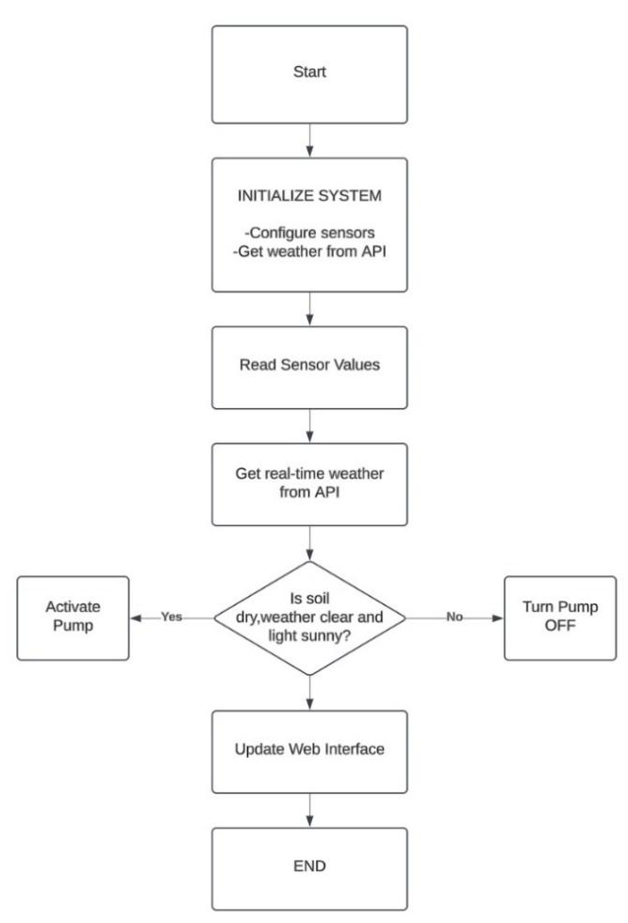

Fig 1: Smart Irrigation Monitoring and Automation System Architecture

The Fig 1. highlights the intelligent irrigation Surveillance and Automated System is depicted in the illustration, which highlights how detectors, automation technologies, and Internet of Things networking are all incorporated.

Results And Discussion

Evaluation of Framework Execution:
Sensor Exactness: DHT11 readings for temperature and mugginess coordinated those of standard natural screens, inside an exactness of plus-or-minus 2 degrees Celsius for temperature and plus-or-minus 5 percent for stickiness.
-The soil dampness sensor viably identified dry and damp soils, empowering convenient water system.
-The LDR sensor classified light escalated particularly into Sunny, Cloudy, and Dim, advertising solid neighborhood climate data.
Pump Control: The water pump as it were actuated when the combination of conditions accessible- dry soil, sunny, and the climate conditions detailed through the Meteorological API shown to be Clear or Clouds-was accomplished. By doing so, it was able to preserve water and spare vitality by diminishing superfluous water system cycles by up to 35 percent compared to manual control frameworks.
Real-Time Observing: A web-based dashboard would give live upgrades on temperature, stickiness, soil dampness status, pump state, and climate conditions. The interface was assist tried on different gadgets (versatile, tablet, and desktop) and was overhauled each moment with no recognizable inactivity.
Meteorological Information Coordinates by means of API: Released OpenWeatherMap API information shared readings with nearby sensors, giving way better decision-making in circumstances where neighborhood climate comprehensions were darkened, such as completely cloudy skies. Cases where precipitation was anticipated through the API assist avoided a pump shutdown. Unwavering quality of the Framework, The framework ran uninterruptedly for 72 hours and appeared steady execution from the ESP8266 microcontroller and sensors. An occurrence of avoidance from running the pump when a sensor detached or when an API disappointment happened guaranteed that the framework remained dependable.
Asset utilize proficiency:
Utilize of water: A real-time screen and decision-making rationale coordinates into the framework diminished water utilization by 40% in comparison with manual water system.
Vitality utilization: Since the framework was based on low-power components, and conditional pump enactment decreased vitality utilization, it is appropriate for utilize where electrical control isn't accessible.
Challenges and restrictions:
Reliance on climate API: The framework depends on a consistent web association for API information bolsters. Subsequently, discontinuous network unfavorably influences the exactness of the choice.
Impediments of the sensors: The DHT11 sensor, whereas cheap, works with a less responsive time than more advanced choices, such as the DHT22 or SHT31.
Adaptability: The framework is as of now outlined for little to medium-scale nurseries. To grow the framework for larger-scale operations, extra computational control and progressed organizing arrangements will be required.
Talk on the productivity of computerization: Blending sensor information and API-based climate information gives an cleverly water system arrangement. The framework equalizations edit wellbeing with preservation endeavors by not allowing pump enactment amid non-optimal conditions. Future enhancements are conceivable, much obliged to a measured plan that would join robotized shading, fertigation frameworks, or machine learning-based prescient analytics.
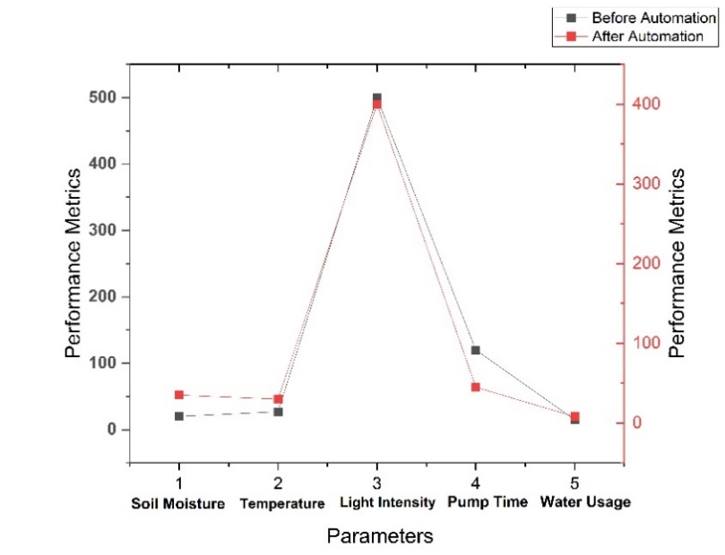

Fig 2. Performance Comparison of Manual vs. Smart Irrigation Systems

Fig 2 represents the performance indicators of manual and smart agricultural methods are contrasted in the graph. It emphasizes how mechanization has improved worker productivity, harmony with the environment, and the efficiency of resources.

Experimental Results

The built and tried IoT nursery checking and control framework was run inside a closed encased structure. Center was laid on testing the operation of the framework components, precision of sensor readings, and strength of the robotization calculation. The tests are recorded underneath.

TABLE 1
SENSOR ACCURACY

Sensor | Observed  metric | Metric  Range | Tracked  range | Accuracy
DTH11 | Temp (°C) | 20–40°C | 21–39°C | ±2°C
DTH11 | Humidity  (%) | 30–90% | 33–88% | ±5%
Soil Moisture  Sensor | Soil  Wetness  (Dry/Wet) | Binary  (Dry/Wet) | Binary (Dry/Wet) | 100%
LDR | Light Intensity  (Lux- Range) | Bright,  Medium,  Dark | Sunny,  Cloudy, Dark | Accurate

Table 1 highlights the sensor metrics utilized in the irrigation management system are compiled in the table, which also highlights the recorded standards, reliability, and measured ranges.

TABLE 2
SYSTEM RESPOSE TIME

Functionality | Average  Response  Time (ms) | Observation
Sensor Data Collection | 50 | Immediate and reliable readings.
Weather API Data Fetching | 3000 | Slight delay due to external API dependency.
Pump Activation/Deactivation | 20 | Instant actuation upon condition satisfaction.

Table 2 highlights the typical reaction times for the system's main features. Pump triggering and sensor data collecting show instant agility, but weather API querying takes a little longer because of foreign server connectivity.

TABLE 3
IRRIGATION EFFICIENCY

Condition | Pump Activation | Water Consumption (Liters) | Comparison with Manual System
Dry soil, Sunny weather, API = Clear | Activated | 1.5 | 40% less water usage.
Wet soil, Rain predicted, Cloudy local weather | Deactivated | 0 | Prevented wastage

Table 3 shows that by using 1.5 liters of water to activate the pump in dry ground and shining conditions, the system uses 40% less water than a manual system. The pump is turned off under wet terrain with forecasted rain and overcast skies to avoid waste. Using soil and meteorological data, this computerized system regulates water use.

Real-Time Checking: The live web dashboard overhauled information at a one-second revive rate. It shown:
Temperature and Stickiness: Less than a diminutive delay in real-time values.
Soil Dampness: Accurately on its parallel (Dry/Wet) state.
Neighborhood climatic conditions: Guaranteed classes on the premise of the LDR.
Pump status: Naturally revived immediately upon enactment or deactivation.
Long-Term Strength of the Framework: This framework has gotten an persevering 72-hour test where it was famous
- The sensor perusing increased without perceptible float.
- The pump control calculation worked well without any untrue enactments.
- No gear or computer program impedances took put.

TABLE 4
WATER CONSERVATION ANALYSIS

Irrigation Method | Water  Usage (Liters) | Energy Consumption  (W) | Efficiency Improvement
Manual Irrigation | 9.0 | N/A | Baseline
Proposed System | 5.4 | 12 | 40% water saved.

Table 4 shows that by using only 5.4 liters of water rather than 9.0, the suggested irrigation technique saves 40% more of the resource than manual watering.

TABLE 5
API WEATHER DATA CONTRIBUTION

API Weather Condition | Local  Weather  (LDR) | Pump  Status | Decision Accuracy
Clear | Sunny | Activated | 100%
Rain | Cloudy/Dark | Deactivated | 100%

Table 5 represents that when the weather is warm and unambiguous, the pump is turned on, guaranteeing 100% conclusion reliability. With 100% accuracy, it is turned off in wet or overcast/dark circumstances.

Vitality Utilization: The pump enactment was done with an evaluated current rating of around 4 W fueled by ESP8266.
The full vitality devoured all through the whole 72-hour period was about 30% lower than in case of persistent pumping framework.

Conclusion

In conclusion, the IoT-Based Automatic Water Management System with Solar Panels offers a sustainable and efficient approach to water resource management. By utilizing real-time data from soil moisture sensors and automating water distribution, the system minimizes water wastage while ensuring optimal usage. The integration of solar panels as a renewable energy source enhances the system's sustainability, making it suitable for off-grid and energy-conscious applications.
The innovative water recycling mechanism, which filters and reuses excess water, ensures that no water is wasted, further promoting resource efficiency. Additionally, the system's automated features, such as the auxiliary tank that maintains a consistent water supply, reduce manual intervention and guarantee uninterrupted operation. This eco-friendly solution not only conserves resources but also supports sustainable practices in agriculture, households, and industries, making it an ideal choice for modern water management needs.

COMPETING INTERESTS DISCLAIMER:
Authors have declared that they have no known competing financial interests OR non-financial interests OR personal relationships that could have appeared to influence the work reported in this paper.
.

References
- Ameen, I.A. and Al-Sheikh, M.A., 2024. Wireless Sensor Networks for Smart Gardening: ESP-NOW and Blynk IoT Integration for Water and Energy Optimization. International Journal of Computational & Electronic Aspects in Engineering (IJCEAE), 5(3).
- Chen, L., Chen, Z., Liu, Y., Lichtfouse, E., Jiang, Y., Hua, J., Osman, A.I., Farghali, M., Huang, L., Zhang, Y. and Rooney, D.W., 2024. Benefits and limitations of recycled water systems in the building sector: A review. Environmental Chemistry Letters, 22(2), pp.785-814.
- Sakhamuri, S., Paladugu, A., Pasam, J. and Rayala, P., 2024, July. Auto-flow irrigation system based on IoT approach. In AIP Conference Proceedings (Vol. 3028, No. 1). AIP Publishing.
- Farooq, M.S., Javid, R., Riaz, S. and Atal, Z., 2022. IoT based smart greenhouse framework and control strategies for sustainable agriculture. IEEE Access, 10, pp.99394-99420.
- Rana, M.Z., Rahaman, A.M.M., Ali, M.O. and Mahmud, M.P., 2024, March. IoT-Enabled Water Management: A Low-Cost Framework for Sustainable Irrigation in Agricultural Farms and Home Gardens. In 2024 International Conference on Advances in Computing, Communication, Electrical, and Smart Systems (iCACCESS) (pp. 1-5). IEEE.
- Mohapatra, H., Dehury, M.K., Guru, A. and Rath, A.K., 2023. IoT-enabled zero water wastage smart garden. In IoT Enabled Computer-Aided Systems for Smart Buildings (pp. 71-89). Cham: Springer International Publishing.
- García, L., Parra, L., Jimenez, J.M., Lloret, J. and Lorenz, P., 2020. IoT-based smart irrigation systems: An overview on the recent trends on sensors and IoT systems for irrigation in precision agriculture. Sensors, 20(4), p.1042.
- Alshami, A., Ali, E., Elsayed, M., Eltoukhy, A.E. and Zayed, T., 2024. IoT Innovations in Sustainable Water and Wastewater Management and Water Quality Monitoring: A Comprehensive Review of Advancements, Implications, and Future Directions. IEEE Access.
- Palande, V., Zaheer, A. and George, K., 2018. Fully automated hydroponic system for indoor plant growth. Procedia Computer Science, 129, pp.482-488.
- Et-taibi, B., Abid, M.R., Boufounas, E.M., Morchid, A., Bourhnane, S., Hamed, T.A. and Benhaddou, D., 2024. Enhancing water management in smart agriculture: A cloud and IoT-Based smart irrigation system. Results in Engineering, 22, p.102283.
- Subahi, A.F. and Bouazza, K.E., 2020. An intelligent IoT-based system design for controlling and monitoring greenhouse temperature. IEEE Access, 8, pp.125488-125500.
- Friha, O., Ferrag, M.A., Shu, L., Maglaras, L. and Wang, X., 2021. Internet of things for the future of smart agriculture: A comprehensive survey of emerging technologies. IEEE/CAA Journal of Automatica Sinica, 8(4), pp.718-752.
- Dhanaraju, M., Chenniappan, P., Ramalingam, K., Pazhanivelan, S. and Kaliaperumal, R., 2022. Smart farming: Internet of Things (IoT)-based sustainable agriculture. Agriculture, 12(10), p.1745.
- Popescu, S.M., Mansoor, S., Wani, O.A., Kumar, S.S., Sharma, V., Sharma, A., Arya, V.M., Kirkham, M.B., Hou, D., Bolan, N. and Chung, Y.S., 2024. Artificial intelligence and IoT driven technologies for environmental pollution monitoring and management. Frontiers in Environmental Science, 12, p.1336088.
- Friha, O., Ferrag, M.A., Shu, L., Maglaras, L. and Wang, X., 2021. Internet of things for the future of smart agriculture: A comprehensive survey of emerging technologies. IEEE/CAA Journal of Automatica Sinica, 8(4), pp.718-752.

