A FUZZY COST OPTIMIZATION APPROACH IN SMART WASTE COLLECTION FM/FM/1 QUEUEING SYSTEM WITH HEXAGONAL NUMBERS

ABSTRACT:
The study introduces a new method for handling parameter uncertainty in FM/FM/1 queueing systems through cost optimization utilizing hexagonal fuzzy numbers. By using six-point hexagonal fuzzy numbers for arrival rates, service cost, and waiting cost parameters, we improve upon conventional fuzzy queueing models and provide a more accurate representation of real-world uncertainties. In both crisp and fuzzy contexts, the study creates a thorough framework for figuring out the best service prices and overall expenses. The model's ability to handle unclear queueing system parameters is confirmed by numerical and graphical evaluations.

KEY WORDS:
FM/FM/1 queueing system, Hexagonal fuzzy numbers, Crisp model, Fuzzy model, Signed distance Defuzzification method, Sensitivity analysis, Fuzzified optimal total cost.

INTRODUCTION
Fuzzy set theory and logic may be used to manage and describe fuzzy information that implies imprecise and ambiguous information for decision-making (Bellman and Zadeh, 1970). According to Mishra and Yadav (2010), Mishra and Shukla (2009), Priya and Sudhesh (2018), Sharma (2016), Singh et al. (2016), Sundari and Palaniammal (2015), Singh B. B. et al. (2020), and Palaniammal and Pradeep (2025), Noppasorn Sutthibutr et al.(2025). Markovian queues have been a major focus in queuing theory research. Researchers have found that fuzzy queuing models outperform crisp ones in Markovian queues due to their greater realism in real-world scenarios. For instance, it is more possibilistic than probabilistic to discuss the mean arrival rate, mean service rate, or both. However, we also concur that whereas arrivals and services at service stations are entirely probabilistic, their numerical formulations are possibilistic.
In addition, fuzzy queuing models have a wider variety of applications than crisp ones since they are more realistic (Vide, Prado, and Fuente, 2010). Queuing models may be divided into two categories. The first is referred to as descriptive and the second as normative. Normative queuing models are those that should be the best fit for the circumstances, whereas descriptive models are ones that actually occur in real-world settings. This model optimizes several queuing model characteristics, including arrival, service, number of servers, queue discipline and controls. Consequently, the descriptive model is a real-situation queuing model, whereas the normative model is an aspirational one. Queuing decision models, sometimes referred to as design and control models, represent the second category of queuing models.
This class of models makes an effort to determine the model's optimal parameters. Among control models, queuing models' service control is dependent on metrics like service rate, server count, queue discipline, or a mix of these. Changing the number of consumers coming, allocating arrivals to certain servers, or establishing tolls or other workable restrictions, such as structuring the physical area and working shift can also help manage arrivals. Recently, there has been a shift in the tendency toward optimizing the queuing model with unknown input data. The fuzzy paradigm is used to try to determine the model based on the input data's uncertainty. Several approaches have been developed to address the design and control models of queues, focusing on performance measures where cost coefficients, as well as arrival and service characteristics, are precisely known.
According to Palpandi and Geetharamani (2013), Shanmugasundaram et al. (2015), Prameela and Kumar (2019) , fuzzy optimization techniques are used in the fuzzy paradigm. The goal of the intervention in this case is to evaluate the influence on the system's typical functioning. According to Barak and Fallahnezhad (2012), Enrique and Enrique (2014), Fathi-Vajargah and Ghasemalipour (2016), Gou et al. (2017), Kannadasan and Sathiyamoorthi (2018), and Hidayah et al. (2019), Singh B B et al. (2020), Chen et al. (2020), Palaniammal and Pradeep (2024, 2025) indicate that fuzzy queuing decision models are necessary to thoroughly examine and explore such models in order to address this situation.

PRELIMINARIES AND NOTATIONS

The following preliminaries and notations are used in this paper:

Defnition 1. Crisp set: A precise, deterministic value with no ambiguity.
Defnition 2. Fuzzy set: A value represented by a membership function to capture uncertainty.

Defnition 3. Defuzzification: The process of converting a fuzzy number into a crisp value for decision-making.

Defnition 4. Signed Distance Method: A defuzzification technique that computes the weighted average of a fuzzy number’s α-cut bounds, emphasizing symmetry.

Defnition 5. Alpha Cut level: A confidence interval ${[x}_{low},x_{high}]$ derived from a fuzzy number
at $∈[0,1]$ .

Defnition 6. Sensitivity analysis: Evaluating how changes in inputs Arrival rate, Service cost and Waiting cost affect outputs in Service rate and total cost in crisp and fuzzy.

NOTATIONS
$_\left(TC\right) =Optimal Total Cost (OTC),$
$$_k = Service cost per unit (SC),$$
$$_c = Waiting cost per unit (WC),$$
$$_λ = Arrival rate of customer (ARC),$$
$$_μ = Optimal Service rate (SR),$$
$$_μ^{*} = Fuzzified Optimal Service Rate (FOSR),$$
$$_k^{*} = Fuzzified Service cost per unit (FSC),$$
$${_c}^{*} = Fuzzified Waiting cost per unit (FWC),$$
$$_λ^{*} = Fuzzified Arrival Rate (FAR),$$
${_\left(TC\right)}^{*}=Fuzzified Optimal Total Cost (FOTC)$

- MODEL DEVELOPMENT AND REAL TIME EXAMPLE

Here, we examine FM/FM/1 : FCFS / ∞ / ∞ both arrival and service follow the Poisson probability rule. The estimated numbers of clients in the line and the system’s projected waiting time, as well as the service utilization factor or busy period, are some of the queuing model's operational features and performance metrics. These operation characteristics are the focus of most articles, but there is a lack of study on the queuing system's optimal overall cost, especially in fuzzy environments. Two key expenses waiting costs and service costs that are in conflict with one another are the basis for the cost model of a queuing system. This suggests that waiting would become more expensive if the quality of service declined. The ideal total cost of the queuing system under discussion can be used to describe the cost model as a performance metric.

REAL TIME EXAMPLE
This case study explores a novel and environmentally conscious application of the FM/FM/1 queueing model under fuzzy conditions in the context of smart waste collection. In a smart city infrastructure, sensor-equipped garbage pickup bins are installed across residential and commercial areas. Once a bin reaches a predefined threshold, it transmits a signal requesting collection. To avoid issues such as overflow, unpleasant odours, and environmental hazards, garbage collection vehicles are dispatched based on these signals. This collection process can be effectively modelled using a queueing system: waste signals act as arrivals, and collection trucks function as servers. However, the exact rate at which bins fill up is uncertain due to various dynamic factors, including the type of locality (residential vs. commercial), events (e.g., festivals, holidays), and weather conditions (e.g., reduced outdoor activity during rain). To capture this uncertainty, fuzzy numbers—specifically hexagonal fuzzy numbers—are used for modeling both arrival and service processes.
The fuzzy parameters used in the model are as follows:
$$Arrival rate \left(λ\right)=\left(19,21,23,25,27,29\right)$$Reflecting variation in waste signal generation at different times and locations.
$$Service cost \left(Cs\right)=\left(27,29,31,33,35,37\right)$$Representing the variable operational costs of deploying collection vehicles.
${Waiting cost (Cw}_{ })=\left(23,25,27,29,31,33\right)$ Accounting for the costs associated with delayed collection, such as environmental penalties and public dissatisfaction.
Using these fuzzy parameters, the total cost function is formulated and optimized to determine the optimal service rate. The signed distance method is employed for defuzzification, enabling decision-makers to achieve a cost-effective and responsive waste management system.
The running expenses of waste collection trucks per unit time include labor, maintenance, and environmental costs associated with operating hybrid or electric vehicles. Delays in emptying dumpsters can lead to costs such as environmental penalties, overflow issues, and public complaints. The primary objective is to apply fuzzy queueing theory to minimize the fuzzy total cost, which includes the operational cost of maintaining the bins and the costs arising from delayed responses.
Queuing models in fuzzy environments are designed and controlled by optimizing the queuing model in its actual scenario with one or more unclear parameters. In this article, we address the fuzzy optimization cost of the Non Markovian queuing model with a single server. This involves fuzzifying the parameters using an appropriate fuzzy set, evaluating specific fuzzy operations and defuzzifying the parameters using the signed distance method. The optimization and computation process is completed. Building the total cost function in a fuzzy environment and optimizing it is our goal.

- METHODOLOGY FRAMEWORK FLOWCHART
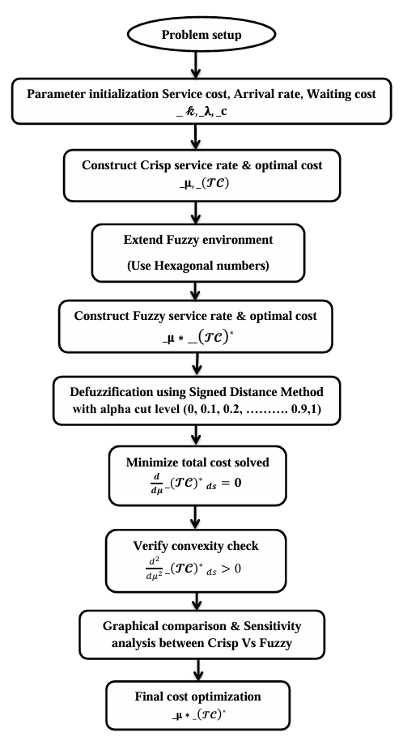

- RESEARCH CONTRIBUTION
In the area of cost optimization in FM/FM/1 queueing systems with fuzzy parameters, this study adds a number of new insights to the field of queueing theory under uncertainty. The suggested methodology uses a structured fuzzy approach to address real-world uncertainty, providing both analytical rigor and practical relevance.

The following summarizes the main contributions:
This paper presents Hexagonal fuzzy numbers, which provide a more realistic modeling of uncertainty than typical triangular or trapezoidal fuzzy numbers, to describe cost characteristics such as service cost, waiting cost and arrival rate. In real-world systems like customer support systems, cloud service scheduling, and environmental service centres, hexagonal fuzzy numbers provide greater flexibility and expressiveness while capturing a greater range of expert estimations and uncertainty. Under clear assumptions, a thorough derivation of the ideal service rate that reduces the FM/FM/1 system's overall running costs is provided.
Using fuzzy arithmetic, the same cost function is then extended into the fuzzy domain, allowing for theoretically coherent modeling of parameter imprecision. A complete decision support tool for uncertain situations is provided by the fuzzy derivation of the optimal service rate and optimal total cost. The fuzzy optimal service rate and total cost are defuzzified using the Signed Distance Method across α-cut levels. Compared to centroid or max-membership approaches, SDM more correctly preserves the central tendency and spread of uncertainty, making it particularly appropriate for Hexagonal numbers. In uncertain queueing contexts, this results in more representative, clear values for decision-making.
By highlighting which parameters have the most impact, the sensitivity measurements offer insight into the robustness of the system and help direct future enhancements or monitoring.
The practical applicability of the model is improved by this degree of sensitivity knowledge, which is rarely included in fuzzy FM/FM/1 optimization research. To aid in decision-makers' intuitive comprehension, comparative graphical representations are created, including crisp versus fuzzy, before and after defuzzification, and sensitivity trends. In addition to helping validate model behaviour under parameter uncertainty, these representations improve management decision support.

6. FUZZY MATHEMATICAL FORMULATION
The cost model can be expressed as
$_\left(TC\right)=_k_μ+_c*_E(n^{*})$ (1)
$_\left(TC\right)=_k_μ+\frac{_c_λ}{_μ-_λ}$ ( 2 )
Where $_k$ = cost of service rate per unit time, $_c$ = cost of waiting customers per unit time
and $_E(n^{*})$= average number of customers in the system.
Total cost function is defined as
$_\left(TC\right)=_k_μ+\frac{_c_λ}{_μ-_λ}$ (3)
For minimum cost w.r.t to service , we have
$\frac{d}{dμ}\left[_\left(TC\right)\right]=\frac{d}{dμ}\left[_k_μ+\frac{_c_λ}{_μ-_λ}\right]=_k- \frac{_c_λ}{{\left(_μ-_λ\right)}^{2}}=0$ (4)

For minimum cost, we must have
$\frac{d^{2}}{dμ^{2}}\left[_\left(TC\right)\right]=\frac{2_c_λ}{{(_μ-_λ)}^{3}}>0$ (5)
Further we define a Hexagonal number $A^{*}=(a^{*},b^{*},c^{*},d^{*},e^{*},f^{*})$ with membership function
$μ_{A}(x)=\left\{\begin{matrix}0 x^{*}≤a^{*} \\ \begin{matrix}\frac{x^{*}-a^{*}}{b^{*}-a^{*}}, a^{*}<x^{*}≤b^{*} \\ \begin{matrix} 1 b^{*}<x^{*}≤d^{*} \\ \begin{matrix}\frac{f^{*}-x^{*}}{f^{*}-e^{*}}, d^{*}<x^{*}≤e^{*} \\ 0 x^{*}≥f^{*}\end{matrix}\end{matrix}\end{matrix}\end{matrix}\right\}$ (6)
Now we wish to fuzzify cost coeffecients and arrival rates $_k,_c,_λ$ with the help of Hexagonal fuzzy numbers as $_k^{*},_c^{*},_λ^{*}$ respectively.
$_k^{*}=({_k}_{1}, _k_{2},{_k}_{3},{_k}_{4},{_k}_{5},{_k}_{6})$, $_c^{*}=({_c}_{1},{_c}_{2},{_c}_{3},{_c}_{4},{_c}_{5},{_c}_{6}),_λ^{*}=(_λ_{1},_λ_{2},_λ_{3},_λ_{4},_λ_{5},_λ_{6})$
${_\left(TC\right)}^{*} =_k^{*}{_μ}^{*}+\frac{_c^{*}{_λ}^{*}}{{_μ}^{*}-{_λ}^{*}}$ (7)
Which implies that
${_\left(TC\right)}^{*}=({_k}_{1}_μ, _k_{2}_μ,{_k}_{3}_μ,{_k}_{4}_μ,{_k}_{5}_μ,{_k}_{6}_μ)+$
$\left(\frac{c_λ_{1}}{-_λ_{1}},\frac{{_c}_{2}_λ_{2}}{-{_λ}_{2}},\frac{{_c}_{3}_λ_{3}}{-{_λ}_{3}},\frac{{_c}_{4}_λ_{4}}{-{_λ}_{4}},\frac{{_c}_{5}_λ_{5}}{-{_λ}_{5}},\frac{{_c}_{6}_λ_{6}}{_μ-_λ_{6}}\right)$ (8)
${ _\left(TC\right)}^{*} =\left(P,Q,R,S,T,U\right) where P={_k}_{1}_μ {_c}_{1}, Q={_k}_{2}_μ {_c}_{2}, R={_k}_{3}_μ {_c}_{3},$
$S={_k}_{4}_μ {_c}_{4},T={_k}_{5}_μ {_c}_{5} , U={_k}_{6}_μ- \frac{{_c}_{6}_λ_{6}}{_μ-{_λ}_{6}}$ (9)
Now we define
${{_\left(TC\right)}^{*}}_{ds}=\frac{1}{2}\left[\int_{0}^{1}{\left({_c}_{L}(ε)+{_c}_{R}(ε)\right)ε dε}\right]$ (10)
$\frac{d}{dμ}{{_\left(TC\right)}^{*}}_{ds}= \frac{1}{4}\left[\left({_k}_{1}+_k_{2}+{_k}_{3}+{_k}_{4}+{_k}_{5}\right)-\frac{{_c}_{5}_λ_{5}}{_μ-{_λ}_{5}}\right]$ (11)
For minimum$\frac{d}{dμ}{{_\left(TC\right)}^{*}}_{ds}=0$ with sufficient condition
$\frac{d^{2}}{{dμ}^{2}}{{_\left(TC\right)}^{*}}_{ds}= \frac{1}{2}\left(\frac{{_c}_{5}_λ_{5}}{{(__μ-{_λ}_{5})}^{3}}\right)>0$
which ultimately gives us $\left({_k}_{1}+_k_{2}+{_k}_{3}+{_k}_{4}+{_k}_{5}\right)*{\left(_μ-{_λ}_{5}\right)}^{3}-{_c}_{5}_λ_{5}=0$ (12)

NUMERICAL RESULTS AND GRAPHICAL ANALYSIS
  - RESULTS OBTAINED FOR CRISP AND FUZZY MODEL
This nonlinear equation is solved using the Signed Distance Defuzzification method with different alpha cut levels offers an efficient way to handle and understand fuzzy input parameters. The optimal service rate _µ and optimal total cost $_\left(TC\right)$ for the crisp model, as well as the fuzzy model's fuzzified optimal service rate _µ* and fuzzified optimal total cost ${_\left(TC\right)}^{*}$, have been computed numerically and graphically.
The results obtained for the crisp model are presented in Tables 1-3.
The results obtained for the fuzzy model are presented in Tables 4-6.

Table 1: Computation table for Optimal Service rate and Total Cost

 | $$_k$$ | $$_c$$ | _λ | _μ | $$_\left(TC\right)$$
Case 1 | 27 | 23 | 19 | 23.02 | 730.25
Case 1 | 29 | 23 | 19 | 22.88 | 776.15
Case 1 | 31 | 23 | 19 | 22.75 | 821.78
Case 1 | 33 | 23 | 19 | 22.64 | 867.17
Case 1 | 35 | 23 | 19 | 22.53 | 912.35
Case 1 | 37 | 23 | 19 | 22.44 | 957.31

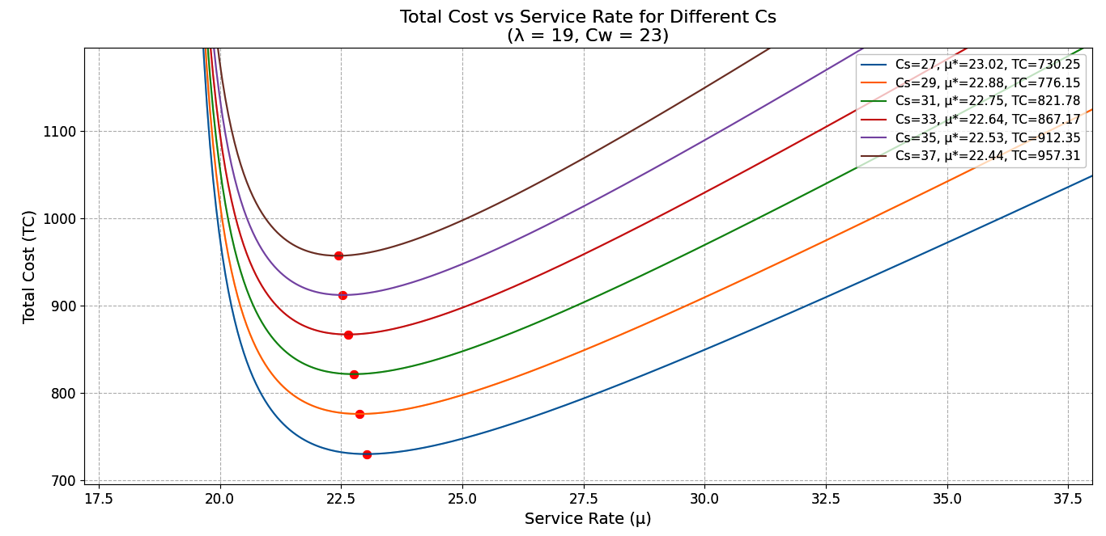

Fig-1

Table 2: Computation table for Optimal Total Cost and Waiting Cost

 | $$_c$$ | _$k$ | _λ | _μ | $$_\left(TC\right)$$
Case 2 | 23 | 27 | 19 | 23.02 | 730.25
Case 2 | 25 | 27 | 19 | 23.19 | 739.50
Case 2 | 27 | 27 | 19 | 23.36 | 748.38
Case 2 | 29 | 27 | 19 | 23.52 | 756.94
Case 2 | 31 | 27 | 19 | 23.67 | 765.21
Case 2 | 33 | 27 | 19 | 23.82 | 773.22

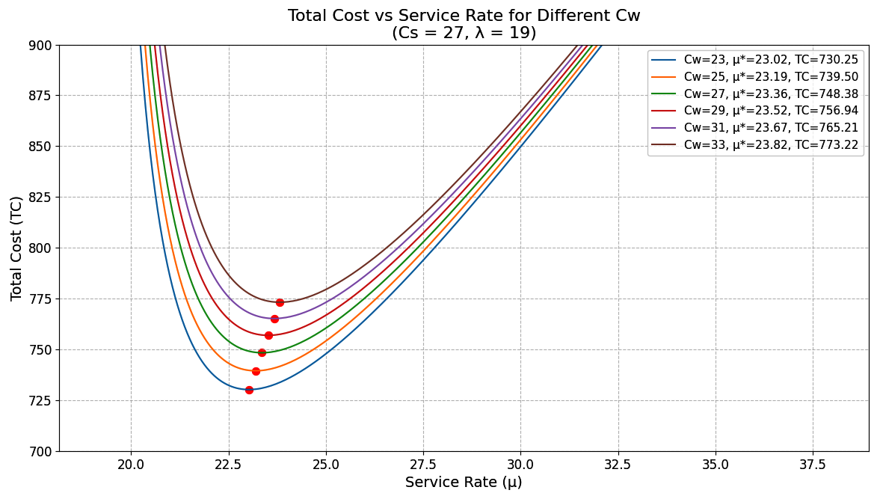

Fig-2

Table 3: Computation table for Optimal Total Cost and Arrival rate.

 | _λ | $$_c$$ | _$k$ | _ μ | $$_\left(TC\right)$$
Case 3 | 19 | 27 | 23 | 23.02 | 730.25
Case 3 | 21 | 27 | 23 | 25.23 | 795.39
Case 3 | 23 | 27 | 23 | 27.43 | 860.02
Case 3 | 25 | 27 | 23 | 29.61 | 924.20
Case 3 | 27 | 27 | 23 | 31.80 | 987.97
Case 3 | 29 | 27 | 23 | 33.97 | 1051.40

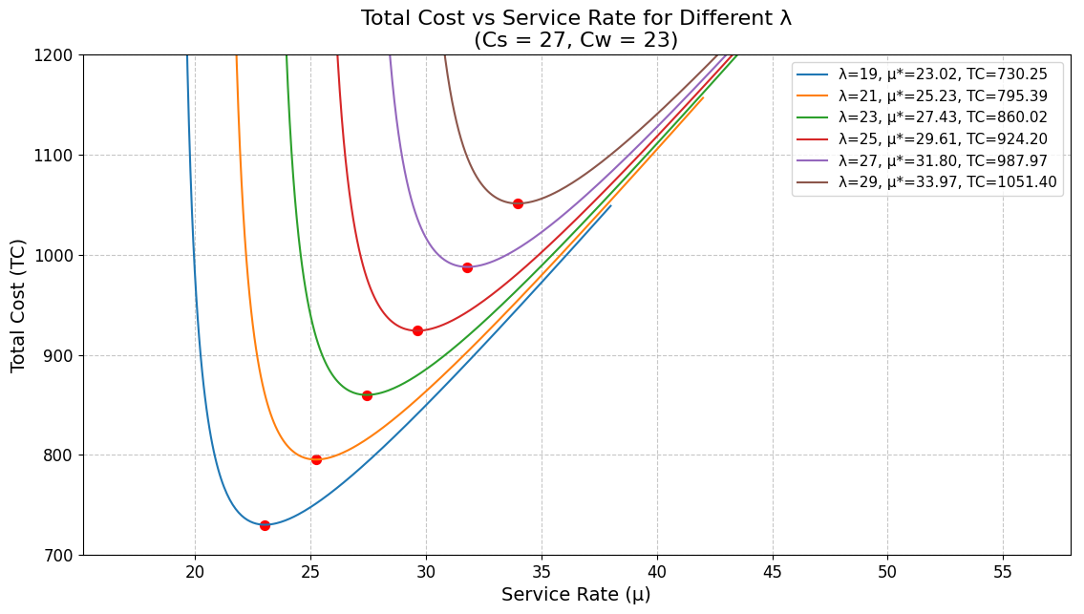

Fig-3

Table 4: Computation table for Fuzzified Service cost _$k$ * & Fuzzified Optimal Total Cost ${_\left(TC\right)}^{*}$

 | $_k$ * |  |  |  |  |  | _c* |  |  |  |  |  | _λ* |  |  |  |  |  | _μ* | $${_\left(TC\right)}^{*}$$
Case 4 | $${ _k}_{1}$$ | $${ _k}_{2}$$ | $${ _k}_{3}$$ | $${ _k}_{4}$$ | $${ _k}_{5}$$ | $${ _k}_{6}$$ | ${_c}_{1}$ | ${_c}_{2}$ | ${_c}_{3}$ | ${_c}_{4}$ | ${_c}_{5}$ | ${_c}_{6}$ | _λ1 | _λ2 | _λ3 | _λ4 | _λ5 | _λ6 | _μ* | $${_\left(TC\right)}^{*}$$
Case 4 | 22 | 24 | 26 | 28 | 30 | 32 | 18 | 20 | 22 | 24 | 26 | 28 | 14 | 16 | 18 | 20 | 22 | 24 | 23.02 | 663.86
Case 4 | 24 | 26 | 28 | 30 | 32 | 34 | 18 | 20 | 22 | 24 | 26 | 28 | 14 | 16 | 18 | 20 | 22 | 24 | 22.88 | 705.59
Case 4 | 26 | 28 | 30 | 32 | 34 | 36 | 18 | 20 | 22 | 24 | 26 | 28 | 14 | 16 | 18 | 20 | 22 | 24 | 22.75 | 747.08
Case 4 | 28 | 30 | 32 | 34 | 36 | 38 | 18 | 20 | 22 | 24 | 26 | 28 | 14 | 16 | 18 | 20 | 22 | 24 | 22.64 | 788.34
Case 4 | 30 | 32 | 34 | 36 | 38 | 40 | 18 | 20 | 22 | 24 | 26 | 28 | 14 | 16 | 18 | 20 | 22 | 24 | 22.53 | 829.41
Case 4 | 32 | 34 | 36 | 38 | 40 | 42 | 18 | 20 | 22 | 24 | 26 | 28 | 14 | 16 | 18 | 20 | 22 | 24 | 22.44 | 870.29

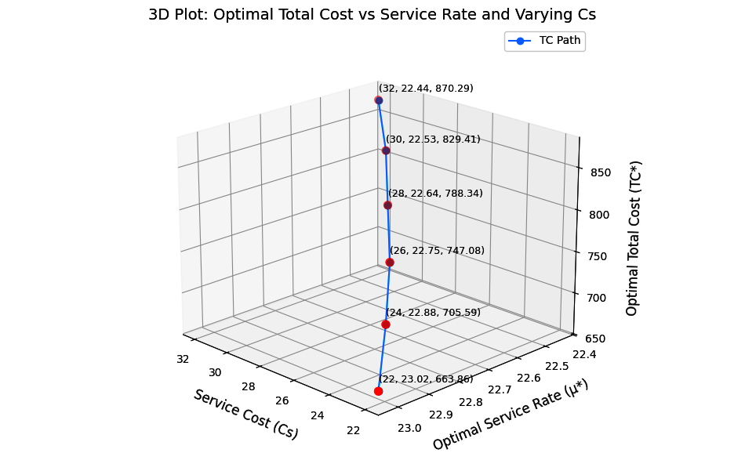

Fig-4

Table 5: Computation table for Fuzzified Waiting cost $_ c$ *& Fuzzified Optimal Total Cost ${_\left(TC\right)}^{*}$

 | ${_c}^{*}$ |  |  |  |  |  | ${_k}^{*}$ |  |  |  |  |  | _λ* |  |  |  |  |  | _μ* | $${_\left(TC\right)}^{*}$$
Case 5 | ${_c}_{1}$ | ${_c}_{2}$ | ${_c}_{3}$ | ${_c}_{4}$ | ${_c}_{5}$ | ${_c}_{6}$ | $${ _k}_{1}$$ | $${ _k}_{2}$$ | $${ _k}_{3}$$ | $${ _k}_{4}$$ | $${ _k}_{5}$$ | $${ _k}_{6}$$ | _λ1 | _λ2 | _λ3 | _λ4 | _λ5 | _λ6 | _μ* | $${_\left(TC\right)}^{*}$$
Case 5 | 18 | 20 | 22 | 24 | 26 | 28 | 22 | 24 | 26 | 28 | 30 | 32 | 14 | 16 | 18 | 20 | 22 | 24 | 23.02 | 663.86
Case 5 | 20 | 22 | 24 | 26 | 28 | 30 | 22 | 24 | 26 | 28 | 30 | 32 | 14 | 16 | 18 | 20 | 22 | 24 | 23.19 | 672.27
Case 5 | 22 | 24 | 26 | 28 | 30 | 32 | 22 | 24 | 26 | 28 | 30 | 32 | 14 | 16 | 18 | 20 | 22 | 24 | 23.36 | 680.35
Case 5 | 24 | 26 | 28 | 30 | 32 | 34 | 22 | 24 | 26 | 28 | 30 | 32 | 14 | 16 | 18 | 20 | 22 | 24 | 23.52 | 688.13
Case 5 | 26 | 28 | 30 | 32 | 34 | 36 | 22 | 24 | 26 | 28 | 30 | 32 | 14 | 16 | 18 | 20 | 22 | 24 | 23.67 | 695.65
Case 5 | 28 | 30 | 32 | 34 | 36 | 38 | 22 | 24 | 26 | 28 | 30 | 32 | 14 | 16 | 18 | 20 | 22 | 24 | 23.82 | 702.93

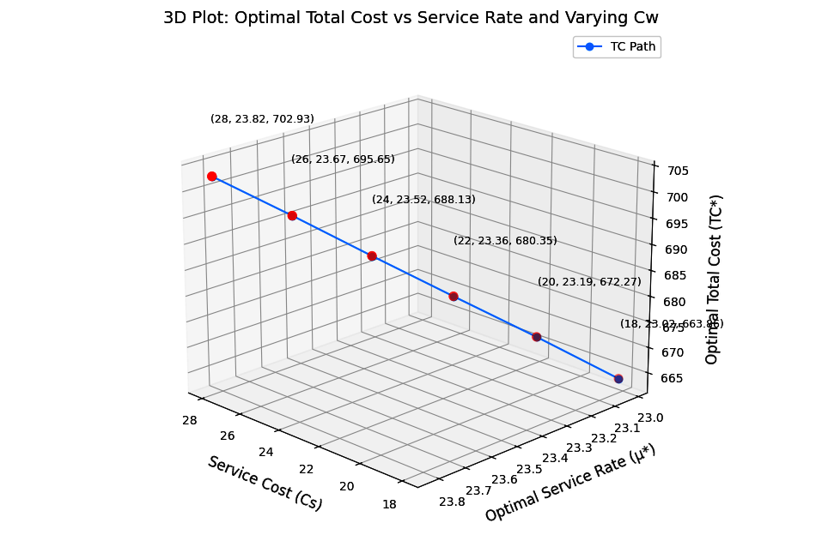

Fig -5

Table 6: Computation table for Fuzzified Arrival Rate _λ* & Fuzzified Optimal Total Cost ${_\left(TC\right)}^{*}$

 | _ λ * |  |  |  |  |  | $${_k}^{*}$$ |  |  |  |  |  | ${_c}^{*}$ |  |  |  |  |  | _μ* | $${_\left(TC\right)}^{*}$$
Case 6 | _λ1 | _λ2 | _λ3 | _λ4 | _λ5 | _λ6 | $${ _k}_{1}$$ | $${ _k}_{2}$$ | $${ _k}_{3}$$ | $${ _k}_{4}$$ | $${ _k}_{5}$$ | $${ _k}_{6}$$ | ${_c}_{1}$ | ${_c}_{2}$ | ${_c}_{3}$ | ${_c}_{4}$ | ${_c}_{5}$ | ${_c}_{6}$ | _μ* | $${_\left(TC\right)}^{*}$$
Case 6 | 14 | 16 | 18 | 20 | 22 | 24 | 22 | 24 | 26 | 28 | 30 | 32 | 18 | 20 | 22 | 24 | 26 | 28 | 23.02 | 663.86
Case 6 | 16 | 18 | 20 | 22 | 24 | 26 | 22 | 24 | 26 | 28 | 30 | 32 | 18 | 20 | 22 | 24 | 26 | 28 | 25.23 | 723.09
Case 6 | 18 | 20 | 22 | 24 | 26 | 28 | 22 | 24 | 26 | 28 | 30 | 32 | 18 | 20 | 22 | 24 | 26 | 28 | 27.43 | 781.84
Case 6 | 20 | 22 | 24 | 26 | 28 | 30 | 22 | 24 | 26 | 28 | 30 | 32 | 18 | 20 | 22 | 24 | 26 | 28 | 29.61 | 840.18
Case 6 | 22 | 24 | 26 | 28 | 30 | 32 | 22 | 24 | 26 | 28 | 30 | 32 | 18 | 20 | 22 | 24 | 26 | 28 | 31.80 | 898.16
Case 6 | 24 | 26 | 28 | 30 | 32 | 34 | 22 | 24 | 26 | 28 | 30 | 32 | 18 | 20 | 22 | 24 | 26 | 28 | 33.97 | 955.81

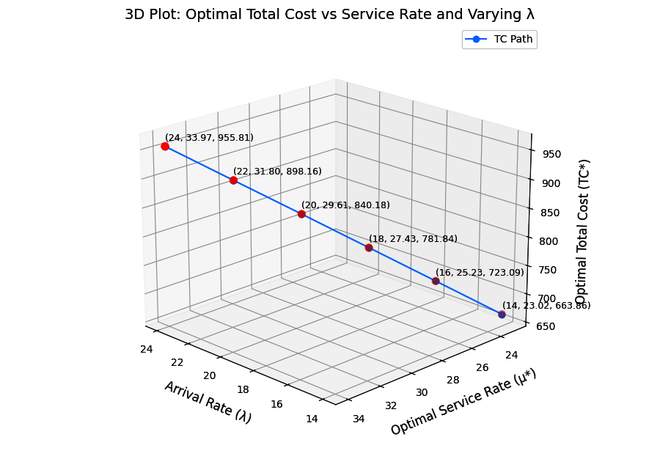

Fig-6

Table 7: Comparison chart for Crisp value Vs Fuzzy value under $_k$ &_$k$ *

$_k$ &_$k$ * | _μ* | $$_\left(TC\right)$$ | $${_\left(TC\right)}^{*}$$
27 | 23.02 | 730.25 | 663.86
29 | 22.88 | 776.15 | 705.59
31 | 22.75 | 821.78 | 747.08
33 | 22.64 | 867.17 | 788.34
35 | 22.53 | 912.35 | 829.41
37 | 22.44 | 957.31 | 870.29

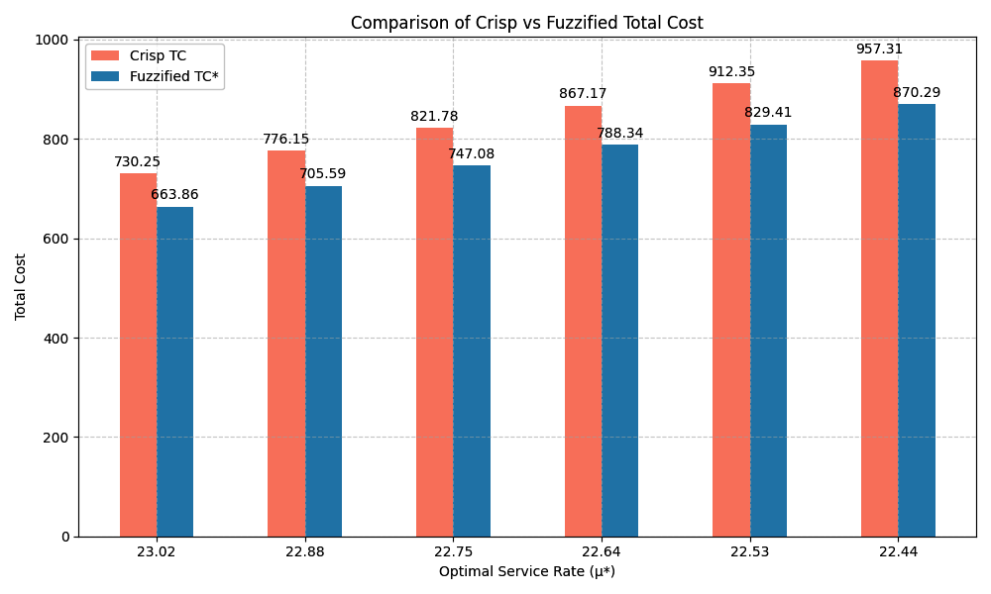

Fig -7

According to the analysis, both crisp and fuzzified total costs rise as the optimal service rate falls.
Table 8: Comparison chart for Crisp value Vs Fuzzy value under $_c$ & ${_c}^{*}$

$_c$ & ${_c}^{*}$ | _μ* | $$_\left(TC\right)$$ | $${_\left(TC\right)}^{*}$$
23 | 23.02 | 730.25 | 663.86
25 | 23.19 | 739.50 | 672.27
27 | 23.36 | 748.38 | 680.35
29 | 23.52 | 756.94 | 688.13
31 | 23.67 | 765.21 | 695.65
33 | 23.82 | 773.22 | 702.93

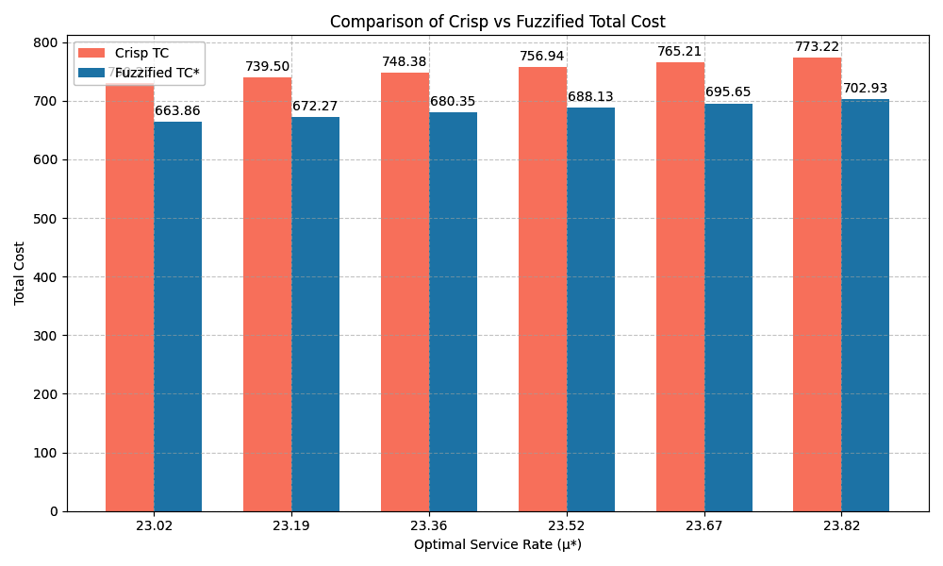

Fig -8
According to the analysis, when the optimal service rate rises, so do the crisp and fuzzified total costs.
Table 9: Comparison chart for Crisp value Vs Fuzzy value under $_λ \&_λ^{*}$
$$_λ \&_λ^{*}$$ | _μ* | $$_\left(TC\right)$$ | $${_\left(TC\right)}^{*}$$
19 | 23.02 | 730.25 | 663.86
21 | 25.23 | 795.39 | 723.09
23 | 27.43 | 860.02 | 781.84
25 | 29.61 | 924.20 | 840.18
27 | 31.80 | 987.97 | 898.16
29 | 33.97 | 1051.40 | 955.81

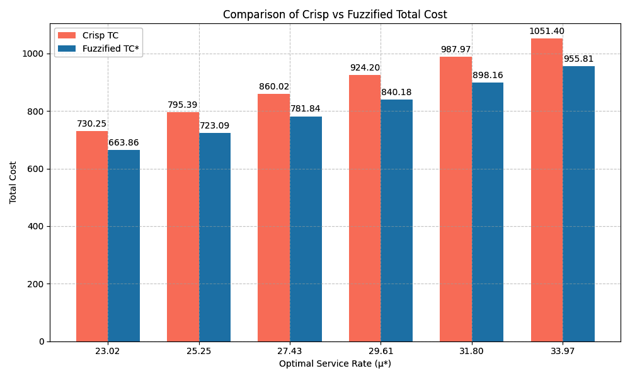

Fig -9

According to the analysis the greater service rates result in higher total costs for both crisp and fuzzified services.
Table 10: Correlation between Service cost and TC (Crisp & Fuzzy)
_k /_k* | _TC (Crisp) | _TC* (Fuzzy)
27 | 730.25 | 663.86
29 | 776.15 | 705.59
31 | 821.78 | 747.08
33 | 867.17 | 788.34
35 | 912.35 | 829.41
37 | 957.31 | 870.29

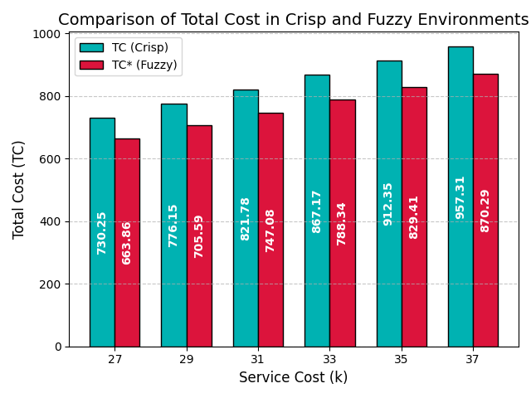
Fig -10

Sensitivity analysis
A sensitivity analysis is a comprehensive examination of the model's variation-propensity.
Table 1 and Fig 1, Illustrates how the crisp model's overall ideal cost rises in tandem with the service cost per unit. It is noteworthy that the overall optimum cost of the model rises in tandem with increases in waiting costs and waiting times per unit in Table 2 and Fig 2. As shown in Table 3 and Fig. 3, the overall optimum cost of the model likewise rises anytime the customer arrival rate to the service channel does.
Table 4 and Fig 4, Illustrates that the overall optimal fuzzy cost of the fuzzy model under discussion rises in proportion to the increase in fuzzy service cost per unit. Table 5 and Fig 5 illustrates that when the fuzzy waiting cost per unit rises, the model's overall optimal fuzzy cost also rises. Finally, Table 6 and Fig 6 shows that if the fuzzy arrival rate of consumers to the service channel rises, the model's overall optimal fuzzy cost also rises. Table 7-9 and Fig 7-9, Illustrates that the Comparison between Crisp and Fuzzy in different Hexagonal parameters. In Table 10 and Fig 10, shows a very essential metric for assessing the model's suitability for use is correlation. As a result, there is a positive association between the overall optimal cost of the model as a variable and the service, waiting and arrival rate as another variable in both the crisp and fuzzy situations. The connection in the former scenario is less positive than in the latter, which is the single fundamental difference between the two contexts.

Conclusion
In this case study, we investigated the application of a fuzzy FM/FM/1 queueing model to smart city waste management through sensor-equipped garbage bins. By incorporating uncertainty in the system parameters using fuzzy numbers, we were able to model real-world variability in waste generation and collection more realistically. In the crisp environment, the system yielded a service cost of 27, a waiting cost of 23, an arrival rate of 19, and an optimal service rate of 23.02, resulting in a total cost (TC) of 730.25 units. In the fuzzy environment, using fuzzy numbers and defuzzification techniques, the service cost, waiting cost, and arrival rate were maintained at the same defuzzified values (27, 23, and 19 respectively), with the optimal service rate also computed as 23.02. However, the total cost (TC) was observed to reduce to 663.86 units. This significant reduction in total cost demonstrates the advantage of using a fuzzy modeling approach, which better captures the uncertainties inherent in real-world systems.
By accounting for variability and imprecision, the fuzzy FM/FM/1 model provides a more efficient and cost-effective waste management strategy compared to the traditional crisp model. This highlights the practical value of fuzzy queueing theory in designing sustainable and responsive smart city operations. This fuzzy FM/FM/1 model thus enables a more flexible and realistic analysis of the smart city's waste collection system under uncertainty, aiming for cost optimization and improved ecological outcomes.

Disclaimer (Artificial intelligence)
Author(s) hereby declare that NO generative AI technologies such as Large Language Models (Chat GPT, COPILOT, etc.) and text-to-image generators have been used during the writing or editing of this manuscript.
Disclosure of conflict of interest
All authors declare that they have no conflicts of interest.
Declaration of competing interest
The authors declare that they have no known competing financial interests or personal relationships that could have appeared to influence the work reported in this paper.

References
- Barak S. and M.S. Fallahnezhad (2012). Cost analysis of fuzzy queuing systems, International Journal of Applied Operational Research, 2(2), 25-36. https://ijorlu.liau.ac.ir/article-1-138
- Belloman R.E. and L.A. Zadeh (1970). Decision-making in a fuzzy environment, Manng. Sci., 17(4), 141-164. http://dx.doi.org/10.1287/mnsc.17.4.B141
- Chen Gang, Liu Zaiming and Zhang Jingchuan (2020). Analysis of strategic customer behavior in fuzzy queueig system. American institute of mathematical sciences, 16(1), 371-386. https://www.aimsciences.org/article/doi/10.3934/jimo.2018157
- Enrique, M. and H.R. Enrique (2014). Simulation of fuzzy queuing systems with a variable number of servers, arrival and service rates, IEEE Transactions on Fuzzy Systems, 22(4), 892- 903. t http://dx.doi.org/10.1109/TFUZZ.2013.2278407
- Fathi-Vajargah B. and Ghasemalipour (2016). Simulation of a random fuzzy queuing system with multiple servers. Journal of Contemporary Mathematical Analysis , 51(2), 103-110.
doi.10.3103/S1068362316020060
- Gou, X., Z. Xu and H. Liao (2017). Hesitant fuzzy linguistic entropy and cross-entropy measures and alternative queuing method for multiple criteria decision making. Information Sciences, 388, 225-246. http://dx.doi.org/10.1016/j.ins.2017.01.033
- Hidayah, M.Z.N., S.A. Nadirah, A.N Atikah, H.N. Su Ain Abu and A. Norani (2019). Comparison of queuing performance using queuing theory model and fuzzy queuing model at check-in counter in airport. Mathematics and Statistics,7(4A), 17-23. http://dx.doi.org/10.13189/ms.2019.070703
- Kannadasan, G. and N. Sathiyamoorthi (2018). The analysis of M/M/1 queue with working vacation in fuzzy environment. International Journal Applications and Applied Mathematics, 13(2), 566-577. https://digitalcommons.pvamu.edu/aam/vol13/iss2/1
- Klir G. and B. Yuan, Fuzzy Sets and Fuzzy Logic, vol. 4, Prentice Hall New Jersey, 1995. https://dl.acm.org/doi/book/10.5555/202684
- Mishra, S.S. and D.C Shukla (2009). A computational approach to the cost analysis of machine interference model. American Journal of Mathematical and Management Sciences, 29(1&2), 277-293. http://dx.doi.org/10.1080/01966324.2009.10737760
- Mishra, S.S. and D.K. Yadav (2010). Computational approach to cost and profit analysis of clocked queuing networks. Contemporary Engineering Sciences, 3(8), 365-370. http://dx.doi.org/10.61294/jiaps2024.2842
- Nathan P. Sherman and Jekrey P. Kharoufeh, An M/M/1 retrial queue with unreliable server, Operations Research Letters 34 (2006), 697- 705. http://dx.doi.org/10.1016/j.orl.2005.11.003
- Noppasorn Sutthibutr , Kunihiko Hiraishi, Navee Chiadamrong (2025), A fuzzy multi-criteria decision-making for optimizing supply chain aggregate production planning based on cost reduction and risk mitigation, Journal of Open Innovation:Technology, Market and complexity,Volume10,Issue4, http://dx.doi.org/10.1016/j.joitmc.2024.100377
- Palaniammal, S. and Pradeep, S. (2024) Cost benefit analysis for non-Markovian bulk queue with server failure’, Int. J. Mathematics in Operational Research, Vol. 28, No. 4, pp.455–474, http://dx.doi.org/10.1504/IJMOR.2024.140351
- Palaniammal, S. and Pradeep, S. (2024) A State Dependent Arrival Analysis In a Non-Markovian Bulk Queue with Server Failures , International Journal of Operational Research, 2024 Vol.53 No.3, pp.235 - 252, http://dx.doi.org/10.1504/IJOR.2023.10056844
- Palaniammal, S. and Pradeep, S. (2025) A Trapezoidal approach to cost optimization in M/M/1 queueing systems , International Journal of Science and Research Archive, 2025 Vol.15 No.1, pp.391-399, http://dx.doi.org/10.30574/IJSRA.2025.15.1.1014
- Palpandi, B. and G. Geetharamani (2013). Evaluation of performance measures of bulk arrival queue with fuzzy parameters using robust ranking technique. International Journal of Computational Engineering Research, 3(10), 55-57.
https://ijceronline.com/papers/G03101053057
- Pardo, M.J. and D. Fuente (2010). Fuzzy markovian decision processes, application to queuing systems, Computers & Mathematics with Applications, 60(9), 2526-2535. https://doi.org/10.1016/j.camwa.2010.08.004
- Prameela, K.U. and P. Kumar (2019). FM / FEk /1 Queuing model with erlang service under various types of fuzzy numbers. International Journal of Recent Technology and Engineering, 8(1), 2277-3878. https://www.ijrte.org/wp-content/uploads/papers/v8i1/A1085058119
- Priya, R.S. and R. Sudhesh (2018). Transient analysis of a discrete-time infinite server queue with system disaster, International Journal of Mathematics in Operational Research, 12(1), 91-101. http://dx.doi.org/10.1051/ro/2016008
- Ritha W and Lilly Robert (2010), Fuzzy queues with priority discipline, Applied Mathematical Sciences 12(4),5 75-582. https://www.m-hikari.com/ams/ams-2010/ams-9-12-2010/rithaAMS9-12-2010.
- Shanmugasundaram S, S. Thamotharan, M. Ragapriya, A Study on Single Server Fuzzy Queueing Model, International Journal of Latest Trends in Engineering and Technology.,volume 6 issue 1, September 2015, 162-169, https://www.ijltet.org/wp-content/uploads/2015/09/22
- Singh B B, S. Rawat, S.K. Yadav and S.S. Mishra (2020), Optimization of Markovian arrival and service Queuing model under Fuzziness, International Journal of Agricultural and Statistical Science, Vol 16,No 2, p 567-572, 2020. https://connectjournals.com/03899.2020.16.567
- Sharma, P. (2016). Optimal flow control of multi-server time sharing queuing network with priority. International Journal of Mathematics in Operational Research, 9(3), 363-374. http://dx.doi.org/10.1504/IJMOR.2016.078826

- Singh, C.J., M. Jain and B. Kumar (2016), Analysis of single server finite queuing model with reneging. International Journal of Mathematics in Operational Research, 9(1), 15-38. http://dx.doi.org/10.1504/IJMOR.2016.077558
- Sundari, M.S. and S. Palaniammal (2015), Simulation of M/ M/1 queuing system using ANN. Malaya Journal of Mathematik, S(1), 279-294. https://www.malayajournal.org/articles/paper26
- Zadeh, L.A. (1978). Fuzzy sets as a basis for a theory of possibility. Fuzzy Sets Syst, 1, 03-28. https://doi.org/10.1016/0165-0114(78)90029-5

