*Case report*

Metastatic Papillary Thyroid Carcinoma Arising from Malignant Struma Ovarii : A Case Report

.

ABSTRACT

|  |
| --- |
| **Aim:** To present an uncommon case of recurrent metastatic papillary thyroid carcinoma arising from malignant struma ovarii. As the occurrence of the tumour is uncommon due to its rarity, there has been lack of data in regards to treatments and follow-up procedures for this tumour.  **Case presentation:** A case of 61 years old parity one lady presented with postmenopausal ovarian mass. She presented with abdominal distention with reduced effort tolerance. The patient underwent total abdominal hysterectomy bilateral saphingoophrectomy, appendicectomy, omentectomy and histopathology reported as papillary thyroid carcinoma arising from malignant struma ovarii. Total thyroidectomy was performed and results were negative for malignancy. The patient experienced recurrence of the disease on the pelvic 10 months post total abdominal hysterectomy bilateral salphingoophrectomy requiring debulking surgery and Hartmann’s procedure.  **Discussion:** Struma ovarii is a rare benign teratoma originated from the ovary represent 2% of all ovarian teratoma. Malignant transformation occurs in about 3% of cases. The most common malignant type transformation of struma ovarii is papillary thyroid carcinoma with 5% rate of metastases (P. Singh et al., 2018). Diagnosis is made postoperatively by histological findings and up until now there is no standard guideline in managing this rare illness.  **Conclusion:** Papillary thyroid carcinoma arising from malignant struma ovarii is an unusual presentation. Diagnosis and management of this entity is challenging and up until this moment there is no standardized treatment for this disease. Thus, intervention should be made individualized considering few factors such as the fertility concern, severity of the disease and histopathological diagnosis. Multidiscipline discussion is recommended in establishing the diagnosis and management for the patient. |

*Keyword: struma ovarii, malignant struma ovarii, papillary thyroid carcinoma, metastatic ovarian malignancy, ovarian tumour*

1. INTRODUCTION

Struma ovarii is a rare benign teratoma originated from the ovary represent 2% of all ovarian teratoma characterized by the presence of >50% of thyroid tissue (Yoo et al., 2008). Malignant transformation occurs in about 3% of cases. The most common malignant type transformation of struma ovarii is papillary thyroid carcinoma with 5% rate of metastases (P. Singh et al., 2018). Diagnosis is challenging as well as managing the disease as it is an uncommon occurrence. Majority of centers widely accepted total abdominal hysterectomy bilateral salphingoophrectomy as first line treatment in patient with no fertility concern. However, role of thyroidectomy remains controversial in managing the papillary thyroid carcinoma arising from malignant struma ovarii.

2. CASE PRESENTATION

We presented a case of a 61 years old lady parity 1, presented with acute abdomen, and reduced effort tolerance and loss of weight and appetite, with left lower limb swelling. Her initial symptoms were abdominal distention and reduced effort tolerance. She had previous history of laparotomy left cystectomy 30 years ago for benign ovarian cyst. The tumour marker showed elevated CA125 which was 1453 U/mL. Contrast enhanced CT scan revealed gross ascites, with a large lobulated solid cystic heterogeneously enhancing pelvic mass with papillary projection measuring 15.1cm x 17.8cm x 17.7cm (AP x W x CC). The mass extends superiorly up to L3 level and is associated with coarse internal calcification. Paraaortic and right iliac lymph nodes seen with largest para-aortic measuring 1.2cm in short axis. Doppler ultrasound of lower limbs confirmed left lower limb deep vein thrombosis therefore anticoagulant was initiated prior to surgery.

The patient underwent debulking surgery with total abdominal hysterectomy and bilateral salphingoophrectomy (TAHBSO), infracolic omentectomy, appendicectomy and resection of peritoneal nodules. Intraoperatively there was presence of 2.5 litre ascitic fluid, with bilateral ovarian tumour with papillary projection densely adhered to the uterus both measuring around 14cm x 10cm. Multiple tumour nodules seen over the omentum, Pouch of Douglas, rectosigmoid serosa layers and left paracolic gutter. Optimal cytoreduction surgery were not achieved as the disease were extensive. Post operatively patient recovered well.

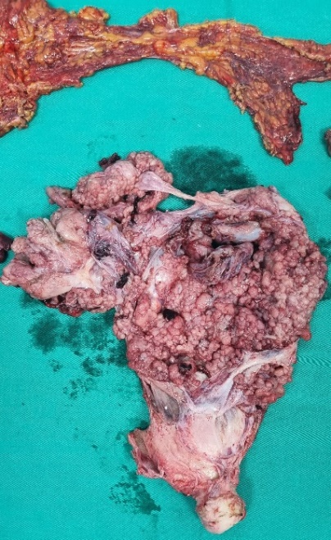

**Figure 1 Gross appearance of hysterectomy specimen**

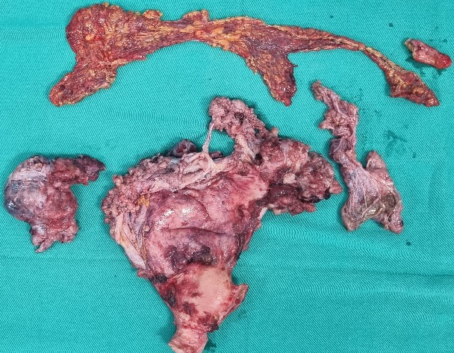

**Figure 2 Gross appearance of specimen of the uterus and cervix, bilateral fallopian tubes and ovaries with the omentum.**

Microscopic histopathology reported section from both ovarian tumours show malignant epithelial cells forming papillary structures with central fibrovascular cores, tubular glands and some solid lobules and nest with breached of capsule. These malignant cells display mild nuclear pleomorphism, inconspious nucleoli, nuclear clearing and nuclear overlapping. Occasional nuclear grooving is seen with mitosis easily seen on the solid area. The surroundings stroma shows aggregates of haemosiderin laden macrophages with some psammoma bodies seen with presence of some stroma hyalinization. Extensive lymphovascular permeation seen. Uterus and bilateral fallopian tubes were not involved. Immunohistochemistry staining shows tumour cells are positive for CK7, PAX8, TTF1, CK19, CD10, ER (patchy), PR (patchy), thyroglobulin (focal). They are negative for CK20, WT1, calretinin, p53, p16, Napsin A, inhibin and GATA3. Ki67 proliferation index were high at the solid area (40%). Final histopathology analysis reported as papillary thyroid carcinoma of bilateral ovary with omental and peritoneal tumour deposits showed metastatic papillary thyroid carcinoma. No evidence of teratomatous elements or struma ovarii after extensive sampling.

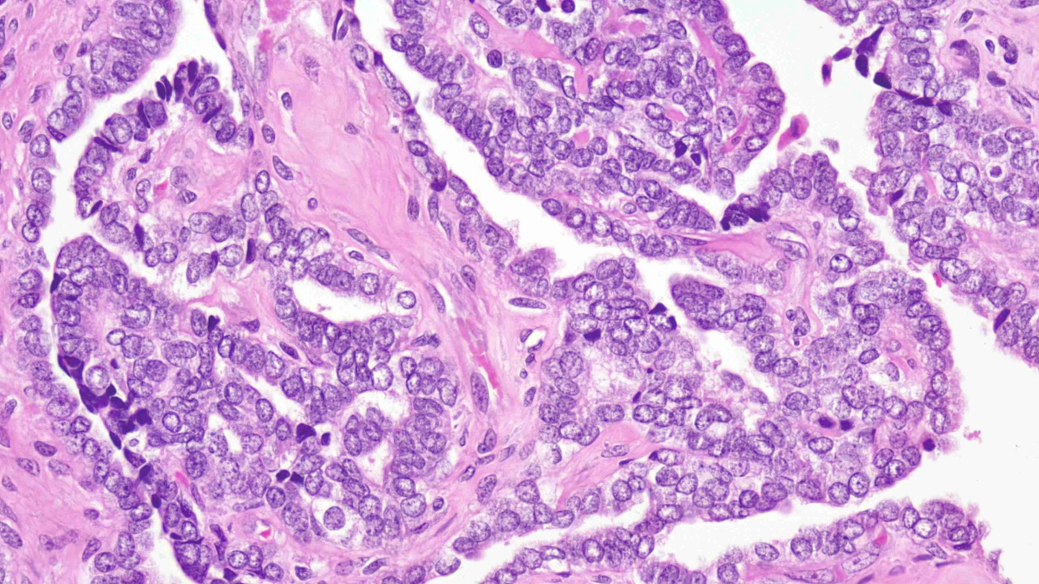

**Figure 3 Papillary thyroid carcinoma (H&E 40X), the high power view illustrates nuclear pleomorphism, nuclear overlapping, nuclear clearing and nuclear groove.**

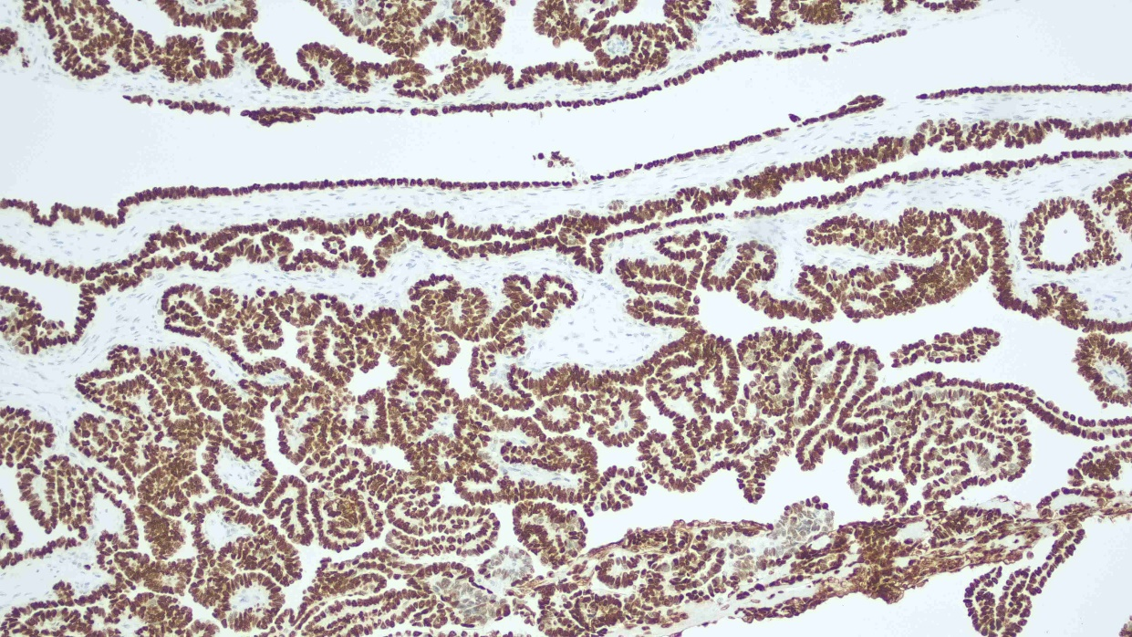

**Figure 4 TTF-1 immunohistochemical stain shows nuclear staining of the papillary thyroid carcinoma.**

Multidisciplinary team board discussion was made as two possible working diagnosis either ovarian metastasis from primary papillary thyroid carcinoma versus papillary thyroid carcinoma arising from malignant struma ovarii. The patient was referred to endocrine surgeon and she underwent total thyroidectomy with the thyroid specimen came back as negative for malignancy. Serum thyroid was within normal range. We concluded the final diagnosis was papillary thyroid carcinoma arising from malignant struma ovarii. She was referred to oncology center and L-Thyroxine for thyroid suppression therapy was initiated.

Unfortunately, 10 months post TAHBSO she presented with abdominal distention suspicious of recurrence as there was residual disease during TAHBSO. There was a hard in consistency mass around 20cm mass arising from left pelvic. Contrast enhanced CT scan showed a well-defined hypodense cystic mass in the left side of the pelvis measuring 9.6 x 10.5 x 12.4 cm (AP x W x CC). There was no enhancing septation, solid component or calcification within this mass and abutting the urinary bladder and another heterogeneously enhancing smaller mass in the lower half of the pelvis measuring 6.7 x 6.3 x 6.9 cm (AP x W x CC) with enhancing septation within compressing the rectosigmoid colon. She underwent laparotomy debulking surgery with Hartmann’s procedure removing 20cm x 20cm pelvic tumour enclosed with sigmoid mesentry and was unable to completely debulk the tumour with multiple tumour nodules left over the bladder, bowel mesentry, peritoneal lining and small bowels. Histopathological analysis reported as metastatic papillary thyroid carcinoma with similar morphology as the total abdominal hysterectomy bilateral salphingoophrectomy specimen. Post-operatively patient recovered well and was referred to oncologist for palliative intention radioactive iodine therapy (I-131) and IM Thyrogen. However, patient declined referral to oncology centre, therefore at this moment she was under our gynaeoncology clinic for active monitoring with good performance status.

3. discussion

Struma ovarii is a rare benign teratoma originated from the ovary represent 2% of all ovarian teratoma characterized by the presence of >50% of thyroid tissue (Yoo et al., 2008). Malignant transformation occurs in about 3% of cases. The most common malignant type transformation of struma ovarii is papillary thyroid carcinoma with 5% rate of metastases (P. Singh et al., 2018). Metastases occur more frequently, up to 23% of the time, in the abdominal cavity, which is considered a local metastasis via direct seeding (Yassa et al., 2008). Frequently the cases of struma ovarii occurs in the age group of 40 to 60 years old with mean age of 43 years (Yoo et al., 2008; Goffredo et al., 2015). The presenting illness were usually nonspecific, however symptoms such as abdominal pain and distention, abnormal uterine bleeding with deep vein thrombosis is common among the patient. Pseudo-Meigs syndrome is also one of the unusual clinical presentations in patient with struma ovarii (DeSimone et al., 2003). Hyperthyroidism observed in 5-8 % in patient with struma ovarii (Gonet et al., 2020). Our patient thyroid function test was within the normal range. Clinical assessment of the patient may not be able to distinguish the different between strumaa ovarii with other ovarian malignancy, however the suspicion of struma ovarii can become one of the differential diagnoses in the patient with ovarian tumour associated with abnormal thyroid hormones level leading to thyrotoxicosis or Graves’ disease. An elevated CA125 may occurred in any types of ovarian tumour therefore it is not specific in diagnosing malignant struma ovarii.

Ultrasound findings may represent solid cystic mass with colour Doppler imaging demonstrate hyper vascular and low resistant flow at the solid area (Yoo et al., 2008). CT images such as calcifications with multiloculated cystic mass with fluid of heterogeneous densities across the locules may represent the characteristic of malignant struma ovarii. However, there is no specific imaging characteristic to establish the diagnosis of malignant struma ovarii therefore a final diagnosis is confirmed via postoperative pathological findings (Abera et al., 2023; Leite et al., 2013). Histopathological diagnosis of malignant struma ovarii corresponded with the guidelines for the diagnosis of primary thyroid cancer based on the characteristic microscopic features after staining the sample with hematoxylin–eosin. Such features include “ground glass nuclei”, intranuclear inclusions, and vascular invasion (Doganay et al., 2008).

Several studies have outlined few points towards poor prognosis. Tumour size varying from 2 to 12 cm was suggested as a marker for an adverse clinical outcome or to assign a “low-risk” and “high risk” patients (Robboy et al., 2009, Shaco-Levy et al., 2010). Robboy et al. suggested that a size of the strumal component ≥6 cm was related to disease recurrence. Another study suggested that an overall size ≥10 cm with strumal component ≥80% were associated with rapid disease progression and death (Robboy et al., 2009). Presence of ascites also may indicate advanced tumour stages. Our patient unfortunately fulfilled the above high-risk criteria in malignant struma ovarii.

Treatment options for malignant struma ovarii were not standardized and varies among centers. The most recognized first line treatment among many centres is total abdominal hysterectomy and bilateral salphingoophrectomy, and options for conventional approach such as unilateral salpingectomy for young patients with fertility preservation surgery (Leite et al., 2013; Schmidt et al., 2007; Trovisco et al., 2004).

The role of thyroidectomy and radioactive iodine therapy for malignant struma ovarii is controversial. Yücesoy G et al reported total thyroidectomy should be included with total abdominal hysterectomy bilateral salphingoophrectomy surgery to rule out the primary thyroid carcinoma with metastases to ovary and subsequently to identify the metastasis, recurrence, and residual tissue with total body scanning with I-131 and serum thyroglobulin levels for monitoring post total thyroidectomy (Yücesoy et al., 2010). Another study recommended for removal of thyroid gland in patients with tumour larger than 2 cm, extra-ovarian metastatic, or high-grade histological traits have to be considered for thyroidectomy followed by I-131 ablation (Siegel et al., 2019). Yassa et al. suggested suppressive thyroxine therapy is recommended to reduce TSH secretion (serum TSH between 0.1 and 0.5 mIU/l) (Yassa et al., 2008). One study by Janzen et al concluded that the best option for patients with malignant struma ovarii larger than one cm is total thyroidectomy followed by I-131 ablation therapy with detectable (>1 ng/ml) post treatment serum thyroglobulin points to persistent or recurrent disease (Janszen et al., 2008). For low-risk malignant struma ovarii whereas thyroidectomy was not performed, adjuvant therapy should be discussed. The disadvantage is that it is unlikely, due to the thyroid still in place, that thyroglobulin becomes undetectable. Recurrence will be suspected in cases with increasing thyroglobulin levels (Oudoux et al., 2016).

Metastases of malignant struma ovarii are unusual and manifest in approximately 5% of cases (Yoo et al., 2008; DeSimone et al., 2003). Intrabdominal direct seedling accounting for up to 23% of cases (Makani et al., 2004). The prognosis of malignant SO is not well understood as the disease in very uncommon. Excellent prognosis observed in the low risk malignant struma ovarii in thyroid carcinoma confined to the ovarii, tumor size less than 2 cm and uncomplicated histological types (Oudoux et al., 2016). Surprisingly, two literatures review observed prolonged survivor rate with relapse occurs in approximately 15–35% of metastatic malignant strumaa ovarii cases (DeSimone et al., 2003; Makani et al., 2004). Fortunately, survival rates after malignant struma ovarii are high. Goffredo et al conducted a retrospective population-level analysis of 68 patients with malignant struma ovarii reported overall survival rates at 5, 10, and 20 years were 96.7%, 94.3%, and 84.9% respectively. This study concluded that patients with malignant struma ovarii had an excellent disease-specific survival rate, regardless of the management strategy employed (Goffredo et al., 2015).

Monitoring post treatment is mandatory for malignant struma ovarii regardless the types of treatment. One study reported recurrence was noticed after an average period of 4 years therefore recommendation of follow-up with serum thyroglobulin levels in cases of malignant Struma ovarii for at least 10 years (Makani et al., 2004). Hatami et al suggested long-term follow-up for the detection of metastases or tumour recurrence by serial serum thyroglobulin and body scanning with I-131 scan or positron emission tomography/computed tomography may be required in selected patients with malignant struma ovarii (Hatami et al., 2008).

4. Conclusion

Papillary thyroid carcinoma arising from malignant struma ovarii is an unusual presentation. The diagnosis and management of this entity is challenging and no standardized treatment for this disease. Thus, intervention should be made individualized correlating few factors such as the fertility concern, severity of the disease and histopathological diagnosis. Multidiscipline approach is crucial in managing the illness.

Consent

All authors declare that written informed consent was obtained from the patient for publication of this case report and accompanying images.

Ethical approval

Not applicable.

References

P. Singh, N. Lath, S. Shekhar, M. Goyal, M. Gothwal, G. Yadav, P. Khera (2018), Struma ovarii: a report of three cases and literature review, J. Midlife Health. 9 (4) 225–229

Goffredo, P., Sawka, A. M., Pura, J., Adam, M. A., Roman, S. A., & Sosa, J. A. (2015). Malignant struma ovarii: a population-level analysis of a large series of 68 patients. *Thyroid: official journal of the American Thyroid Association*, *25*(2), 211–215.

Yoo S. C., Chang, K. H., Lyu, M. O., Chang, S. J., Ryu, H. S., & Kim, H. S. (2008). Clinical characteristics of struma ovarii. *Journal of gynecologic oncology*, *19*(2), 135–138.

DeSimone, C. P., Lele, S. M., & Modesitt, S. C. (2003). Malignant struma ovarii: a case report and analysis of cases reported in the literature with focus on survival and I131 therapy. *Gynecologic oncology*, *89*(3), 543–548.

Gonet A, Ślusarczyk R, Gąsior-Perczak D, Kowalik A, Kopczyński J, Kowalska A. (2020). Papillary Thyroid Cancer in a Struma Ovarii in a 17-Year-Old Nulliparous Patient: A case Report. Diagnostics (Basel). 10(1), 45

Abera SA, Molla DK, Abera KA, Adisu GD, Worku MA, Molla YD (2023). Struma Ovarii with Papillary Thyroid Carcinoma and Metastasis to the Appendix: A Case Report and Literature Review. *Int Med Case Rep J*., 16, 571-578.

Leite, I., Cunha, T. M., Figueiredo, J. P., & Félix, A. (2013). Papillary carcinoma arising in struma ovarii versus ovarian metastasis from primary thyroid carcinoma: a case report and review of the literature. *Journal of radiology case reports*, *7*(10), 24–33.

Robboy, S. J., Shaco-Levy, R., Peng, R. Y., Snyder, M. J., Donahue, J., Bentley, R. C., Bean, S., Krigman, H. R., Roth, L. M., & Young, R. H. (2009). Malignant struma ovarii: an analysis of 88 cases, including 27 with extraovarian spread. *International journal of gynecological pathology : official journal of the International Society of Gynecological Pathologists*, *28*(5), 405–422.

Shaco-Levy, R., Bean, S. M., Bentley, R. C., & Robboy, S. J. (2010). Natural history of biologically malignant struma ovarii: analysis of 27 cases with extraovarian spread. *International journal of gynecological pathology : official journal of the International Society of Gynecological Pathologists*, *29*(3), 212–227.

Schmidt, J., Derr, V., Heinrich, M. C., Crum, C. P., Fletcher, J. A., Corless, C. L., & Nosé, V. (2007). BRAF in papillary thyroid carcinoma of ovary (struma ovarii). *The American journal of surgical pathology*, *31*(9), 1337–1343.

Trovisco, V., Vieira de Castro, I., Soares, P., Máximo, V., Silva, P., Magalhães, J., Abrosimov, A., Guiu, X. M., & Sobrinho-Simões, M. (2004). BRAF mutations are associated with some histological types of papillary thyroid carcinoma. *The Journal of pathology*, *202*(2), 247–251.

Yücesoy G, Cakiroglu Y, Muezzinoglu B, Besnili B, Yucesoy I (2010). Malignant struma ovarii: a case report. *J Korean Med Sci*., 25(2), 327-329.

Siegel, M. R., Wolsky, R. J., Alvarez, E. A., & Mengesha, B. M. (2019). Struma ovarii with atypical features and synchronous primary thyroid cancer: a case report and review of the literature. *Archives of gynecology and obstetrics*, *300*(6), 1693–1707.

Doganay, M., Gungor, T., Cavkaytar, S., Sirvan, L., & Mollamahmutoglu, L. (2008). Malignant struma ovarii with a focus of papillary thyroid cancer: a case report. *Archives of gynecology and obstetrics*, *277*(4), 371–373.

Makani, S., Kim, W., & Gaba, A. R. (2004). Struma Ovarii with a focus of papillary thyroid cancer: a case report and review of the literature. *Gynecologic oncology*, *94*(3), 835–839.

Oudoux, A., Leblanc, E., Beaujot, J., & Gauthier-Kolesnikov, H. (2016). Treatment and follow-up of malignant struma ovarii: Regarding two cases. *Gynecologic oncology reports*, *17*, 56–59.

Hatami, M., Breining, D., Owers, R. L., Del Priore, G., & Goldberg, G. L. (2008). Malignant struma ovarii--a case report and review of the literature. *Gynecologic and obstetric investigation*, *65*(2), 104–107.

Janszen, E. W., van Doorn, H. C., Ewing, P. C., de Krijger, R. R., de Wilt, J. H., Kam, B. L., & de Herder, W. W. (2008). Malignant struma ovarii: good response after thyroidectomy and I ablation therapy. *Clinical medicine. Oncology*, *2*, 147–152.

Yassa, L., Sadow, P., & Marqusee, E. (2008). Malignant struma ovarii. *Nature clinical practice. Endocrinology & metabolism*, *4*(8), 469–472.