Challenges to Mainstreaming TVET in Bangladesh: Understanding the Gaps Between Policy and Practice

Abstract
This study examined the obstacles that prevented Technical and Vocational Education and Training (TVET) from being successfully mainstreamed in Bangladesh, even after thorough policy frameworks were developed. It used document analysis, stakeholder interviews, and field observations to have a qualitative look at how TVET-related policies were being implemented. The results showed notable gaps between policy and practice, which were caused by antiquated curricula, inadequate industry engagement, insufficient governance frameworks, a lack of funding, and enduringly unfavorable public opinions of Technical and vocational education and Training (TVET). All of these elements worked against the creation of a flexible and long-lasting TVET system. The study came to the conclusion that structural changes, such as improved policy coordination, more funding, curriculum modernization, industry collaborations, and public awareness campaigns, were necessary to solve these issues. These revelations helped to clarify the TVET ecosystem in Bangladesh and provided practical suggestions for matching employable skill development to market demands.

Keywords: TVET, Policy Implementation, Skills Development, TVET reform.

1. Introduction
Bangladesh faces the dual challenge of youth unemployment and a shortage of skilled labor(M. Rahman et al., 2021). TVET has the potential to address both issues by providing practical education aligned with labor market needs. While national policies such as the National Skills Development Policy (NSDP) aim to promote TVET, its practical integration remains limited(Halimuzzaman et al., 2024). Bangladesh has seen significant economic expansion in recent decades, which has increased demand for a skilled labor force to support industrialization and development(Mujeri & Mujeri, 2021). The demand for technically trained labor and the supply of educated people, however, continue to be significantly out of sync. This disparity is especially concerning in light of the nation's expanding youth population and rising graduate jobless rates. By providing young people with market-driven, job-ready skills, Technical and Vocational Education and Training (TVET) has emerged as a viable way to close this skills gap(Majola, 2024).
In Bangladesh, TVET's integration into the regular educational system is still somewhat limited, despite its potential. The significance of skills development for economic growth and poverty reduction has been emphasized by national policies such as the Education Policy 2010 and the National Skills Development Policy (NSDP)(Kgalema et al., 2021). Nevertheless, there have been several obstacles in converting these policy goals into practical and expandable procedures. TVET's growth, quality, and social acceptance have all been hampered by the current disconnect between the creation of policies and their actual application. This policy-practice split is caused by a number of problems, such as disjointed institutional governance, out-of-date training materials, a lack of funding and human resources, and a failure to coordinate between industry stakeholders and education providers(Mohammad Sarwar Hossain Islam et al., 2024). Furthermore, vocational education is sometimes devalued in societal conceptions as a last alternative for pupils who don't achieve in regular academic paths. These enduring issues imply that enhancing TVET results necessitates more than just policy pledges; it calls for extensive structural changes as well as a change in the way that vocational education is viewed and rewarded(Zancajo & and Valiente, 2019).

This paper explores the various obstacles to TVET mainstreaming in Bangladesh and looks at the reasons why the current frameworks for policy have not been able to produce the desired results. The study intends to offer evidence-based insights and suggestions for more efficient TVET governance and implementation by examining the systemic, institutional, and sociocultural aspects of the policy-practice gap.

2. Objectives
The objectives of this study are:
- To identify the systemic challenges affecting the implementation of TVET policies in Bangladesh.
- To assess the alignment between TVET curricula and industry requirements.
- To examine the institutional and resource-related barriers to effective TVET delivery.
- To understand societal perceptions of TVET and their impact on enrollment and outcomes.
- To propose actionable strategies to bridge the policy-practice gap in TVET.
3. Literature Review
Recent research has shed important light on the obstacles to and possible facilitators of Bangladesh's Technical and Vocational Education and Training (TVET) mainstreaming. Although Bangladesh has created a number of national programs to improve skills development, (Panth & Maclean, 2020) contend that institutional fragmentation and inadequate coordinating mechanisms have resulted in uneven implementation. Their research highlights the continued marginalization of vocational tracks in the national education system as well as TVET institutions' inadequate ability to adjust to changing market demands(Majola, 2024). The lack of a coherent plan to include TVET into the larger agenda for educational and economic development is a significant obstacle, claim (K. A. Rahman, 2022). They draw attention to the fact that the Technical Education Board and the National Skills Development Authority (NSDA) sometimes function in silos, resulting in inefficiencies and overlaps(Walcutt & Schatz, 2019). Furthermore, they note that bureaucratic slowness and political meddling impede the development and revision of policies. (Omar & Kamaruzaman, 2024) investigate how industry collaborations might improve Technical and Vocational Education and Training. In order to close the gap between theory and practice, they stress the necessity of demand-driven courses and organized apprenticeship programs. But they discover that collaborations between TVET providers and business sector actors are still haphazard and unsystematic, frequently confined to short-term initiatives without ongoing involvement or outcome monitoring (Harikirishanan, 2024). Both the International Labour Organization (ILO, 2022) and UNESCO (2021) stress how crucial inclusive governance structures and sufficient funding are to the success of TVET programs in poor nations. These international assessments highlight Bangladesh's persistent underfunding of Technical and Vocational Education and Training (TVET), pointing out that per capita investment in vocational training is still significantly lower than regional averages. In order to advance social mobility and equity, they also demand that women and underrepresented groups participate more actively in TVET programs(Leong, 2024).
(Shimu & Haolader, 2025) investigates the stigma associated with technical and vocational education and training in Bangladesh from a sociocultural standpoint. According to his research, TVET's appeal among young people and their families is limited by ingrained cultural assumptions that portray it as a route for pupils who are academically less capable. Weak job placement systems and employer biases that prioritize generic academic credentials over occupational competencies support this viewpoint.

All things considered, the research shows a complicated interaction of institutional, monetary, cultural, and policy-related elements that still prevent TVET from becoming mainstream in Bangladesh. Although national technical vocational qualification frameworks (NTVQF) offer a good starting point, substantial reforms are necessary to successfully operationalize these policies and match them with the demands of the labor market.

4. Methodology
This study used a qualitative research approach to investigate the institutional, systemic, and sociocultural hurdles that impeded TVET mainstreaming in Bangladesh. Three primary techniques were used to gather data: field observations, semi-structured interviews, and document analysis. The official position on TVET development was evaluated by a systematic assessment of pertinent policy documents, such as the Education Policy 2010, the National Skills Development Policy (NSDP), sustainable development goal (SDG) and several Five-Year Plans. To learn more about the implementation issues and attitudes around TVET, 23 purposefully chosen stakeholders—including students, industry representatives, TVET educators, and policymakers—were interviewed in a semi-structured manner. In order to get a firsthand look at the institutional procedures, resource limitations, and operational realities, five TVET institutions in both urban and rural locations were also visited. Data were analyzed using thematic analysis to identify recurring patterns, contradictions, and key themes that reflected the gaps between policy and practice.

5. Analysis and Discussion
The analysis identified five key themes that highlighted the ongoing discrepancy between Bangladesh's TVET policy goals and implementation results. Policy evaluations, interviews, and field observations all revealed the same themes: industry connection, curricular relevance, governance and coordination, institutional capacity, and societal perception.

5.1 Governance and Policy Implementation
Among the most important shortcomings in Bangladesh's TVET mainstreaming was the synchronization of governance and policy. While different aspects of TVET policy and implementation were overseen by a number of institutions, including the National Skills Development Authority (NSDA), the Ministry of Education (MoE), the Ministry of Labour and Employment (MoLE), and the Bangladesh Technical Education Board (BTEB), there was no single lead agency with overarching authority to ensure coherence and accountability(S. M. A. Imran et al., 2024). Frequently, this multi-agency arrangement led to uncertainty about jurisdictional boundaries, policy overlaps, and redundant activities. According to interview data, there was little to no interministerial collaboration and it was mostly ad hoc, without formal structures like inter-agency monitoring units or joint task teams. Additionally, due to a lack of enforcement authority and low stakeholder participation, the National Skills Development Policy (NSDP) and the National Skills Development Council (NSDC) continued to play mostly symbolic roles in promoting inter-sectoral cooperation. Fund disbursement delays, inconsistent regulatory control, and a weak monitoring and evaluation (M&E) culture all hindered the implementation of the policy(Islam et al., 2025). According to respondents, regional and institutional players were rarely included in planning procedures, and national goals were frequently not successfully localized. Ownership was compromised by this top-down strategy, which also caused a discrepancy between local reality and national priorities. Furthermore, the consistency necessary for successful transformation was disrupted by frequent changes in goals brought on by political meddling and fluctuating leadership within important organizations. The study concluded that the policy-to-practice gap will persist in the absence of a strong, centralized coordinating organization with the authority to supervise TVET reform and institutional capacity to enforce standards and timetables.
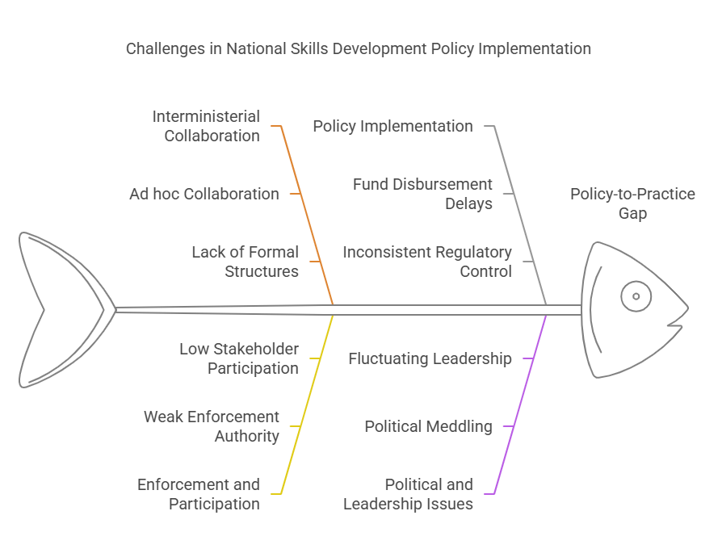
Figure 01: Challenges in National Skills Development Policy Implementation

5.2 Institutional Constraints
Stakeholder input and field observations showed that the majority of TVET institutions had serious resource shortages. In addition to having old or insufficient technology, many facilities were woefully understaffed and lacked contemporary digital tools. Inadequate laboratory facilities, outdated workshops, and a lack of classrooms were among the infrastructure flaws that further hampered efficient instruction(Julius Kumi Egyir, 2022). Local disparities in skill development were exacerbated by these deficiencies, which were especially noticeable in training facilities in rural and semi-urban areas. Limitations in human resources become an urgent issue. Many universities reported ongoing teacher shortages, with current faculty frequently missing current pedagogical training or real-world experience. Attracting people from appropriate technical industries was challenging due to the recruitment process's frequent bureaucracy and lack of funding(Mohammad Sarwar Hossain Islam et al., 2024). Furthermore, there was little to no organized support for CPD, which prevented trainers from improving their abilities or implementing innovative teaching strategies. Inadequate institutional management and ineffective administrative practices also contributed to capacity limitations. Many training facilities, according to a number of stakeholders, lacked decision-making autonomy and mostly relied on centralized directives that did not take local needs into account. Further limiting institutional flexibility were financial limitations, which made it challenging to maintain current infrastructure or launch creative activities. These difficulties were made worse by a widespread deficiency of mechanisms for data management and performance monitoring. Institutions' capacity to match training with real job results was weakened by their frequent lack of trustworthy student monitoring, impact evaluation, or labor market feedback systems. Despite policy aspirations to increase access and relevance, TVET providers were still ill-prepared to deliver high-quality education at scale in the absence of focused investments in infrastructure, human resources, and institutional governance.
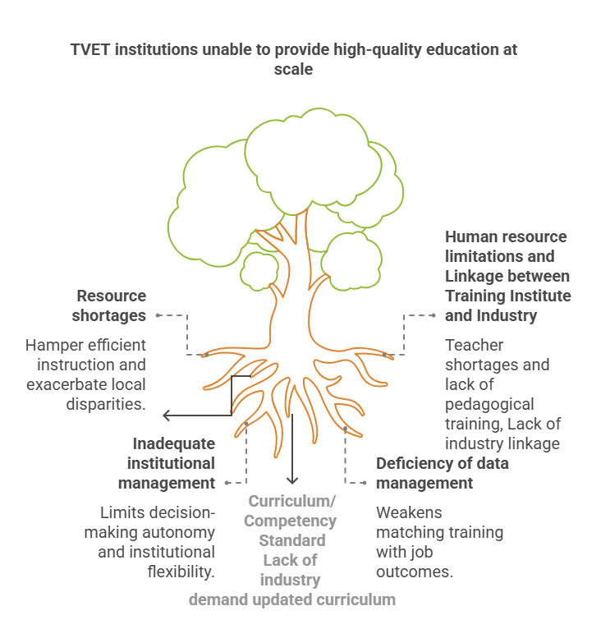

Figure 02: TVET institutions unable to provide high-quality education at scale

5.3 Curriculum and Industry Linkages
The antiquated character of TVET curricula was a persistent issue among educators and industry representatives. The majority of universities used conventional modules that did not take into account the demands of the modern industry or developments in technology(S. Imran et al., 2024). Participants pointed out that there was a mismatch between supply and demand since skill sets taught in schools frequently had no direct application in the labor market. This discrepancy damaged the TVET system's reputation and made graduates less employable. It was challenging for institutions to change or alter their material to satisfy particular regional or sectoral demands because of the national curriculum framework's rigidity. In several instances, curricula that had not been revised in more than ten years had neglected to incorporate new digital skills, technologies, green economy trends, or developing industries like e-commerce and renewable energy. As a result, graduates frequently lacked exposure to skills that businesses actively sought.
Curriculum reform, according to stakeholders, needs to be flexible and adaptable. This includes procedures for direct industry participation in curriculum creation, validation, and implementation in addition to regular reviews. But there was still little cooperation between institutions and business partners, and when there were consultations, they were frequently ceremonial rather than meaningful(Bhuiyan et al., 2025). The absence of soft skills like problem-solving, cooperation, and communication in graduates, as well as practical training components, frustrated employers. Many training programs' theoretical direction was another significant problem. Practical sessions were few and far between, and when they did occur, they were weakened by inadequate equipment, antiquated technology, and packed workshops. The lack of dual training systems or other work-based learning methods added to the skills mismatch. Despite leaving training facilities with credentials, graduates lacked the self-assurance and skills necessary in practical situations. Reforming curricula with an emphasis on flexibility, modularity, and labor market alignment is important in order to close the skills gap. By implementing competency-based training and Assessment (CBT&A), credit transfer programs, and stackable credentials, students will be able to customize their education to fit certain career routes and adjust to shifting job markets. Strong quality assurance procedures must be implemented in tandem with these reforms to guarantee that the material satisfies both domestic and international requirements.
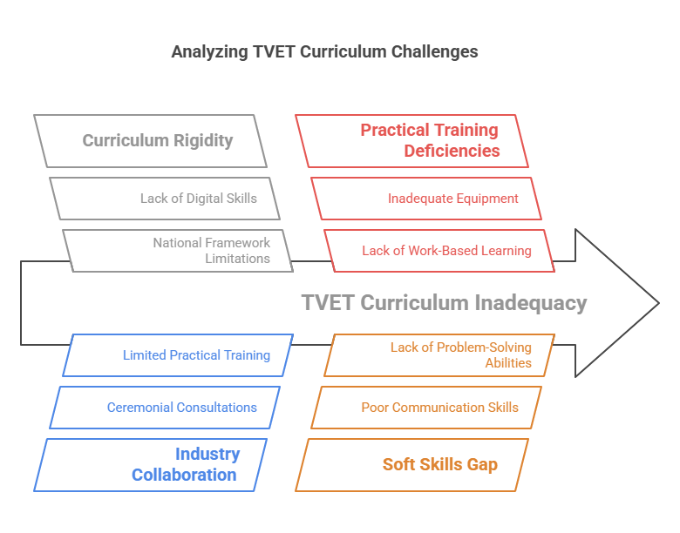
Figure 03: Analyzing TVET Curriculum Challenges

5.4 Financial and Resource Allocation
One major obstacle to the successful mainstreaming of TVET in Bangladesh was the distribution of funds and resources. Although the government had attempted to provide money for vocational education and training, numerous institutions complained that the funding was inadequate and frequently delayed, which hindered their capacity to operate efficiently(Mohammad Sarwar Hossain Islam et al., 2024). Even though there was a clear national goal to upgrade and expand TVET, funding was frequently scarce and resources were dispersed among several programs and institutions. This resulted in a shortage of resources that made it difficult to update curricula, undertake reform initiatives, and acquire necessary training supplies. The absence of appropriate budgeting procedures was cited by a number of parties as a major problem. Generally speaking, the resources allotted to TVET institutions were rigid, making it difficult to reroute them to address new demands or particular regional difficulties. Funds intended for infrastructure development, for instance, were occasionally misappropriated for administrative costs or other unrelated purposes. The distribution of cash was opaque due to the lack of a well-defined and organized system for financial planning; political connections, rather than needs assessments, determined which regions or institutions received more than others.
Financial management procedures were frequently inadequate at the institutional level. Dedicated finance officers or departments with the know-how to effectively handle funds were lacking in many TVET institutions. Because of this, the allocated funds were occasionally misused, which resulted in procurement delays, wasteful spending, or missed project deadlines. This made it even harder for training facilities to update their operations or adapt to the changing demands of the labor market. The significant reliance on donor financing was another important factor contributing to financial difficulties. TVET programs were greatly aided by foreign donors, but this reliance on outside sources also led to risks. These funds had strict requirements and were frequently linked to certain projects or results, which limited the ability of institutions to allocate resources in accordance with their own goals. Furthermore, if donor financing ran out, it was frequently questioned whether these projects could continue. Many TVET programs were left unfinished or failed to have the intended effect because there was no steady, long-term funding plan in place. Employers lacked clear incentives to invest in education and training, and the private sector's contribution to TVET funding remained modest. Without realizing that workforce development investments may eventually benefit their own companies by guaranteeing a qualified and competent worker pool, employers sometimes expected the government or educational institutions to cover the entire cost of training. A more strategic approach to resource allocation and financial planning is necessary to meet these difficulties. It is essential to make sure that TVET institutions receive timely and sufficient funding, with systemic flexibility to meet changing requirements. TVET programs would be more effective overall if institutional financial management were strengthened, strong monitoring systems were put in place, and funding was allocated fairly based on actual needs. A more sustainable model for vocational education in Bangladesh might also be established by establishing financial incentives for private sector participation in TVET, such as tax cuts or subsidies for businesses that provide apprenticeships.

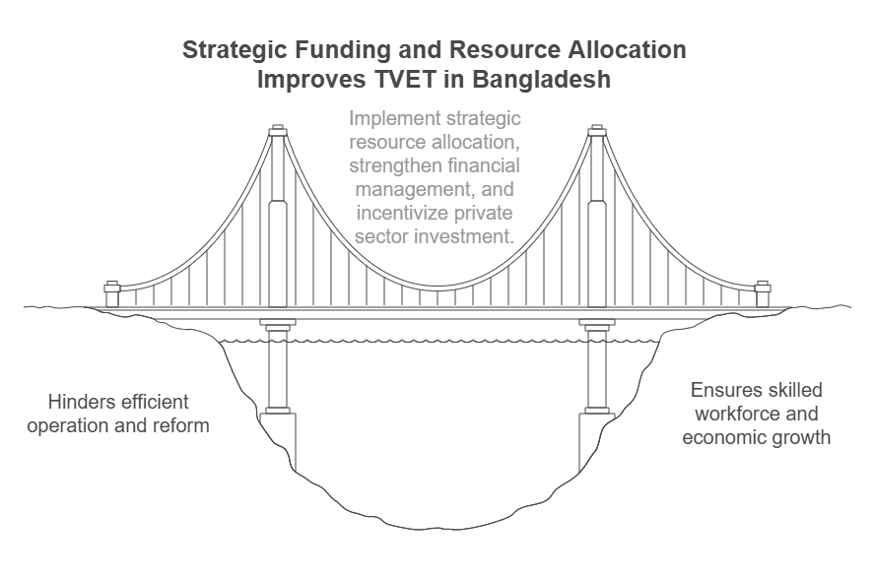
Figure 04: Strategic Funding and Resource Allocation Improves TVET in Bangladesh

5.5 Social Perception and Student Motivation
One of the key obstacles to the successful mainstreaming of vocational education and training (TVET) in Bangladesh was the social view of TVET. TVET was still stigmatized as a secondary, less desired route for people who couldn't achieve in traditional academic programs, despite the fact that it may offer useful skills and job prospects(Palash Saha, 2025). Due to the public's lack of support for vocational education as a result of this unfavorable impression, student enrollment and motivation were low.
The pervasive notion that TVET was a route for students who had "failed" academically rather than a respectable and fulfilling career choice was a major contributing factor to this problem. In Bangladeshi society, where academic achievement in traditional topics was frequently valued more highly than technological or vocational abilities, this viewpoint was firmly established. As a result, many families dissuaded their kids from going to TVET because they thought it was less respectable than ordinary education(Islam et al., 2025). TVET's value was diminished in the eyes of students, parents, and society at large due to the societal stigma produced by the idea that vocational education was only for those who were academically weak or unambitious. Additionally, those who did decide for TVET frequently struggled with low self-esteem and motivation. This was partially because their parents, teachers, and classmates devalued their chosen career, maybe viewing vocational training as a "second-rate" alternative. The absence of social recognition or job opportunities in the labor market deterred many students from being motivated to succeed in TVET programs. Consequently, there was frequently a discrepancy between the actual advantages that students saw and the work that went into vocational training.
Lack of knowledge about the possible career options accessible to TVET program graduates made matters worse. Many students were not completely aware of the technical and vocational occupations, skilled trades, and entrepreneurial options that TVET may lead them. Uncertainty regarding the worth of the education they were receiving was exacerbated by a lack of precise information regarding employment opportunities, pay, and career advancement within TVET sectors. Students have little knowledge of the success and upward mobility they could attain through vocational education in the absence of appropriate career guidance and role models in vocational sectors. Additionally, students' confidence was frequently undermined by the design and caliber of TVET programs. Students found it challenging to view TVET as a means of achieving professional success due to rigid curricula, antiquated training facilities, and little exposure to contemporary technology. Students were frequently faced with a curriculum that did not correspond with the demands of the labor market when they enrolled in training programs, which left them unprepared for obstacles they would face in the real world. As a result, many lost interests in studying because they could not understand how their education would directly affect their chances of finding work in the future. Furthermore, these motivating problems were made worse by the absence of industry active participation in TVET programs. Students were less likely to be inspired by the idea of using their talents in a professional setting when they were not given the chance to interact with actual companies or obtain practical experience through internships or apprenticeships. Students' enthusiasm and professional aspirations were further dampened by the lack of job preparation that came from the misalignment between training programs and industry expectations. A diversified strategy is required to change public perceptions of TVET in order to address these problems. First, in order to emphasize the importance of vocational education and the variety of employment options accessible to TVET graduates, public awareness campaigns are essential. Emphasizing the legitimacy, stability, and earning potential that TVET employment can provide, such advertisements should target not just kids but also parents, instructors, and the larger community. Policymakers and educational institutions must also endeavor to improve TVET programs' quality by bringing them closer to industry demands, integrating contemporary technologies, and giving students real-world, experiential learning opportunities. This can entail expanding industry collaborations, creating internship and apprenticeship programs, and encouraging a continuous improvement mindset in TVET institutions. In order to give students clear direction on employment prospects, career advancement, and the possibility of entrepreneurship in technical domains, it is also imperative that TVET universities implement improved career counseling services. In order to inspire current students, positive role models—such as accomplished TVET graduates—should be emphasized. TVET's social perception can be changed and students can be inspired to pursue it with confidence by showcasing its successes and practical advantages. Bangladesh can start to close the gap between TVET policy and practice by tackling these social and motivational obstacles. This would make vocational education a valued and practical option for students, thereby boosting the country's overall economic growth.
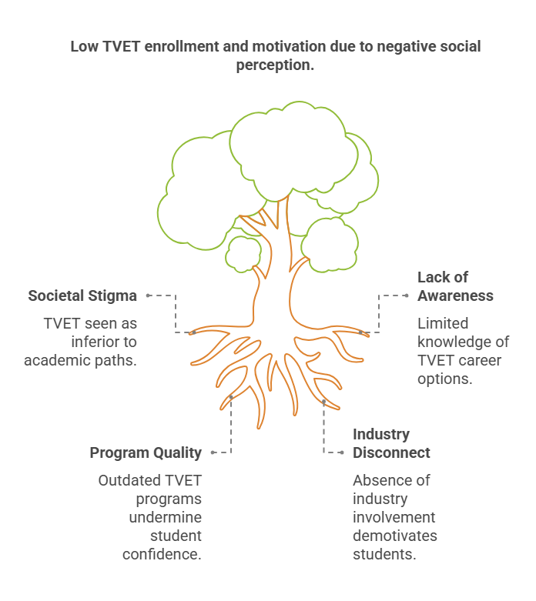
Figure 05: Low TVET enrollment and motivation due to negative social perception

5.6 Recommendations to overcome the challenges
Here are some key recommendations to overcome the challenges identified in mainstreaming TVET in Bangladesh:

- Create a single, empowered body to oversee and harmonize TVET policy, implementation, and monitoring across all relevant ministries and agencies.
- Need special annual development budget (Development & Revenue) for TVET development
- Need MPO system from government support of Private training service provider (TSP), like as the government's share in the payroll of the non-government educational institutions
- Institutionalize regular coordination mechanisms such as joint task forces or inter-agency councils to align efforts and reduce duplication.
- Ensure timely and adequate funding for infrastructure, faculty recruitment, curriculum development, and technological upgrades in TVET institutions.
- Offer tax incentives, subsidies, or co-financing models to encourage employers to participate in training delivery, internships, and curriculum development.
- Regularly review and update curricula in consultation with industry stakeholders to ensure alignment with emerging sectoral demands.
- Introduce structured professional development programs for instructors and recruit technically qualified trainers with industry experience.
- Mandate and facilitate structured internships, apprenticeships, and industry-based learning to provide real-world exposure for students.
- Use media and community outreach to promote positive perceptions of TVET, showcasing success stories and viable career paths.
- Establish guidance and counseling units in TVET institutions to help students make informed career choices and understand job market dynamics.
- Base financial distribution on needs assessments and performance metrics to address regional disparities and institutional gaps.
- Implement robust M&E frameworks to track outcomes, identify bottlenecks, and ensure continuous improvement of TVET programs.

6. Conclusion
The study on the challenges to mainstreaming TVET in Bangladesh has illuminated several key gaps between policy intentions and the realities of implementation. Even though there have been a lot of policy-level initiatives to support and advance TVET as a way to meet the country's skills development needs, there have been several obstacles in the way of these policies' actual implementation. To fully fulfill the promise of TVET in Bangladesh, a complex array of issues must be resolved, including the limitations found in governance, institutional capability, curriculum relevance, industry engagement, funding allocation, and societal views(Haolader & Shimu, 2024). At the governance level, dispersed and frequently redundant efforts have been the result of the lack of a centralized and coordinated organization to manage the diversified TVET landscape. The seamless implementation of TVET reforms has been hampered by the absence of interministerial cooperation and the inadequacy of enforcement authority of policy-making organizations(Cuenco, 2018). Significant resource restrictions, such as obsolete infrastructure, insufficient faculty, and financial limitations, have exacerbated these institutional difficulties and had a direct effect on the standard of instruction given to pupils. To guarantee that TVET graduates are employable, two significant obstacles have been the curriculum's relevance and the discrepancy between the skills taught and the demands of the labor market. Graduates are frequently unprepared to meet the needs of the labor market as a result of the strict, antiquated curricula and a lack of cooperation between training institutions and industry partners. Furthermore, many students lack real-world experience due to the inadequate integration of practical training, such as internships or apprenticeships, which further restricts their employment options. These difficulties are made worse by the problems with funding (development and revenue budget by Govt.) and resource distribution. The allocation of resources is still insufficient, with funds frequently being delayed or misallocated, despite the policy's goals to increase TVET and enhance quality. Many schools have been unable to update their facilities, hire competent personnel, or adopt contemporary teaching techniques as a result. The durability of TVET reforms is dubious because of the additional instability brought about by the reliance on donor finance. In Bangladesh, the unfavorable social attitude of vocational education is a major obstacle to mainstreaming TVET. For people who struggle in regular academic education, TVET is frequently viewed as a backup option. The system's overall efficacy is hampered by this stigma, which deters gifted kids from enrolling in TVET programs and demotivates those who do. Increasing student enrollment and motivation requires a change in public perspectives as well as more knowledge of the possible job options offered by TVET.To overcome these obstacles, a thorough and well-coordinated strategy is needed. The creation of a centralized authority for TVET oversight will help to guarantee that policies are executed more successfully by bolstering governance and policy coordination. To close the skills gap, more funding must be allocated to TVET infrastructure, faculty training, and curriculum reform. Furthermore, developing closer ties between TVET institutions and business would assist match training curricula to industry demands and give students real-world experience. Furthermore, the stigma attached to vocational education can be lessened by enhancing public attitudes of TVET through awareness campaigns and showcasing the achievements of TVET graduates. In order to see TVET as a respectable and worthwhile educational pathway that gives students not only employability but also chances for entrepreneurship and career growth, societal views must change. In conclusion, mainstreaming TVET in Bangladesh has several obstacles, however these obstacles are not insurmountable. Bangladesh can establish an efficient and long-lasting TVET system by tackling the systemic problems with governance, resource distribution, curriculum development, industry involvement, and social attitudes. By giving its workers the skills they need to succeed in a labor market that is becoming more competitive and international, such initiatives will support the country's economic progress.

References

Bhuiyan, Md. M. H., Dey, K. N., Saha, P., Sarker, P. K., Md. Halimuzzaman, & Biswas, Md. T. (2025). EXPLORING THE ROLE OF ARTIFICIAL INTELLIGENCE IN TRANSFORMING HR PRACTICES. International Journal of Business Management and Economic Review, 08(01), 98–110. https://doi.org/10.35409/IJBMER.2025.3646
Cuenco, G. C. (2018). Decentralizing TVET in a Federal Philippines. http://hdl.handle.net/1880/109316
Halimuzzaman, M., Wafik, M., Chakrabortty, P., & Mahbub, S. (2024). Public Relation and Educational Outcomes of Films in Bangladesh: A Study on Hawa. Journal of Primeasia, 5, 1–7. https://doi.org/10.25163/primeasia.519834
Haolader, F. A., & Shimu, S. S. (2024). A Comparison of National Qualifications Frameworks and Recognition, Validation, and Accreditation Mechanism of Informal Learning in Vocational Education and Training Among Selected Countries. In M. Pilz (Ed.), Informal Learning in Vocational Education and Training: Illuminating an Elusive Concept (pp. 363–382). Springer Fachmedien. https://doi.org/10.1007/978-3-658-44341-2_17
Harikirishanan, D. (2024). A critical examination of forging ‘industry-driven’ partnerships in Malaysian TVET institutions [Thesis, Heriot-Watt University]. https://www.ros.hw.ac.uk/handle/10399/5057
Imran, S., Kabir, N., Uddin, I., Ali, K., Halimuzzaman, M., Bank, I., Plc, B., & Swarupkathi, B. (2024). Consumer Behavior and Sustainable Marketing Practices in the Ready-Made Garments Industry. International Journal of Management Studies and Social Science Research, 6, 152–161. https://doi.org/10.56293/IJMSSSR.2024.5322
Imran, S. M. A., Islam, S., Kabir, N., Uddin, I., Ali, K., & Halimuzzaman, Md. (2024). Consumer Behavior and Sustainable Marketing Practices in the Ready-Made Garments Industry. International Journal of Management Studies and Social Science Research, 06(06), 152–161. https://doi.org/10.56293/IJMSSSR.2024.5322
Islam, Md. A., Goldar, S. C., Imran, S. A., Halimuzzaman, Md., & Hasan, S. (2025). AI-Driven green marketing strategies for eco-friendly tourism businesses. International Journal of Tourism and Hotel Management, 7(1), 56–60. https://doi.org/10.22271/27069583.2025.v7.i1a.125
Julius Kumi Egyir, P. D. A. (2022). Infrastructural Challenges and Student Academic Performance: Evidence from a Developing Nation. International Journal of Innovative Science and Research Technology.
Kgalema, V., Marock, C., & Allais, S. (2021). The Alignment of Black Economic Empowerment and Skills Policies in South Africa. https://hdl.handle.net/10539/33466
Leong, W. Y. (2024). TVET for All: Fostering Social Equity Through Inclusive Skills Education. 2024 International Conference on TVET Excellence & Development (ICTeD), 284–288. https://doi.org/10.1109/ICTeD62334.2024.10844604
Majola, E. (2024). Vocational Education and the Relentless Struggles of TVET Graduates in the Eastern Cape, South Africa: A Freirean Approach.
Mohammad Sarwar Hossain Islam, Mohammad Rabiul Basher Rubel, Mohammed Imam Hossain, Md. Kamruzzaman, Sathi Akter, Md. Halimuzzaman, & Mohammad Rezaul Karim. (2024). Impact of financial and internet support on SME performance: Moderating effect of technology adoption during COVID-19 pandemic. World Journal of Advanced Engineering Technology and Sciences, 13(2), 105–118. https://doi.org/10.30574/wjaets.2024.13.2.0533
Mujeri, M. K., & Mujeri, N. (2021). Structural Transformation: Theory and Global Evidence. In M. K. Mujeri & N. Mujeri (Eds.), Structural Transformation of Bangladesh Economy: A South Asian Perspective (pp. 13–44). Springer. https://doi.org/10.1007/978-981-16-0764-6_2
Omar, M., & Kamaruzaman, F. M. (2024). Technical and Vocational Education Training and Industry Collaboration: A Bibliometric Review. Journal of Education and Learning (EduLearn), 18(4), 1582–1592.
Palash Saha, M. S. (2025). Employee Motivation and Behavior in Construction Engineering Projects. International Journal of Social Science and Economic Research.
Panth, B., & Maclean, R. (Eds.). (2020). Anticipating and Preparing for Emerging Skills and Jobs: Key Issues, Concerns, and Prospects (Vol. 55). Springer Singapore. https://doi.org/10.1007/978-981-15-7018-6
Rahman, K. A. (2022). Interplays between English Teaching-Learning and Assessment Practice in Secondary Schools [Thesis, ©University of Dhaka]. http://reposit.library.du.ac.bd:8080/xmlui/xmlui/handle/123456789/1831
Rahman, M., Farooq, M. O., & Selim, M. (2021). Mitigating educated youth unemployment in Bangladesh. The Journal of Developing Areas, 55(1). https://muse.jhu.edu/pub/51/article/766446
Shimu, S. S., & Haolader, F. A. (2025). TVET is under-resourced and held in low regard? Teachers’ perceptions of TVET in Bangladesh. Education + Training, ahead-of-print(ahead-of-print). https://doi.org/10.1108/ET-12-2023-0551
Walcutt, J. J., & Schatz, S. (2019). Modernizing Learning: Building the Future Learning Ecosystem. In Advanced Distributed Learning Initiative. Advanced Distributed Learning Initiative. https://eric.ed.gov/?id=ED603521
Zancajo, A., & and Valiente, O. (2019). TVET policy reforms in Chile 2006–2018: Between human capital and the right to education. Journal of Vocational Education & Training, 71(4), 579–599. https://doi.org/10.1080/13636820.2018.1548500

