**Review Article**

**Economic, Environmental, and Management Perspectives on Soil Pollution and Sustainable Remediation Strategies**

**ABSTRACT**

**Background:** Soil pollution reflects a significant environmental challenge that impacts human health, ecosystems, and agricultural productivity. Confronting this challenge requires a comprehensive strategy that integrates economic, environmental, and management perspectives.

**Objective:** The aim of this study is to assess and identify economical, sustainable remediation techniques that reduce financial impacts and improve contaminated soil. Create management plans for soils that efficiently lower pollutant levels and integrate several remediation methods suited to particular contaminants and situations. This article provides a comprehensive examination of soil pollutants in addition to potential solutions, including Phytoremediation and Bioremediation.

**Key Findings:** Implementing cost-effective soil management strategies, treating wastewater, utilising bio-based biodegradable mulching, and employing hydroxyapatite (Hap) or combining various environmentally friendly remediation techniques can effectively reduce agricultural risks and minimise the costs associated with the contaminated soil treatment process.

**Conclusion:** addressing soil pollution requires a comprehensive strategy that mixes economic feasibility, environmental responsibility, and efficient management practices. Strategies for sustainable remediation provide to reduce pollution while simultaneously fostering a healthier ecosystem and promoting financial sustainability. By emphasising these viewpoints, parties involved can strive for a sustainable future.

**Keywords**: Bioremediation; Economic impact; Environmental management; Policy frameworks, Soil pollution; Sustainable remediation,

1. **INTRODUCTION**

One of the most vital components of human life is soil. Soil research is, therefore, one of our most crucial current and future duties. Due to human activity, soil is under threat each year, 9 million hectares of forests and 7 million hectares of agricultural land lost globally (Körschens, 2006). Soil is an important part of the ecosystem as its basis for biochemical cycle and growth of vegetation, hence, it is vital for food, feed, timber, and fiber production. Soil is a mixture of minerals that are inorganic materials and organic matter. Moreover, it is a habitat of much biodiversity, a gram of soil containing 6000 different bacteria, a wide range of nematodes, protests, mites, enchytraeids, and meters of fungal hyphae (Trap *et al.*, 2016). The health of soil is the function capacity of soil as a crucial living system. It assists plants and animals’ sustainable production, sustains or improves the quality of air and water, and enhances the health of plants and animals. Human activities (anthropogenic) influence soil health, quality, and components of soil, which, as a result, lead to polluting the soil (Doran and Zeiss, 2000). Soil pollution is a vital environmental issue, which can be defined as a decline in its production because of the presence of soil pollutants. These can have impacts on chemical, biological, and physical properties of soil that in turn reduce its production. Pollutants include different types of solid waste and chemical substances organic or inorganic (Mishra *et al.*, 2016). Agriculture, [deforestation](https://www.sciencedirect.com/topics/earth-and-planetary-sciences/deforestation), urbanization, industrialization and mining activities can also cause soil pollution directly or indirectly (Yaqub, 2024). The zero-pollution target that set by the European Union's soil strategy for 2030 states that pollution must be reduced in case of protection human health by 2050; therefore, prevention pollution is a priority (European Environment Agency, 2022). As demonstrated byRuzevicius (2009) maintained that environmental protection has become a crucial issue globally, for instance, protecting ecosystems, natural resources, plants and animals, human life, air, and water (Mohammed et al., 2020). Therefore, coordination and combination efforts of all international organizations and countries are needed instead of solving environmental problems by ecological activities of just some countries. Sustainability and environmental friendly soil management is becoming critical as global warming and climate change become more of a concern (Sirwan *et al.,* 2025). Even though the whole world is commonly on a warming trend, there is a huge change in weather patterns. Thus, the idea of sustaining is to be able to maintain or sustain an activity and the environment that surrounds the activity. Moreover, the main principle of sustainable development (SD). This is making social and economic development without serious impacts on environment (Khansa et al., 2022; Harun et al., 2018), as according to the world commission which known as Brundtland Commission (1987) who define SD as “development that meets the needs of the present without compromising the ability of future generations to meet their own needs” (Hameed, 2024; Burton, 1987). In addition, SD has been transformed from a sociopolitical into a principally economic concept and becomes incorporated into environmental management (Hameed et al., 2025; Neima et al., 2023; Williams, 2001). The definition of sustainability in terms of managing land should involve environmental, physical, and socioeconomic aspects (Palaniet et *al.,* 2025). To be sustainable, it needs to be economically viable for society generally and farmers especially, but without causing environmental degradation; therefore, to produce healthy food, it would require fertile soil (Hameed *et al.,* 2024; Hudhud *et al.,* 2015; Johnston *et al.*, 2009). Due to increasing population, the demand for agriculture, manufacturing and urbanization are increasing (Neima et al., 2023). In addition, the inhibition of degradation of the environment is important to move toward sustainable practices (Piñeiro *et al.*, 2020). Hence, sustainable agriculture is the application of adequate environmental management (Sirwan *et al.,* 2019). Sustainable agriculture is a type of production system that assists and conserves natural resources such as soil and creates the best utilization of non-renewable resources (Harun *et al.,* 2025; NAL, 2023). It is vital to protect the soil, as it is a crucial part of producing healthy and nutritional food. This article aims to illustrate the main reasons for soil pollution and suggest some possible solutions ((Salih *et al.,* 2019).

1. **Economic Perspectives on Soil Pollution**

**Costs of Soil Degradation**

Soil pollution leads to significant economic losses, including contaminated soils, loss of agricultural productivity, affecting food security and farmer incomes (FAO, 2021). Studies estimate that crop yields can fall by as much as 50% when soils are contaminated, which has resulted in millions of economic losses to farmers." Due to exposure to toxic pollutants such as heavy metals, there was a significant increase in medical expenses due to chronic diseases and increased health care expenses (WHO, 2022). In addition, the health impacts resulting from the contaminants in soil and the costs associated with the same places a heavy burden on public health systems. Soil remediations methods (e.g., excavation, bioremediation, chemical treatment) are costly, and the global remediation costs are estimated in billions annually (Khalid *et al.,* 2021). Overall, there is a strong economic argument that we should be investing in sustainable remediation to address soil pollution (Yaqub, 2024). It lowers both direct and indirect costs, enhances economic development, and is consistent with global sustainability objectives like SDG 15 (Life on Land) and SDG 3 (Good Health and Well-being).

Figure 1. showing the distribution of global plastic use by sector. The largest chunk made up of packaging at 36%, which is the biggest driver of plastic waste. Next is building and construction with 16%, and textiles at 14%. Consumer and institution products account for 10%, transport 7%, and electrical/electronic products 4%. The remaining 12% are classified as other uses. Commenting on the post, the caption read: "With over 400 million tonnes of plastic produced every year, it is packaging plastics, particularly plastic designed for single use such as a bottle of water, that are at the root of plastic pollution."

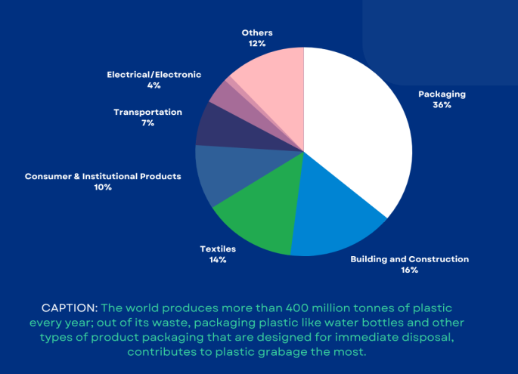

**Fig.1. Distribution of Plastic Usage by Industry**

Based on four scenarios, the estimated global direct costs of municipal solid waste management (in US$ billions, 2020 value) would reach 2050 as shown in fi9gure 4, for details please see (Hoornweg *et al.,* 2013). In 2020 the overall figure was $252.3 billion, including collection ($149.1B), landfill ($34.6B), waste-to-energy ($31.5B), recycling ($20.1B), and dumping ($17B). Under business as usual (2050 “Waste Management as Usual”) costs have soared to $417.3 billion, primarily as a result of the increased cost of collection ($243B) and inflation across all categories (with the exception of recycling which remains low). Under the “Waste Under Control” scenario, costs fall a bit to $394.0 billion. Collection costs are down to $230.7B, but recycling and landfill investments are up. The “Circular Economy” model presents another outcome. With less waste generation and more recycling, total costs fall to $254.6 billion near the 2020 baseline. For example, recycling shots up to $49.9B, collection falls to $154.4B and dumping disappea s. Key takeaways: A circular economy can reduce waste management costs and environmental impact by lessening waste generation and increasing recycling.

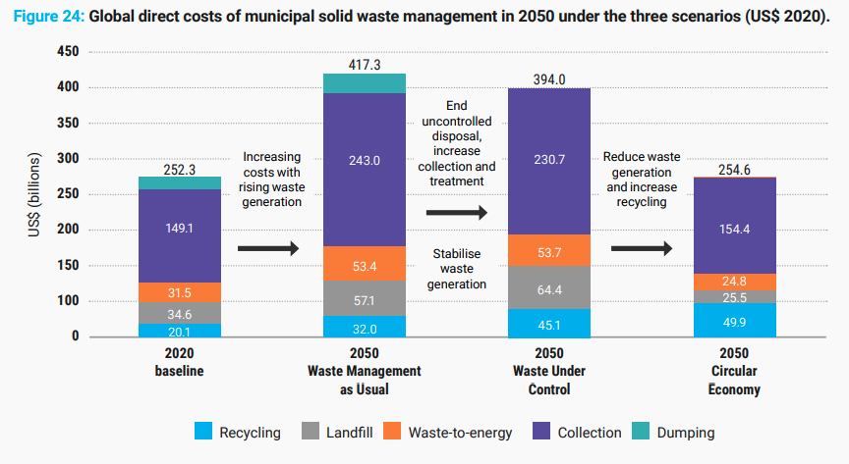

**Fig.2.** **Global direct costs of municipal solid waste management in 2050 under the three scenarios (USS 2020).**

**Economic Benefits of Sustainable Remediation**

While sustainable remediation strategies lack commercial value upfront, they can prevent long-term economic costs and promote public health and ecosystem services (Omar *et al.,* 2025). This increases markets for green technologies and services in soil remediation, and so creating jobs and stimulating economic growth. These sustainable remediation approaches (e.g. phytoremediation, biochar application) can save the costs in the longer run, thus better investment (Rahman *et al.,* 2021). According to recent findings Ali *et al. (*2020) lower operational costs compared to conventional methods. Increased land value post-remediation granting a boon to real estate and the agriculture sector (Salih *et al.,* 2025).

1. **Environmental Impacts of Soil Pollution**

The percentage of soil pollutants varies widely depending on the region, type of pollution, and land use. Soil pollution affects 20-25% of agricultural soils globally, with heavy metals, pesticides, and industrial chemicals contributing to 30-40% of contamination cases. Heavy metals, pesticides, and petroleum hydrocarbons account for 15-20% of contamination. Plastics and microplastics are growing concerns, and other pollutants are 5-10%. In some **heavily industrialized regions**, contamination can exceed **50%** (e.g., near mining areas, chemical plants, or untreated waste disposal sites). Table.1. sows the main sources of soil pollution (Yaqub, 2025).

**Table.1.** **Main sources of soil pollution and their approximate contributions.**

| **Source of Pollution** | **Estimated Contribution** | **Common Pollutants** | **Primary Impact Areas** |
| --- | --- | --- | --- |
| **Industrial Waste** | ~30% | Heavy metals (Pb, Cd, Hg), chemicals, solvents | Factories, manufacturing zones, dumping sites |
| **Agricultural Chemicals** | ~35% | Pesticides, herbicides, fertilizers (nitrates) | Farmlands, irrigation regions |
| **Mining & Smelting** | ~20% | Arsenic, lead, sulfur, radioactive waste | Mining regions, ore processing areas |
| **Urban Waste & Landfills** | ~15% | Plastics, micro plastics, heavy metals, e-waste | Cities, informal dumps, sewage sludge sites |

**Agriculture as a Source of Soil Pollution**

Overuse of pesticides, fertilizers, hormones, and antibiotics and using untreated wastewater for irrigation led to soil pollution. Toxic substances disrupt soil microbiota and harm plant/animal species (Rodríguez-Eugenio *et al.,* 2018).

**Using Chemical fertilizers and pesticides**

Agriculture practice is known to contribute to soil pollution via firstly applying chemical fertilizers and pesticides which are known as point source pollution, secondly diffuse pollution for instance atmospheric deposition and flood. Land pollution is closely related to air pollution and surface and groundwater pollution (FAO). Therefore, the sources for land pollution related to agriculture are wastewater for irrigation, pesticides and fertilizers, plastic materials (for example, polyethylene for mulching and greenhouse purposes, and empty packaging (FAO) As illustrated in Figure 1.

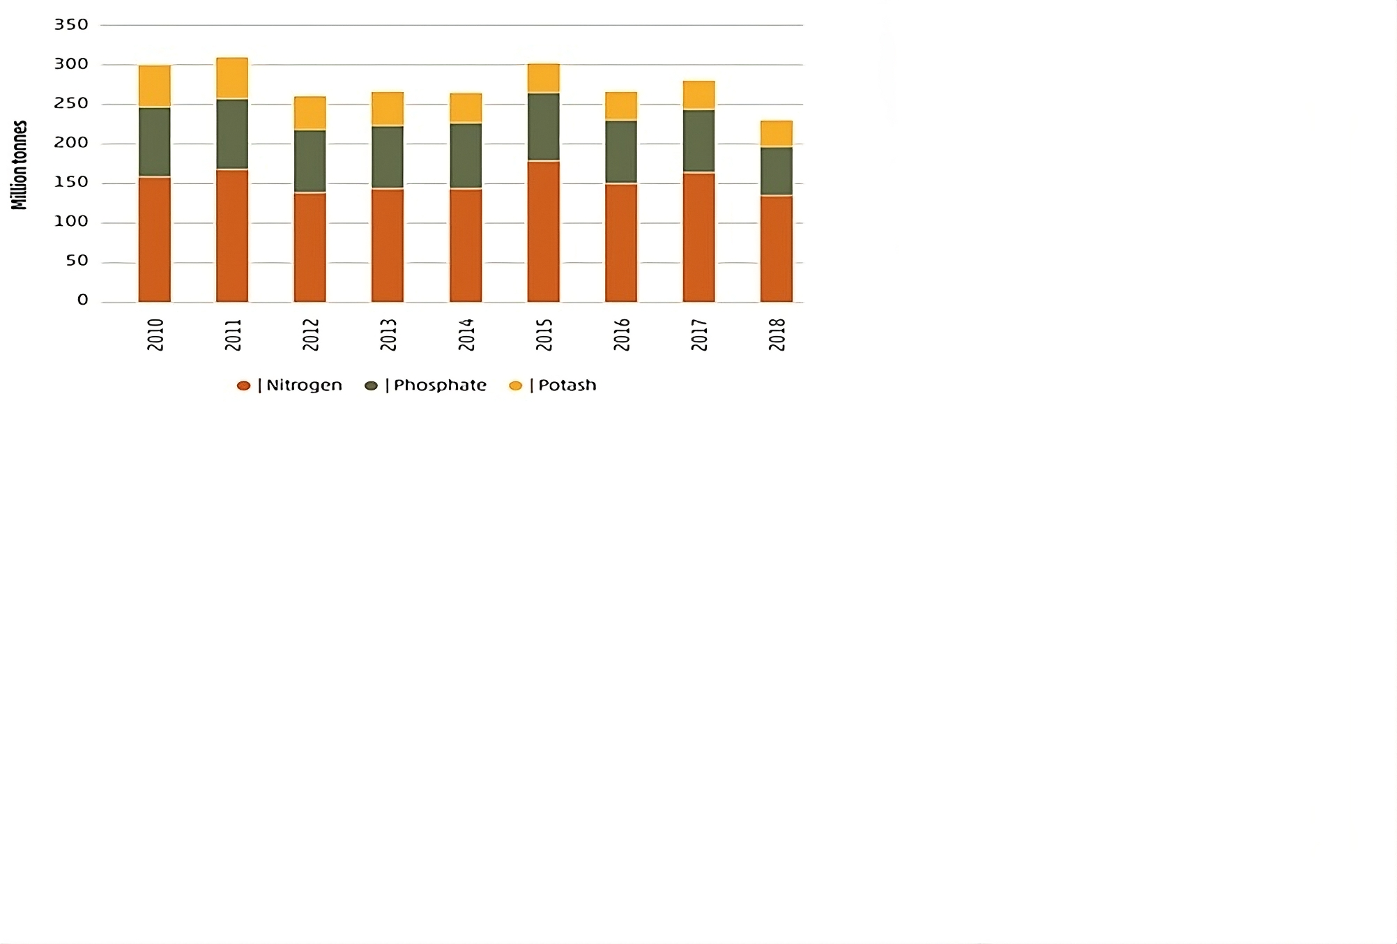

**Fig.3. global use of inorganic fertilizer in agriculture. Source: (FAOSTAT, 2020).**

As it is clear from the figure 3. a great number of chemical fertilizers is used in some countries and region which leads to the saturation of soil with nutrients and some of them runoff with rain water or water of irrigation which causes pollution of surface water and cause eutrophication, and some leaching and cause groundwater pollution. Furthermore, farmers use chemical fertilizers efficiently in developed countries, however, they are utilized in huge amounts in developing countries because of a lack of training (Ismaeel *et al.,* 2019; Rahman and Zhang 2018). This would go with the study that was achieved by Raheem *et al.* (2020), which illustrates that 93% and 99% of farmers use pesticides and chemical fertilizers, respectively, on their lands in Sulaimani.

**Agricultural plastic waste**

Recently, using plastic in agriculture has been increasingly adopted, such as using plastic for small tunnels, irrigation pipes and drippers, mulching films, fertilizers, and pesticide bags or containers. According to Briassoulis and Giannoulis (2018), using polyethylene mulching to maintain soil moisture, maintain soil temperature, decline in land compaction, and weed control is essential for reducing inputs of water, energy, and chemical substance, which in turn it assists to gain sustainable agriculture production. However, this plastic mulching is a non-biodegradable product that is a vital source of land pollution and has negative impacts on the environment and economy, as these plastics are required to be removed by farmers after each crop harvesting (Merino *et al.*, 2019). Hence, this mulching is left on the land or burned; in other words, it is not disposed of properly (Vox *et al.*, 2016). The research of Chae and an (2018); Lwanga *et al.* (2017), and Astner *et al.* (2019) demonstrate that microplastic (MPs) and nano-plastics (NPs) from polyethene mulch have negative effects on environmental and it can enter the food chain and cause to explore health disease.

**Wastewater for Irrigation**

Urbanization, increasing population, economic development, and enhancement of the quality of life led to a rise in the volume of wastewater that was produced by commercial, industrial, and domestic sources (Qadir *et al.*, 2010). Many farmers in developing countries are using untreated wastewater for the irrigation of their crops, particularly in areas close to the cities (Faruqui *et al.*, 2004; Qadir *et al.*, 2010; and Zia *et al.*, 2017). Wastewater has environmental and health consequences; for instance, irrigation with wastewater has the potential of accumulating organic contaminants and trace elements, it also causes the transmission of deadly pathogens. Such crops including vegetable crops are known to hold trace elements from untreated waste water and consumption of these crops can lead to serious human health problems (Zia *et al.,* 2017). Additionally, it may impact adversely the physical characteristics of soil. A second research conducted by Zwolak *et al.* (2019) that vegetables seriously polluted by heavy metals are grown around industrial-oriented area or adjacent to crowded roadway. Vegetables cultivated on lands irrigated with wastewater become highly plantations that are irrigated within these fields getting contaminated with heavy metals that actually accumulate in edible parts of these vegetables. We should not stop using the above due to the intentions we made for the buildup of heavy metals in the plants since but fertilization and plant protection agents also result in heavy metals buildup in the plants. Leafy and root vegetables should not be grown in contaminated soil, as they absorb heavy metals more easily than other vegetables.

**Solid Waste**

Waste generation is now a significant environmental challenge and a key contributor to various pollution sources, including health hazards, environmental degradation and ecosystem damage. According to Rashid *et al.* (2018), environmental, health, and aesthetic risks are substantially increased by municipal solid waste management methods, including open dumping, landfills, incinerations, recycling, and compaction. Poor management risks degrading soil, water, and air quality, and threatening the health of humans and animals. Solid waste is a major source of pollution, contributing to global warming. Solid waste is a major cause of ecological harm, health risks, and environmental deterioration (Hamasalih *et al.,* 2025). It creates land pollution, water pollution, marine pollution, groundwater pollution, air pollution, health risks, wildlife destruction, habitat loss, and aesthetic and economic consequences. Improperly operated landfills pollute soil with hazardous chemicals; leachate from rotting garbage seeps into the earth. Uncollected garbage draws insects and emits poisons that lead to cancer and neurological diseases (Ali *et al.,* 2024). Destruction of habitat threatens biodiversity; wildlife suffers from eating and entanglement. Among the ways to cut solid waste pollution are cutting, reusing, recycling, appropriate trash disposal, composting, encouraging biodegradable items, and increasing public awareness.

**Oil and its derivatives**

According to Yanxun *et al.*, (2011) and Pinedo *et al.* (2013), oil such as diesel, heavy oil, and gasoline is a main source of energy in modern society. With an increased population, the energy demand rises significantly (Neima et al., 2021). Nonetheless, oil can lead to soil and groundwater pollution through different leakage of oil. Moreover, it is becoming a main source of soil pollution, especially oil spillage in places of oil production, and areas in which equipment is serviced such as oil stations, transportation, and storage (tank). It can go down to the depth through the soil, and pollution will be more expensive and difficult to treat (Agbogidi *et al.*, 2005; Janipour, 2017; Pashkevich and Bykova, 2022). Furthermore, this kind of pollution has massive effects on water movement in the soil leading to a decrease in supply capacities and water infiltration (Salih *et al.,* 2019). In addition, oil pollution influences the chemical and physical characteristics of soil, which results in polluting soil and causes negative effects on plant growth (MARINESCU *et al*., 2011). A common environmental problem is crude oil contamination, which can come from both natural and man-made sources. Refineries, heating oil storage tanks, motor fuel stations, and unintentional spills are common sources (Saeed, 2025). The complex combination of hydrocarbons that makes up crude oil includes asphaltenes, resins, and aliphatic and aromatic hydrocarbons. A case study conducted in Perisoru, Braila County, examined the effects of contamination from crude oil on the physical and chemical characteristics of soil. The quantities of potassium, mobile phosphorous, C/N ratios, and organic carbon varied, according to the results. High pollution levels impede the development of crops. Petroleum compounds become more poisonous as their molecular weights fall (MARINESCU *et al.*, 2011). As shown in Figure 4.

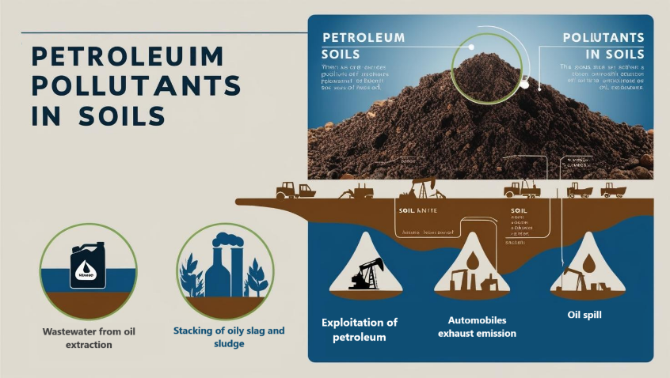

**Fig.4.** **Human exposure to pollution from oil extraction activities.**

Moreover, a major health danger is posed by heavy metal contamination in the environment and human body. An investigation of the presence of metals, particularly heavy metals, in the blood of workers producing crude oil was conducted in the Kurdistan Region in northern Iraq (KRI). The exposed group had at least a one-fold increase in metal concentrations compared to the control group, with a strong connection seen between the two groups values. Nonetheless, it is still necessary to evaluate the ecotoxicological and environmental significance of heavy metals in industrial settings (Sirwan, 2024; MARINESCU *et al*., 2011).

1. **Environmental Management in the Prevention of Soil Pollution**

According to Živković (2016), environmental management is a new scientific approach established in the ecology field at the end of the 20th century, which aimed to minimize the technological and technical effects on biotic and abiotic components of the environment. In addition, environmental management encompasses all human beings; some anthropogenic activities cause serious environmental impacts. in other words, some people are involved in utilizing resources, whilst others pay attention to pollution prevention and resource development (Sirwan and Harun, 2024; Živković and Veljković, 2020). Furthermore, there are different environmental management tools such as the Environmental Management System (EMS), Carbon footprint, Ecolabels, and Life cycle Analysis (LCA). These have advantages in sustainability and prevention of pollution in its different forms, for instance, soil pollution, water pollution, and air pollution. EMS provides a standard framework that can be used by an organization to improve its environmental performance (Hameed and Sirwan, 2019). This research, which was done by Mohammad pour *et al.* (2018), illustrates an adequate solution to decline the negative impacts of construction on the environment through EMS. The construction of an airplane has environmental impacts such as increased consumption of energy, expanding the residential areas, and increase in waste generation. Moreover, contamination of land, water, and air, and destroy of biodiversity, and cause noise pollution. For this reason, it is essential to bring under control with EMS (Environmental Management System) practices (Şen, 2022). A famous model of EMS is ISO the International Standard Organization (ISO), which is “continuous improvement,” a process of enhancing the EMS for improving environmental performance in agreement with the organization’s environmental policy (Živković and Veljković, 2020). The main aim of ISO 14001 (ISO, 2015) is to balance the protection of the environment and pollution prevention to the socio-economic needs (Rino and Salvador, 2017). Moreover, many researches demonstrate the benefits of applying an EMS depending on ISO 14001 for customers and companies, it delivers advantages market, operational, strategic, economic and environmental companies, and utilizing ISO certification as tool of marketing (Rino, 2017).

1. **Sustainable Remediation Strategies**

Emerging eco-friendly technologies include phytoremediation, bioremediation, nanoremediation, composting, , regenerative agriculture.

**Phytoremediation of Soil**

Recently the technique of phytoremediation considered sustainable, environmentally friendly, novel, cost-effective, promising, and solar-driven to eliminate heavy metals from the environment, depending on the plant's capacity to extract heavy metals from soil and water and accumulate them in different plant’s parts (fruit, stem, leaves, flowers, and root) without negative impacts on biological activities, soil fertility and structure (Gavrilescu, 2022; Kumar *et al.* 2022). The research done by Giordani *et al.* (2005) used some crops to absorb nickel. Therefore, beans appeared to be the most effective in nickel accumulation followed by barely, sorghum, and tomato. According to Moosavi and Seghatoleslami (2013) some 400 plant species from at least 45 plant families hyperaccumulate metals. Brassicaceae, Fabaceae, Euphorbiaceae, Asteraceae, Lamiaceae, and Scrophulariaceae are a few of the families. Very high bioaccumulation potential for Cd/Zn, Cu, Co, Se, and Ni is present in crops such as alpine pennycress (Thlaspi caerulescens), Haumaniastrum robertii, Ipomea alpine, Sebertia acuminate and Astragalus racemosus. Furthermore, Plante soil with Bassia scoparia (L.) demonstrates a great decline in the level of sulfur. It has the potential to remedy sulfur and petroleum hydrocarbons; hence it can be a helpful tool for remedying arid soil polluted by crude oil (Moubasher *et al.,* 2015). The current research that was done by Chen *et al.*, (2000) leads to the following conclusions: Chemical amendments such as calcium carbonate, steel sludge, and furnace slag may lower the amount of Cd present in wheat, Chinese cabbage, and brown rice. According to a combined analysis of the impact on plant yields and Cd concentration in plants, furnace slag is the most efficient (Zia *et al.,* 2025). According to preliminary findings, vetiver grass has a comparatively higher capacity to extract zinc, lead, and copper from soil; nevertheless, more research is required to determine the best way to handle the obtained materials. The problem of soil heavy metal pollution may be solved by integrating chemical treatment with phytoremediation. Also, The paper descriptively mentioned the latest technologies of phytoremediation soil contaminated with metals thriving on phytoextraction and phytostabilization in detail. Even with its disadvantages, these soils can be dealt with using innovative, new methods. This is not only profitable but also an ecosystem restorative approach owing to its association with the sustainable site management strategy of phytomanagement (Burges *et al.,* 2018). According to recent findings examined the principle of phyto-remediation of corn as a major crop to remediate lead and cadmium contaminated soiland it is a best plants for the accummulator type of plant in phytoremediation (Mojiri, 2011). Moreover, the study investigated the potential of nine common wild herbs (Cynodon dactylon, Silbyum mariaunum, Xanthium strumarium, Juncus effuses, Centaurea iberica, Echinops ritro, Onopordum acanthium, Akkoub guideline and Papyrus reeds) for their potential as phytoremediators in removing heavy metals from soil contaminated with Kwashe landfill leachate in the Kurdistan Region of Iraq (KRI). The results indicated that the Bioaccumulation Factor (BAF) outperformed the Bioconcentration Factor (BCF) in predicting the plants' efficacy. Although the highest value of BAF was obtained for Xanthium strumarium (Papyrus reeds), all plants were effective at bioaccumulating Chromium, Nickel, Cu, and Iron. Based on Liu *et al.,* (2018) ornamental plants are gaining more and more popularity and are even capable of phytoremediation for contaminated ground soils in urban areas. The ability of their resist organic pollutants and heavy metals adds their ecological and economic value

**Bioremediation of Soil**

Bioremediation is defined as the reduction, removal, transformation or degradation of pollutants or contaminants to less harmful compounds by the action of micro-organisms. Bioremediation is now accepted as a low-cost and environmentally friendly method for cleaning up contaminated land (Lynch and Moffat, 2005; Calvo *et al.,* 2009). In addition, Bioremediation is an eco-friendly, low-cost, and multiple-purpose technology to reclaim polluted soils. It minimizes health risks and maintains biodiversity. Costlier, ex-situ bioremediation approaches like bioaugmentation and biostimulation enable controlled treatment. But the expense of remediation is not the only consideration. Bioremediation as a solution is dependent on ranging factors such as the location of the contaminated area, bioremediation goals, effectiveness, cost, and public acceptance. Using a combination of techniques can augment effectiveness and negate individual weaknesses. When it comes to choosing the one method that suits your process the best, studies and planning are indispensable. In order to guide the development of suitable bioremediation methods and conserve the long-term stability of the terrestrial ecosystem, it is important to understand the diversity of microorganisms and metabolites with ability to decontaminate the environment (Sales da Silva *et al.,* 2020). According to a study by Ali *et al.,* (2020), oil-bioremediation in undiluted heaps was almost as successful as diluted ones when applied to desert soil that had been saturated with crude oil. Six months later, 53-63% of the oil was gone, while 14–24% remained. The primary contributors to the hydrocarbonoclastic bacterial populations in the wastes were Gordonia, Pseudomonas, Arthrobacter, Microbacterium, Micrococcus, Nocardioides, and Dietzia. D. papillomatosis demonstrated the highest tolerance, with the majority of isolates tolerating up to 20% oil. Moreover, a recently developed sustainable, affordable, and diverse feedstock-mediated carbon-rich by-product, known as "biochar," is a unique and multifunctional sorbent that can play a crucial role in the bioremediation of several highly hazardous petroleum refinery wastes containing various types of aliphatic, aromatic, and other complex hydrocarbons, as well as heavy metals, in contaminated soils. Because of its large surface area and micropores, which allow pollutants to be adsorbed on the surface, biochar is currently used as a carrier sorbent for a variety of microorganisms. These microorganisms stimulate the in-situ bioremediation of several hazardous polycyclic aromatic hydrocarbon (PAH) compounds and heavy metals. Biochar can be used both independently and in conjunction with manure compost to remove numerous dangerous contaminants from polluted soils. In addition, the research of Sharma *et al.*, (2020) reports that there is a clear relationship exists between agricultural soil fertility and heavy metal contamination. Because heavy metals are tenacious, they can be kept in the environment for a very long time, making their removal from soil extremely challenging. Heavy metal removal from the environment is accomplished by the employment of several in-situ bioremediation techniques. Among such, in-situ biochar application is a well-known heavy metal remediation technique that is successful in lowering the mobility of heavy metals in soils. In addition to reducing bioavailability and toxin-induced stress on the biotic component of soil, biochar efficiently absorbs heavy metals.

**Other Methods for Treatment Polluted Soil**

* It is very important to implement comprehensive management methods including policies, treatment, regulation, institutional dialogues financial arrangements and enhance awareness of the public generally and farmers particularly (Qadir *et al.*, 2010a). Therefore, it would decrease the agricultural risks. According to Qadir *et al.* (2010b) The reuse of water can have significant advantages if managed with environmental management and resource planning. As recommended by the study of Galib *et al.* (2018) that found that it is vital to treat wastewater before putting it in the canals or used for irrigation.
* Another solution for agricultural sources of soil pollution is Utilizing mulching film made of bio-based biodegradable that is eco-friendly, it assists in achieving sustainable practice. The study by Briassoulis and Giannoulis (2018) found that bio-based mulching has the same efficiency as non-biodegradable one, besides it does not release inadequate particles. Furthermore, it is essential to afford greater agricultural sustainability (Menossi *et al.*, 2021).
* As well as hydroxyapatite (Hap) can be another way to solve soil pollution. Hydroxyapatite (Hap) is a calcium phosphate biomaterial (Ca10(PO4)6(OH)2) and is called a biomaterial. It has a great advantage in the environmental management field, as it assists in the cleanup of water, air, and land. It has great capacities in ion exchange and adsorption, as well as base-acid adjustability (Ibrahim *et al.*, 2020).
* **Nanoremediation** or Nanoparticles (e.g., zero-valent iron) for targeted pollutant removal (Kumar *et al.,* 2021).

**6. DISCUSSION**

The integration of economic and environmental perspectives is crucial for addressing soil pollution. Policymakers must consider the long-term economic benefits of investing in sustainable remediation strategies. Additionally, public awareness and community involvement are essential for successful implementation.

**Implications for Policy**

Policies should incentivize sustainable practices in agriculture and industry, promoting the use of less harmful substances and encouraging the adoption of remediation technologies. Economic instruments, such as pollution taxes or subsidies for sustainable practices, can drive change. Effective soil management requires robust policies that enforce regulations on pollutants and promote sustainable practices.

**Stakeholder Engagement**

Involving local communities, businesses, and governments in decision-making ensures that remediation strategies are context-specific and widely supported.

**Monitoring and Assessment**

Ongoing assessment of soil quality and remediation effectiveness is essential for adaptive management, allowing for timely interventions and policy adjustments.

**Future Directions**

Future research should focus on developing innovative remediation technologies and assessing their economic viability. Long-term studies on the ecological impacts of various remediation strategies are also needed to inform best practices. Sustainable soil remediation requires a balance between economic feasibility, environmental protection, and effective governance. Future research should focus on:

* **Cost-benefit analysis** of emerging remediation technologies.
* **Public-private partnerships** for large-scale remediation projects.
* **AI and remote sensing** for real-time soil pollution monitoring.

Adopting integrated strategies will ensure long-term soil health, supporting global sustainability goals (SDG 15: Life on Land).

* 1. **CONCLUSION**

For human existence, food, feed, and the creation of fiber, soil is essential. Its qualities may be harmed by pollution resulting from human endeavors like mining, deforestation, and agriculture. The 2030 soil policy of the European Union seeks to cut pollution by 2050. Global environmental protection is a concern, and sustainable development includes social and economic growth without negatively affecting the environment. Food security is ensured by sustainable agriculture, which protects natural resources like soil. As a result, environmental management a scientific strategy to reduce the environmental effect of human activity can help accomplish it. Agriculture is one of the human activities that contributes to soil and air pollution. Developed nations use chemical fertilizers and pesticides efficiently, whereas poor countries use them excessively because of inadequate training. Additionally, mulching with polyethylene in agriculture lowers the amount of water, energy, and chemicals used, but it also pollutes land and has a detrimental influence on the ecosystem, which harms earthworms and the food chain. Additionally, untreated wastewater used to irrigate crops in underdeveloped nations has negative effects on the environment and human health. In addition, another human activity that can pollute soil and groundwater is the use of oil, a significant energy source. This can have an impact on plant development, water flow, supply capacity, and treatment costs. Among the options for resolution is the ecologically safe and sustainable method of removing heavy metals from the environment called phytoremediation. It depends on the plant's capacity to take up and remove metals without interfering with biological processes or soil fertility. Using biochar as part of bioremediation is an affordable and ecologically beneficial way to repair polluted soils, lower health risks, and protect biodiversity. Ultimately, reducing agricultural hazards and promoting sustainability may be achieved using hydroxyapatite (Hap), bio-based biodegradable mulching, wastewater treatment for irrigation, and complete management strategies.

**Reference**

Agbogidi, M. O., Nweke, U. F., & Eshegbeyi, O. F. (2005). Effects of soil pollution by crude oil on seedling growth of Leucaena Leucocephala (LAM) De Witt. *Global Journal of Pure and Applied Sciences*, *11*(4), 453-456.

Ali, N., Dashti, N., Khanafer, M., Al-Awadhi, H., & Radwan, S. (2020). Bioremediation of soils saturated with spilled crude oil. *Scientific reports*, *10*(1), 1116.

Ali, B., Nazari, F., Mustafa, K., Yaqub, K.Q. and Alyani, M.A., 2024. Impact of Trade Liberalization on Economic Growth in Developing Countries. *Bulletin of Business and Economics (BBE)*, *13*(2), pp.1128-1133.

Astner, A. F., Hayes, D. G., O'Neill, H., Evans, B. R., Pingali, S. V., Urban, V. S., & Young, T. M. (2019). Mechanical formation of micro-and nano-plastic materials for environmental studies in agricultural ecosystems. *Science of the Total Environment*, *685*, 1097-1106.

Briassoulis, D., & Giannoulis, A. (2018). Evaluation of the functionality of bio-based plastic mulching films. *Polymer Testing*, *67*, 99-109.

Burges, A., Alkorta, I., Epelde, L., & Garbisu, C. (2018). From phytoremediation of soil contaminants to phytomanagement of ecosystem services in metal contaminated sites. *International journal of phytoremediation*, *20*(4), 384-397.

Calvo, F. J., Bolckmans, K., & Belda, J. E. (2009). Development of a biological control‐based Integrated Pest Management method for Bemisia tabaci for protected sweet pepper crops. *Entomologia Experimentalis et Applicata*, *133*(1), 9-18.

Chae, Y., & An, Y. J. (2018). Current research trends on plastic pollution and ecological impacts on the soil ecosystem: A review. *Environmental pollution*, *240*, 387-395.

Chen, H. M., Zheng, C. R., Tu, C., & Shen, Z. G. (2000). Chemical methods and phytoremediation of soil contaminated with heavy metals. *Chemosphere*, *41*(1-2), 229-234.

Doran, J. W., & Zeiss, M. R. (2000). Soil health and sustainability: managing the biotic component of soil quality. *Applied soil ecology*, *15*(1), 3-11.

European Environment Agency, (2022). Available at: <https://www.eea.europa.eu/publications/zero-pollution/health/soil-pollution>. Accessed on 5/12/2023.

Food and Agriculture Organization of the United Nations (FAO) (2023). Source of Land Pollution. Available at [https://www.fao.org/3/cb4894en/online/src/html/chapter-03-3.html. Accessed on 5/12/2013](https://www.fao.org/3/cb4894en/online/src/html/chapter-03-3.html.%20Accessed%20on%205/12/2013).

Galib, S. M., Mohsin, A. B. M., Parvez, M. T., Lucas, M. C., Chaki, N., Arnob, S. S., ... & Islam, M. N. (2018). Municipal wastewater can result in a dramatic decline in freshwater fishes: a lesson from a developing country. *Knowledge & Management of Aquatic Ecosystems*, (419), 37.

Gavrilescu, M. (2022). Enhancing phytoremediation of soils polluted with heavy metals. *Current Opinion in biotechnology*, *74*, 21-31.

Hamasalih, I.K., Salih, A.M., Mohammed, B.A., Yaqub, K.Q., Ahmed, Y.A. and Palani, P.M., 2025. Attracting foreign direct investment is central to successful economic development and balance with environmental protection. *Int J Sci R Tech*, *2*(3).

Hamasalih, I. K., Salih, A. M., Sdiq, S. J. M., Yaqub, K. Q., Raheem, S. M., & Latif, A. D. (2025). Tanjaro River pollution and its impact on the aquatic food chain. *Science and Education*, *5*(3), 235-244.

Hameed, K. (2024). An exploration of entrepreneurship in agriculture: an initial framework for sustainable development in the Kurdistan Region-Iraq. Doctoral dissertation, University of Sulaimani, College of Agricultural and Engineering Sciences, Agribusiness and Rural Development Department.

HAMEED, K., HARUN, R., & FATAH, A. O. (2024). The Economic Sustainability of Industrial Potato Production Within Entrepreneurial Strategies. *Bulletin of the University of Agricultural Sciences & Veterinary Medicine Cluj-Napoca. Horticulture*, *81*(1).

Hameed, K., Sirwan, K., Omar, Z. O., Mohammed, E. F., Sourkan, S., Salih, A. M., & Yaqub, K. Q. (2025). Addressing the issue of Poverty, Economic Growth, Health Matters, and Environmental Challenges. *International Journal of Scientific Research in Modern Science and Technology*, *4*(3), 18-32.

Harun, R., Hameed, K., Sirwan, K., Ali, R. A., Sdiq, S. J. M., Rasul, H. I., ... & Yaqub, K. Q (2025). The Effect of Human Resource Management on Employees and Business Performance: An Environmental Perspective. Contemporary Research Analysis. *Perspective*, *2*(03-2025).

Hudhud, H. A., Shata, M. A., & Ismael, K. S. (2015). An economic study for the production of poultry meat in the province of Sulaymaniyah. *J. Agric. Econom. Social Sci*, *6*(2), 153-63.

Ibrahim, M., Labaki, M., Giraudon, J. M., & Lamonier, J. F. (2020). Hydroxyapatite, a multifunctional material for air, water and soil pollution control: A review. *Journal of hazardous materials*, *383*, 121139.

Ismaeel, K. S., Hamafarj, K. H., Harun, R., & Muresan, I. (2019). Productivity Gains from Training: The Views of Beekeepers in Sulaimani City. *ProEnvironment Promediu*, *12*(39).

Janipour, S. (2017). Soil Pollution and Ways to prevent it in the Management of Urban Space. *Journal of Research in Science, Engineering and Technology*, *5*(01), 9-13.

Johnston, A. E., Poulton, P. R., & Coleman, K. (2009). Soil organic matter: its importance in sustainable agriculture and carbon dioxide fluxes. *Advances in agronomy*, *101*, 1-57.

Khansa, H. A. M. E. E. D., SIRWAN, K., & SALAR, L. (2022). Tourists Attitude and Perception Toward Rural Tourism Development. *ProEnvironment Promediu*, *15*(50).

Körschens, M. (2006). The importance of long-term field experiments for soil science and environmental research–a review. *Plant Soil Environ*, *52*(Special Issue), 1-8.

Kumar, A., Tripti, Raj, D., Maiti, S. K., Maleva, M., & Borisova, G. (2022). Soil pollution and plant efficiency indices for phytoremediation of heavy metal (loid) s: two-decade study (2002–2021). *Metals*, *12*(8), 1330.

Liu, J., Xin, X., & Zhou, Q. (2018). Phytoremediation of contaminated soils using ornamental plants. *Environmental Reviews*, *26*(1), 43-54.

Lwanga, E. H., Gertsen, H., Gooren, H., Peters, P., Salánki, T., van der Ploeg, M., ... & Geissen, V. (2017). Incorporation of microplastics from litter into burrows of Lumbricus terrestris. *Environmental Pollution*, *220*, 523-531.

Lynch, J. M., & Moffat, A. J. (2005). Bioremediation–prospects for the future application of innovative applied biological research. *Annals of Applied Biology*, *146*(2), 217-221.

MARINESCU, M., Toti, M., TANASE, V., PLOPEANU, G., CALCIU, I., & Marinescu, M. (2011). The effects of crude oil pollution on physical and chemical characteristics of soil. *Research journal of agricultural science*, *43*(3), 125-129.

Menossi, M., Cisneros, M., Alvarez, V. A., & Casalongué, C. (2021). Current and emerging biodegradable mulch films based on polysaccharide bio-composites. A review. *Agronomy for Sustainable Development*, *41*(4), 53.

Merino, D., Mansilla, A. Y., Casalongué, C. A., & Alvarez, V. A. (2019). Performance of bio-based polymeric agricultural mulch films. *Polymers for agri-food applications*, 215-240.

Mishra, R. K., Mohammad, N., & Roychoudhury, N. (2016). Soil pollution: Causes, effects and control. *Van Sangyan*, *3*(1), 1-14.

Mojiri, A. (2011). The potential of corn (Zea mays) for phytoremediation of soil contaminated with cadmium and lead. *Journal of Biological and Environmental sciences*, *5*(13).

Moosavi, S. G., & Seghatoleslami, M. J. (2013). Phytoremediation: a review. *Advance in Agriculture and Biology*, *1*(1), 5-11.

Moubasher, H. A., Hegazy, A. K., Mohamed, N. H., Moustafa, Y. M., Kabiel, H. F., & Hamad, A. A. (2015). Phytoremediation of soils polluted with crude petroleum oil using Bassia scoparia and its associated rhizosphere microorganisms. *International Biodeterioration & Biodegradation*, *98*, 113-120.

Mohammed, A., Salih, A. and Raof, H., 2020. Vipulanandan constitutive models to predict the rheological properties and stress–strain behavior of cement grouts modified with metakaolin. *Journal of Testing and Evaluation*, *48*(5), pp.3925-3945.

Omar, Z.O., Hamasalih, I.K., Salih, A.M., Mohammed, K.S., Sdiq, S.J.M., Ali, S. and Ahmed, A., 2025. Gypsum Calcination in order to Clear Impurities and to Use Phosphogypsum at its Entire Cycle Microbial Bioremediation. *Int. J. Sci. R. Tech*, *2*(3).

Palani, P.M., Ahmed, Y.A., Yaqub, K.Q., Salih, A.M. and Mohammed, B.A., 2025. Rethinking economic growth: Integrating environmental constraints into growth theories.

Pashkevich, M. A., & Bykova, M. V. (2022). Methodology for thermal desorption treatment of local soil pollution by oil products at the facilities of the mineral resource industry. *Записки Горного института*, *253*, 49-60.

Pinedo, J., Ibáñez, R., Lijzen, J. P. A., & Irabien, A. (2013). Assessment of soil pollution based on total petroleum hydrocarbons and individual oil substances. *Journal of environmental management*, *130*, 72-79.

Qadir, M., Bahri, A., Sato, T., & Al-Karadsheh, E. (2010). Wastewater production, treatment, and irrigation in Middle East and North Africa. *Irrigation and Drainage Systems*, *24*, 37-51.

Qadir, M., Wichelns, D., Raschid-Sally, L., McCornick, P. G., Drechsel, P., Bahri, A., & Minhas, P. S. (2010). The challenges of wastewater irrigation in developing countries. *Agricultural water management*, *97*(4), 561-568.

Raheem, S. M., Neima, H. A., & Rasul, H. I. (2022). Challenges and Opportunities of Urban Solid Waste Management in Sulaymaniyah City. *Department of Agribusiness and Rural Development, College of Agricultural Sciences, University of Sulaimani, Iraq*.

Rahman, K. A., & Zhang, D. (2018). Effects of fertilizer broadcasting on the excessive use of inorganic fertilizers and environmental sustainability. *Sustainability*, *10*(3), 759.

Rahman, A., Khazini, L., & Salih, A. M. (2021). Origins of water pollution in Tanjaro River. Third National Congress of Chemistry and Nanochemistry from Research to National Development, 45–50.

Rashid, C., Tahir, J., & Mustafa, O. (2018). Solid waste management: a case study in Chamchamal (Dwbra Valley open dump), Sulaimani, Kurdistan Region. In *Proceedings of the 2nd International Conference of Natural Science 2017*.

Rino, C. A. F., & Salvador, N. N. (2017). ISO 14001 certification process and reduction of environmental penalties in organizations in Sao Paulo State, Brazil. *Journal of Cleaner Production*, *142*, 3627-3633.

Saeed, M.S., Salih, A.M., Ahmed, R.K., Hussein, H., Hama, Y.O. and Yaqub, K.Q., 2025. Amplifying Awareness: The Media's Role in Environmental Advocacy in Iraq. *Int. J. Sci. R. Tech*, *2*(3).

Sales da Silva, I. G., Gomes de Almeida, F. C., Padilha da Rocha e Silva, N. M., Casazza, A. A., Converti, A., & Asfora Sarubbo, L. (2020). Soil bioremediation: Overview of technologies and trends. *Energies*, *13*(18), 4664.

Salih, A., Williams, C. and Khanaqa, P., (2019). Heavy metal removals from industrial wastewater using modified zeolite: study the effect of pre-treatment. *Journal of Garmian University,* 6(2), pp.406-416

Salih, A. M., Williams, C., & Khanaqa, P. (2019). Synthesis of Zeolite Na-LSX from Iraqi Natural Kaolin using Alkaline Fusion Prior to Hydrothermal Synthesis Technique. *UKH Journal of Science and Engineering*, *3*(1), 10-17.

Salih, A.M., Abdulrahman, R.R., Hussein, H.H.S., Aivas, S.A., Yaqub, K.Q. and Latif, A.D., 2025. Characterization of natural zeolite and evaluation of its adsorption capacity. *British Journal of Interdisciplinary Research*, *2*(4), pp.31-47.

Scott, C. A., Faruqui, N. I., & Raschid-Sally, L. (2004). Wastewater use in irrigated agriculture: management challenges in developing countries. In *Wastewater use in irrigated agriculture: Confronting the livelihood and environmental realities* (pp. 1-10). Wallingford UK: Cabi Publishing.

Şen, G. (2022). Can A Green Business Strategy Be An Alternative to the Success of the Airport Environmental Management System?. *Journal of Aviation*, *6*(2), 241-250.

Sharma, G. K., Jena, R. K., Hota, S., Kumar, A., Ray, P., Fagodiya, R. K., ... & Ray, S. K. (2020). Recent development in bioremediation of soil pollutants through biochar for environmental sustainability. *Biochar applications in agriculture and environment management*, 123-140.

SIRWAN, K., & HARUN, R. (2024). The Value Chain and Sustainable Efficiency of Industrial Potatoes Through an Entrepreneur. *Bulletin of the University of Agricultural Sciences & Veterinary Medicine Cluj-Napoca. Horticulture*, *81*(1).

Sirwan, K., Hameed, K., & Neima, H. A. (2019). The Constrains and Challenges of Beekeeping in Sulaymaniyah Governorate, Kurdistan Region, Iraq. *Journal of Agricultural Economics and Social Sciences*, *10*(10), 569-572.

Sirwan, K., Hameed, K., Rasul, H. I., Salih, A. M., Mahmood, A. A., Sdiq, S. J. M., Raheem, S. M., Omar, Z. O., Muhamad, A. O., & Yaqub, K. Q. (2025). United States' monetary policy and climate action: How the US Federal Reserve supports renewable energy. Contemporary Research Analysis Journal, 2(3), 129–141. <https://doi.org/10.55677/CRAJ/03-2025-Vol02I03>.

Trap, J., Bonkowski, M., Plassard, C., Villenave, C., & Blanchart, E. (2016). Ecological importance of soil bacterivores for ecosystem functions. *Plant and Soil*, *398*, 1-24.

Yanxun, S., Yani, W., Hui, Q., & Yuan, F. (2011). Analysis of the groundwater and soil pollution by oil leakage. *Procedia Environmental Sciences*, *11*, 939-944.

Yaqub, K.Q., 2024. The role of oil revenue in shaping Iraq's public budget. *British Journal of Interdisciplinary Research*, *1*(2), pp.1-24.

Yaqub, K.Q., 2024. Volatility of Oil Revenue and the Real Exchange, Empirical Evidence from Iraq. *Education*, *4*(9), pp.1063-1072.

Yaqub, K.Q., 2025. Analysis of Nominal and Real Exchange Rates in the Iraqi Economy (1970-2013). British Journal of Interdisciplinary Research, 2(3), pp.17-41.

Zia, M. H., Watts, M. J., Niaz, A., Middleton, D. R., & Kim, A. W. (2017). Health risk assessment of potentially harmful elements and dietary minerals from vegetables irrigated with untreated wastewater, Pakistan. *Environmental geochemistry and health*, *39*, 707-728.

Zia, A., Ali, M.Z., Jamil, M.N., Mukhtar, Z., Yaqub, K.Q. and Javed, K., 2025. The Impact of Financial Monetary Economic Variables on Economic Growth. *Kashf Journal of Multidisciplinary Research*, *2*(01), pp.1-18.

Živković, S., & Veljković, M. (2020). The concept and objectives of environmental management. *Economics of sustainable development*, *4*(2), 37-47.

Zwolak, A., Sarzyńska, M., Szpyrka, E., & Stawarczyk, K. (2019). Sources of soil pollution by heavy metals and their accumulation in vegetables: A review. *Water, air, & soil pollution*, *230*, 1-9.