Original Research Article

Limberg Flap Procedure for Sacrococcygeal Pilonidal Sinus Disease

ABSTRACT
Sacrococcygeal pilonidal sinus disease is a common morbid condition. Several procedures have been described for its management with their merits and demerits. The present study was carried out to evaluate the efficacy and complications following Limberg flap reconstructive surgery. A total of 78 patients underwent Limberg flap procedure between March 2022 and March 2025. The local minor postoperative complications were flap edema in nine patients, seroma in eight, flap necrosis in five and wound sepsis in ten. These minor local complications nearly took 1-3 weeks to heal with regular dressing and antibiotic usage. Four patients develop wound dehiscence and took nearly six weeks for healing by secondary intention. Three patients developed recurrence at median follow-up of 22 months. Limberg flap procedure is an effective and reliable procdure if correctly performed.
Keywords- Limberg flap, Pilonidal sinus, Sacrococcygeal

1. Introduction:
Sacrococcygeal pilonidal sinus disease (PSD) affects especially the young males causing significant morbidity. The diagnosis can be made easily by observing epithelized follicle opening (sinus) in the natal cleft i.e., cleavage between the buttocks. The term pilonidal (L) meaning “nest of hairs”.
The incidence of PSD is 26 per 100000 and generally presents as a cyst, abscess, sinus tracts with or without discharge [1-3]. Males are commonly affected then females, both are rare before puberty and often after the age of 40 years [4]. Initially it was suggested that PSD could be of congenital origin but now it is widely accepted that it is of acquired origin. Hair follicles have never been demonstrated in walls of sinus, the projecting hairs from sinus are dead hairs, with their pointed ends directing towards the blind end of sinus. Karydekis suggested high quality of hair, extreme force and vulnerability to infection in the causation of disease [6]. A deep natal cleft is favorable environment for sweating, maceration, bacterial contamination and penetration of hairs. Other risk factors include obesity, local trauma or irritation, sedentary lifestyle, family history or bouncy ride.
The infection in relation to a hair follicle allows hair to enter the skin by the suction created by movement of the buttocks, so creating a subcutaneous acute or chronically infected midline abscess or tract. From the primary sinus, secondary tracts may spread laterally, which may emerge at the skin as granulation tissue-lined, discharging openings. Usually the sinus tract runs cephalad. The extensive disease with numerous pilonidal openings, branching tracts, and overt symptoms may require wide excision of the diseased region [7].
Recurrence in PSD is highly dependent on surgical procedure and follow-up time [8]. Varous techniques for management of PSD have been described: clipping of hairs with good hygiene, excision of tract with packing, excision and primary closure, marsupilization and flap techniques like Limberg flap [9], modified Limberg flap [10], oval rotation flap [11], Duformental flap [12], triangular closure technique [13], flag excision and flap procedure [14], and Karydaki’s procedure [15].
Amongst the flap reconstruction techniques, Limberg flap is most commonly used procedure with good results [7]. With this technique of rhomboid excision, there occurs flattening of intergluteal sulcus with much less hairy fasciocutaneous flap with less perspiration. The tension free repair can be made using a wide, well- vascularised flap. The present study was carried to evaluate results of Limberg flap technique in the management of PSD.

Materials and methods:
The present study involves 78 patients (63 males and 15 females), from March 2022 to March 2025 in the Department of Surgery at tertiary care center. The average age of patient was 25 (range 15-52) years.
Patients with only solitary opening and without branching tracts were excluded from the study. Patients with active sepsis were also excluded. Five patients came after having previous incision and drainage of pilonidal abscess and eight patients with recurrent pilonidal sinus were included in the study.

Procedure:
All patients were operated in prone position with buttocks strapped apart under spinal/general anesthesia. Initially methylene blue (1-1.5 ml) and hydrogen peroxide (0.5 ml) is injected into the sinus opening. A rhomboid area of skin and subcutaneous fat is excised, which includes both midline pits and any lateral sinus extensions (Figure 1). The long axis of rhomboid is in the midline and its shape is determined by angles of 60° at A and C and 120° at B and D. Accuracy is essential and the tissue to be excised and flap must be measured and marked at the start of the surgery. Planning using precise angles is difficult and following linear measurements are an alternative. The line A- C is drawn and its length measured. C should be adjacent to the perianal skin and A is placed so that all diseased tissue can be included in the excision. The line B-D transects the midpoint of A-C at right angles and is 60% of its length. It is this ratio that determines the correct shape of the rhomboid. The flap is planned so that D-E is a direct continuation of the line B-D and is of equal length to the incision B-A, to which it will be sutured after rotation. E-F is parallel to D-C, and equal length. After rotation, it will be sutured to A-D.
The skin and subcutaneous fat to be removed are excised including postsacral fascia. The flap is raised so that it includes skin, subcutaneous fat and fascia overlying gluteus maximus. The flap is based on superior gluteal and sacral perforators. It is then rotated to cover the midline rhomboid defect. The adhesive tapes are released to allow suture flap without tension. Stay sutures are taken at corner points. Deep absorbable sutures of 2/0 vicryl to include fascia and fat are placed over a vacuum drain and finally the skin is closed with interrupted sutures or staplers. This operation produces a tension free flap of uncovered skin in the midline (Figure 2)[16]. Antibiotics were given for 7-10 days initially intravenously and then orally. Suction drain was removed after 2-4 days. The sutures/staplers were removed on 10th- 12th postoperative day. The patient was advised not to put pressure on the flap for three weeks. The patients were assessed for postoperative complications, length of hospital stay and regular follow-up. The mean follow up was 22 months.

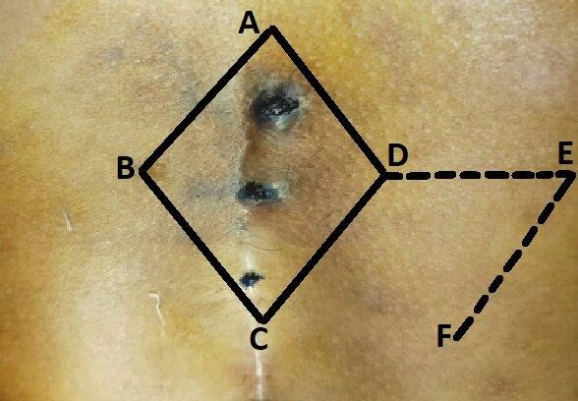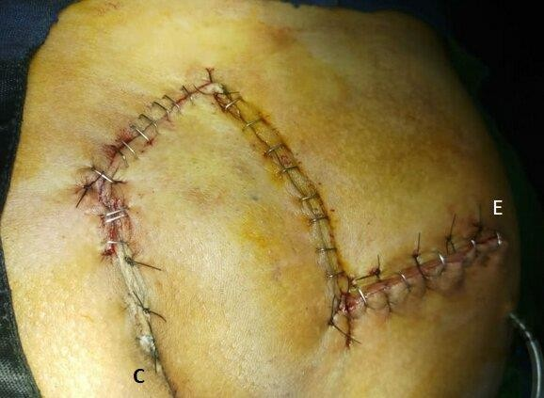
Figure 1 Figure 2
Flap marking Final appearance of Limberg flap
[A-C = Long axis after sutures and staplers
B-D = Short axis, 60% of A-C
D-E = B-A
E-F = D-C
Flap of C-D-E-F is mobilized on a pedicle of C-F]

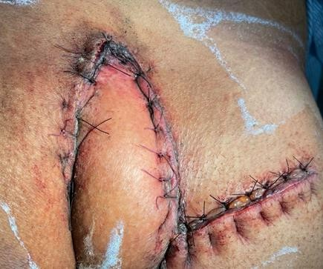
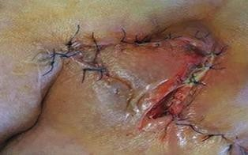
Figure 3 Figure 4
Limberg flap necrosis and flap edema Limberg flap wound dehiscence

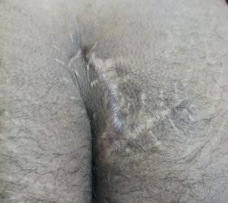

Figure 5
Scar mark after Limberg flap repair

Results:
In the present study 78 patients (63 males and 15 females) with mean age of 25 (range 15-52) years were included. Seventy three presented with discharge, 42 with pain, eight with recurrent PSD and five came after previous incision and drainage of pilonidal abscess.
The operative time ranged from 60 to 110 (mean 90) minutes. The hospital stay ranged from 72 to 96 hours. The pain score was in range of 2-8 with mean score 4.5.
Nine patients developed flap edema (Figure 3) which subsided of its own in two weeks. Seroma developed in eight patients which resolved in nearly eight days. Five patients developed flap necrosis (Figure 3) which required debridement and dressing and took nearly three weeks to heel by secondary intention. Four patients developed wound dehiscence (Figure 4) which healed with secondary intention over a period of six weeks.
None of the patients required readmission after initial surgical procedure. The mean time to return work was 20 (range 15-48) days. The histopathology report of all patients came as chronic non-specific inflammatory lesion except one whose report was low grade squamous cell carcinoma with free margins. Three patients developed recurrence at mean follow up of 22 months.

Discussion:
The sacrococcygeal PSD affects young population causing significant morbidity. The age incidence of PSD can be explained by the fact that only after puberty stiff body hairs appear and after middle age the hairs soften. The Negros with less and curly hairs are rarely affected by this disease which are ill adapted for a drilling effect [5].
The ideal surgical treatment should ensure minimum postoperative complications, short hospitalization, rapid return to normal activities, and better cosmesis with low recurrence rate at long term follow-up [7] [17]. The emphasis in surgical procedure should be flattening of natal cleft without midline closure of resultant defect and avoiding any wound scar in the depth of the fold. The fundamental objective in treatment of PSD is stopping of hair insertion [14].
The dead space at surgical site and in subcutaneous tissue as well as tension occurring in the skin may cause seroma, hematoma, dehiscence and infection. Minor early postoperative complications were seen in 18 patients which were treated using minimally invasive methods such as simple aspiration, drainage and antibiotics. The infection causing factors include increased bacterial colonization, wound close to anal canal, obesity, hygiene difficulties and humidity. Deep seated infections if overlooked at surgery can endanger flap viability. The postoperative pain is generally mild and can be managed by routine NSAIDs. However, we noted postoperative regional loss of sensation in five patients.
We observed flap necrosis in five patients. The flap necrosis is often a preventable complication if the tissue is handled gently when preparing the flap and care is taken not to impair the pedicular structures of the flap. When preparing flaps, do not damage the vascular structures by avoiding extensive dissection particularly in pedicular region [11].
We noted postoperative wound dehiscence in four patients. When these patients were questioned, nearly all of them stated that they performed improper exercises which may have caused the excessive strain in the region in early postoperative period and they have overlooked their local hygiene.

The term “recurrence” is defined as disease symptoms re-emerging a while after full recovery of wound [11]. Stauffer et al [8] analysed data from 139 non-randomised controlled trials and observed recurrence of 0.4% at 12 months, 1.6% at 24 months, 5.2% at 60 months and 11.4% at 120 months in Limberg flap procedure. They found steep increase of recurrence with longer follow-up. The follow-up of PSD patients should be always planned long term i.e. five or ten years if reliable conclusions are to be drawn regarding the efficacy of a new procedure or on the efficacy of your own results using an already known technique [8]. Due to decrease recurrence rates and shorter hospital stay Limberg falp can be employed in primary and secondary cases of complicated pilonidal sinus disease and also for sacrococcygeal recurrent pilonidal sinus disease [18] [19].

Conclusion:
Sacrococcygeal PSD is difficult task for both patient and treating surgeon. Following Limberg flap reconstruction after excision of pilonidal sinus, the patient gets relief from weeping and smelling bottom with little or no distortion of the contour of bottom. The procedure is quick to perform, useful both in primary and recurrent diseases with acceptable postoperative complication rate and can be easily mastered by general surgeons.

COMPETING INTERESTS DISCLAIMER:
Authors have declared that they have no known competing financial interests OR non-financial interests OR personal relationships that could have appeared to influence the work reported in this paper.

References:
- Humphires AE, James E. Evaluation and management of pilonidal sinus. Surg Clin North Am 2010;
90: 113-124.
- Sondenna K, Anderson E. Patient characteristics and symptoms in chronic pilonidal sinus disease. Int J Colorectal Dis. 1995; 10: 39-42.
- Hull TL, Wu J. Pilonidal disease. Surg Clin North Am. 2002;82: 1169-1185.
- Clothier PR, Haywood IR. The natural history of the postanal pilonidal sinus. Ann R College Surg England. 1984; 6 201-203.
- Brearley R. Pilonidal sinus: a new theory of origin. Br J Surg. 1955; 43:62-68.
- Karydakis GE. Easy and successful treatment of pilonidal sinus after explanation of its causative process. Aust N2 J Surg. 1992;62:385-389.
- Singh PK, Gohil RK, Saxena N. Limberg flap procedure for sacrococcygeal pilonidal sinus: a prospective study. Int Surg J 2017; 4: 2238-2242.
- Stauffer VK, Leudi MM, Kauf P, et al. Common surgical procedures in pilonidal sinus disease: A meta- analysis, merged data analysis, and comprehensive study on recurrence. Scientific reports. 2018;8: 3058:1-27.
- Althal SK, Rajan CS, Reddy N. Limberg flap for sacrococcygeal pilonidal sinus a safe and sound procedure. Indian J Surg 2013: 75: 298-301.
- Cihan A, Ulcan BH, Comert M et al. Superiority of asymmetric modified Limberg flap for surgical treatment of pilonidal sinus disease. Dis Colon Rectum. 2006; 49: 244-249.
- Karapolat B, Buyukakincak S, Kurnaz E, Kucuktula V. Comparision of Limberg flap and oval flap techniques in sacrococcygeal pilonidal sinus surgery. Turk J Surg 2018; 34:311-314.
- Yildan M, Cavdar F, Yildiz MK. The evaluation of a modified Dufourmental flap after S-type excision for pilonidal sinus disease. The Scientific World Journal 2013; Article ID 459147, 5 pages.
- Mutaf M, Temel M, Koc MN. A new surgical technique for closure of pilonidal sinus defects: Triangular closure technique. Med Sci Monit 2017; 23:1033-1042.
- Yucel E, Tezcan L, Yilmaz C, Akin ML. “Flag excision and flap” procedure. A novel modification for off- midline closure after pilonidal sinus excision. Indian J Surg 2015; 77 (Suppl 3): S1191-S1195.
- Kumar NA, Sutradhar P. Karydakis procedure for sacrococcygeal pilonidal sinus disease: Our experience. Indian J Plast Surg 2014; 47: 402-406.

- Farquharson M, Hollingshead J, Moran B. Farquharson’s textbook of operative general surgery. 10 th Ed. CPC Press, Taylor and Francis group, London, 2015 (10th edition), 456-458.

- Omar Abdeleraheem, Magdy Khalil, Comparative study between excision with primary closure versus Limberg flap for treatment of primary sacrococcygeal pilonidal sinus. October 2017. International Surgery Journal 4:3581-5.

- Ihan Bali et al;.Effectivenes of Limberg and Karydakis Flap in recurrent pilonidal sinus disease. May 2015: 70: 350-5.

- Bahadir Oz et al, A comparison of surgical outcome of fasciocutaneous V-Y advancement falp and Limberg falp for recurrent sacrococcygeal pilonidal disease. May 2017: 40:197-202.

