**Giant Cell Tumor of the Distal Ulna: A case report**

**Abstract**

Giant cell tumor is a rare tumor of mesenchymal origin, it is considered a benign tumor with locally aggressive characteristics and the ability to metastasize. This tumor typically arises in the epiphyseal regions of long bones, most often after the completion of bone growth. Localization at the distal end of the ulna is extremely rare and has therapeutic specificities.

We present a case of a giant cell tumor of the distal end of the ulna treated surgically by en bloc resection of the tumor with a favorable postoperative course. Through a review of the literature, we aim to analyze the epidemiological, therapeutic, and prognostic particularities associated with this uncommon site.

**Key words:**Giant cell tumor of bone, Distal ulna tumors, Wrist, surgery.

**Introduction :**

The giant cell tumor (GCT), previously referred to as "myeloplax tumor," is a benign osseous tumor, with malignant transformation occurring in less than 1% of cases (1). Distal ulnar localization is exceptionally rare, representing approximately 0.8% of all cases, according to Tomeno (2). GCT presents challenges in terms of recurrence and therapeutic management (3).

We present a case of GCT of the distal ulna in à 40-year-old patient.

The aim of this study is to explore the epidemiological, therapeutic, and prognostic dimensions of this pathology "

**Case report :**

We report the case of a 40-year-old patient, right-handed with no medical history, who presented whith a chronic painful left wrist evolving over a 10-month period with no history of trauma or infection. Clinical examination revealed a hard, immobile, and tender swelling at the distal end of the left ulna.. Mobility of the left wrist was limited and painful at the end of the stroke, with Pronosupination at (30°/150°); flexion at 70° and extension at 40°. There was no fever, no deterioration in general condition, and no local signs of inflammation or satellite adenopathy.

Radiological examination (figure 1a, figure 1b) shows a lytic lesion of the lower extremity of the ulna, blowing out the external cortex and invading the medial cortex.

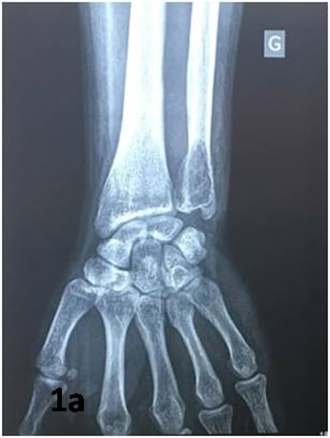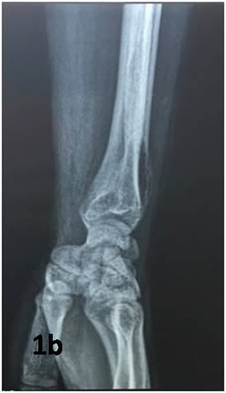

Figure 1: 1a : Left wrist X-ray frontal view, 1b : Left wrist X-ray lateral view

A CT scan of the left wrist revealed an expansive lesion in the inferior metaphysis of the distal left ulna, measuring 30 × 17 mm. The lesion was blowing out the bony cortex, which was locally breached, with discrete soft-tissue contrast but no obvious mass.  
MRI demonstrated a metaphyseal expansile process with intramedullary extension, slightly eccentric and predominantly posterolateral, associated with circumferential periosteal oedema and moderate effusion in the sheath of the ulnar extensor tendon (Figure 2: a, b, c, d).

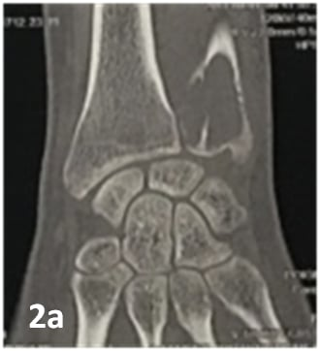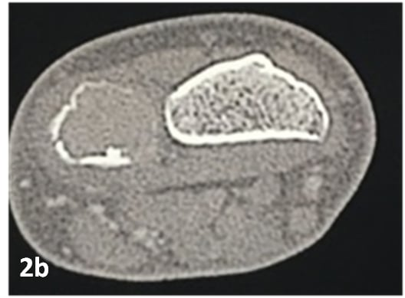

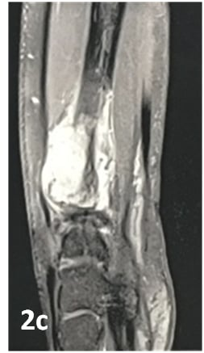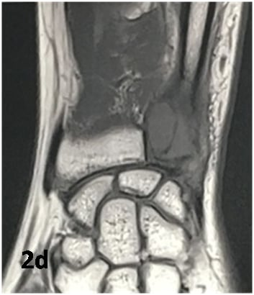

Figure 2: 2a: Frontal plane of a CT scan of the left wrist without PDC injection showing a centromedullary lesion that blows out the lateral bone cortex

2b : Horizontal section of a CT scan of the left wrist with PDC injection.

2c : Sagittal section of an MRI scan showing the tumor in a heterogeneous hypersignal pattern on T2-weighted sequences, strongly enhanced after injection of gadolinium.

2d : MRI of the wrist in T1-weighted sequences in frontal section shows a homogeneously hypointense inferior epiphysometaphyseal ulnar process.

In view of the clinic and radiological results, a giant cell tumour was suspected and confirmed by biopsy. Given the distal location of the tumour, we opted for resection of the distal ulna to achieve complete excision of the lesion (Figure 3a, 3b).

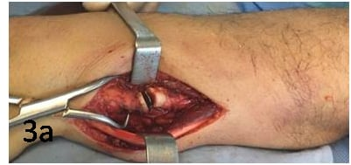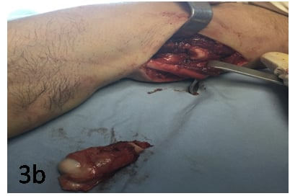

Figure 3: 3a : limits of tumor resection

3b :resection specimen.

Pathological examination confirmed the diagnosis of GCT. We noted no complication in the post-operative follow-up. The patient underwent a rehabilitation program and returned to work 3 months following the operation.

At a five-year-follow-up, no local recurrence was reported. Wrist function was restored, with better articular mobility (figure 4a, 4b, 4c).

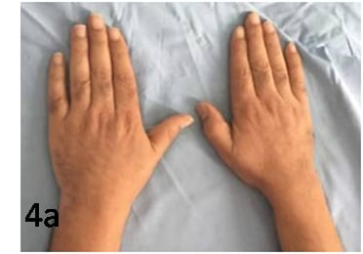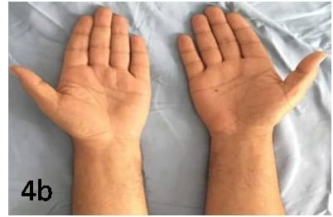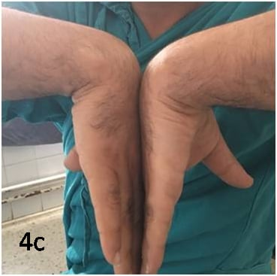

Figure 4: 4a: complete pronation 5 years postoperatively.

4b: complete supination 5 months postoperatively.

4c : flexion at 70°.

**Discussion**

The giant cell tumor (GCT) was initially described by Astley Cooper in 1818. But it was in 1940 that Jeff and Lichtenstein differentiated giant cell tumors as a separate entity from other bone tumors (2), (3). GCTs constitute 4-9.5% of all primary bone tumors, and 18-23% of benign bone tumors [4] [5]. The most common site is the knee, accounting for over 50% of cases (5). localization at the distal end of the ulna is extremely rare (0,45 a 3%) and has therapeutic specificities (6).

They are characterized by local aggressivity and unpredictable progression to recurrence or malignant degeneration, which occurs in 5-10% of cases. Giant cell tumors are solitary in over 99% of cases. Multifocal GCTs, either synchronous or metachronous, are relatively rare and poorly understood, as noted by Park et al. (7). These two possibilities must be considered when informing and monitoring patients with multifocal giant cell tumour (GCT). The tumor is observed in young adults, with a peak between 20 and 40 years, with a slight female predominance (5). GCTs are located in the epiphysis of long bones in the majority of cases, but may extend into the metaphysis without invading the articulation (5).

Clinical symptoms are non-specific and typically include bone pain, localized swelling, and restricted movement, in decreasing order of frequency. The discovery of a pathological fracture is seen in 10% of cases (2). X-rays are most often used to suggest the diagnosis. The typical appearance is pure metaphyseal osteolysis, eccentric to the axis of the bone. Osteolysis may extend across the entire width of the bone, often involving the subchondral bone (4). The classic multilocular honeycomb pattern is highly suggestive of the diagnosis. Cortical rupture, spicular periosteal reaction, Codman spurs and soft tissue invasion are seen in advanced or degenerated forms (8,9).

Campanacci et al (5) have proposed a radiographic classification, which considers the aggressivity of the tumour - our patient's tumour is classified as grade 3. Radiography also plays a part in extension evaluation, revealing pulmonary metastases, a rare evolutionary modality in GCTs. Depending on the series, their frequency varies from 1% to 6% (5). CT scan verifies cortical integrity and extension into the soft tissues, with visualization of a thin band of remaining periosteum surrounding the lesion, and its relation to articular cartilage.

Giant cell tumor poses the problem of recurrence and malignant degeneration (10, 11, 12).

Several therapeutic procedures have been used for the treatment of GCT: curettage, bone grafting, calcitonin (13, 14, 15) but often pose a problem of recurrence. At the level of the distal end of the ulna, bloc resection of the tumor despite its impact on wrist mobility gives better results. Thus, en bloc resection of distal ulna GCT is associated with a significantly lower recurrence rate compared to curettage and yields favorable functional outcomes. Given the higher risk of recurrence following curettage, patients should be thoroughly informed about the potential benefits and risks of opting for a joint-preserving procedure involving the distal radioulnar joint. Further more, reconstructions after tumor resection of the ulna head do not appear necessary. [Lenian Zhou](https://pubmed.ncbi.nlm.nih.gov/?term=Zhou%20L%5BAuthor%5D) demonstrated the superiority of en bloc resection of the ulna compared to the Sauvé Kapandji and Darrach procedures with a lower recurrence rate, but exposed to reduced wrist strength and pain due to instability of the ulna stump (16). This complication was raised by I. Mujaddid who proposed stabilization of the ulna stump by stabilization with the extensor ulnaris carpi tendon (17).

**Conclusion**

The location of giant cell tumors in the distal extremity of the ulna is an exception. GCT is easily diagnosed on imagery when the radiological appearance is typical.

Treatment is always surgical, to prevent recurrence and ensure good functional results. The choice of treatment method depends on a whole range of factors, including the aggressiveness of the tumour, its benign character and its site. Bloc resection of the distal ulna has a good results and little recurrence compared to other techniques.

**References**

1. Bertoni F, Bacchini P, Staals EL. Malignancy in giant cell tumor of bone. Cancer. 2003;97:2520–252).
2. Tomeno B, Langwin I, Forest M. Tumours à cellules géantes. EMC, App. Locomoteur 1980 ; 4030 : C30, 11.
3. Dahlin DC, Unni K. Bone tumors. General aspecs and data on 8542 cases. C. Thomas Publisher, ed Springfield (Illinois). 1986 ; 119-140 and 337-45.
4. Szendroi M. Giant-cell tumour of bone. J Bone Joint Surg Br 2004;86:5–12.
5. Campanacci M, Boriani N, Boriani S, Sudanese S. Giant-cell tumor of bone. J Bone Joint Surg Am 1987;69:105.
6. [Luka Đudarić](https://pubmed.ncbi.nlm.nih.gov/?term=%C4%90udari%C4%87%20L%5BAuthor%5D), [Gordana Ivanac](https://pubmed.ncbi.nlm.nih.gov/?term=Ivanac%20G%5BAuthor%5D) [Eugen Divjak](https://pubmed.ncbi.nlm.nih.gov/?term=Divjak%20E%5BAuthor%5D) [Čedna Tomasović Lončarić](https://pubmed.ncbi.nlm.nih.gov/?term=Lon%C4%8Dari%C4%87%20%C4%8CT%5BAuthor%5D) [Ojdana Petričević Krečak](https://pubmed.ncbi.nlm.nih.gov/?term=Kre%C4%8Dak%20OP%5BAuthor%5D) and [Boris Brkljačić](https://pubmed.ncbi.nlm.nih.gov/?term=Brklja%C4%8Di%C4%87%20B%5BAuthor%5D). Giant Cell Tumor of the Distal Ulna: Multimodal Radiological Investigation of a Very Rare Location. [Am J Case Rep.](https://www.ncbi.nlm.nih.gov/pmc/articles/PMC8279079/) 2021; 22: e932130-1–e932130-7.
7. Park YK, Ryu KN, Han CS, Bae DK : Multifocal, metachronous giant-cell tumor of the ulna. A case report. J Bone Joint Surg Am, 1999, 81, 409-413.
8. Kwon JW, Chung HW, Cho EY, Hong SH, Choi SH, Yoon YC, et al. MRI finding of giant cell tumors of the spine. AJR 2007;189: 246–50.
9. Semlali, S., Malajati, H., Eddarai, M., Amil, T., Bousselmame, N., Akjouj, S., & Chaouir, S. (2012). Les tumeurs à cellules géantes de l’os. Feuillets de Radiologie, 52(3), 131–146.
10. Rock MG. Curettage of giant cell tumor of bone : factor influencing local recurrences and metastasis. Chir Organi Mov 1990 ; 75 (suppl. 1) : 204-5.
11. Bertoni .F, Present .D, Enneking .W.F. Giant-cell tumor of bone with pulmonary metastases. Journal of bone and joint surgery, 1985, 67 A, 6 : 890 – 900.
12. [Sandeep Kumar Yadav](https://pubmed.ncbi.nlm.nih.gov/?term=Yadav+SK&cauthor_id=38350706) , [Rajesh Kumar Rajnish](https://pubmed.ncbi.nlm.nih.gov/?term=Rajnish+RK&cauthor_id=38350706) , [Vimal Prakash](https://pubmed.ncbi.nlm.nih.gov/?term=Prakash+V&cauthor_id=38350706). [Aasma Nalwa](https://pubmed.ncbi.nlm.nih.gov/?term=Nalwa+A&cauthor_id=38350706). Malignant giant cell tumour of distal ulna. BMJ Case Rep. 2024 Feb 13;17(2):e258047.
13. Bini SA, Gili K, O’Johnson. Giant cell tumor of bone : curettage and cement reconstruction. Clin Orthop 1995 ; 321 : 245-50.
14. Nouri H, Hedi Meherzi M, Ouertatani M, Mestiri M, Zehi K, Douik M, Zouari M. Calcitonin use in giant cell bone tumors. Orthop Traumatol Surg Res. 2011 Sep;97(5):520-6. doi: 10.1016/j.otsr.2011.03.019.
15. Ayerza MA, Aponte-Tinao LA, Farfalli GL, Lores Restrepo CA, Muscolo DL. Joint preservation after extensive curettage of knee giant cell tumors. Clin Orthop Relat Res 2009;467: 2845–51.
16. [Lenian Zhou](https://pubmed.ncbi.nlm.nih.gov/?term=Zhou%20L%5BAuthor%5D) [Juan Tang](https://pubmed.ncbi.nlm.nih.gov/?term=Tang%20J%5BAuthor%5D),[Longxiang Shen](https://pubmed.ncbi.nlm.nih.gov/?term=Shen%20L%5BAuthor%5D),[Zhichang Zhang](https://pubmed.ncbi.nlm.nih.gov/?term=Zhang%20Z%5BAuthor%5D),and [Ting Yuan](https://pubmed.ncbi.nlm.nih.gov/?term=Yuan%20T%5BAuthor%5D). Giant cell tumors of the distal ulna: long-term recurrence rate and functional outcomes of en blocresection versus curettage in a multicenter study. [J Orthop Surg Res.](https://www.ncbi.nlm.nih.gov/pmc/articles/PMC10544164/) 2023; 18: 743.
17. Mujaddid I, Pamudji U, Savero I, Handry T, Brian W. Wide resection giant cell tumor of distal ulna and stabilization ulnar stump with extensor Carpi ulnaris tendon (2 case reports). Int J Surg Case Rep. 2020;74:58-62.