An Epidemiological Observation for the cases of lipoma in the Surgical Departments

Abstract

Background: lipomas are the most common forms of benign soft tissue tumors. they occur as various-sized lumps that rarely transform into malignant tumors. they form as a result of a focal hypertrophy of adipose cells and are usually located subcutaneously. generally, they are palpable through the covering tissues, soft to the touch, round or oval, painless, usually movable and covered with unchanged skin. they remain mostly asymptomatic and therefore are ignored by both patients and general practitioners. nevertheless, growing lipomas may cause problems, mainly esthetic. however, in advanced stages, their surgical removal may even require general anesthesia The present study aimed to study the incidence of lipoma with respect to age, gender, site and other parameters.
Objective: To evaluate the incidence and peaks of age, the gender commonly affected, the most common site and the extent of depth.
Methods: This retrospective study was conducted to include cases during (2020-2021) It included cases attending Al jala hospital, Benghazi, Libya.

Results: The mean age was (45), males outnumber the females, superficial lipoma more common than deeply seated lipoma. Back was the most common site and usually the treatment is one-day surgery.
Conclusion: Lipoma is common in different age groups predominately adult males; it is a benign condition that usually takes one-day surger
Introduction
Lipoma is the commonest soft-tissue tumour and may occur in almost any organ of the human body. The solitary subcutaneous lipoma alone accounts for one quarter to one half of all soft tissue tumors (Stout 1953, Kirchner & Wiinsch 1981, Myhre-Jensen 1981), whereas subfascial (intra- or extramuscular) lipomas have been considered to be rare (Bick 1936, Myhre-Jensen 1981). Angiolipomas and multiple subcutaneous lipomas have been described as separate entities (Howard & Helwig 1960, Berendes 1974) but are, in most reports, not separated from simple solitary lipomas. )Anders R & Nils O. Berg 1983) The majority of lipomatous lesions are benign and they are characterized by slow growth; they are composed of mature adipose tissue organized into lobes, which is, in turn, surrounded by fibrous capsules (El-Monem MHA et al.,2006). They occur most often in the 5th to 6th decade of life (Ahuja AT et al., 1998) and are usually sporadic. However, they may be associated with syndromes such as hereditary multiple lipomatosis, Gardner syndrome and Madelung’s disease, among others (Felipe Aluja J. et al 2016). Subcutaneous lipomas are the most common presentation (supported by this current study and others). They present as soft, subcutaneous, oval or round nodules that are palpable and covered by normal skin. They are painless and movable. they mostly occur on the neck, upper back, arms, abdomen and thighs. Small-size lipomas usually do not present symptoms but, when they grow larger, may cause problems, especially aesthetic ones. (Sitarz r et al. 2018). The etiology of lipomas in general is unknown. Possible theories implicate obesity, trauma, and genetics as contributing to their formation (El-Monem MHA et al.2006). Lipomas are more common in obese individuals (Fornage BD & Tassin GB. 1991) Although tumor size may increase with weight gain, tumor size does not decrease during periods of weight loss (Kim, K.-H et al. 2021). Two explanations linking trauma to lipoma formation exist. One is that inflammation following trauma may induce lipoma formation through the release of growth factors and cytokines (Grivas TB et al 2009) The other is that necrosis of fatty tissue may cause pre-adipocytes to differentiate and form lipomas. Finally, there may be a genetic component to lipoma formation. Individuals that present with multiple lipomas often report a positive family history (Nadar MM et al. 2010). Familial cases of angiolipomas, a variant of lipomas, have reported an autosomal dominant inheritance. Studies in cytogenetics have linked translocations and inversions involving regions 12q13–15and 6p13q to lipoma formation anywhere on the body (Fornage BD & Tassin GB. 1991). The incidence of lipomas is also boosted in patients with obesity, dyslipidemia mitochondrial dysfunction and endocrinopathies such as nodular goiter, diabetes mellitus and Cushing’s syndrome. Considerable reports of long-term immunosuppression (especially corticosteroid therapy) association with the development of lipomas have been stated. (Tabatabaei, S. A. (2023). Familial multiple lipomatosis (FML) is a condition in which patients develop multiple lipomas. Most of-ten lipomas appear in the third decade of life and their number increases until the fifth decade; numerous lesions develop gradually on the extremities and trunk. A clinical diagnosis is made based on an evaluation of the family pedigree and the presenting symptoms of the disease in its members (Gologorsky D et al.2007) Another disease with autosomal dominant inheritance accompanied by lipomas is multiple endocrine neoplasia type 1 (MEN 1) – a genetic disease predisposing to parathyroid, pancreatic, and pituitary tumors. We can observe both multiple and solitary lipomas as one of the skin lesions found in these patients (Asgharian B et al.2004). Lipomas in autosomal recessive disorder is included Wilson’s disease. Schaefer et al. detected subcutaneous lipomas in 21 of the 80 patients examined, with 16 cases involving multiple subcutaneous lipomas. The higher prevalence of lipomas did not associate with the severity of the disease, its presentation, or anti-copper therapy. They suggested that subcutaneous lipomas may be considered a clinical sign that could facilitate the diagnosis of this disease in some cases (Schaefer M et al. 2015). Lipomas belong to benign lipomatous neoplasms and are coded 2E80.0 according to the International Classification of Diseases 11th Revision effective of 1 January 2022. ( Marzyńska, D etal. 2023). Typically, a lipoma consists of mature adipocytes surrounded by a fibrous capsule and present as painless, slow growing, mobile masses, well-circumscribed and do not invade local structures. (Lichon, S., & Khachemoune, A. 2018). Most lipomas enlarge slowly, and their presence does not cause any symptoms. The complications caused by lipomas are due to the mass effect and their pressure on surrounding structures. For instance, intracranial lipomas may cause diplopia, hydrocephalus, seizures, hearing impairment, and vertigo (Özkul E et al. 2021). A lipoma compressing the superior vena cava can lead to edema of the head, neck, and upper limb, as well as pain and numbness Additionally, chest lipomas can be responsible for shortness of breath, coughing, haemoptysis, and even angina and heart failure (Ahuja AT et al. 1998). In other reported cases, gastric lipomas have caused pain, nausea, vomiting, and gastrointestinal bleeding. (Marzyńska, D.,2023). To assist with clinical diagnosis, ultrasound, computed tomography (CT), or MRI may be utilized. Generally, ultrasound may provide the most rapid assessment and can be used if a patient cannot tolerate an MRI. However, CT and MRI provide a more detailed three-dimensional picture of the tumor in relation to local neurovascular structures (Özkul E. et al 2021) One study reviewed 134 cases of soft tissue masses in the hand and wrist, and found that the MRI correctly diagnosed 94% of the cases (Rotunda AM. Et al 2005). Lipomas do not regress spontaneously. Unchanging lesions often are observed without intervention. The majority of the patients desire treatment for lipomas due to cosmetic reasons. However, the decision to employ surgical excision relies on considerable factors, including size of lesion (especially in cases with the size of greater than 10 cm), rapid growth, location, patient comorbidities and symptoms such as pain or itching. liposuction is an alternative removing strategy for large lipomas. Complete surgical excision of the capsule and lobules is recommended for a better outcome (Lichon, S., & Khachemoune, A.2018). Liposuction and lipolytic injection therapies are used in the management of lipomas. Employing injections of Prednisolone (a corticosteroid agent) and isoproterenol (a β-2 adrenergic agonist agent) in combination is also a modality of treatment that induces the lipolysis and decreases superficial subcutaneous lipoma’s volume by 50% over 4 weeks in addition to the ease of post-injection surgical removal. Furthermore, intralesional phosphatidylcholine and deoxycholate have been employed to shrink tiny lipomas (Rotunda AM et al 2005). Aims of the study are:
1-Find out the incidence and peak of age of lipoma
2-Find out the sex distribution
3- Analyze the incidence of site according to sex.
4-Analyze the recurrence rate versus first time presentation.
5-Analyze the incidence of the depth according to sex.
6-Analyze the circumstances of the surgical treatment, one-day surgery or not.

Materials and Methods
The study was conducted in Al jala hospital, City of Benghazi – Libya. It included the cases visited the surgical clinic during (2020-2021) and diagnosed clinically and histopathologically as cases of lipoma. Information regarding cases were retrospectively gathered from the patent’s archives with respect to privacy. A total number of 70 cases.
The data analyzed with the next consideration: age, sex, site, depth of the lesion, recurrence rate and days of the admission.

Statistical analysis: The whole data were evaluated statistically by using SPSS which has also been applied along with Microsoft word to make tables, graphs, pie diagrams, etc.
The clinical data so received were evaluated. A comparison with other similar studies was done.

Results
A total number of 70 cases included in the study, during two years (2020-2021). The mean age was 45 years, the maximum 78 years and minimum 20 years old. (Table no.1). The peak of age (42-53) years, see (Figure 1)

Descriptive Statistics (Age Deviations)
 | N | Minimum | Maximum | Mean | Std. Deviation
Age | 70 | 20.00 | 78.00 | 45.0143 | 13.49019
Valid N (listwise) | 70

Table no.1: Minimum and maximum age

Figure 1. Age distribution and peak of age groups

In this current study, there was male predominance, male patients were 46 (65.71%), while females were 24 (34.28%). (Table no.2) (Figure 2.)

Descriptive Statistics (Sex)
Sex |  | N | Mean | Std. Deviation | Sex
female  male  Total | 24 | 40.8333 | 13.32101 | female | 24
female  male  Total | 46 | 47.1957 | 13.19700 | male | 46
female  male  Total | 70 | 45.0143 | 13.49019 | Total | 70

Table no. 2. Sex distribution of the cases

Figure 2. Sex distribution of the cases

In this study 10 sites of lipoma determined as variables (axillary, back, chest, face, flank, hand, inguinal, neck, shoulder, thigh) and they were distributed according to sex in the following table (Table no. 3)
Descriptive Statistics (Site distribution according to sex)
(Site * Sex Crosstabulation)
 |  |  | Sex |  | Total
 |  |  | female | male | Total
Site | axillary | Count | 1 | 0 | 1
Site | axillary | % within Sex | 4.2% | 0.0% | 1.4%
Site | back | Count | 5 | 18 | 23
Site | back | % within Sex | 20.8% | 39.1% | 32.9%
Site | chest | Count | 3 | 2 | 5
Site | chest | % within Sex | 12.5% | 4.3% | 7.1%
Site | face | Count | 1 | 4 | 5
Site | face | % within Sex | 4.2% | 8.7% | 7.1%
Site | flank | Count | 2 | 5 | 7
Site | flank | % within Sex | 8.3% | 10.9% | 10.0%
Site | hand | Count | 3 | 3 | 6
Site | hand | % within Sex | 12.5% | 6.5% | 8.6%
Site | inguinal | Count | 1 | 1 | 2
Site | inguinal | % within Sex | 4.2% | 2.2% | 2.9%
Site | neck | Count | 3 | 7 | 10
Site | neck | % within Sex | 12.5% | 15.2% | 14.3%
Site | shoulder | Count | 3 | 0 | 3
Site | shoulder | % within Sex | 12.5% | 0.0% | 4.3%
Site | thigh | Count | 2 | 6 | 8
Site | thigh | % within Sex | 8.3% | 13.0% | 11.4%
Total |  | Count | 24 | 46 | 70
 |  | % within Sex | 100.0% | 100.0% | 100.0%

Table no. 3 Site×Sex Crosstabulation

Regarding whether the lipoma was primary vs recurrent, the following table reveals this according to the sex distribution. (Table no.4)
Descriptive Statistics (Primary× Recurrent lipoma according to sex)
Primary lesion × Sex Crosstabulation
 |  |  | Sex |  | Total
 |  |  | female | male | Total
Primary lesion | False | Count | 0 | 2 | 2
Primary lesion | False | % within Sex | 0.0% | 4.3% | 2.9%
Primary lesion | True | Count | 24 | 44 | 68
Primary lesion | True | % within Sex | 100.0% | 95.7% | 97.1%
Total |  | Count | 24 | 46 | 70
 |  | % within Sex | 100.0% | 100.0% | 100.0%

Table no.4. Primary× Recurrent lipoma according to sex

In this study regarding depth of the lipoma, the following table shows the results superficial or deep distributed according to sex. (Table no. 5)
Descriptive Statistics (Superficial× deep lipoma according to sex)
Superficial × Sex Crosstabulation
 |  |  | Sex |  | Total
 |  |  | female | male | Total
Superficial | False | Count | 5 | 15 | 20
Superficial | False | % within Sex | 20.8% | 32.6% | 28.6%
Superficial | True | Count | 19 | 31 | 50
Superficial | True | % within Sex | 79.2% | 67.4% | 71.4%
Total |  | Count | 24 | 46 | 70
 |  | % within Sex | 100.0% | 100.0% | 100.0%

Table no.5. Superficial× deep lipoma according to sex
According to the depth and the extent of surgery, the following table results of the tretement. Cases which had minor surgical operations for lipoma excision and released same day vs cases which admitted most likely for having deeply seated lipoma. (Table no. 6)(Figure 3)
Descriptive Statistics (Same day discharge× admission according to sex)
Operated, discharged same day * Sex Crosstabulation
 |  |  | Sex |  | Total
 |  |  | female | male | Total
Operated, discharged same day | False | Count | 6 | 11 | 17
Operated, discharged same day | False | % within Sex | 25.0% | 23.9% | 24.3%
Operated, discharged same day | True | Count | 18 | 35 | 53
Operated, discharged same day | True | % within Sex | 75.0% | 76.1% | 75.7%
Total |  | Count | 24 | 46 | 70
 |  | % within Sex | 100.0% | 100.0% | 100.0%

Table no.6. Same day discharge× admission according to sex

Figure 3. Same day discharge× admission
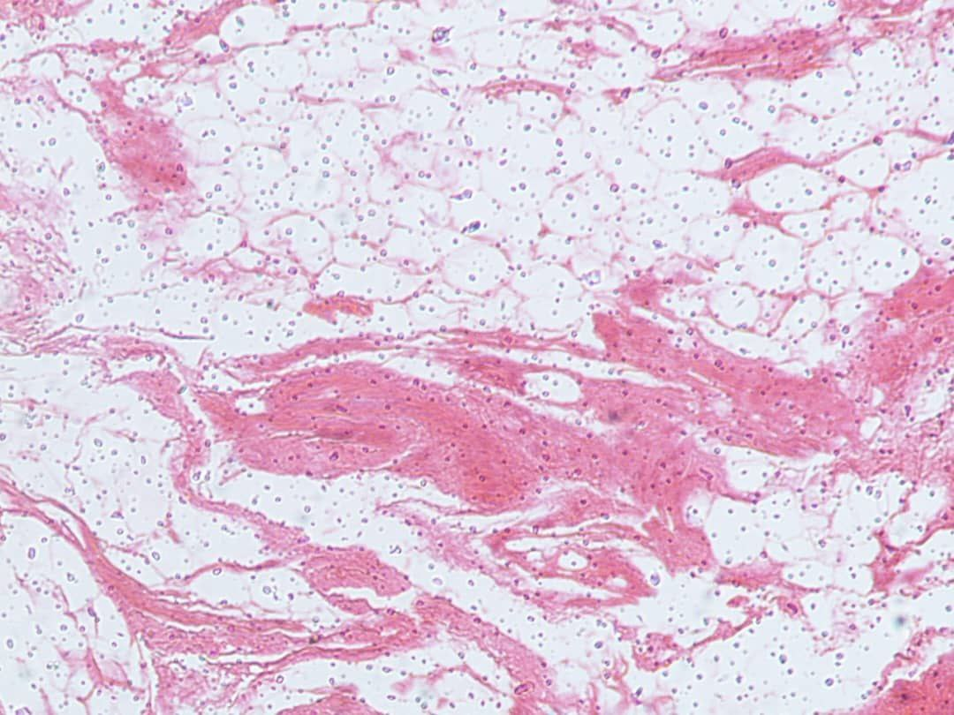
Figure- 4 Adipose connective tissue by using H stain
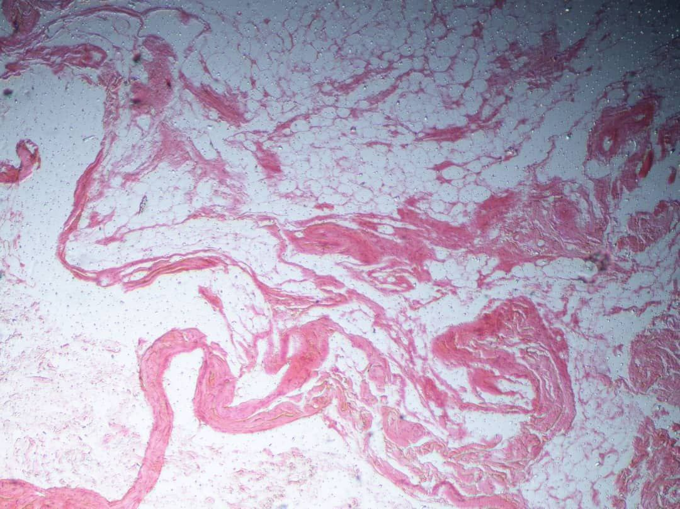
Figure-5 Adipose connective tissue by using E stain

Discussion
In this current study regarding incidence of lipoma in Al jala surgical hospital, 70 cases of both genders, different ages were collected during two years
(2020-2021) , their data arranged and analyzed.The maximum age was 78 years and minimum 20 years old. The mean age was 45 years old. Those results are close to the results of retrospective observational study which included patients who underwent Lipoma excision in Bhopal, Madhya Pradesh, India, where the mean of age was 42. While the maximum age was 81, the minmum age was 7 years old (Ashutosh A. et al. 2022) as a side note our study did not include the pediatric age groups. In the same study by (Ashutosh A. et al. 2022) there was male predominance as a gender, this is totally in agreement with our current study where males (65.1%) outnumber the female cases (34.28%). Furthermore, the incidence of lipoma in children which is rare compared to adults, also reported male predominance over females (Özkul E, et al. 2021). Also, another retrospective study conducted in Kyung Hee University School of Medicine, Seoul, Korea, there were similar values observed. there were more males than females (247 vs. 212; male-to-female ratio,1.16:1) and the mean age was 44 years old (Kim, K. et al. 2021). In This study we included the anatomical sites for the distribution of lipoma in conjunction with sex distribution, they were 10 sites, the most common site was the back (32.9%) followed by the neck (14.3%) followed by thigh (11.4%), the least lipoma was in the inguinal region (2.9%) with equivocal male to female ratio. This finding is in strong agreement with (Ashutosh A. et al. 2022) who reported that lipoma is most commonly in the back in his study, while (Anders R. & Nils O. 1983) reported that head and neck region are the most common sites followed by the upper back. (Özkul E, et al. 2021) observed that lipoma in children is most commonly in the thigh region. In this study we observed that lipoma as a first-time manifestation was predominant accounting (97.1%) of total cases, only (2.9%) observed as recurrent lipoma, both values with male predominance. Evaluating the extent of lipoma, we observed superficial type of lesions, operated by minor surgeries and most of the patients discharged same day and deeply seated lesions eg. Inguinal lipoma, where the patients were admitted for few days. The superficial lipoma in this study found to account (72.4%) while the deeply seated lipoma (28.6%), male predominance in both values. In the study conducted by. (Kim, K. et al. 2021) to observe relationship between depth of the lipoma and histomorphology, the superficial lipoma reported account (82.4%) of the cases while deeply seated lipoma accounted (17.5%). Also (Kim, K. et al. 2021) reported that deep-seated lipomas were larger than superficial lipomas. Lastly evaluating the circumstances of the surgical treatment of lipoma, (75.7%) of the cases had surgical procedure which most likely was minor and discharged smoothly same day, while (24.3%) of the cases admitted for few days according to the medical records which means the surgical procedure was a bit major and general anesthesia might have been used.
Conclusion
This study included 70 cases of lipoma, all presented to the surgery clinic. We concluded that the mean age was (45) years old and male gender much more affected than the female gender. We observed that analyzing the anatomical sites of lipoma, back is the most common site followed by the neck and so many previous studies supported our result. The least common site was the inguinal region. Revising the rate of appearance and recurrence, lipoma in our study was observed as primary lesion in (97.1%) of the cases, recurrent in only (2.9%). While evaluating the depth of the tumor, incidence of superficial lipoma was more than deeply seated lipoma accounting (82.4%) of total cases. Regarding the surgery itself (75.7%) were minor surgical intervention and discharged same day. In summary, Lipomas are the most common soft tissue tumors, more common in the male gender with spectrum of age (20-80) years, more commonly in the back with low recurrence rate. deep-seated lipomas are less common than superficial lipomas and the latter are usually treated surgically in the same day.

Recommendations
- lipomas are benign; however, the diagnosis should be confirmed by a doctor.
- asymptomatic lipomas, even small in size, need to be followed up by a general practitioner in order to administer appropriate treatment at the appropriate time.
- complete and regular physical examinations enable the detection of subcutaneous lipomas, even at an early stage, and therefore, this should be strict standard practice for general practitioners.
- Deeply seated lipomas cause various symptoms depending on location.
- lipomas require differentiation from other malignant disease.
LIMITATIONS OF THE STUDY
- The study was retrospective, we had difficulty to access to all patients detailed records, and determine the main complain (Pain) vs (Cosmetic concerns)
- Limitation and shortage in information regarding the histopathological reports of operated cases, unfortunately made it impossible for us to go further in our study and evaluate the histomorphology of the specimens post-operations.

Reference

- Sitarz r, Skierucha M, Jazienicki M, kurylcio a, wierzbicki r, Maciejewski r, Polkowski wP. lipomas – a health condition that cannot be ignored. Fam Med Prim Care Rev 2016; 18(4): 473–476, doi: 10.5114/fmpcr.2016.637042
- Özkul E, Elçi S, Elçi M, Alemdar C. Big and deep seated lipomatous tumours in children : results of surgical treatment. Acta Orthop Belg. 2021 Jun;87(2):243-246. PMID: 34529376.
- Kim, K.-H., Kwon, S.-H., Sim, W.-Y., & Lew, B.-L. (2021). The study of relationship between anatomical sites and depth of the lipoma. Annals of Dermatology, 33(6), 562. https://doi.org/10.5021/ad.2021.33.6.562
- Ashutosh A., Nandkishor Jatav, Saumya Gupta, Avinash Yadav, Krishnanand (2022) Lipoma-The Universal Tumor: A Demographic Study From Central India.JCDR. 2022: 3152-3156
- Lichon, S., & Khachemoune, A. (2018). Clinical presentation, diagnostic approach, and treatment of Hand Lipomas: A Review. Acta Dermatovenerologica Alpina Pannonica et Adriatica, 27(3). https://doi.org/10.15570/actaapa.2018.27
- Marzyńska, D., Żaba, R., & Lacka, K. (2023). Lipomas: Genetic basis of common skin lesions and their occurrence in rare diseases. Advances in Dermatology and Allergology, 40(4), 481–486. https://doi.org/10.5114/ada.2023.129529
- Anders Rydholm & Nils O. Berg (1983) Size, Site and Clinical Incidence of Lipoma: Factors in the Differential Diagnosis of Lipoma and Sarcoma, Acta Orthopaedica Scandinavica, 54:6, 929-934, DOI: 10.3109/17453678308992936
- Tabatabaei, S. A. (2023). Lipoma; a Common Neoplasm. https://doi.org/10.21203/rs.3.rs-2781683/v1
- Felipe Aluja Jaramillo, Juan Andrés Mora Salazar, Andrés Mauricio Cabezas, Daniel Upegui Jiménez, Nohora Eugenia Castaño Restrepo, Carolina Tramontini Jens (2016) Rev. C olomb. Radiol. 2016; 27(1): 4369-77
- El-Monem MHA, Gaafar AH, Magdy EA. Lipomas of the head and neck: presentation variability and diagnostic work-up. J Laryngol Otol. 2006;120:47-55
- Ahuja AT, King AD, Kew J, et al. Head and neck lipomas: sonographic appearance.AJNR Am J Neuradiol. 1998;19:505-8.
- Fornage BD, Tassin GB. Sonographic appearances of superficial soft tissue lipomas. J Clin Ultrasound. 1991;19:215–20.
- Grivas TB, Psarakis SA, Kaspiris A. Liapi G. Giant lipoma of the thenar – case study and contemporary approach to its aetiopathogenicity. Hand (NY) 2009;4:173–6.
- Nadar MM, Bartoli CR, Kasdan ML. Lipomas of the hand: a review and 13 patient case series. Eplasty. 2010;10:e66.
- Gologorsky D, Gologorsky Y, Yarygina AS, et al. Familial multiple lipomatosis: report of a new family. Cutis 2007; 79:227-32
- Asgharian B, Turner ML, Gibril F, et al. Cutaneous tumors in patients with multiple endocrine neoplasm type 1 (MEN1) and gastrinomas: prospective study of frequency and development of criteria with high sensitivity and specificity for MEN1. J Clin Endocrinol Metab 2004; 89: 5328-36.
- Schaefer M, Gotthardt DN, Didion C, et al. Increased prevalence of subcutaneous lipomas in patients with Wilson disease. J Clin Gastroenterol 2015; 49: 61-3.
- Rotunda AM, Ablon G, Kolodney MS. Lipomas treated with subcutaneous deoxycholate injections. J AmAcad Dermatol. 2005;53(6):973-8

