A Centripetal Approach to Incisional Hernia Repair: Reflections from a Personal Surgical Evolution

Abstract
Background: Incisional hernia repair is fraught with challenges—high recurrence, complex anatomy, and inconsistent healing. Over my three-decade-long surgical career, I have refined a technique I call the centripetal approach. This method begins with a wide incision in healthy tissue and proceeds inward, enabling en-bloc removal of the hernia sac and all compromised tissues. Anatomical closure is reinforced with self-adhering mesh placed with wide overlap. In large defects, a dual mesh is used while preserving the sac to protect viscera. LigaSure energy devices assist in achieving near-bloodless dissection, and wound care is supported with VAC dressings when necessary.
Methods: This approach was born from cumulative experience with complex and recurrent hernias. A wide elliptical incision is made in healthy skin, progressing centripetally. Attenuated skin, fat, fascia, and the sac are removed en-bloc. Primary closure is achieved with loop Polydioxanone (PDS) or Polyamide black (Ethilon) sutures. A Prolene - preferably self-adherent (ProGrip) mesh overlaps the repair by 5–10 cm. If the defect risks compartment syndrome, a dual mesh is inserted, and the sac is retained. Closure is done in three layers: Scarpa, subcutaneous, and dermal with inverted sutures. Suction drains and VAC dressings are used as needed.
Results and Conclusion: This technique has provided durable, reproducible results across a range of complex cases. With minimal dissection, reduced bleeding, and excellent wound integrity, it offers a balanced and robust alternative to more extensive or compartment-separating approaches. Supported by surgical literature and grounded in personal surgical evolution, this method deserves wider recognition and application.

Keywords: Incisional hernia, centripetal approach, en-bloc excision, dual mesh, ProGrip mesh, anatomical closure, LigaSure, VAC dressing, mesh overlap.

Introduction

Incisional hernias remain a vexing complication of abdominal surgery, with reported incidences ranging from 10–20% postoperatively [1,2]. Despite the integration of mesh repair techniques, recurrence rates continue to hover between 15–30% [3], and in some series, higher in complex or re-recurrent cases. The search for the most effective, durable, and safe method of repair is ongoing.
In this context, I share my personal evolution toward what I now refer to as the centripetal approach. This is a technique shaped not in textbooks but through years of first-hand encounters with challenging abdominal wall reconstructions, multi-recurrent hernias, and patients whose lives were marred by failed repairs.
This method centers on three principles:
1. Wide exposure and en-bloc removal of all attenuated tissue.
2. Meticulous anatomical repair without component separation.
3. Generous mesh reinforcement, ensuring wide overlap.
In its simplicity lies its strength. My objective is not to present an invention, but a refinement—an approach forged from experience, precision, and consistency.

Case presentation

The surgery begins with a wide elliptical incision in healthy, non-attenuated skin, well beyond the edges of the defect. This centripetal dissection—moving from normal to abnormal—provides a clean plane and enables safe, bloodless entry. Compromised skin, subcutaneous fat, fascia, and the hernia sac are excised en-bloc, minimizing dead space and potential infection [4].
The hernial contents are gently separated from the sac using LigaSure instruments: Exact for precision, Impact for deeper tissue, and vascular pedicles. These devices reduce lateral thermal injury and enhance hemostasis [5,6].
The defect is closed anatomically using loop Polydioxanone (PDS) or Polyamide black (Ethilon) sutures, respecting native tissue alignment. I avoid component separation to limit dissection and the risk of postoperative complications [7]. Over the repair, a Prolene (ProGrip) self-adhering mesh is placed, ensuring at least 5–10 cm of overlap in all directions [8,9]. Studies affirm that inadequate overlap is a leading cause of recurrence [10].
In cases where closure may risk abdominal compartment syndrome, I employ a dual mesh inlay. Importantly, I retain the hernia sac to serve as a biological barrier between the viscera and mesh, minimizing adhesions and fistula risks [11].
Closure proceeds in three layers:
• Scarpa’s fascia
• Subcutaneous fat
• Inverted dermal sutures (critical for skin integrity over 3–4 weeks)
A suction drain is always placed over the mesh. If signs of seroma or infection emerge, I promptly use VAC dressings, which support faster wound healing and prevent breakdown [12,13].

Discussion
The Problem of Recurrence
Despite advancements, incisional hernia repair often fails—not because of surgical inadequacy, but due to small oversights: missed secondary defects, poor mesh integration, or excessive dead space. Studies report recurrence rates exceeding 20% even with mesh [3,14]. The centripetal approach counters this by ensuring wide exposure, clean dissection, and no missed defects.

Mesh Integration and Overlap
Literature overwhelmingly supports mesh use, but emphasizes sufficient overlap—a minimum of 5 cm is often cited [9,10]. Shrinkage, tissue creep, and mechanical strain can otherwise unseat the mesh. My practice extends overlap to 7–10 cm wherever anatomy permits.

Why Not Component Separation?
While effective, component separation adds morbidity. Dissection extends laterally, risking infection and delayed healing [7]. It is found that by completely removing the sac and compromised tissue, this could usually achieve tension-free closure without additional separation.

LigaSure and Bloodless Surgery
The use of energy sealing systems like LigaSure has transformed hernia repair. Compared to conventional cautery, they offer faster dissection, better hemostasis, and fewer seromas [5,6]. Blood loss rarely exceeds 5 mL in even the most extensive cases.

VAC Dressings: Prevention, Not Rescue
Seromas are a known complication, particularly in onlay mesh repairs. It is proactively monitor for collections and use VAC dressings early, not as a rescue but as a preventive adjunct. Literature supports VAC for reducing wound tension, improving vascularity, and preventing infection [12,13].

Lessons from Recurrent Cases
Many of the patients are re-recurrent—sometimes after laparoscopic, sometimes open mesh repairs. The two most frequent causes are:
• Missed secondary defects
• Insufficient mesh overlap

Thus, it is never beginning closure without full exposure of the abdominal wall. The centripetal approach naturally ensures this.

Conclusion
This study is a narrative of surgical evolution. Over the years, we moved from conventional midline incisions and cautious dissection to a confident, centripetal approach that begins in untouched skin, exposes everything, and restores integrity layer by layer. The hernia repair becomes not just a mechanical act, but a conversation with the tissues, an effort to restore wholeness with minimal trauma. This approach has served well across a spectrum of patients—from minor bulges to hanging abdomens.

Ethics approval: This article is in compliance with ethical principles.

References
1. Luijendijk RW, et al. A comparison of suture repair with mesh repair for incisional hernia. N Engl J Med. 2000;343(6):392–8.
2. Baucom RB, et al. Incidence and risk factors for hernia recurrence after repair. JAMA Surg. 2015;150(3):210–7.
3. Burger JW, et al. Long-term follow-up of a randomized controlled trial of suture versus mesh repair. Ann Surg. 2004;240(4):578–83.
4. Bittner R, et al. Guidelines for laparoscopic treatment of ventral and incisional abdominal wall hernias. Surg Endosc. 2014;28:2–29.
5. Jayne DG, et al. Energy-based vessel sealing devices in abdominal surgery. Br J Surg. 2012;99(3):301–10.
6. Arenal JJ, et al. LigaSure vs conventional dissection: comparative study. Int J Colorectal Dis. 2005;20(3):250–4.
7. Novitsky YW, et al. Open preperitoneal ventral hernia repair with component separation. Surg Innov. 2009;16(3):235–9.
8. Deerenberg EB, et al. Importance of mesh overlap in hernia repair: a systematic review. Hernia. 2020;24(2):165–73.
9. Timmermans L, et al. Mesh size and recurrence in incisional hernia repair. Hernia. 2012;16(5):521–6.
10. LeBlanc KA. Laparoscopic incisional and ventral hernia repair. Surg Clin North Am. 2000;80(4):1113–30.
11. Bellows CF, et al. Positioning of mesh in hernia repair: implications for adhesions. Surg Clin North Am. 2013;93(5):1255–70.
12. Stannard JP, et al. Negative pressure wound therapy after ventral hernia repair. Ann Surg. 2012;255(4):696–702.
13. Dessy LA, et al. VAC system in wound healing after hernia repair. Ann Plast Surg. 2013;71(1):30–6.
14. Holihan JL, et al. Mesh location affects recurrence: a meta-analysis. Ann Surg. 2016;263(3):576–82.

Figure 1.
Wide elliptical incision and centripetal dissection demonstrating en-bloc separation of skin, subcutaneous fat, fascia, and sac from the parietes. This intraoperative image highlights the hallmark of the centripetal approach—a wide local elliptical incision taken in healthy parietes, progressing inward, with the attenuated anterior abdominal wall tissues being carefully lifted as one composite layer.
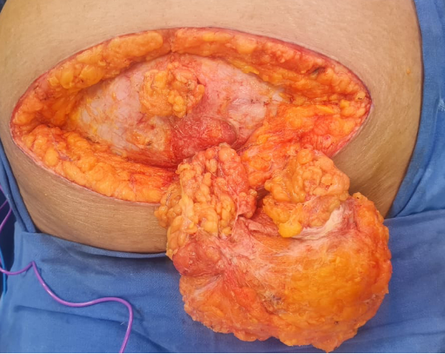

Figure 2.
Multiple discrete hernial defects with visible umbilicus, sac, and omentum after tissue separation. Following en-bloc excision of attenuated tissues, the anatomical extent of the hernia is clearly seen, with punctate and separated fascial defects, hernial sac, and omentum visualized distinctly.
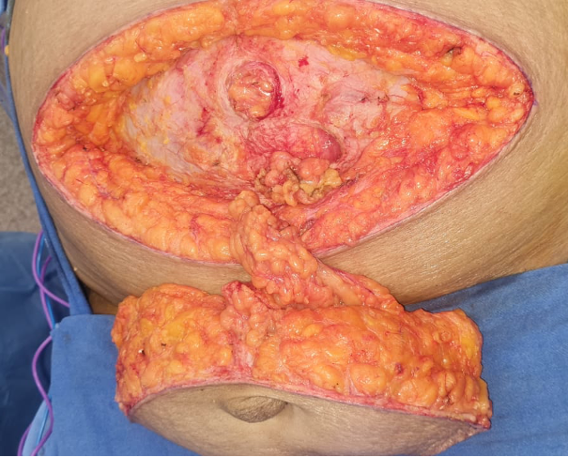

Figure 3.
Final mesh placement following anatomical closure of all defects. A self-adhering ProGrip mesh has been quilted in place, covering the entire repair site with at least 5–10 cm overlap. All defects have been primarily closed before mesh reinforcement.
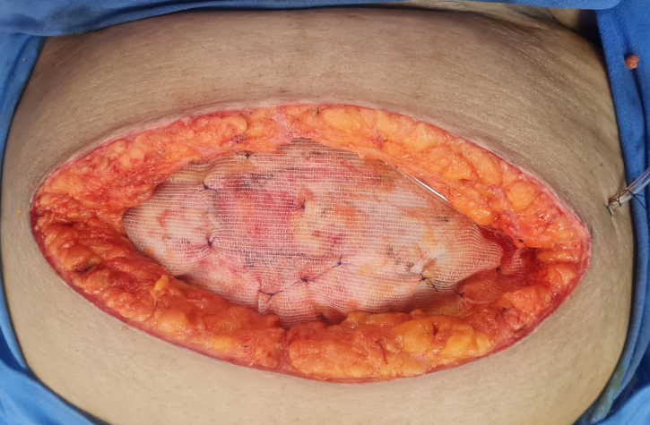

Figure 4.
Excised specimen demonstrating attenuated parietal tissues and omentum. This image shows the complete specimen removed en-bloc, including skin, fat, fascial elements, and adherent omentum, alongside a measurement scale to illustrate its size and extent.
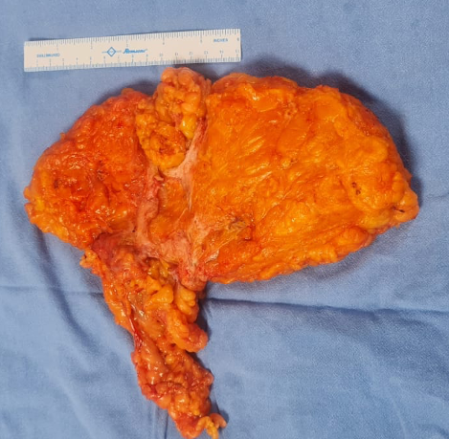
Figure 5.
Final layered closure of the incision after mesh placement. The surgical site following anatomical repair and mesh reinforcement shows a tension-free, multi-layered closure with approximation of Scarpa’s fascia, subcutaneous tissues, and inverted dermal sutures. The incision demonstrates a clean, well-aligned wound suitable for optimal healing.
