***Case report***

**MALIGNANT PERITONEAL MESOTHELIOMA: A CASE REPORT**

**ABSTRACT:**

Malignant peritoneal mesothelioma (MPM) is a rare and aggressive cancer that arises from mesothelial cells lining the peritoneal cavity. It accounts for approximately 10% to 30% of all mesotheliomas and occurs more frequently in men. Although the role of asbestos as a risk factor remains controversial, it is often implicated in the pathogenesis of peritoneal mesothelioma. Clinical presentation is often silent or characterized by non-specific symptoms. As a result, diagnosis is frequently made at an advanced stage, sometimes incidentally during abdominal surgery.  
Imaging and histopathology are essential tools for diagnosis, while immunohistochemistry helps confirm or rule out the disease. Therapeutic management is based on cytoreductive surgery, with or without hyperthermic intraperitoneal chemotherapy. This strategy can improve the prognosis of this aggressive malignancy.

*Keywords:* Malignant peritoneal mesothelioma, ascites, immunohistochemistry.

1. **INTRODUCTION:**

Malignant peritoneal mesothelioma (MPM) is a rare and rapidly aggressive disease that develops from mesothelial cells lining the peritoneal cavity. This entity represents approximately 10% to 30% of all mesotheliomas [1]. It occurs more frequently in men, with an estimated incidence ranging from 0.5 to 3 cases per million in men and from 0.2 to 2 cases per million in women [2]. The involvement of asbestos in the development of peritoneal mesothelioma remains a subject of debate. Clinical and radiological features are non-specific, and the definitive diagnosis relies on histological examination and immunohistochemistry [2].

1. **CASE PRESENTATION:**

We report the case of a 52-year-old man with no significant medical history, notably without known exposure to asbestos or other toxic agents, who presented with painless abdominal distension that had gradually developed over the past nine months. The complaint was accompanied by weight loss, with no associated fever or digestive or extradigestive signs.

On examination, the patient was alert and hemodynamically and respiratory stable (blood pressure: 130/80 mmHg, respiratory rate: 18 breaths/min), with a Performance Status of 0. His body mass index (BMI) was 23 kg/m², and his abdominal circumference at the umbilicus was 100 cm. There was no pallor or mucocutaneous jaundice. Abdominal examination revealed a large-volume peritoneal effusion without hepatosplenomegaly, palpable masses, or peripheral lymphadenopathy.

A thoraco-abdomino-pelvic CT scan showed a large amount of ascites without other abnormalities (Fig. 1). Analysis of the ascitic fluid revealed a protein-rich exudate (43 g/L) with a negative adenosine deaminase (ADA) level of 20 IU/L. Cytological examination revealed atypical cells in the ascitic fluid. Tumor markers (CA 19-9, CEA, CA 125, and AFP) were negative. Upper and lower gastrointestinal endoscopy were unremarkable. Diagnostic laparoscopy revealed abundant ascites and white granulations scattered throughout the peritoneal cavity. Histological (Fig. 2) and immunohistochemical examination supported the diagnosis of an epithelioid peritoneal mesothelioma with papillary architecture. Immunohistochemical analysis revealed tumor cells positive for WT1, podoplanin, and calretinin (Fig. 3).

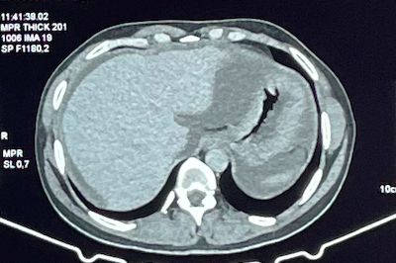

Figure 1**:** Axial computed tomography scan after contrast injection, showing large-volume ascites (arrow).

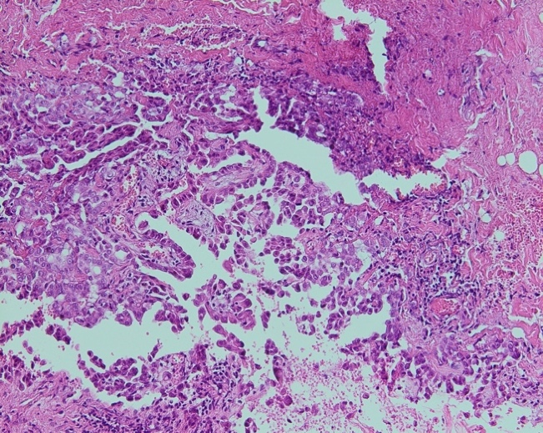

Figure 2: Hematoxylin and eosin–stained histological section (magnification ×200) showing a tumoral proliferation with papillary and micropapillary architecture. The tumor cells are medium-sized and cuboidal, with relatively abundant eosinophilic cytoplasm and hyperchromatic nuclei.

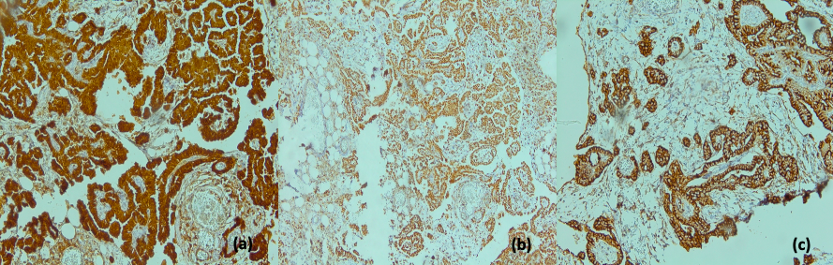

Figure 3**:** The tumor proliferation shows diffuse expression of the following markers: Calretinin (a), Podoplanin (b), WT1 (c).

The case was discussed at a multidisciplinary tumor board meeting. The patient underwent cytoreductive surgery followed by hyperthermic intraperitoneal chemotherapy (HIPEC) with cisplatin, and was then managed in the oncology department with quarterly follow-up, including a general clinical examination, thoraco-abdomino-pelvic CT scan, tumor markers (CEA and CA 125), and therapeutic paracentesis in case of respiratory discomfort.  
Clinical evolution was favorable, with sustained preservation of a good general condition. Follow-up imaging at three months revealed low-volume ascites, which remained stable over time and did not require any drainage procedures during a two-year follow-up period.

1. **DISCUSSION:**

Malignant peritoneal mesothelioma (MPM) is a primary tumor that develops from a serous membrane, most commonly the pleura, less frequently the peritoneum, and exceptionally the pericardium or the tunica vaginalis testis [1]. MPM is a rare disease, with an estimated annual incidence ranging from 0.5 to 3 cases per 100,000 men and 0.2 to 2 cases per 100,000 women, according to European Eurocim and American SEER (Surveillance, Epidemiology, and End Results) databases [2]. The average age of onset varies from 47 to 60.5 years [3]. MPM more commonly affects men, likely due to higher occupational exposure to asbestos [4].

A European study (RARECARE) estimates the 5-year overall and relative survival rates at 9.8% and 11.4%, respectively [5]. The analysis of the French MESOPATH pathological database reports 349 cases recorded between 1989 and 2015, with a male-to-female ratio of 1.3 and a median age at diagnosis of 66 years. The median overall survival was 11.4 months, with a 5-year survival rate of 21% [6].

The role of asbestos as a risk factor for the development of MPM remains debated. Some studies suggest that asbestos exposure is a significant etiological factor, although its implication is weaker than in pleural mesothelioma [7]. Other mineral fibers, such as erionite (from the zeolite group) or mica, have also been implicated in the tumorigenesis of MPM [8,9]. The role of infection with simian virus SV40 seems to have been ruled out [10].

MPM is often asymptomatic or presents with nonspecific symptoms at an early stage. Consequently, the diagnosis is often made at intermediate or advanced stages. Clinical manifestations are diverse, with abdominal distension (41% to 86%) and abdominal pain (31% to 87%) being the most common [2]. Radiological signs are also nonspecific and minimally contributory: compression of the viscera, thickening of the peritoneal lining, tumor masses, ascites [3]. The diagnosis may sometimes be made incidentally during abdominal surgery.

The macroscopic appearance is nonspecific, either as multiple nodules or whitish plaques, or as masses. These masses may be solid, cystic, or mucinous. Infiltration of the intestinal wall, omentum, and/or diaphragm is often associated. Tumor biopsy is the key diagnostic procedure; it should be preferred over simple cytological study of ascitic fluid, which has a low yield for detecting a primary tumor, with sensitivity estimated between 30% and 75% [11]. This biopsy can be performed via percutaneous radiological, endoscopic, or laparoscopic surgical methods, with preference for the most easily accessible site.

Histologically, MPM is classified, according to the 2015 WHO classification [12], into three main types: sarcomatoid (or sarcomatous), biphasic, and epithelioid (or epithelial). The latter is the most common and has a favorable prognosis [13]. Within this subtype, several histological patterns have been described [14]:  
– Most frequent: solid, micropapillary, tubulopapillary.  
– Rarer: papillary, acinar, trabecular, pleomorphic, adenomatoid, microcystic, clear cell, transitional, deciduoid, small cell.

Immunohistochemistry is essential for the diagnosis of MPM and should always include a panel of antibodies selected based on the patient’s gender and the differential diagnoses considered. This panel should include at least two “positive” antibodies such as anti-calretinin, anti-CK5/6, and anti-WT1, as well as two “negative” antibodies such as anti-EP4, anti-ACE, anti-CDX2, anti-hormonal receptors (in women), or anti-TTF1 (if associated pleural involvement) [15]. Differential diagnoses will be discussed based on whether the histological type is epithelioid or sarcomatoid. The use of a single antibody is not recommended.

MPM was previously considered an intermediate- to advanced-stage malignant tumor with a poor prognosis. In recent years, however, thanks to therapeutic advances used in clinical practice, particularly cytoreductive surgery (CRS) combined with hyperthermic intraperitoneal chemotherapy (HIPEC) as the primary treatment strategy, along with systemic chemotherapy, intraperitoneal chemotherapy, and immunotherapy, patient survival rates have significantly improved.

In the study conducted by Salo et al. [16], involving 50 patients with MPM, 44 patients (88%) received palliative care with chemotherapy, 4 patients (8%) were treated with radical surgery combined with chemotherapy, and only 2 patients (4%) received treatment with CRS combined with HIPEC.

The 5-year survival rate was 50% for patients treated with CRS + HIPEC and reached 75% for those who received radical surgery combined with chemotherapy. This latter therapeutic strategy was significantly associated with prolonged survival compared to radiotherapy alone (p = 0.008), chemotherapy + radiotherapy (p = 0.043), the combination of surgery + chemotherapy + radiotherapy (p = 0.039), and palliative surgery (p = 0.009).

1. **CONCLUSION:**

Epithelioid peritoneal mesothelioma is a rare condition, with the etiological role of asbestos exposure remaining controversial. Diagnosis is often delayed due to the nonspecific nature of clinical signs. The pathological diagnosis relies on morphological and immunohistochemical characteristics. An antibody panel, combining both "positive" and "negative" markers, is recommended by international experts. Therapeutic management must be multidisciplinary. The introduction of new protocols combining maximal cytoreductive surgery and hyperthermic intraperitoneal chemotherapy has significantly improved the prognosis of this disease.

**REFERENCES:**

[1] Sebbag G, Yan H, Shmookler BM, Chang D, Sugarbaker PH. Results of treatment of 33 patients with peritoneal mesothe- lioma. Br J Surg 2000;87:1587—93.

[2] Mery E, Hommell-Fontaine J, Capovilla M, Chevallier A, Bibeau F, Croce S, et al. Malignant Peritoneal Mesothelioma: Review and Current Data. Ann Pathol 2014;34:26—33.

[3] Cao S, Jin S, Cao S, Shen J, Hu J, Che J, et al. Advances in malignant peritoneal mesothelioma. Int J Colorectal Dis 2014, http://dx.doi.org/10.1007/s00384-014-2029-1.

[4] Baker PM, Clement PB, Young RH. Malignant peritoneal mesothelioma in women: a study of 75 cases with emphasis on their morphologic spectrum and differential diagnosis. Am J Clin Pathol 2005;123:724—37.

[5] Gatta, G. et al., 2011. Rare cancers are not so rare: the rare cancer burden in Europe. European journal of cancer (Oxford, England : 1990), 47(17), pp.2493–2511.

[6] Le Stang, N. et al., 2019. Incidence and survival of peritoneal malignant mesothelioma between 1989 and 2015: A population-based study. Cancer epidemiology, 60, pp.106–111.

[7] Boffetta P. Epidemiology of peritoneal mesothelioma: a review. Ann Oncol 2007;18:985—90.

[8] Roushdy-Hammady I, Siegel J, Emri S, Testa JR, Carbone M. Genetic-susceptibility factor and malignant mesothelioma in the Cappadocian region of Turkey. Lancet 2001;357:444—5.

[9] Chahinian AP, Pajak TF, Holland JF, Norton L, Ambinder RM, Mandel EM. Diffuse malignant mesothelioma. Prospective evaluation of 69 patients. Ann Intern Med 1982;96:746—55.

[10] Attanoos, R.L. et al., 2018. Malignant Mesothelioma and Its Non-Asbestos Causes. Archives of pathology & laboratory medicine, 142(6), pp.753–760.

[11] Henderson, D.W. et al., 2013. Challenges and controversies in the diagnosis of mesothelioma: Part 1. Cytology-only diagnosis, biopsies, immunohistochemistry, discrimination between mesothelioma and reactive mesothelial hyperplasia, and biomarkers. Journal of clinical pathology, 66(10), pp.847–853.

[12] Travis, W.D. et al., 2015. Introduction to The 2015 World Health Organization Classification of Tumors of the Lung, Pleura, Thymus, and Heart. Journal of Thoracic Oncology, 10(9), pp.1240–1242

[13] Krasinskas, A.M. et al., 2016. Prognostic significance of morphological growth patterns and mitotic index of epithelioid malignant peritoneal mesothelioma. Histopathology, 68(5), pp.729–737.

[14] Hartman, D.J. et al., 2017. Reproducibility for histologic parameters in peritoneal mesothelioma. Human pathology, 67, pp.54–59.

[15] Galateau-Salle, F. et al., 2016. The 2015 World Health Organization Classification of Tumors of the Pleura: Advances since the 2004 Classification. Journal of thoracic oncology: official publication of the International Association for the Study of Lung Cancer, 11(2), pp.142–154.

[16] Salo S , Ilonen I , Laaksonen S , et al . Malignant Peritoneal Mesothelioma: Treatment Options and Survival [J],2019,39(2) :839-845. 10.21873/anticanres.13183.