**Re-thinking diabetes management in aging populations: Balancing longevity, quality of life, and innovations.**

**Abstract**

The rapidly increasing world population and the prevalence of diabetes mellitus demand revisiting and reexamination of traditional and already existing management. Older people with diabetes face unique physiological, cognitive, and social challenges that complicate standardized therapeutic approaches. While the traditional treatment emphasizes the control of glucose levels in the blood, a strict adherence to HbA1c targets may lead to adverse effects like low blood sugar (hypoglycemia), polypharmacy, and diminished quality of life. This article recommends a patient-centered model that prioritizes longevity, general well-being, and functional independence. By leveraging emerging technologies, personalizing glycemic targets, and integrating an interdisciplinary care model, healthcare systems can better address the subtle needs of aging persons. Furthermore, adopting practical implementation strategies, including simplified regimens of medication and community-based support systems, ensures a holistic approach to care. Policies and research must focus on expanding clinical trials that are geriatric-inclusive, enhancing provider training, and providing access to innovative healthcare solutions. This paradigm shift will enable a more effective, sustainable, and equitable approach to diabetes management in the elderly.

**Introduction**

The convergence of two world challenges- the aging population and the increasing prevalence of diabetes- brings about a reevaluation of current treatment paradigms. (1) By 2050, the proportion of adults aged 65 and above is expected to double, while diabetes cases will continue to increase due to lifestyle factors, increased life expectancy, and improved diagnostic capabilities. (2) Elderly people with diabetes most times experience multi-morbidity, frailty, and cognitive decline, complicating conventional disease management approaches designed for younger populations. (3)

Despite these noticeably different needs, clinical guidelines and treatment strategies frequently apply uniform targets and interventions across age groups. (4) This generalized approach risks overtreatment, leading to multiple drug use, hypoglycemia, and diminished quality of life. (5) On the other hand, undertreatment may contribute to preventable complications and reduce functional independence.(6) A more subtle strategy is essential, especially one that considers not only control of blood glucose but also broader health objectives, including longevity, autonomy, and management of symptoms.(7)

This review advocates for a balanced and patient-centered approach that integrates longevity goals, quality of life considerations, and innovative treatment advancements. By tailoring diabetes care to the unique physiological, psychological, and social situations of the geriatric, healthcare systems can enhance outcomes while preserving well-being. Such a change requires a paradigm that prioritizes personalized treatment thresholds, interdisciplinary care models, and emerging technologies that enhance both safety and efficacy(8). Addressing these obstacles with a holistic perspective will ensure that older individuals with diabetes receive care that aligns with their evolving health priorities and life goals.(9)

**Personalizing Glycemic Targets in Older Adults**

Conventionally, the management of diabetes has focused on standardized HbA1c targets to prevent long-term complications. However, in the elderly, rigid adherence to these targets may not always align with the health goals of the individual, given the variation in functional status, comorbidity burden, and life expectancy(10). A more individualized approach that balances the risks and benefits of glycemic control is essential.(11)

**Moving Beyond Standardized HbA1c Targets**

Rigid glycemic control in older adults may magnify the risk of low blood glucose, which can lead to falls, cognitive impairment, and cardiovascular events(12). Conversely, overly relaxed control may contribute to complications related to high blood glucose. Individualized targets should be based on a comprehensive assessment of each patient’s health status and personal preferences(13).

**Risk-Benefit Analysis for Individualized Care**

1. **Functional Status and Frailty:** Older individuals with more stable health conditions may tolerate more stringent glycemic control, whereas frail individuals with limited functional reserves may benefit from a more relaxed approach to minimize treatment burden and hypoglycemia risk.
2. **Comorbidity Burden:** The presence of multiple chronic conditions brings about a balance between glucose control and overall disease management. For patients with significant multiple chronic conditions, prioritizing symptom management and quality of life may outweigh strict glycemic regulation.
3. **Life Expectancy:** The benefits of strict glycemic control in preventing complications often take years to manifest. In people with limited life expectancy, the focus should move toward avoiding acute complications and enhancing well-being rather than achieving stringent HbA1c targets.
4. **Hypoglycemia Vulnerability:** Older adults, particularly those on insulin or sulfonylureas, are at heightened risk for hypoglycemia. Frequent episodes can lead to severe consequences, including cognitive decline and cardiovascular complications. Adjusting therapeutic regimens to minimize this risk is important.

**Patient-Centered Outcomes That Matter Most**

To effectively manage diabetes in older adults, outcomes that enhance quality of life should be prioritized, such as maintaining independence, preventing hospitalizations, and reducing treatment burden. Engaging patients in shared decision-making ensures that glycemic targets align with their values and preferences, fostering a more individualized and meaningful approach to care(14).

In conclusion, moving beyond a one-size-fits-all HbA1c target in older adults allows for an approach in subtlety that considers functional status, comorbidities, life expectancy, and risk of low blood glucose. Personalizing glycemic goals based on these factors can improve health outcomes and overall well-being in this vulnerable population(15).To support individualized diabetes care in older adults, Figure 1 below outlines the primary factors that guide the personalization of glycemic targets.

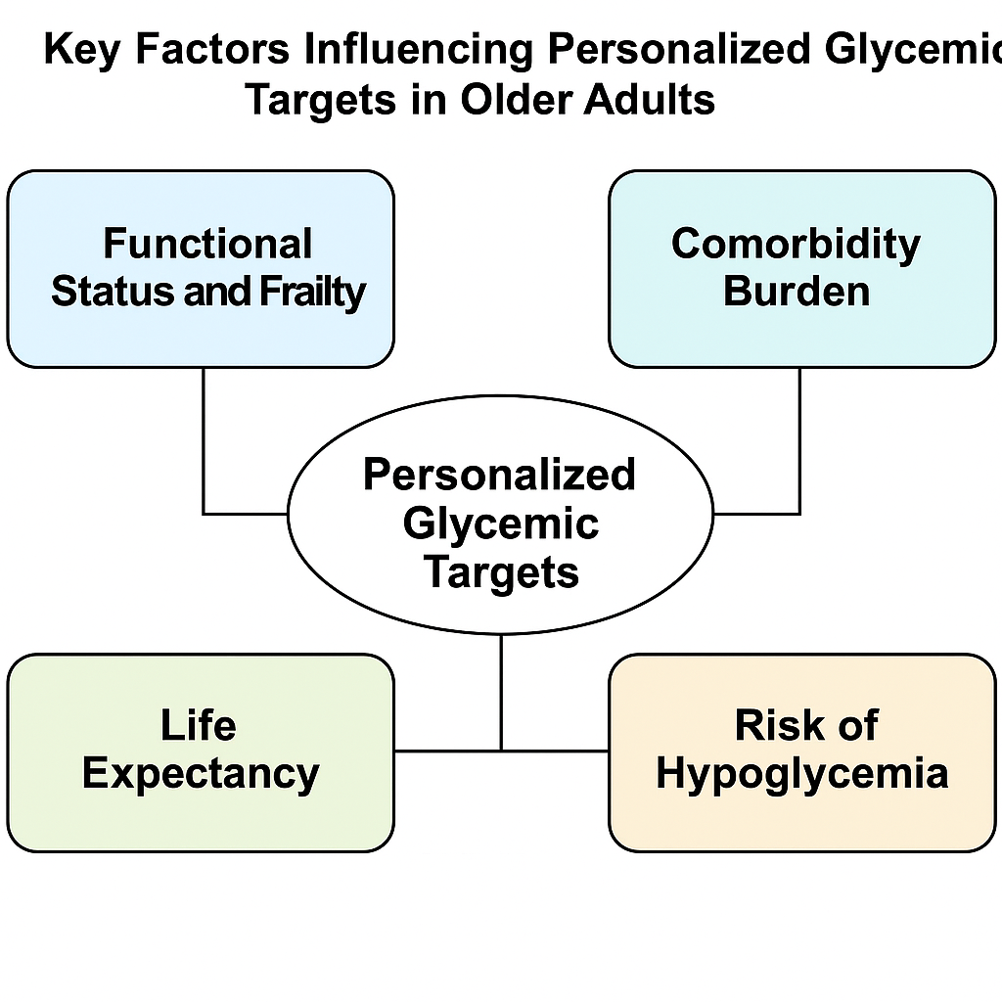

**Figure 1: Key Factors Influencing Personalized Glycemic Targets in Older Adults**. This diagram highlights four central considerations in setting personalized HbA1c targets for older adults: functional status and frailty, comorbidity burden, life expectancy, and the risk of hypoglycemia. Each of these interrelated factors must be evaluated in the context of patient goals to determine the safest and most effective glycemic control strategy.

**Quality of Life Considerations**

Managing chronic conditions and antimicrobial-resistant infections requires a holistic approach that spans beyond clinical outcomes to address the patient’s overall well-being. Several key factors influence quality of life, including treatment burden, medication complexity, polypharmacy, mental health, shared decision-making, and functional independence. (16)

**Treatment Burden and Medication Complexity**   
Patients with chronic infections often experience significant treatment burdens, including frequent clinic appointments, complex treatment regimens, and invasive procedures(17). Managing antibiotic-resistant infections may involve prolonged or combination therapies, requiring strict adherence to dosing schedules. These regimens can lead to physiological and mental stress, contributing to decreased treatment adherence and overall quality of life. Reducing regimen complexity through simplified dosing, long-acting formulations, and patient-centered strategies can help alleviate these burdens(18).

**The Impact of Polypharmacy**  
Polypharmacy, which is known as the concurrent use of multiple medications, is an increasing concern, particularly among older people and immunocompromised patients. The impacts from the use of antibiotics, chronic disease medications, and adjunctive treatments may lead to increased side effects, drug-drug interactions, and a heightened risk of adverse events(19). Optimizing antimicrobial stewardship while considering the patient’s existing medication regimen is essential to minimizing polypharmacy-related complications(20). Deprescribing unnecessary medications and integrating pharmacogenomic insights can help tailor treatment while reducing unnecessary risks(21).

**Mental Health and Cognitive Dimensions**  
Chronic infections and complex therapies can have a negative psychological impact, including anxiety, depression, and cognitive impairment(22). Patients taking long-term antibiotic medication or dealing with recurring infections may feel mental discomfort, which can impair motivation and treatment adherence(23). Cognitive changes, such as brain fog or memory problems, might impede self-care. Integrating mental health care, such as counseling, mindfulness practices, and social support systems, can improve patient resilience and well-being. (24)

**Shared Decision-Making Approach**

A patient-centered approach to antimicrobial treatment prioritizes shared decision-making, making patients and caregivers active partners in care planning. Involving patients in discussions about treatment alternatives, risks, and benefits increases trust and adherence. When selecting therapeutic strategies, healthcare providers should communicate openly with patients and take into account their preferences and quality-of-life goals(25).

**Prioritizing Functional Independence**

When treating patients with persistent infections, maintaining functional independence is a crucial consideration. Mobility, independence, and everyday living activities can be jeopardized by excessive treatment burdens, adverse drug reactions, and extended hospital stays. Effective disease management can be achieved by patients through a multidisciplinary strategy that incorporates physical therapy, nutritional assistance, and rehabilitation. Giving priority to interventions that promote mobility and self-sufficiency can enhance quality of life and long-term results. (26)

**Adoption of Selective Innovation**   
A thorough assessment of the advantages of new technology, especially for senior citizens, must inform their implementation in the healthcare industry. Innovations should remain affordable and accessible while promoting independence, improving health outcomes, and improving quality of life(27).

**Assessing Valuable Advantages for the Older Population**   
It is a known fact that not every technological innovation offers significant advantages to the elderly population. By facilitating early disease identification, enhancing drug adherence, and lowering hospitalization rates, advancements in telemedicine, medication management, and wearable health monitoring have had a favorable influence. The benefits of emerging healthcare technology for typical aging-related issues like mobility support, cognitive health, and managing chronic diseases should be taken into account while evaluating them. (28)

**Ensuring Accessibility and Usability**  
Due to physical restrictions, cognitive changes, or unfamiliarity with digital tools, older populations may find it difficult to use technology. Accessibility can be increased by creating user-friendly interfaces with voice-activated capabilities, larger fonts, and clear directions. Furthermore, offering continuing assistance and training sessions can boost user confidence and promote the long-term adoption of advantageous technology. (29)

**The Role of Caregivers in Technology Integration**

The adoption of healthcare technologies is greatly aided by healthcare providers. Their participation guarantees correct setup, troubleshooting, and encouragement for regular use, whether they are family members or paid caregivers. Better health management for the elderly can be promoted by educating caregivers about the features and advantages of these technologies, which can close the gap between innovation and real-world implementation(30).

**Cost-Effectiveness** **Considerations**  
The cost-effectiveness of sophisticated healthcare technology needs to be carefully considered, even though it provides promising solutions. Solutions should lower total healthcare costs, be reasonably priced, and offer quantifiable health benefits. Government subsidies, insurance coverage, and reimbursement schemes can all contribute to the wider population's access to necessary technologies. A sustainable incorporation into aging healthcare systems is ensured by giving priority to innovations that strike a balance between affordability and efficacy(31).

**Realistic Implementation Techniques**  
A multimodal strategy that emphasizes cooperation, simplification, and community involvement is necessary for effective healthcare initiatives for older populations. (32)

**Team-Based Methods Including Geriatric Knowledge**   
Comprehensive care is guaranteed by a multidisciplinary team that includes allied health specialists, pharmacists, and geriatricians. By using geriatric experience, therapies can be more effectively tailored to reduce side effects, increase adherence, and improve patient outcomes. (33)

**Simplified Medication Regimens**   
Simplifying medication regimens can improve adherence and reduce the chance of mistakes. Medication management for older persons can be enhanced by techniques such as using combination therapy, deprescribing unnecessary medications, and using simple dose schedules(34).

**Enhanced Communication Methods**  
Patients, caregivers, and healthcare professionals must communicate clearly and consistently. Treatment programs are better understood and followed when visual aids, technological reminders, and patient-friendly teaching materials are used(35).

**Community Support Systems**  
Utilizing community resources like home health services, senior centers, and peer support networks encourages social interaction and enhances access to care. (36)

**Research and Policy Implications**

Promoting independence and general well-being for aging populations necessitates research initiatives and policy reforms that address accessibility, inclusivity, and provider training.

**Needs for Inclusive Clinical Trials**

Expanding clinical trials to include older adults guarantees that treatments are tested for safety and efficacy in this population; age-inclusive research results in more individualized and effective healthcare interventions.

**Coverage for Appropriate Technologies and Support Services**

Policies should emphasize insurance coverage for necessary technologies, like telehealth services and glucose monitoring systems, to improve quality of life and disease management.

**Training Healthcare Providers in Geriatric Diabetes Care**  
Healthcare professionals need specialized training in managing diabetes in older adults, emphasizing individualized treatment plans, medication safety, and holistic care approaches to improve patient outcomes.

**Conclusion**

Optimizing diabetes management in aging populations requires moving beyond conventional glycemic targets to embrace a more holistic and personalized approach. By balancing longevity with quality of life, healthcare systems can minimize treatment burdens while maximizing patient autonomy and well-being. Integrating geriatric expertise, innovative technologies, and community support structures fosters a more responsive care model that aligns with the evolving needs of older adults. To achieve these goals, policymakers, researchers, and healthcare providers must collaborate on age-inclusive clinical research, policy reforms, and provider education initiatives. By shifting toward a patient-centered paradigm, we can ensure that aging individuals with diabetes receive comprehensive, dignified, and effective care that enhances both health outcomes and overall life satisfaction.

REFERENCES

1. Lee SH. The Growing Challenge of Diabetes Management in an Aging Society. Diabetes Metab J. 2023 Sep 26;47(5):630.

2. Kirkman MS, Briscoe VJ, Clark N, Florez H, Haas LB, Halter JB, et al. Diabetes in Older Adults. Diabetes Care. 2012 Nov 14;35(12):2650–64.

3. Sinclair AJ, Abdelhafiz AH. Multimorbidity, Frailty and Diabetes in Older People–Identifying Interrelationships and Outcomes. J Pers Med. 2022 Nov;12(11):1911.

4. Guidelines I of M (US) C on S for DTCP, Graham R, Mancher M, Wolman DM, Greenfield S, Steinberg E. Promoting Adoption of Clinical Practice Guidelines. In: Clinical Practice Guidelines We Can Trust [Internet]. National Academies Press (US); 2011 [cited 2025 Apr 5]. Available from: https://www.ncbi.nlm.nih.gov/books/NBK209543/

5. Sonmez A, Tasci I, Demirci I, Haymana C, Barcin C, Aydin H, et al. A Cross-Sectional Study of Overtreatment and Deintensification of Antidiabetic and Antihypertensive Medications in Diabetes Mellitus: The TEMD Overtreatment Study. Diabetes Ther. 2020 May 1;11(5):1045–59.

6. Tappenden KA, Quatrara B, Parkhurst ML, Malone AM, Fanjiang G, Ziegler TR. Critical Role of Nutrition in Improving Quality of Care: An Interdisciplinary Call to Action to Address Adult Hospital Malnutrition. J Acad Nutr Diet. 2013 Sep 1;113(9):1219–37.

7. MSD Manual Consumer Version [Internet]. [cited 2025 Apr 5]. Diabetes Mellitus (DM) - Hormonal and Metabolic Disorders. Available from: https://www.msdmanuals.com/home/hormonal-and-metabolic-disorders/diabetes-mellitus-dm-and-disorders-of-blood-sugar-metabolism/diabetes-mellitus-dm

8. Kruk ME, Gage AD, Arsenault C, Jordan K, Leslie HH, Roder-DeWan S, et al. High-quality health systems in the Sustainable Development Goals era: time for a revolution. Lancet Glob Health. 2018 Nov 1;6(11):e1196–252.

9. Yun JS, Kim K, Ahn YB, Han K, Ko SH. Holistic and Personalized Strategies for Managing Elderly Type 2 Diabetes Patients. Diabetes Metab J. 2024 Jul 26;48(4):531–45.

10. Longo M, Bellastella G, Maiorino MI, Meier JJ, Esposito K, Giugliano D. Diabetes and Aging: From Treatment Goals to Pharmacologic Therapy. Front Endocrinol [Internet]. 2019 Feb 18 [cited 2025 Apr 5];10. Available from: https://www.frontiersin.org/journals/endocrinology/articles/10.3389/fendo.2019.00045/full

11. American Diabetes Association Professional Practice Committee. 6. Glycemic Targets: Standards of Medical Care in Diabetes—2022. Diabetes Care. 2021 Dec 16;45(Supplement_1):S83–96.

12. Therapeutics Initiative | [151] Minimizing harms of tight glycemic control in older people with type 2 diabetes [Internet]. [cited 2025 Apr 5]. Available from: https://www.ti.ubc.ca/2024/10/09/151-minimizing-harms-of-tight-glycemic-control-in-older-people-with-type-2-diabetes/

13. Toney-Butler TJ, Thayer JM. Nursing Process. In: StatPearls [Internet]. Treasure Island (FL): StatPearls Publishing; 2025 [cited 2025 Apr 5]. Available from: http://www.ncbi.nlm.nih.gov/books/NBK499937/

14. American Diabetes Association Professional Practice Committee. 1. Improving Care and Promoting Health in Populations: Standards of Care in Diabetes—2025. Diabetes Care. 2024 Dec 9;48(Supplement_1):S14–26.

15. Yun JS, Kim K, Ahn YB, Han K, Ko SH. Holistic and Personalized Strategies for Managing in Elderly Type 2 Diabetes Patients. Diabetes Metab J. 2024 Jul 26;48(4):531–45.

16. Liu D, Qiu L, Han L, Wang Y, Wang F, Liu X, et al. Prevalence and influencing factors of medication-related burden among patients with late-life depression in a typical city of eastern China: a cross-sectional study. BMC Public Health. 2024 Dec 18;24(1):3521.

17. Puro V, Coppola N, Frasca A, Gentile I, Luzzaro F, Peghetti A, et al. Pillars for prevention and control of healthcare-associated infections: an Italian expert opinion statement. Antimicrob Resist Infect Control. 2022 Jun 20;11(1):87.

18. Oliveira M, Antunes W, Mota S, Madureira-Carvalho Á, Dinis-Oliveira RJ, Dias da Silva D. An Overview of the Recent Advances in Antimicrobial Resistance. Microorganisms. 2024 Sep;12(9):1920.

19. Kommu S, Carter C, Whitfield P. Adverse Drug Reactions. In: StatPearls [Internet]. Treasure Island (FL): StatPearls Publishing; 2025 [cited 2025 Apr 5]. Available from: http://www.ncbi.nlm.nih.gov/books/NBK599521/

20. Hoel RW, Connolly RMG, Takahashi PY. Polypharmacy Management in Older Patients. Mayo Clin Proc. 2021 Jan 1;96(1):242–56.

21. Goldberg S. MedCity News. 2024 [cited 2025 Apr 5]. Polypharmacy is a Health Killer: Personalized Medication Management is the Answer. Available from: https://medcitynews.com/2024/11/polypharmacy-is-a-health-killer-personalized-medication-management-is-the-answer/

22. Müller N. Infectious Diseases and Mental Health. 2014 Nov 26 [cited 2025 Apr 5]; Available from: https://karger.com/books/book/190/chapter/5127054/Infectious-Diseases-and-Mental-Health

23. NurseTogether [Internet]. 2021 [cited 2025 Apr 5]. Noncompliance (Ineffective Adherence) Nursing Diagnosis & Care Plans. Available from: https://www.nursetogether.com/noncompliance-nursing-diagnosis-care-plan/

24. How Home Health Care Can Improve Mental Clarity and Focus [Internet]. [cited 2025 Apr 5]. Available from: https://www.downersgrovehc.com/blog/how-home-health-care-can-improve-mental-clarity-and-focus

25. Bujold M, Pluye P, Légaré F, Hong QN, Beaulieu MC, Bush PL, et al. Decision-making and related outcomes of patients with complex care needs in primary care settings: a systematic literature review with a case-based qualitative synthesis. BMC Prim Care. 2022 Nov 9;23(1):279.

26. Ijaz N, Buta B, Xue QL, Mohess DT, Bushan A, Tran H, et al. Interventions for Frailty Among Older Adults With Cardiovascular Disease. JACC. 2022 Feb 8;79(5):482–503.

27. Recent Advancements in Emerging Technologies for Healthcare Management Systems: A Survey - PMC [Internet]. [cited 2025 Apr 5]. Available from: https://pmc.ncbi.nlm.nih.gov/articles/PMC9601636/

28. Alruwaili MM, Shaban M, Elsayed Ramadan OM. Digital Health Interventions for Promoting Healthy Aging: A Systematic Review of Adoption Patterns, Efficacy, and User Experience. Sustainability. 2023 Jan;15(23):16503.

29. Liu M, Wang C, Hu J. Older adults’ intention to use voice assistants: Usability and emotional needs. Heliyon. 2023 Nov 1;9(11):e21932.

30. Lindeman DA, Kim KK, Gladstone C, Apesoa-Varano EC. Technology and Caregiving: Emerging Interventions and Directions for Research. The Gerontologist. 2020 Feb;60(Suppl 1):S41–9.

31. Kim DD, Basu A. How Does Cost-Effectiveness Analysis Inform Health Care Decisions? AMA J Ethics. 2021 Aug 1;23(8):639–47.

32. Srivarathan A, Jensen AN, Kristiansen M. Community-based interventions to enhance healthy aging in disadvantaged areas: perceptions of older adults and health care professionals. BMC Health Serv Res. 2019 Jan 5;19(1):7.

33. Song Y, Chen L, Liu Y, Xia X, Hou L, Wu J, et al. Geriatrician-led multidisciplinary team management improving polypharmacy among older inpatients in China. Front Pharmacol [Internet]. 2023 May 4 [cited 2025 Apr 6];14. Available from: https://www.frontiersin.org/journals/pharmacology/articles/10.3389/fphar.2023.1167306/full

34. Australian Journal of General Practice [Internet]. [cited 2025 Apr 6]. Strategies to simplify complex medication regimens. Available from: https://www1.racgp.org.au/ajgp/2021/january-february/strategies-to-simplify-complex-medication-regimens

35. Effective Communication in Health Care [Internet]. 2021 [cited 2025 Apr 6]. Available from: https://publichealth.tulane.edu/blog/communication-in-healthcare/

36. The Role of Peer Support Groups in Senior Healthcare [Internet]. [cited 2025 Apr 6]. Available from: https://www.downersgrovehc.com/blog/the-role-of-peer-support-groups-in-senior-healthcare