Review Article

Modulating Gut Microbiota for Precision Medicine in Diabetes: A Paradigm Shift in Personalized Treatment Strategies

Abstract
Diabetes mellitus is a challenge to the health of the public, with its prevalence increasing significantly, economically, hence causing healthcare burdens. Conventional treatment strategies have mostly failed to consider each person's variability, which has necessitated a personalized strategy to improve patient therapeutic outcomes. Erupting research has described the human gut microbiota as a peculiar determinant of metabolic health, impacting insulin sensitivity, glucose homeostasis, and inflammatory pathways. In this review, we could delve into the interrelation between gut microbiota and diabetes, focusing on microbiome-based strategies such as probiotics, prebiotics, dietary modifications, fecal microbiota transplantation (FMT), and targeted microbiome pharmacological agents. Strides in metagenomics, artificial intelligence (AI)-driven microbiome analysis, and multi-omics integration have further improved precision medicine approaches in diabetes management. Although promising findings have been made, there are still challenges the inter-individual variability in microbiome composition, ethical concerns, and the cause for widespread involvement of human subjects in clinical trials. Leveraging microbiome-targeted therapies gives a novel avenue for improving glycemic control and alleviating diabetes progression, making the way for precision medicine in metabolic disorders.
Keywords Gut Microbiota, Precision Medicine, Diabetes Management, Microbiome-Based Interventions, Metabolic Disorders
Introduction
Diabetes as a Global Health Challenge
Diabetes mellitus has, over the years, proven to be a chronic metabolic disorder featuring hyperglycemia as a result of compromised secretion of insulin, insulin resistance, or both. Diabetes is currently a major threat to healthcare all over the world. (1) The International Diabetes Federation (IDF) has estimated that 537 million adults were living with diabetes as of 2021 and is projected to reach 783 million by 2045. (2). The impact of diabetes goes beyond the health of individuals, adding greatly to the cost of healthcare, no productivity, and placing stress on the economy. (3)
Diabetes is grouped majorly into Type 1 diabetes (T1D), which is an autoimmune anomaly giving rise to pancreatic β-cell destruction, and Type 2 diabetes (T2D), which arises from resistance to insulin and relative deficiency of insulin. (4) Diabetes also includes gestational and monogenic diabetes. Despite the success that has been made in glucose-lowering therapies, diabetes management is still not at its best for a lot of patients due to the diversity in response to treatment. (5)
As the prevalence of diabetes increases, it gives us more reason to necessitate novel methods that go beyond the common therapies. Personalized medicine has come to stay and offers a hopeful strategy to create treatment based on individual genetic, metabolic, and environmental profiles. (6) In this case, the gut microbiota, which refers to the legion of microorganisms that reside in the gastrointestinal tract, has surprisingly gained recognition as a peculiar determinant factor that can influence diabetes pathogenesis and therapeutic outcomes. (7)
Emerging Role of Gut Microbiota in Metabolic Diseases
There are trillions of microorganisms in the human gut, including bacteria, viruses, fungi, and archaea, which are together called the gut microbiota. This microorganism plays an essential role they plan in digestion, immune regulation, and metabolic homeostasis. (8) Over the past years, reported evidence has demonstrated gut microbiota dysbiosis to have an imbalance in microbial composition, which constitutes metabolic disorders, such as obesity, insulin resistance, and diabetes. (9)
Research comparing diabetic and non-diabetic individuals has reported distinct gut microbiota signatures, indicating a relationship between microbial diversity and glucose metabolism. For example, lower diversity and diversity in key bacterial taxonomy, such as Akkermansia muciniphila and Faecalibacterium prausnitzii, have been reported to be linked with insulin resistance and chronic inflammation. (6) These may add to the defects of gut permeability, systemic inflammation, and metabolic dysfunction, subsequently leading to worsened conditions as diabetes progresses. (10)
Besides, gut microbiota-derived metabolites, such as short-chain fatty acids (SCFAs) and secondary bile acids, have an impact on insulin sensitivity and energy metabolism, further representing the role of the microbiome in metabolic health. (11) Owing to this compelling relationship, it is necessary to modulate the gut microbiota through personalized strategies, which include probiotics, prebiotics, diet modifications, and fecal microbiota transplantation (FMT), which has appeared as a promising therapeutic intervention for diabetes management (12)
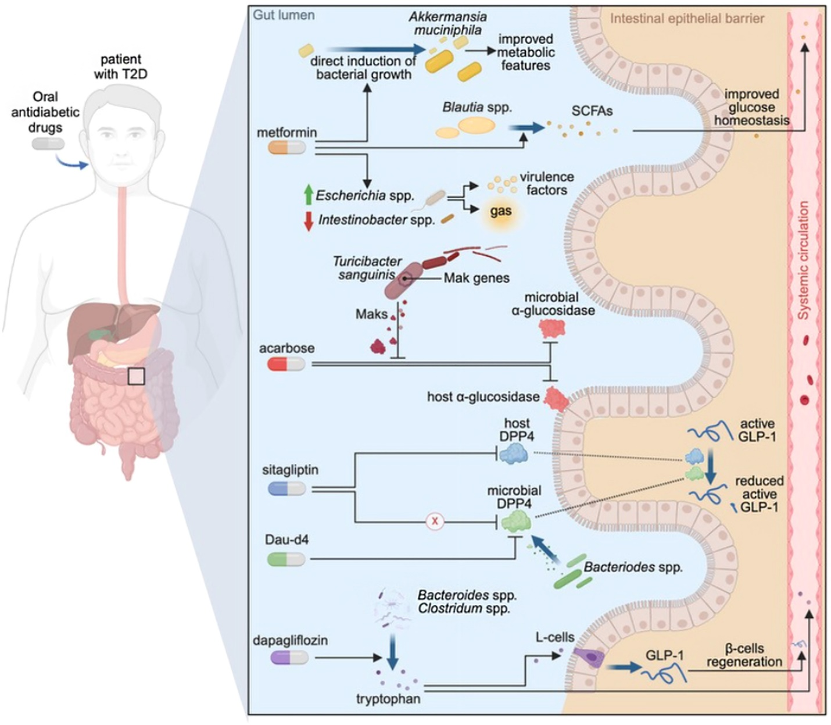
Figure 1 illustrates how gut microbiota modulates metabolic pathways in diabetes, including interactions with antidiabetic drugs, SCFA production, and intestinal barrier integrity. (13)
Rationale for Personalized Approaches in Diabetes Treatment
The current diabetes treatment follows a generic approach, often giving rise to the efficacy of therapy to vary and adverse effects. The heterogeneity of diabetes being affected by genetics, lifestyle, microbiome composition, and metabolic profile highlights the urgent need for precision medicine focused on an individual's unique characteristics. (14)
Recent success in metagenomics, metabolomics, and artificial intelligence (AI)-driven data analysis has encouraged a deeper understanding of the impact of the microbiome on diabetes. (15) The invention of these technologies enhances the recognition of microbial biomarkers, giving way to personalized interventions that can regulate glycemic control. For example, personalized dietary recommendations that rely on microbiome profiling have offered promising results in refining postprandial glucose responses. (10)
By incorporating microbiome science into personalized diabetes treatment plans, healthcare professionals can improve patient therapeutic outcomes, reduce adverse effects, and develop microbiome-targeted therapies. (16) This comprehensive review aims to explore the complex correlation between gut microbiota and diabetes, with an emphasis on personalized microbiome-based strategies and their potential to modernize the management of diabetes. By extracting current literature, we will provide insights into the potential of gut microbiota modulation as the bedrock of personalized diabetes care, opening doors for microbiome-based therapeutic innovations. (7)
Gut Microbiota and Its Role in Glucose Homeostasis
Composition and Function of Gut Microbiota
Trillions of microorganisms, including bacteria, viruses, fungi, archaea, and protozoa, are found in the gut microbiota. (17)These microorganisms perform various physiological functions, such as modifying the immune system, maintaining the intestinal barrier, and metabolizing nutrients. Firmicutes and Bacteroidetes constitute the majority of the four bacterial phyla in the gut microbiota, which includes Actinobacteria, Proteobacteria, Bacteroidetes, and Firmicutes. (17)

A healthy microbiome enhances proper digestion, aids in metabolite production, and helps combat pathogenic microorganisms. (16) It plays a role in glucose extraction for energy, gut hormone regulation, and inflammatory pathways. Additionally, gut bacteria assist in the fermentation of dietary fibers to produce short-chain fatty acids (SCFAs) such as acetate, propionate, and butyrate, which influence insulin sensitivity and glucose metabolism. (18)

However, dysbiosis refers to changes in the composition of the microbiota, which can lead to metabolic disorders such as obesity, insulin resistance, and diabetes. (10) Any alteration in gut microbiota can result in high gut permeability, chronic inflammation, and altered metabolic signaling, which may further lead to glucose homeostasis impairment. (19)Explaining the relationship between gut microbiota and glucose metabolism gives a foundation for creating microbiome-based interventions for diabetes management. (7)
Influence of Gut Microbiota on Insulin Sensitivity and Glucose Metabolism
Findings have revealed a close connection between the composition of the gut microbiota and insulin sensitivity, glucose metabolism, and metabolic health. Through several mechanisms mentioned below, the gut microbiota impacts these processes. (7,20)
1. Regulation of SCFA Production: Bacteria of economic importance, such as Faecalibacterium prausnitzii and Akkermansia muciniphila, can ferment dietary fibers to give SCFAs, which can subsequently improve the sensitivity of insulin, reduce inflammation, and normalize hepatic glucose production. (21) Butyrate, especially, has proven to help mitochondrial function better in muscle and liver cells, giving rise to better glucose uptake. (22)
2. Modulation of Gut Hormones: The gut microbiome is very useful in regulating gut-derived hormones like glucagon-like peptide-1 (GLP-1) and peptide YY (PYY), which enhance insulin secretion and appetite regulation. Some strains of bacteria encourage GLP-1 secretion, subsequently improving glycemic control. (23)
3. Influence on Intestinal Permeability and Inflammation: An impeded gut microbiota can mediate the intestinal barrier, facilitating the entry of lipopolysaccharides LPS and other bacterial endotoxins into the blood circulation, prompting low-grade chronic inflammation. This inflammatory state is related to insulin resistance, a trademark of Type 2 diabetes (24)
4. Metabolism of Acid: The composition of Bile acid is regularized by gut bacteria, which influences glucose metabolism through engagement of farnesoid X receptor (FXR) and Takeda G-protein receptor 5 (TGR5). Metabolic dysfunction can be a result of dysbiosis, which alters bile acid metabolism. (25)
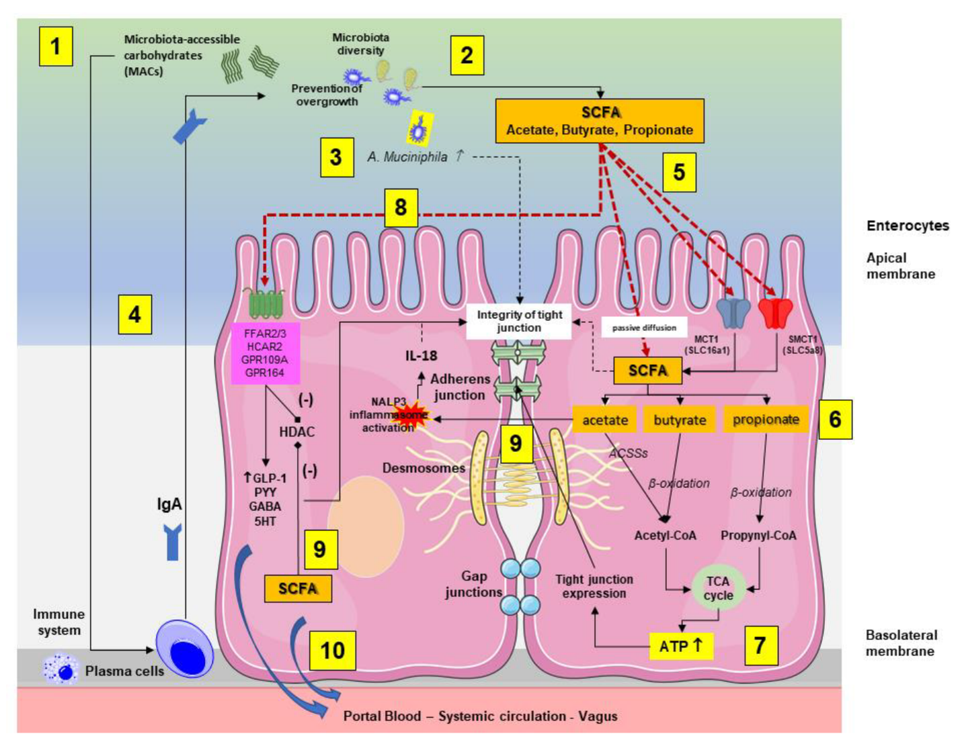

Figure 2: Mechanisms by which gut microbiota-derived short-chain fatty acids (SCFAs) regulate gut integrity, inflammation, and metabolism. SCFAs enhance tight junction integrity, modulate immune responses, and influence ATP production and gut hormone secretion, contributing to glucose homeostasis. (26)
Dysbiosis and Its Implications in Type 1 and Type 2 Diabetes
Type 1 and type 2 diabetes have been reported to experience Gut dysbiosis, even though the mechanism of action differs in each of them. (10)
Dysbiosis in Type 1 Diabetes
T1D is a self-destructive immune response identified by the loss of pancreatic β-cells, resulting in insulin deficiency. A lot of research has reported that people with T1D have lower microbial diversity, with fewer butyrate-producing bacteria (Faecalibacterium, Roseburia) and an elevated presence of pro-inflammatory bacteria such as Bacteroides. (27) The loss of beneficial SCFA-producing bacteria may give rise to dysregulation of the immune system and β-cell destruction. Also, a disparity in the microbiota composition in early life may affect immune system development and make an individual more susceptible to T1D. 28
Dysbiosis in Type 2 Diabetes
Insulin resistance is the major driver of Type 2 Diabetes, and the disparity in gut microbiota is highly related to its pathophysiology. Diabetic patients demonstrate a high Firmicutes/Bacteroidetes ratio, giving rise to improved energy extraction from food and potential weight gain. (7) They also present higher levels of bacteria that produce endotoxin, which can contribute to low-grade chronic inflammation and metabolic dysfunction. They also have lower populations of SCFA-producing bacteria, disrupting insulin sensitivity. (28) All these changes can facilitate systemic inflammation, oxidative stress, and metabolic disturbances, further deteriorating glycemic control. Funny enough, some microbial signatures may serve as biomarkers for predicting diabetes, leading to advances in microbiome-based diagnostics and interventions. (29)
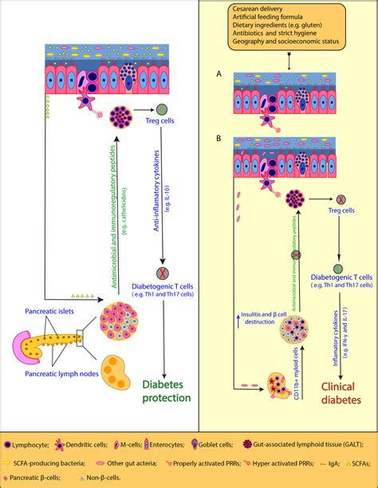
Figure 3: The gut microbiota role in modulating immune responses and the development of Type 1 Diabetes (T1D). A balanced microbiota supports Treg cells and anti-inflammatory cytokines, leading to diabetes protection (left panel). Conversely, gut dysbiosis leads to increased diabetogenic T cells, β-cell destruction, and clinical diabetes. (30)

Recognizing the role of gut microbiota in diabetes has urged interest in microbiome-strategized therapies, including probiotics, prebiotics, fecal microbiota transplantation (FMT), and dietary modifications. Tackling dysbiosis through personalized interventions may provide an innovative therapeutic approach to effectively manage diabetes. (27)

Mechanistic insights: Gut Microbiota-derived metabolites in diabetes
The gut microbiota is home to an intricate network of microorganisms that maintain an interdependent relationship with human health. Many studies have shown that they play a critical role in the development of some chronic diseases, such as obesity, diabetes, atherosclerosis, and non-alcoholic fatty liver disease. Recent research has also shown that metabolites produced by the gut microbiota, including short-chain fatty acids, bile acids, and lipopolysaccharides they are very essential in diabetes pathogenesis (31)
Impact of Short-chain fatty acids on metabolic pathways
The gut microbiota ferments nondigestible carbohydrates, which produce short-chain fatty acids (SCFA) as the main end products. They are the primary end products. (32) They are produced through saccharolytic fermentation of carbohydrates that escape digestion and absorption in the small intestine, and the pathways of SCFA production are well understood. Fermentation of Amino acids can also produce short-chain fatty acids, primarily acetate and propionate. This process is linked to methanogenesis and appears to be elevated in inflammatory conditions. (33)
SCFA and butyrate are important for maintaining the colonic epithelium. They also appear to play a role in regulating the integrity of the epithelial barrier through coordinated regulation of tight junction proteins (TJP), which regulate the intracellular molecular highway between the lumen and hepatic portal system. (32)
SCFA plays a potential regulatory role in glucose homeostasis in an adenosine monophosphate-activated protein kinase-dependent manner, involving peroxisome proliferator-activated receptor. Evidences suggest that SCFA elicits effects on multiple tissues in a concerted action to improve intestinal, hepatic, and whole-body glucose homeostasis. (26)

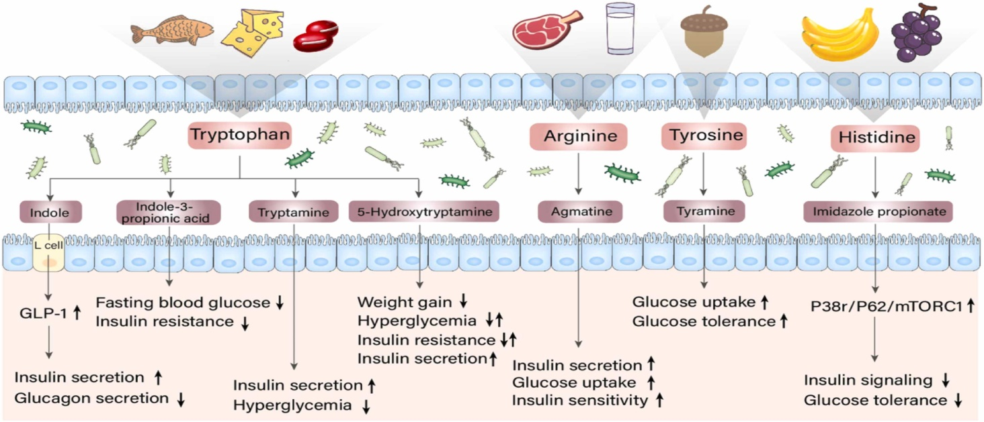
Figure 4: The potential effects of these metabolites on T2DM are shown(16)
Bile acid metabolism and its role in glycemic control
Bile acids (BAs), one of the main components of bile, are amphipathic molecules with detergent properties known mainly for their participation in the absorption of lipids and fat-soluble vitamins in the gut, as well as cholesterol solubilization in the bile and induction of bile flow. (34)
Research has shown BA's role in the treatment of diabetes, which is that bile acids act as a chelating agent in patients with type 2 diabetes. Also, bariatric surgery has demonstrated its contribution to bile acid metabolism as part of the benefits that help in glucose control in diabetic patients (35)

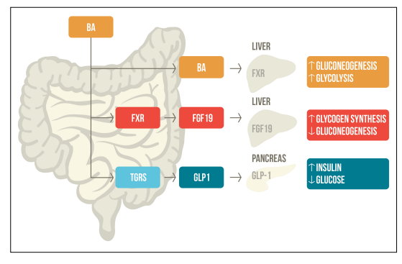

Figure 5. Bile acids regulate glucose metabolism through FXR and TGR5 activation. After a meal, bile acids stimulate these receptors, influencing glycogen synthesis, gluconeogenesis, and insulin secretion. (36)

Microbial lipopolysaccharides influence inflammation and insulin resistance.
Gram-negative bacteria's Lipopolysaccharides initiate inflammation. This LPS is taken up by LPS-binding protein and transferred to the TLR4 receptor complex, activating proinflammatory pathways.(37) Soluble CD14 is enhanced by LPS activation, leading to the recruitment of intracellular adaptor proteins and activation of proinflammatory kinases.(38) Nuclear factor kB (NFkB) and activator protein-1 (AP-1) transcription factors triggers the production of pro inflammatory proteins including tumor necrosis factor-a (TNFa), monocyte chemotactic protein (MCP)-1, and interleukin (IL)-6.(39)Disrupting TLR4 expression shields mice from the negative metabolic effect of a high fat diet including resistance to insulin and inflammation. These findings provide compelling evidence that the insulin signaling cascade is negatively regulated by TLR4.(40)

Personalized micro-biome-based interventions for diabetes
New research gives details of the potential of personalized micro-biome-based interventions for diabetes management. Some of these details include probiotics, prebiotics, fecal microbiota transplantation, dietary modifications, and microbiome-targeted drugs. (41)
Probiotics and prebiotics: Individualized formulations and therapeutic potential
Probiotics and prebiotics have been extensively studied for their potential benefits on gut health and immune function. (42) Probiotics are beneficial microorganisms that confer health benefits when administered in the right proportion. They are indigestible fibers that selectively feed beneficial bacteria in the gut, leading to increased health outcomes. (43) Despite an increase in prebiotic human studies, a comprehensive review of major databases has revealed a notable absence of meta-analyses on malnutrition and a scarcity of population-based prebiotic research. (42) There have, however, been several reviews and meeting reports highlighting the ability of prebiotics to alter the gut microbiota. A lot of personalized probiotic formulations, based on people’s microbial profile, may optimize therapeutic outcomes. Prebiotics, like inulin and resistant starch, selectively stimulate SCFA-producing bacteria. (44)
Some specific strains, such as Lactobacillus and Bifidobacterium, improve insulin sensitivity by reducing inflammation and enhancing gut barrier integrity. (45)

Fecal microbiota transplantation: A precision approach for gut microbiota modulation
While transferring fecal matter from a healthy donor to a recipient aiming to restore microbial diversity is called Fecal Microbiota Transplantation or Fecal Infusion. It requires the introduction of a liquid healthy donor into the patient's gastrointestinal tract for the treatment of a specific disease. (46) It can be done via several methods, such as the nasojejunal tube, upper endoscopy, and retention enemas, which are the preferred mode of delivery. The best route for administration depends on the features and location of the disease, as shown by successful results obtained in the treatment of metabolic diseases by the duodenal administration of feces. (47)
Finally, donor selection is important and easier for FMT than for other organ transplants, but accurate evaluation is necessary to avoid disease transmission to the recipient. (48)
Dietary modifications: Nutritional interventions targeting specific microbial profiles
A balanced diet is essential to maintain a symbiotic relationship between the host and gut microbiota. It provides enough energy, vitamins, proteins, and minerals to maintain optimal bodily functions. (49) Proper nutrition safeguards the intestines by stimulating mucus production and activating immune cells, such as goblet and Paneth cells, to produce antimicrobial peptides. (50) Proper nutrition can disrupt the intestinal epithelial cells, resulting in enteric infections in the host. Targeted microbiota modulation through probiotics and diet may be used to promote organism gut microbiota health. (49)

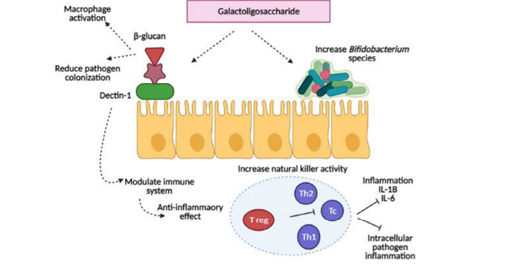

Figure 6 shows the role of galactooligosaccharides in maintaining intestinal integrity. (51)
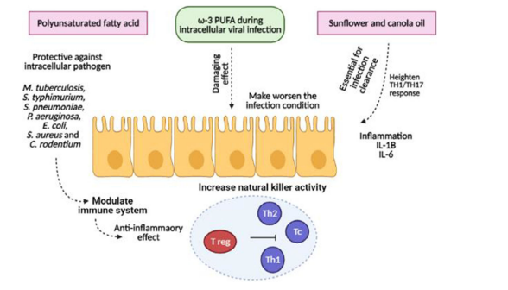
Figure 7 shows the effect of omega-3 fatty acids during the intracellular viral infection. (52)

Pharmacological modulation: microbiome-targeted drugs in diabetes management
The gut microbiota plays a crucial role in diabetes prevention and treatment, as it regulates various biological functions and depends on adjustable factors like diet or drugs. (27)The high increase in the prevalence of type 2 diabetes could be due to environmental changes. (53) Genetic and environmental factors affect the composition of gut microbiota, but unless significant ecological changes occur, it remains stable in adult individuals (54)

One specific bacterium that has been the focus of several obesity and type 2 diabetes studies is the mucus-colonising Akkermansia muciniphila. Zhang et al found A. muciniphila to be decreased in individuals with prediabetes and newly diagnosed type 2 diabetes, suggesting that low abundance of this bacterium could be a biomarker for glucose intolerance. (55) More recently, A. muciniphila was observed to be decreased before the onset of type 2 diabetes in twins, while high abundance was associated with a healthier metabolic status in overweight/obese humans and greater improvements in glucose homeostasis and body composition after energy restriction. (56)

Advances in Microbiome-Based Precision Medicine
Metagenomics Sequencing and Microbiome Profiling for Personalized Treatment
The concept of metagenomics suggests pairs of genes might be detected and analyzed in a sample. Metagenomics has promise as a revolutionary approach that might transform diagnosis in infectious illnesses, replacing the conventional culture-based microbiology that has essentially stayed the same for decades. (57) Using whole genome sequencing (WGS), metagenomics aims to analyze the functional capabilities and biodiversity of the microbial community. (58) By retrieving all the genetic material from a sample, researchers can characterize the entire range of organisms present in a habitat. This includes bacteria, viruses, plasmids, eukaryotes, and archaea with their respective gene content. (58)
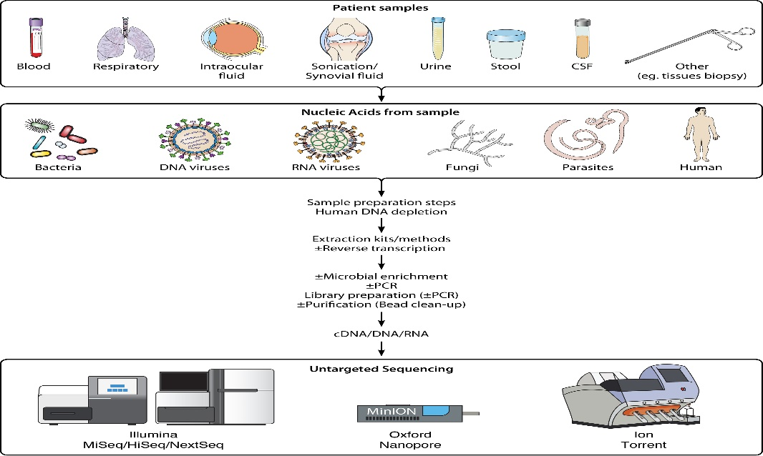
Figure 8 represents the metagenomics flow diagram of patient samples undergoing nucleic acid extraction. (59)
Microbial profiling has become important for understanding and identifying microbial diversity. Recent advancements in molecular biology are enhancing the ability to conduct more research on microbiomes, including those involving uncultivated species. (60) These evolutions allow researchers to investigate microbial ecosystems effectively, emphasizing the roles of diverse microorganisms in their habitat. (61)
The human body houses glycomes and supports microbial habitats that initiate interactions between organs, which serve as a crucial factor in metabolic processes. (62) Personalized medicine is leveraging microbiome profiling and metagenomics. Identifying microbial populations and the effect they have on human health provides important awareness. (63) The formation and roles of these microbial communities enable personalized healthcare delivery. The indication of an organized approach in medicine shows how useful the microbiome is in transforming human health. (64) Concurrently, precision medicine is gaining relevance, aiming to provide adequate personalized healthcare treatments that consider the genetic makeup of individuals, lifestyle, and environmental exposures. (65) This approach will change how health and disease management are observed, with the possibility of organizing approaches that are effective for each person. (66)
Machine Learning and AI-Driven Microbiome Analysis for Individualized Diabetes
Diabetes encompasses a diverse metabolic disorder that is depicted by hyperglycemia, resulting from abnormalities in the action of insulin secretion, or both. Various pathogenic mechanisms contribute to the initiation of diabetes, including factors that lead to insulin resistance and autoimmune damage to pancreatic cells, which ultimately leads to insufficient insulin production. (67) This inadequacy may present either reduced insulin secretion or decreased response of tissues to insulin, alongside complex hormonal pathways, which result in a deficiency in insulin action. (1) Combining artificial intelligence in managing diabetes has changed therapy and monitoring strategies. AI-powered technologies, which include machine learning and advanced algorithms, help with early evaluation, allowing for prompt intervention and customized treatment plans. (68) By analyzing the patient data, AI will improve the accuracy of diabetes prognosis, facilitating personalized treatment options and improving health outcomes. (69) Furthermore, AI has encouraged the development of new diabetes medications, enlarging the available therapeutic options. In Addition, the ability to make decisions by AI systems and self-management tools empowers patients, allowing them to manage their diabetes actively. (68)
Recently, research has investigated the relationship between the microbiome, metabolome, and lipidome in Type 1 Diabetes, with the aid of machine learning (ML) techniques for analysis. (70)The results show that models focusing on metabolite composition are more precise in predicting T1D status than those based on gut microbiota composition, which demonstrates moderate accuracy. (71) Specific lipids, metabolites, and bacterial species have been identified as likely biomarkers for T1D. This shows the importance of integrating various biological layers to enhance our understanding and potential prediction of T1D. (72)
Gut Microbiota Biomarkers for Predicting Therapeutic Responses
The gut of humans represents a large microbial ecosystem that houses about trillions of microorganisms. These microorganisms interact with the host, where they aid in digestion, immunity, and overall health. (62) Preserving healthy homeostasis, which includes immune system development, vitamin production, nutrient absorption, epithelial mucosa integrity, and pathogen resistance, depends on the interaction. (73)Given this relationship, a term known as dysbiosis is defined as an alteration in the makeup of the microbiota and is related to several human disorders, which include both extra-digestive and digestive cancers. (74)
The gut microbiome as an indicator of how well a treatment will work has become a subject of recent research. Studies have shown that a higher microbial population and an increased number of bacteria producing short-chain fatty acids are related to the fast response of anti-integrin medications in inflammatory bowel disease (IBD). (75) This indicates that the composition and benefits of the gut microbiome play a crucial role in patient outcomes and in organizing therapeutic approaches in IBD, and also in other conditions. (76)This relationship could lead to efficient personalized treatment strategies that leverage the microbiome to enhance therapeutic efficacy. (77) With the increased response of gut microbiota for cancer therapy, it will be a novel strategy that might pave the way for gut microbial diversities as a prognostic indicator for cancer therapies, such as immunotherapy, chemotherapy, radiation, and surgery. (78) Sequencing metagenomic shotgun and 16S rRNA of patient fecal samples has been utilized to elucidate specific pathways for digestive malignancies and other cancers. (79)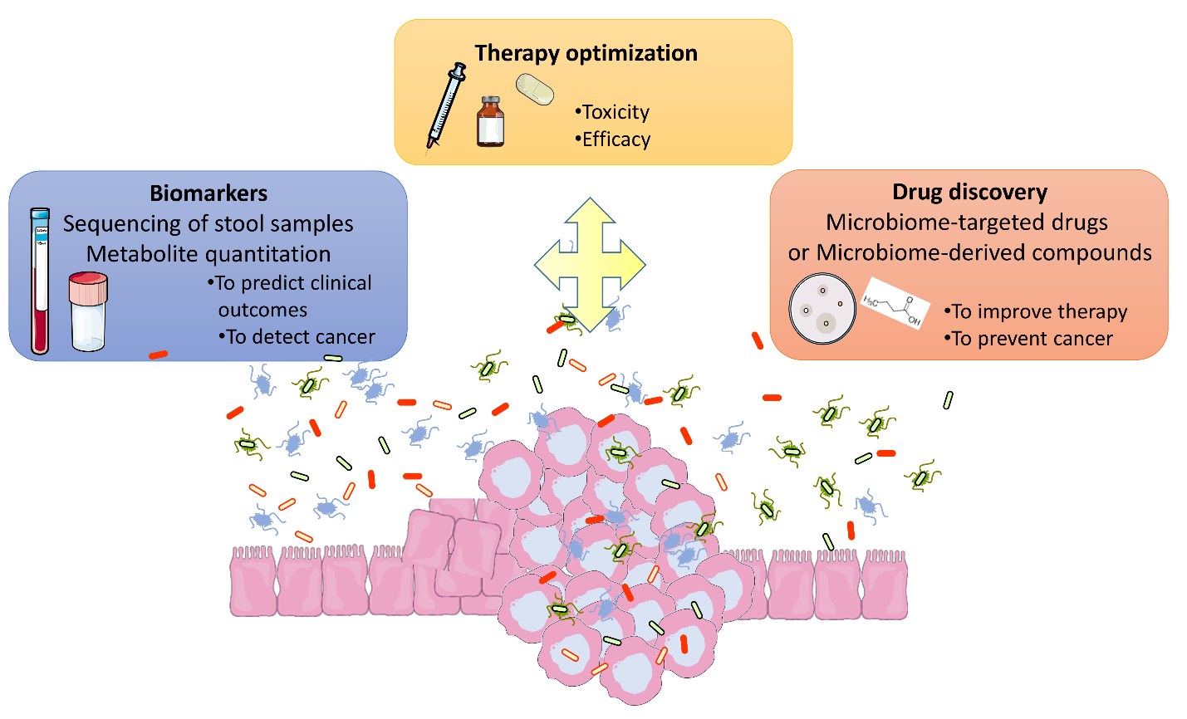
Figure 9 shows the usage of the gut microbiota in the discovery of new and innovative therapeutic tools (52)
Challenges and Future Directions
Variability in Microbiome Composition Across Populations
Microbiota can differ greatly among individuals and in their interactions with their various human hosts, which is influenced by multiple sites. Research, which includes studies from the Human Microbiome Project, revealed that formation of gut microbiomes differs among human groups and is influenced by different factors which including nutrition, lifestyle, ethnicity, and genetics. (80) These differences show the advantage of including these factors when examining microbiota in other groups. The function of gut microbiomes can be influenced by dietary practices, including the eating of a particular food, such as dairy or fermented foods. (49) Specific microbial signatures, which represent past eating patterns and cultural behaviors, can also be influenced by location and ethnicity. (81) As research continues to investigate these relationships, understanding the importance of microbiome composition can aid in developing targeted health interventions and treatments tailored to specific populations. (82) Various population-based factors influence the variance in microbiome profiles. In a case study, Dutch individuals ingest more milk and fewer antibiotics than those in other European nations, and as such, identifying microbiome-based biomarkers for specific illnesses involves considering the population-based differences and microbial composition among healthy individuals. (80) Numerous reviews of microbiome studies from different perspectives have been published recently, but a thorough overview of the findings related to changes in microbiome composition specific to geography, ethnicity, or lifestyle is long overdue (80)
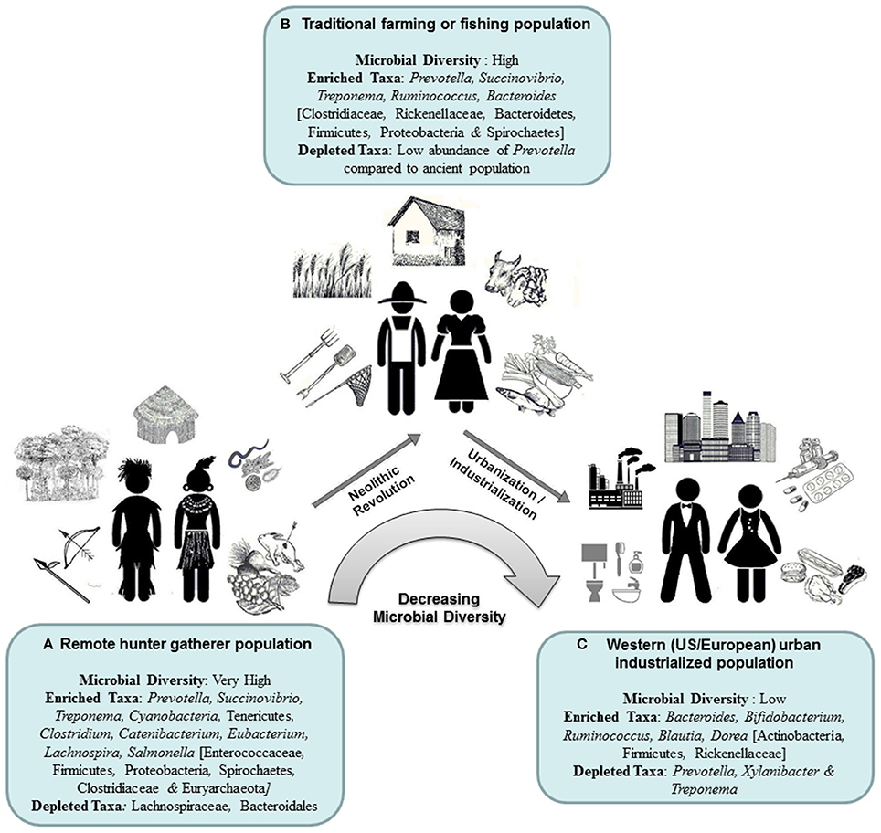
Figure 10 shows the geographical variations in gut microbiome formation 84
Ethical Considerations in Microbiome-Based Interventions
Microbiome research presents several ethical challenges in clinical settings, particularly regarding personal identity, privacy, and data protection. (83) Since microbiome data can reveal sensitive insights about individuals, there is a risk of unintended consequences if this information is misused or disclosed improperly. (84) For instance, microbiome profiles could be linked to health predispositions, raising questions about how this data should be managed and individuals' rights over their microbiome information. (80)
Most microbiome research utilizes low-risk, noninvasive sampling methods, such as fecal self-collection, saliva collection, oral, vaginal, and nasal swabs, and skin brushing. (85) Aside from the invasive endoscopic samples required to gather and examine gut microbiota, the risks associated with studying the human microbiome are generally minimal. Microbiome research should investigate whether current legislation is sufficient to protect the privacy of personal information, as human microbial profiles may reveal clear insights about an individual's habits and lifestyle. (80)Furthermore, given the potential for personal identification from microbial samples, the privacy protections currently in place for human tissue samples and genetic information should be extended to microbiome research. (83)
Significant concerns about biobanking, informed consent, and commercialization arise from the gathering and analysis of microbiome data. Participants of the investigation must be fully aware of how their microbiome data will be used, shared, and preserved, making informed consent critical. (86) Because microbiome data might reveal sensitive information about an individual's health, its implications must be communicated clearly due to this complication. (15) Another ethical consideration in human microbiome research is the use of biobanks as essential infrastructures. Although the goals and scope of human microbiota biobanks and the clinical data differ from those of biobanks holding human tissue samples, microbiota samples remain important medical resources with considerable promise for treating various illnesses. (83) Thus, they must be handled with the same privacy protection as human tissue samples. Research institutions and clinics worldwide are organizing an increasing number of stool banks, supporting personalized medicine objectives and maximizing the therapeutic use of stool samples for procedures like fecal microbiota transplantation (FMT) (87)
Need for Large-Scale Clinical Trials to Validate Microbiome-Targeted Therapies
Studies have revealed the potential of microbiome-targeted treatments for various illnesses, which include metabolic and functional gastrointestinal disorders (FGIDs). (88) Despite this, some important obstacles remain before microbiome research can be effectively applied in therapeutic contexts. (77) Successfully translating FGIDs requires a systems approach that will incorporate multiple layers of data, given the subtle diversity in microbiota formation and the need for more precise adjustments in microbial activity. (89) Fecal microbiota transplantation represents a new concept for treating intestinal microbiota diseases. However, the reactions, ethical dilemmas, and mechanisms of action that are connected with FMT continue to be points of contention. (90) Diverse reports about the safety and efficacy of Fecal microbiota transplantation treatment largely arise from the inconsistencies in donor screening processes, the production and condition of the fecal bacterial solution, and the methods that are used for transplantation. (91) This variability
highlights the necessity for standardized protocols and further research to fully understand how FMT can be effectively applied in clinical settings. Future, efficient randomized controlled clinical trials are important to handle these concerns and to provide more evidence-based medical information. This verification is crucial for confirming the efficiency of microbiome-targeted therapies and for understanding their influence on various health conditions. (78) Research should be done extensively to help in understanding the relationships that are between microbiome formation, individual variability, and therapeutic outcomes, which will lead to better treatment strategies that accommodate the unique microbiome profiles of diverse populations. (92) By emphasizing these rigorous trials, the medical community can more effectively harness microbiome research for personalized medicine.
Integrating Microbiome Research with Other Omics Approaches for Holistic Precision Medicine
In complex metabolic diseases, the incorporation of multi-omics becomes a powerful tool for predicting treatment responses. (93)By incorporating clinical data in genomics, transcriptomics, proteomics, and metabolomics, we can identify the predictive and diagnostic biomarkers that will facilitate personalized medicine. This holistic view of patient biology aids in the ability to approach therapies based on individual profiles and also improves the outcomes in metabolic disorders. (94) The field of multi-omics combines information from many large-scale platforms, like microbiomics, metabolomics, transcriptomics, proteomics, epigenomics, and genomics. By using this approach, scientists can better understand illnesses and also develop treatment pathways and actionable biomarkers. Multi-omics gives researchers a previously unknown capacity to identify the complex relationships and underlying causes of health and illness by combining data from several molecular levels. (95)Through the use of this integrated approach, multi-omics will help in understanding disease development and treatment efficacy, going beyond discrete findings. 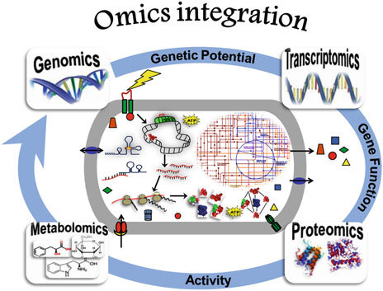
Figure 11 illustrates the integration of multi-omics approaches in microbiome research, highlighting the intricate cellular processes and interactions between biological layers in response to external stimuli. (96)

Conclusion
The role of gut microbiota in the pathophysiology and treatment of diabetes is rapidly increasing, enabling the room for microbiome-targeted strategies to enhance glycemic control and metabolic health. Personalized procedures utilizing microbiome profiling, AI-driven analytics, and precision nutrition offer a paradigm shift in diabetes management. Nevertheless, important challenges are still there, which include population-based variability in microbiome composition, ethical considerations in microbiome research, and the importance of robust clinical validation. Future studies should expatiate on integrating microbiome data with other omics technologies to transform precision medicine strategies and develop targeted microbiome-based therapeutics. Tackling this menace will enhance the transcribing of microbiome science into clinical settings, leading to enhanced patient outcomes and advancing the field of diabetes care.

REFERENCES
1. Dilworth L, Facey A, Omoruyi F. Diabetes Mellitus and Its Metabolic Complications: The Role of Adipose Tissues. Int J Mol Sci. 2021 Jan;22(14):7644.
2. International Diabetes Federation [Internet]. [cited 2025 Mar 27]. Facts & figures. Available from: https://idf.org/about-diabetes/diabetes-facts-figures/
3. A systematic review of the economic burden of diabetes mellitus: contrasting perspectives from high and low middle-income countries - PMC [Internet]. [cited 2025 Mar 27]. Available from: https://pmc.ncbi.nlm.nih.gov/articles/PMC11034455/
4. Diagnosis and Classification of Diabetes Mellitus. Diabetes Care. 2009 Jan;32(Suppl 1):S62–7.
5. Sugandh F, Chandio M, Raveena F, Kumar L, Karishma F, Khuwaja S, et al. Advances in the Management of Diabetes Mellitus: A Focus on Personalized Medicine. Cureus. 15(8):e43697.
6. Yan Q, Li D, Jia S, Yang J, Ma J. Novel gene-based therapeutic approaches for the management of hepatic complications in diabetes: Reviewing recent advances. J Diabetes Complications. 2024 Feb 1;38(2):108688.
7. Craciun CI, Neag MA, Catinean A, Mitre AO, Rusu A, Bala C, et al. The Relationships between Gut Microbiota and Diabetes Mellitus, and Treatments for Diabetes Mellitus. Biomedicines. 2022 Jan 28;10(2):308.
8. Thursby E, Juge N. Introduction to the human gut microbiota. Biochem J. 2017 Jun 1;474(11):1823–36.
9. Patra D, Banerjee D, Ramprasad P, Roy S, Pal D, Dasgupta S. Recent insights of obesity-induced gut and adipose tissue dysbiosis in type 2 diabetes. Front Mol Biosci. 2023 Sep 28;10:1224982.
10. Menafra D, Proganò M, Tecce N, Pivonello R, Colao A. Diet and gut microbiome: Impact of each factor and mutual interactions on prevention and treatment of type 1, type 2, and gestational diabetes mellitus. Hum Nutr Metab. 2024 Dec 1;38:200286.
11. Gao R, Meng X, Xue Y, Mao M, Liu Y, Tian X, et al. Bile acids-gut microbiota crosstalk contributes to the improvement of type 2 diabetes mellitus. Front Pharmacol. 2022 Oct 25;13:1027212.
12. Sahle Z, Engidaye G, Shenkute Gebreyes D, Adenew B, Abebe TA. Fecal microbiota transplantation and next-generation therapies: A review on targeting dysbiosis in metabolic disorders and beyond. SAGE Open Med. 2024 May 31;12:20503121241257486.
13. Baars DP, Fondevila MF, Meijnikman AS, Nieuwdorp M. The central role of the gut microbiota in the pathophysiology and management of type 2 diabetes. Cell Host Microbe. 2024 Aug 14;32(8):1280–300.
14. Chung FM, Yang YH, Shieh TY, Shin SJ, Tsai JCR, Lee YJ. Effect of alcohol consumption on estimated glomerular filtration rate and creatinine clearance rate. Nephrol Dial Transplant Off Publ Eur Dial Transpl Assoc - Eur Ren Assoc. 2005 Aug;20(8):1610–6.
15. Abavisani M, Khoshrou A, Foroushan SK, Ebadpour N, Sahebkar A. Deciphering the gut microbiome: The revolution of artificial intelligence in microbiota analysis and intervention. Curr Res Biotechnol. 2024 Jan 1;7:100211.
16. Liu J, Tan Y, Cheng H, Zhang D, Feng W, Peng C. Functions of Gut Microbiota Metabolites, Current Status and Future Perspectives. Aging Dis. 2022 Jul 11;13(4):1106–26.
17. Caballero-Flores G, Pickard JM, Núñez G. Microbiota-mediated colonization resistance: mechanisms and regulation. Nat Rev Microbiol. 2023 Jun;21(6):347–60.
18. den Besten G, van Eunen K, Groen AK, Venema K, Reijngoud DJ, Bakker BM. The role of short-chain fatty acids in the interplay between diet, gut microbiota, and host energy metabolism. J Lipid Res. 2013 Sep;54(9):2325–40.
19. Hrncir T. Gut Microbiota Dysbiosis: Triggers, Consequences, Diagnostic and Therapeutic Options. Microorganisms. 2022 Mar 7;10(3):578.
20. Palmnäs-Bédard MS, Costabile G, Vetrani C, Åberg S, Hjalmarsson Y, Dicksved J, et al. The human gut microbiota and glucose metabolism: a scoping review of key bacteria and the potential role of SCFAs. Am J Clin Nutr. 2022 Oct 1;116(4):862–74.
21. Fusco W, Lorenzo MB, Cintoni M, Porcari S, Rinninella E, Kaitsas F, et al. Short-Chain Fatty-Acid-Producing Bacteria: Key Components of the Human Gut Microbiota. Nutrients. 2023 May 6;15(9):2211.
22. Mollica MP, Mattace Raso G, Cavaliere G, Trinchese G, De Filippo C, Aceto S, et al. Butyrate Regulates Liver Mitochondrial Function, Efficiency, and Dynamics in Insulin-Resistant Obese Mice. Diabetes. 2017 May;66(5):1405–18.
23. Zeng Y, Wu Y, Zhang Q, Xiao X. Crosstalk between glucagon-like peptide 1 and gut microbiota in metabolic diseases. mBio. 15(1):e02032-23.
24. Vincenzo FD, Gaudio AD, Petito V, Lopetuso LR, Scaldaferri F. Gut microbiota, intestinal permeability, and systemic inflammation: a narrative review. Intern Emerg Med. 2023 Jul 28;19(2):275.
25. Pathak P, Xie C, Nichols RG, Ferrell JM, Boehme S, Krausz KW, et al. Intestine farnesoid X receptor agonist and the gut microbiota activate G-protein bile acid receptor-1 signaling to improve metabolism. Hepatol Baltim Md. 2018 Oct;68(4):1574–88.
26. Portincasa P, Bonfrate L, Vacca M, De Angelis M, Farella I, Lanza E, et al. Gut Microbiota and Short Chain Fatty Acids: Implications in Glucose Homeostasis. Int J Mol Sci. 2022 Jan;23(3):1105.
27. Sadagopan A, Mahmoud A, Begg M, Tarhuni M, Fotso M, Gonzalez NA, et al. Understanding the Role of the Gut Microbiome in Diabetes and Therapeutics Targeting Leaky Gut: A Systematic Review. Cureus. 15(7):e41559.
28. Festi D, Schiumerini R, Eusebi LH, Marasco G, Taddia M, Colecchia A. Gut microbiota and metabolic syndrome. World J Gastroenterol WJG. 2014 Nov 21;20(43):16079–94.
29. Oguntibeju OO. Type 2 diabetes mellitus, oxidative stress and inflammation: examining the links. Int J Physiol Pathophysiol Pharmacol. 2019 Jun 15;11(3):45.
30. Abdellatif AM, Sarvetnick NE. Current understanding of the role of gut dysbiosis in type 1 diabetes. J Diabetes. 2019 Aug;11(8):632–44.
31. Brandsma E, Kloosterhuis NJ, Koster M, Dekker DC, Gijbels MJJ, van der Velden S, et al. A Proinflammatory Gut Microbiota Increases Systemic Inflammation and Accelerates Atherosclerosis. Circ Res. 2019 Jan 4;124(1):94–100.
32. Morrison DJ, Preston T. Formation of short-chain fatty acids by the gut microbiota and their impact on human metabolism. Gut Microbes. 2016 Mar 10;7(3):189–200.
33. Mutuyemungu E, Singh M, Liu S, Rose DJ. Intestinal gas production by the gut microbiota: A review. J Funct Foods. 2023 Jan 1;100:105367.
34. Alberto González-Regueiro J, Moreno-Castañeda L, Uribe M, Carlos Chávez-Tapia N. The Role of Bile Acids in Glucose Metabolism and Their Relation with Diabetes. Ann Hepatol. 2017 Nov 1;16:S15–20.
35. Hou Y, Zhai X, Wang X, Wu Y, Wang H, Qin Y, et al. Research progress on the relationship between bile acid metabolism and type 2 diabetes mellitus. Diabetol Metab Syndr. 2023 Nov 17;15:235.
36. Sonne DP, Hansen M, Knop FK. Bile acid sequestrants in type 2 diabetes: potential effects on GLP1 secretion. Eur J Endocrinol. 2014 Aug;171(2):R47-65.
37. Farhana A, Khan YS. Biochemistry, Lipopolysaccharide. In: StatPearls [Internet]. Treasure Island (FL): StatPearls Publishing; 2025 [cited 2025 Mar 27]. Available from: http://www.ncbi.nlm.nih.gov/books/NBK554414/
38. Ciesielska A, Matyjek M, Kwiatkowska K. TLR4 and CD14 trafficking and its influence on LPS-induced pro-inflammatory signaling. Cell Mol Life Sci CMLS. 2020 Oct 15;78(4):1233–61.
39. Liu T, Zhang L, Joo D, Sun SC. NF-κB signaling in inflammation. Signal Transduct Target Ther. 2017 Jul 14;2:17023.
40. Lancaster GI, Langley KG, Berglund NA, Kammoun HL, Reibe S, Estevez E, et al. Evidence that TLR4 Is Not a Receptor for Saturated Fatty Acids but Mediates Lipid-Induced Inflammation by Reprogramming Macrophage Metabolism. Cell Metab. 2018 May 1;27(5):1096-1110.e5.
41. Koneru HM, Sarwar H, Bandi VV, Sinha M, Tarar P, Bishara R, et al. A Systematic Review of Gut Microbiota Diversity: A Key Player in the Management and Prevention of Diabetes Mellitus. Cureus. 16(9):e69687.
42. Sheridan PO, Bindels LB, Saulnier DM, Reid G, Nova E, Holmgren K, et al. Can prebiotics and probiotics improve therapeutic outcomes for undernourished individuals? Gut Microbes. 2014 Jan 1;5(1):74–82.
43. Ji J, Jin W, Liu S, Jiao Z, Li X. Probiotics, prebiotics, and postbiotics in health and disease. MedComm. 2023 Nov 4;4(6):e420.
44. Bamigbade GB, Subhash AJ, Kamal-Eldin A, Nyström L, Ayyash M. An Updated Review on Prebiotics: Insights on Potentials of Food Seeds Waste as a Source of Potential Prebiotics. Molecules. 2022 Sep 13;27(18):5947.
45. Crudele L, Gadaleta RM, Cariello M, Moschetta A. Gut microbiota in the pathogenesis and therapeutic approaches of diabetes. eBioMedicine. 2023 Oct 5;97:104821.
46. Biazzo M, Deidda G. Fecal Microbiota Transplantation as New Therapeutic Avenue for Human Diseases. J Clin Med. 2022 Jul 15;11(14):4119.
47. Verdier C, Denis S, Gasc C, Boucinha L, Uriot O, Delmas D, et al. An Oral FMT Capsule as Efficient as an Enema for Microbiota Reconstruction Following Disruption by Antibiotics, as Assessed in an In Vitro Human Gut Model. Microorganisms. 2021 Feb 11;9(2):358.
48. Greenwald MA, Kuehnert MJ, Fishman JA. Infectious Disease Transmission during Organ and Tissue Transplantation. Emerg Infect Dis. 2012 Aug;18(8):e1.
49. Zhang P. Influence of Foods and Nutrition on the Gut Microbiome and Implications for Intestinal Health. Int J Mol Sci. 2022 Aug 24;23(17):9588.
50. Zhang M, Wu C. The relationship between intestinal goblet cells and the immune response. Biosci Rep. 2020 Oct 16;40(10):BSR20201471.
51. Salazar N, Arboleya S, Valdés L, Stanton C, Ross P, Ruiz L, et al. The human intestinal microbiome at extreme ages of life. Dietary intervention as a way to counteract alterations. Front Genet. 2014 Nov 21;5:406.
52. Lundberg R. Humanizing the gut microbiota of mice: Opportunities and challenges. Lab Anim. 2019 Jun 1;53(3):244–51.
53. Dendup T, Feng X, Clingan S, Astell-Burt T. Environmental Risk Factors for Developing Type 2 Diabetes Mellitus: A Systematic Review. Int J Environ Res Public Health. 2018 Jan;15(1):78.
54. Ahn J, Hayes RB. Environmental Influences on the Human Microbiome and Implications for Noncommunicable Disease. Annu Rev Public Health. 2021 Apr 1;42:277–92.
55. Mruk-Mazurkiewicz H, Kulaszyńska M, Czarnecka W, Podkówka A, Ekstedt N, Zawodny P, et al. Insights into the Mechanisms of Action of Akkermansia muciniphila in the Treatment of Non-Communicable Diseases. Nutrients. 2024 May 29;16(11):1695.
56. Yan J, Sheng L, Li H. Akkermansia muciniphila: is it the Holy Grail for ameliorating metabolic diseases? Gut Microbes. 13(1):1984104.
57. Roux S, Matthijnssens J, Dutilh BE. Metagenomics in Virology. Encycl Virol. 2021;133–40.
58. Pérez-Cobas AE, Gomez-Valero L, Buchrieser C. Metagenomic approaches in microbial ecology: an update on whole-genome and marker gene sequencing analyses. Microb Genomics. 2020 Jul 24;6(8):mgen000409.
59. Govender KN, Street TL, Sanderson ND, Eyre DW. Metagenomic Sequencing as a Pathogen-Agnostic Clinical Diagnostic Tool for Infectious Diseases: a Systematic Review and Meta-analysis of Diagnostic Test Accuracy Studies. J Clin Microbiol. 2021 Aug 18;59(9):e0291620.
60. Van Rossum T, Ferretti P, Maistrenko OM, Bork P. Diversity within species: interpreting strains in microbiomes. Nat Rev Microbiol. 2020 Sep 1;18(9):491–506.
61. Tomasulo A, Simionati B, Facchin S. Microbiome One Health model for a healthy ecosystem. Sci One Health. 2024 Jan 1;3:100065.
62. Ogunrinola GA, Oyewale JO, Oshamika OO, Olasehinde GI. The Human Microbiome and Its Impacts on Health. Int J Microbiol. 2020 Jun 12;2020:8045646.
63. Virgin HW, Todd JA. METAGENOMICS AND PERSONALIZED MEDICINE. Cell. 2011 Sep 30;147(1):44–56.
64. Microbiome and Human Health: Current Understanding, Engineering, and Enabling Technologies - PMC [Internet]. [cited 2025 Mar 27]. Available from: https://pmc.ncbi.nlm.nih.gov/articles/PMC9837825/
65. Precision and Personalized Medicine: How Genomic Approach Improves the Management of Cardiovascular and Neurodegenerative Disease - PMC [Internet]. [cited 2025 Mar 27]. Available from: https://pmc.ncbi.nlm.nih.gov/articles/PMC7397223/
66. Nilsen P, Seing I, Ericsson C, Birken SA, Schildmeijer K. Characteristics of successful changes in health care organizations: an interview study with physicians, registered nurses and assistant nurses. BMC Health Serv Res. 2020 Feb 27;20(1):147.
67. Antar SA, Ashour NA, Sharaky M, Khattab M, Ashour NA, Zaid RT, et al. Diabetes mellitus: Classification, mediators, and complications; A gate to identify potential targets for the development of new effective treatments. Biomed Pharmacother Biomedecine Pharmacother. 2023 Dec;168:115734.
68. Guan Z, Li H, Liu R, Cai C, Liu Y, Li J, et al. Artificial intelligence in diabetes management: Advancements, opportunities, and challenges. Cell Rep Med. 2023 Oct 2;4(10):101213.
69. Mayya V, Kandala RNVPS, Gurupur V, King C, Vu GT, Wan TTH. Need for an Artificial Intelligence-based Diabetes Care Management System in India and the United States. Health Serv Res Manag Epidemiol. 2024 Aug 28;11:23333928241275292.
70. Tan H, Shi Y, Yue T, Zheng D, Luo S, Weng J, et al. Machine learning approach reveals microbiome, metabolome, and lipidome profiles in type 1 diabetes. J Adv Res. 2024 Oct;64:213–21.
71. Tan H, Shi Y, Yue T, Zheng D, Luo S, Weng J, et al. Machine learning approach reveals microbiome, metabolome, and lipidome profiles in type 1 diabetes. J Adv Res. 2023 Nov 30;64:213–21.
72. Gu Z, Pan L, Tan H, Wang X, Wang J, Zheng X, et al. Gut microbiota, serum metabolites, and lipids related to blood glucose control and type 1 diabetes. J Diabetes. 2024 Oct 27;16(10):e70021.
73. Yoo JY, Groer M, Dutra SVO, Sarkar A, McSkimming DI. Gut Microbiota and Immune System Interactions. Microorganisms. 2020 Oct;8(10):1587.
74. DeGruttola AK, Low D, Mizoguchi A, Mizoguchi E. Current understanding of dysbiosis in disease in human and animal models. Inflamm Bowel Dis. 2016 May;22(5):1137–50.
75. Mah C, Jayawardana T, Leong G, Koentgen S, Lemberg D, Connor SJ, et al. Assessing the Relationship between the Gut Microbiota and Inflammatory Bowel Disease Therapeutics: A Systematic Review. Pathogens. 2023 Feb 6;12(2):262.
76. Gyriki D, Nikolaidis C, Stavropoulou E, Bezirtzoglou I, Tsigalou C, Vradelis S, et al. Exploring the Gut Microbiome’s Role in Inflammatory Bowel Disease: Insights and Interventions. J Pers Med. 2024 May 11;14(5):507.
77. Gulliver EL, Young RB, Chonwerawong M, D’Adamo GL, Thomason T, Widdop JT, et al. Review article: the future of microbiome‐based therapeutics. Aliment Pharmacol Ther. 2022 Jul;56(2):192–208.
78. Yan J, Yang L, Ren Q, Zhu C, Du H, Wang Z, et al. Gut microbiota as a biomarker and modulator of anti-tumor immunotherapy outcomes. Front Immunol. 2024 Nov 28;15:1471273.
79. Aitmanaitė L, Širmonaitis K, Russo G. Microbiomes, Their Function, and Cancer: How Metatranscriptomics Can Close the Knowledge Gap. Int J Mol Sci. 2023 Jan;24(18):13786.
80. Ma Z, Zuo T, Frey N, Rangrez AY. A systematic framework for understanding the microbiome in human health and disease: from basic principles to clinical translation. Signal Transduct Target Ther. 2024 Sep 23;9(1):1–36.
81. Ethnicity influences the gut microbiota of individuals sharing a geographical location: a cross-sectional study from a middle-income country | Scientific Reports [Internet]. [cited 2025 Mar 28]. Available from: https://www.nature.com/articles/s41598-021-82311-3
82. Microbiome and Human Health: Current Understanding, Engineering, and Enabling Technologies - PMC [Internet]. [cited 2025 Mar 28]. Available from: https://pmc.ncbi.nlm.nih.gov/articles/PMC9837825/
83. Ejtahed HS, Parsa M, Larijani B. Ethical challenges in conducting and the clinical application of human microbiome research. J Med Ethics Hist Med. 2023 Jul 7;16:5.
84. Hawkins AK, O’Doherty KC. “Who owns your poop?”: insights regarding the intersection of human microbiome research and the ELSI aspects of biobanking and related studies. BMC Med Genomics. 2011 Oct 7;4:72.
85. Qin X, Gu Y, Liu T, Wang C, Zhong W, Wang B, et al. Gut mycobiome: A promising target for colorectal cancer. Biochim Biophys Acta BBA - Rev Cancer. 2021 Jan 1;1875(1):188489.
86. Alkhatib R, Gaede KI. Data Management in Biobanking: Strategies, Challenges, and Future Directions. BioTech. 2024 Sep 2;13(3):34.
87. Lopetuso LR, Laterza L, Petito V, Pecere S, Quaranta G, Del Chierico F, et al. Serial Fecal Microbiota Infusions via Colonoscopy for Active Ulcerative Colitis: A Feasibility, Safety, and Translational Monocentric Italian Study. Microorganisms. 2023 Oct;11(10):2536.
88. Wei L, Singh R, Ro S, Ghoshal UC. Gut microbiota dysbiosis in functional gastrointestinal disorders: Underpinning the symptoms and pathophysiology. JGH Open Open Access J Gastroenterol Hepatol. 2021 Mar 23;5(9):976–87.
89. Mars RAT, Frith M, Kashyap PC. Functional Gastrointestinal Disorders and the Microbiome-What Is the Best Strategy for Moving Microbiome-based Therapies for Functional Gastrointestinal Disorders into the Clinic? Gastroenterology. 2021 Jan;160(2):538–55.
90. Zikou E, Koliaki C, Makrilakis K. The Role of Fecal Microbiota Transplantation (FMT) in the Management of Metabolic Diseases in Humans: A Narrative Review. Biomedicines. 2024 Aug;12(8):1871.
91. Karimi M, Shirsalimi N, Hashempour Z, Salehi Omran H, Sedighi E, Beigi F, et al. Safety and efficacy of fecal microbiota transplantation (FMT) as a modern adjuvant therapy in various diseases and disorders: a comprehensive literature review. Front Immunol. 2024 Sep 26;15:1439176.
92. Kamel M, Aleya S, Alsubih M, Aleya L. Microbiome Dynamics: A Paradigm Shift in Combatting Infectious Diseases. J Pers Med. 2024 Feb 18;14(2):217.
93. Hu C, Jia W. Multi-omics profiling: the way toward precision medicine in metabolic diseases. J Mol Cell Biol. 2021 Aug 18;13(8):576–93.
94. Vitorino R. Transforming Clinical Research: The Power of High-Throughput Omics Integration. Proteomes. 2024 Sep 6;12(3):25.
95. Chen C, Wang J, Pan D, Wang X, Xu Y, Yan J, et al. Applications of multi‐omics analysis in human diseases. MedComm. 2023 Jul 31;4(4):e315.
96. Govender KN, Street TL, Sanderson ND, Eyre DW. Metagenomic Sequencing as a Pathogen-Agnostic Clinical Diagnostic Tool for Infectious Diseases: a Systematic Review and Meta-analysis of Diagnostic Test Accuracy Studies. J Clin Microbiol. 59(9):e02916-20.

