***Short communication***

**Impact of hepcidin assay on anemia management in hemodialysis patients**

**Abstract**

Hepcidin is a polypeptide that regulates iron homeostasis by preventing iron absorption from the intestine and inhibiting iron release from macrophages and hepatocytes. High levels of hepcidin appear to be a predisposing factor for anemia in chronic inflammatory diseases such as chronic kidney disease and in dialysis patients. The aim of this study is to explore the impact of hepcidin measurement on the management of anemia in hemodialysis patients.

Single-center study involving chronic hemodialysis patients at the IBN Rochd center in Casablanca. Stable adult patients undergoing hemodialysis for at least 6 months for 3 times a week. Patients who had received a blood transfusion during the 3 months preceding our study and patients with hematological, infectious or tumoral pathologies were excluded from our study.

Blood samples were taken for hemoglobin, ferritin, CRP and hepcidin levels.

Hepcidin levels were measured by enzyme-linked immunosorbent assay (ELISA method to ensure accurate and reliable results).

This study included 35 hemodialysis patients, with a mean age of 40 ± 11.3 years.The mean hemoglobin level was 8.24 g/dl. Ferritin levels are highly variable, ranging from 6 to 281 ng/ml, with an average of 124nl/ml, the mean hepcidin level is 23.7ng/ml.

Hepcidin levels were positively correlated with CRP levels (P<0.001) and ferritin levels (p<0.02), Fifty-three percent of patients were receiving treatment with erythropoiesis-stimulating agents (ESAs), after 3 months of treatment hepcidin levels were significantly lower (mean 19.15ng/ml) than those not receiving ESA (mean 35.53ng/ml). The p-value obtained (0.0068) was well below the threshold (p<0.05), indicating a statistically significant difference between the 2 groups.

25% of our patients were on injectable iron, but their hepcidin levels were higher (mean hepcidin =28.10) than those who were not, but this difference was not statistically significant at the conventional threshold.

Keywords: hepcidin, hemodialysis

**Introduction**

Anemia is a major problem in hemodialysis patients, due to its multiple consequences, including hemodynamic alterations and the asthenia it causes. The etiology of anemia in ESRD is multifactorial, with key mechanisms involving relative erythropoietin (EPO) deficiency, reduced erythrocyte lifespan and iron deficiency and maldistribution.

Hepcidin, a polypeptide regulating iron homeostasis, synthesized by the liver and induced by excess iron and inflammatory cytokines, blocks iron in macrophagic and intestinal cells by binding to ferroprotein. Binding of hepcidin to ferroprotein leads to internalization and lysosomal degradation of the ferroprotein, inhibiting iron release from macrophages, and resulting in reduced intestinal iron absorption.

In patients with CKD, the inflammatory state resulting from excessive production and retention of uremic toxins, exposure to catheters, dialysis membranes and fluids increases hepcidin production. This increase in circulating hepcidin is crucial for the disordered availability and supply of iron for erythropoiesis.(4)

In patients with CKD, hepcidin levels are significantly increased, even up to 9-fold in MH patients (1). Impaired renal clearance, rare elimination by dialysis, chronic inflammation and, paradoxically, parenteral iron administration may be involved in the increase.

This study aims to explore the impact of hepcidin assay on the management of anemia in hemodialysis patients

**Materials and methods**

Single-center study involving chronic hemodialysis patients at the IBN Rochd center in Casablanca. Stable adult patients on hemodialysis for at least 6 months for 3 times a week.

Exclusion criteria

* Blood transfusion within the previous 3 months
* Hematological, infectious or tumoral pathologies

Blood samples were taken from MHD patients at the start of the HD session. Hb, ferritin and CRP levels were measured by standard laboratory methods. Samples for analysis of serum hepcidin levels were carefully shipped to the laboratory in France, in the form of refrigerated serum, where they were examined using the ELISA method to ensure accurate and reliable results.

Statistical analysis

Mean ± standard deviations were calculated for quantitative variables (Hb, serum hepcidin, serum ferritin, CRP).

To analyse the correlation between different parameters, we will use the Mann-Whitney U test. This test is appropriate because we are comparing two independent groups on a continuous variable (hepcidin level).

**-** Significance level: p < 0.05

**Results**

This study involved 35 hemodialysis patients.

The mean age of our patients was 40 +/- 11.3 years.

Mean hemoglobin level was 8.24 g/dl.

Ferritin levels ranged from 6 to 281 ng/ml, with an average of 124ng/ml.

|  |  |
| --- | --- |
| Parameter | Value |
| Number of patients | 35 |
| Mean age | 40 ± 11,3 yeras |
| Sex (% males) | 60% |

**Table 1: Demographics of patients included in the study**

|  |  |
| --- | --- |
| Parameter | Value |
| Hemoglobin | 8,24g/dl |
| Ferritin | 124ng/ml |
| CRP | 23ng/ml |
| Hepcidin | 24,45ng/ml |

**Table 2: Mean levels of Hemoglobin, Ferritin, CRP and Hepcidin**

- Mean hemoglobin level was 8.24g/dl.

- Ferritin levels are highly variable, ranging from 6 to 281 ng/mL, with an average of 124 ng/mL (Hepcidin and ferritin: significant positive correlation (p < 0.02)).

- Hepcidin levels: Hepcidin mean: 24.45 ng/mL Hepcidin standard deviation: 18.42 ng/mL

Graph 1: Statistical correlations between CRP and hepcidin levels

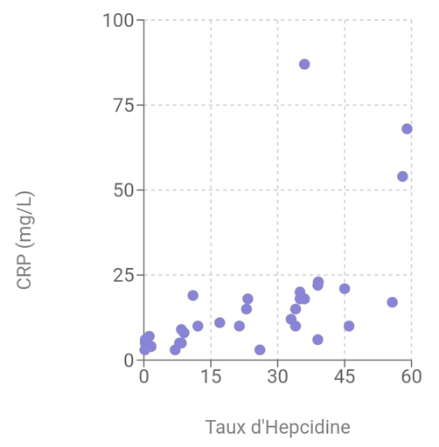

Treatment with Erythropoietin Stimulating Agents (ESAs) :

1. With EPO treatment and no response: 31.43% (mean hepcidin level 37.37)
2. With EPO treatment and response: 42.86% (mean hepcidin level 7.27)
3. Without treatment: 25.71% (mean hepcidin level 33.26)

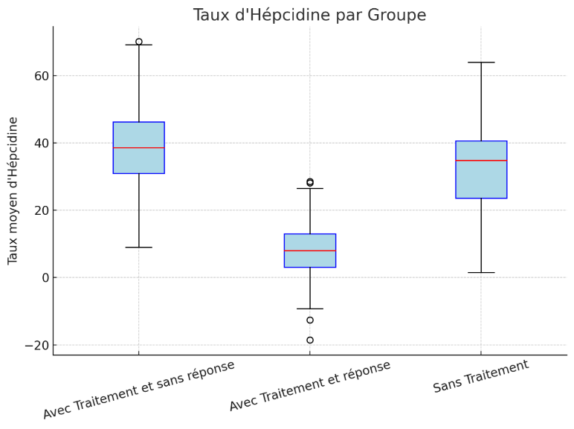

Figure 1: Box plot showing hepcidin levels( ng/l) for the three groups:

Dialysis patients were divided into three subgroups (responders and non-responders and those receiving no EPO treatment). Non-responders who did not show an increase in Hb of 2 g/dL within 2 months of EPO treatment despite dose escalation.

Statistically significant difference (p = 0.0068)

Treatment with injectable iron

* + - 19% of patients received injectable iron
    - Mean hepcidin level: 28.10 ng/ml (higher than patients without injectable iron)

**Discussion**

Increased hepcidin in response to inflammation aggravates anemia by limiting iron utilization(1). Our results show that elevated hepcidin levels are associated with higher ferritin levels, highlighting the impact of inflammation on iron management.

In this study, CRP was significantly correlated with serum hepcidin. As hepcidin synthesis is known to be induced by inflammation, this positive correlation was expected. Our results are comparable to those of other studies in renal failure patients, which have shown a correlation between hepcidin levels and CRP.(3)

Impact of Erythropoietin Stimulating Agents (ESAs)

Treatment with ESAs, notably Darbepoetin α, has been shown to be effective in reducing hepcidin levels. In line with the observations of McCarthy et al. (2015) ( 2 ), our ESA-treated patients showed significantly lower hepcidin levels, suggesting improved anemia management. While serum hepcidin levels were found to be higher in non-EPO and EPO-resistant patients than in responders, with a statistically significant difference.

A previous study concluded that hepcidin levels are considered a better predictor of response to EPO In CKD, increased inflammation and possibly decreased hepcidin clearance may lead to increased serum hepcidin levels, iron-restricted erythropoiesis and EPO resistance (2).

Treatment with injectable iron

Paradoxically, patients receiving injectable iron had higher hepcidin levels. This phenomenon, also observed by Weiss et al. (2019), highlights the need for an individualized approach to anemia management.(5)

**Conclusion**

Hepcidin appears to be a promising biomarker for guiding anemia treatment strategies in hemodialysis patients. This study paves the way for future research aimed at establishing treatment protocols based on hepcidin levels, with the aim of improving patients' quality of life.

**COMPETING INTERESTS DISCLAIMER:**

Authors have declared that they have no known competing financial interests OR non-financial interests OR personal relationships that could have appeared to influence the work reported in this paper.

# References

# 1 Sany, Dawlat1; Elsawy, Abd Elbasat1; Elshahawy, Yasser125(5):p 967-973, September 2014. | DOI: 10.4103/1319-2442.139868 Hepcidin and the Regulation of Iron Homeostasis in Patients on Maintenance Hemodialysis

# 2 McCarthy, J. et al. (2015). Efficacy of Erythropoiesis-Stimulating Agents in Patients with Chronic Kidney Disease. Journal of Nephrology.

# 3 Kautz, L., et al. (2014). Hepcidin Regulation and Iron Metabolism in Chronic Kidney Disease. Blood.

# 4 Serum Hepcidin Levels in Patients with End-Stage Renal Disease on Hemodialysis Rubab, Zille; Amin, Huma; Abbas, Khizer; Hussain, Shabbir; Ullah, Muhammad Ikram; Mohsin, Shahida Saudi Journal of Kidney Diseases and Transplantation 26(1):p 19-25, January-February 2015.

# 5 Weiss, G. et al. (2019). The role of hepcidin in iron metabolism in patients with chronic kidney disease. Kidney International