Original Research Article
Optimized nanosponges for topical delivery of posaconazole: a promising approach for enhanced antifungal therapy
ABSTRACT
Aim:
This study focuses on the development and evaluation of a transdermal drug delivery system (TDDS) for Vinpocetine to enhance its bioavailability and ensure sustained drug release, thereby improving therapeutic efficiency and patient adherence.
Objective:
The research objectives involve formulating matrix-type transdermal patches using various polymers, characterizing their physical and chemical properties, assessing drug release and permeation through in vitro and ex vivo methods, and evaluating the optimized patch for drug-excipient compatibility and dermal safety.
Methodology:
Transdermal patches were formulated via the solvent evaporation technique using polymers such as HPMC, EC, and Eudragit RS100 in different ratios, with PEG 400 as the plasticizer. The patches were analyzed for thickness, weight uniformity, folding endurance, tensile strength, moisture-related parameters, drug content, and pH. In vitro drug release was assessed using Franz diffusion cells, while ex vivo skin permeation was performed on rat abdominal skin. Compatibility was evaluated using FTIR spectroscopy, and skin irritation potential was examined using albino rats.
Results:
Formulation F3 (HPMC:EC 1:1) showed optimal characteristics, including good mechanical integrity, high drug loading (98.23%), and sustained release over 24 hours (94.67%). FTIR results confirmed no significant drug-polymer interaction. Ex vivo studies demonstrated prolonged permeation without skin irritation.
Conclusion:
The developed Vinpocetine transdermal patch showed favorable release and safety profiles, suggesting its potential as an effective alternative to oral delivery by improving bioavailability and reducing the need for frequent administration.
1. INTRODUCTION
Topical fungal infections present a significant therapeutic challenge due to their recurrent nature, chronic course, and the poor skin penetration of antifungal agents like posaconazole (PCZ). PCZ, a triazole with broad-spectrum efficacy against dermatophytes and zygomycetes, suffers from low water solubility and limited skin absorption, placing it in BCS Class II, which restricts its effectiveness in topical applications (1,5).
To address these limitations, nanosponges (NS)—a novel class of porous polymer-based drug carriers—have demonstrated potential in enhancing drug solubility, modulating release kinetics, and improving dermal delivery. Their sponge-like architecture allows for high drug entrapment, resistance to degradation, and controlled drug release (2,6,7). Among various polymers, polycaprolactone (PCL) has gained particular attention for its excellent biocompatibility, biodegradability, and ability to facilitate both targeted and sustained drug delivery. These characteristics make PCL-based nanoparticles ideal for localized drug administration due to their prolonged circulation, effective tissue targeting, and reduced uptake by phagocytic cells (3,9).
In this study, the solvent evaporation method was employed to develop posaconazole-loaded nanosponges using polycaprolactone (PCL) as the polymeric base. This technique, recognized for producing nanocarriers with controlled morphology and particle size, involves emulsifying a drug-polymer solution in an organic solvent into an aqueous phase containing a stabilizer, followed by the evaporation of the solvent to form nanosponges (8,10). The resulting drug-loaded nanosponges were subsequently incorporated into a Carbopol 934-based hydrogel, which enhances skin adherence, facilitates ease of application, and promotes better patient compliance (1,4).
Comprehensive evaluations were carried out to study the nanosponge gel’s physicochemical properties, drug release behavior, and potential for sustained antifungal activity. This formulation approach aims to overcome the limitations of conventional topical treatments and provide a more effective and targeted therapy for fungal skin infections (10).
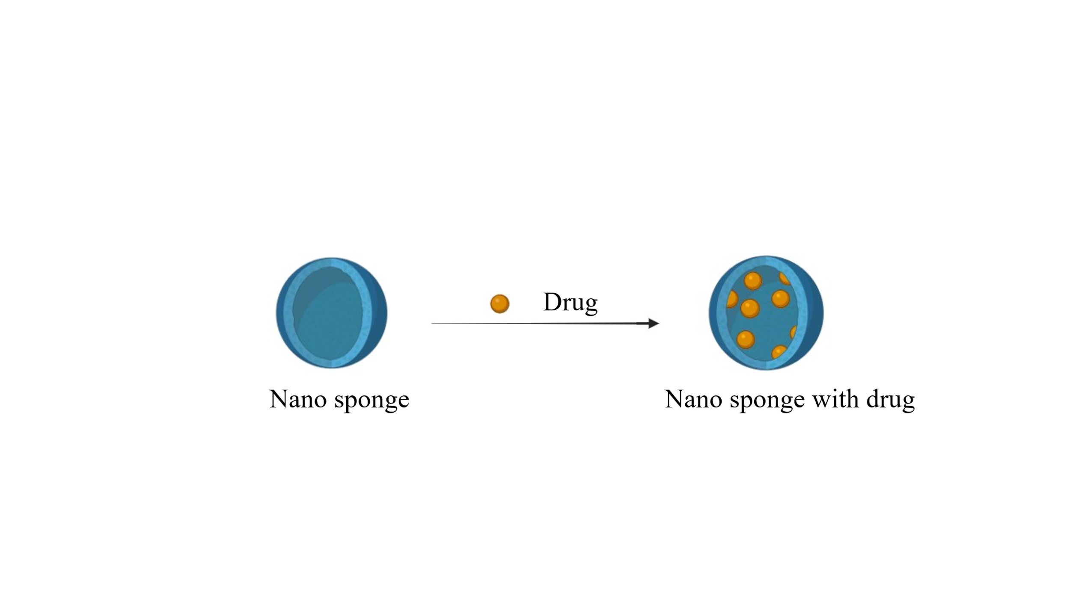
Figure 1: Nano sponges encapsulating drug
Formula | PCZ (mg) | PCL (mg) | PVA% | Stirring Speed (rpm) | DCM: Ethanol (mL) 3:1 | DW (ml)
F1 | 500 | 300 | 0.6 | 1500 | 20 | 100
F2 | 500 | 100 | 0.75 | 1200 | 20 | 100
F3 | 500 | 500 | 0.75 | 1000 | 20 | 100
F4 | 500 | 300 | 0.5 | 500 | 20 | 100
F5 | 500 | 200 | 0.4 | 1000 | 20 | 100
F6 | 500 | 300 | 0.75 | 1500 | 20 | 100
F7 | 500 | 200 | 0.3 | 500 | 20 | 100
F8 | 500 | 250 | 0.75 | 1500 | 20 | 100

Table 1: Composition of PCZ NS(15)

Ingredients w/w % | Pure PCZ | F6-PCZ NS
Posaconazole (gm) | 0.3 | NS eq. to 0.3 gm
Carbopol 934 (gm) | 0.3% | 0.3%
Triethanolamine | Few drops | Few drops
Ethanol 95 % (v/v) | 20 | 20
Propylparaben (gm) | 0.05 mg | 0.05 mg
Deionized water q. s | 100 | 100

Table 2: Composition of PCZ NS loaded-hydrogel(15)
2. MATERIALS AND METHODS
2.1 Materials
Posaconazole in powdered form was obtained from Yarrow Chem, while polycaprolactone (PCL), PVA, and dichloromethane (DCM) were sourced from Ottochemie, Mumbai. Ethanol was procured from Hi-Media, and all other chemicals and reagents used in the study were of analytical grade.
2.2 Preparation of Posaconazole (PCZ)-loaded Nanosponges
Posaconazole-loaded nanosponges were prepared using the emulsion solvent evaporation technique, incorporating varying concentrations of ethyl cellulose [7]. In this method, a measured quantity of PVA was dissolved in 100 mL of water to form the continuous aqueous phase. This was gradually combined with a dispersed organic phase containing posaconazole and polymer dissolved in a 20 mL mixture of dichloromethane and ethanol. The emulsion was stirred magnetically at 1500 rpm for two hours. Afterward, the formed nanosponges were collected by filtration, dried in a hot air oven at 40°C for 24 hours, and stored in sealed vials. The different formulations are detailed in Table 1.(13,14)
Figure 2: Chemical structure of Posaconazole.(16)
2.3 Formulation of Nanosponge-Loaded Hydrogels
To prepare the hydrogel, 1 gram of Carbopol 934 was soaked in 100 mL of distilled water for 12 hours and then stirred using a magnetic stirrer to form a uniform dispersion. The mixture was allowed to stand for 15 minutes to eliminate any entrapped air. Propylparaben, used as a preservative, was dissolved in a small amount of warm water. The pH of the resulting solution was adjusted by slowly adding triethanolamine with continuous stirring. Finally, the prepared polymer solution was blended with either pure posaconazole or lyophilized nanosponge-loaded PCZ to obtain the two hydrogel formulations outlined in Table 2.(17)
2.4 Evaluation of the Prepared Nanosponges
2.4.1 Visual examination
A small amount of the ethosomal dispersion was spread onto a glass slide using a glass rod for visual assessment. The formation of multilamellar vesicles was confirmed by examining the sample under an optical microscope at 10x and 40x magnifications.
2.4.2 SEM Analysis
Scanning electron microscopy (SEM) was conducted on a Vega/TESCAN instrument to assess surface morphology, topographical characteristics, and structural differences between the raw drug and the nanosponge formulation.(19)
2.4.3 Particle Size and Size Distribution
Particle size and polydispersity index were determined using a Malvern Zetasizer, following dilution of 1 mL of the nanosponge suspension in 10 mL of distilled water.
2.4.4 Zeta Potential Measurements
The zeta potential of the nanosponge dispersion was assessed using a Zetasizer. This measurement indicates the extent to which similarly charged particles in the dispersion repel each other. The electrophoretic mobility of the nanosponge was measured in a U-shaped tube at 25°C, allowing the determination of the surface charge (zeta potential) of the formulation.
2.4.5 Drug Entrapment Efficiency
Entrapment Efficiency was evaluated using centrifugation to isolate posaconazole ethosomal vesicles. The vesicles were subjected to 90 minutes of high-speed centrifugation at 20,000 rpm in a refrigerated centrifuge. After separation of the sediment and supernatant, the vesicles were lysed with methanol to release the drug. The amount of drug in the sediment was quantified by UV-visible spectrophotometry at 427 nm after suitable dilution. The entrapment efficiency was calculated using the following formula:(11,12)
EE% = Total amount of drug – free amount of drug *100
Total drug

2.5 The In-vitro Dissolution Profile of Prepared Nanosponges
A dialysis membrane (with a molecular weight cutoff of 8000-14000, USA) was utilized to release the drug from the nanosponges. The membrane was first soaked in phosphate buffer (pH 7.4) for 8 hours. Subsequently, an aqueous nanosponge dispersion containing 500 mg and 250 mg of the drug was placed in a USP type II dissolution apparatus at a fixed rotation speed of 100 rpm and a temperature of 37.5°C. The system was maintained at a constant volume by withdrawing 3 mL of the dissolution medium every hour and replacing it with an equal volume of fresh medium for a period of seven hours. The samples were analyzed using a UV spectrophotometer at the appropriate wavelength.(18)
2.6 Fourier Transform Infrared (FTIR) Spectroscopy
The FTIR spectrum of pure Posaconazole shows sharp and distinct peaks corresponding to functional groups such as O-H/N-H (~3300 cm⁻¹), C-H (~2900 cm⁻¹), and aromatic C=C (~1600 cm⁻¹), confirming its structural integrity. In contrast, the FTIR spectrum of Posaconazole-loaded nanosponges shows broadening, shifting, or reduction in intensity of these characteristic peaks. This indicates physical entrapment or interaction of the drug with the polymer matrix (PCL). The absence or alteration of specific drug peaks suggests successful encapsulation without chemical degradation. Additionally, new peaks in the fingerprint region further confirm the formation of nanosponges. These changes collectively justify successful drug loading into the nanosponges.
2.7 DSC
The DSC thermograms of pure posaconazole and the selected nanosponge formulation (F6) were obtained to evaluate their thermal characteristics and compatibility between the drug and the polymer. Each sample, weighing 5 mg, was sealed in an aluminum pan and analyzed under a nitrogen atmosphere. The temperature was gradually increased from 30°C to 300°C at a heating rate of 10°C/min. The resulting thermograms were analyzed for any shifts or changes in the melting point, which would indicate the extent of crystallinity and the efficiency of the drug encapsulation process.
3. EVALUATION OF PREPARED PCZ LOADED-HYDROGEL
3.1 Physical Appearance and pH of Hydrogel Formulas
The hydrogels were inspected for uniformity and overall appearance, and their pH was recorded at 25 °C using a calibrated pH meter.(21)
3.2 Viscosity
The viscosity of the PCZ-loaded nanosponge hydrogel was measured using a digital viscometer (Model: Myr Rotational, spindle no. R7) at room temperature and rotational speeds ranging from 20 to 200 rpm. The measurements were conducted in triplicate (n = 3), with each hydrogel sample allowed to settle for approximately 15 minutes before taking the readings.(22)
3.3 In-Vitro Drug Release Study of the Prepared Hydrogel Formulas
In vitro release studies of both the nanosponge‐loaded and plain PCZ hydrogels were performed using a USP Type II dissolution apparatus. The system comprised 900 mL of phosphate buffer (pH 7.4) maintained at 37 ± 0.5 °C and stirred at 100 rpm. Approximately 3.3 g of each hydrogel was enclosed in a dialysis membrane (MWCO 8000–14 000) and immersed in the dissolution medium. Over a 7-hour period, 5 mL samples were withdrawn at regular intervals and immediately replaced with fresh buffer to maintain sink conditions. Each sample was filtered and analyzed for drug content by UV spectrophotometry.(17)
4. RESULT AND DISCUSSION
Eight formulations were tested to evaluate the effect of different parameters on particle size. The average particle sizes of the formulations varied between 100 ± 33.6 nm and 400 ± 24.9 nm. A summary of the particle sizes for the different formulations and parameters is provided in Table 3.
Formula code | Mean Particle size(nm) ± SE* | Zeta potential ± SE* | PDI ± SE*
F1 | 210 ± 12.1 | -21.6 ± 1.2
  0.21
F2 | 180 ± 8.4
  -23.1 ± 1.5
  0.18
F3 | 245 ± 15.2 | -19.8 ± 1.0
  0.27
F4 | 310 ± 20.3
  -17.5 ± 1.3
  0.34
F5 | 290 ± 15.6
  -16.8 ± 1.1
  0.30
F6 | 182.5 ± 14.1 | -19.37 ± 1.0 | 0.43
F7 | 340 ± 9 |  | 0.38
  -15.2 ± 1.0
F8 | 195 ± 4 | -23.8 ± 1.2 | 0.19
*SE standard error, n = 3
Table 3: The mean particle size, Zeta, PDI of different formulations
The size of the PCZ-loaded PCL nanoparticles was strongly influenced by process and formulation parameters. When stirring was conducted at moderate speeds (around 1,000–1,200 rpm, as in F2 and F3), sufficient shear forces yielded smaller particles (≈180–245 nm). Slower agitation (500 rpm in F4 and F7) led to poorer emulsification and larger droplets (≈310–340 nm), while very high speeds (1,500 rpm in F1, F6, F8) caused mild particle aggregation.
Similarly, using 0.75% PVA (F2, F3, F8) provided better droplet stabilization and finer particles (≈180–245 nm), whereas lower PVA levels (0.3–0.5% in F4, F5, F7) resulted in coalescence and larger sizes (≈290–340 nm). Reducing PCL content to 100–250 mg (F2, F8) decreased the organic phase viscosity and produced smaller particles; increasing PCL to 300–500 mg (F3, F4) raised viscosity and limited droplet dispersion, yielding larger particles.
In summary, achieving optimal nanosponge size requires a balance of moderate stirring (≈1,000 rpm), higher emulsifier concentration (0.75% PVA), and lower polymer load (100–250 mg PCL).(23,24)
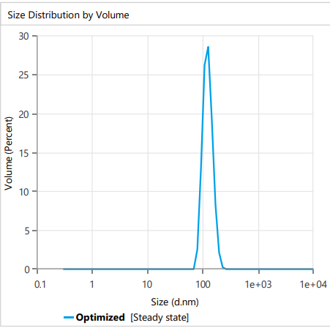
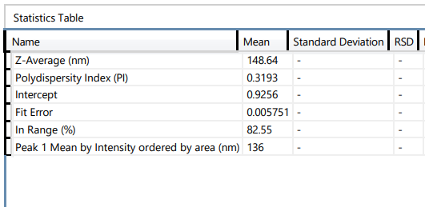
Figure 3: F6 Particle size

4.1 In-vitro Dissolution Profile of Prepared Nanosponges
Formulation F6 achieved the highest drug release, reaching 85% at 8 hours, thanks to its optimized 500 mg PCZ : 300 mg PCL ratio that avoided overly dense matrices and ensured both efficient drug loading and sustained release. The use of a high stirring speed (1500 rpm) produced smaller, more uniform nanosponges with greater surface area—accelerating diffusion—while 0.75% PVA effectively stabilized the emulsion droplets, reducing aggregation and promoting consistent particle formation.In contrast, other formulations like F3 and F5, despite having similar PVA levels, demonstrated lower release due to factors such as increased drug loading (leading to higher viscosity and larger particles), or lower PCL content that compromised matrix structure. The optimal balance of ingredients and process parameters in F6 allowed for superior drug release behavior, making it the most effective formulation among the tested ones.(25)

Figure 4: Comparison release study

4.2 Fourier Transform Infrared (FTIR) Spectroscopy
The FT-IR spectrum of pure posaconazole displayed characteristic peaks at 3323.71 cm⁻¹ (CH₂ stretching), 1736.58 cm⁻¹ (C=O stretching), and 1631 cm⁻¹ (C=O–NH), confirming the presence of the functional groups. The spectrum of the lyophilized nanosponge formulation did not show any significant shift in these peaks, indicating that there were no chemical interactions between posaconazole and the excipients, thus ensuring the drug's chemical stability within the formulation.(26)
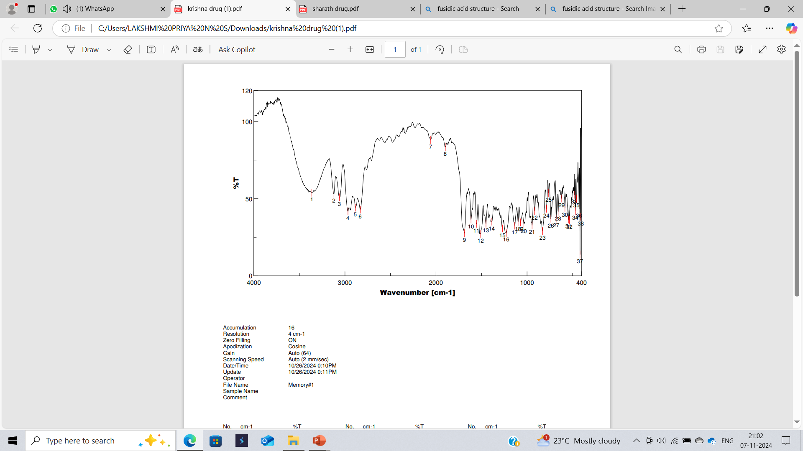
Figure 5: FTIR of Drug
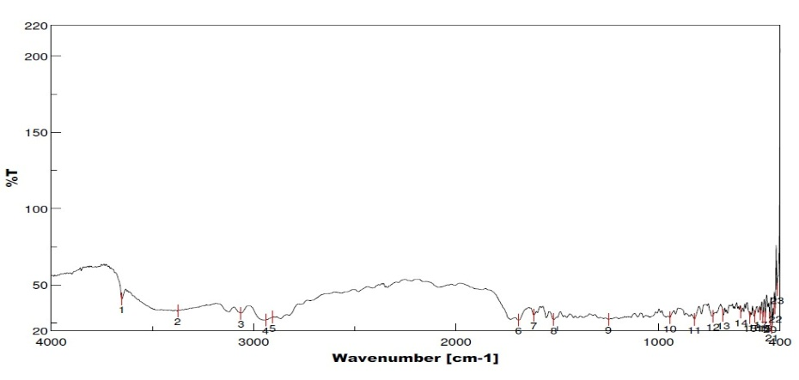
Figure 6: FTIR of F6 formulation

4.3 Differential Scanning Calorimetry
The DSC thermogram of pure posaconazole showed a sharp endothermic peak at 173.39°C, corresponding to its melting point, indicating its crystalline nature. In contrast, the DSC curve of formulation F6 exhibited a broad and low-intensity endothermic peak around 154°C, with the characteristic sharp melting peak of posaconazole significantly diminished. This shift and reduction in intensity suggest a partial or complete conversion of the drug from a crystalline to an amorphous or molecularly dispersed state within the polymer matrix.
The absence of a sharp melting peak and the appearance of a broad signal at a lower temperature confirm successful encapsulation of the drug within the PCL nanosponges. This thermal behavior supports strong interaction or dispersion of posaconazole in the polymer, indicating enhanced physical stability, efficient drug loading, and no detectable incompatibility with excipients.
Figure 7: DSC of Drug
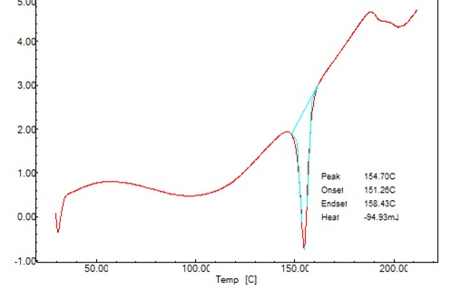
Figure 8: DSC of Formulation

4.4 Scanning Electron Microscopy (SEM)
The uneven forms of PCZ-loaded nanosponges were revealed by scanning electron microscopy. As seen in Figure 9, the NS surface was rough and had a porous structure.(27)
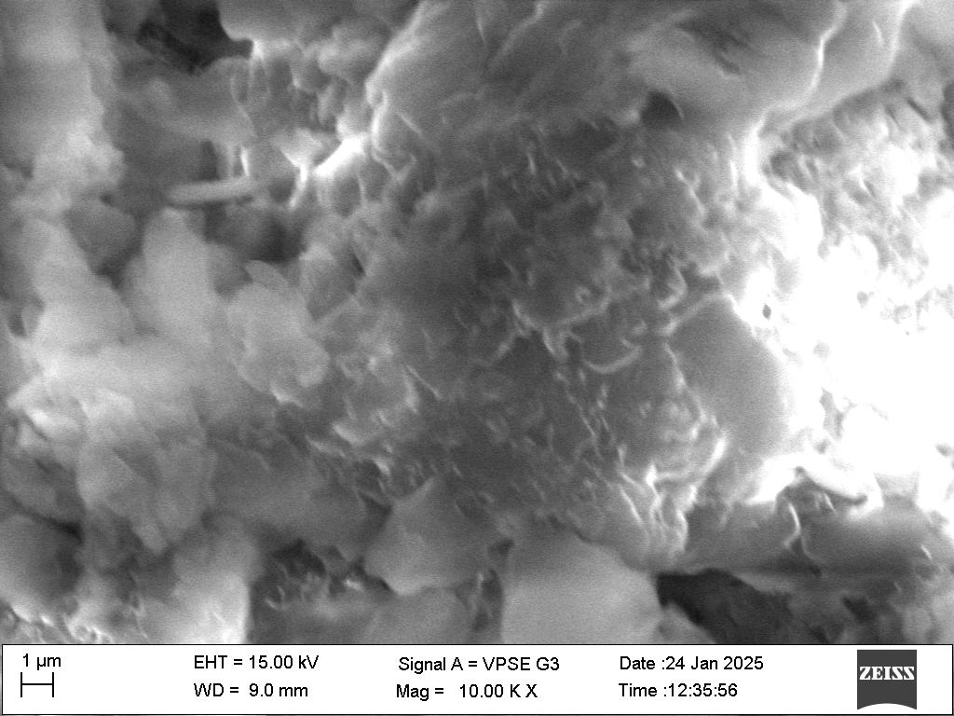
FIG 9 SEM image
4.5 Physical Appearance and pH of Hydrogel Formulas
The hydrogel that was produced was smooth, translucent, and homogeneous throughout. The pH of the hydrogel loaded with PCZ NS was 6.21 ± 0.137, indicating the product's compatibility. The findings were consistent with the study on fluconazole-loaded hydrogel nanosponge.
4.6 Viscosity
The viscosity of PCZ-loaded NS hydrogel was approximately between 4,100 and 23,200 CP, whereas the viscosity of pure PCZ hydrogel was between 3,400 and 20,000 CP (Figure 10). Because the preparation was simple to remove from the container and had a smooth texture when applied to the diseased area, the viscosity value of PCZ-loaded NS hydrogel was excellent.(28)
4.7 The In-vitro Dissolution Profile of Prepared Hydrogels Formulas
According to the release profile shown in Figure 11, the dissolution rate of PCZ NS laden hydrogel was noticeably higher than that of pure PCZ hydrogel. Comparing the in-vitro release of PCZ nanosponge from hydrogel to pure PCZ hydrogel, who prepared a topical hydrogel of NS loaded with lemongrass. The higher porosity of the larger particles during preparation allows the PCZ to leak to the hydrogel, resulting in faster release rates.
5. CONCLUSION
The present study aimed to develop PCZ-loaded nanosponges to achieve controlled drug release and improve the bioavailability of posaconazole. The nanosponges were successfully prepared using the solvent evaporation method, employing polycaprolactone (PCL) as the polymer. This method proved to be simple, effective, and reproducible. Among all formulations, F6 emerged as the most promising, exhibiting a sustained release profile with up to 85% drug release over 8 hours. The use of PCL significantly contributed to the formation of a stable nanosponge matrix that enhanced drug entrapment and prolonged release. The nanosponge system offers potential advantages such as reduced dosing frequency, improved patient compliance, and enhanced therapeutic efficacy, making it a suitable approach for the topical treatment of fungal infections.
6. REFERENCES
- Mohammed BS, Al-Gawhari FJ. Preparation of Posaconazole Nanosponges for Improved Topical Delivery System. Int J Drug Deliv Technol. 2022;12(1):8-14. doi:10.25258/ijddt.12.1.2
- Srinivas P, Reddy AJ. Formulation and Evaluation of Isoniazid Loaded Nanosponges for Topical Delivery. Pharm Nanotechnol. 2015;3(1):68–76.
- Łukasiewicz S, Mikołajczyk A, Błasiak E, Fic E, Dziedzicka-Wasylewska M. Polycaprolactone Nanoparticles as Promising Candidates for Nanocarriers in Novel Nanomedicines. Pharmaceutics. 2021;13(2):191. doi:10.3390/pharmaceutics13020191
- Singh SP, Tripathi DM. Formulation and Evaluation of Posaconazole Drug Loaded Ethosomal Gel for Antifungal Activity. Int J Pharm Pharm Res. 2021;23(1):34-46.
- Cavalli R, Trotta F, Tumiatti W. Cyclodextrin-based nanosponges for drug delivery. J Incl Phenom Macrocycl Chem. 2006;56(1):209–213. doi:10.1007/s10847-006-9085-2
- Swaminathan S, Vavia PR, Trotta F. Formulation of betamethasone-loaded nanosponges for topical delivery: physicochemical characterization and in vitro/in vivo evaluation. J Pharm Sci. 2013;102(12):4724–4734. doi:10.1002/jps.23724
- Trotta F, Tumiatti W, Cavalli R, Roggero C. Cyclodextrin-based nanosponges as drug carriers. Beilstein J Org Chem. 2012;8:2091–2099. doi:10.3762/bjoc.8.235
- Kalhapure RS, Akamanchi KG. Novel rifampicin-loaded polycaprolactone nanoparticles prepared by a new emulsification method using choline-based ionic liquids. Colloids Surf B Biointerfaces. 2012;94:320–327. doi:10.1016/j.colsurfb.2012.01.036
- Shende P, Kasture P, Gaud R. Nanosponges: a new colloidal drug delivery system. Sys Rev Pharm. 2013;4(1):1–6.
- Patel EK, Oswal RJ. Nanosponge and microsponges: a novel drug delivery system. Int J Res Pharm Chem. 2012;2(2):237–244.
- Singh, S. P., & Tripathi, D. M. (2021). Formulation and evaluation of posaconazole drug loaded ethosomal gel for antifungal activity. International Journal of Pharmacy & Pharmaceutical Research (IJPPR), 23(1).
- Zeng Zhaowu., Wang Xiaoli., Zhang Yangde., Li Nianfeng., “Preparation of matrine etosome, its prcutaneous permeation in vitro and anti-inflammatory activity in rats”, J.Liposome Research, 2009, 19(2), 155162.
- Renuka S, Roderick BW, Kamla P. Evaluation of the kinetics and mechanism of drug release from econazole nitrate nanosponge loaded carbopol hydrogel. Ind J Pharmaceut Educat Res 2011; 45(1): 25-31.
- Srinivas P, Jahnavi Reddy A. Formulation and evaluation of isoniazid loaded nanosponges for topical delivery. Pharmaceutical Nanotechnology. 2015 Mar 1;3(1):68-76.
- Mohammed BS, Al-Gawhari FJ. Preparation of Posaconazole Nanosponges for Improved Topical Delivery System. International Journal Of Drug Delivery Technology. 2022;12(01):8-14.
- Hens B, Brouwers J, Corsetti M, Augustijns P. Supersaturation and Precipitation of Posaconazole Upon Entry in the Upper Small Intestine in Humans. J Pharm Sci [Internet]. 2016;105(9):2677–84
- M. Vimal Kumar Varma and P.Amareshwar. Current Pharma Research. Curr Pharma Res. 2011;1(4):300–5.
- Shringirishi M, Mahor A, Gupta R, Prajapati SK, Bansal K, Kesharwani P. Fabrication and characterization of nifedipine loaded β-cyclodextrin nanosponges: An in vitro and in vivo evaluation. J Drug Deliv Sci Technol [Internet]. 2017;41:344–50.
- Stefanache A, Ignat M, Peptu CA, Diaconu A, Stoleriu I, Ochiuz L. Development of a prolonged-release drug delivery system with magnolol loaded in amino-functionalized mesoporous silica. Appl Sci. 2017;7(3):1–13.
- Osmani RAM, Kulkarni PK, Shanmuganathan S, Hani U, Srivastava A, Prerana M, et al. A 32 full factorial design for development and characterization of a nanosponge-based intravaginal in situ gelling system for vulvovaginal candidiasis. RSC Adv. 2016;6(23):18737–50.
- Abbas MM, Rajab NA. Preparation and characterization of etodolac as a topical nanosponges hydrogel. Iraqi J Pharm Sci. 2019;28(1):64–74.
- Ahmed MM, Fatima F, Mohammed AB. Olive Oil Based Organogels for Effective Topical Delivery of Fluconazole: In-vitro Antifungal Study. J Pharm Res Int. 2020;32(25):29–36
- Miladi K, Sfar S, Fessi H, Elaissari A. Encapsulation of alendronate sodium by nanoprecipitation and double emulsion: From preparation to in vitro studies. Ind Crops Prod [Internet]. 2015;72:24–33.
- Press D. Design and formulation of a topical hydrogel integrating lemongrass-loaded nanosponges with an enhanced antifungal effect: in vitro / in vivo evaluation. 2015;(January).
- Bohrey S, Chourasiya V, Pandey A. Polymeric nanoparticles containing diazepam: Preparation, optimization, characterization, in-vitro drug release and release kinetic study. Nano Converg. 2016;3(1):3–9
- Tang P, Wang L, Ma X, Xu K, Xiong X, Liao X, et al. Characterization and In Vitro Evaluation of the Complexes of Posaconazole with β- and 2,6-di-O-methyl-β-cyclodextrin. AAPS PharmSciTech. 2017;18(1):104–114.
- Amin OM, Ammar A, Eladawy SA. Febuxostat loaded β-cyclodextrin based nanosponge tablet: an in vitro and in vivo evaluation. J Pharm Investig [Internet]. 2020;50(4):399–411.(sem eva)
- Hayder Kadhim Drais. Design and Evaluation of Nystatin Gel Based Emulsion for Oromucosal Fungal Infection. World J Pharm Pharm Sci. 2016;5(6):297–307

