Original Research Article
FORMULATION AND IN VITRO EVALUATION OF LORATADINE FLOATING SYSTEM CONTAINING HYDROPHOBIC CARRIER GELUCIRE 43/01

ABSTRACT

Aim: The aim of the present study is to develop Loratadine floating lipid based drug delivery system for prolong gastric retention time and sustained drug release.
Place and Duration of Study: KLE College of Pharmacy, Bengaluru Department of pharmaceutics, Between June 2024- March 2025.
Methodology: The lipid based drug delivery systems were prepared by varying concentration lipid i.e., gelucire 43/01 and gelucire 50/13 and keeping drug ratio constant. The product thus produced, was investigated for physical characteristics including DSC, XRD, FT-IR and also for the in vitro release of drug from the carrier. Gelucire 43/01, a low-density hydrophobic carrier, facilitated buoyancy and contributed to the sustained release of the drug from the delivery systems. In contrast, Gelucire 50/13, a hydrophilic carrier with notable surface-active properties, improved drug solubility and wettability, thereby enhancing the dissolution rate in various formulations.
Results: The % yield and drug content of different lipid based systems are estimated by UV Spectroscopy were found to range from 71.12 to 90.88 % drug release of optimized formulation in pH 1.2 with zero lag time was found to be 56.17 ± 0.33% in 6 hours. From the DSC, FT-IR, and XRD analyses confirmed that Loratadine exhibited an amorphous nature within the lipid-based formulation, which contributed to an enhanced dissolution rate and the absence of significant interactions between the drug and the carrier was indicated by the compatibility studies.
Conclusion: It can be concluded that F7 would be most suitable formulation which is likely to increase solubility and has stable release with zero lag time in stomach. Hence the floating lipid based drug delivery system can be effectively utilized to treat allergic rhinitis.
Keywords: Lipid based formulation, Loratadine, gelucire 43/01, gelucire 50/13, antilipidimic drug, hydrophobic drug.
- INTRODUCTION
Lipid-based delivery systems have gained significant attention in recent years due to their inherent capacity to improve the bioavailability of lipophilic compounds with poor aqueous solubility. Various formulations, including self-microemulsifying drug delivery systems (SMEDDS), solid lipid nanoparticles (SLNs), and phytosomes, have been developed to enhance the oral bioavailability of such compounds [1]. Lipid-based drug delivery systems (LBDDS) exhibit size-dependent properties that contribute to their effectiveness, thereby increasing their prominence in pharmaceutical research. [2]. Lipids offer several formulation advantages, including low melting viscosity, which eliminates the requirement for organic solvents and reduces exposure to potentially toxic substances such as initiators and residual monomers. Furthermore, their excellent biodegradability and biocompatibility, coupled with their ability to form protective layers around active pharmaceutical ingredients, contribute to reduced gastric irritation and improved drug stability [3].
Gelucire is a member of the polyethylene glycol (PEG) ester family, comprising mono-, di-, and triglycerides of fatty acids. Its physicochemical properties vary depending on its hydrophilic-lipophilic balance (HLB) and melting point range. Formulations designed for immediate or rapid drug release typically utilize Gelucire grades composed solely of PEG esters[4,5]. In oral drug delivery systems, Gelucire enhances drug solubility and bioavailability, supports sustained release profiles, masks unpleasant taste, and offers protection to the active pharmaceutical ingredient (API) against light, humidity, and oxidative degradation. [6]. Gelucire is available in two grades based on its Hydrophilic-Lipophilic Balance (HLB) value. Grades with an HLB value below 6 are water-insoluble, those between 6 and 9 are water-dispersible, and values above 9 indicate water-soluble grades. Gelucire 50/13 (stearoyl macrogol-32 glycerides) is a widely used hydrophilic grade characterized by a hydrophilic-lipophilic balance (HLB) of 11 and a melting point of 50°C. It is a non-ionic excipient composed of polyethylene glycol (PEG) esters, free PEG, and a small proportion of glycerides. Upon contact with aqueous media, it forms a fine dispersion or microemulsion, facilitating improved drug solubilisation[7]. Conversely, Gelucire 43/01 is a commonly utilized hydrophobic grade, classified as a hard fat according to the National Formulary (NF) and European Pharmacopoeia (EP). It is a semisolid material with an HLB value of 1 and a melting point of 43°C, commonly employed in modified-release drug delivery systems such as floating drug delivery systems (DDS) and lipid-based capsule matrices. Additionally, it offers protective properties against oxidative degradation, moisture, and light, thereby enhancing the stability of the active pharmaceutical ingredient (API) [8].
Gastro-Retentive Drug Delivery System (GRDDS) including low and high-density formulations. Low-density systems are designed to remain buoyant within the gastric contents for an extended duration, thereby enhancing gastric retention [9]. These formulations can be classified into effervescent and non-effervescent systems. Oral dosage forms that exhibit buoyancy, allowing them to float on the gastric fluids and retain in the stomach for a prolonged period, are referred to as Floating Drug Delivery Systems (FDDS) [10].
Histamines are biologically active compounds that play a vital role in the body’s immune response, gastric acid secretion, and functioning as neurotransmitters. They are synthesized and stored primarily in mast cells and basophils and are released in response to allergens or injury. Once released, histamines bind to specific receptors (H1, H2, H3, and H4) to mediate various physiological effects, such as vasodilation, increased vascular permeability, and smooth muscle contraction [11]. Antihistamines are biologically active amine that inhibits the action of histamine involved in allergic reactions, neurotransmission and gastric acid secretion. These drugs mainly act by antagonizing histamine receptors, particularly H1 and H2 receptors, which are the most clinically relevant targets [12].
Loratadine belongs to 2nd generation antihistamines and classified under BCS II which has high permeability and low solubility. Due to its favourable safety profile, minimal central nervous system effects, and lack of significant drug interactions, loratadine remains a preferred choice for long-term management of allergic conditions. When it is administered orally it undergo extensive first-pass metabolism in the liver with the oral bioavailability of less than 40 % [13].
Thus, the major objective of the present study was to design and evaluate floating granules of loratadine using gelucire 43/01 for sustained drug delivery.
2. MATERIAL AND METHODS
2.1 Materials
Loratadine was purchased from Apotex Pharmachem INC Bengaluru, Gelucire 50/13 (Gattefose, France), Gelucire 43/01 (Gattefose, France), Hydrochloric acid (RFCL Limited, New Delhi).
2.2 Instrumentation
The instruments used in the study include an analytical balance, an electrical balance (Dhona 200D), a digital pH meter (Digisum Electronics, Hyderabad), UV-visible spectrophotometer (SHIMADZU UV-1700 PC, Japan), FT-IR spectrophotometer (Jasco 460 Plus FT-IR), USP I dissolution tester (TDT-08L, Electrolab, Mumbai), differential scanning calorimeter, ultrasonic soncator (Wensar WUC-1.8L), and X-ray crystallography equipment.
2.3 Formulation of Loratadine Floating Lipid Based Drug Delivery Systems
The lipid carriers, Gelucire 43/01 and Gelucire 50/13, were measured and placed in a beaker, then melted at 50°C. The accurately weighed amount of Loratadine was incorporated into the molten lipid mixture, with continuous stirring to ensure uniform distribution. The molten formulation was allowed to cool and solidify at room temperature. Once solidified, the granules were sieved and subjected to subsequent evaluation. [14].
The same procedure was employed to prepare all nine formulations, with variations in the lipid concentrations while maintaining a constant Loratadine ratio.
Table 1: Composition of different formulations of Loratadine lipid based drug delivery.
Formulation Code | Gelucire Ratio |  | Drug (mg)
Formulation Code | Gelucire 43/01 | Gelucire 50/13 | Drug (mg)
F1 | 2 | 2 | 100
F2 | 2 | 1.5 | 100
F3 | 2 | 1 | 100
F4 | 4 | 2 | 100
F5 | 4 | 1.5 | 100
F6 | 4 | 1 | 100
F7 | 6 | 2 | 100
F8 | 6 | 1.5 | 100
F9 | 6 | 1 | 100
2.4 Characterization and Evaluation [15]
2.4.1 % Yield of Loratadine lipid based formulation
The yield of the Loratadine lipid-based drug delivery system (LBDDS) was calculated using the formula:
$Percentage yield= \frac{Actual weight of the product}{Total weight of the product } × 100$ e.q 1
2.4.2 Drug content
For quantitative analysis, 10 mg of each Loratadine lipid formulation from all batches was accurately weighed and placed into individual 10 mL volumetric flasks, followed by dilution with 0.1N hydrochloric acid. The samples were subjected to sonication at 60 °C for approximately 30 minutes to ensure complete dissolution. After dissolution, 0.2 mL of the solution was transferred to a separate 10 mL volumetric flask, diluted to volume with pH 1.2 buffer, and subsequently filtered. The absorbance of the resulting filtrate was measured at 273 nm using a UV-visible spectrophotometer, employing 0.1N HCl as the reference blank. [16].
$Drug Content \left(\%\right)=\frac{Amount of drug present}{Teoritical drug loaded expexted} × 100$ e.q 2
2.4.3 In Vitro Evaluation of Floating Ability
Using a USP 24 Type II dissolution apparatus simulated gastric fluid (pH 1.2) was maintained at 37 ± 0.2°C and subjected to agitation at 50 and 100 rpm. The buoyancy of the granules was monitored over a 6-hour period, with the percentage of granules remaining afloat being recorded. Additionally, the floating time was evaluated through direct visual observation. [17].
2.4.4 In vitro drug release pattern Loratadine LBDDS
The in vitro drug release of Loratadine floating systems was evaluated using a USP Type I (basket) dissolution apparatus using dissolution medium of 900 mL of 0.1N hydrochloric acid, temperature 37 ± 0.5°C with 100 rpm. At 60-minute intervals, 5 mL sample was withdrawn and immediately replaced with an equal volume of fresh dissolution medium to maintain sink condition. This was done for period of 6 hours. Later samples were analyzed at 275 nm using a UV spectrophotometer, with pH 1.2 buffer serving as the blank [18].
2.4.5 Fourier transform infrared spectroscopy
The Jasco 460 plus-FTIR spectrophotometer was used to determine the drug excipient interactions. A small amount of sample is mixed with the KBr and triturated. This prepared mixture subjected to the spectra in the range 4000-400cm1 were determined using dried KBr as a blank. Spectral peaks were identified and recorded [19].
2.4.6 Differential scanning calorimetry
DSC was performed by weighing approximately 2–5 mg of each sample, which was placed in an open aluminum pan and heated over a temperature range of 0 to 350°C. The heating was conducted at a scanning rate of 10°C per minute under a nitrogen atmosphere [20,21].
2.4.7 X-ray diffraction (XRD)
X-ray diffractograms of DOX and FM5 was recorded at room temperature with a gradation of high-temperature measurement using monochromatic copper K-alpha radiation at 15 mA and 40 kV (Rigaku Mini flex-600 5th generation) [22,23].
3. RESULTS AND DISCUSSION
3.1 Characterization of Floating Lipid Granules
Improved % drug yield was notably achieved in formulations utilizing lower amounts of Gelucire 50/13 and Gelucire 43/01, possibly due to enhanced homogeneity in drug dispersion within the lipid matrix. The drug content across all nine formulations varied from 71.12% to 90.88%, with formulation F7 displaying the highest content, likely resulting from its increased Gelucire 43/01 and decreased Gelucire 50/13 concentrations. Floating time was performed, it ranges from 3 to 6.5 and is observed that the formulation having higher concentration of Gelucire 43/01 showed increased floating time [24]
Table 2: Percentage yield, Drug content and Floating time of Loratadine lipid based formulation
Formulation code | % Yield | Drug content | Floating time (hr)
F1 | 99.67 | 88.18 ± 1.15 | 3.5
F2 | 98.19 | 86.24 ± 1.43 | 3
F3 | 99.1 | 87.47 ± 0.28 | 4
F4 | 99.32 | 89.69 ± 0.36 | 5
F5 | 99.47 | 90.67 ± 0.38 | 5.5
F6 | 75.15 | 71.12 ± 1.29 | 4.5
F7 | 99.36 | 90.88 ± 0.57 | 6.2
F8 | 99.63 | 90.741 ± 0.47 | 6
F9 | 99.47 | 89.56 ± 0.971 | 6.5
3.2 In Vitro Drug Release Studies
The in vitro release profile of Loratadine demonstrated immediate drug release with zero lag time in an acidic medium (pH 1.2, 0.1N HCl) over a 6-hour duration. This consistent release behavior can be attributed to the enhanced solubility of Loratadine under acidic conditions. Among the tested formulations, F7 exhibited the most stable and sustained release, with drug release percentages ranging from 27.92 ± 0.35% to 56.17 ± 0.33% across all formulations in pH 1.2 over the study period [25,26].

Fig 1: Cumulative drug release
3.3 Drug Excipient Compatibility Studies
3.3.1 Fourier transform infrared spectroscopy (FTIR)
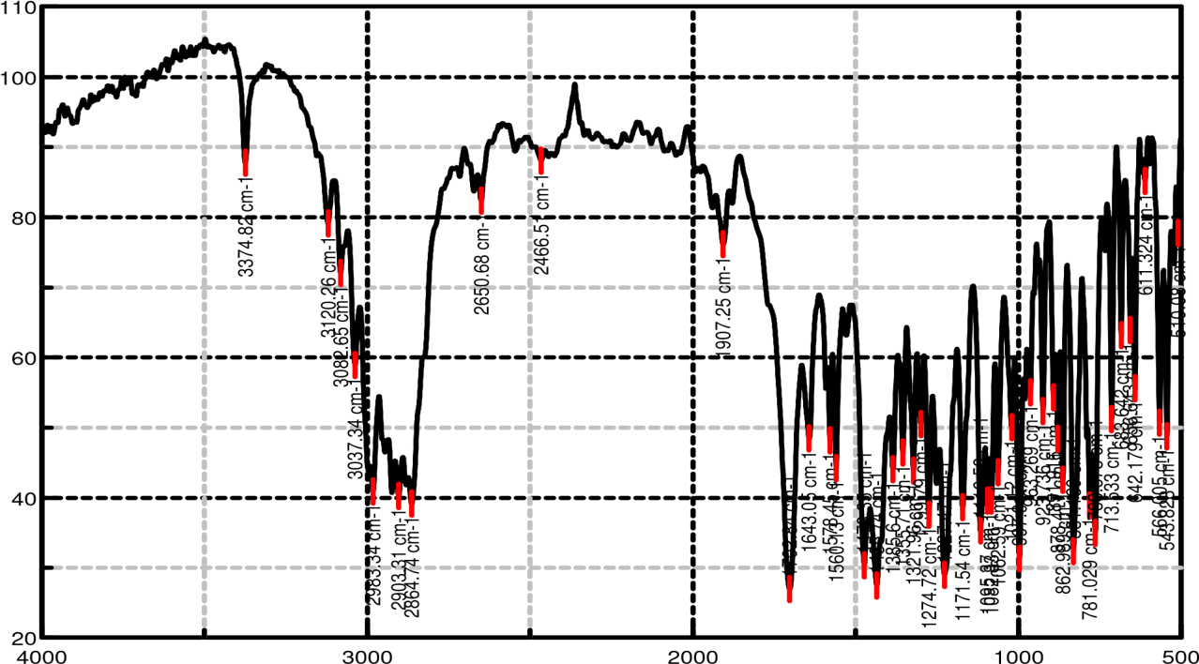
The infrared (IR) spectrum of Loratadine exhibited a characteristic peak at 1274.72 cm⁻¹, corresponding to C–O stretching of the carboxylate group. Peaks observed at 1560.13 cm⁻¹ and 1435.74 cm⁻¹ were attributed to the stretching vibrations of the benzene ring. The peak at 1321.96 cm⁻¹ was indicative of C–N stretching within the aryl amine group, while the peak at 748.03 cm⁻¹ was associated with aryl C–Cl stretching. Additionally, a peak at 1702.84 cm⁻¹ was assigned to the C=O stretching vibration of the ester functional group. These distinctive spectral features were also present in the IR spectrum of the formulated product, confirming that the chemical structure of Loratadine remained intact during formulation.

Fig 2: FTIR spectra of Loratadine
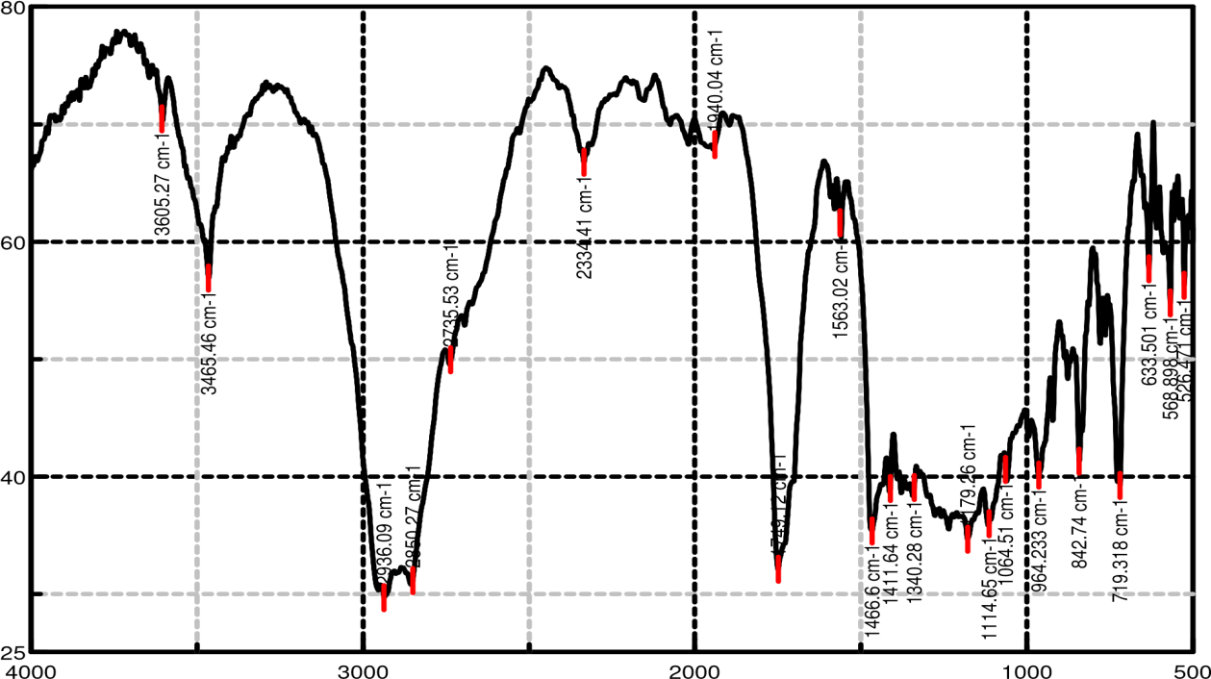
Fig 3: FTIR spectra of Formulation F7

3.3.2 Differential scanning calorimetry
DSC thermogram of the pure drug Loratadine showed a sharp endothermic peak at 140°C, corresponding to its melting point and indicating its crystalline nature. In contrast, the DSC thermogram of formulation F7 showed the absence of this sharp peak, suggesting that Loratadine is converted from a crystalline to an amorphous state within the formulation. Additionally, two distinct thermal events were observed at 232°C and 262°C, which are indicative of the thermal degradation of the carriers Gelucire 43/01 and Gelucire 50/13, respectively.
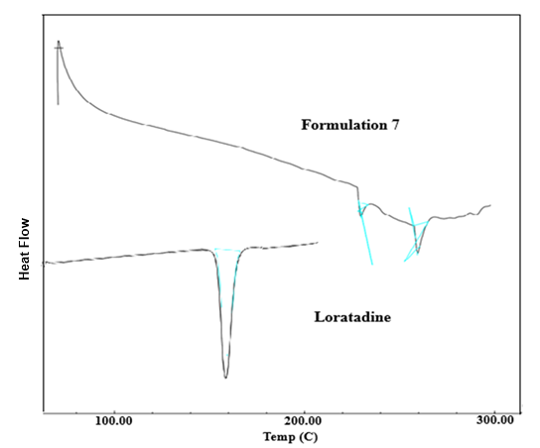
Fig 4: DSC of Loratadine and Formulation 7

3.3.3 X-Ray Diffraction
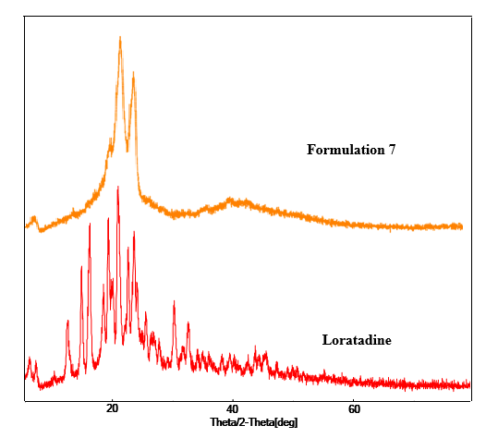
X-ray diffraction analysis was performed on both pure Loratadine and formulation F7. The diffractogram of the pure drug displayed sharp and intense peaks, characteristic of its crystalline structure. However, these distinct peaks were absent in the diffractogram of formulation F7, indicating a transformation of Loratadine from a crystalline to an amorphous state. This conversion to an amorphous form within the lipid-based matrix is associated with an improvement in the drug’s dissolution rate.
Fig 5: XRD of Loratadine and Formulation 7

4. CONCLUSION
The present study focused on the formulation of lipid-based delivery systems for Loratadine using Gelucire 43/01 and Gelucire 50/13, serving as hydrophobic and hydrophilic carriers, respectively. Among the nine formulations developed, formulation F7 demonstrated optimal performance, exhibiting a production yield of 99.35%, drug content of 90.89 ± 0.591%, and a floating duration of 6 hours. The cumulative drug release from F7 in 0.1 N HCl over 6 hours was 56.17 ± 0.33%. Characterization studies, including DSC, FT-IR, and XRD analyses, confirmed the conversion of Loratadine to its amorphous form within the lipid matrix, which contributed to enhanced dissolution. Furthermore, no significant drug–excipient interactions were observed, indicating compatibility between the drug and carriers.

5. REFERENCE
- Meins J, Behnam D, Abdel-Tawab M, 2018. Enhanced absorption of boswellic acids by a micellar solubilized delivery form of Boswellia, extract NFS J, 11, 12–16.
- Vijayarani KR, Govindarajulu M, Ramesh S, Alturki M, et al, 2020. Enhanced Bioavailability of Boswellic Acid by Piper longum A Computational and Pharmacokinetic Study, Front Pharmacol, 11, 1-8.
- Shrestha H, Bala R, Arora S. Lipid-Based Drug Delivery Systems. J Pharm (Cairo). 2014;2014:801820. doi: 10.1155/2014/801820. Epub 2014 May 19. PMID: 26556202; PMCID: PMC4590796.
- S. Singh, S. Chakraborty, D. Shukla, B. Mishra, Lipid-An emerging platform for oral delivery of drugs with poor bioavailability, Eur. J. Pharm. Bio. Pharm. 73 (2009) 1-15.
- P. Upadhaya, J.K. Pandit, A.K. Wahi, Gelucire: an alternative formulation technological tool for both sustained and fast release of drugs in treating diabetis mellitus type II disease, J. Sci. Ind. Res. 72 (2016) 776-780.
- A.I. Mohamed, E. Mahmoud, Formulation of immediate release pellets containing famotidine solid dispersions, Saudi Pharm. J. 22 (2) (2014) 149-156.
- A.J. Humberstone, W.N. Charman, Lipid-based vehicles for the oral delivery of poorly water soluble drugs, Adv. Drug Del. Rev. 25 (1997) 103–128.
- K.C. Panigrahi, C.N. Patra, G.K.Jena, D.Ghose, J.Jena, S.K. Panda, M. Sahu, Gelucire: A versatile polymer for modified release drug delivery system, Future Journal of Pharmaceutical Sciences. 4 (2018) 102-108.
- Zhao S, Lv Y, Zhang J-B, et al. Gastroretentive drug delivery systems for the treatment of Helicobacter pylori. World J Gastroenterol. 2014;20(28):9321–9329.
- Mandal UK, Chatterjee B, Senjoti FG. Gastro-retentive drug delivery systems and their in vivo success: a recent update. Asian J Pharm Sci. 2016;11(5):575–584.
- Branco AC, Yoshikawa FS, Pietrobon AJ, Sato MN. Role of histamine in modulating the immune response and inflammation. Mediators of inflammation. 2018;2018(1):9524075.
- Simons, F. E. R., & Simons, K. J. (2020). Histamine and H1-antihistamines: celebrating a century of progress. Journal of Allergy and Clinical Immunology, 145(2), 471–483. https://doi.org/10.1016/j.jaci.2019.12.979
- Islam N, Khan NU, Razzaq A, Menaa F, Khan ZU, Hussain A, Rehman SU, Iqbal H, Ni J. Loratadine oral bioavailability enhancement via solid dispersion loaded oro-dispersible films: Formulation, characterization and pharmacokinetics. Colloids and Surfaces B: Biointerfaces. 2023 Oct 1;230:113526.
- S.K. Jain, A. Gupta, Development of gelucire 43/01 beads of metformin hydrochloride for floating delivery, AAPS Sci. Tech. 10 (4) (2009) 1128-1136.
- Dave V, Yadav RB, Kushwaha K, Yadav S, Sharma S, Agrawal U. Lipid-polymer hybrid nanoparticles: Development & statistical optimization of norfloxacin for topical drug delivery system. Bioactive materials. 2017 Dec 1;2(4):269-80.
- Galgatte, U.C.; Kumbhar, A.B.; Chaudhari, P.D. Development of in situ gel for nasal delivery: Design, optimization, in vitro and in vivo evaluation. Drug Deliv. 2014, 21, 62–73.
- S. Shimpi, B. Chauhan, K.R. Mahadik, A. Paradkar, Preparation and Evaluation of Diltiazem Hydrochloride-Gelucire 43/01 Floating Granules Prepared by Melt Granulation, AAPS Pharm SciTech 5 (3) (2004) Article 43.
- Patel, A. R., Vavia, P. R., & Misra, A. (2014). Lipid-based drug delivery systems: Promising approach for improving oral bioavailability of poorly water-soluble drugs. Journal of Controlled Release, 192, 323–332.
- Mahajan, H. S., Tyagi, V. K., & Shirkhedkar, A. A. (2012). Formulation and evaluation of mucoadhesive buccal films of loratadine. Pharmaceutical Development and Technology, 17(5), 488–495. https://doi.org/10.3109/10837450.2010.542600
- Khan, K. A., Raghavendra Rao, N. G., & Puttaswamy, N. G. (2011). Characterization and dissolution studies of loratadine solid dispersions. International Journal of Pharmaceutical Sciences and Drug Research, 3(2), 98–103.
- Desai, J., Alexander, K., & Riga, A. (2012). Characterization of polymeric dispersions of loratadine prepared by hot melt extrusion. International Journal of Pharmaceutics, 436(1–2), 304–312.
- Patel, R. P., Patel, M. M., & Patel, N. M. (2012). Physicochemical characterization and in vitro dissolution behavior of solid dispersions of loratadine with polyethylene glycol 6000 and polyvinylpyrrolidone K30. Dissolution Technologies, 19(3), 24–30. https://doi.org/10.14227/DT190312P24.
- Moustafa, Y. M., Elshafeey, A. H., & Elsayed, I. (2021). Development of loratadine nanostructured lipid carriers: Statistical optimization and in-vitro characterization. Drug Development and Industrial Pharmacy, 47(7), 1136–1145.
- Singh, A., Sharma, P. K., & Malviya, R. (2015). Enhancement of solubility of poorly water soluble drugs by solid dispersion technique. International Journal of Pharmaceutical Sciences and Research, 6(10), 4176–4183.
- Kumari, M., Pathak, K., & Verma, P. (2022). Lipid-based nanocarriers for oral delivery of poorly water-soluble drugs: A promising approach for loratadine. Journal of Drug Delivery Science and Technology, 67, 102953.
- Bansal, A. K., Harikumar, S. L., & Kaur, R. (2021). Formulation and evaluation of self-microemulsifying drug delivery system (SMEDDS) for enhancing solubility of loratadine. Journal of Drug Delivery and Therapeutics, 11(2), 15–22.

