## DIGITAL TRANSFORMATION IN PHARMACEUTICAL OPERATIONS: A COMPREHENSIVE REVIEW OF IOT APPLICATIONS.

## ABSTRACT

**Background:** The pharmaceutical industry is undergoing a significant transformation due to the integration of Industrial Internet of Things (IIoT) technologies. This technology is being applied across various aspects of the pharmaceutical value chain, including manufacturing, warehousing, supply chain logistics, drug discovery, clinical trials, energy efficiency, and safety protocols. IIoT enhances operational efficiency, product quality, regulatory compliance, and sustainability by leveraging real-time data collection, predictive analytics, and intelligent automation. However, challenges such as data privacy, standardization, system integration, and cybersecurity pose challenges. This paper provides a comprehensive review of IIoT's transformative impact on pharmaceutical operations, identifying enablers and barriers to its adoption, and paving the way for a more intelligent, connected, and resilient pharmaceutical industry.

**Keywords:** Industrial Internet of Things (IIoT); Pharmaceutical Industry; Clinical research; Digital Transformation; Warehousing; Energy efficiency; Predictive maintenance.

**Objective:** This paper explores the transformative use of Industrial Internet of Things (IIoT) in pharmaceutical operations, highlighting its enhanced connection, data-driven insights, and automation, which significantly improves pharmaceutical manufacturing , supply chain optimization, energy efficiency, clinical research , warehousing and drug development.

**Conclusion:** The integration of IIoT in pharmaceutical operations signifies a transformative move towards enhanced and more effective processes. By utilizing real-time monitoring, predictive maintenance, automated data analysis, and enhanced energy management, IIoT elevates product quality, minimizes waste, and bolsters adherence to regulatory standards. While notable advantages are clear across various sectors—manufacturing, clinical studies, supply chains, and beyond—issues surrounding data privacy, system integration, and standardization need to be addressed to fully unlock the possibilities of this digital evolution. The path ahead for IIoT in pharmaceuticals involves addressing these obstacles to establish a secure, sustainable, and intelligent operational framework.

1. **INTRODUCTION**

The fast growth of customer demands and technology has necessitated that organizations use innovative ways to enhance operational efficiency and quality in their current operations [1]. Among all industries, pharmaceuticals have significant roles in health sectors and are thus eager to explore innovative methods for process enhancement and product advancement. [2].The increasing prevalence of global health emergencies, alongside the heightened demand resulting from the COVID-19 pandemic, has expedited the necessity for the implementation of innovative technologies across various operations to facilitate improved outcomes [3]. The pandemic has served as a significant catalyst for transformation within the pharmaceutical industry, highlighting vulnerabilities in numerous traditional systems and accelerating the necessity to enhance manufacturing, drug development, and distribution networks [4]. Consequently, it has demonstrated a method for integrating artificial intelligence and the internet of things to enhance efficiency and productivity in pharmaceutical manufacturing [5]. Artificial intelligence and the Internet of Things are beginning to reshape the pharmaceutical landscape, emerging as transformative technologies [6]. The Internet of Things (IoT) interlinks a variety of devices and sensors, facilitating data interchange and real-time monitoring without the need for operator intervention or device engagement [7]. This technology, in conjunction with AI, can provide a significant improvement in operational efficiency, product quality, and regulatory compliance compared to the traditional, inefficient manual processes prevalent in the business [8].

The Internet of Things (IoT) framework holds significant relevance in industrial settings. The Industrial Internet of Things (IIoT), often referred to as Industry 4.0, represents a transformative technology poised to enhance manufacturing and production processes through the deployment of numerous networked embedded sensing devices and the integration of advanced computing technologies [11,12].

The goal of the IoT is to create an intelligent ecosystem by utilizing smart features alongside sensory and networking technologies to gather information automatically and transmit it over the Internet for analysis. The elimination of a human aspect distinguishes IoTs from the traditional Internet. IoT devices gather data concerning people's circumstances, evaluate them, and intervene based on them [13]. Over 75% of demand will be generated by IoT devices. 90% of automobiles will be Internet-connected. Biometrics, sensors, and built-in spatially technologies will be used in the gadgets. This paper examines the application of Industrial Internet of Things (IIoT) within pharmaceutical operations, emphasizing its ability to enhance connectivity, provide data-driven insights, and facilitate automation.

**2. IOT ARCHITECTURE**

A significant number of IoTs have been developed, and research on IoT frameworks can assist in governing and guiding the implementation of these essential components. [14]. The IoT architecture consists of three layers: a perception/hardware layer, a network/communication layer, and an interfaces/services layer. The components of an IoT system include hardware/devices, communication/messaging protocols, and interfaces/services [15].

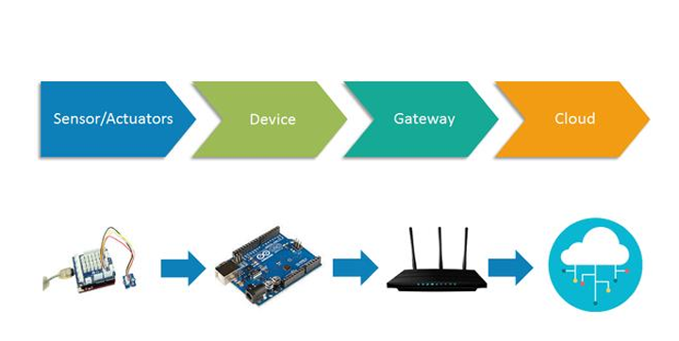

**Figure 1**: The architecture of the IOTs.

The three-layer design constituted the conventional architecture at the inception of the Internet of Things. It is categorized under three strata: perception, network, and application [16]. The first layer is the physical layer, including sensors that gather data on the environment. The second layer is the network layer, which facilitates connection for smart devices and is responsible for transferring sensor data. The application layer is the third and final layer, responsible for providing specific services to the user. The three-layer architecture embodies the fundamental notion of the IoT; yet, it is inadequate for comprehensive IoT research since it often focuses on minute details. Consequently, several additional layered structures have been documented in the literature [17].

**2.1. KEY TECHNOLOGIES ENHANCING IOT FOR EFFICIENT PHARMACEUTICAL OPERATIONS.**   
The Internet of Things can be characterized as a vast and intricate ecosystem consisting of numerous interconnected real-world entities that depend on networking, data processing, sensory, and communication technologies [18]. RFID serves as the primary technology for IoT, enabling microchips to wirelessly transmit data to receivers. The implementation of RFID technology enables the tracking, monitoring, and analysis of objects embedded with RFID tags [19]. Another essential technology in the IoT landscape is Wireless Sensor Networks (WSNs), which primarily operate using smart sensors for monitoring and sensing purposes. Since the 1980s, RFID technology has been utilized in the production, distribution, and retail of pharmaceutical products, while WSN is being implemented in healthcare and industrial supervision [18,20]. The advancement of technologies is propelling the development of IoT. A variety of technologies and devices, including ZigBee, barcodes, Wimax, near-field communication, cloud computing, and location-based services, are being utilized to establish a secure IoT system [21].

**2.1.1**. **Radio-frequency identification (RFID)** is a technology that facilitates the identification, tracking, and transfer of data. There are five primary classes of RFID tags [22]. The class 1 tags comprise passive tags equipped with read/write memory capabilities. Class 2 tags ensure compliance with formal security protocols. Class 3 includes semi-passive tags that are powered by a battery and may incorporate sensors. The class 4 active tags are powered by batteries and are capable of interacting with similar tags. Ultimately, class 5 tags facilitate the activation of other tags and are directly connected to the back-end networks.

**2.1.2**. **Wireless sensor networks (WSN)** are networks of sensors used for monitoring and regulating the conditions of numerous devices, including their temperature, sound levels, location, and mobility. Temperature, flow rate, infrared radiation, air pollution, moisture closeness and displacement, pressure, and velocity are being monitored by the use of sensors [23]. WSN can engage and interface with RFID tags [24].

**2.1.3**. **Middleware:** Middleware is a software layer designed for service-oriented purposes. This layer enables software developers to connect with multiple devices such as RFID tags, sensors, and actuators.

**2.1.4**. **Cloud computing:** Cloud computing is a computer software that operates via the Internet. It encompasses diverse computing resources (computers, software, storage, network, etc.) that may be allocated and accessed upon request. Due to the substantial amount of data produced by IoT devices, cloud computing is important [24]. Numerous IoT cloud platforms exist in the market that operate similarly to middleware software. Their primary aim is to connect IoT devices and their applications as seen in Fig. 2 Technologies enabling IoT. Cloud-computing services seem to be a viable option for data center ownership and administration.

**2.1.5**. **IoT applications:** They enable system-to-system and human-to-system connections. IoT apps consist of the interface between the user and the devices. The data must be presented intuitively, demonstrating proficiency in identifying issues and recommending remedies.

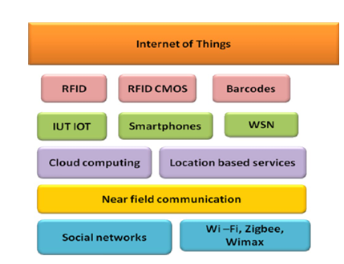

**Fig. 2:** Technologies empowering IoT in smart industries

**2.2 IIOT DIGITALIZATION TREND**

Traditional manufacturing plants are undergoing a transformation into smart facilities due to the extensive adoption of advanced technologies such as the Industrial Internet of Things (IIoT) and cyber-physical systems (CPS) [25]. The integration of advanced technologies and the convergence of physical and virtual systems are defining characteristics of digital transformation. While digitization has been around for some time, its intricacies continue to develop and change. It is clear that the processes of digital transformation are influenced by the staff and the resources at their disposal. Consequently, technology and expertise are essential for the transition to digital. The Internet of Things has the potential to transform business landscapes, leading to significant operational advantages and enhanced quality of products and services. Furthermore, a transformation in the big data landscape is expected as part of establishing a competitive advantage through data mining, which is essential for a company's sustainability across various sectors. At this level, the utilization of big data is anticipated to expand significantly, enabling the prediction of future sales of goods or services, forecasting consumer behavior and trends in both real-world and digital environments, and identifying cybersecurity concerns. Three primary categories for classifying the cybersecurity-related challenges that hinder organizations from embracing new digital technologies include: (i) awareness and knowledge; (ii) integration of legacy and emerging technologies; and (iii) time and resources allocated to cybersecurity. The robotics industry is anticipated to experience significant growth in the near future. Robots will be utilized not only to substitute human labor but also to engage with individuals. Robots are anticipated to advance towards greater autonomy, flexibility, and cooperation.

**2.3 IOT IN HEALTHCARE**

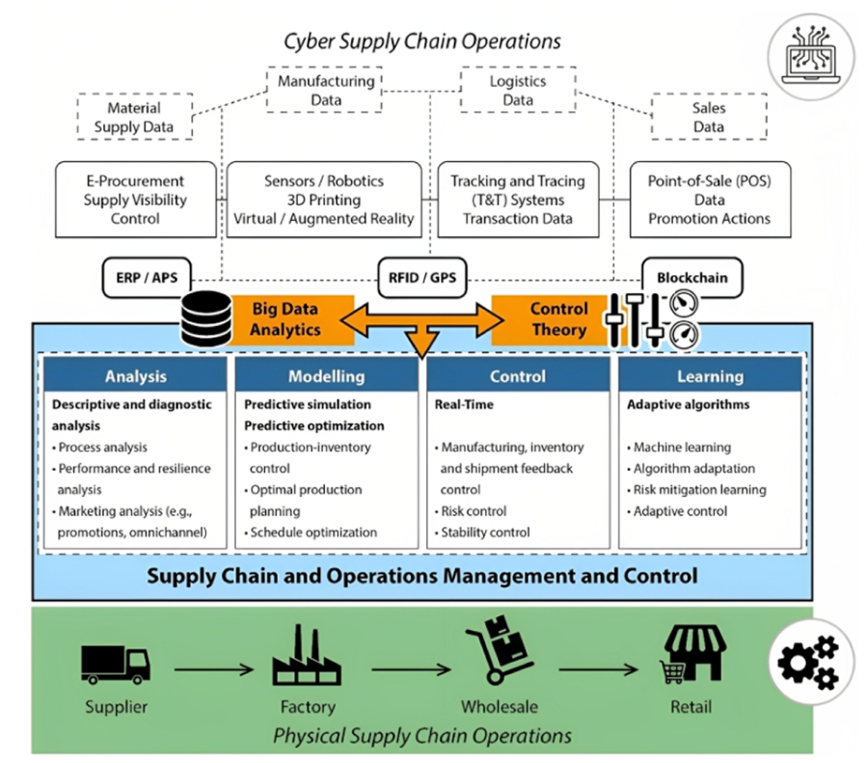Most global healthcare systems are inefficient, unwieldy, and consistently susceptible to errors. The healthcare sector relies on diverse procedures and equipment, making technological automation and enhancement easily adaptable. The healthcare sector will see a significant transition due to emerging technologies that facilitate many duties, including report dissemination across multiple parties and locations, record storage, and prescription distribution [26]. IoT applications in healthcare provide several benefits that may be categorized into patient, staff, and asset monitoring; personal identification and authentication; automated data collection and processing; and tracking. Monitoring patient flow may significantly improve the operations of medical facilities. Furthermore, authentication and identity are compromised by record-keeping errors, discrepancies in birth identification, and incidents that may harm the patient. The management of medical inventory, process automation, expedited form processing, automated procedure assessments, and more services rely on automated data collection and submission. The sensor gadget facilitates patient-centered functionalities, particularly in the diagnosis of diseases and the use of real-time data on health indicators [27]. Monitoring patient compliance with prescriptions, telemedicine solutions, and health alerts are among the application domains for this industry. The sensor may provide information post-usage and after patient monitoring, and is applicable for both outpatients and inpatients, as well as dental Bluetooth devices and toothbrushes. RFID, Bluetooth, and WiFi are further IoT components applicable in this context. These significantly enhance techniques for assessing and monitoring essential factors such as blood pressure, body temperature, heart rate, blood glucose, and cholesterol levels.

**3. IOTS IN PHARMACEUTICAL OPERATIONS**

The innovative and transformative technology of Industry 4.0, also known as IIoT, is facilitated by IoT in industrial automation, which has progressed from the commercial to the industrial sector. The IIOT is facilitating a rapid transition to Industry 4.0, a series of commercial operations transforming production for future generations. IIoT-enabled Industry 4.0 may provide improved efficiency, superior quality, reduced prices, and greater safety [28,30]. The IIOT will significantly enhance functions such as industrial assembly, administration, quality management, and scheduling. The IIOT's technology is expected to enhance the utility of distinctive brands and operational models such as on-demand 3D printed items and machines-as-a-service (real-time operations) [29].

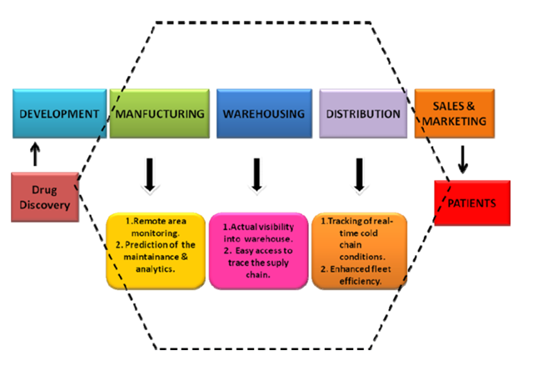

**Fig 3.** IoT application in pharmaceutical Industry

**3.1. IOT IN PHARMACEUTICAL MANUFACTURING INDUSTRY**

Pharmaceutical manufacturing firms use cutting-edge technology and sophisticated information systems. The processes are monitored by many specific IT systems, some of which are centralized. Some systems are localized and do not consistently include all requirements for excellent production in a highly regulated sector. Alongside the surveillance of individual systems, comprehensive real-time perspectives of the plant operations across many systems are required (31). Integration of automated data collection and real-time IoT data analysis from equipment on the production floor is also required. The persistent issue is the direct communication across departments, plant floor operations, and management, stemming from insufficient real-time data integration to enhance process flow and ensure timely product manufacture. The acronym IoT PM, which stands for Internet of Things for Pharmaceutical Manufacturing, has the potential to fundamentally transform the operations of pharmaceutical manufacturing plants. It enables the monitoring of industrial activity from any distant place at any time. Consequently, real-time monitoring facilitates waste reduction, enhances equipment utilization, and decreases production costs. The integration of processes, products, and personnel is referred to as Industrial IoT, with the manufacturing industry being the primary benefactor. Equipment may already be linked; IoT serves as an additional advantage that leverages data and computational capabilities (32).   
This produces useful insights into the plant workflow, monitors, and regulates equipment performance well in advance of breakdowns. The Internet of Things directs the pharmaceutical production industry towards a paperless environment with reduced labor requirements (33).

**3.1.1 Predictive Maintenance in Pharmaceutical**

Pharmaceutical production relies significantly on equipment dependability to ensure product quality and minimize unscheduled downtime. Predictive maintenance, using predictive analytics with real-time data monitoring, provides a more proactive method for asset management [34]. It enables firms to foresee imminent equipment failures by persistently monitoring equipment data, enabling remedial measures prior to disruptions affecting the whole production line.   
**3.1.2 Predictive Analytics for Equipment Malfunction and Process Anomaly**   
Predictive maintenance forecasting entails using a machine learning system that analyzes past equipment performance data gathered from installed sensors. This knowledge gathers patterns indicating early symptoms of wear when an object is likely to fail. For example, real-time data on vibration, temperature, and pressure enable the program to detect anomalies at an early stage, allowing repairs to be conducted during periods of reduced output [35,36]. In contrast to conventional preventive maintenance, which adheres to predetermined timetables, predictive maintenance will, on the other hand, be dictated by the actual equipment performance data, ensuring that a service is performed only when needed [37].

**3.1.3** **Anomaly Detection and Forecasting:** The algorithms in machine learning learn the way things run normally; therefore, any deviation from normality shows inefficiency or an impending failure. An example is of the pattern of energy use that can depict packaging machinery efficiency losses, where maintenance teams can go on taking remedial measures to avoid costly repairs or the loss of production [38].

**3.1.4 Supervised Learning:** These algorithms have extensive applications in forecasting equipment failure by using previously classified historical data. Should the historical data indicate the timing and circumstances of a machine's failure (Figure 4), these algorithms may discern patterns before similar occurrences [39]. The technologies often used include regression analysis, decision trees, and support vector machines, which facilitate the prediction of outcomes such as the remaining lifespan of operational equipment or the likelihood of situations that may result in failures [40].

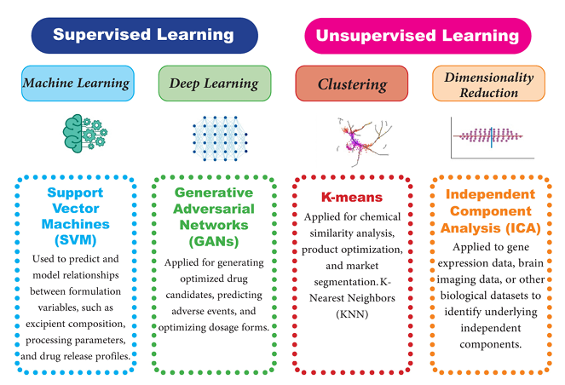

**Fig 4:** Different models of AI learning /tools for predictive pharmaceutical maintenance solutions.

**3.1.5 Unsupervised Learning:** The model in unsupervised learning identifies patterns and anomalies in unlabeled data. Such exploratory data analysis would be quite beneficial. Typical instances include the revelation of concealed correlations or behaviors within machine performance data. Clustering classifies operational circumstances that exhibit similar behavior or identifies anomalous occurrences that may indicate potential breakdowns [41]. Supervised and Unsupervised learning most predictive maintenance systems in the pharmaceutical sector include both supervised and unsupervised learning techniques. In other words, unsupervised learning may be used during data preparation and cleaning, followed by clustering, whereas supervised learning is utilized for specific predictive tasks. The integrated strategy enhances the accuracy and reliability of predictive maintenance efforts [42].

**4. IOT IN DRUG DISCOVERY AND DEVELOPMENT**

The Internet of Things encompasses not just the devices, but also the manner in which they interact and provide a real-time linked experience. The artificial intelligence market in U.S. healthcare was forecast to exceed USD 320 million in 2016, with an anticipated growth of 38% in subsequent years (43). Thirty-five percent of investments go to drug discovery applications within the artificial intelligence business. Currently, the first phases of drug discovery are propelled by machine learning and artificial intelligence. Researchers are using machine learning algorithms to save development time and establish a robust and sustainable medication pipeline. With the progression of cloud computing, machine learning algorithms have gained traction in pharmaceutical laboratories. This predicts the future laboratory's goal, emphasizing digital connection and the introduction of novel pharmaceuticals to healthcare markets (44).

The process of introducing new pharmaceuticals to the market typically spans 12 to 14 years and requires substantial financial commitments. The automation of drug development reduced expenses by up to 70% (45). A London-based benevolent organization used artificial intelligence to identify two possible medication targets for Alzheimer’s disease, prompting pharmaceutical firms to advance their research and development efforts on these strategies. The drug design firm Exscientia employs an AI platform for the creation and screening of compounds to facilitate drug development (46). They swiftly create and evaluate small amounts of molecules that may enhance the existing models and contribute to novel designs. During the pursuit of novel pharmaceuticals IoT, cloud computing, machine learning, and other technologies provide speedier, more cost-effective, and efficient solutions (47). In the drug development process using data sets, diverse information is interconnected to identify the behavioral patterns of the chemical under examination. It illustrates the behavior of the drug in relation to the patient's medical result based on the existing data. It is anticipated that one in a thousand molecules originally deemed safe would ultimately get FDA approval as a medication (48).

The traditional approach to drug development is both costly and time-intensive. The integration of emerging technologies will shape the future of drug discovery. The Internet of Things interlinks people, processes, data, and objects via the internet. Digital transformation is the integration of information technology, operational technology, and data to enhance insights, improve operations, and increase productivity (49). The IoT-based data analysis of drug development environments enhances the repeatability of studies while minimizing human participation and errors in processes and testing (50).

**5. IOT IN CLINICAL RESEARCH TRIAL**

Internet of Things (IoT) enables manufacturers, marketers, and retailers to integrate data in order to enhance the clinical outcomes of patients, which is a significant challenge. In the realm of clinical trials, IoT is becoming equally ubiquitous (51). Almost all pharmaceutical companies, contract research organizations, and service providers intend to expand their utilization of IoT in order to expedite the release of novel medicines and biologics to the market and reduce the need for substantial investments. The safety and efficacy of investigational medications under clinical trials can be more effectively understood by collecting data in innovative ways with IoT and preserving it in the cloud. The data acquired via devices could be sent to the cloud and accessed by clinical coordinators in real time, allowing for site-less trials and patient surveillance in their homes or at a local clinic. By increasing the number of patients and geographic regions, organizations can increase the number of trials, thereby increasing the likelihood of introducing new medications to the market more quickly. IoT devices, which are digital instruments that collect and analyze digital biomarkers from patients, are employed in clinical trials (52).

**6.** **IOT IN PHARMARCEUTICAL WAREHOUSING**

In the pharmaceutical sector, warehousing represents a vital component. To ensure a consistent and timely distribution of pharmaceutical products, pharmaceutical companies maintain storage and warehousing facilities in various regions across the country. Many pharmaceutical industries may choose to manage their warehouse operations in-house, as this allows them to oversee their storage conditions and operations directly, given the specific nature of their products. A McKinsey study indicates that warehousing constitutes 95% of logistics costs in the pharmaceutical sector, highlighting the significant expense associated with warehousing in this industry [53]. Tracking products in the warehouse and optimizing the use of operators and transport equipment is a challenging endeavor without real-time visibility into the activities. The implementation of IoT in warehouses improves the efficiency and precision of various warehouse operations, including stock-taking, product sorting, and both inbound and outbound logistics. This enhances operational efficiency and elevates the standard of warehouse service. The comprehensive management and oversight of warehousing operations can be effectively achieved through the utilization of WSN technology, RFID technology, and wireless video monitoring systems. RFID technology effectively enhances the identification rate of products and facilitates monitoring and control during inbound and outbound activities. When the stocks or storage devices equipped with RFID tags move through the area with RFID readers, the readers will effectively capture the data and transmit it to the control systems. To minimize travel distance, labor expenses, and picking distance in both inbound and outbound operations, Zhou et al. [54]

**6.1.1.** **Monitoring Inventory at Every Stage:** The Internet of Things (IoT) facilitates the connection of pharmaceutical products from their arrival at the warehouse to their delivery to the customer. It offers critical information regarding expiration dates, enabling timely actions to prevent losses associated with product damage. This approach effectively reduces wastage and spoilage of products.

**6.1.2.** **Vision Picking (Utilizing Smart Glasses):** Vision picking is a facet of augmented reality that enables operators to do tasks hands-free and efficiently. This may enhance shop efficiency. Operators may see order selecting guidance via a visual display using smart eyewear. As a wearable device, it needs little training for warehouse managers and does not require any structural modifications to the facility.

**6.1.3.** **Data Analytics:** The IoT enables the observation of all logistics, trends, and potentialities inside the framework. Furthermore, real-time visibility enables prompt and efficient responses to market fluctuations. The data provided by the IoT facilitates the identification of underperforming regions inside the warehouse, enabling informed strategic decision-making.

**6.1.4.** **Automated Tasking:** Automated tasking is executed via drones. These drones may do cycle counts at night and provide the data for operators to reassess in the morning. It will prevent operational downtimes and minimize costs associated with human labor, such as wages, power, and time. Robotics enabled by IoT aids in the picking and packaging processes. The automation of repetitive operations facilitates the reallocation of human resources to other areas. Order discrepancies and inventory levels may also be reduced.

**7. IOT IN PHARMACEUTICAL SUPPLY CHAIN MANAGEMENT**

The pharmaceutical industry, while closely linked to healthcare and medical research, also relies heavily on production, supply chain, and transportation as critical components of its operations. The pharmaceutical supply chain has specific preferences and key considerations due to the unique environmental requirements for handling pharmaceutical products, distinguishing it from standard supply chain networks. The pharmaceutical supply chain comprises several critical phases: Manufacturers, Retailers, Hospitals/Pharmacies, and Consumers [55].

In terms of pharmaceutical drugs and medical supplies, it is essential that product specifications remain unchanged during the transition from manufacturing units to customers. This scenario employs remote monitoring and network analysis as techniques for visualizing transport and warehousing operations in real time. The Internet of Things is poised to revolutionize supply chain processes, offering significant revenue opportunities and enhancing operational efficiency. The operational efficiency encompasses asset tracing, operator relations, predictive inventory management, connected fleets, maintenance scheduling, and revenue opportunities [56].



**Fig. 5.** Supply chain and operations control in Smart Industries

**8. IOT IN PHARMACEUTICAL ENERGY EFFICIENCY**

IoT devices can track energy use throughout the pharmaceutical sector and pinpoint opportunities for enhancing energy efficiency. This may diminish expenses and decrease the factory's carbon impact. IoT devices may monitor energy use in real-time and pinpoint opportunities for optimization in energy usage during component manufacture within the pharmaceutical sector. The procedure may be executed to diminish energy expenses and enhance sustainability in component manufacturing [57]. Utilizing IoT technology, smart factories can monitor and optimize energy use in real-time, leading to substantial energy savings and cost reductions [58]. Several methods by which IoT might enhance energy efficiency in smart factories, particularly in the pharmaceutical sector, are outlined below;   
**8.1.** **Energy Monitoring**: IoT sensors provide real-time surveillance of energy use across several sectors of the industry, including manufacturing lines, lighting, and heating systems. This data may then be examined to identify inefficiencies and potential improvement possibilities [59].

**8.1.2** **Automated Control Systems**: IoT devices can be used to automate energy usage across different systems within the manufacturing facility. For instance, lighting and heating systems may be automatically modified in accordance with occupancy levels or ambient temperature [60].   
**8.1.3**. **Renewable Energy Integration:** IoT technology enables pharmaceutical industries to incorporate renewable energy sources like solar or wind power, facilitating a sustainable production process. The process can contribute to decreasing reliance on fossil fuels and reducing energy costs through effective energy consumption management in the manufacturing process [61].

**8.1.4. Smart lighting:** IoT devices can regulate illumination in industrial settings. This may include the automated deactivation of lights in unoccupied spaces, modulation of illumination according to the natural light levels in a room, or the adjustment of lighting to correspond with certain duties in a designated area [62].

**8.1.5**. **Energy-efficient HVAC:** IoT devices facilitate the monitoring and optimization of heating, ventilation, and air conditioning (HVAC) systems. This may include modifying the temperature according to occupancy or external weather conditions, or using sensors to identify when a facility is vacant and then decreasing HVAC demand appropriately [63].   
**8.1.6**. **Energy storage:** IoT devices can facilitate the management of energy storage systems. This may include charging batteries during off-peak periods when energy costs are lower and using stored energy during peak periods when energy costs are higher [64]. Energy-efficient methodologies in wireless sensor networks for intelligent manufacturing facilities in the industrial sector Figure 6 illustrates 4.0. IoT technology has the potential to revolutionize energy efficiency in smart industries, yielding substantial energy savings, cost reductions, and environmental advantages. Utilizing IoT technology in smart factories enables businesses to enhance energy efficiency, save expenses, and mitigate environmental effect [65].

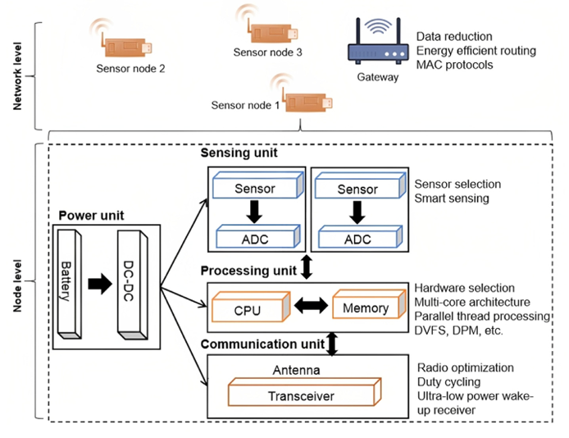

**Fig. 6.** Energy-saving techniques in wireless sensor networks for smart factories

**9. IOT IN PHARMACEUTICAL SAFETY PROTOCOL MONITORING**

IoT devices serve as a means to oversee employee safety, guaranteeing adherence to safety protocols and facilitating the swift identification and resolution of any hazards. An illustration of IoT-enabled monitoring in production processes is the use of predictive maintenance for machinery and equipment [66]. By collecting data from sensors on machines and equipment, it is feasible to pinpoint signs of wear and tear or other issues that could signal an impending breakdown in the component production process [67]. Implementing a safety monitoring procedure enables factory managers to establish an accurate maintenance schedule, thereby minimizing downtime and averting expensive production delays [68]. In summary, IoT technology has the potential to improve safety monitoring in smart factories through the provision of real-time data and predictive analytics, which facilitate proactive maintenance and notify workers of possible hazards [69].

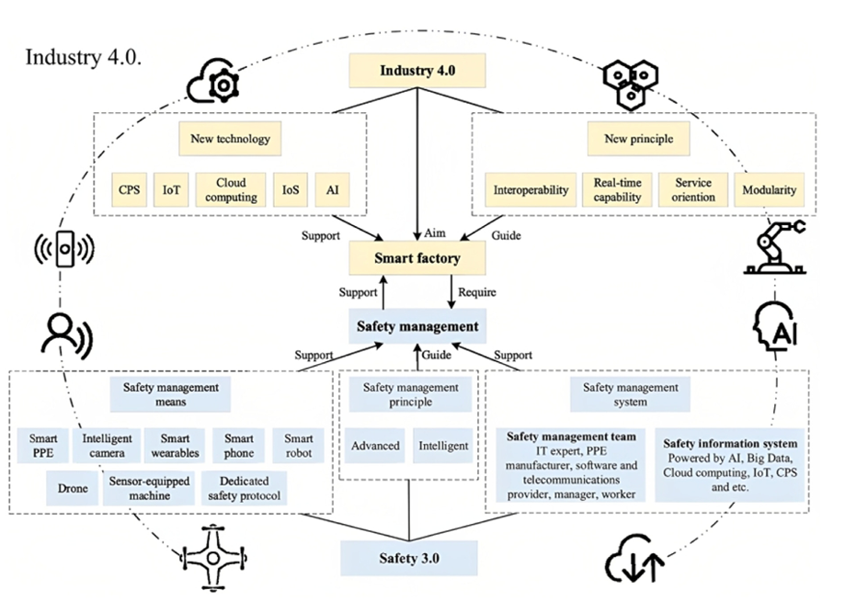

**Fig. 7**. The integration of Safety Protocol and Industry 4.0

**10. KEY CHALLENGES OF INTERNET OF THINGS (IOTS) ACROSS SMART INDUSTRIES**

**10.1. Confidentiality and Security**  
There is a necessity for numerous security measures to ensure comprehensive protection of data and systems. Numerous attacks frequently exploit vulnerabilities in specific devices to gain access to the system, thereby compromising the security of protected devices (70; 71). As Internet usage continues to rise, it is essential to fully consider the features of the Internet of Things (IoT), which is becoming an integral component of the future of the Internet. A number of contemporary IoT devices exhibit vulnerabilities that are recognized by researchers. Furthermore, as the Internet of Things (IoT) relies on pre-existing wireless sensor networks (WSNs), it inherits the privacy and security vulnerabilities associated with WSNs (70).

**10.1.2 Data Processing, Analysis, and Management**   
Data processing, analysis, and management are critical challenges arising from the heterogeneity of the Internet of Things and the substantial volume of data produced, especially in the era of big data (70). Most systems depend on centralized architectures to transfer data and perform compute-intensive tasks on foreign cloud platforms. Concerns exist that conventional cloud architectures may fail to effectively transport vast quantities of data generated and used by IoT-enabled devices, while simultaneously accommodating the escalating computational needs within specified time constraints (72). Consequently, most systems depend on established mobile cloud computing and fog computing technologies. Both depend on edge processing to resolve this problem. Another area of research in data management is the use of information-centric networks (ICNs) inside the Internet of Things. These information-centric systems facilitate content retrieval and expedite access to services, proving to be very beneficial in the access, distribution, and management of developed material and its delivery. This strategy, however, presents many challenges, including the proper extension of the ICN paradigm across Fixed Network Edge, the facilitation of IoT static and mobile devices, and the segregation of ICN functionality into resource-constrained devices (72).

**10.1.2 Evaluation and Recognition**   
Surveillance and detection technology has advanced significantly, yet it continues to evolve with an emphasis on energy efficiency and design aspects. Detectors and trackers are typically anticipated to remain continuously active in order to obtain immediate data. As a result, they play a vital role in energy efficiency, especially in prolonging lifespan. Recent breakthroughs in nanotechnology and biotechnology, along with advancements in downsizing, have enabled the creation of nanoscale actuators and sensors (73).

**10.1.3 M2M Communication and Associated Protocols**   
The constrained Application Protocol (CoAP) and Message Queue Telemetry Transport (MQTT) serve as examples of communication protocols designed for the Internet of Things. However, an open IoT standard has yet to be established. All objects should be interconnected, even though not all require the Internet to transmit data to a specific gateway. Furthermore, various wireless technologies such as LORA, IEEE 802.15.4, and Bluetooth are accessible; however, it remains unclear if these technologies will persist in offering a diverse array of IoT connection options (74).

**11. CONCLUSION**   
The Internet of Things is an innovative system that is establishing a foundation for its beneficial use in pharmaceutical sciences, namely in manufacturing, warehousing, supply chain management, drug development, and clinical trials. The Internet of Things (IoT) has the capacity to enhance pharmaceutical operations by facilitating intelligent solutions for ubiquitous connectivity across many platforms and modalities. The Internet of Things (IoT) is advancing as a crucial sector, seeing significant progress in the creative use of technology inside pharmaceutical operations to improve consumer satisfaction. The advancement of IoT-based systems in pharmaceutical sciences must focus on delivering safe, sustainable, and economically viable pharmaceutical goods. Big data management, temperature detection and management, and counterfeit pharmaceutical items may represent future applications of IoT-based technology.

**DISCLAIMER (ARTIFICIAL INTELLIGENCE)**   
  
The authors of this article declare that no generative AI tools, including Large Language Models (such as ChatGPT, COPILOT, etc.) and text-to-image generators, were used in the preparation or editing of this paper.

**REFERENCE:**

1. Agrawal, G.; Tushir, S.; Arora, D.; Sangwan, K. Artificial Intelligence in Pharmaceutical Drug Delivery. In Proceedings of the 2024 International Conference on Computational Intelligence and Computing Applications (ICCICA), Samalkha, India, 23–24 May 2024; Volume 1, pp. 406–410.
2. Vora, L.K.; Gholap, A.D.; Jetha, K.; Thakur, R.R.S.; Solanki, H.K.; Chavda, V.P. Artificial intelligence in pharmaceutical technology and drug delivery design. Pharmaceutics 2023, 15, 1916. [CrossRef] [PubMed]
3. Colombo, S. Applications of artificial intelligence in drug delivery and pharmaceutical development. In Artificial Intelligence in Healthcare; Academic Press: Cambridge, MA, USA, 2020; pp. 85–116.
4. Liu, J.; Luo, H.; Liu, H. Deep learning-based data analytics for safety in construction. Autom. Constr. 2022, 140, 104302. [CrossRef]
5. Hassanzadeh, P.; Atyabi, F.; Dinarvand, R. The significance of artificial intelligence in drug delivery system design. Adv. Drug Deliv. Rev. 2019, 151, 169–190. [CrossRef] [PubMed]
6. Lee, J.; Bahri, Y.; Novak, R.; Schoenholz, S.S.; Pennington, J.; Sohl-Dickstein, J. Deep neural networks as gaussian processes. arXiv 2017, arXiv:1711.00165.
7. Badjatiya, P.; Gupta, S.; Gupta, M.; Varma, V. Deep learning for hate speech detection in tweets. In Proceedings of the 26th International Conference on World Wide Web Companion, Perth, Australia, 3–7 April 2017; pp. 759–760.
8. Brata, K.C.; Funabiki, N.; Riyantoko, P.A.; Panduman, Y.Y.F.; Mentari, M. Performance Investigations of VSLAM and Google Street View Integration in Outdoor Location-Based Augmented Reality under Various Lighting Conditions. Electronics 2024, 13, 2930. [CrossRef]
9. Morchid, A.; El Alami, R.; Raezah, A.A.; Sabbar, Y. Applications of internet of things (IoT) and sensors technology to increase food security and agricultural Sustainability: Benefits and challenges. Ain Shams Eng. J. 2024, 15, 102509. [CrossRef]
10. Leicht-Deobald, U.; Busch, T.; Schank, C.; Weibel, A.; Schafheitle, S.; Wildhaber, I.; Kasper, G. The challenges of algorithm based HRdecision-making for personal integrity. In Business and the Ethical Implications of Technology; Springer Nature: Cham, Switzerland, 2022; pp. 71–86.
11. A Ilmudeen, Aboobucker, and Hayat Malik Babur. (2016) “A Review of Information Technology Governance, Business Strategy and Information Technology Strategy.” International Journal of Advanced Research in Computer Science and Software Engineering.
12. Tange, Koen, Michele De Donno, Xenofon Fafoutis, and Nicola Dragoni. (2020) “A Systematic Survey of Industrial Internet of Things Security: Requirements and Fog Computing Opportunities.” IEEE Communications Surveys and Tutorials.
13. Meng, C. Z. (2017). A General Architecture of IoT System. IEEE International Conference on Computational Science and Engineering (CSE) and IEEE International Conference on Embedded and Ubiquitous Computing (EUC), 659-664
14. Masud, M. (2013). Towards Internet of things: Survey and future vision. Int. J. Comput. Network, 1 -17.
15. Sarangi, P. S. (2017). Internet of Things: Architectures, Protocols and Applications. Journal of Electrical and Computer Engineering, 25.
16. Muntjir, M. &. (2017). An Analysis of Internet of Things(IoT): Novel Architectures, Modern Applications,Security Aspects and Future Scope with Latest Case Studies. Building Services Engineering Research and Technology.
17. Mehta R, Sahni J, Khanna A. Internet of Things: vision, applica tions and challenges. Proced Comp Sci. 2018;132:1263–9. https ://doi.org/10.1016/j.procs.2018.05.042.
18. Ren L, Zhang L, Tao F, Zhang X, Luo Y, Zhang Y. A methodol ogy towards a virtualization-based high-performance simulation platform supporting the multidisciplinary design of complex products. Enterp Inf Syst. 2012;6:267–90.
19. Tao F, LaiLi Y, Xu L, Zhang L. FC-PACO-RM: a parallel method for service composition optimal-selection in the cloud manufacturing system. IEEE Trans Ind Inf. 2012;9:2023–33. https://doi.org/10.1109/TII.2012.2232936.
20. López TS, Ranasinghe DC, Patkai B, McFarlane D. Taxonomy, technology and applications of smart objects. Inf Syst Front. 2011;13:281–300.
21. Rayes A, Salam S (2017) The internet of things from hype to reality. In: Things in IoT: sensors and actuators, Chap 3. Springer International Publishing AG, pp 57–77
22. Lee J, Bagheri B, Kao HA. A cyber-physical systems architec ture for industry 4.0-based manufacturing systems. Manuf Lett. 2015;3:18–23.
23. Bonomi F, Milito R, Zhu J, Addepalli S (2012) Fog computing and its role in the internet of things. In: Proceedings of the first edition of the MCC workshop on Mobile cloud computing. pp. 13–16
24. Thoben KD, Wiesner S, Wuest T. Industrie 4.0 and smart manufacturing—a review of research issues and application examples. Int J Autom. 2017; 11:4–16. https://doi.org/10.20965 /ijat.2017.p0004.
25. Mano, L. Y., Faiçal, B. S., Nakamura, L. H. V., Gomes, P. H., Libralon, G. L., Meneguete, R. I., Filho, G. P. R., Giancristofaro, G. T., Pessin, G., Krishnamachari, B., & Ueyama, J. (2016). Exploiting IoT technologies for enhancing Health Smart Homes through patient identification and emotion recognition. Computer Communications, 89–90, 178–190. <https://doi.org/10.1016/j.comcom.2016.03.010>.
26. Miraz, M. H., Ali, M., Excell, P. S., & Picking, R. (2015). A review on Internet of Things (IoT), Internet of Everything (IoE) and Internet of Nano Things (IoNT). 2015 Internet Technologies and Applications, ITA 2015 - Proceedings of the 6th International Conference, September, 219–224. <https://doi.org/10.1109/ITechA.2015.7317398>.
27. Peter Onu and Charles Mbohwa. (2021) “Reimagining the Future: Techno Innovation Advancement in Manufacturing,” Materials today: Proceeding.
28. Badarinath, Rakshith, and Vittaldas V. Prabhu. (2017) “Advances in Internet of Things (Io T) in Manufacturing.” In IFIP Advances in Information and Communication Technology.
29. Pharmaceutical Manufacturing is Labeled a Success With Newly Integrated Plant Operations [Internet]. decisyon 2019. [cited 18 May 2019]. Available from: https://www.decisyon.com/iot-plant-operations-decisyon-digital-factory/
30. Improving Efficiency in Pharma Manufacturing ThroughIoT Technologies [Internet]. SpendEdge 2018. [cited 15 April 2019] Available from: https://www.spendedge.com/blogs/efficiency-pharma-manufacturing-iot
31. Rayes A, Salam S.Internet of Things From Hype to Reality. Springer International Publishing 2017.
32. Singh, A.P.; Saxena, R.; Saxena, S.; Maurya, N.K. Artificial Intelligence Revolution in Healthcare: Transforming Diagnosis, Treatment, and Patient Care. Asian J. Adv. Res. 2024, 7, 241–263.
33. Joshi, M. Artificial Intelligence (AI) in healthcare. Int. J. Innov. Res. Sci. Eng. Technol. 2024, 13, 451–453.
34. Choubey, A.; Choubey, S.B.; Prafull, K.; Daulatabad, V.S.; John, N. Healthcare Transformation: Artificial Intelligence Is the Dire Imperative of the Day. Cureus 2024, 16, e62652. [CrossRef]
35. Gupta, S.; Kumar, V.; Gupta, P. Role of artificial intelligence in health sector. In Challenges in Information, Communication and Computing Technology; CRC Press: Boca Raton, FL, USA, 2025; pp. 690–695.
36. Ahmadi, A.; RabieNezhad Ganji, N. AI-driven medical innovations: Transforming healthcare through data intelligence. Int. J. BioLife Sci. (IJBLS) 2023, 2, 132–142.
37. Channapatna, R. Role of AI (Artificial Intelligence) and Machine Learning in Transforming Operations in Healthcare Industry: An Empirical Study. Int. J. 2023, 10, 2069–2076.
38. Al Kuwaiti, A.; Nazer, K.; Al-Reedy, A.; Al-Shehri, S.; Al-Muhanna, A.; Subbarayalu, A.V.; Al Muhanna, D.; Al-Muhanna, F.A. A review of the role of artificial intelligence in healthcare. J. Pers. Med. 2023, 13, 951. [CrossRef]
39. Poalelungi, D.G.; Musat, C.L.; Fulga, A.; Neagu, M.; Neagu, A.I.; Piraianu, A.I.; Fulga, I. Advancing patient care: How artificial intelligence is transforming healthcare. J. Pers. Med. 2023, 13, 1214. [CrossRef]
40. Navath, S. Transforming healthcare: The impact and future of artificial intelligence in healthcare. J. Artif. Intell. Mach. Learn. 2023, 1, 16–21. [CrossRef]
41. Robinson R. The Internet of Things: Beyond Hype and Into Reality [Internet]. Pharma Voice [cited 17 April 2019]. https://www.pharmavoice.com/article/internet-of-things/ Available from: <https://www.pharmavoice.com/article/internet-of-things/>
42. Staines R. Healthcare AI market worth $10bn plus by 2024 – report [Internet]. pharmaphorum 2018. [cited 26 April 2019]. Available from: <https://pharmaphorum.com/digital/healthcare-ai-market-worth-10bn-plus-2024-report/>
43. Gaskell A. Using Machine Learning to Make Drug Discovery More Efficient [Internet].DZone 2016. [cited 10 May 2019]. Available from: <https://dzone.com/articles/using-machine-learning-to-make-drug-discovery-more>
44. Fan P. How AI Can Speed Up Drug Discovery [Internet]. Synced 2018. [cited 06 June 2019].Available from: [https://syncedreview.com/2018/04/14/how-ai-can-speed-up-drug discovery/](https://syncedreview.com/2018/04/14/how-ai-can-speed-up-drug%20discovery/)
45. Fleming N. Computer calculated compounds. Nature 2018. 557: S55-S57.
46. Gralla P. Speeding drug discovery with AI and big data [Internet]. 2018. [cited 20 June 2019]. Available from: [https://www.hpe.com/us/en/insights/articles/speeding-drug discovery-with-ai-and-big-data-1802.html](https://www.hpe.com/us/en/insights/articles/speeding-drug%20discovery-with-ai-and-big-data-1802.html)
47. Abel J. Digital Transformation of Pharma and Biotech [Internet].ARC Report 2019. [cited 20 June 2019]. Available from: https://www.arcweb.com/blog/digital-transformation pharma-biotech
48. Automation, IoT and the future of smarter research environments [Internet].Pharma IQ News 2018. [cited 26 May 2019]. Available from: https://www.pharma-iq.com/pre clinical-discovery-and-development/news/automation-iot-and-the-future-of-smarter research-environments
49. Palmer J. The Future of Mobility and Medicine. Applied Clinical Trials 2018. 27(9): 1-3.
50. Internet of Things in Clinical Trials [Internet].JLI Social Media 2018. [cited 24 May 2019]. Available from: <https://www.jli.edu.in/blog/iot-clinical-trials/>
51. Li W, Kara S. Methodology for monitoring manufacturing environment by using wireless sensor network (WSN) and the internet of things (IoT). Proced CIRP. 2017;61:323–8.https :// doi.org/10.1016/j.procir.2016.11.182.
52. Mc Kinsey Global Institue. The Internet of Things: mapping the value beyond the hype. San Francisco: Mc Kinsey and Com pany; 2015.
53. Zhou JR, Zhang HJ, Zhou HL. Localization of pallets in ware houses using a passive RFID system. J Central South Univ. 2015;22:3017–25
54. Xue Y, Liu H. RFID-based intelligent storage and retrieval sys tems in automated warehouse. J Softw. 2011;6:1844–50. https:// doi.org/10.4304/jsw.6.9.1844-1850.
55. Marathe A, Awwad M (2018) Internet of Things: oppurtunities and applications in pharmaceutical manufacturing and logistics. American society for engineering management, international annual conference.
56. K. Nigappa, J. Selvakumar, Industry 4.0: a cost and energy efficient micro PLC for smart manufacturing, Indian J. Sci. Technol. 9 (2016) 1–6.
57. M. Elsisi, M.-Q. Tran, K. Mahmoud, M. Lehtonen, M.M. Darwish, Deep learning based industry 4.0 and internet of things towards effective energy management for smart buildings, Sensors 21 (2021) 1038
58. O. Kanoun, S. Khriji, S. Naifar, S. Bradai, G. Bouattour, A. Bouhamed, D. El Houssaini, C. Viehweger, Prospects of wireless energy-aware sensors for smart factories in the industry 4.0 era, Electronics 10 (2021) 2929.
59. N. Hossein Motlagh, M. Mohammadrezaei, J. Hunt, B. Zakeri, Internet of things (IoT) and the energy sector, Energies 13 (2020) 494.
60. F. Shrouf, J. Ordieres, G. Miragliotta, Smart factories in Industry 4.0: a review of the concept and of energy management approached in production based on the Internet of Things paradigm, in: 2014 IEEE International Conference on Industrial Engineering and Engineering Management, IEEE, 2014, pp. 697–701.
61. N. Mohamed, J. Al-Jaroodi, S. Lazarova-Molnar, Leveraging the capabilities of industry 4.0 for improving energy efficiency in smart factories, IEEE Access 7 (2019) 18008–18020.
62. T. Ahmad, H. Zhu, D. Zhang, R. Tariq, A. Bassam, F. Ullah, A.S. AlGhamdi, S.S. Alshamrani, Energetics systems and artificial intelligence: applications of industry 4.0, Energy Rep. 8 (2022) 334–361.
63. P. Boopalan, S.P. Ramu, Q.-V. Pham, K. Dev, P.K.R. Maddikunta, T.R. Gadekallu, T. Huynh-The, Fusion of Federated Learning and Industrial Internet of Things: A Survey, Computer Networks, 2022, 109048.
64. A.F. Abate, L. Cimmino, I. Cuomo, M. Di Nardo, T. Murino, On the impact of multimodal and multi-sensor biometrics in smart factories, IEEE Trans. Ind. Inf. 18 (2022) 9092–9100.
65. M. Ahmadi, M. Pahlavani, A. Karimi, M. Moradi, J. Lawrence, The impact of the fourth industrial revolution on the transitory stage of the automotive industry, in: Sustainable Manufacturing in Industry 4.0: Pathways and Practices, Springer, 2023, pp. 79–96.
66. M. Javaid, A. Haleem, R.P. Singh, R. Suman, Enabling flexible manufacturing system (FMS) through the applications of industry 4.0 technologies, Int. Things and Cyber-Phys. Syst. 2 (2022) 49–62.
67. B. Esmaeilian, J. Sarkis, K. Lewis, S. Behdad, Blockchain for the future of sustainable supply chain management in Industry 4.0, Resources, Conserv. Recycl. 163 (2020), 105064.
68. Alansari, Z., Anuar, N. B., Kamsin, A., & Soomro, S. (2018). 'S. August. https://doi.org/10.1007/978-3-319 95450-9.
69. Chaudhry, J., Saleem, K., Haskell-Dowland, P., & Miraz, M. H. (2018). A survey of distributed certificate authorities in manets. Annals of Emerging Technologies in Computing, 2(3), 11–18. <https://doi.org/10.33166/AETiC.2018.03.002>.
70. Abu Daia, A. S., Ramadan, R. A., & Fayek, M. B. (2018). Sensor networks attacks classifications and mitigation. Annals of Emerging Technologies in Computing, 2(4), 28–43. https://doi.org/10.33166/AETiC.2018.04.003.
71. Belkeziz, R., & Jarir, Z. (2017). A survey on Internet of Things coordination. Proceedings - 2016 3rd International Conference on Systems of Collaboration, Sysco 2016, May. <https://doi.org/10.1109/SYSCO.2016.7831328>.
72. Nikhat Akhtar, & Yusuf Perwej. (2020). The Internet of nano things (IoNT) existing state and future Prospects. GSC Advanced Research and Reviews, 5(2), 131–150. <https://doi.org/10.30574/gscarr.2020.5.2.0110>.
73. Dwivedi, J. N. (2021). Internet of Things (IoT) and Machine to Machine (M2M) Communication Techniques for Cyber Crime Prediction. Intelligent Data Analytics for Terror Threat Prediction, January, 31–55. <https://doi.org/10.1002/9781119711629.ch2>.
74. Bilal, D., Rehman, A.-U., & Ali, R. (2018). Internet of Things (IoT) Protocols: A Brief Exploration of MQTT and CoAP. International Journal of Computer Applications, 179(27), 9–14. <https://doi.org/10.5120/ijca2018916438>.