***Original Research Article***

**Checklist of wild orchids of Koppa taluk, Chikkamagaluru, Karnataka**

**ABSTRACT:**

Orchids are charismatic group of flowering plants, exhibit remarkable diversity and ecological importance. Despite their evolutionary and economic importance, comprehensive studies on orchid diversity in specific regions are often lacking. This research paper aims to fill this gap by thoroughly studying orchid diversity in different regions of Koppa taluk of Chikkamagaluru district, Karnataka. The study area possessed vegetations like evergreen, semi evergreen, moist deciduous, dry deciduous, scrubby, Shola grasslands and *Acacia* plantation. Extensive and intensive field surveys revealed the occurrence of 97 species of orchids belonging to 40 genera. Among these, epiphytes (64), terrestrial (33) and mycoheterotrophic (2). The findings provide valuable insights into the orchid flora of Koppa taluk, highlighting its endemism and distributional status in the study area

**KEY WORDS:** Distribution, Epiphytes, Kudremukh Reserve Forest, Myco-trophic, Terrestrial.

**INTRODUCTION:**

Orchidaceae is one of the largest families of flowering plants in the world, comprising of 20,000-30,000 species (POWO, 2024). Orchids are widely distributed in tropics, subtropics and temperate regions. Within the tropics, orchids form an important feature of the vegetation, chiefly as epiphytes. About 73% of species are epiphytes, and these make a significant contribution to the epiphytic plant communities in the tropical forests. The orchids can be divided into epiphytes, terrestrial, saprophytes and lithophytes, since they have evolved to adapt to various habitats. Orchids are very widely distributed but their largest diversity occurs in the tropics (Dressler, 1981).

In India, there are around 1256 species of 156 genera; in that 307 species are endemic to India (Singh et al. 2019). According to Rao (1998) more than 46% of the known species of orchids are endemic to Western Ghats. The diversity of orchids decreases from North East to North West Himalaya (Chowdhery and Wadhwa, 1984; Deva and Naithani, 1986; Pangtey & al., 1991; Chowdhery, 1999). In India, wild orchid diversity is high in two biodiversity hotspots viz., the North Eastern region accounts for about 800 species, and the Western Ghats have 375 species (Bose & al., 1999). Kudremukh National Park records 38 genera and 68 species, which is second dominant family in Floristic works of Kudremuk National park, one of the World Hertiage site, which is from Koppa taluk, Chikmangluru (Sringeswara & al. 2013).

In Karnataka, the Orchidaceae family has 59 genera and roughly comprising of 203 species (Krishnaswamy, 2004).However, detailed studies focusing on orchid diversity at the district level are limited, hindering our understanding of their distribution patterns and conservation status in specific regions. About 200 species were known to occur in the Western Ghats at the time contributed significantly to the understanding of orchids in peninsular India. The present paper briefly explains the diversity of orchids in Koppa taluk of Chikkamagaluru district, Karnataka. The study area comes under Western Ghats and it accounts for so many endemic orchid species.

**MATERIAL AND METHODS:**

**Study area and Vegetation types**

The selected study area was Koppa taluk which comes under Malnad region of Chikkamagaluru District, Karnataka (Fig. 01). Koppa is one of the seven taluks in Chikkamagaluru district and is known for its scenic beauty and rich vegetation. The major study area was comprising of selected places of Koppa Forest Division and Kudremukh, along with other places of Koppa taluk. Koppa taluk is located at 13.530 N and 75.360 E. The temperature of this region varies between 180 C to 310 C and the annual rainfall is nearly 1600 to 3400 mm. The present study was carried out from June 2022 to October 2024. Continued field visits were carried out to each selected areas for the documentation of orchids during flowering and fruiting seasons. Random sampling techniques were used to conduct the survey.

**Documentation and Identification**

Throughout the field visits necessary photos were taken and important aspects are noted down. Further, plants are documented thoroughly using available information in online and offline resources. NIKON D3300 DSLR and iPhone14 Pro Max were used for the better and clear photography. The plants have been identified with the help of available floras, checklists and manuals (Gamble, 1935; Rao, 1998; Yoganarasimhan et al. 1999 and Jalal, 2022). For almost all taxa names, followed the nomenclatural references accepted by POWO (2025).

**RESULTS AND DISCUSSIONS:**

The present paper records 97 species (Fig. 4-11) of 40 genera in different locations of Koppa taluk of Chikkamagaluru, Karnataka. In total, the number of epiphytic orchids were higher than that of terrestrial. A total of 64 epiphytic, 31 terrestrial and 2 mycoheterotrophic orchid species (Fig. 02) from the Orchidaceae family were identified by floristic analysis in the various study areas. *Dendrobium*, *Oberonia*, *Habenaria*, *Bulbophyllum*, *Porpax* and *Peristylus* are the most abundant genera found in the study areas. Species richness of each genera follows like this, *Dendrobium* (9), *Oberonia* (9), *Habenaria* (8), *Bulbophyllum* (7), *Porpax* (6), *Peristylus* (5), *Liparis* (4), *Nervilea* (4), *Aerides* (3), *Smithsonia* (3), *Zeuxine* (3), *Coleogyne*, *Cymbidium*, *Eulophia*, *Gastrochilus*, *Lusia* and *Vanda* with each 2 species respectively. Further 24 genera were having one species each. The most dominant epiphytic orchid genera found in different regions were *Pholidota*, *Cleisostoma*, *Cymbidium* and *Rhynchostylis*. *Cleisostoma tenuifolium* and *Pholidota imbricata* were almost common in every locations i.e., indicating the highest abundance. *Nervilia crociformis* and *Crepidium* *versicolor* were the dominant ground orchids found in Gunavanthe and Hirekere respectively. *Habenaria* species were observed in grasslands more frequently. Whereas, two mycoheterotrophic orchids were observed viz., *Aphyllorchis montana* (Gadikal region) and *Epipogeum roseum* (Gunavanthe region) which were restricted to single place. Some orchids are endemic to Western Ghats (37), Western Ghats & Eastern Ghats (6), India (3) and Other than India also (50) (Fig. 03).

**Note:** Out of total 97 species, we have photographed 94 species but couldn’t collect photos of other 3 species (*Cymbidium aloifolium* (L.) Sw., *Diploprora championii* (Lindl.) Hook.f. *Disperis neilgherrennis* Wight)

**CONCLUSION:**

Studies on diversity of orchids in different regions of Koppa taluk of Chikkamagaluru district offers an insight into the occurrence of different orchid species in that particular area. The similar studies were made earlier in the regions includes distribution of ground orchids in different ground orchids in Chikkamagaluru district by (Krishna Swamy, 2011) and (Udupa & al. 2023) in Sringeri region. The main reason for the orchids richness in these locations is due to the presence of evergreen type of forests, grasslands and low human activity in the region. The good amount of annual rainfall, humidity, precipitation and shady are the major factors that are influencing the growth of orchids. Even certain reasons are devoted to regional practices, indicating the less or no human intervention. All these factors are evidently responsible for the rich growth of orchids.

Apart from these necessary conditions, there are few things which are directly or indirectly hindering the orchid population. Habitat destruction by Forest department for developmental work, Collection of orchid flowers by local people and Natural calamities are the main reasons leading to decline of natural population of orchids. So, further steps to be taken for educating the local communities and general public in preserving and conserving the orchids in their natural habitat. Still there are locations which are untouched and hence extended study is required to know the diversity of orchids in those areas.

**REFERENCES:**

Abraham, A. and Vatsala, P. 1981. Introduction to orchids with illustrations and descriptions of 150 South Indian orchids. Tropical botanical graden and research Institute, Palode, Thiruvanthapuram, Kerala, India. Pp 285–287.

Atwood, J. T. 1986. The size of the Orchidaceae and the systematic distribution of epiphytic orchids. Selbyana 9: 171-86.

Balakrishnan, N. P. and Nair, N. G. 1976. New records of orchids from Andaman Islands. Bulletin of the Botanical Survey of India 18: 149-154.

Benzing, D. H. and Atwood Jr, J. T. 1984. Orchidaceae: ancestral habitats and current status in forest canopies. Systematic Botany 155-165.

Bose, T. K. and Bhattacharjee, S. K. 1980. *Orchids of India*. Naya Prokash, Kolkata.

Chowdhery, H. J. 1999. Himachal Pradesh. Floristic diversity and conservation strategies in India. 2: 845-887.

Chowdhery, H. J. And Wadhwa, B. M. 1984. *Flora of Himachal Pradesh*. Botanical Survey of India, Calcutta. 1-3.

Deva, S. and Naithani, H. B. 1986. The orchid flora of North West Himalaya. Print and Media Associates, New Delhi.

Dressler, R. L. 1981. *The orchids*. Natural history and classification. Cambridge: Harvard University Press.

Dressler, R. L. and Dodson, C. H. 1960. Classification and phylogeny in the Orchidaceae*.* Annals of the Missouri Botanical Garden. 47: 25–67.

Duthie, J. F. 1906. The orchids of the northwestern Himalaya. Annals of the Royal Botanic Garden, Calcutta. 9: 81-211.

Gamble, J. S. and Fischer, C. E. C. 1935. *Flora of the Presidency of Madras*. Botanical Survey of India, Calcutta.

Gunaga, S. V., Jadeyegowda, M., Kushalappa, C. G., Mallikarjun, J., Ramesh, M. N. And Dinesha, S. 2024. Assessment of orchid diversity in the sacred groves of Kodagu, India’s Central Western Ghats Biodiversity Hotspot: implications for biocultural diversity management. Plant and Soil. 1-15.

Hegde, S. M. and Krishnaswamy, K. 2023. Terrestrial Orchid Diversity in Sagara Taluk of Shimogga District Central Western Ghats Region of Karnataka. *The Journal of Plant Science Research* 39(1): 67-74.

Hegde, S. N. 1997. Orchid wealth of India. Proceedings of the National Academy of Sciences, India 63(3): 229-44.

Jalal, J. J. 2012. Distribution Pattern of Orchids in Uttarakhand, Western Himalayas, India. International Journal of Plant Science. 3.

Jalal, J. S. and Singh, P. 2015. Threatened orchids of Maharashtra: A preliminary assessment based on IUCN regional guidelines and conservation prioritisation. The Journal of Orchid Society of India. 29: 1-14.

Janakiram, T. and Baskaran, V. 2018. Commercialization and conservation aspects of orchids. The Journal of the Orchid Society of India. 32: 55-61.

Jayanthi, J. and Jalal, J. S. 2023. A checklist to the orchids of Biligiri Rangaswamy Temple Tiger Reserve, Western Ghats, India Lankesteriana. 23(1): 45-79.

Krishna Swamy, K., Udupa, K., Santhosh, N. R. and Gurudev, M. R. 2011. Distribution of ground Orchids in grasslands of Chickmagalur district, Karnataka. Orchid Society of India. 25: 81-85.

Krishnaswamy, K. 2005. *Studies on the Orchidaceae*. Ph. D. thesis, University of Mysore. Manasagangotri, Kamataka, India.

Krishnaswamy, K. Krishna Kumar, H. N., Ramakrishna, T. M. and Ramaswamy S. N. 2004. Studies on Distribution and Phenology of Orchids in Karnataka. Orchid Society of India. 18 (1-2): 81-96.

Ninawe, A. S. and Swapna, T. S. 2017. Orchid diversity of Northeast India– traditional knowledge and strategic plan for conservation. The Journal of Orchid Society of India. 31: 41-56.

POWO, 2024 "Plants of the World Online". Facilitated by the Royal Botanic Gardens, Kew. Published on the internet; http://www.plantsoftheworldonline.org/ Retrieved 31st November 2024.

Rao, A. N. 2004. Medicinal Orchid wealth of Arunachal Pradesh. Newsletter: Environmental Information System on Conservation of Medicinal Plants. 1(2): 1-5.

Rao, A. N. 2018. Monopodial orchids in India- an update. The Journal of The Orchid society of India. 36: 75-90.

Rao, T. A. and Sridhar, S. 2007. *Wild orchids in Karnataka: A pictorial compendium*. Institute of Natural Resources Conservation Education, Research and Training.

Singh, S.K., Agarawala D. K., Jalal, J. S., Dash, S. S., Mao, A. A. And P. Singh 2019. Orchids of India, a Pictorial Compendium. Botanical Survey of India: 140-141.

Sringeshwara, A. N., **Shivanna, M. B. and Balakrishna Gowda 2013. Floristic diversity in Kudremukh National Park, Western Ghats, Karnataka. Indian Institute of Science Bangalore ENVIS - Environmental Information System, Centre for Ecological Sciences.**

Yoganarasimhan, S. N. 1981. *Flora of Chikkmagaluru District*, *Karnataka*, *India*. The University of California, International Book Distributors, Dehradun. 407.

Yonzone, R., Lama, D., Bhujel, R. B. and Rai, S. 2012. Orchid species diversity of Darjeeling Himalaya of India. International Journal of Pharmacy and Life Sciences. 3(3).

**Table 01.** Checklist of Koppa taluk, Chikmagluru, Karnataka:

|  |  |  |  |  |  |  |
| --- | --- | --- | --- | --- | --- | --- |
| **Scientific name** | **Habitat** | **Vegetation** | **Location** | **Flowering season** | **Endemism** | **Status** |
| *Acampe praemorsa* (Roxb.) Blatt. & McCann | E | MD, SE | Ammadi | March-April | O | C |
| *Aerides crispa* Lindl. | E | E, SE | Dorgal | June-September | WG & EG | O |
| *Aerides maculosa* Lindl. | E | E | Dorgal | June-August | WG & EG | O |
| *Aerides ringens* (Lindl.) C.E.C.Fisch. | E | MD, SE | Gadikal | April-July | O | C |
| *Aphyllorchis montana* Rchb.f. | MY | MD | Gadikal | August-September | O | O |
| *Bulbophyllum fischeri* Seidenf. | E | E, SE | Kudremukh | October-November | WG | R |
| *Bulbophyllum fuscopurpureum*Wight | E | E | Kudremukh | January-February | WG | R |
| *Bulbophyllum mysorense* (Rolfe) J.J.Sm. | E | E, SE | Kudremukh | June-September | WG | R |
| *Bulbophyllum proudlockii* (King & Pantl.) J.J.Sm. | E | E, SE | Gadikal | January-April | WG | O |
| *Bulbophyllum sterile* (Lam.) Suresh | E | MD, SE | Hariharapur | January-February | WG & EG | O |
| *Bulbophyllum stocksii* (Benth. ex Hook.f.) J.J.Verm., Schuit. & de Vogel | E | MD, SE | Gadikal | January-February | WG | C |
| *Bulbophyllum tremulum* Wight | E | MD, SE | Gunavanthe | January-February | WG | R |
| *Calanthe sylvatica* (Thouars) Lindl. | T | E, Gr | Kudremukh | August-December | O | R |
| *Cheirostylis flabellata* (A.Rich.) Wight | T | E, MD | Kudremukh | February-May | O | R |
| *Chiloschista confusa* M.J.Mathew, J.Mathew, P.M.Salim & Szlach. | E | E | Koppa rural | April-May | WG | O |
| *Cleisocentron neglectum*M. J. Mathew & J. Mathew | E | SE | Kudremukh | August-September | WG | R |
| *Cleisostoma tenuifolium* (L.) Garay | E | E | Koppa rural | June-August | O | C |
| *Coelogyne breviscapa* Lindl. | E | E, SE | Kademakki | January-February | WG | C |
| *Coelogyne imbricata*(Hook.) Rchb.f. | E | E | Hunasekoppa | July-August | O | C |
| *Cottonia peduncularis* (Lindl.) Rchb.f. | E | E, SE | Gadikal | March-April | O | C |
| *Crepidium versicolor* (Lindl.) Sushil K.Singh, Agrawala & Jalal | T | E | Gubbugadde | July-August | O | C |
| *Cymbidium aloifolium* (L.) Sw. | E | E, SE | Urumakki | April-May | O | R |
| *Cymbidium bicolor* Lindl. | E | E, SE | Ammadi | May-June | O | O |
| *Dendrobium aqueum* Lindl. | E | E, SE, MD | Kudremukh | October-January | WG | R |
| *Dendrobium barbatulum* Lindl. | T | MD, Gr | Kudremukh | December-January | WG | O |
| *Dendrobium crepidatum* Griff. | E | E, SE | Shivapura | March-April | O | O |
| *Dendrobium crispum* Dalzell | E | E, SE | Kudremukh | November-December | O | R |
| *Dendrobium jerdonianum* Wight | E | E | Kudremukh | February-March | WG | R |
| *Dendrobium lawianum* Lindl. | E | E, SE | Jammitige | February-March | WG | C |
| *Dendrobium macrostachyum* Lindl. | E | E, SE | Jammitige | March-April | O | C |
| *Dendrobium nanum* Hook.f. | E | E | Kudremukh | July-April | WG | O |
| *Dendrobium nodosum* Dalzell | E | E, SE | Urumakki | October-November | WG & EG | O |
| *Dienia ophrydis* (J.Koenig) Seidenf. | T | E, SE | Kudremukh | July-August | O | O |
| *Diploprora championii* (Lindl.) Hook.f. | E | SE, MD | Kudremukh | August-September | O | O |
| *Disperis neilgherrennis* Wight | E | E, SE | Kudremukh | June-July | O | R |
| *Epipogium roseum* (D.Don) Lindl. | MY | E, SE | Gadikal | February-May | O | O |
| *Eulophia nuda* Lindl. | T | SE, MD | Keeranakere | April-May | O | O |
| *Eulophia picta* (R.Br.) Ormerod | T | SE, MD | Hunasekoppa | July-August | O | O |
| *Gastrochilus acaulis* (Lindl.) Kuntze | E | E, SE | Keeranakere | February-March | WG | O |
| *Gastrochilus flabelliformis* (Blatt. & McCann) C.J.Saldanha | E | E, SE | Hunasekoppa | September-October | WG | O |
| *Habenaria crinifera* Lindl. | E | E, Gr | Kudremukh | July-August | O | O |
| *Habenaria grandifloriformis* Blatt. & McCann | T | E, Gr, MD | Galigudda | June-July | I | C |
| *Habenaria heyneana* Lindl. | T | Gr | Kudremukh | August-September | WG & EG | C |
| *Habenaria longicorniculata* J.Graham | T | Gr | Galigudda | August-September | O | O |
| *Habenaria marginata* Colebr. | T | FF | Hunasekoppa | August-September | O | O |
| *Habenaria multicaudata* Sedgw. | T | FF | Kudremukh | August-September | WG | R |
| *Habenaria perrottetiana* A.Rich. | T | Gr | Kudremukh | August-September | WG | R |
| *Habenaria plantaginea* Lindl. | T | Gr | Galigudda | September-October | O | O |
| *Liparis biloba* Wight | T | Gr | Kudremukh | August-October | WG | O |
| *Liparis odorata* (Willd.) Lindl. | T | FF | Galigudda | July-August | O | C |
| *Liparis viridiflora* (Blume) Lindl. | E | E, | Kudremukh | August-September | O | O |
| *Liparis wightiana* Thwaites | T | Gr | Kudremukh | August-September | WG | R |
| *Luisia macrantha* Blatt. & McCann | E | E, SE | Karkibile | January-May | WG | O |
| *Luisia zeylanica* Lindl. | E | E, SE | Karkibile | August-September & January-March | O | O |
| *Nervilia concolor* (Blume) Schltr. | T | E, SE, FF | Gubbugadde | June-July | O | O |
| *Nervilia infundibulifolia* Blatt. & McCann | T | MD, SE | Gunavanthe | June-July | O | C |
| *Nervilia plicata* (Andrews) Schltr. | E | SE, FF | Kudremukh | June-July | O | O |
| *Nervilia simplex*(Thouars) Schltr. | T | MD, SE | Gadidal | June-July | O | C |
| *Oberonia bicornis* Lindl. | E | E, SE | Kudremukh | September-October | O | O |
| *Oberonia brunoniana* Wight | E | S, SE | Gubbugadde | September-October | WG & EG | O |
| *Oberonia chandrasekharanii* V.J.Nair, V.S.Ramach. & R.Ansari | E | E | Kudremukh | August-September | WG | R |
| *Oberonia ensiformis* (Sm.) Lindl. | E | SE, MD | Gubbugadde | September-October | O | O |
| *Oberonia falconeri* Hook.f. | E | E, SE | Gubbugadde | September-October | O | O |
| *Oberonia josephi* C.J.Saldanha | E | E | Hunasekoppa | August-September | WG | O |
| *Oberonia proudlockii* King & Pantl. | E | E, SE | Keeranakere | November-December | WG | O |
| *Oberonia verticiliata* Lindl. | E | E, SE | Keeranakere | January-February | O | C |
| *Oberonia* sp. | E | SE, MD | Kudremukh | January-February | UN | R |
| *Pecteilis gigantia* (Sm.) Raf. | T | Gr & FF | Kudremukh | September-October | O | C |
| *Peristylus aristatus* Lindl. | T | SE, MD, FF | Gadikal | September-October | O | C |
| *Peristylus densus* (Lindl.) Santapau & Kapadia | T | Gr | Kudremukh | August-September | O | C |
| *Peristylus plantagineus* (Lindl.) Lindl. | T | SE, MD, FF | Kudremukh | August-September | O | O |
| *Peristylus secundus* (Lindl.) Rathakr. | T | E, GR | Kudremukh | August-September | WG | O |
| *Peristylus spiralis* A.Rich. | T | E, GR | Kudremukh | August-September | O | R |
| *Pinalia mysorensis* (Lindl.) Kuntze | E | E | Sigadalu | July-September | WG | C |
| *Polystachya concreta* (Jacq.) Garay & H.R.Sweet | E | SE, MD | Surekoppa | July-August | O | C |
| *Porpax albiflora* (Rolfe) Schuit., Y.P.Ng & H.A.Pedersen | E | E | Kudremukh | August-September | WG | R |
| *Porpax braccata* (Lindl.) Schuit., Y.P.Ng & H.A.Pedersen | E | E, SE | Kudremukh | June-July | WG | O |
| *Porpax exilis* (Hook.f.) Schuit., Y.P.Ng & H.A.Pedersen | E | E, SE | Surekoppa | August-September | WG | C |
| *Porpax filiformis* (Wight) Schuit., Y.P.Ng & H.A.Pedersen | E | E, SE | Gadikal | August-September | WG | C |
| *Porpax jerdoniana* (Wight) Rolfe | E | E, SE | Surekoppa | August-September | I | C |
| *Porpax reticulata* Lindl. | E | E, SE | Surekoppa | May-June | O | C |
| *Rhynchostylis retusa* (L.) Blume | E | MD, SE | Karkibile | May-June | O | O |
| *Robiquetia josephiana* Manilal & C.S.Kumar | E | E | Kudremukh | March-May | WG | R |
| *Satyrium nepalense* D.Don | T | Gr | Kudremukh | August-September | O | C |
| *Schoenorchis nivea*(Lindl.) Schltr. | E | E | Kudremukh | July-August | WG | C |
| *Sirhookera lanceolata* (Wight) Kuntze | E | E, SE | Kudremukh | July-August | O | R |
| *Smithsonia aculate* (Dalzell) C.J.Saldanha | E | SE, MD | Surekoppa | May-June | WG | R |
| *Smithsonia straminea* C.J.Saldanha | E | E, SE | Gadikal | April-May | WG | O |
| *Smithsonia viridiflora* (Dalzell) C.J.Saldanha | E | SE, MD | Surekoppa | April-May | WG | R |
| *Thelasis pygmaea* (Griff.) Lindl. | E | E, SE | Kudremukh | March-May | O | R |
| *Trichoglottis tenera* (Lindl.) Rchb. f. | E | E | Kudremukh | March-April | WG | R |
| *Tropidia angulosa (*Lindl.) Blume | T | E, SE | Kudremukha | August-October | I | R |
| *Vanda testacea* (Lindl.) Rchb.f. | E | MD, SE | Jayapura | March-May | O | O |
| *Vanda thwaitesii* Hook.f. | E | E, SE, MD | Surekoppa | December-January | WG | R |
| *Zeuxine gracilis* (Breda) Blume | T | SE, FF | Kudremukh | January-February | O | R |
| *Zeuxine longilabris* (Lindl.) Trimen | T | MD, SE, FF | Gadikal | January-February | O | O |
| *Zeuxine strateumatica* (L.) Schltr. | T | Gr | Kudremukh | January-February | O | R |

**E-** Epiphyte; **T-** Terrestrial; **MY-** Mycotrophic; **E-**Evergreen; **SE-**Semi-evergreen; **MD-**Moist-deciduous; **Gr-**Grassland; **FF-**Forest floors; **O-**Other than India; **WG-**Western Ghats; **EG-**Eastern Ghats; **I-**India; **UN-**Unknown; **C-**Common; **R-**Rare; **O-**Occasional

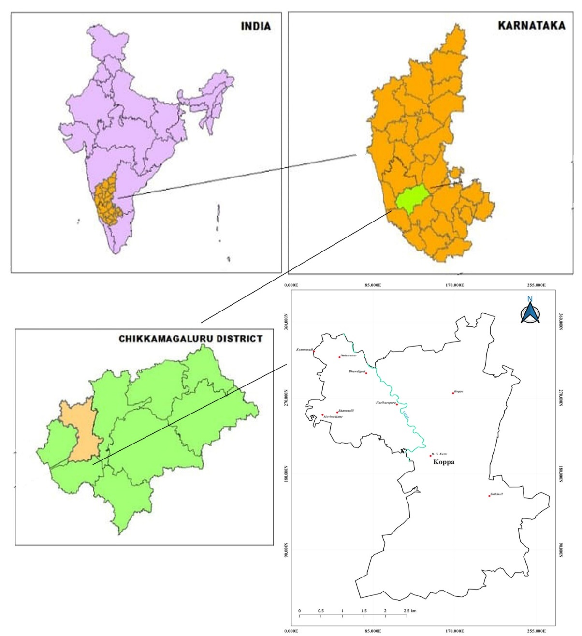

**Fig. 01.** Study area showing Koppa Taluk, Chikkamagaluru, Karnataka.

**Fig. 02.** Percent occurrence of Wild orchid (Habitat wise) at Koppa taluk, Chikkamagaluru, Karnataka.

**Fig. 03.** Percent occurrence of wild orchids based on their endemism

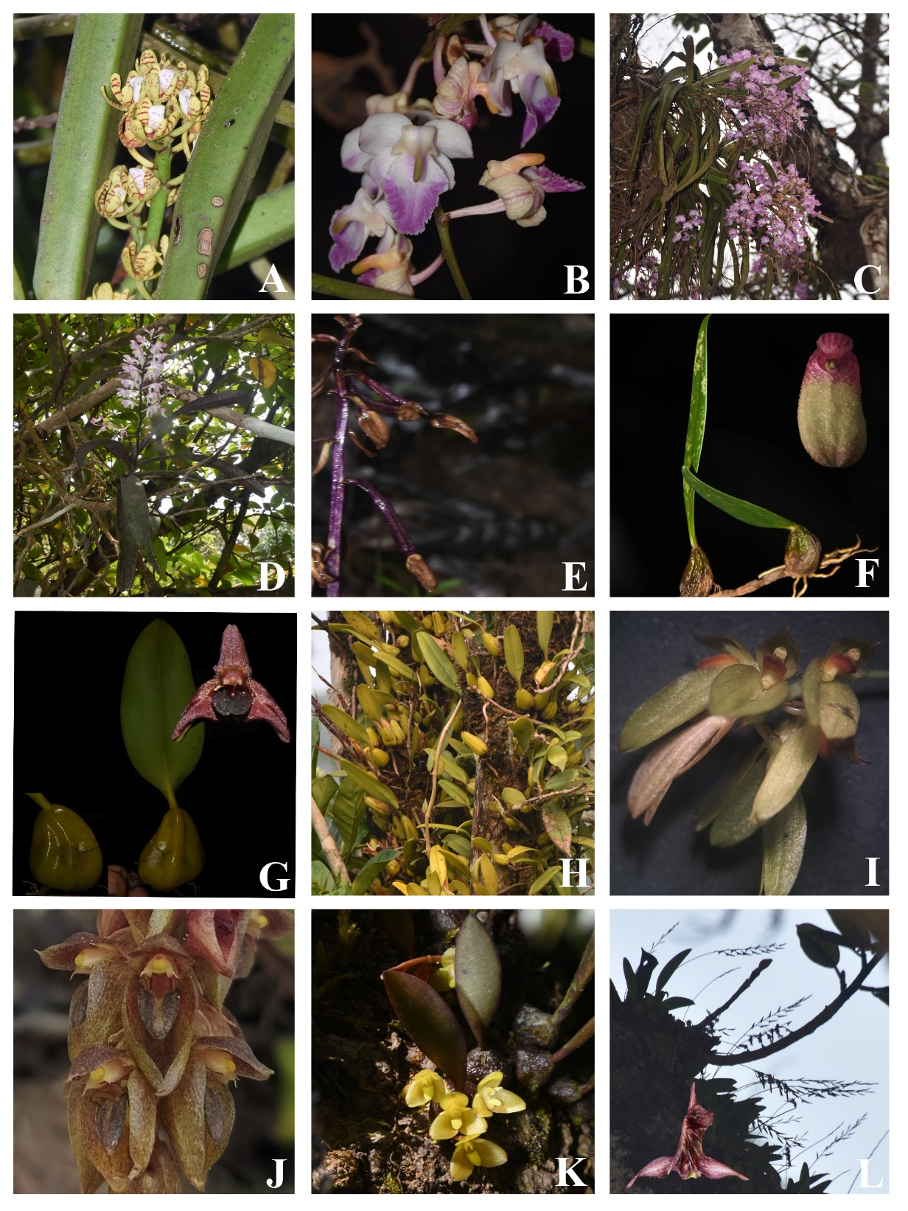

**Fig. 04. A.** *Acampe praemorsa* (Roxb.) Blatt. & McCann; **B.** *Aerides crispa* Lindl.; **C.** *Aerides maculosa* Lindl.; **D.** *Aerides ringens* (Lindl.) C.E.C.Fisch.; **E.** *Aphyllorchis montana* Rchb.f.; **F.** *Bulbophyllum fischeri* Seidenf.; **G.** *Bulbophyllum fuscopurpureum* Wight; **H.** *Bulbophyllum mysorense* (Rolfe) J.J.Sm.; **I.** *Bulbophyllum proudlockii* (King & Pantl.) J. J .Sm.; **J.** *Bulbophyllum sterile* (Lam.) Suresh; **K.** *Bulbophyllum stocksii* (Benth. ex Hook.f.) J. J. Verm., Schuit. & de Vogel; **L.** *Bulbophyllum tremulum* Wight

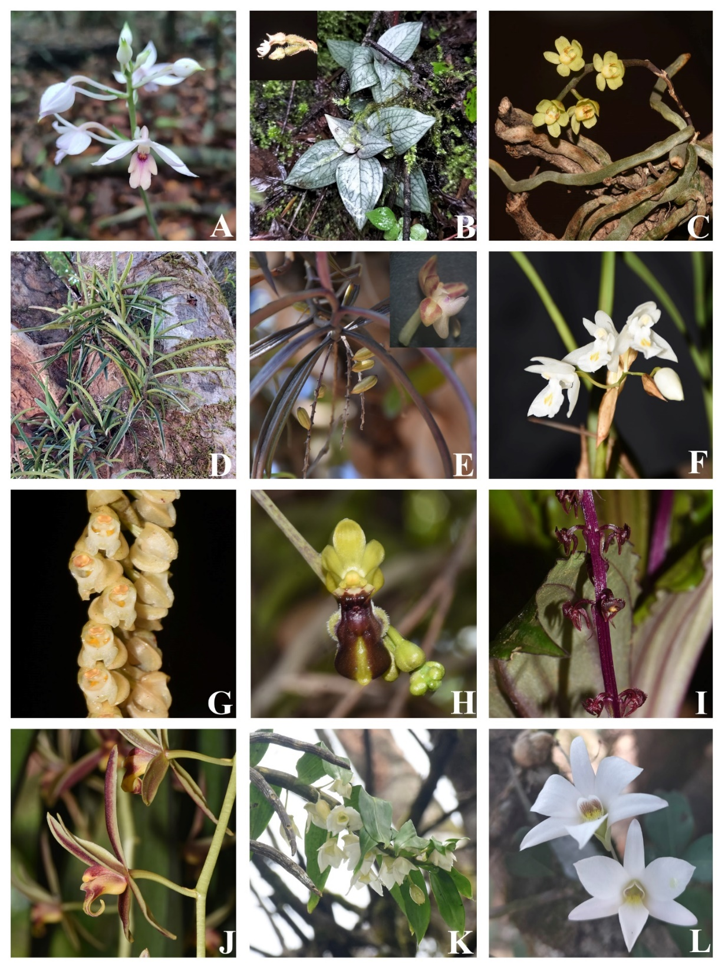

**Fig. 05. A.** *Calanthe sylvatica* (Thouars) Lindl.; **B.** *Cheirostylis flabellata* (A.Rich.) Wight; **C.** *Chiloschista confusa* M. J. Mathew, J. Mathew, P. M. Salim & Szlach.; **D.** *Cleisocentron neglectum* M. J. Mathew & J. Mathew; **E.** *Cleisostoma tenuifolium* (L.) Garay; **F.** *Coelogyne breviscapa* Lindl.; **G.** *Coelogyne imbricata* (Hook.) Rchb. f.; **H.** *Cottonia peduncularis* (Lindl.) Rchb.f.; **I.** *Crepidium versicolor* (Lindl.) Sushil K. Singh, Agrawala & Jalal; **J.** *Cymbidium bicolor* Lindl.; **K.** *Dendrobium aqueum* Lindl.; **L.** *Dendrobium barbatulum* Lindl.

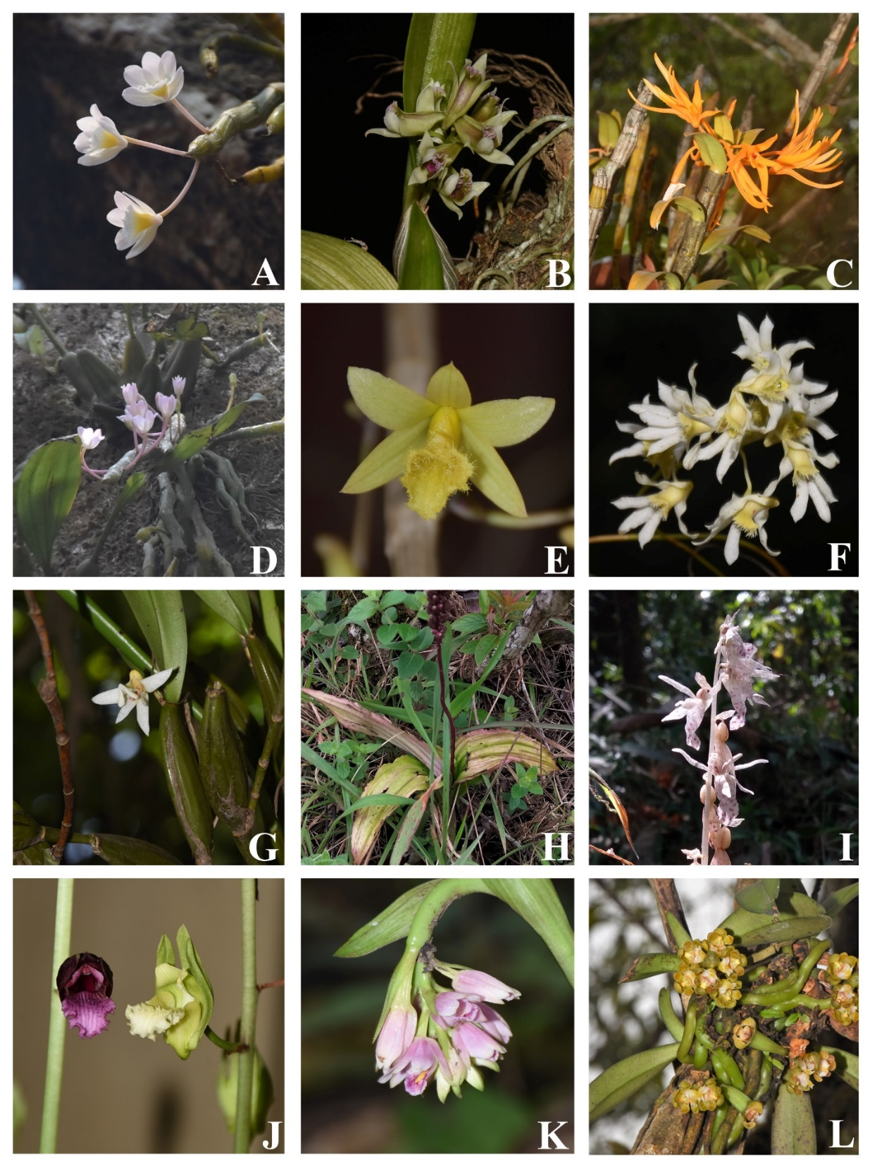

**Fig. 06. A.** *Dendrobium crepidatum* Griff.; **B.** *Dendrobium crispum* Dalzell; **C.** *Dendrobium jerdonianum* Wight; **D.** *Dendrobium lawianum* Lindl.; **E.** *Dendrobium macrostachyum* Lindl.; **F.** *Dendrobium nanum* Hook.f.; **G.** *Dendrobium nodosum* Dalzell; **H.** *Dienia ophrydis* (J. Koenig) Seidenf.; **I.** *Epipogium roseum* (D. Don) Lindl.; **J.** *Eulophia nuda* Lindl.; **K.** *Eulophia picta* (R.Br.) Ormerod; **L.** *Gastrochilus acaulis* (Lindl.) Kuntze

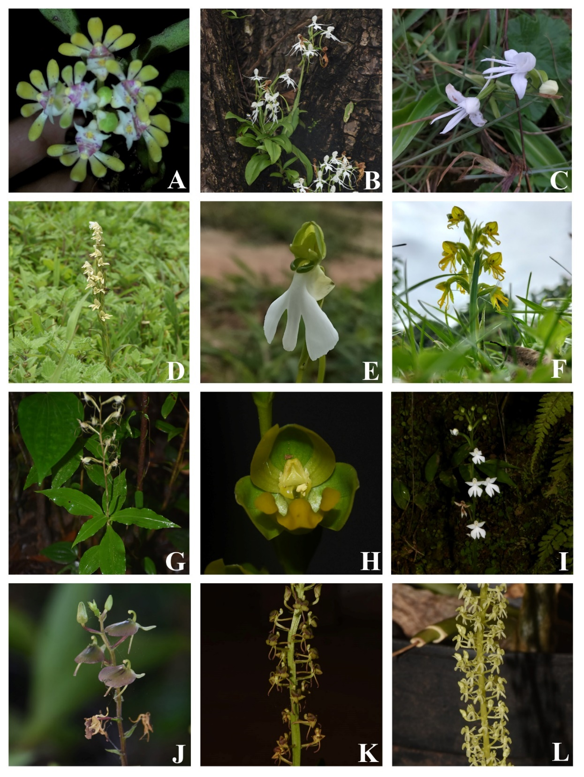

**Fig. 07. A.** *Gastrochilus flabelliformis* (Blatt. & McCann) C. J. Saldanha; **B.** *Habenaria crinifera* Lindl.; **C.** *Habenaria grandifloriformis* Blatt. & McCann; **D.** *Habenaria heyneana* Lindl.; **E.** *Habenaria longicorniculata* J. Graham; **F.** *Habenaria marginata* Colebr.; **G.** *Habenaria multicaudata* Sedgw.; **H.** *Habenaria perrottetiana* A. Rich.; **I.** *Habenaria plantaginea* Lindl.; **J.** *Liparis biloba* Wight; **K.** *Liparis odorata* (Willd.) Lindl.; **L.** *Liparis viridiflora* (Blume) Lindl.

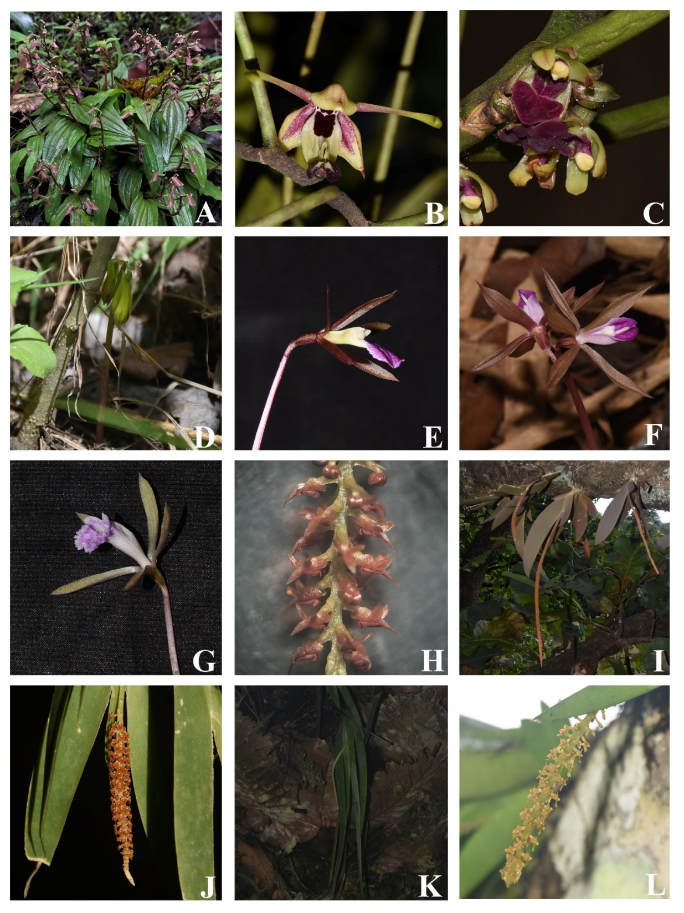

**Fig. 08. A.** *Liparis wightiana* Thwaites; **B.** *Luisia macrantha* Blatt. & McCann; **C.** *Luisia zeylanica* Lindl.; **D.** *Nervilia concolor* (Blume) Schltr.; **E.** *Nervilia infundibulifolia* Blatt. & McCann; **F.** *Nervilia plicata* (Andrews) Schltr.; **G.** *Nervilia simplex* (Thouars) Schltr.; **H.** *Oberonia bicornis* Lindl.; **I.** *Oberonia brunoniana* Wight; **J.** *Oberonia chandrasekharanii* V. J. Nair, V. S. Ramach. & R. Ansari; **K.** *Oberonia ensiformis* (Sm.) Lindl.; **L.** *Oberonia falconeri* Hook. f.

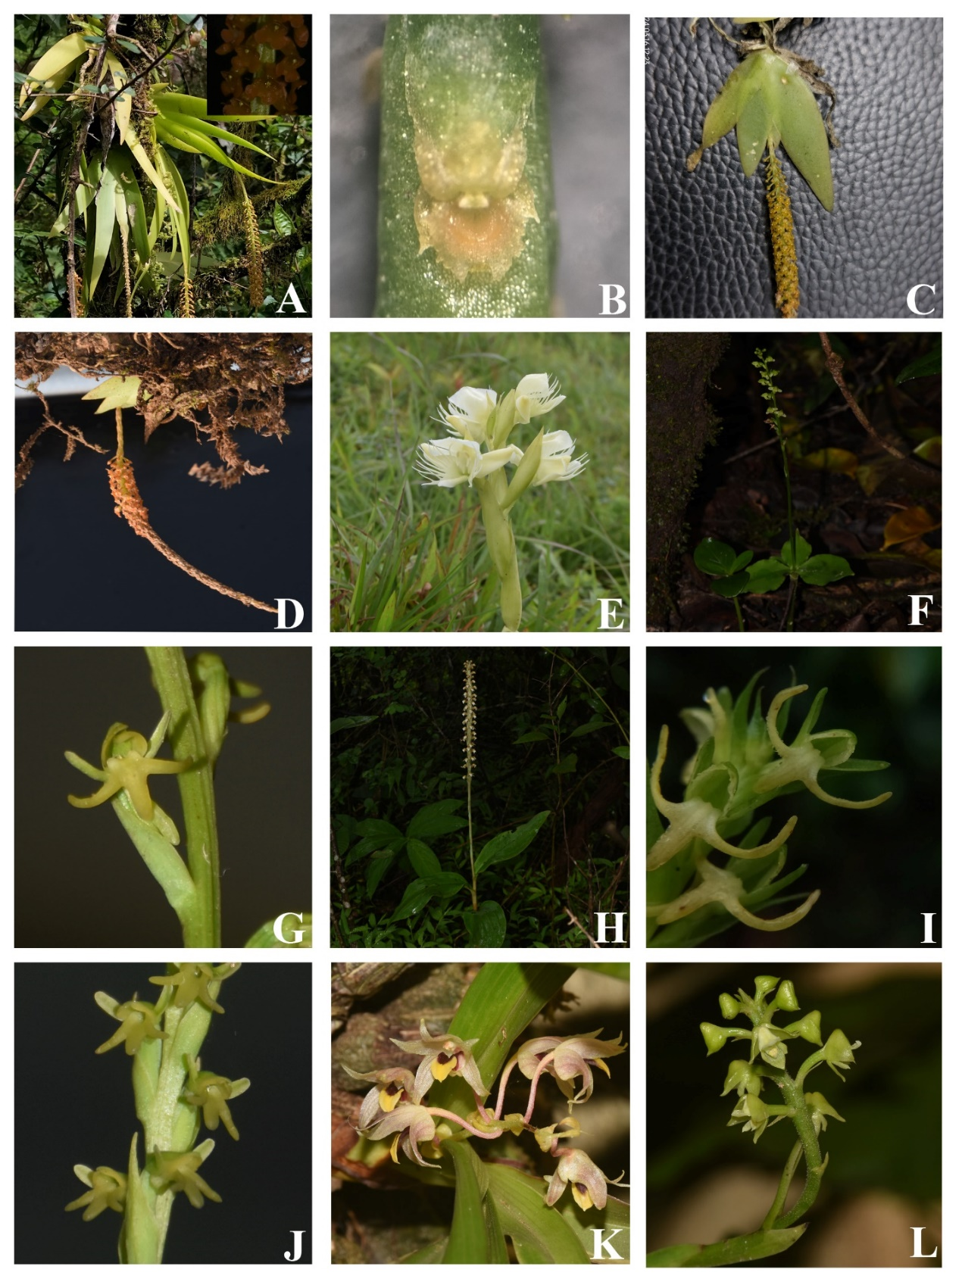

**Fig. 09. A.** *Oberonia josephi* C.J.Saldanha; **B.** *Oberonia proudlockii* King & Pantl.; **C.** *Oberonia recurva* Lindl.; **D.** *Oberonia* sp.; **E.** *Pecteilis gigantea* (Sm.) Raf.; **F.** *Peristylus aristatus* Lindl.; **G.** *Peristylus densus* (Lindl.) Santapau & Kapadia; **H.** *Peristylus plantagineus* (Lindl.) Lindl.; **I.** *Peristylus secundus* (Lindl.) Rathakr.; **J.** *Peristylus spiralis* A.Rich.; **K.** *Pinalia mysorensis* (Lindl.) Kuntze; **L.** *Polystachya concreta* (Jacq.) Garay & H. R. Sweet

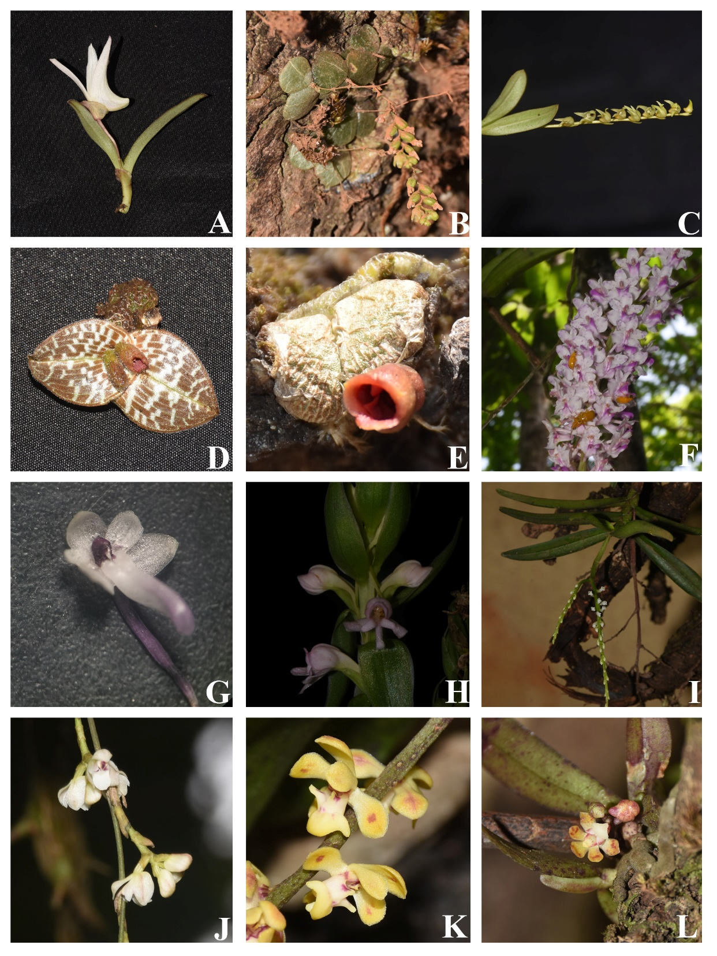

**Fig. 10. A.** *Porpax braccata* (Lindl.) Schuit., Y.P.Ng & H.A.Pedersen; **B.** *Porpax exilis* (Hook.f.) Schuit., Y.P.Ng & H.A.Pedersen; **C.** *Porpax filiformis* (Wight) Schuit., Y.P.Ng & H.A.Pedersen; **D.** *Porpax jerdoniana* (Wight) Rolfe; **E.** *Porpax reticulata* Lindl.; **F.** *Rhynchostylis retusa* (L.) Blume; **G.** *Robiquetia josephiana* Manilal & C.S.Kumar; **H.** *Satyrium nepalense* D. Don; **I.** *Schoenorchis nivea* (Lindl.) Schltr.; **J.** *Sirhookera lanceolata* (Wight) Kuntze; **K.** *Smithsonia maculata* (Dalzell) C.J.Saldanha; **L.** *Smithsonia straminea* C.J.Saldanha

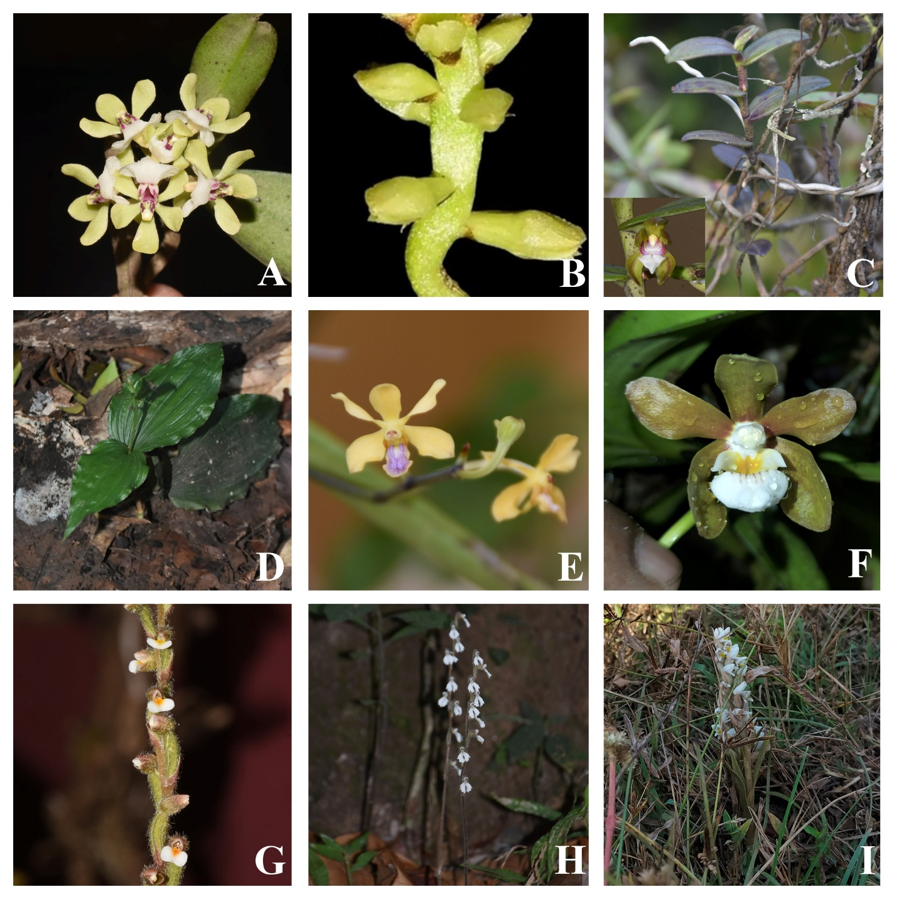

**Fig. 11. A.** *Smithsonia viridiflora* (Dalzell) C.J.Saldanha; **B.** *Thelasis pygmaea* (Griff.) Lindl.; **C.** *Trichoglottis tenera* (Lindl.) Rchb. f.; **D.** *Tropidia angulosa* (Lindl.) Blume; **E.** *Vanda testacea* (Lindl.) Rchb.f.; **F.** *Vanda thwaitesii* Hook.f.; **G.** *Zeuxine gracilis* (Breda) Blume; **H.** *Zeuxine longilabris* (Lindl.) Trimen; **I.** *Zeuxine strateumatica* (L.) Schltr.