Assessment of Aquatic Macrophytes in
Selected Sampling Sites in Sawaga River, Malaybalay City, Bukidnon

ABSTRACT

Aims: The study aimed to identify the species and distribution of aquatic macrophytes found in the selected sampling sites along Sawaga River, as well as their conservation status and the corresponding implications it has on the environmental status of the river.
Study design: The study employed a descriptive research design.
Place and Duration of Study: Sawaga River, Malaybalay City, Bukidnon (Casisang Site, Impalambong Site, Kalasungay Site) and Central Mindanao University Museum, Maramag, Bukidnon; January 2024 to December 2024
Methodology: The transect walk method was utilized to collect the aquatic macrophyte species in the sampling sites. Additionally, the collected specimens underwent preservation through the use of denatured alcohol.
Results: Of all the three (3) sampling sites, only three distinct aquatic macrophyte species were recorded across all sites: Cyperus involucratus Rottb. (emergent), Hydrocotyle sp. (creeping), and Pistia stratiotes (floating). The computed Shannon-Wiener Diversity Index (H’ = 1.0114) and Margalef’s Species Richness Index (D = 1.1162) across all sampling sites indicate generally low species richness. All species were classified as Least Concern by the IUCN.
Conclusion: There is a limited presence of aquatic macrophytes in Sawaga River, attributed to environmental stressors such as seasonal climate variation and anthropogenic pollution. It is recommended that succeeding studies expand the number of sampling sites and consider other seasonal periods to gain a more comprehensive understanding of the ecological status of the river.

Keywords: Aquatic macrophytes, Genera, Species, Transect walk

1. INTRODUCTION

Aquatic macrophytes, or widely called aquatic plants, are a series of plant species that consider the aquatic environment as their natural habitat and can mostly survive with just it being surrounded by bodies of water. Macrophytes are aquatic photosynthetic organisms that grow permanently or from time to time as submerged, floating, or on the water surface of inland freshwater or brackish waterbodies (Chambers et. al., 2008; Murphy et. al., 2019; Alahuhta et. al., 2021). They are taxonomically diverse, visible to the naked eye, and examples of these include vascular aquatic plants, bryophytes, green macroalgae, and charophytes (Lesiv et. al., 2020). Aquatic plants are easily found in lakes, streams, and rivers, most particularly in the shallowest areas of these bodies of water. The said shallow areas are called the littoral zones, and the plants that grow on them are divided into three groups. [5]. Aquatic plants also play a part in regulating water temperature and quality, the amount of nutrients in a body of water, and fluctuations in water levels (Dar et. al., 2014).

The province of Bukidnon has numerous rivers, lakes, and streams that are considered significant natural resources (Galan et. al., 2015). Sawaga River, a river dominantly situated in Malaybalay City, serves as one of the major sources of water in the city for drinking, irrigation, and industrial uses (Opiso et. al., 2014). However, the aquatic flora of the river is poorly documented and studied, prompting efforts to assess the composition of species in Sawaga River to serve as baseline information among nearby residents and the general public.

The researchers found significance in conducting this study, considering the many functions of macrophytes in the aquatic environment and to increase the amount of knowledge in the community regarding it. Macrophytes are considered as an essential component in the food web of the aquatic environment and the hosts of ecological functions in the habitat (Chambers et. al., 2008). The abundance of macrophytes in a lake resulted in high nutrient concentrations and high vegetation (Swe et. al., 2021). Their purposes are inclined toward nutrient cycling and habitat provisions, and they also participate in water cycling and gas production in their environment (Thomaz et. al., 2021). The presence of macrophytes and their activity enhance water purification and disease control, which are important regulatory services. They are used to refine water quality as green technology, which is effective, costs less energy, and is environment-friendly (Patel et. al., 2020). Aside from regulating water quality, macrophytes are considered sources of natural resources for the industrial production of paper pulp, biofuel, and natural therapeutics (Haroon et. al., 2022). Even in a man-made aquatic area, they also have the ability to decrease water pollution by removing metals, pharmaceutical products, pesticides, cyanotoxins, and nanoparticles (Kochi et. al., 2020).

Assessment and diversity studies of aquatic macrophytes were conducted across the Philippines. In specific sites in the Lumbocan River of Butuan City, a total of 6 species from 6 families and 3 divisions were identified (Saro et. al., 2022). 63 different macrophyte species were found in the Verde Island Passage of Batangas in a specific period of time, in the summer, southwest, and northeast monsoons (Najeen et. al. 2021). Marine benthic macrophytes are types of macrophytes situated in coastal ecosystems, and 37 submerged species belonging to 15 families were found in coastal areas near mines in Claver, Surigao del Norte (Orboc et. al., 2022). Meanwhile, in Balili River, La Trinidad, Benguet, 38 species of macrophytes under 37 genera and 19 families were identified (Napaldet et. al., 2019).

Furthermore, the study aimed to identify the species and taxonomy of aquatic macrophytes in Sawaga River and their physiological characteristics. The study provided an overview of the species found in the river to the nearby residents, keeping track of their conservation status and considering the significance they contribute to the aquatic ecosystem in the areas since it regulates water quality and are indicators of environmental health. The study aimed to provide additional knowledge and data on aquatic macrophyte species found in the river and in the province of Bukidnon.

2. materialS and methods

2.1. Research Design

This study used a descriptive research design to identify the aquatic plants in Sawaga River, Malaybalay City, Bukidnon, as well as their diversity and richness in the river. The main goal was to understand the different types of aquatic plants, their distribution in the area, and their implications. The researchers observed the study site and recorded the plants they found, focusing on their classification and environmental implications to provide a basis for future research and to monitor changes over time.

2.2. Entry Protocol

Necessary permits, including to those from institutions, agencies, and authorities were obtained prior to conducting the study to ensure an ethical, consented and professional approach.
2.3. Locale of the Study

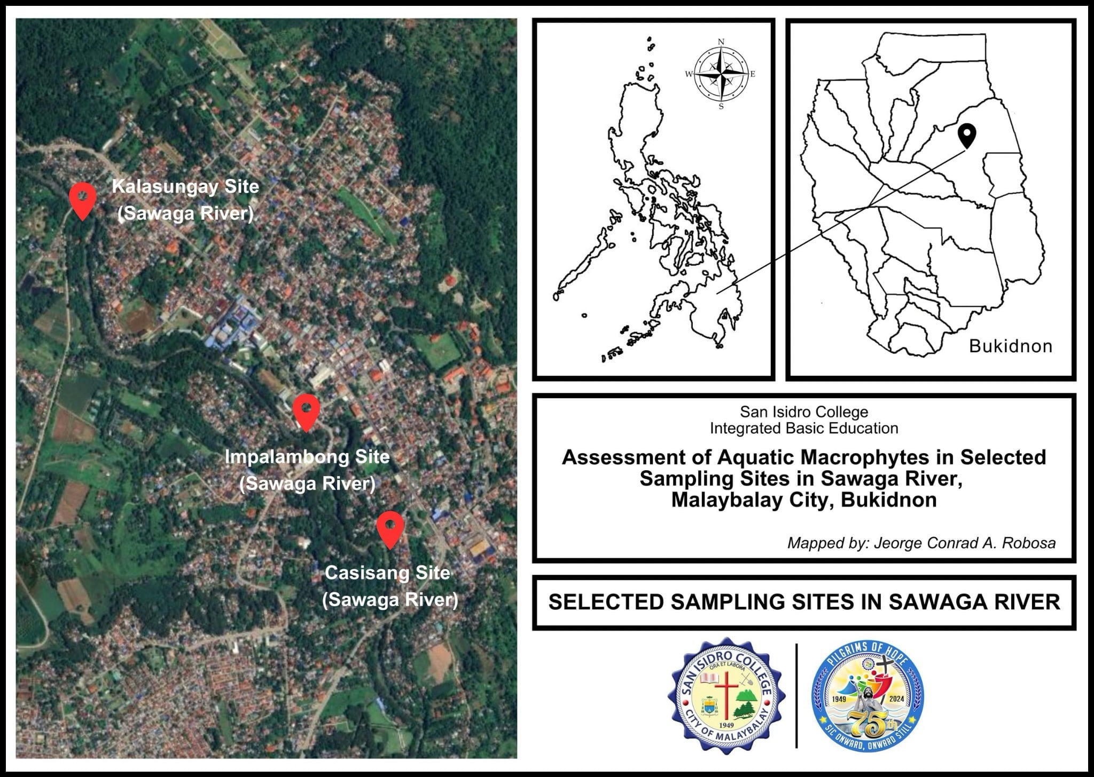
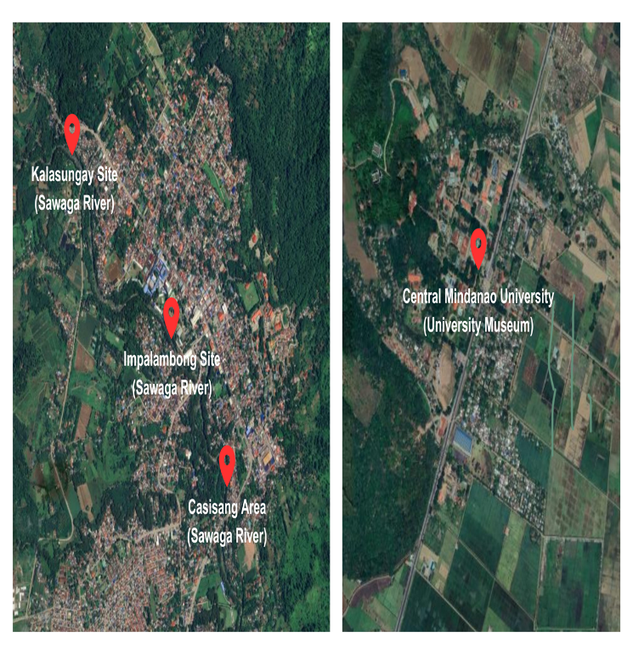
The researchers conducted an assessment of macrophyte species in Sawaga River, located in Malaybalay City, Bukidnon. In particular, sampling sites were selected, namely the Casisang Site, Impalambong Site, and the Kalasungay Site. Following sample collection, specimens were brought to the University Museum of Central Mindanao University, Maramag, Bukidnon, for their taxonomical identification.

Fig. 1. Map of sampling sites

2.4. Collection of Samples

The researchers used the transect walk method, also utilized in the study of Asido et. al. (2024), in evaluating and collecting samples in the area. Starting and finishing points were determined where researchers count and identify macrophytes. It started at the Impalambong area, walking 240 meters from the starting point 20 meters away from the roadside. The collection of samples followed at the Kalasungay area, starting at a point 210 meters away from the roadside and walking up to 373 meters. The collection of samples concluded at the Casisang area, starting 20 meters away from the roadside and ending 367 meters away. The data collected from the area covered were used to make assumptions about the entire habitat. After collection, specimens were soaked in denatured alcohol and let dry for preservation, following the principles and observations in the study of Johnson et. al. (2023).

2.5. Identification of Aquatic Macrophytes

The collected samples underwent preliminary identification using online research resources. Following this, the specimens were sent to Central Mindanao University Museum in Maramag, Bukidnon, for final identification. This is to ensure the accuracy of the identified species.

2.6. Documentation

The identified species of aquatic macrophytes were photographed in their natural habitat, captured in their untouched state without any human intervention. The research area's photo samples were collected for the purpose of documentation, allowing for a visual record of the macrophytes within their natural habitat.

2.7. Ethical Consideration

The data accumulated during the course of study were treated the with highest respect and care. Safety precautions were strictly followed to prevent the contraction of any potential afflictions and to avoid the risk of harm. Additionally, the Wildlife Resources Conservation and Protection Act of 2001 was followed to ensure proper handling of the species and their surrounding environment. Moreover, the school is not accountable for any of the researchers’ individual actions during the conducting of the study.

3. RESULTS AND DISCUSSION

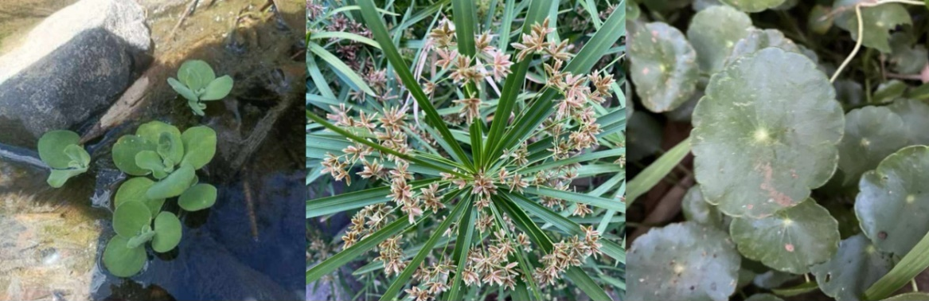
3.1. Aquatic Macrophyte Species

Fig. 2. From left to right: Pistia stratiotes, Cyperus involucratus Rottb., Hydrocotyle sp.

Table 1. List of collected aquatic macrophyte species

Family | Genera | Species
Araceae | Pistia | Pistia stratiotes
Araliaceae | Hydrocotyle | Hydrocotyle sp.
Cyperaceae | Cyperus | Cyperus involucratus Rottb.

Table 1 shows the aquatic macrophyte species collected from the selected sampling sites in Sawaga River, Malaybalay City, Bukidnon. There are three (3) species overall that differ under three (3) families and three (3) genera. The family of Araliaceae has one (1) species found which is Hydrocotyle sp.. Araceae has one (1) species found which is Pistia stratiotes L.. Family Cyperaceae has one (1) species found which is Cyperus involucratus Rottb. The population of macrophytes in the sites are significantly low, attributed to factors such as the variability of precipitation induced by change in climate, urban runoff, and the prevalence of urban settlements along the area (Lind et. al., 2022; Grzybowski et. al., 2022).

In the study of Rafael et. al. (2016), urbanization is a major factor contributing to the species composition of an aquatic area. They are characterized by high pollution levels and frequent disturbance of habitats. In turn, it translates to a low number of species turnout. Also in the study, aquatic macrophytes were much more present in non-urban settlements than those in the urban setting due to the water bodies being classified as hypereutrophic.

Sawaga River, according to the study of Bertomen et. al. (2017), is a polluted body of water, with nitrite and ammonia levels being significantly elevated, despite the water quality assessments meeting the standards of the Department of Environment and Natural Resources (DENR). The said findings were stemmed from human activities such as disposal of waste and agricultural runoff. Additionally, in the study of Violon et. al. (2024), the river has become a hotspot for water-borne diseases, also attributed by poor waste management and industrial activity, therefore bringing the river to a disturbed state.

The reported macrophytes are known to demonstrate responses to environmental stressors. For instance, the study of Heneidy et. al. (2019) stated that the genus Hydrocotyle upholds the characteristic of being sensitive to environmental change facing the risk of reducing their suitable habitats in native ranges while expanding. Meanwhile generally, aquatic macrophytes are greatly influenced by human activities and anthropogenic processes and pressures were known to play a key role in their taxonomical structure (Florescu et. al., 2024).

3.1. Diversity and Richness of Aquatic Macrophytes

The diversity of macrophyte species can also be determined through responses in environmental conditions such as nutrient levels and other hydromorphological conditions. Given that, it has become an element of assessing the ecological status of a body of water (Tarkowska-Kukuryk and Grzywna, 2022). Consequently, the diversity and richness of the aquatic macrophyte species found in the site were calculated below using the Shannon-Wiener Diversity Index and Margalef’s Species Richness Index.

Table 2. Species diversity and richness in each sampling site

Selected Sampling Site | Shannon-Wiener Index | Margalef’s Richness Index
Casisang | 0.6931 | 1.4427
Impalambong | 0.0000 | 0.0000
Kalasungay | 1.0986 | 1.8205
Sawaga River | 1.0114 | 1.1162

Table 2 shows the species diversity and richness of each selected sampling site based on the identified set of aquatic macrophytes. Among all the sites, the Kalasungay area was the only site where all three (3) identified species were present, recording a diversity and species richness index of 1.0986 and 1.8205 respectively, followed by the Casisang site with the species P. stratiotes L. and C. involucratus Rottb. present and recording a diversity and richness index of 0.6931 and 1.4427 respectively. However, the Impalambong site translated no value, since only the species C. involucratus Rottb. was identified. Generally, the diversity and richness of species across all the sites in the river is low.

Aquatic macrophyte communities are influenced by hydrological conditions such as the movement of water. It also affects the nutrient flow in the aquatic ecosystem (Dong et. al., 2014). Given that Sawaga River is a lotic ecosystem, the same study also stated that nutrients in lotic ecosystems tend to get replenished depending on the rate of flow.

Globally, the distribution of macrophytes are not linear to that of latitude. The richness of macrophytes tend to be high at subtropical regions and low tropical latitudes. Meanwhile, it decreases in regions neighboring the equator like the Philippines, and more significantly in high latitudinal areas. Given this, it can be said that it is attributed to factors such as climate variability and the availability of their corresponding habitats (Murphy et. al., 2019).

3.3. Conservation Status of Aquatic Macrophytes

Macrophytes, like the entire ecosystem, are interconnected. Their composition helps promote a higher biodiversity in an area, thus being vital in their respective conservations (Cabral et. al., 2025). The conservation status of the identified aquatic macrophytes in Sawaga River are listed below

Table 3. List of collected aquatic macrophyte species and their respective conservation status

Family | Species | Conservation Status (IUCN)
Araceae | Pistia stratiotes | Least Concern
Araliaceae | Hydrocotyle sp. | Least Concern
Cyperaceae | Cyperus involucratus Rottb. | Least Concern

The identified aquatic macrophytes across all the sampling sites in Sawaga River, namely P. stratiotes L., Hydrocotyle sp., and C. involucratus Rottb. were all classified as Least Concern (LC) by the IUCN Red List, stated in Table 3 above. This states that all the identified species are not significantly at risk of endangerment or currently facing extinction, and they generally exist in a wider population across their distribution. In general, the wide distribution of macrophytes can be attributed to factors such as their reproductive ability, their level of competitiveness, disposal mechanisms, among others.

In the case study by Du et. al. (2022), the level of competitiveness of the invasive species Phragmites australis and the endemic species Triarrhena lutarioriparia were compared. The study concluded that they outcompete each other in various environmental instances. This indicates that widespread macrophyte species, especially those invasive, tend to exhibit a high level of competitiveness in the ecosystem, allowing them to coexist or even dominate over endemic species.

Each identified species possesses mechanisms that contribute to their wide distribution. The species P. stratiotes L., according to the study of Coelho et. al. (2025), is capable of thriving in highly dense environments through investing more in both sexual and asexual reproduction, suggesting that the species upholds more energy and more resources, and thrives especially with their long leaves and stolons. The Hydrocotyle species is considered invasive, particularly the species Hydrocotyle ranunculoides, in which it forms dense mats and has interconnected ramets that help it dominate aquatic ecosystems (Djeddour, 2022). Meanwhile, C. involucratus Rottb. is known to withstand environmental stressors, especially in high nutrient concentration and the presence of contaminants according to Pincam et. al. (2019).

4. Conclusion

The study identified three (3) distinct species from three (3) families and three (3) genera, namely P. stratiotes L. from Araceae, Hydrocotyle sp. from Araliaceae, and C. involucratus Rottb. from Cyperaceae. Subsequently, the total species diversity and richness index across all sampling sites in Sawaga River were recorded at 1.0114 and 1.1162, respectively, indicating a generally low diversity and richness of macrophytes in the river, attributed to factors such as pollution and industrial use, among others.

References

Alahuhta, J., Lindholm, M., Baastrup-Spohr, L., García-Girón, J., Toivanen, M., Heino, J., & Murphy, K. (2021). Macroecology of macrophytes in the freshwater realm: Patterns, mechanisms and implications. Aquatic Botany, 168, 103325. https://doi.org/10.1016/j.aquabot.2020.103325

Asido, L. T., Marte, Q. F. A., Eñano, D. O., Bebis, N., Saldo, I. J. P., Calo, J. R. D., Dandoy, M. J. P., & Asiñero, R. M. V. (2024). Assessment of Wild Mushroom Species in Lantapan, Bukidnon, Philippines. American Journal of Food Science and Technology, 12(1), 1–7. https://doi.org/10.12691/ajfst-12-1-1

Bertomen, W. K., Roa, E., Tubio, E., Vedra, S., & Dela Peña, G. (2017). Water Quality of Sawaga River, Malaybalay City, Bukidnon, Philippines. International Journal of Science and Research (IJSR), 6(7), 1090–1095. https://doi.org/10.21275/art20175318

Cabral, G. S., Silva, R. S., Bomfim, F. F., Juen, L., Casatti, L., Montag, L., Dias-Silva, K., Oliveira-Junior, J. M. B., & Michelan, T. S. (2025). Macrophyte species uniqueness is driven by habitat integrity, sediment structure, and spatial components in streams around the Amazon National Park. Aquatic Botany, 198, 103871. https://doi.org/10.1016/j.aquabot.2025.103871

Chambers, A., Lacoul, P., J, Murphy K, & M, Thomaz S. (2008). Global diversity of aquatic macrophytes in freshwater. Developments in Hydrobiology, 9–26. https://doi.org/10.1007/978-1-4020-8259-7_2

Coelho, F., Deboni, L., & Lopes, S. (2025). Density-dependent reproductive and vegetative allocation in the aquatic plant Pistia stratiotes (Araceae). Revista de Biología Tropical, 53(3-4), 369–376. https://www.scielo.sa.cr/scielo.php?pid=S0034-77442005000200007&script=sci_arttext&utm_source=chatgpt.com

Dar, N. A., Pandit, A. K., & Ganai, B. A. (2014). Factors affecting the distribution patterns of aquatic macrophytes. Limnological Review, 14(2), 75–81. https://doi.org/10.2478/limre-2014-0008

Djeddour, D. (2022). Hydrocotyle ranunculoides (floating pennywort). CABI Compendium, CABI Compendium. https://doi.org/10.1079/cabicompendium.28068

Dong, B., Qin, B., Gao, G., & Cai, X. (2014). Submerged macrophyte communities and the controlling factors in large, shallow Lake Taihu (China): Sediment distribution and water depth. Journal of Great Lakes Research, 40(3), 646–655. https://doi.org/10.1016/j.jglr.2014.04.007

Du, Y., Zhou, Q., Peng, Z., Peng, F., Xi, L., & Li, Y. (2022). Does a Widespread Species Have a Higher Competitive Ability Than an Endemic Species? A Case Study From the Dongting Lake Wetlands. Frontiers in Plant Science, 13. https://doi.org/10.3389/fpls.2022.864316

Florescu, L. I., Catana, R. D., Mihai, R. A., Dumitrache, A. C., & Moldoveanu, M. M. (2024). Macrophyte Community Distribution in Relation to Anthropization Influences and Phytoplankton Development in an Urban Lake Chain. Water, 16(23), 3467–3467. https://doi.org/10.3390/w16233467

Galan, G. L., Ediza, M. M., Servasques, M. S., & Porquis, H. C. (2015). Diversity of Gastropods in the Selected Rivers and Lakes in Bukidnon. International Journal of Environmental Science and Development, 6(8), 615–619. https://doi.org/10.7763/ijesd.2015.v6.668

Gettys L.A., Haller W.T., Petty D.G. (2014) Biology and control of aquatic plants: a best management practices handbook, 3rd edn. Aquatic Ecosystem Restoration Foundation, Marietta

Grzybowski, M., Burandt, P., Katarzyna Glińska-Lewczuk, Lew, S., & Krystian Obolewski. (2022). Response of Macrophyte Diversity in Coastal Lakes to Watershed Land Use and Salinity Gradient. International Journal of Environmental Research and Public Health, 19(24), 16620–16620. https://doi.org/10.3390/ijerph192416620

Haroon, A. M. (2022). Review on aquatic macrophytes in lake manzala, egypt. The Egyptian Journal of Aquatic Research, 48, 1–12. https://doi.org/10.1016/j.ejar.2022.02.002Jacobs, S. W. L. (1993). Hydrocharitaceae, in G.J. Harden. Plantnet.rbgsyd.nsw.gov.au. https://plantnet.rbgsyd.nsw.gov.au/cgi-bin/NSWfl.pl?page=nswfl&lvl=sp&name=Hydrilla~verticillata

Heneidy, S. Z., Halmy, M. W. A., Fakhry, A. M., & El-Makawy, A. M. (2019). The status and potential distribution of Hydrocotyle umbellata L. and Salvinia auriculata Aubl. under climate change scenarios. Aquatic Ecology, 53(4), 509–528. https://doi.org/10.1007/s10452-019-09705-4

Johnson, G., Steven, Lichter‐Marck, I. H., Wagner, W. L., & Wen, J. (2023). Ethanol preservation and pretreatments facilitate quality DNA extractions in recalcitrant plant species. Applications in Plant Sciences, 11(3). https://doi.org/10.1002/aps3.11519

Kochi, L. Y., Freitas, P. L., Maranho, L. T., Juneau, P., & Gomes, M. P. (2020). Aquatic macrophytes in constructed wetlands: A fight against water pollution. Sustainability, 12, 9202. https://doi.org/10.3390/su12219202

Lesiv, S., Polishchuk, I., & Antonyak, L. (2020). Aquatic macrophytes: ecological features and functions. Studia Biologica, 14, 79–94. https://doi.org/10.30970/sbi.1402.619

Lind, L., Eckstein, R. L., & Relyea, R. A. (2022). Direct and indirect effects of climate change on distribution and community composition of macrophytes in lentic systems. Biological Reviews, 97(4). https://doi.org/10.1111/brv.12858

Murphy, K., Efremov, A., Davidson, T. A., Molina-Navarro, E., Fidanza, K., Camila, Chambers, P., Grimaldo, T., Martins, V., Springuel, I., Kennedy, M., Mormul, R. P., Dibble, E., Hofstra, D., Lukács, Balázs András, Gebler, D., Baastrup-Spohr, L., & Urrutia-Estrada, J. (2019). World distribution, diversity and endemism of aquatic macrophytes. Aquatic Botany, 158, 103127. https://doi.org/10.1016/j.aquabot.2019.06.006

Najeen, A., Rula, Khay, A., Ramos-Danila, Ann, J., Valera, P., Matthew, J., Arcega, H., & Saco, J. (2021). Macrophyte Diversity and Conservation Values of the Verde Island Passage, Philippines. https://philjournalsci.dost.gov.ph/images/pdf/pjs_pdf/vol151_S1_Marine_Botany/macrophyte_diversity_and_conservation_values_Verde_Island_Passage_.pdf

Napaldet, J., & Inocencio, B. (2019). Diversity Of Aquatic Macrophytes In Balili River, La Trinidad, Benguet, Philippines As Potential Phytoremediators. Biodiversitas Journal of Biological Diversity, 20, 1048–1054. https://doi.org/10.13057/biodiv/d200416

Opiso, E. M., & Alburoa, J. L. R. (2014). Hydro-Geochemical Characteristics of Sawaga River, Malaybalay City, Bukidnon. Liceo Journal of Higher Education Research, 10(1), 56+. https://link.gale.com/apps/doc/A512868751/AONE?u=anon~ebd1a1ed&sid=googleScholar&xid=66538fea

Orboc, D. R., Jumawan, J. C., Ombat, L., Capangpangan, R. Y., & Seronay, Romell A. (2022). Marine benthic macrophytes diversity and concentration of heavy metals in thalassia hemprichii near mining area of Claver, Surigao del Norte, Philippines. Journal of Ecosystem Science and Eco-Governance, 29–39. https://doi.org/10.54610/jeseg/4.2.2022.004

Patel, H. A., & Sahoo, S. (2020). A review of water quality improvement with the help of aquatic macrophytes. Current World Environment, 15, 398–405. https://doi.org/10.12944/cwe.15.3.04

Pincam, T., Brix, H., & Arunothai Jampeetong. (2019). Growth performance of tropical wetland species (Cyperus involucratus Rottb. and Thalia geniculata L.) in anaerobic digester effluent and their water treatment efficiency. Ecological Engineering, 143, 105667–105667.

Rafael, L., Scherner, F., Douglas Correia Burgos, Roxana Cardoso Barreto, & Maria, S. (2016). Urbanization effects on the composition and structure of macrophytes communities in a lotic ecosystem of Pernambuco State, Brazil. Brazilian Journal of Biology, 76(4), 888–897. https://doi.org/10.1590/1519-6984.03515

Saro, J., Pascual, K., Coquilla, D., & Araneta, M. J. (2022). Aquatic Macrophytes Composition And Diversity In Selected Sites Of Lumbocan River, Butuan City, Agusan Del Norte, Philippines. American Scientific Research Journal for Engineering, Technology, and Sciences, Volume 84, 1–14.

Swe, T., Lombardo, P., Ballot, A., Thrane, J.-E., Sample, J., Eriksen, T. E., & Mjelde, M. (2021). The importance of aquatic macrophytes in a eutrophic tropical shallow lake. Limnologica, 90, 125910. https://doi.org/10.1016/j.limno.2021.125910

Tarkowska-Kukuryk, M., & Grzywna, A. (2022). Macrophyte communities as indicators of the ecological status of drainage canals and regulated rivers (Eastern Poland). Environmental Monitoring and Assessment, 194(3). https://doi.org/10.1007/s10661-022-09777-0

Thomaz, Sidinei Magela. (2021). Ecosystem services provided by freshwater macrophytes. Hydrobiologia. https://doi.org/10.1007/s10750-021-04739-y

Violon, J., Lubos, L., & Velos, S. (2024). Sawaga River’s Curse: The Violation of Residents’ Right To Health Through Waterborne Diseases. SSRN Electronic Journal. https://doi.org/10.2139/ssrn.4986199

