*Case report*

Sporotrichoid Tuberculosis Verrucosa Cutis: Clinical and Dermoscopic Insights

`

.

ABSTRACT

|  |
| --- |
| **Aims:** We report a rare case of extensive tuberculosis verrucosa cutis (TBVC) with a sporotrichoid pattern, highlighting its dermoscopic features and diagnostic challenges. This case aims to raise awareness of atypical TBVC presentations and the potential value of dermoscopy in aiding diagnosis.  **Presentation of Case:** An 89-year-old immunocompetent woman presented with an eight-month history of asymptomatic verrucous plaques and nodules on the lower limbs in a sporotrichoid pattern, associated with an exudative lesion on the left ear. Dermoscopy revealed papillated surfaces, linear vessels, brown and red-orange structureless areas, chrysalides, and whitish scales. Histopathology showed granulomatous inflammation with caseous necrosis. Tuberculin skin test and interferon-gamma release assay were positive. Chest CT revealed cavitary pulmonary tuberculosis. A diagnosis of multifocal TBVC was made. The patient was treated with a six-month course of rifampicin, isoniazid, pyrazinamide, and ethambutol, leading to complete resolution of skin lesions.  **Discussion:** TBVC is a rare form of cutaneous tuberculosis, typically presenting as a solitary lesion. Sporotrichoid and multifocal patterns are exceptional. Dermoscopy may assist in differentiating TBVC from other infectious or inflammatory dermatoses. Diagnosis remains challenging due to negative microbiological results in most cases, making clinico-pathological correlation essential.  **Conclusion:** This case illustrates an unusual extensive presentation of TBVC with characteristic dermoscopic features. Dermoscopy can support early diagnosis, especially in endemic areas, allowing timely treatment and preventing complications. |

*Keywords: Tuberculosis verrucosa cutis, Cutaneous tuberculosis, Sporotrichoid pattern, Dermoscopy, Granulomatous dermatosis*

1. INTRODUCTION

Cutaneous tuberculosis is a rare form of Mycobacterium tuberculosis infection, accounting for about 2% of extrapulmonary tuberculosis cases (Zinoune et al., 2019). Tuberculosis verrucosa cutis (TBVC) is a particularly rare clinical variant, typically affecting immunocompetent individuals, and often misdiagnosed due to its variable presentation and paucibacillary nature. Diagnostic delay can increase the physical, emotional, and financial burden on patients, particularly those from disadvantaged backgrounds.

This report highlights a rare case of extensive TBVC with an atypical sporotrichoid distribution and auricular involvement, describing its dermoscopic features that may aid diagnosis.

2. Presentation of Case

An 89-year-old woman presented with asymptomatic skin lesions on the lower limbs evolving over eight months, associated with asthenia and significant weight loss. She had previously received anti-staphylococcal antibiotics without improvement. The patient had no history of diabetes or immunosuppressive therapy. However, her nephew had been treated for pulmonary tuberculosis ten years prior.

Dermatological examination revealed multiple vegetative plaques and nodules of varying sizes with a verrucous surface, an infiltrated base, and a firm consistency distributed along the lower limbs in a sporotrichoid pattern. Additionally, an exudative erythematous and crusted plaque was observed on the left ear (Fig.1).

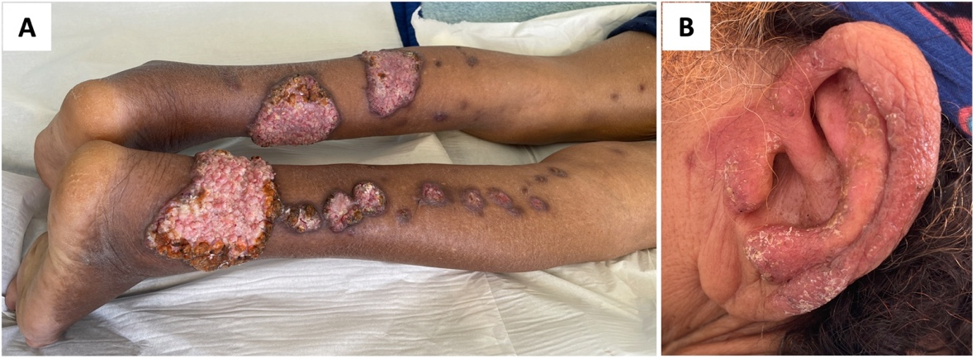

**Fig. 1. Clinical presentation showing verrucous plaques and nodules with a sporotrichoid pattern along the lower limb (A), as well as an erythematous, crusted lesion on the left ear (B).**

Dermoscopy of the lower limb lesions showed a papillated surface with irregularly dilated vessels within the papillae, brown areas, chrysalides, and red-orange globular and structureless areas. Dermoscopy of the ear lesion revealed a red-orange background, linear vessels, shiny white streaks, and yellowish-white scales (Fig. 2).

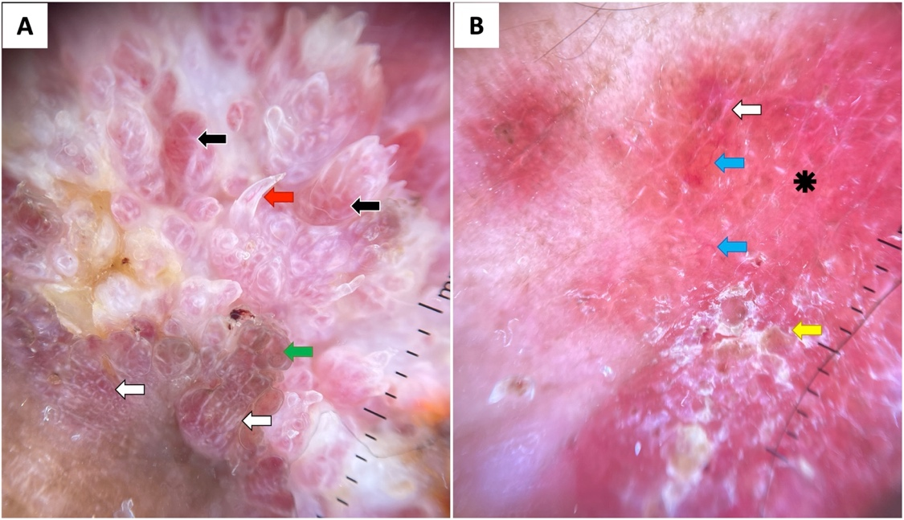

**Fig. 2. Dermoscopy of limb (A) and ear (B) lesions showing a papillated surface with dilated vessels within the papillae (red arrow), red-orange structureless globular structures (black arrows), brown areas (green arrow), white streaks (white arrows), linear tortuous vessels (blue arrows), yellow-whitish scales (yellow arrow), and a red-orange background (black asterisk).**

Laboratory tests showed mild anemia (hemoglobin: 11.1 g/dL), an elevated erythrocyte sedimentation rate (55 mm/h), and normal C-reactive protein (2.8 mg/dL). HIV serology was negative. Skin smear for leishmaniasis and sputum testing for tuberculosis were negative, but the tuberculin skin test (TST) was phlyctenular.

Two biopsies were performed from both limb and ear lesions. Bacteriological examination, including Ziehl-Neelsen staining, was negative. Direct mycological examination and culture were also negative. Histopathology revealed epithelioid and multinucleated giant cell granulomas with caseous necrosis, consistent with cutaneous tuberculosis. Interferon-gamma release assay (IGRA) testing was positive, and a full-body CT scan revealed cavitary lesions in the right upper lobe, consistent with pulmonary tuberculosis.

Based on clinical, biological, radiological, and histopathological findings, a final diagnosis of multifocal tuberculosis was established, with pulmonary and cutaneous involvement in the form of extensive TBVC exhibiting a sporotrichoid pattern on the lower limbs and an exudative presentation on the left ear.

The patient was treated with rifampicin (10 mg/kg/day), isoniazid (5 mg/kg/day), pyrazinamide (25 mg/kg/day), and ethambutol (10 mg/kg/day) for two months, followed by four months of rifampicin and isoniazid, resulting in complete resolution of lesions.

3. discussion

Tuberculosis remains endemic in many developing countries, including Morocco (Zinoune et al., 2019; Gallouj et al., 2011). Cutaneous involvement, however, is rare, primarily caused by Mycobacterium tuberculosis, less frequently by Mycobacterium bovis, and rarely by bacillus Calmette-Guérin (BCG).

The clinical presentation of cutaneous tuberculosis is influenced by the host's immune status, bacterial virulence, and the mode of skin invasion (Pau et al., 2009). The most common forms include scrofuloderma, gummatous tuberculosis, and lupus vulgaris (Gallouj et al., 2011; Pau et al., 2009; Ledesma et al., 2023).

Tuberculosis verrucosa cutis (TBVC), also known as warty tuberculosis, is an uncommon variant, often resulting from exogenous inoculation in immunocompetent individuals. Despite their intact immunity, some rare cases of multifocal TBVC with extra-cutaneous localizations, particularly pulmonary, have been reported. Our case represents one of these rare instances.

TBVC typically manifests as a solitary lesion, with extensive presentations being exceptionally rare, usually occurring in immunocompromised patients. Lesions commonly develop on trauma-exposed areas contaminated with infected sputum or other tuberculosis material. In Europe, the hands are predominantly affected, whereas in Asia and Africa, the lower limbs are more frequently involved (Reza et al., 2023).

A sporotrichoid pattern, characterized by lesions arranged linearly along lymphatic vessels, is more commonly associated with sporotrichosis but has been reported in various forms of cutaneous tuberculosis, including gummas, lupus vulgaris, and, rarely, TBVC. It is more prevalent in children and young adults due to efficient lymphatic drainage and increased trauma exposure, which was not the case in our patient (Azendour et al., 2021; Downey et al., 2015).

Dermoscopy is a valuable tool for differentiating TBVC from its mimickers. To date, only seven cases of TBVC dermoscopy have been reported in the literature. Common features include a yellowish or reddish background, yellow-orange globular and structureless areas, a papillated surface with irregularly dilated vessels, dot, hairpin, and linear curved vessels, yellowish-white scales, hemorrhagic crusts, pigmented globules, brown areas, white structureless areas, and white streaks (Jindal et al., 2022; Jakhar et al., 2021; Prasanna et al., 2023; Septiafni et al., 2022). Our findings align with these descriptions.

Given its paucibacillary nature, confirming the diagnosis of TBVC can be challenging. Although TST is usually phlyctenular, culture results are frequently negative, and PCR testing, although more sensitive, is not routinely performed in resource-limited settings (Weaver et al., 2023). Histopathology typically reveals tuberculoid granulomatous inflammation in the dermis, with epidermal hyperplasia (Reza et al., 2023). However, bacteriological isolation of M. tuberculosis in skin lesions is achieved in only about one-third of cases (Hadj et al., 2014). Consequently, diagnosis of TBVC usually relies on clinico-pathological correlation and therapeutic response to antimycobacterial agents.

4. Conclusion

This case highlights an atypical, extensive presentation of tuberculosis verrucosa cutis (TBVC) with a sporotrichoid pattern and auricular involvement, associated with pulmonary tuberculosis. Although TBVC is classically described as a solitary lesion in immunocompetent individuals, clinicians should be aware of its potential for multifocal and unusual presentations. Dermoscopy emerges as a useful non-invasive tool, revealing characteristic features such as a papillated surface, irregularly dilated vessels, yellow-orange and red-orange structureless areas, brown pigmentation, white streaks, and yellowish-white scales. These patterns may assist in differentiating TBVC from other infectious or inflammatory skin conditions. Given the diagnostic limitations of microbiological tests in paucibacillary forms, a multidisciplinary approach integrating clinical, dermoscopic, histopathological, and immunological findings is essential. Early recognition and treatment are crucial to prevent complications and improve outcomes, particularly in tuberculosis-endemic regions.

**CONSENT**

All authors declare that written informed consent was obtained from the for publication of this case report and accompanying images. A copy of the written consent is available for review by the Editorial office/Chief Editor/Editorial Board members of this journal

Ethical approval (where ever applicable)

This case report did not require institutional ethical approval as per our institution’s policy for single patient case reports. All procedures performed were in accordance with the ethical standards of the Declaration of Helsinki.

Acronyms, Abbreviations

**TBVC:** Tuberculosis verrucosa cutis

**TST:** Tuberculin skin test

**IGRA:** Interferon-gamma release assay

**CT:** Computed tomography

**BCG:** Bacillus Calmette-Guérin

**PCR:** Polymerase chain reaction

**HIV:** Human immunodeficiency virus

**ESR:** Erythrocyte sedimentation rate

**CRP:** C-reactive protein

References

1. Zinoune, S., Baybay, H., Assenhaji, I. L., Chaouche, M., Douhi, Z., Elloudi, S. et al. (2019). A cross study of cutaneous tuberculosis: A still relevant disease in Morocco (A study of 146 cases). Madridge J Case Rep Stud, 3(1), 126-129. DOI: 10.18689/mjcrs-1000131
2. Gallouj, S., Harmouch, T., Karkos, F. Z., Baybay, H., Meziane, M., Sekal, M. et al. (2011). Cutaneous tuberculosis: a 36-case series from Morocco. Med Trop (Mars), 71(1), 58-60. PMID: 21585093
3. Pau, W. S. C., AlSaffar, H., Weinstein, M., & Kitai, I. (2009). Sporotrichoid-like tuberculosis. Pediatr. Infect. Dis. J, 28(12), 1135-1136. DOI: 10.1097/INF.0b013e3181abe007
4. Ledesma, J. F. M., Hurtado, M. E. P., Lerma, E. H., Medina, M. E. E., Ramírez-Madrigal, M. A., & Troche, P. F. (2023). Dermatological Manifestations Due to Mycobacterium Tuberculosis Infection. J. Clin. Invest, 3(3), 400-402. DOI: 10.47191/ijmscrs/v3-i3-22.
5. Reza, I. B., Ahasan, H. N., & Prince, S. K. Z. (2023). A Suspicious Skin Lesion: Sufferings of A Remittance Warrior. J. Med, 24(1), 67-68. DOI:10.3329/jom.v24i1.64908
6. Azendour, H., Meziane, M., Znati, K., Benzekri, L., & Senouci, K. (2021). A polymorphous cutaneous tuberculosis. Int. J. Mycobacteriol, 10(1), 85-88. DOI: 10.4103/ijmy.ijmy_224_20
7. Downey, C., Navajas, L., Andino, R., Vera-Kellet, C., & Manríquez, J. J. (2015). Sporotrichoid pattern tuberculosis: an unusual presentation of cutaneous tuberculosis in an immunocompetent patient. Rev. Chil. Infectol, 32(2), 234-237. DOI: 10.4067/S0716-10182015000300015
8. Jindal, R., Chauhan, P., & Sethi, S. (2022). Dermoscopy of the diverse spectrum of cutaneous tuberculosis in the skin of color. Dermatol. Pract. Concept, 12(4), e2022203 PMID: [36534549](https://pubmed.ncbi.nlm.nih.gov/36534549/)
9. Jakhar, D., Gupta, R. K., & Sarin, N. (2021). Dermoscopy of tuberculosis verrucosa cutis. Indian Dermatol. Online J, 12(1), 206-207. DOI: 10.4103/idoj.IDOJ_292_19
10. Prasanna, S., Mithari, H., & Kharkar, V. (2023). A cross sectional descriptive study of dermoscopic features of clinical variants of cutaneous tuberculosis. Indian J. Tuberc, 70(4), 501-507. DOI: [10.1016/j.ijtb.2023.05.020](https://doi.org/10.1016/j.ijtb.2023.05.020)
11. Septiafni, K., Pamudji, R., Rusmawardiana, R., & Argentina, F. (2022). Tuberculosis verrucous cutis mimicking chromoblastomycosis: A case report and diagnostic challenges. Int. J. Mycobacteriol, 11(2), 208-210. DOI: 10.4103/ijmy.ijmy_57_22
12. Weaver, D. A. R., Pacheco, J. M. P., Palafox, S. Y. H., Aquino, A. L., & Mata, J. Á. I. R. (2023). Verrucous cutaneous tuberculosis: report of a case in an atypical location. Dermatol. Cosmet. Med. Quirúrg, 20(4), 427-430.
13. Hadj, I., Meziane, M., Mikou, O., Inani, K., Harmouch, T., & Mernissi, F. Z. (2014). Tuberculous gummas with sporotrichoid pattern in a 57-year-old female: A case report and review of the literature. Int. J. Mycobacteriol, 3(1), 66-70. DOI: [10.1016/j.ijmyco.2013.10.007](https://doi.org/10.1016/j.ijmyco.2013.10.007)