**Effectiveness of bleomycin infiltration in the treatment of keloids**

**Abstract**

**Introduction** The aim of this study was to evaluate the efficacy of bleomycin in the treatment of keloids in phototype VI patients. **Materials and methods**: We included patients aged over 16 years with keloids evolving between 12 and 24 months who had never been treated. Bleomycin was dissolved in 14 cc (10 cc of 0.9% isotonic saline and 4 cc of xylocaine). Using an insulin syringe, the product was administered every 15 . Efficacy was assessed using the Patient- Observer Assessment Scale (POSAS) at d0, d30, d60 and d90. **Results**: We enrolled 31 patients and performed an average of 2.77 sessions. The observer's POSAS improved from 30.46 to

13.45. The patient's POSAS decreased from 36.95 to 13.48. All the POSAS parameters improved. In terms of tolerance, we observed side effects in 21 cases (67.7%). In the immediate short term, these were agitation in 1 case (3.2%) and hypotension in another (3.2). Only one patient (3.2%) experienced transient dizziness. In the medium and long term, skin necrosis was noted in 13 cases (41.9%), and peri-lesional hyperpigmentation in 6 cases (19.4%). One of our patients developed transient bilateral palmar hyperpigmentation. **Conclusion**: Bleomycin infiltration is effective in the treatment of keloids. Dissolution in 14cc of solution is indicated to prevent necrosis.

**Key word** : Cheloid, bleomycin, Senegal

## Introduction

Keloids are a concern in phototype VI because of their frequency and the difficulty of treating them [1,2]. In sub-Saharan Africa, its treatment is hampered by recurrent post-surgical recurrences, cortico-induced metabolic complications and the inaccessibility of the CO2 laser.

Bleomycin infiltration has been shown to be effective in this indication [3- 5]. Its cure rate is estimated at between 66% and 70%, irrespective of the duration of the disease, the type of disease and the evolutionary profile [3]. Its use is all the more beneficial in that it leads to a complete cure without recurrence after 2 years [4].

The aim of this study was evaluate the efficacy of bleomycin infiltration during keloids in dark phototypes.

# METHODOLOGY

This was a single-arm, open-label, therapeutic trial designed to assess the efficacy of Bleomycin in keloids on black skin.

# Study population

inclusion criteria were:

-At least one keloid between 12 and 24 months of age

-Be at least 16 years old

-Never have been treated for keloids

-Granting consent

The following were not included: pregnant or breast-feeding women, patients with a tare, and patients who reported intolerance to bleomycin.

The following cases were excluded from the study: serious side effects

-who decided not to take part in the study lost to follow-up

# 2.2. Preparation of bleomycin

In view of the numerous cases of necrosis reported, which we attribute to the concentration of the product (preparation with 10ml), a dilution was carried out in. The vial containing 15 mg of lyophilised active ingredient was dissolved in 10 ml of SSI to which we added 4 ml of xylocaine hydrochloride, making a 40% dilution.

# 2.3. Infiltration

Using an insulin syringe, the preparation was administered into the keloid mass, infiltrating orthogonally, point by point.

The stopping criterion on one point was the change in the colour of the lesion, in this case the appearance of a whitish colour opposite the infiltrated area, reflecting the presence of the preparation in the treated area.

# 2.4 Rate administration

An infiltration was performed every 15 days for 5 sessions, i.e. 25% less than the authorised cumulative dose. Healing or subsidence was a criterion for discontinuation, while a therapeutic window was observed in the event of necrosis.

# 2.5. Evaluation criteria

Assessments were made at baseline (D0), at D30, at D60 and at D90.

Efficacy was assessed using the Patient and Observer Scar Assessment POSAS). An external evaluator administered the observer's POSAS, while the patient's POSAS was assessed by the patient himself [6]. A regression of the score reflects

the effectiveness of the treatment. Persistence or a score higher than that recorded at inclusion meant that the treatment was ineffective and infiltrations should be stopped. The occurrence of local and systemic side-effects was investigated. A blood count, azotemia and creatinin were taken at each check-up. A chest X-ray was performed at baseline and at D90.

# 2.6 Data analysis

It was carried out using SPSS 2.0 software. The parametric test compared the scores with a confidence level of 0.05.

# 2.7. Ethical considerations

Patients were free to participate or to withdraw from the study. Refusal to take part in the study did not prevent the patient from being treated. Other therapeutic alternatives were offered.

The participant's identity was protected.

# RESULTS

We collected 31 cases of keloids. The mean age was 37.77 ± 16.50 years.

The sex ratio was 0.48. The keloids had progressed for 18.48 ± 4.4 months. We performed an average of 2.77 ± 0.96 [1-5]. The evolutionary profile of the

POSAS-observer is illustrated in Figure 1. The score went from 67.26± 21.04 to 27.26

±12,98. The patient's score for partial assessment of functional signs fell from

36.95±16.5 to 13.48±8.78. The intensity of pruritus and pain had decreased (Figure 2). Analysis of the curves shows a significant improvement in physical and functional signs from the first injection. Tumour subsidence was noted, characterised by the disappearance of the relief with a mean relief item of

from 2.94 ± 1.44 to 1.38 ± 0.74 (**images 1 and 2)**. In two patients, we noted a complete disappearance of the keloid from the first injection. These were a case of post-piercing auricular keloid (**image 3)** and another post-shaving (**image 4**) which had been evolving for 13 months and 18 months respectively.

We observed side effects in 21 cases (67.7%). In the immediate short term, these were agitation in 1 case (3.2%) and hypotension in another (3.2). Only one patient (3.2%) experienced transient vertigo. Pain persisted beyond 2 hours after injection in 12 cases (38.7%). In the medium and long term, local adverse events included skin necrosis in 13 cases (41.9%) and peri-lesional hyperpigmentation in 6 cases (19.4%). Inflammatory chondritis was observed in 1 case (3.2%).

One of our patients developed bilateral and transient palmar hyperpigmentation. No systemic effects were noted.

## Discussion

We report on the efficacy and safety of bleomycin on keloids in 31 patients. This is the first study carried out in our context and the second in black Africa [5]. The encouraging results we obtained justify the inclusion of bleomycin as a treatment for keloids. Bleomycin has a special place in sub-Saharan Africa, where the treatment of keloids is essentially based on corticosteroids and surgery, which are hampered by metabolic complications and recurrent post-surgical relapses. Use of the CO2 laser is hampered by its high cost and uncertain efficacy on phototype

VI. Bleomycin therefore occupies a place of choice in the therapeutic armoury due to its accessibility, rapidity of action and good tolerance, which improve patient compliance with treatment. Adherence is consolidated by the remarkable involution after the first injection, such as

as illustrated by the significant reduction in the score at D30 (Figures 1 and 2).

On average, three to five infiltrations are carried out [7]. Although efficacy was observed from the first infiltration, we continued the treatment after an average of 3 sessions for residual keloids (2.77). Savané M and Duretz C performed on average the same number of infiltrations [4,5]. In certain forms of tumour, treatment may be continued beyond the three infiltrations, and discontinuation depends on the therapeutic response and tolerance, while avoiding exceeding the recommended cumulative dose (300mg).

In 2 patients, the evolution was spectacular, with complete disappearance of the keloid at D30. In our practice, given the size of the lesions, several sessions of triamcinolone treatment would be necessary obtain the same result. This was also the case for tumour forms of the beard and knee, which could only evolve after several corticosteroid infiltrations, further exposing the patient to iatrogenic complications. The latter, such as diabetes, have been noted in our practice.

The use of bleomycin is all the more beneficial in that it causes fewer recurrences than the other techniques (3% after 2 years) mentioned above [7]. Our 9-month follow-up is insufficient to draw any conclusions about recurrence. Long- term follow-up of patients would enable this parameter to be assessed.

Necrosis was the main side effect observed. It necessitated the observation of a therapeutic window combined with symptomatic treatment, which resulted in cure in all cases and resumption of treatment. Observed in 41.9% of cases, it was less frequent than in the study by Savané M et al where it occurred in 77.77% [4]. The 40% dilution (i.e. 10 cc of SSI and 4 cc of xylocaine) that we used is thought to be the explanatory factor. According to Professor Dubertet L, with whom we spoke during the first congress of the Mauritanian dermatology society, held from 14 to 15 February in Nouackchott, infiltrations of

bleomycin in keloids had been started by his team. However, in view of the high frequency of necrosis, which was almost constant, this protocol was definitively abandoned. This study demonstrates the value of dilution in preventing necrosis without compromising efficacy.

## Conclusion

Bleomycin infiltration is effective in the treatment of keloids in phototype VI. Dilution in 14 cc of solution is recommended to prevent necrosis.



35

30

25

20

15

10

5

0

POSAS J0

POSAS J30

POSAS J60

POSAS J90

## Figure 1: Evolution of the POSAS-observer from D to D90



9

8

7

6

5

4

3

2

1

0

7,97

6,73

4,29

3,11

3,65

2,33

2,7

2,29

J 0 J 30 J 60 J 90

Pain

Pruritus

**Figure 2: Evolution of pain and pruritus**

**Averages**

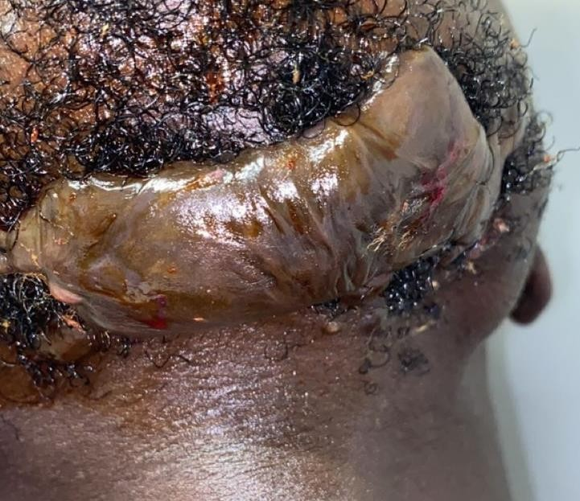

**a**

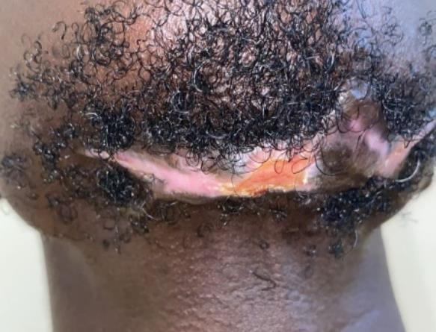

**b**

## Image 1: Lesion subsidence following 3 injections a: before

**b : after (D90)**

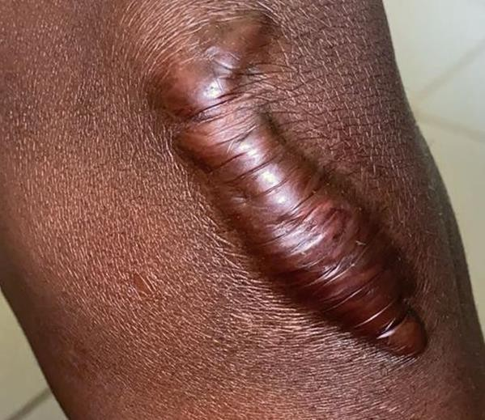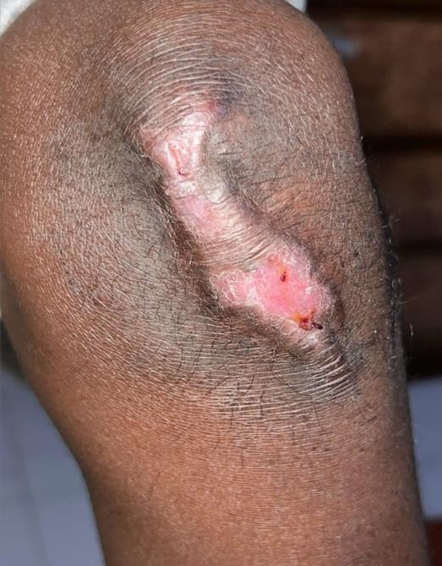

**a**

**b**

**Image 2: Improvement a post-traumatic keloid of the knee after 2 injections a: before b: assessment at D30**

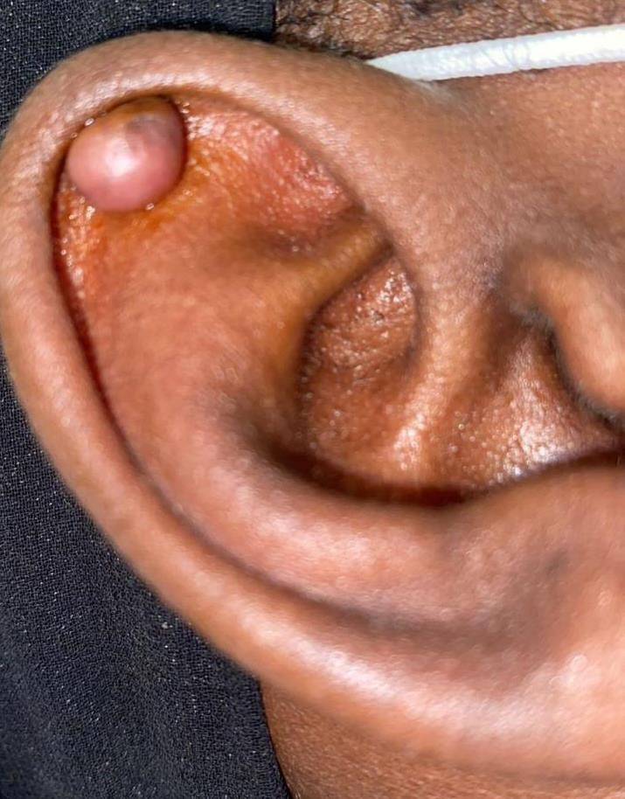

**a**

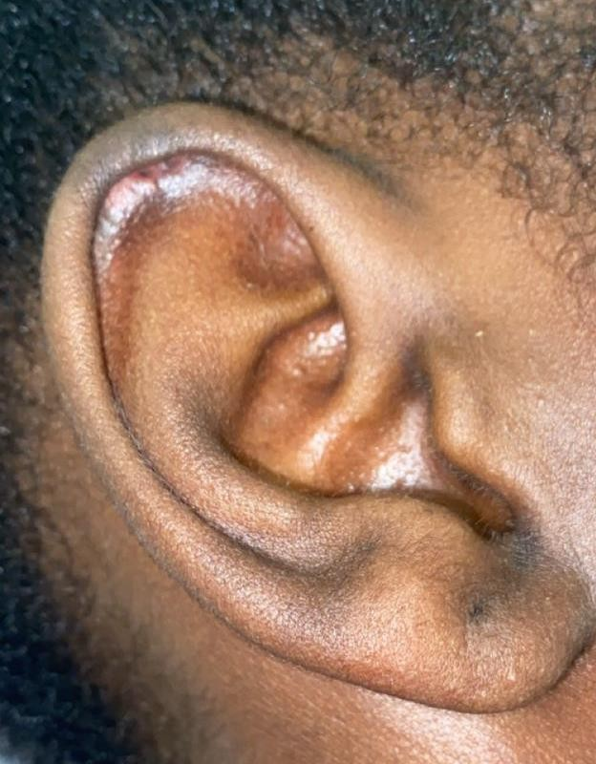

**b**

**Image 3: Healing of an auricular keloid following a single session a : before b: disappearance (D30)**

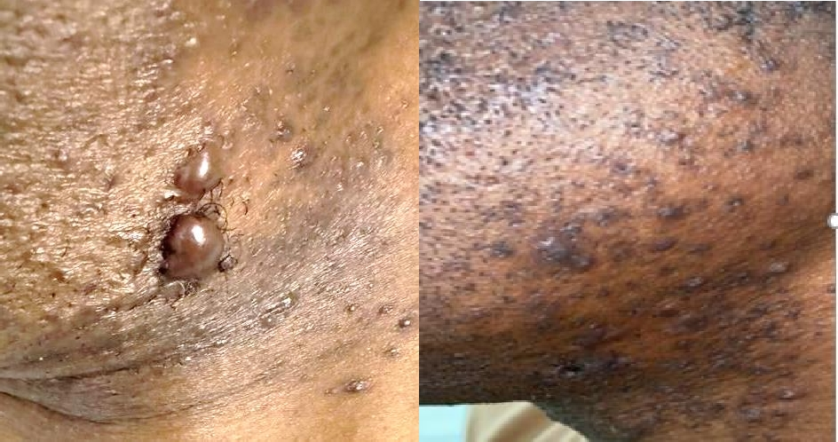

**Image 4: Healing a case of post-shave keloid following a single session**

**a :before b : recovery (d30)**

**REFERENCES**

1 . Yedomon GH, Adegbidi H, Atadokpede F, Akpadjan F, Mouto EJ, do Ango-Padonou F. Chéloïdes sur peau noire: à propos de 456 cas. Med Sante Trop 2012; 22: 287- 91. Disponible sur Doi :10.1684/mst.2012.0052

2. Allah KC, Yéo S, Kossoko H, Assi Djè Bi Djè V, Richard Kadio M. Cicatrices chéloïdes sur peau noire : mythe ou réalité. Annales de Chirurgie Plastique Esthétique.2013; 58 :115-22. Disponible sur Doi : 10.1016/j.anplas.2012.02.005

3. Khan HA, Sahibzada MN, Paracha MM. Comparaison of the efficacy of intralesional bleomycin versus intralesional triamcinolone acetonide in the treatment of keloids. Dermatol Ther. 2019;32(5):e13036 Disponible sur Doi: 10.1111/dth.13036

4. Duretz C, Saint-Martin C, Bernard P, Reguiai Z. Traitement des cicatrices chéloïdes par injections intra-lésionnelles de bléomycine suivi au long cours. Unité de recherche clinique, CHU Reims, France, Ann Dermatol Venereol 2016,143(12):402-403 Disponible sur Doi: 10.1016/j.annder.2016.09.653

5. Savané M, Diané BF, Kanté MD1, Soumah MM, Diallo MS, Keita AS, Tounkara MT, Keita M, Cisse M. New keloids treated with bleomycin intra-lesional infiltration in patients in a West African country: Resultats of the Guinean experience (Conakry). Our Dermatol Online. 2023;14:41-45. Submission: 13.10.2023; Accessible sur Doi : 10.7241/ourd.2023S2.3

6. Draaijers, L. J., Tempelman, F. R., Botman, Y. A, et al. (2004). The patient and observer scar assessment scale: A reliable and feasible tool for scar evaluation. Plast Reconstr Surg, 1967; 113:1960–1965.

7. Kim WI, Kim S, Cho SW, Cho MK. The efficacy of bleomycin for treating keloid and hypertrophic scar: A systematic review and meta-analysis. J Cosmet Dermatol. 2020;00:1–10. Disponible : https://doi.org/10.1111/ jocd.13390