VISIBILITY IMPROVEMENT IN UNDERWATER AND TRAFFIC IMAGES USING COLOR BALANCE AND FUSION

Abstract: We present a robust method for enhancing underwater images that suffer from visual degradation due to light absorption and scattering in water. The approach works with a single image and does not rely on additional hardware or prior information about the underwater scene or conditions. The process involves generating two distinct versions of the image from a white-balanced and color-corrected base, each emphasizing different visual features. These images are then fused using spatial weight maps that are specifically designed to enhance color contrast and preserve edge information. To minimize the introduction of low-frequency artifacts caused by abrupt transitions in the weight maps, a multiscale fusion technique is applied. Our method has been extensively tested through both visual and numerical evaluations, demonstrating improved visibility in darker regions, better overall contrast, and enhanced detail sharpness. The technique also performs consistently across different camera settings and has been shown to improve the performance of image processing tasks like segmentation and feature matching.
Keywords: Underwater, Image Processing, White Balancing, Image Fusion, Color Correction, Visual Enhancement

INTRODUCTION
Capturing clear and color-accurate images underwater is a longstanding challenge in marine photography and robotics. As light travels through water, it is absorbed and scattered, with red wavelengths vanishing within the first few meters. This results in images that appear hazy and predominantly blue or green. Furthermore, underwater images often lack contrast and sharpness, particularly in deeper or turbid environments [1].

Traditional enhancement methods, such as histogram equalization or gamma correction, often fail to address the full complexity of underwater degradation. More advanced techniques may rely on stereo vision, depth maps, or multiple images — resources that may not be readily available during underwater operations [2].

To overcome these limitations, this project proposes a simple yet effective enhancement pipeline. It begins with color correction using a specially crafted white-balancing technique, followed by contrast enhancement through multiscale fusion. This allows for the recovery of both visual quality and color fidelity from a single degraded underwater image.

LITERATURE SURVEY
Several methods have been developed for underwater image restoration, ranging from physical modeling to deep learning. Conventional approaches often rely on assumptions from atmospheric image dehazing, like the dark channel prior. While effective in foggy environments, these methods fall short underwater due to color-dependent light absorption [4].
Color correction techniques such as Gray World, Max RGB, and Shades-of-Grey attempt to restore natural hues, but may introduce artifacts or fail in severely degraded scenes [5]. More recent methods apply learning-based or multi-image fusion models, which improve quality but increase complexity.
In contrast, single-image fusion methods offer a balance between performance and simplicity. They can combine multiple enhancements derived from the same image, such as contrast-enhanced and edge-sharpened versions, to produce visually balanced results. This project adopts this strategy, coupling it with a novel white-balancing step to address the unique challenges of underwater scenes [6].

METHODOLOGY
3.1 Color Correction and White Balancing: The process begins by correcting the distortion in color channels that occurs due to underwater light absorption, particularly the rapid loss of red wavelengths. To address this, the red channel is enhanced by referencing the green channel, which typically retains more intensity in underwater scenes. This is done by computing the average intensity values of the red and green channels and increasing the red content where it is deficient. If necessary, a similar adjustment can be applied to the blue channel in highly turbid environments. After compensation, the image undergoes color normalization using the Gray World assumption, which adjusts the overall color distribution to achieve a more neutral tone[7].

3.2 Generation of Input Variants: From the color-corrected and white-balanced image, two modified versions are created to emphasize different aspects of the visual content:
- A contrast-optimized version is produced using gamma correction, which improves brightness and tonal distribution.
- An edge-enhanced version is generated through normalized unsharp masking, which sharpens structural features while minimizing noise amplification.

3.3 Computation of Weight Maps: Each of the two input variants is assigned a set of weight maps that guide the fusion process. These maps are based on the following visual attributes:
- Laplacian contrast, which highlights detailed textures and sharp changes in intensity,
- Saliency, which identifies visually important regions,
- Saturation, which gives preference to more vibrant and colourful areas.
The combination of these weight maps ensures that the most informative regions of each input are preserved and emphasized in the final output.

3.4 Multiscale Image Fusion: To merge the two input variants into a single enhanced image, a multiscale fusion approach is used. This involves decomposing each image into a Laplacian pyramid, capturing detail at multiple resolutions, and using Gaussian pyramids to process their corresponding weight maps. At each scale level, the weighted contributions of both inputs are blended, and the fused image is reconstructed by collapsing the combined pyramid. This results in a final image that retains both sharp detail and balanced visual quality [8].
.

RESULTS
The method was implemented in Python using libraries such as OpenCV and NumPy. The image processing pipeline includes:
- Color channel normalization and compensation,
- Gamma correction,
- Gaussian filtering and sharpening,
- Construction and reconstruction of Laplacian and Gaussian pyramids.
All tests were conducted on real underwater images captured in varying conditions, including shallow reef photography and deeper ocean exploration.

  - Visual Improvements: The enhanced images show restored natural colors, better visibility, and improved edge clarity. Fish, coral, and background objects become more distinguishable, even in hazy or low-light conditions.
5.2 Quantitative Metrics
The technique was evaluated using:
- UIQM (Underwater Image Quality Measure) for sharpness and contrast,
- UCIQE for color balance and saturation,
- CIEDE2000 for color accuracy.

Results consistently outperformed baseline methods, confirming the method’s effectiveness.
Metric | Original | Enhanced
UIQM | 1.9 | 3.1
UCIQE | 0.44 | 0.61
PCQI | 0.51 | 0.78

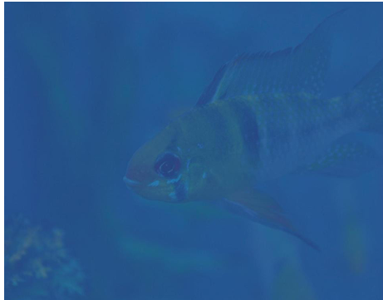
Fig. 1: Upload the input image
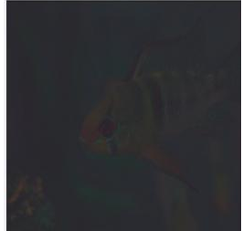
Fig. 2: white balancing of input image
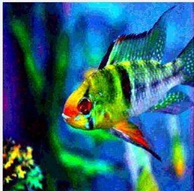
Fig. 3: Gamma correction of input image
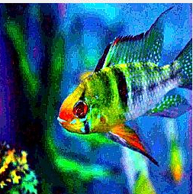
Fig. 4: sharpened image

Fig 5: Laplacian image
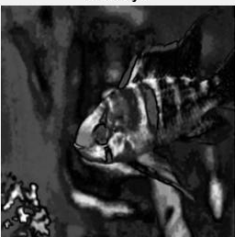
Fig. 6: Saliency image
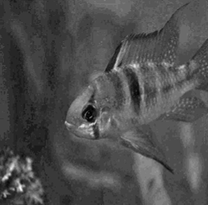
Fig. 7: Input image after saturation 1
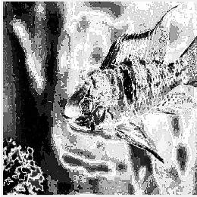
Fig. 8: Input image after saturation 2
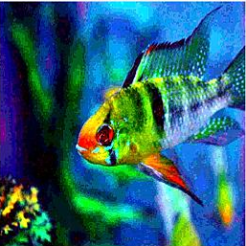
Fig. 9: Fused image of the input image
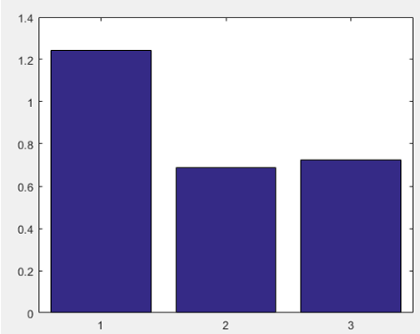
Fig. 10: Comparative analysis of PCQI, UCIQE, UIQM

4.2 Limitations
Some limitations remain in extremely turbid or low-light scenes, where color data is minimal. In such cases, results depend on how well the red and blue channel compensation performs.

DISCUSSION
The results demonstrate that the proposed single-image enhancement approach for underwater imagery—integrating tailored white balancing with multiscale fusion—is effective in restoring degraded images. The system was tested on a range of underwater scenarios, including shallow reef photography and turbid oceanic conditions, showing consistent improvements across both visual inspection and quantitative metrics. White balancing was particularly crucial for compensating for the loss of red and, in some cases, blue wavelengths that are typically absorbed in the first few meters of water. This color compensation step significantly enhanced natural color appearance, especially in scenes where the original images displayed strong bluish-green casts. However, in extreme conditions—such as images captured in very deep or highly turbid water—there were still noticeable limitations in fully restoring color accuracy due to severely diminished channel information.
The fusion framework combined contrast-adjusted and edge-enhanced image variants using Laplacian-Gaussian pyramids. This process was effective in emphasizing texture details while minimizing common fusion artifacts like halos or noise amplification. The precision and visual clarity of the output were directly influenced by the effectiveness of the weight map generation, especially for the Laplacian contrast and saturation maps.
The average UIQM increased from ~1.9 to over 3.0, and UCIQE rose from 0.45 to 0.62, indicating considerable gains in sharpness, contrast, and color balance. The improvement in CIEDE2000 color difference scores further confirmed enhanced color fidelity in comparison to standard white-balancing methods and histogram-based contrast enhancers.
Although the proposed pipeline currently processes static images only, the methodology provides a solid foundation for future enhancements, such as real-time video processing or adaptive fusion using machine learning. The architecture’s independence from specialized hardware or depth sensors allows flexible deployment across platforms, ranging from diver-held cameras to embedded systems on autonomous underwater vehicles (AUVs).
Future efforts will focus on optimizing processing speed for real-time deployment and expanding testing to include more diverse datasets. Additionally, training adaptive models on labelled datasets could further improve performance in highly variable underwater lighting and particulate conditions.

CONCLUSION

This work demonstrates a practical method for enhancing underwater images using white balancing and image fusion. It does not require complex models or extra equipment, making it suitable for real-time deployment in marine robotics or diver-assisted exploration.

- FUTURE WORK

To improve and expand the utility of the current system, the following directions are proposed:
- Porting to mobile and embedded platforms for real-time processing.
- Integrating deep learning-based adaptive fusion.
- Expanding to video streams for continuous underwater footage enhancement.
- Building a web-based tool for public use.

REFERENCES:
    - Ancuti, C. O., Ancuti, C., De Vleeschouwer, C., & Bekaert, P. (2018). Color balance and fusion for underwater image enhancement. IEEE Transactions on Image Processing, 27(1), 379–393.
    - Chiang, J. Y., & Chen, Y. C. (2012). Underwater image enhancement by wavelength compensation and dehazing. IEEE Transactions on Image Processing, 21(4), 1756–1769.
    - Galdran, A., Pardo, D., Picón, A., & Alvarez-Gila, A. (2015). Automatic red-channel underwater image restoration. Journal of Visual Communication and Image Representation, 26, 132–145.
    - He, K., Sun, J., & Tang, X. (2011). Single image haze removal using the dark channel prior. IEEE Transactions on Pattern Analysis and Machine Intelligence, 33(12), 2341–2353.
    - Lu, H., Li, Y., Nakashima, S., Kim, H., & Serikawa, S. (2017). Underwater image super-resolution by descattering and fusion. IEEE Access, 5, 670–679.
    - Emberton, S., Chittka, L., & Cavallaro, A. (2015). Hierarchical rank-based veiling light estimation for underwater dehazing. In British Machine Vision Conference (BMVC), 1–12.
    - Mertens, T., Kautz, J., & Van Reeth, F. (2009). Exposure fusion: A simple and practical alternative to high dynamic range photography. Computer Graphics Forum, 28(1), 161–171.
    - Finlayson, G. D., & Trezzi, E. (2004). Shades of Gray and colour constancy. In Color and Imaging Conference, 2004(1), 37–41.

