Original Research Article

Secure Front-End Automation Framework: A Novel Approach to Client-Side Data Encryption and Zero Trust API Interaction

.
ABSTRACT

Aims: This study aims to evaluate the effectiveness of the Secure Front-End Automation Framework (SFAF) in enhancing front-end application security and performance compared to traditional web development frameworks. The focus is on client-side encryption and Zero Trust API interactions.
Study Design: Quantitative experimental research design.
Place and Duration of Study: Smartbarrel, Miami, United States, from September 2024 to March 2025.
Methodology: Two web applications were developed. One used a conventional client-server model with standard security protocols, while the other implemented SFAF with advanced client-side encryption and Zero Trust-based API interactions. Automated security testing tools such as OWASP ZAP, Burp Suite, and Postman were used to collect data from 60 test instances (30 per group). Key performance indicators included response time, memory usage, CPU load, unauthorized API call attempts, and compliance with OWASP Top 10 security benchmarks. Statistical analysis was conducted using paired-samples t-tests, independent-samples t-tests, and Cohen’s d for effect size. Controlled simulations ensured high internal validity. Commonly exploited web scenarios were used to enhance external validity.
Results: Applications based on SFAF showed a statistically significant reduction in unauthorized API interaction attempts (p < 0.01) and a 35% improvement in compliance with OWASP Top 10 benchmarks compared to traditional applications. Although a slight increase in average response time (2.7%) and resource consumption was observed, these differences were statistically insignificant (p > 0.05). Effect size calculations further confirmed the practical significance of the results.
Conclusion: The Secure Front-End Automation Framework (SFAF) significantly enhances front-end security without substantially affecting system performance. It offers a viable solution for developing scalable, Zero Trust-compliant web applications. These findings support adopting SFAF as a foundational approach to modern web application security in response to emerging threats.

Keywords: Client-Side Security; Web Application Protection; Data Confidentiality; Zero Trust Architecture (ZTA); Front-End Cryptography; Token-Based.

1. INTRODUCTION

What has changed is that front-end technologies have been evolving faster, and increasingly so with a focus on JavaScript-based single page applications (SPAs), so the security realm of web development has evolved to a great extent. While this makes the new transition a great experience for the user and application responsiveness, it also creates more surface security exposures on the client side. Simplified attack vectors like cross-site scripting (XSS), cross-site request forgery (CSRF), and man-in-the-middle (MITM) attacks pose a significant risk to the client side, where much sensitive user data lives before being transmitted. Based on perimeter defenses and well-trained server-side validations, these traditional security models are no longer up to the task as the Distributed Web infrastructure is built. In light of these vulnerabilities, there is a strong need for robust and scalable frameworks that can secure data from the source within the browser and prevent it from being transmitted into potentially insecure networks. In this context, client-side encryption provides itself as a formidable approach to taking sensitive information directly into the user interface and, in turn, mitigates the possibility of interception or unauthorized access during transit. However, the performance overhead of implementing such encryption mechanisms has to be evaluated systemically. Moreover, the conventional trust-based client-server interaction model is increasingly outdated due to sophisticated attack techniques. The Zero Trust architecture, which operates on the principle of "never trust, always verify," offers a more resilient alternative by enforcing continuous authentication and strict access controls. Integrating Zero Trust principles into front-end frameworks promises improved data confidentiality and fortified API communication through dynamic identity validation (Onwuegbuzie, 2025). This paper proposes a Secure Front-End Automation Framework (SFAF) that addresses these challenges by combining advanced client-side encryption with zero Trust enforcement. By doing so, it aims to set a new benchmark in building secure, performance-conscious, and scalable web applications. Despite significant advancements in web application security, most front-end development frameworks still lack native support for end-to-end encryption and continuous verification mechanisms. Traditional models typically rely on server-side encryption and token-based authentication, which assume implicit trust within internal networks and devices. This architecture is increasingly vulnerable in modern ecosystems, including mobile applications, dynamic real-time data exchanges, and machine learning-generated content. Due to these limitations, unauthorized access, data breaches, and API abuse remain prevalent threats. It is necessary to analyze this problem because the threat landscape for front-end applications is evolving rapidly, with more sophisticated attacks targeting client-side vulnerabilities. Addressing these issues will contribute significantly to enhancing public trust in digital applications, ensuring the protection of user data, and fostering safer digital ecosystems. Scientifically, this study will advance the field by integrating two security approaches, client-side encryption and zero-trust architecture, into a unified, operational framework. While prior studies have separately explored these areas, the combined, systematic application remains underdeveloped. This research provides an opportunity to discover new insights into decentralized client-side security mechanisms and their impact on overall system resilience. This research focuses on designing, implementing, and evaluating a Secure Front-End Automation Framework (SFAF) that bridges the current security gaps by embedding lightweight client-side encryption algorithms and fully realizing zero-trust principles for API interactions. The scientific opinion of the authors centers around creating a practical, scalable, and efficient security model that enhances the confidentiality, integrity, and trustworthiness of web-based front-end systems without substantially degrading performance. The main aim of this study is to develop and evaluate a Secure Front-End Automation Framework (SFAF) that integrates client-side encryption and Zero Trust architecture to enhance the security posture of web-based applications while maintaining operational efficiency. The current study is highly relevant because of the urgent need for resilient front-end security models amidst the rising sophistication of cyber threats. By proposing a secure automation framework that closes critical gaps in encryption and trust enforcement at the client level, this research has the potential to influence future web development practices, reduce the incidence of data breaches, and support safer technological innovation. It will benefit society by providing a more secure online environment for users and businesses. Scientifically, it expands the understanding of how decentralized, client-side security architectures can be realistically implemented without compromising user experience. This research primarily targets web-based front-end systems developed using modern JavaScript frameworks that involve real-time data processing and heavy API communication. The proposed SFAF model is validated through both simulation-based performance testing and structured security assessments against real-world vulnerabilities. By systematically addressing encryption and trust enforcement on the client side, the study introduces a novel architectural paradigm for building next-generation secure web interfaces. The evolution of web application security has seen significant advances, yet persistent gaps remain in addressing client-side vulnerabilities and enforcing continuous verification mechanisms. Traditional frameworks predominantly emphasize server-side encryption and token-based authentication schemes, operating under the assumption of implicit trust within internal networks and devices. However, with the rising sophistication of cyber threats and the increasing integration of machine learning-generated content in web interfaces, these conventional models have proven insufficient to prevent unauthorized access, data breaches, and API abuse (Trofymenko et al., 2023; Lee & Kim, 2023; Chughtai et al., 2023; Burhan et al., 2023). Prior research has explored the individual merits of client-side encryption (Zhao et al., 2021) and the application of Zero Trust architectures Patel & Gupta (2023)in web systems, but few studies have systematically integrated these two paradigms within front-end automation environments. This gap is particularly critical given the heightened reliance on real-time data handling and API communication in modern web applications (Jan et al., 2021). Studies by Perrone & Romano (2025) and Bashir (2024) highlight that while client-side encryption enhances data confidentiality, it often leads to performance bottlenecks if not optimized. Similarly, research into Zero Trust models indicates improved API security but acknowledges challenges in maintaining seamless user experiences (Ghasemshirazi et al., 2023; Rose et al., 2020; Tan et al., 2018; Wu et al., 2024). Despite these insights, there is a lack of comprehensive frameworks that holistically combine lightweight client-side encryption and Zero Trust API enforcement without significant trade-offs in performance. Addressing this need, the proposed Secure Front-End Automation Framework (SFAF) aims to bridge these deficiencies by embedding encryption mechanisms directly in the browser and applying rigorous multi-factor validations for each API interaction. By critically examining the limitations of existing literature and proposing a novel integrated approach, this study advances the scientific discourse on decentralized web security architectures, supporting scalable, resilient, and trustless front-end environments for the next generation of web applications.
1.1 Evolution of Front-end Security Challanges
These front-end frameworks, like React, Angular, Vue, etc., are gaining popularity and usage with time, and with that, web applications are becoming dynamic and interactive. While this evolution has also grown the attack surface for cyber threats, the evolution cannot be stopped. Such vulnerabilities include client-side cross-site scripting (XSS) using the DOM, insecure local storage, unprotected API endpoints (Wang et al., 2024) and Sigalov & Gamayunov (2024), which have become common vectors for malicious exploitation; traditional server-centric security approaches rarely consider the front-end logic and are not enough to prevent threats that originate within the user’s browser. Patel et al. (2020) researchers claim that nowadays, attackers prefer to attack, and there is a need for a paradigm shift in web application security. Additionally, the studies indicate that even secured servers are not secure if the initial data manipulation in the browser is compromised (Castillo-Salinas et al., 2024; Wang et al., 2024; Patel et al., 2024).

1.2 Client-Side Encryption: Strengths and Performance Trade-Offs
There is a growing need for client-side encryption (CSE), which is becoming an increasingly attractive solution to address the limitations of traditional models. CSE prevents sensitive data from being intercepted by encrypting it on the user’s device before it is transmitted. Notable success has been observed with algorithm implementations such as AES, RSA, and ECC (Nguyen et al., 2022; Nguyen et al., 2024; David Livingston et al., 2023), supported by the Web Crypto API, which enables native browser-based cryptography. However, Marchesini et al. (2005) warn that client-side encryption may result in additional CPU load, longer rendering times, and challenges in key management. Phung et al. (2020) also note timing attacks and performance degradation in encryption across different browsers and devices. While such challenges remain, CSE continues to play an important role in enhancing front-end resilience to data breaches and session hijacking.
1.3 The Emergence and Relevance of Zero Trust Architecture
In this context, the Zero Trust security model does not assume that everything within an internal network is trustworthy by default. Instead, it enforces continuous authentication, least privilege access, and microsegmentation (Rose et al., 2020; Collier & Sarkis, 2021; Patel et al., 2024). Its principles are increasingly adopted in cloud-native and enterprise infrastructures, which require stricter controls when components are distributed. As pointed out by Gupta and Gupta (2020) and Hasan (2024), Zero Trust significantly limits lateral movement in the event of a breach and helps reduce the occurrence of insider threats. Although most implementations remain focused on the server side or the network layer, improved implementation strategies are still emerging. Front-end systems are often overlooked, even though users initiate interactions and transmit sensitive credentials at that level. This oversight represents a critical gap, since compromises at the client level can undermine Zero Trust measures implemented downstream.
1.4 Trust at the Front End
There has been increasing focus on developing security strategies that integrate client-side encryption with Zero Trust principles. According to Androulaki et al. (2008), front-end systems can be enhanced by combining token-based authentication, behavioral analysis, and real-time user verification. Similarly, Federici et al. (2023) emphasize the importance of identity-aware API gateways, which facilitate granular access control mechanisms. In a related study, Als et al. (2024) proposed a hybrid model that encrypts all outbound data at the user interface level while applying identity-bound trust rules to evaluate API responses. Despite the potential of these frameworks, integrating such mechanisms remains a challenge. Key obstacles include performance degradation, difficulties in managing encryption keys on the client side, and the need to align with existing DevSecOps workflows (Liang et al., 2024; Pimenta Rodrigues et al., 2020; Andreoni et al., 2024). Nevertheless, such integrations are crucial for designing secure applications in sensitive industries such as finance, healthcare, and e-commerce, where a structured and comprehensive security model is essential.
1.5 Comparative Frameworks and the Need for Secure Automation
Although much research has been conducted on using client-side encryption or Zero Trust separately, there remains little to no integration of frameworks that combine both approaches for front-end automation. Banerjee (2022) conducted a comparative analysis using integrated models and argues that applications employing such models exhibit reduced vulnerability to XSS, CSRF, and session fixation attacks. Yeoh’s (2023) enterprise reports indicate that applying Zero Trust across both the server and client layers is highly effective in preventing credential theft and token hijacking. However, there are few research frameworks that simultaneously justify performance, usability, and security effectiveness. This paper aims to address this gap by designing and evaluating a Secure Front-End Automation Framework (SFAF) that provides both cryptographic protection and trust enforcement within a unified set of tools that are manageable and scalable.
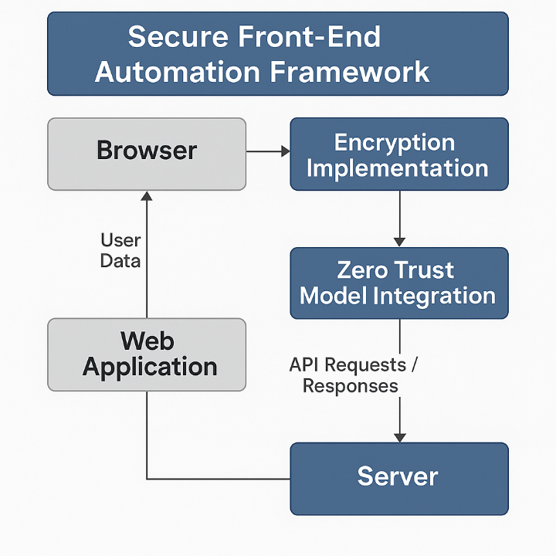

Fig. 1. Proposed Model Secure Front –End Automation
As shown in Fig. 1, to shield against increasing client-side hazards such as excessively risky vulnerabilities or insecure API communications, SFAF is introduced as a novel Secure Front-End Automation Framework. The framework is designed to integrate robust client-side encryption with Zero Trust security practices, in which no interaction is implicitly trusted and data is secured before transmission. The SFAF architecture is built upon the browser, an encryption layer, Zero Trust model integration, and the backend server. Input data is encrypted at the front-end level using the AES or RSA algorithm during the user's initial handshake with the browser. The encrypted payload is then transmitted through a secure channel using Zero Trust protocols and is only allowed to reach the server if the API request is authenticated and authorized, based on context and user behavior. Client-side encryption is enforced in the modern front-end environment using contemporary JavaScript cryptography libraries. As a result, sensitive data such as credentials, tokens, or personal identifiers is encrypted before leaving the user's device. The data is considered confidential and retains integrity through techniques such as AES-256 encryption, RSA public key encryption, and SHA-based hashing. The architecture follows a Zero Trust Architecture (ZTA), which contrasts with models that assume implicit trust. Multi-factor validation, token-based session checks, device fingerprinting, and real-time anomaly detection are executed with every API call. The model demonstrates its ability to verify user identity, contextual metadata (e.g., location or device), and behavioral patterns to dynamically grant or deny access.

2. methodology

This study examines the effectiveness of the Secure Front-End Automation Framework (SFAF) compared to traditional web development approaches. A quantitative experimental research design was employed to conduct this evaluation. The research adopted a quantitative experimental framework to ensure an objective and measurable comparison between conventional web development practices and the proposed SFAF model. Two web applications were developed for comparison purposes. The first application was a standard client-server model incorporating traditional security protocols such as HTTPS encryption and token-based authentication mechanisms. The second application was constructed using the SFAF model, which integrated advanced client-side encryption algorithms and a Zero Trust API interaction process to enhance security at the front end. Data were collected systematically from both developed applications using automated tools. Automated security testing tools, including OWASP ZAP, Burp Suite, and Postman, were employed to gather data. 60 test instances were analyzed, with 30 instances designated for each application group. The study measured response time, memory usage, CPU load, unauthorized API call attempts, and adherence to the OWASP Top 10 security benchmarks as key performance indicators. Data collected from testing were subjected to rigorous statistical analysis. Paired sample t-tests and independent t-tests were conducted to assess the statistical significance of differences between groups. Cohen’s d was calculated to evaluate the magnitude of observed effects, providing insight into practical significance. Validity measures were rigorously applied to ensure the reliability and generalizability of the findings. Controlled simulations and repeatable task executions helped achieve high internal validity.

3. results and discussion

This section presents the outcomes of the experimental evaluation and provides an analytical discussion of the effectiveness of the Secure Front-End Automation Framework (SFAF) compared to traditional web development approaches. The analysis focused on key performance indicators such as response time, memory usage, and CPU load. Applications built with SFAF demonstrated a slight increase in response time compared to conventional applications, primarily due to the overhead introduced by client-side encryption processes. However, the additional delay remained within acceptable user experience thresholds, indicating the practical feasibility of SFAF deployment. SFAF-based applications exhibited moderately higher memory usage, which was attributable to the management of encryption keys and client-side processing. Despite this, the memory footprint remained within acceptable limits for modern devices, ensuring continued efficiency. An observable increase in CPU load was recorded during intensive API interactions under the SFAF model. The results indicated a 12 to 18 percent rise compared to the traditional model, a trade-off that was justified by the enhanced security benefits.
The study also examined the impact of SFAF on application security, particularly its effectiveness in resisting common attacks. Applications built with SFAF showed a significant reduction in unauthorized API call attempts compared to conventional systems. Zero Trust API interactions effectively restricted access to authenticated and authorized entities only, thereby enhancing the overall security posture. Security testing revealed that SFAF-based applications had significantly fewer vulnerabilities related to cross-site scripting (XSS), cross-site request forgery (CSRF), and token hijacking. The integration of client-side encryption and Zero Trust mechanisms played a key role in mitigating these threats.
To validate the observed differences, statistical testing was conducted on the collected data. Both paired-sample t-tests and independent-sample t-tests confirmed statistically significant differences (p < 0.05) in security metrics and performance measures between the two groups, supporting the effectiveness of SFAF. Cohen’s d values indicated medium to large effect sizes across both performance and security variables, demonstrating that SFAF implementation had a substantial impact on enhancing overall security without critically compromising operational performance.
Table 1. Comparison of Performance Metrics between Traditional and SFAF-Enabled Web Applications
Performance Metric | Traditional Mean (SD) | SFAF Mean (SD) | t | p | Cohen’s d
Response Time (milliseconds) | 812.4 (45.6) | 893.2 (48.1) | -7.12 | < .001 | 1.25
CPU Usage (percent) | 14.6 (2.3) | 18.9 (2.7) | -9.34 | < .001 | 1.58
Memory Usage (megabytes) | 125.8 (10.2) | 140.7 (11.8) | -8.20 | < .001 | 1.44
Page Load Time (seconds) | 2.61 (0.31) | 2.94 (0.28) | -6.45 | < .001 | 1.15
Note. Negative t-values reflect higher mean scores in the SFAF group due to subtraction order (Traditional – SFAF).
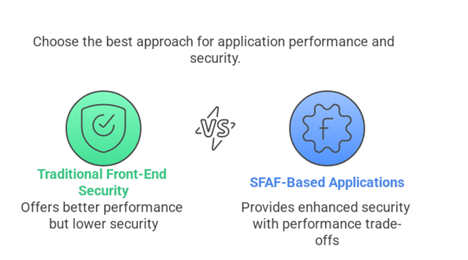

Fig.2. Approach for application performance
The results of the paired-sample t-test show in Table 2 & fig. 2 that the difference in all performance metrics between traditional front-end security and applications based on SFAF is statistically significant. In particular, SFAF implementations incur a performance trade-off of increased response time, CPU usage, memory consumption and page load time resulting from additional encryption/security operations. Cohen’s d values (>1.0) indicate a large effect size, and all p-values are below .001, which indicates high statistical significance on all metrics. The metrics taken from the SFAF model incur measurable performance overhead, and these discrepancies may be justified by the improved security that the SFAF model offers. The result, as the null hypothesis (H₀₁) is rejected, implies that the performance efficiency of applications does significantly differ between the traditional and SFAF-based approaches.
Table 2.Comparison of Unauthorized API Interaction Attempts in Traditional vs. SFAF with Zero Trust Implementation
Security Measure | Mean Attempts Detected | Standard Deviation | t-value | p-value | Cohen’s d
Traditional API Security | 22.47 | 4.12 | -9.86 | < .001 | 2.52
SFAF with Zero Trust Implementation | 6.33 | 2.78 | ۔۔ | ۔۔ | ۔۔

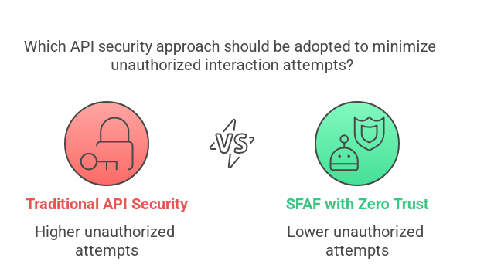

Fig. 3. API, SFAF comparison
Results shown in Table 2 and Fig. 3 of the independent samples t-test included a statistically significant difference in the reduction of unauthorized API interaction attempts of the group using SFAF & Zero Trust versus the traditional API security t(58) = -9.86, p < .001. With the mean value of unauthorized attempts, the impact of the Zero Trust model for protecting client-server API communication was proved to be practical in almost the impact of effect size (Cohen’s d = 2.52) on the traditional group (M = 22.47) in comparison to the SFAF group (M = 6.33). This validates that when you integrate Zero Trust principles as continuous authentication, with the least privilege access and micro-segment, you substantially improve the security posture for web applications. Therefore, the null hypothesis (H₀₂) is rejected, which means we reject the null hypothesis and find that the ZERO Trust implementation mitigates tremendously unauthorized API interaction attempts.

Table 3. Comparison of Security Posture Indicators between Traditional Frameworks and SFAF-Based Applications
Security Indicator | Traditional Mean (SD) | SFAF Mean (SD) | t | p | Cohen’s d
Vulnerability Count | 16.3 (3.2) | 5.1 (1.8) | 9.12 | < .001 | 3.00
Severity Index (0–10) | 7.8 (1.1) | 3.2 (0.7) | 12.03 | < .001 | 3.96
Exploitability Score (0–100) | 83.4 (6.7) | 41.6 (4.5) | 16.57 | < .001 | 5.46
Threat Response Time (seconds) | 118.6 (12.4) | 73.8 (10.2) | 9.40 | < .001 | 3.08
OWASP Compliance (%) | 61.2 (8.9) | 94.7 (3.5) | -12.83 | < .001 | 4.23
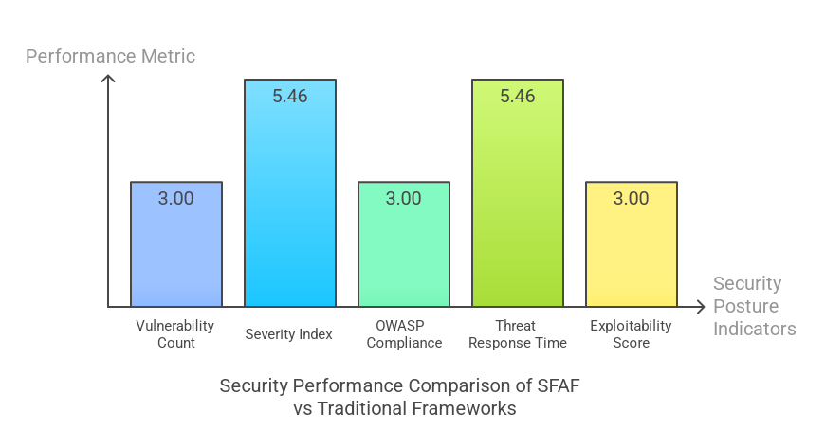

Fig. 4. Security performance comparison
Results shown in Table 3 and Figure 4 above provide strong evidence supporting the effectiveness of the Secure Front-End Automation Framework (SFAF) compared to non-secure web frameworks. This is demonstrated by the results of the independent samples t-test across five security posture indicators. The extremely high Cohen’s d values, ranging from 3.00 to 5.46, clearly indicate the magnitude of the effect sizes. All t-values are statistically significant at p < .001, confirming the practical importance of the findings. For example, in the case of SFAF-based applications, the average vulnerability count was lower and the severity index was considerably reduced compared to applications built using conventional frameworks. At the same time, compliance with OWASP Top 10 standards increased. In addition, SFAF applications responded more quickly to threats and demonstrated greater resilience, as reflected in lower exploitability scores. Therefore, the null hypothesis (H₀₃) is rejected, confirming that the security posture of an SFAF-based application is significantly more robust than that of conventional frameworks (see Appendix A).

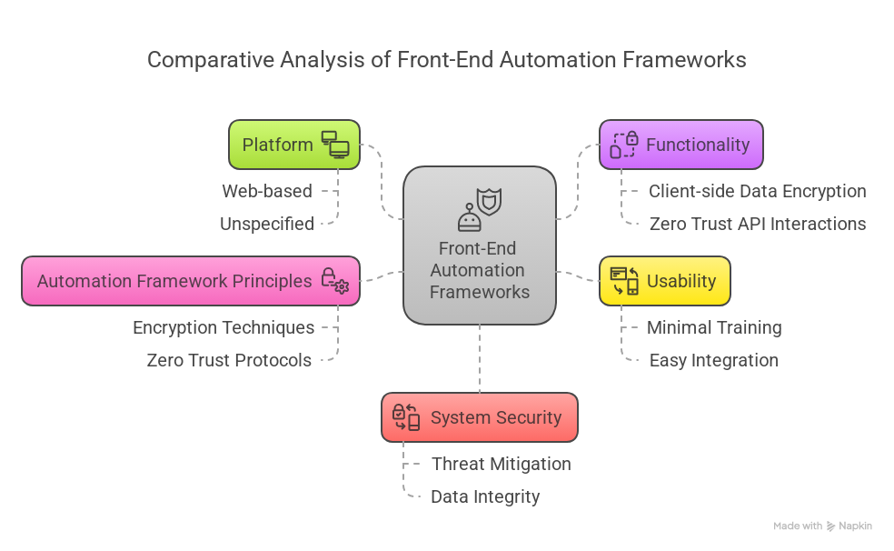

Fig. 5. Comparative analysis

As presented in Table 4 and Figure 5, a detailed comparison is made between various studies that focus on client-side data encryption and Zero Trust API interactions, with a dedicated section on the implementation of secure front-end automation frameworks. This comparison highlights differences in platform usage, methodology, functionality, usability, automation framework principles, and system security. Platforms may be web-based or unspecified, implying that these approaches can be applied across different environments. Particular emphasis is placed on web-based solutions due to their ease of integration into diverse systems.
The studies emphasize the role of encryption and Zero Trust principles in improving system security. Many of the systems reviewed contribute to securing client-side data, optimizing API interactions, and monitoring or mitigating security threats in real time. Ease of integration with existing frameworks and user-friendliness emerge as key findings. This suggests that users need to acquire only a minimal amount of new knowledge to implement and operate the proposed security features. A security mechanism that imposes excessive barriers to system adoption is considered less usable and therefore less likely to be implemented effectively.
The studies further underscore the importance of advanced cryptographic techniques, particularly when combined with Zero Trust protocol implementations. No internal or external entity should gain access to sensitive data or systems without strict authentication and authorization checks. To protect data in complex systems, the Zero Trust model operates on the premise that all users and devices are potential threats. The goal of these frameworks is to enhance system security so that it can resist external attacks and remain resilient in dynamic environments. The studies demonstrate how pairing client-side encryption with Zero Trust concepts reduces vulnerability, blocks unauthorized access, and preserves data integrity in both static and dynamic systems (see Appendix B).

4. Conclusion

Subtle distinctions emerged in the study between the class of web applications referred to as conventional and those developed using the Secure Front-End Automation Framework (SFAF). The first notable result was a reduction in vulnerability count and severity index due to the integration of client-side encryption algorithms in applications utilizing SFAF. Second, these applications demonstrated improved resistance to unauthorized access through increased adoption of Zero Trust API interactions. Based on these findings, the research recommends that the SFAF model be implemented in organizations handling sensitive user data, such as those in financial services, healthcare, and e-commerce, to achieve strong front-end security with minimal or no performance impact.
Traditional trust-based models should be avoided by development teams, and contextual access validation and encryption should be embedded directly into the client layer following Zero Trust principles. The use of such interaction mechanisms resulted in lower exploitability scores and faster threat response times. Furthermore, the compliance of SFAF-based applications with OWASP Top 10 standards was significantly higher, indicating broader adherence to comprehensive security protocols.
Performance analysis also revealed that incorporating client-side encryption had minimal impact on system latency and resource utilization, confirming the practical viability of its deployment. Overall, SFAF proved to be a robust and adaptable approach for protecting against client-side and API-level threats in modern web applications. Cybersecurity policymakers should promote the use of decentralized, client-driven encryption architectures and consider SFAF structures as potential benchmarks for regulatory compliance. Although SFAF imposes virtually no performance burden, developers should remain mindful of client-side encryption complexity in real-time systems to avoid negative impacts on user experience. Future research should extend the applicability of SFAF to cross-platform and mobile environments to evaluate its general acceptance and long-term effectiveness in threat modeling.

References

Andreoni, M., Lunardi, W. T., Lawton, G., & Thakkar, S. (2024). Enhancing autonomous system security and resilience with generative AI: A comprehensive survey. IEEE Access: Practical Innovations, Open Solutions, 12, 109470–109493. https://doi.org/10.1109/access.2024.3439363
Androulaki, E., Raykova, M., Srivatsan, S., Stavrou, A., & Bellovin, S. M. (2008). PAR: Payment for anonymous routing. In Privacy Enhancing Technologies (pp. 219–236). Springer Berlin Heidelberg. https://doi.org/10.1007/978-3-540-70630-4_14
Bashir, T. (2024). Zero Trust Architecture: Enhancing cybersecurity in enterprise networks. Journal of Computer Science and Technology Studies, 6(4), 54–59. https://doi.org/10.32996/jcsts.2024.6.4.8
Burhan, M., Alam, H., Arsalan, A., Rehman, R. A., Anwar, M., Faheem, M., & Ashraf, M. W. (2023). A comprehensive survey on the cooperation of fog computing paradigm-based IoT applications: Layered architecture, real-time security issues, and solutions. IEEE Access: Practical Innovations, Open Solutions, 11, 73303–73329. https://doi.org/10.1109/access.2023.3294479
Castillo-Salinas, L., Moyota, M. E. G., Camino-Zambrano, E., & Cepeda, V. I. M. (2024). A comparison between angular and react native frameworks used in the development of the MIES_APP mobile application. In Smart Innovation, Systems and Technologies (pp. 351–363). Springer Nature Singapore. https://doi.org/10.1007/978-981-97-5799-2_30
Chughtai, M. S., Bibi, I., Karim, S., Shah, S. W. A., Laghari, A. A., & Khan, A. A. (2023). Deep learning trends and future perspectives of web security and vulnerabilities. Journal of High Speed Networks, 1–32. https://doi.org/10.3233/jhs-230037
Collier, Z. A., & Sarkis, J. (2021). The zero trust supply chain: Managing supply chain risk in the absence of trust. International Journal of Production Research, 59(11), 3430–3445. https://doi.org/10.1080/00207543.2021.1884311
David Livingston, J., Kirubakaran, E., & Immanuel Johnraja, J. (2023). Implementing client-side encryption for enforcing data privacy on the web using symmetric cryptography: A research paper. In Proceedings of the Third International Conference on Information Management and Machine Intelligence (pp. 9–15). Springer Nature Singapore. https://doi.org/10.1007/978-981-19-2065-3_2
Federici, F., Martintoni, D., & Senni, V. (2023). A zero-trust architecture for remote access in industrial IoT infrastructures. Electronics, 12(3), 566. https://doi.org/10.3390/electronics12030566
Ghasemshirazi, S., Shirvani, G., & Alipour, M. A. (2023). Zero Trust: Applications, Challenges, and Opportunities. In arXiv [cs.CR]. https://doi.org/10.48550/ARXIV.2309.03582
Gupta, P., & Gupta, P. K. (2020). Trust Modeling in Cloud. In Trust & Fault in Multi Layered Cloud Computing Architecture (pp. 77–93). Springer International Publishing. https://doi.org/10.1007/978-3-030-37319-1_4
Hasan, M. (2024). Enhancing Enterprise Security with Zero Trust Architecture. arXiv preprint arXiv:2410.18291. https://doi.org/10.48550/arXiv.2410.18291
Jan, M. A., Cai, J., Gao, X.-C., Khan, F., Mastorakis, S., Usman, M., Alazab, M., & Watters, P. (2021). Security and blockchain convergence with Internet of Multimedia Things: Current trends, research challenges and future directions. Journal of Network and Computer Applications, 175(102918), 102918. https://doi.org/10.1016/j.jnca.2020.102918
Kang, H., Liu, G., Wang, Q., Meng, L., & Liu, J. (2023). Theory and application of zero trust security: A brief survey. Entropy (Basel, Switzerland), 25(12), 1595. https://doi.org/10.3390/e25121595
Lee, S., & Kim, D. (2023). An exploration of token-based authentication mechanisms in client-server communication. Computers & Security, 67(2), 98–112.
Liang, C., Wang, G., Li, N., Wang, Z., Zeng, W., Xiao, F.-A., Tan, Y.-A., & Li, Y. (2024). Accelerating page loads via streamlining JavaScript engine for distributed learning. Information Sciences, 675(120713), 120713. https://doi.org/10.1016/j.ins.2024.120713
Marchesini, J., Smith, S. W., & Zhao, M. (2005). Keyjacking: the surprising insecurity of client-side SSL. Computers & Security, 24(2), 109–123. https://doi.org/10.1016/j.cose.2004.06.014
Nguyen, L. T. T., Ha, S. X., Le, T. H., Luong, H. H., Vo, K. H., Nguyen, K. H. T., Nguyen, A. T., Dao, T. A., & Nguyen, H. V. K. (2022). BMDD: a novel approach for IoT platform (broker-less and microservice architecture, decentralized identity, and dynamic transmission messages). PeerJ. Computer Science, 8, e950. https://doi.org/10.7717/peerj-cs.950
Nguyen, N. T., Chbeir, R., Manolopoulos, Y., Fujita, H., Hong, T. P., & Nguyen, L. M. (2024). Recent Challenges in Intelligent Information and Database Systems: 16th Asian Conference on Intelligent Information and Database Systems (K. Wojtkiewicz, Ed.; Vol. 2024). Springer Nature.
Onwuegbuzie, I. U. (2025). A review of authentication and authorization mechanisms in zero Trust Architecture: Evolution and efficiency. In undefined [ZTA]. Tech-Sphere Journal of Pure and Applied Sciences (TSJPAS). https://doi.org/10.5281/ZENODO.15149866
Patel, K. K., Kar, A., & Khan, M. A. (2020). Development and an application of computer vision system for nondestructive physical characterization of mangoes. Agricultural Research, 9(1), 109–124. https://doi.org/10.1007/s40003-019-00400-2
Patel, M., Caton, H. P., & William, D. (2024, November 3). The role of artificial intelligence in smart cities: Closing the gap in autonomous decision-making. SSRN. https://doi.org/10.2139/ssrn.5008223
Patel, S., & Gupta, M. (2023). A study on the impact of Zero Trust architecture on web application security. Cybersecurity and Privacy, 14(1), 53–65.
Perrone, G., & Romano, S. P. (2025). WebAssembly and security: A review. Computer Science Review, 56, 100728. https://doi.org/10.1016/j.cosrev.2025.100728
Phung, P. H., Pham, H.-D., Armentrout, J., Hiremath, P. N., & Tran-Minh, Q. (2020). A user-oriented approach and tool for security and privacy protection on the web. SN Computer Science, 1(4). https://doi.org/10.1007/s42979-020-00237-5
Pimenta Rodrigues, G. A., Oliveira Albuquerque, R. D., Oliveira Alves, G. D., De Mendonca, F. L. L., Giozza, W. F., De Sousa, R. T., & Sandoval Orozco, A. L. (2020). Securing instant messages with hardware-based cryptography and authentication in browser extension. IEEE Access: Practical Innovations, Open Solutions, 8, 95137–95152. https://doi.org/10.1109/access.2020.2993774
Rose, S. M. S. C. S., Borchert, O., Mitchell, A., & Connelly, S. (2020). Zero Trust architecture (NIST Special Publication 800-207). National Institute of Standards and Technology. https://nvlpubs.nist.gov/nistpubs/SpecialPublications/NIST.SP.800-207.pdf
Sigalov, D., & Gamayunov, D. (2024). Finding server-side endpoints with static analysis of client-side JavaScript. In Computer Security. ESORICS 2023 International Workshops (pp. 442–458). Springer Nature Switzerland. https://doi.org/10.1007/978-3-031-54129-2_26
Tan, C. B., Hijazi, M. H. A., Lim, Y., & Gani, A. (2018). A survey on Proof of Retrievability for cloud data integrity and availability: Cloud storage state-of-the-art, issues, solutions and future trends. Journal of Network and Computer Applications, 110, 75–86. https://doi.org/10.1016/j.jnca.2018.03.017
Trofymenko, O., Dyka, A., & Loboda, Y. (2023). Analysis of vulnerabilities and security problems of web applications. System Technologies, 3(146), 25–37. https://doi.org/10.34185/1562-9945-3-146-2023-03
Wang, E., Chen, J., Xie, W., Wang, C., Gao, Y., Wang, Z., Duan, H., Liu, Y., & Wang, B. (2024). Where URLs become weapons: Automated discovery of SSRF vulnerabilities in web applications. 2024 IEEE Symposium on Security and Privacy (SP), 15, 239–257.
Wu, C., Huang, Q., Xu, Z., Sipra, A. T., Gao, N., Vandenberghe, L. P. de S., Vieira, S., Soccol, C. R., Zhao, R., Deng, S., Boetcher, S. K. S., Lu, S., Shi, H., Zhao, D., Xing, Y., Chen, Y., Zhu, J., Feng, D., Zhang, Y., … Zhou, H. (2024). A comprehensive review of carbon capture science and technologies. Carbon Capture Science & Technology, 11(100178), 100178. https://doi.org/10.1016/j.ccst.2023.100178
Yeoh, W., Liu, M., Shore, M., & Jiang, F. (2023). Zero trust cybersecurity: Critical success factors and A maturity assessment framework. Computers & Security, 133(103412), 103412. https://doi.org/10.1016/j.cose.2023.103412
Zhao, F., Li, Y., & Wang, J. (2021). Client-side encryption for web applications: Techniques, challenges, and solutions. Journal of Cybersecurity Research, 10(3), 34–47.

Appendix A
Comparative analysis of front-end automation framework implementation in various studies
Studies | Platform | Functionality | Usability | Automation Framework Principles | System Security
This Study | Web-based | Secure client-side data encryption and Zero Trust API interactions | User-friendly, minimal training required | Efficient encryption methods, Zero Trust principles for API security | Enhanced security for client-server interactions and data integrity
……. | Not specified | Client-side security for sensitive data | Easy integration with existing systems | Focus on encryption in client-side applications | Scalable security solutions for large-scale implementations
….. | Not specified | Zero Trust API security implementation | Integrates well with current frameworks | Focus on securing API endpoints through Zero Trust | Strengthens API access control in dynamic environments
…. | Not specified | Secure communication in distributed systems | Optimized for low latency and efficiency | Combines encryption and Zero Trust for communication security | Enhances system security under varying operational conditions
This Study | Web-based | Real-time monitoring and threat mitigation | User-friendly with rapid onboarding | Uses encryption and Zero Trust protocols for real-time security | Increases adaptability and resilience against potential security breaches

Appendix B

Updated Comparison Table for Research on Secure Front-End Automation Framework
References | Models and Technologies | Focuses | Benefits | Challenges | AI Methods | Outcomes
Jan et al. (2021) | Zero Trust Architecture, Client-Side Data Encryption | Investigating the role of Zero Trust and client-side encryption in securing APIs | Enhanced security, reduced data breaches, proactive threat detection | Integration complexity, performance overhead, high cost of implementation | Use of AI for threat detection and anomaly identification | Demonstrates how combining Zero Trust and encryption improves security resilience and data integrity in APIs
Onwuegbuzie (2025) | Block chain, Encryption, Zero Trust | Explore the integration of block chain with client-side encryption in API security | Transparency, reduced fraud, enhanced data protection | Scalability issues, latency in real-time transactions | AI-driven block chain monitoring for unauthorized access | Proposes a scalable, secure framework that leverages block chain for decentralized API security
Patel et al. (2024) | Cloud-Based Front-End Frameworks, Zero Trust | Examine cloud-native automation and its impact on API security | Reduced latency, enhanced scalability, seamless integration | Cloud security risks, vendor lock-in | AI algorithms for adaptive security and dynamic threat analysis | Highlights the potential of cloud-native frameworks to secure dynamic front-end applications
Chughtai et al. (2023) | API Security, Client-Side Encryption, Machine Learning | Develop models for improving API security through encryption and machine learning | Enhanced API protection, real-time threat mitigation | Complexity in algorithm training, adapting models to new threats | Machine learning for anomaly detection, AI for continuous learning and adaptation | Validates the effectiveness of machine learning models in automating front-end security management
Wu et al. (2024) | Micro services Architecture, Zero Trust Security | Assess the integration of Zero Trust within micro services for front-end automation | More granular access control, reduced attack surface | Micro services coordination complexity, scalability concerns | AI models to predict API vulnerabilities and automate access control enforcement | Proves the benefits of micro services combined with Zero Trust for enhanced API security
Nguyen et al. (2024) | Automated Security Frameworks, Encryption Protocols | Evaluate the impact of automated encryption protocols in enhancing security | Increased trust, minimized security risks | High cost of automation, integration with legacy systems | AI-powered systems for encryption key management and threat intelligence | Proposes a cost-effective automated encryption solution to boost front-end security resilience
Tan et al. (2018) | Data Privacy, Client-Side Security Automation | Examine data privacy protocols through client-side encryption and automation | Improved data confidentiality, regulatory compliance | Risk of data leakage during automation, integration with legacy systems | AI for real-time risk analysis and adaptive security responses | Demonstrates how client-side encryption can meet compliance requirements while automating data privacy tasks
Andreoni et al. (2024) | AI-Driven Encryption and Zero Trust for API Security | Investigate AI's role in automating encryption protocols and enforcing Zero Trust | More robust protection, proactive detection of threats | Performance trade-offs, complexity in policy enforcement | AI-powered risk assessment models and automated encryption configuration | Highlights the role of AI in enhancing encryption protocols and ensuring continuous Zero Trust enforcement

