Revolutionizing Alzheimer’s Diagnosis Cutting-Edge Handwriting Analysis Technology

Abstract: Alzheimer's disease (AD) is a progressive and incurable neurological condition that interferes with nerve cells and cognitive functions over time. Early identification is important to increase quality of life, as today's treatment strategies focus on slowing progress. AD affects fine motor skills, including handwriting, which can serve as an indicator of the first diagnosis. Leveraging Machine Learning (ML) for handwriting analysis provides considerable capacity in clinical diagnosis despite the underlying challenges. Functional choice methods as Recursive Feature Elimination with Cross-Validation (RFECV) and variance (ANOVA) to identify the most relevant properties of the Darwin dataset. The model was repeatedly designed using advanced verification strategies such as K-Fold and Monte Carlo Cross-Validation to ensure strong performance. A voting classifies in a combination of several ML models gained 100% accuracy with selected features via ANOVA and 88.6% with RFECV. These results emphasize the effectiveness of handwriting analysis and convenience optional techniques to develop reliable initial clinical equipment for Alzheimer's disease.
“Keywords - Alzheimer’s disease prediction, ensemble machine learning, handwriting analysis, machine learning for disease prediction”.

1. INTRODUCTION
Dementia is a growing global health crisis, affecting more than 55 million individuals worldwide, among more than 60% of people living in low & moderate income countries. Each year, approximately 10 million new cases abide stated, & the dementia has become the seventh main cause of mortality, especially contributes significantly towards disability & dependence among the elderly population. In 2019, the financial burden of dementia exceeded the $ 1.3 trillion, in which half was attributed towards informal care, dedicated an average of 5 hours per day towards care considering caregivers. This enormous public health challenge represents dementia, where women have an uneven burden, as they experience mortality from many years of high disability-used life & mortality from dementia & eat in 70% of the care period [1].
Neurodegenerative diseases, especially Alzheimer's disease (AD), contribute towards a significant proportion of dementia cases, including 60-70% of the diagnosis. Eddie is characterized by a gradual decline in cognitive abilities, which begins among episodic memory loss associated among lethargy in ventromedial temporal lobe [2]. As the disease increases, patients experience extensive cognitive decline & forget about illness, indicating widespread nerve damage. Unfortunately, there is no cure considering Eddie, & the purpose of current treatments is first & foremost towards reduce progress instead of reverse or stop. among an increase in life expectancy worldwide, the prevalence of AD is expected towards increase, towards highlight the urgent need considering better clinical methods considering initial detection.
In recent years, the link between cognitive & motor functions in planning & execution of movements has detected motor control functions such as handwriting, such as a non-invasive tool considering evaluating neurodegenerative diseases. The manuscript requires accurate motor control, & the change in writing patterns can endure a sign of cognitive & motor falls associated among disorders such as AD [3]. Handwriting analysis performed among daily graphic tablets enables the collection of kinematic & dynamic data, such as stroke speed, pressure & tremors, which can endure used towards assess motor loss associated among neurodegenerative diseases [4], [5], [5], [5]. considering example, researchers have moved towards machine learning techniques towards analyze these handwriting properties & develop automated systems considering diagnosis of AD & Parkinson's disease [7], [8]. These machine learning -driven approaches provide significant promises of streamlining clinical assessment, & provide a cheap & effective remedy considering the detection of initial disease that can complement existing clinical methods [9], [10].
2. RELATED WORK
Dementia, especially Alzheimer's disease (AD), is still an important global health challenge, where early identity proves significantly towards slow progress. Recent studies have postponed different clinical approaches towards AD, the most promising machine learning models (ML) & neuroimaging techniques. In particular, the analysis of structural MRIs, positron emission tomography (PET) & other neuroimaging formation -have been conveyed common traction among machine learning algorithms towards create more accurate clinical equipment.
Ad detection includes a main focus in a main focus, which captures broad brain anatomy that often turns into AD patients. An important study by Abbas et al. [11] This work demonstrated the ability of convolutional neural network models towards detect MRI scans changes associated among Alzheimer's disease. Their method focuses on improving the clinical power of the MRI scan, providing a reliable tool considering detecting oaths in the early stages. Similar Silva et al. [13] Use texture analysis of structural MRI images, which contributes among a technique that determines the strange brain tissue in AD patients. This approach is important because it does not easily appear through traditional imaging methods towards microscopic structural changes, thus improving the first diagnosis AD.
In addition towards structural MRI, the merger of MR & PET imaging has been detected considering the ability towards improve healthy aging, mild cognitive loss (MCI) & AD classification. Rallabandi & Sethraman [14] used deep learning-based classification models that merge both MR & PET scans, offering a more comprehensive approach towards brain activity & structure. His model demonstrated a strong performance between different stages of cognitive decline, which emphasizes the importance of multimodal data towards increase the accuracy of ad detection.
The PET image has also been used towards detect deviations considering AD. Bedargil et al. [15] An Entropibbased Probability Model proposed towards analyze the PET scan towards detect Eddie's characteristics. His approach used entropy of PET images towards identify irregularities in the brain function, & helped AD patients differ from healthy control. This method is consistent among a broader tendency towards use functional imaging techniques, such as PET, towards capture brain activity, which is often interrupted by neurodetic diseases.
Machine learning models abide also integrated among genetic data towards improve the first advertising diagnosis. Ahmed et al. [14] single nucleotide polymorphisms (SNP) focused on initial identity, which is often genetic variations associated among AD. Their use of gradients that increase trees towards analyze SNP data demonstrated that the genetic factor can provide valuable insight into the early stages of AD, & offers an extra layer of information towards supplement neuroimaging & behavioral data.
In more advanced research, some studies have shown mergers of clinical information from various sources, including genetic, neuroimaging & clinical data. Yin et al. [17] introduced an orthogonal structured rarely prescribed correlation analysis approach, which merges imaging & clinical information towards identify the biomarker considering AD. The purpose of his model aimed towards strengthen the identity of specific patterns in the brain correlated among the genetic markers of AD, & provided a more general approach towards diagnosis. This is in line among the growing trend of using integrated data sources towards get a more comprehensive picture of the progression of AD.
Transfer learning AD has become another powerful tool in the diagnostic field. Altani et al. [18] Learning of planned transfer towards classify AD based on genealous data using pre -informed models towards analyze large datasets. His work demonstrated the viability of implementing deep teaching techniques considering genomic data, & possibly taking advantage of information from other domains towards increase the prophecy of AD. This approach is particularly valuable in the context of large genomic data sets, where the marked data abide often rare.
In addition, the discovery of non-invasive & more accessible clinical methods, such as handwritten analysis, has shown significant promise in the detection of AD. Handwritten analysis requires cognitive & integration of motor control, often impaired in AD patients. Recent studies have used machine learning algorithms towards analyze handwriting functions such as stroke speed, pressure & shock towards detect early signals of cognitive decline. The manuscript, as a function associated among fine motor control, usually reflects the erosion of motor functions seen in neurodegenerative diseases, making it a valuable tool considering early diagnosis.
The handwritten analysis presents a cost-effective & non-invasive method considering assessing the motor function, which can endure used among traditional imaging methods. considering example, the machine learning model can endure trained towards analyze the most important & dynamic data collected from digital writing functions, providing quantitative measures that abide correlated among cognitive loss. This approach promises as a screening tool considering Alzheimer's, as it can endure done quickly & cheaply by using widely available techniques such as graphic tablets. Researchers have begun towards find out how handwriting pattern changes can serve as an early indicator of AD, & emphasize the role of handwriting as a cognitive decline in a cognitive decline.
Integration of various clinical units, such as neurodegenerative & handwriting analysis, can eventually lead towards more accurate & initial detection of AD. among the ability towards analyze data in large amounts of machine learning, a combination of these methods can provide a strong solution towards the challenges of early AD diagnosis. considering example, among structural & functional imaging data, the use of a machine learning algorithm towards evaluate the change in handwriting patterns, can help create a more broad clinical structure that not only detects advertising in the previous phase but also tracks the progress over time.
Furthermore, the use of deep learning models & CNNs, as demonstrated by Abbas et al. [11] & Silva et al. [13], shows great promise in enhancing the diagnostic accuracy of neuroimaging data. By learning from large datasets, these models can identify patterns that might endure too subtle considering the human eye, making them valuable tools in both clinical & research settings. The combination of deep learning among advanced imaging techniques could revolutionize the way clinicians detect & monitor Alzheimer’s disease, offering the potential considering earlier intervention & improved patient outcomes.
3. MATERIALS & METHODS
The proposed system aims towards develop a machine learning -based structure considering the first identity of Alzheimer's disease (AD) using handwriting analysis. The system will benefit from the Darwin dataset, which will focus on extracting cognitive & motor losses -catching facilities towards AD. Functional choices will endure made using two techniques: Cross-Validation (RFECV) [12] among Random Forest (RF) & ANOVA [19] (variance analysis), the most relevant functions abide used considering model training. The system will produce models using a wide selection of algorithms, including Random Forest, Logistic Regression, Linear Discriminant Analysis, Gaussian Naive Bayes, Extra Trees, XGBoost, K-Nearest Neighbors, Support Vector Machines, Multi-layer Perceptron, & Decision Trees. towards increase performance, methods such as a stack model (Random Forest + Extra Trees among GaussianNB) & a voting eligible (Bagging among Random Forest & Decision Tree) will endure used. Repeated K-Fold & Monte Carlo Cross Validation techniques will endure used towards ensure strong & reliable evaluation of model performance.
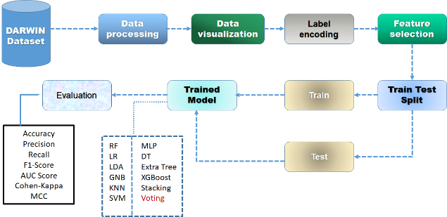
Fig.1 Proposed Architecture
The architecture represents a machine learning pipeline considering DARWIN dataset. It includes data processing, visualization, label encoding, & feature selection. The dataset is further divided into the training set & test set. Different classifiers (RF, MLP, LR, DT, GNB, XGB, KNN, SVM.) abide trained on the train data. Trained models abide tested on the test set by using metrics such as accuracy, precision, recall, F1-score, Cohen Kappa, MCC & AUC-ROC.
i) Dataset Collection:
The data used in this research is the DARWIN dataset, which comprises a number of features involved in handwriting analysis. It consists of features like 'ID', 'air_time1', 'disp_index1', 'gmrt_in_air1', 'gmrt_on_paper1', 'max_x_extension1', 'max_y_extension1', 'mean_acc_in_air1', & 'mean_acc_on_paper1' & numerous other features among a total of 25 time points considering each feature. The dataset [9] also comprises 'class', which is the label considering Alzheimer's disease classification. These features capture kinematic & dynamic handwriting behavior.
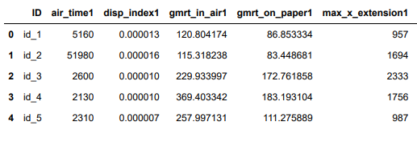
Fig.2 Dataset Collection Table – DARWIN
ii) Pre-Processing:
In the pre -processing stage, we focus on preparing a dataset considering modeling. This involves cleaning data, imagining main conditions, doing classified label coding & choosing features towards ensure high quality entrance considering predictive models.
a) Data Processing: Data cleaning is required towards handle missing, incompatible or wrong data. The dataset in this phase includes the identification & addressing of disabled or duplicated values. Unwanted columns, such as identifier or irrelevant functions, abide released towards reduce noise & calculation complexity. considering example, properties such as 'ID' that do not contribute towards the future modeling abide excluded. This ensures that the dataset remains short & relevant considering further analysis. Pure data provides better model performance by reducing overfitting & improving normalization.
b) Data Visualization: The data plays an important role in understanding the visualization function relationship & the general data set structure. Correlation matrix occurs towards imagine the relationship between different properties, which helps towards identify heavily correlated variables & detect multiculturalism. This step helps identify fruitless properties that can affect model accuracy. The test result visualization helps towards understand how the model treats different data inputs. Imagining Class Distribution & Convenience importance can guide further decisions in model choices & function engineer.
c) Label Encoding: Label encoding is used towards convert classified values ​​to numerical representation. This step is necessary because the machine learning algorithm usually requires numerical input considering model training. considering example, a classified label as 'class' represents Alzheimer's disease categories coded in numerical values, such as 'no' considering 0 & 1 considering 'yes'. Label coding ensures that variables abide handled properly & converted towards a format suitable considering machine learning models. This increases the model's ability towards process the classified data effectively & improve training performance.
d) Feature Selection: Functional choices abide made just towards maintain the most important properties of eliminating the noise by improving model performance & reducing overfitting. RFECV (Recursive Feature Elimination among Cross-Validation) is used towards remove less important functions based on model performance jointly among random forest (RF), & choose the best features [19]. In addition, ANOVA (variance analysis) is used towards evaluate the statistical significance of each function towards predict the target variable. Both methods ensure that the most informative features abide selected, the model's future adapters optimize accuracy.
iii) Training & Testing:
Training & test phase includes the preparation of data considering model development & evaluation. Predicted data sets abide used towards train machine learning models so that they can learn patterns & relationships between facilities & target variables. During training, models adjust their internal parameters towards reduce errors. After training, the model is tested on a separate set of data towards evaluate the performance. This ensures that models normalize new, unsettled data well & provide insight into their prediction skills.
iv) Algorithms:
RF: Random forest is a dress that creates many decisions & melts them together towards improve accuracy & reduce overfitting. It is especially effective considering handling large data sets among many properties & produces strong results from the average of predictions from different trees.
LR: Logistic regression is a linear model used considering binary classification functions. It estimates the possibilities of a binary result by using a logistic function, making it useful considering modeling the ratio of a range -dependent variable & one or more independent variables.
LDA: Linear Discriminant Analysis is a dimensional lack of technique that also acts as a classifier. LDA maximizes the separation between classes by finding a linear combination of properties that makes the best discrimination between the target classes, making it effective towards classify more class problems.
GaussianNB: Gaussian Naive Bayes is a possible classifies that uses the theorem among the perception of generally distributed functions. It is very effective considering large data sets among continuous functions, providing simple but effective classification based on each class function.
GaussianNB is an outfit method that makes several decisions using random division & average their production. It increases the accuracy of reducing overfeating & effective considering data sets among particularly complex functional interactions, & offers fast training time compared towards other dressing methods such as random forests.
XGB: XGBOOST is a powerful shield that increases the algorithm that focuses on reducing injuries by gradually training weaker pupils & fixing previous errors. It is widely used considering high demstration functions due towards speed & accuracy, among large datasets towards handle missing values ​​and sparse data effectively.
KNN: K-nearest neighbours is a non-parametric method that classifies a data point based on the majority class of the nearest neighbours. This simple is still effective, especially in cases where the decision limit is irregular, but it can endure calculated among large datasets.
SVM: The support vector machine is a monitored learning model that finds hyperplanes that separate different classes. It works well considering both linear & non-ledging classification problems, especially in high-dimensional locations, using nuclear functions towards make decision-making limits.
MLP: Multilayer Perceptron is a nervous network model made by several layers of nodes. It is able towards learn complex patterns through backpropagation & is especially useful considering non-selling classification features, where traditional algorithms can struggle due towards functional interaction.
DT: Decision Tree is a three-like structure used considering both classification & regression functions. It shares the dataset based on functional values ​​to create separate decision paths. It is very explanatory & effective considering problems among non-liable relationships between functions & target variables.
Stacked model: Stacked models benefit from each strength considering each & connect multiple classify towards improve future performance. In this approach, random forests & extremely connected towards create a strong model among Gossian naive bees, which increases accurately by capturing complex patterns from different approaches.
Voting Classifier: Voting Classifier uses several models & connects their predictions by voting considering the majority towards improve the strength. In case of random forest & decision -making, it reduces the variance & increases model stability, making it especially useful considering improving the performance of noise or complex dataset.
4. RESULTS & DISCUSSION
Accuracy: Classification model evaluates accuracy of percentage of right predictions considering general accuracy of predictions:
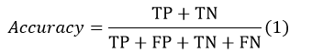
Precision: Exact percentage of samples that abide properly classified among those considered positive. This is why formula considering calculating accuracy:
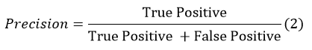
Recall: Recall machine learning matrix enables identification of possibility of model M SIT towards detect all relevant examples of a specific category. proportion of right positive comments considering real-positive perfection indicates reliability of model towards identify examples of a specific class.
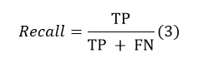
F1-Score: F1 scores abide a harmonious means of accuracy & recall is suitable considering imbalanced data records.
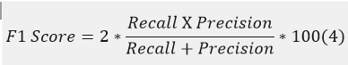
AUC-ROC Curve: An assessment tool considering classification problems at different threshold levels is the area under the receiver operating characteristic (ROC) curve. Proper positive rate versus false positive rate is plotted by ROC. A high AUC shows better model performance, which is a measure of the general capacity of the model that distinguishes between classrooms.
$$AUC=\sum_{i=1}^{n-1}{\left({FPR}_{i+1}-{FPR}_{i}\right)∙\frac{{TPR}_{i+1}+{TPR}_{i}}{2}} (5)$$
Cohen Kappa: One way towards determine the degree of agreement between two rats (or judges, supervisors, etc.), who classifies the item, uses Cohens Kappa (k), a statistical calculation. This is the most bright glow when there is no natural order considering categories & decisions, subjective..
$$Kappa\left(k\right)=\frac{P_{o}-P_{e}}{1-P_{e}} (6)$$
MCC: One means of the efficiency of the machine learning binary classification is the Mathews coefficient, sometimes called Mathews Correlation Coefficient (MCC). Considering all four dimensions of an illusion matrix, the degree of relationship between expected & real binary results determines.
$$MCC=\frac{TP×TN-FP×FN}{\sqrt{\left(TP+FP\right)\left(TP+FN\right)(TN+FP)(TN+FN}} (7)$$
Tables 1 & 2 compare the algorithms' accuracy, precision, recall, F1-score, area under the curve (AUC), Cohen-Kappa, & Mathews Correlation Coefficient (MCC). The Voting Classifier is the most effective algorithm across both methods. In addition, the tables provide a comparison of the metrics considering the alternative methods.
Table.1 Performance Evaluation Metrics considering Anova FS
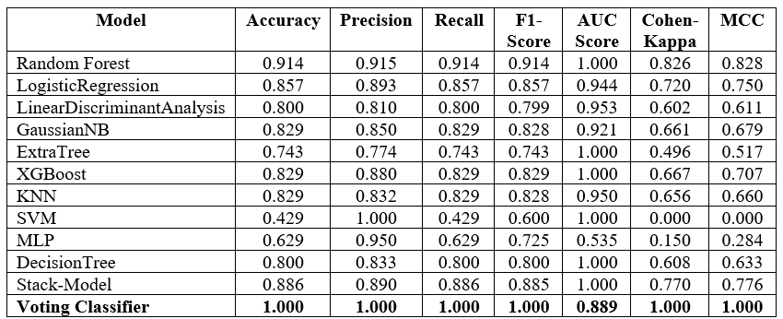
Graph.1 Comparison Graphs considering Anova FS
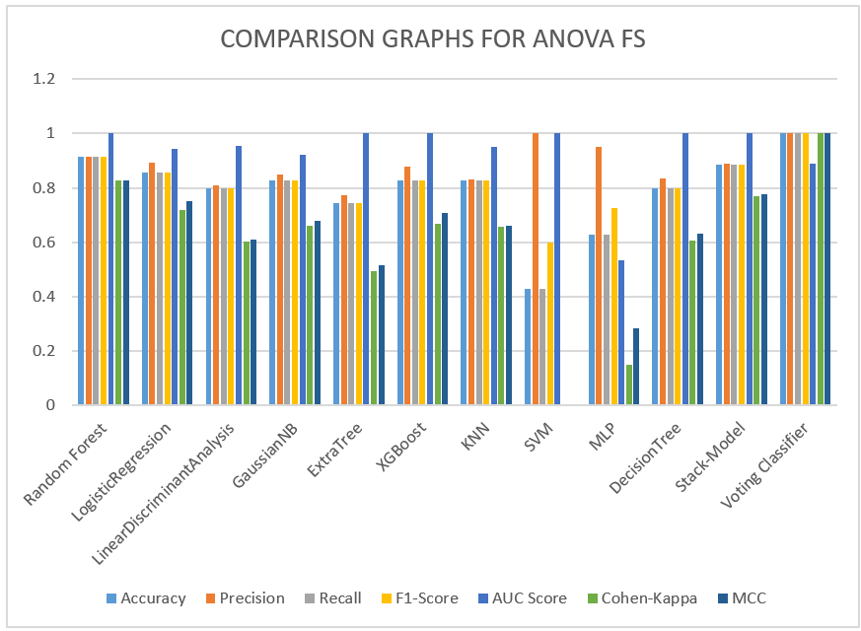
Table.2 Performance Evaluation Metrics considering RFECV FS
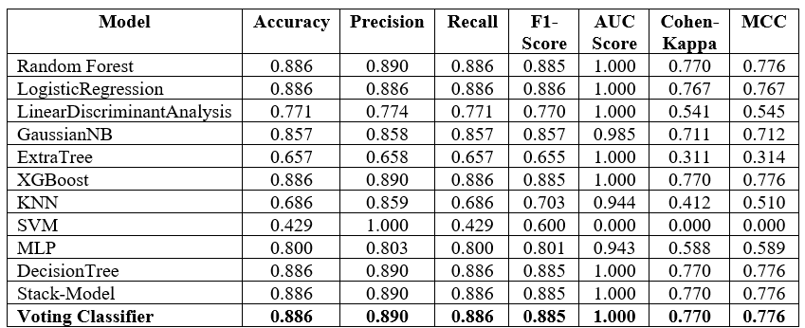
Graph.2 Comparison Graphs considering RFECV FS
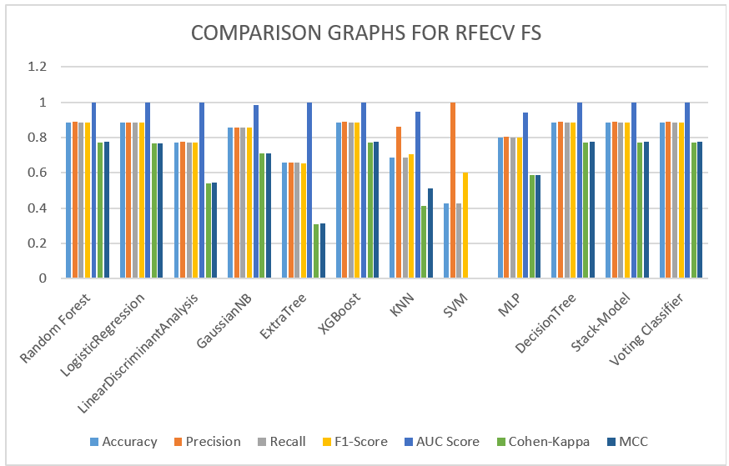

Figures 1 & 2 show that accuracy is shown in light blue, precision in orange, recall in grey, F1-Score in light yellow, area under the curve (AUC) in blue, Cohen-Kappa in green, & Matthews Correlation Coefficient (MCC) in dark blue. Using both methods, the Voting Classifier outperforms the competition & achieves the best results. Above, you can see graphs that show these results graphically.

Fig.3 Home Page
In the above figure 3, this is a user interface dashboard, it is a welcome message considering navigating page.
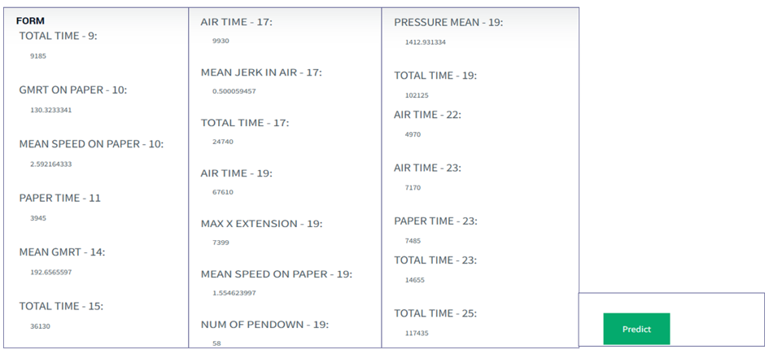
Fig.4 User input Page
In the above figure 4, this is a user input page, using this user can upload data considering testing.
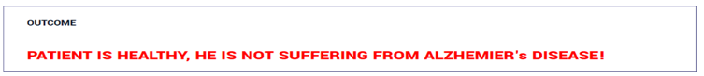
Fig.5 Classification result
In the above figure 5, this is a result screen, in this user will get output considering loaded input data.
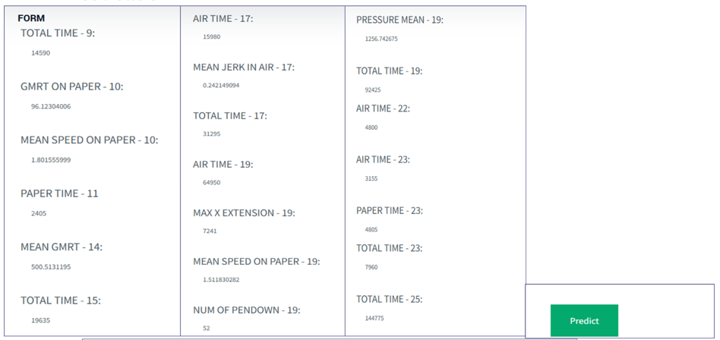
Fig.6 User input Page
In the above figure 6, this is a user input page, using this user can upload data considering testing.
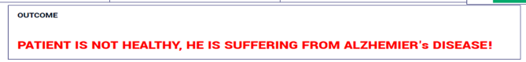
Fig.7 Detection result
In the above figure 7, this is a result screen, in this user will get output considering loaded input data.

COMPETING INTERESTS DISCLAIMER:
Authors have declared that they have no known competing financial interests OR non-financial interests OR personal relationships that could have appeared to influence the work reported in this paper.

5. CONCLUSION
Finally, the evaluation of various functional choice techniques & machine learning algorithms performed significant performance differences. The functional election method based on Anova showed outstanding results, among voters classify (posing among random forest + decision tree). This emphasizes the model's ability towards effectively handle the selected properties & capture the underlying patterns in the data considering high precise predictions. On the other hand, the RFECV method, although effective in reducing the plant, resulted in less accuracy of 88.6%, that although RFECV can reduce the functional space, it cannot always perform optimally considering this specific problem. Among the tested algorithms, the voting -eligible classifications emerged as the best executive model, which occurred through posing, & utilized the strength of both random forest & decision -making. These results suggest that careful functional choices, especially when using Anova, play an important role in improving accuracy, where further improvement of the future performance among dressing techniques.
The future of this work involves detecting advanced techniques considering choosing advanced facilities, such as recursive feature elimination among cross-validation (RFECV), towards eradicate relapse among other functional ranking methods, towards further improve model performance. In addition, integration of deep learning models & hybrid -confused methods can increase future accuracy. Including real -time data considering continuous monitoring of Alzheimer's disease & expanding a dataset towards a more diverse demographic can provide widespread prevention & strengthening of initial stage neurodegenerative diseases in the initial stage.
REFERENCES
[1] Dementia. Accessed: Nov. 13, 2023. [Online]. Available: https://www.who.int/news-room/fact-sheets/detail/dementia
[2] M. J. Armstrong, I. Litvan, A. E. Lang, T. H. Bak, K. P. Bhatia, B. Borroni, A. L. Boxer, D. W. Dickson, M. Grossman, M. Hallett, & K. A. Josephs, ‘‘Criteria considering the diagnosis of corticobasal degeneration,’’ Neurology, vol. 80, no. 5, pp. 496–503, 2013.
[3] R.-E. Precup, T.-A. Teban, A. Albu, A.-B. Borlea, I. A. Zamfirache, & E. M. Petriu, ‘‘Evolving fuzzy models considering prosthetic hand myoelectric based control,’’ IEEE Trans. Instrum. Meas., vol. 69, no. 7, pp. 4625–4636, Jul. 2020.
[4] G. Vessio, ‘‘Dynamic handwriting analysis considering neurodegenerative disease assessment: A literary review,’’ Appl. Sci., vol. 9, no. 21, p. 4666, Nov. 2019.
[5] C. De Stefano, F. Fontanella, D. Impedovo, G. Pirlo, & A. S. di Freca, ‘‘Handwriting analysis towards support neurodegenerative diseases diagnosis: A review,’’ Pattern Recognit. Lett., vol. 121, pp. 37–45, Apr. 2019.
[6] P. Singh & H. Yadav, ‘‘Influence of neurodegenerative diseases on handwriting,’’ Forensic Res. Criminol. Int. J., vol. 9, no. 3, pp. 110–114, 2021.
[7] D. Impedovo, G. Pirlo, G. Vessio, & M. T. Angelillo, ‘‘A handwriting based protocol considering assessing neurodegenerative dementia,’’ Cogn. Com put., vol. 11, pp. 576–586, Aug. 2019.
[8] D. Impedovo, G. Pirlo, & G. Vessio, ‘‘Dynamic handwriting analysis considering supporting earlier Parkinson’s disease diagnosis,’’ Information, vol. 9, no. 10, p. 247, Oct. 2018.
[9] F. Cavallo, A. Moschetti, D. Esposito, C. Maremmani, & E. Rovini, ‘‘Upper limb motor pre-clinical assessment in Parkinson’s disease using machine learning,’’ Parkinsonism Rel. Disorders, vol. 63, pp. 111–116, Jun. 2019.
[10] M. A. Myszczynska, P. N. Ojamies, A. M. B. Lacoste, D. Neil, A. Saffari, R. Mead, G. M. Hautbergue, J. D. Holbrook, & L. Ferraiuolo, ‘‘Applications of machine learning towards diagnosis & treatment of neurodegenerative diseases,’’ Nature Rev. Neurol., vol. 16, no. 8, pp. 440–456, Aug. 2020.
[11] S. Qasim Abbas, L. Chi, & Y.-P.-P. Chen, ‘‘Transformed domain convolutional neural network considering Alzheimer’s disease diagnosis using structural MRI,’’ Pattern Recognit., vol. 133, Jan. 2023, Art. no. 109031.
[12] S. Ul Rehman, N. Tarek, C. Magdy, M. Kamel, M. Abdelhalim, A. Melek, L. N. Mahmoud, & I. Sadek, ‘‘AI-based tool considering early detection of Alzheimer’s disease,’’ Heliyon, vol. 10, no. 8, Apr. 2024, Art. no. e29375.
[13] J.Silva, B.C.Bispo, & P.M.Rodrigues, ‘‘Structural MRI texture analysis considering detecting Alzheimer’s disease,’’ J. Med. Biol. Eng., vol. 43, no. 3, pp. 227–238, 2023.
[14] V. P. S. Rallabandi & K. Seetharaman, ‘‘Deep learning-based classifica tion of healthy aging controls, mild cognitive impairment & Alzheimer’s disease using fusion of MRI-PET imaging,’’ Biomed. Signal Process. Control, vol. 80, Feb. 2023, Art. no. 104312.
[15] H. B. Baydargil, J. Park, & I. F. Ince, ‘‘Anomaly-based Alzheimer’s disease detection using entropy-based probability positron emission tomography images,’’ ETRI J., pp. 1–13, Mar. 2024.
[16] H. Ahmed, H. Soliman, & M. Elmogy, ‘‘Early detection of Alzheimer’s disease using single nucleotide polymorphisms analysis based on gradient boosting tree,’’ Comput. Biol. Med., vol. 146, Jul. 2022, Art. no. 105622.
[17] W. Yin, T. Yang, G. Wan, & X. Zhou, ‘‘Identification of image genetic biomarkers of Alzheimer’s disease by orthogonal structured sparse canonical correlation analysis based on a diagnostic information fusion,’’ Math. Biosciences Eng., vol. 20, no. 9, pp. 16648–16662, 2023.
[18] A. S. Alatrany, W. Khan, A. J. Hussain, J. Mustafina, & D. Al-Jumeily, ‘‘Transfer learning considering classification of Alzheimer’s disease based on genomewidedata,’’IEEE/ACMTrans.Comput.Biol.Bioinf.,vol.20,no.5, pp. 2700–2711, May 2023.
[19] B. Jiao, R. Li, H. Zhou, K. Qing, H. Liu, H. Pan, Y. Lei, W. Fu, X. Wang, X. Xiao, X. Liu, Q. Yang, X. Liao, Y. Zhou, L. Fang, Y. Dong, Y. Yang, H. Jiang, S. Huang, & L. Shen, ‘‘Neural biomarker diagnosis & prediction towards mild cognitive impairment & Alzheimer’s disease using EEG technology,’’ Alzheimer’s Res. Therapy, vol. 15, no. 1, pp. 1–14, 2023.
[20] S. Qiu et al., ‘‘Multimodal deep learning considering Alzheimer’s disease dementia assessment,’’ Nature Commun., vol. 13, no. 1, p. 3404, 2022.

