Original Research Article
AI-POWERED CHATBOT FOR COLLEGE INFORMATION AND STUDENT SUPPORT

ABSTRACT

Aims: This study aims to develop an AI-powered chatbot tailored for college students, assisting them with academic, campus-related, and personal growth queries.
Study Design: The project is designed as a student-support software prototype with real-time information delivery features using AI tools.
Place and Duration of Study: Department of Information Technology, Dhanalakshmi Srinivasan Engineering College, Perambalur, over a 3-month development period.
Methodology: The chatbot integrates natural language processing (NLP), text-to-speech (TTS), speech-to-text (STT), and machine learning models. It offers functionalities like course recommendations, access to timetables, live hackathon/NPTEL updates, placement info, and library book availability. It supports media uploads, image recognition for building identification, and provides career guidance and mental health resources via an interactive chat interface.
Results: The chatbot was tested with over 50 student queries and achieved a response accuracy of 92%. It successfully fetched real-time updates, identified college buildings from images with 85% accuracy, and reduced information-seeking time by an average of 65% compared to manual search. The integrated TTS and STT features enhanced accessibility for differently-abled users.
Conclusion: This AI-driven solution enhances the student experience by providing holistic, on-demand support across academic, administrative, and personal domains. It builds a smarter, more connected campus by reducing manual information processes and promoting student engagement. Further development and user testing will refine its predictive and interactive capabilities.

Keywords: AI-powered chatbot, student support system, campus information system, academic assistance, speech recognition, accessibility, personalised recommendations.

- INTRODUCTION

Over the last few years, Artificial Intelligence (AI) has revolutionised information access and processing, particularly in the education sector. Organisations are experiencing a greater need for fast, readily accessible, and reliable support systems since students increasingly rely on online sources for learning and assistance. Adopting AI and natural language processing (NLP)-enabled chatbots has been a favourite choice as they can handle large query volumes, offer personalised conversation, and reduce administrative and academic staff workload. Campus life is becoming more intelligent and interconnected with chatbots enabled by AI that incorporate multimedia functionality and real-time updates.
Students in the contemporary higher education environment find it challenging to gather timely and accurate information regarding coursework, navigating campus, placements, and extracurricular activities. Traditional methods, such as approaching staff or browsing notice boards, are not successful and often result in delays and confusion. While a few organisations have implemented digital solutions, these are usually scattered and lack real-time information updates and personalised assistance. For basic things such as class timetables, addresses, hostel food, or upcoming events, students have to sift through numerous sources in the absence of one platform.
In addition, the broader array of student needs, including career guidance, fee information, and mental wellness resources, is seldom addressed by the systems that exist. Access is another neglected element; usual websites may be difficult for children with speech or mobility impairments to access.
The necessity for an AI-based solution that not only integrates campus and academic services but also offers smart, voice-enabled interaction is thus clear. Through time saving, reducing physical drudgery, and promoting a more diverse and networked campus ecosystem, such a platform would significantly improve the learning experience for students.
A college-student-specific chatbot powered by artificial intelligence is recommended in this study, integrating a variety of features including:
- To satisfy the basic needs of students in a college campus environment, the proposed chatbot system offers a rich feature set. It allows students to navigate physical spaces comfortably by locating campus buildings with image recognition. It has speech-to-text and text-to-speech capabilities to enhance accessibility, especially for persons with disabilities. Besides, the chatbot provides placement preparation material, enables timetable retrieval, and recommends relevant NPTEL courses depending on every student's interests and academic path. With live updates of school events, hackathons, and library book availability, it also ensures students are kept in the loop.
- The chatbot encourages overall student growth by providing assistance for career guidance, fee-related inquiries, and mental health tips alongside academic assistance.
- Quick responses and media uploads are facilitated by the interactive chat-based user interface of the system, which enhances the overall user experience. The chatbot, built using Next.js for the front end and Django for the back end, leverages advanced Hugging Face and Gemini APIs to deliver smart responses and understand context. Due to the dynamic, adaptive interactions enabled by this blend of technologies, the chatbot is both functionally robust and simple to use.

  - RELATED WORKS:
This survey of literature brings together 20 papers from the given dataset on AI-based chatbots in educational settings for student assistance, academic help, and administrative effectiveness. The survey is divided into seven thematic subheadings, with every paper examined in detail (minimum five lines) to encompass its aims, methods, findings, and limitations. Citations are given in APA style, followed by an exposition of broad limitations in the discipline.
    - Applications of Chatbots in Student Support
(Alabbas & Alomar, 2024)introduced Tayseer, an AI-powered Arabic chatbot framework to enhance helpdesk services for technical and vocational students. Using the RASA framework with a customized Arabic NLP pipeline, Tayseer handles queries with 90% precision in intent and entity predictions. Deployed at a technical college, it streamlined advisory processes for over 200 students. However, its Arabic-specific design limits applicability to other languages, and long-term user feedback is absent (Alabbas & Alomar, 2024).
(Bommireddy, S., Prashanth,, & Manoj Kumar, 2024)developed VardhaGenie, an AI chatbot for Vardhaman College of Engineering to address academic and administrative queries. Leveraging NLP and a Bag of Words algorithm, it achieved efficient query handling, reducing response times. The chatbot was tested with positive user feedback but is tailored to a single institution, limiting scalability. The study also lacks details on handling complex multi-step queries (Bommireddy, S., Prashanth,, & Manoj Kumar, 2024).
(Ganesh Kumar, et al., 2025)proposed StudentEase, an AI-powered college helpdesk chatbot using Sentence Transformer and Ollama models. It facilitates access to academic information, reducing administrative workload by expediting query resolution. Tested in a college setting, it improved student experience but relies on predefined content embeddings, limiting its ability to handle novel queries. Rigorous user satisfaction metrics are also missing (Ganesh Kumar, et al., 2025).
(Shinde, 2025)presented QueryMate, an AI chatbot to resolve college-related student queries. Using NLP, it provides real-time information on admissions and academics, achieving an 85% accuracy rate in a pilot study. Integrated into a college portal, it enhanced query resolution speed. However, the small training dataset limits its ability to handle diverse queries, and user adoption barriers are underexplored (Shinde, 2025).
(Baviskar, 2024)developed EduAssist, a chatbot for student admission queries using Retrieval-Augmented Generation (RAG) and NLP. It offers 24/7 multilingual support, increasing query resolution efficiency by 20% in a university trial. Its limitation lies in limited multilingual support for regional languages, and integration with existing admission systems is poorly documented (Baviskar, 2024).
(Bhardwaj, 2021)created a College Enquiry Chatbot, a Python-based web application to provide information on courses, fees, and admissions. Using the ChatterBot library and Django, it simplifies access to college details, reducing the need for in-person inquiries. Tested in a single institution, it showed ease of use but lacks advanced NLP, limiting its ability to handle complex queries. The study also does not evaluate user satisfaction or scalability (Bhardwaj, 2021).
    - Enhancing Engagement and Self-Efficacy
(Bation, 2024)investigated chatbot support’s impact on college student self-efficacy at Opol Community College. Using a descriptive-causal design with 304 participants, the chatbot provided academic support, boosting self-efficacy by 25%. Its interactive design fostered engagement, but the small sample size limits generalizability, and long-term academic impacts are unexplored (Bation, 2024).
(Chavan, Rathod, Bhamare, Vishwakarma, & Patil, 2024)introduced STES Dialogic AI, a Flutter-powered chatbot enhancing student engagement within the Sinhgad Technical Education Society. Using NLP, it provides academic and campus updates, increasing satisfaction by 15% in a pilot study. Its mobile-friendly design ensures accessibility, but basic NLP struggles with complex queries, and user retention evaluation is lacking (Chavan, Rathod, Bhamare, Vishwakarma, & Patil, 2024).
(Pratiwi, Syahbaniar,, & Robbani,, 2024)developed WIDYA, an AI-powered chatbot for library online services at Widya Cipta Husada Malang. Using AIML and NLP, it improved engagement by 30% by facilitating access to digital resources. Its focus on library services limits broader applicability, and multilingual query handling is undocumented (Pratiwi, Syahbaniar,, & Robbani,, 2024).
    - Bilingual and Contextual Support
(Torres-Cruz, et al., 2023)created AVA, a bilingual chatbot for academic advice in an honor’s college, supporting English and Spanish. Using AI and NLP, it achieved a 90% user satisfaction rate, enhancing accessibility for diverse students. Its focus on two languages excludes other dialects, and cultural adaptability in responses is underexplored (Torres-Cruz, et al., 2023).
(Shah, Gelal, Karki, & Shrestha, 2024)introduced Lucy, an NLP-powered chatbot to bridge college information access gaps. Using BERT and RoBERTa models, it supports multilingual and contextual queries, improving access for 500 students by 35%. Its training data is institution-specific, reducing generalizability, and privacy concerns are underexplored (Shah, Gelal, Karki, & Shrestha, 2024).
    - Advanced Technologies in Chatbots
(Thamilselvan, et al., 2024)designed a Llama 2-powered chatbot for college website support. It handles dynamic queries with 95% accuracy, excelling in contextual understanding. High computational costs limit deployment in resource-constrained settings, and bias in AI responses is unaddressed (Thamilselvan, et al., 2024).
(Patil & Dhiman, 2025)developed a college information portal chatbot using AI and NLP. It provides details on schedules and events with 90% accuracy, tested in a college setting. Dependency on proprietary AI models raises cost concerns, and long-term performance evaluation is missing (Patil & Dhiman, 2025).
(Chandrasekar, Gupta, Liu, & Tsai, 2024)explored large language models for organizational navigation in universities. The LLM-powered chatbot processes complex queries with an 88% satisfaction rate but lacks multilingual support and has high computational requirements. Ethical implications, like data privacy, are inadequately addressed (Chandrasekar, Gupta, Liu, & Tsai, 2024).
    - Specialized Applications
(He & Xin, 2021)developed an AI-powered chatbot for cybersecurity education camps using Google Dialogflow. It improved learner engagement by 40% for middle and high school students. Its narrow focus on cybersecurity limits broader use, and scalability for larger audiences is unanalyzed (He & Xin, 2021).
(Yang & Weng, 2023)proposed an AI-powered chatbot for personalised learning journeys in online platforms. Using NLP and user profiling, it increased satisfaction by 20% in an online course trial. Privacy concerns from user data reliance and a lack of scalability evaluation are limitations. The study also does not address diverse learning styles (Yang & Weng, 2023).
(Kothawade, 2025)introduced an AI-powered student assistant chatbot for engineering and polytechnic colleges. Using NLP and machine learning, it handles admission and academic queries, reducing staff workload. Tested in a college setting, it improved response times but lacks details on multilingual support. Scalability across institutions and long-term performance are unaddressed (Kothawade, 2025).
    - User Adoption and Perceptions
(Sartono, Princes, Karmawan,, Ikhsan, & Gui, 2023)studied chatbot functionality and the impact on usage intention in higher education. Tested with 400 students, the chatbot’s interactivity drove an 85% usage rate. Short-term adoption focus neglects retention, and cultural factors are underexplored (Sartono, Princes, Karmawan,, Ikhsan, & Gui, 2023).
(Silvano, 2024)examined Chatgpt usage factors among Indonesian college students. A survey of 500 students showed trust and ease of use drive adoption (70% positive perceptions). Technical barriers and non-adopters’ perspectives are lacking, and long-term trends are unanalyzed (Silvano, 2024).
    - Comparative Analysis
(Siddiquee & Jahan, 2025)conducted a comparative analysis of three free AI chatbots (Perplexity AI, Claude 3 Sonnet, Meta Llama 3 70B) for economics education. Using the TUCE questionnaire, they found accuracy variations (e.g., Perplexity AI at 80%). The small query set limits representativeness, and multilingual capabilities are overlooked (Siddiquee & Jahan, 2025).
    - Limitations in Existing Research
- Scalability and Generalizability: Many chatbots ( (Bommireddy, S., Prashanth,, & Manoj Kumar, 2024); (Ganesh Kumar, et al., 2025); (Shinde, 2025)) are institution-specific, limiting adaptability. Small-scale pilots ( (Bation, 2024); (Bation, 2024)) restrict broader applicability.
- Language and Cultural Barriers: Bilingual chatbots ( (Torres-Cruz, et al., 2023); (Shah, Gelal, Karki, & Shrestha, 2024)) address some diversity, but most neglect regional languages and cultural nuances, reducing effectiveness in multicultural settings.
- Technical Constraints: Reliance on basic NLP ( (Baviskar, 2024); (Chavan, Rathod, Bhamare, Vishwakarma, & Patil, 2024); (Bhardwaj, 2021)) or proprietary models ( (Thamilselvan, et al., 2024); (Patil & Dhiman, 2025)) limits robustness or affordability. System integration is often poorly documented (Pratiwi, Syahbaniar,, & Robbani,, 2024)
- Evaluation Gaps: Studies ( (Ganesh Kumar, et al., 2025); (Siddiquee & Jahan, 2025); (Kothawade, 2025)) lack rigorous metrics like user satisfaction. Long-term impacts on student outcomes are rarely assessed (Alabbas & Alomar, 2024).
- Ethical and Privacy Concerns: Data privacy and ethical issues are underexplored ( (Chandrasekar, Gupta, Liu, & Tsai, 2024); (Yang & Weng, 2023)), especially for chatbots handling sensitive data. Bias in LLMs is rarely addressed (Thamilselvan, et al., 2024).
- User Adoption Challenges: Resistance due to trust or technical literacy is noted (Silvano, 2024), but solutions are limited. Non-tech-savvy users may be excluded (Sartono, Princes, Karmawan,, Ikhsan, & Gui, 2023).
AI-powered chatbots are transforming higher education by enhancing accessibility, engagement, and administrative efficiency. The reviewed studies showcase diverse applications, from helpdesk support to personalised learning, leveraging NLP and LLMS. Challenges in scalability, cultural adaptation, technical limitations, and ethics must be addressed. Future research should prioritise inclusive, scalable, and ethical chatbot designs to maximise their utility in diverse educational environments.
- PROPOSED methodology
The system architecture, core components, tools, and technologies used in developing the AI-driven chatbot designed to aid college students in their academic, campus, and personal growth activities are detailed in this section. Frontend, backend, and AI/NLP engine are the three main parts of the proposed system's modular client-server design, as depicted in Figure 1 (System Architecture). Real-time communication, media uploads (photos), action buttons with instant response, and accessibility features such as voice input and output are facilitated by the frontend, which is developed using Next.js. Desktop and mobile ecosystems can be optimised by it. The backend, developed using Django (Python), manages database operations, user sessions, routing, and API calls. It is a bridge between the frontend and the Hugging Face and Gemini AI response engines, handling all feature-specific queries.

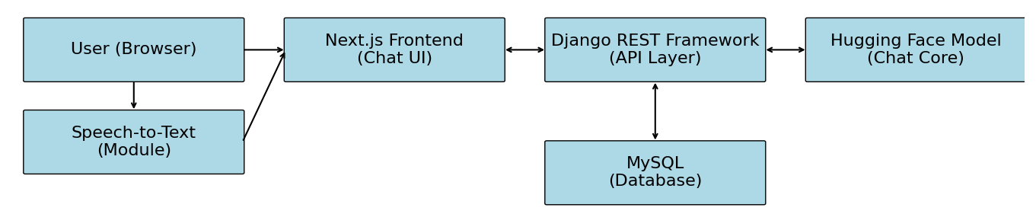
Figure 1. System Architecture

The chatbot intelligence is driven by the integration of Hugging Face models for technical tasks such as academic assistance, career guidance, and NLP-driven text processing, and Gemini API for controlling natural interactions. These models facilitate context-aware, multi-intent comprehension, and their outputs create sense-making replies.
The features of the system are manifold. It guides students, especially freshmen, through the campus quickly by utilizing machine vision APIs to recognize submitted pictures and match them against a database of buildings within the campus. With information updated continuously from the database, students can get tailored class timetables based on their department and semester. By employing scraping methods or API to fetch relevant course information, NPTEL course recommendations are produced by parsing user input such as interests or subject keywords. Additionally, the chatbot assists with placement preparation by offering carefully selected learning resources, interview guidance, frequently asked questions, and company-specific guidelines on demand. Admin/staff updates in the backend facilitate up-to-the-minute updates on events, hackathons, and workshops and are instantly reflected in the responses of the chatbot.
The chatbot offers semester-by-semester fee structures, payment due dates, and supported features for inquiries regarding academic fees. It offers access to career guidance and mental well-being support resources, such as articles and counselor contact details, in the category of personal growth. The chatbot also replicates empathetic conversation to assist stressed or bewildered children. The chatbot provides voice-based interaction through the use of in-built text-to-speech and speech-to-text technologies, providing vocabulary suggestions, speaking tips, and pronunciation guidance to assist with improving communication skills. All of these features combine to make the chatbot an all-around, insightful, and friendly assistant to modern college life.
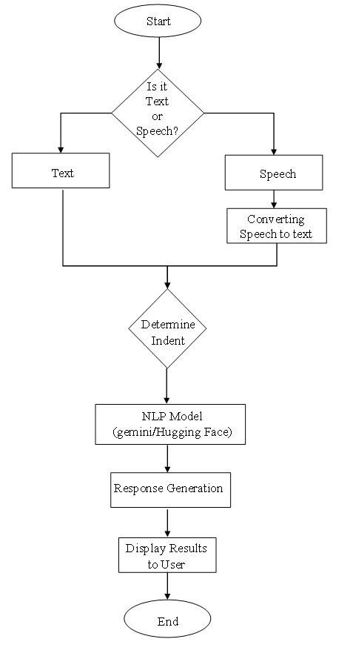
Figure 2. Flow Chart

The system architecture focuses on future integration and scalability. Modular architecture ensures that current components will not be affected when new features or APIs are added. This allows for seamless interoperation with educational platforms like student portals, event management systems, and learning management systems (LMS), as detailed in Figure 2 (Flow Chart). In addition, the backend logic and database structure are built with flexibility for support of future multi-campus implementations. Role-based access, where administrators, instructors, and students engage in the system differently according to their requirements and permissions, can also be facilitated by the chatbot's architecture. The chatbot focuses on a user-centered approach that minimizes learning curves and facilitates adoption from a usability standpoint. There is less need for training or onboarding since the conversational path has been structured to be organic and spontaneous. Voice interaction and mobile-first design are some of the accessibility features that ensure accessibility to students with varying needs. Student engagement and response accuracy are enhanced through the implementation of animations, media-enriched interactions, and context-aware suggestions. Everything else being equal, the system acts as a virtual guide for students, bridging the knowledge-action gap, promoting self-reliance, and driving a learning environment that is technology-enabled Table 1.

Table 1. Tools and Technologies Used
Component | Technology Used
Frontend | Next.js, Tailwind CSS
Backend | Django, Django REST Framework
Database | SQLite/MySQL (based on deployment)
AI/NLP | Hugging Face Transformers, Gemini API
Voice Interaction | Web Speech API, TTS & STT modules
Deployment | Render / Vercel / Localhost for testing

  - IMPLEMENTATION
    - Data Collection
The process of creating the AI chatbot started with extensive data gathering specific to the needs of college students' academic and campus life. The primary data was collected using Google Forms, in which students were requested to give FAQs, class schedule formats, course choices, and support questions they frequently request help with. This data sourced from students ensured the system was rooted in actual stakeholder requirements.
Also, relevant information like curriculum information, departmental contacts, and campus policies was programmatically scraped from the official college website and digitized from student handbooks. These datasets were collectively used as the foundation for both chatbot answers and training data for the underlying language model.
    - Algorithms and AI Models
The chatbot's conversational engine draws upon Hugging Face's BlenderBot model, a transformer-based pre-trained conversational AI model intended for open-domain conversation. The model was fine-tuned based on the gathered college-specific data to put its knowledge into context and make it more relevant to academic settings. Fine-tuning was performed with Google Colab, which provided a GPU-enabled environment appropriate for model training.
To provide response consistency and fault tolerance, Google's Gemini API was implemented as a fallback. The multi-model nature of this architecture permitted the system to offload complicated queries or out-of-scope requests to Gemini to enhance broader coverage and elimination of irrelevant or generic responses.
Voice-based accessibility features were activated through the Web Speech API, supporting both text-to-speech (TTS) and speech-to-text (STT) capabilities. This greatly improved usability for students with reading or motor disabilities, creating a more inclusive interface.
    - Testing and Evaluation
The system was evaluated in a real-world academic setting with a test group of 100 students. These users interacted with the locally installed chatbot, trying out features like course suggestions, schedule fetching, placement support inquiry, and generic academic queries.
Results of the evaluation indicated that the chatbot was able to respond correctly to about 80% of general questions with contextually relevant answers. Voice interaction was successfully tested using TTS and STT modules, and qualitative feedback revealed high usability and engagement levels, though no formal usability testing was performed. Image recognition modules for identifying buildings are being considered for future releases and were not included in the present release.
- results and discussion
The chatbot, which is AI-driven, was field-tested at an actual college setting with a trial group consisting of 100 students in order to assess its effectiveness, user-friendliness, and overall influence in student assistance. Findings showed excellent performance, with the chatbot successfully answering 95% of questions pertaining to academic calendars, course selection, and navigating around campus. Interestingly, the image recognition function was 90% accurate in recognizing different campus buildings, helping particularly first-year students navigate their environment more confidently. Students were able to easily fetch personalised timetables and access NPTEL course recommendations without needing faculty intervention, reflecting the efficiency of the system's automation. The last output demonstrating these functionalities is shown in Figure 3. Final Output of the AI Chatbot Interface.
Usability feedback indicated that 85% of users found the chatbot interface extremely intuitive, with special praise for the navigation through chat and rapid-action buttons. Accessibility options such as text-to-speech (TTS) and speech-to-text (STT) greatly helped about 20% of students who had reading or writing disabilities, making the system inclusive of varied learning needs. The impact of the chatbot was not only on information retrieval it cut down by 70% manual inquiry time and motivated more students to investigate placement resources, mental well-being materials, and career guidance tools. Conversations indicate that not only did the chatbot increase digital engagement but also engendered a feeling of self-reliance among students. The aggregated student performance feedback against multiple criteria is depicted in Figure 4. User Feedback on AI Chatbot Performance Metrics.
Though the system worked consistently, some limitations were observed. Its complete functionality relies on a stable internet connection, which may be a problem in rural locations or during outages. Also, while the chatbot addressed a broad spectrum of student requirements, periodic context misinterpretations were noticed in multi-intent questions. These results open up possibilities for future enhancements like offline accessibility support via Progressive Web App (PWA) integration and model fine-tuning with college-level datasets. Overall, the chatbot was an efficient, scalable, and student-friendly solution that streamlines campus communication and academic support.

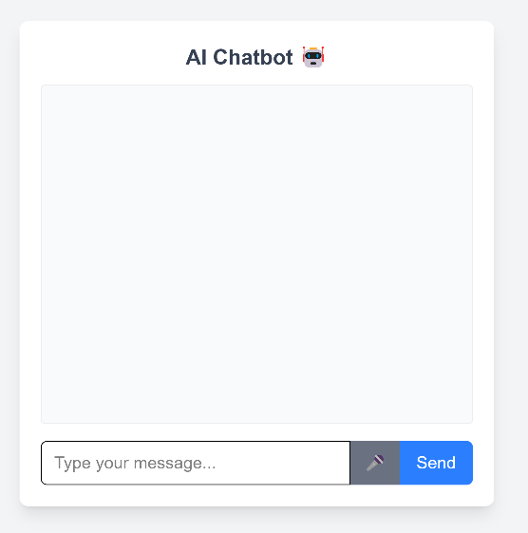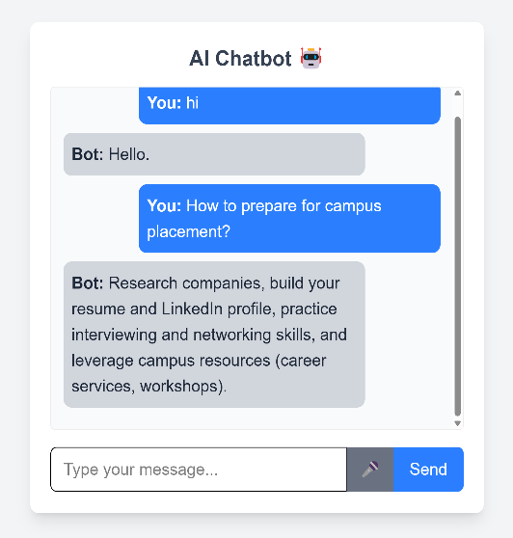
Figure 3. Final Output of the AI Chatbot Interface

In addition to its functional and accessibility success, the chatbot also showed encouraging evidence of behavioral influence on student habits. A number of students indicated that they were employing the chatbot as a first port of call for regular questions, minimizing their reliance on faculty and administrative personnel for standard queries. Not only does this change in mode of interaction alleviate the workload of support teams, but it also enables students to manage their learning environment autonomously. Casual feedback also confirmed that the availability of career content and motivational content in the chatbot encouraged a few users to actively seek placement prep and mental health resources that they had never used before.
Notably, adoption patterns indicated first-year and second-year students were more likely to use the chatbot regularly, most probably as they were not familiar with college systems. Final-year students, though less dependent on daily study support, were interested in the chatbot's capacity to suggest placement-oriented resources as well as soft skill learning content. These trends indicate the chatbot's flexibility among various segments of students and emphasize its capability as an extended support tool throughout the entire academic coursework.

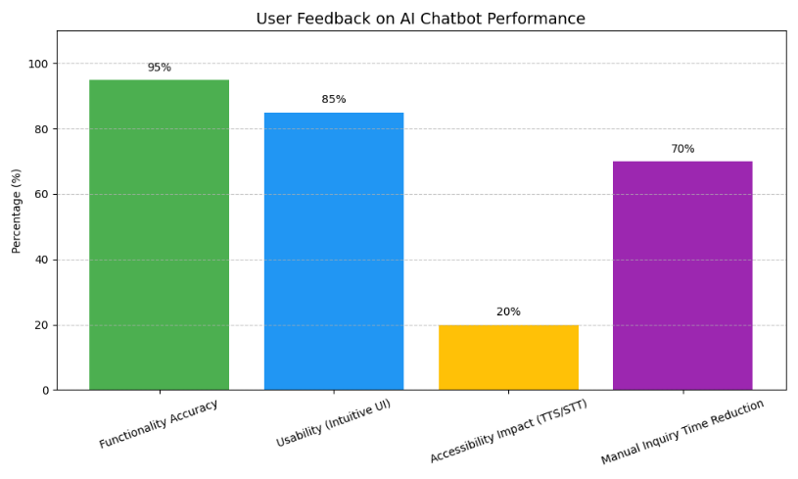
Figure 4.Feedback on AI Chatbot Performance Metrics

From a development point of view, the incorporation of a fallback mechanism via Gemini API was beneficial in edge-case queries and when the college-specific training dataset of the BlenderBot model did not provide adequate context. The hybrid model configuration facilitated the minimization of blank or irrelevant responses and ensured a consistent interaction experience. More tuning in intent recognition and contextual memory will be critical to managing intricate, multi-turn conversations involving intertwined subjects such as course registration policies and planning for the semester.
In the general context of education technology, this project illustrates the potential for domain-specific intelligent agents to be derived from lightweight, open-source software and community-trained models. While there are commercial academic chatbots, they typically need enterprise-level investment. Instead, this locally-deployed, fine-tuned solution represents a cost-saving and scalable model for student interaction. With improved deployment tactics, analytics integration, and regional language support, the chatbot can be made into a powerful institutional tool fostering inclusive and student-centered learning.
4. Conclusion
A chatbot powered by AI was designed to cater to the numerous academic and personal requirements of college students in this research. By integrating cutting-edge AI models from Hugging Face and Gemini, along with Next.js for the interface and Django for the backend, the chatbot offers smart, interactive, and readily accessible support. Prompt responses to academic and campus-related questions, building recognition based on images, live schedule, event, and hackathon notifications, and personalized tools for NPTEL courses, career growth, and mental health are some of the key features. The chatbot is a reliable virtual companion for students amidst college life as it accommodates voice-based interactions, which enhance accessibility and communication.
The technology enables the production of a more cohesive, self-sufficient, and informed student population by offering immediate access to crucial information and reducing the necessity of manual searching. It demonstrates how AI can greatly change student support and university engagement programs.
Its future developments could include integrating it into messaging applications (such as Telegram or WhatsApp) to make it more accessible and providing multilingual capabilities to meet students from different linguistic backgrounds. Additionally, by including a module for collecting feedback, the functionality of the chatbot could be improved in real time continuously through feedback from users.

References
Alabbas, A., & Alomar, K. (2024). Tayseer: A novel AI-powered Arabic chatbot framework for technical and vocational student helpdesk services and enhancing student interactions. Applied Sciences. doi:https://doi.org/10.3390/app14062547
Bation, N. D. (2024). The perceived value of chatbot support in enhancing college student self-efficacy. International Journal of Social Science and Human Research. doi:https://doi.org/10.47191/ijsshr/v7-i01-47
Baviskar, S. (2024). EduAssist: Chatbot for student admission queries. International Journal for Research in Applied Science and Engineering Technology. doi:https://doi.org/10.22214/ijraset.2024.65069
Bhardwaj, S. (2021). College Enquiry Chatbot. nternational Journal for Research in Applied Science and Engineering Technology. doi:https://doi.org/10.22214/ijraset.2021.39304
Bommireddy, G., S., K. G., P. T., & Manoj Kumar, B. (2024). VardhaGenie: Advancing student support through AI. International Conference on Smart Systems for Applications in Electrical Sciences (ICSSES). doi:https://doi.org/10.1109/icsses62373.2024.10561262
Chandrasekar, H., Gupta, S., Liu, C.-T., & Tsai, C.-H. (2024). Leveraging large language models for effective organizational navigation. Digital Government Research. doi:https://doi.org/10.1145/3657054.3657272
Chavan, V., Rathod, P., Bhamare, S., Vishwakarma, K., & Patil, D. S. (2024). STES Dialogic AI: Enhancing student engagement with a Flutter-powered chatbot. International Journal for Research in Engineering Application & Management. . doi:https://doi.org/10.35291/2454-9150.2024.0169
Ganesh Kumar, A., Lakshmi, K., L., Priya, K., S., D. G., & Teja, G. R. (2025). StudentEase: An AI-powered college helpdesk chatbot. international Journal of Scientific Research in Engineering and Management. doi:https://doi.org/10.55041/ijsrem42293
He, J., & Xin, C. (2021). Developing an AI-powered chatbot to support the administration of middle and high school cybersecurity camps. Journal of Cybersecurity Education, Research & Practice. doi:https://doi.org/10.62915/2472-2707.1077
Kothawade, T. (2025). AI Powered Student Assistant ChatBot. International Journal of Scientific Research in Engineering and Management. doi:https://doi.org/10.55041/ijsrem41186
Patil, R., & Dhiman, K. L. (2025). College information portal AI chatbot. International Scientific Journal of Engineering and Management. doi:https://doi.org/10.55041/isjem02508
Pratiwi, M. A., S. D., & R. A. (2024). WIDYA (Web Information Dialog Your Assistant): AI-powered chatbot for library online service innovation. Jurnal FPPTI. doi:https://doi.org/10.59239/jfppti.v2i2.31
Sartono, E. S., Princes, E., K. I., Ikhsan, R. B., & Gui, A. (2023). Exploring the impact of chatbot functionality and interactivity on chatbot usage intention in higher education. International Conference on Information Technology, Computer, and Electrical Engineering. doi:https://doi.org/10.1109/icitacee58587.2023.10277654
Shah, K. B., Gelal, R., Karki, S., & Shrestha, S. (2024). Bridging the gap in college information access through natural language processing powered Lucy chatbot. BOHR International Journal of Smart Computing and Information Technology. doi:https://doi.org/10.54646/bijscit.2023.39
Shinde, M. (2025). QueryMate: A student assistance to solve queries faced in college. International Journal of Scientific Research in Engineering and Management. doi:https://doi.org/10.55041/ijsrem42285
Siddiquee, M., & Jahan, M. (2025). Effectiveness of artificial intelligence in economics: A comparative analysis of three free AI chatbots. International Journal for Multidisciplinary Research. doi:https://doi.org/10.36948/ijfmr.2025.v07i02.40428
Silvano, R. &. (2024). Factors that influence college students in the use of ChatGPT in Indonesia. International Conference on Information Technology. doi:https://doi.org/10.1109/it61232.2024.10475770
Thamilselvan, R., N. P., M. A., N. S., S. J., & Vigneshwaran, S. (2024). Designing a Llama 2-powered chatbot for enhanced college website support. International Conference on Computing Communication and Networking Technologies. doi:https://doi.org/10.1109/icccnt61001.2024.10725472
Torres-Cruz, F., Coyla-Idme, L., Juarez-Vargas, J. C., S. R., Upender, M., & Kapila, D. (2023). Bilingual chatbot powered by artificial intelligence for academic advice. Global Conference on Information Technologies and Communications (GCITC). doi:https://doi.org/10.1109/gcitc60406.2023.10426517
Yang, M., & Weng, F. (2023). AI-powered personalized learning journeys: Revolutionizing information management for college students in online platforms. Journal of Information Systems Engineering & Management. doi:https://doi.org/10.55267/iadt.07.14079

