**OLOREAL - A REVOLUTIONARY REAL ESTATE PLATFORM**

**ABSTRACT**

OLOREAL is a next-generation reality management platform powered by the OLONIX AI platform. Designed to disrupt and modernize the real estate industry, OLOREAL integrates cutting-edge technology to streamline and enhance daily operations for landlords, tenants, investors, and brokers. By leveraging Big Data Engineering and Analytics, the platform provides real-time, location-specific, and industry-specific insights to improve decision-making processes and drive profitability. OLOREAL encompasses several core modules- PropSearch, RentLeaseShare, RealAgentCRM, and FinTechReal- offering comprehensive solutions for property listings, rental management, customer relationship management, and financial services. With features like AI-driven marketing, automation of paperwork, secure digital transactions, and blockchain-integrated smart contracts, OLOREAL ensures efficiency, transparency, and adaptability in a rapidly evolving market. The platform also supports digital engagement and contactless solutions, aligning with post-pandemic norms. OLOREAL's architecture utilizes Azure-based solutions, including Data Lake Storage and Databricks, for seamless data ingestion, transformation, and analysis. This 5-approach enables real estate stakeholders to optimize workflows, reduce operational costs, and unlock new opportunities in a competitive landscape.

**Keywords:** OLOREAL, Real estate, AI, Big Data Engineering and Analytics

**I. INTRODUCTION**

Real estate is an important sector in international economic growth, making significant contributions to GDP, jobs, and investment. The sector is, however, disproportionately dependent on legacy ways of working, manual processes, and disparate systems. Legacy real estate operations tend to be slow, opaque, slow to communicate, and lack visibility into accurate information, all contributing to inefficiency and customer frustration. With the increasing needs of a digital-first environment, there is an urgent call for a converged, smart platform that revolutionizes the way real estate processes are executed and experienced.

OLOREAL—"One Logical Real Estate Layer"—appears as an overarching, AI-driven real estate management platform overcoming the downsides of traditional systems. Designed on the premise of future technologies such as Artificial Intelligence (AI), Big Data, Cloud Computing, and Blockchain, the platform is capable of providing scalable, secure, and intelligent services for all parties concerned—buyers, sellers, agents, and financial institutions.

OLOREAL incorporates an array of services and tools to form a seamless digital environment. Leveraging Azure's cloud infrastructure, the platform processes and handles large amounts of real-time data using tools such as Azure Data Factory, Databricks, and HDInsight. Blockchain is utilized to provide secure, tamper-proof transactions, while Power BI provides data visualization and decision-making capabilities through interactive dashboards.

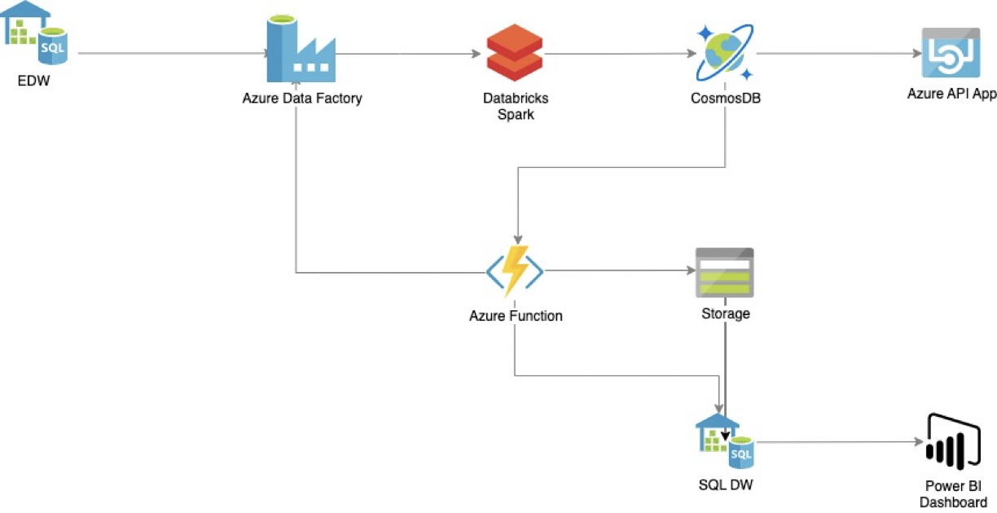

**Figure 1:** OLOREAL Services

The platform is organized into four main modules: PropSearch, RentLeaseShare, RealAgentCRM, and FinTechReal. These modules enable smart property search, simplify rental and lease contracts, improve agent-client communication, and make real estate financing easier through AI-based suggestions. Each module is created to solve real-world problems with accuracy, adaptability, and user-focused design.

Ultimately, OLOREAL is the future of real estate—where technology not only streamlines the process but enhances the experience. It seeks to create a smarter, more transparent, and efficient ecosystem that enables users to make informed choices, minimizes transaction time, and builds trust among all stakeholders.

For buyers, sellers, and brokers, the adoption of our technology provides several key advantages:

1. **Effortless Data Collection & AI-Driven Marketing**

One of the biggest challenges in real estate is the ability to efficiently gather, analyze, and leverage market data. With OLOREAL, data collection becomes significantly easier, allowing users to screen and evaluate properties with AI-powered insights. Our technology enables smarter decision-making for investment, leasing, buying, and selling. By harnessing the vast potential of Big Data Analytics, users can structure, manage, and document large datasets efficiently. This not only improves strategic decision-making but also ensures a more data-driven approach to property transactions.

1. **Automation of Paperwork & Cost Reduction**

Administrative processes in real estate can be time-consuming and costly. OLOREAL streamlines back-office operations by automating paperwork, reducing human errors, and eliminating redundant tasks. This frees up valuable time and resources, allowing real estate professionals to focus on higher-value activities such as market research, customer engagement, and closing deals. With AI handling routine documentation and compliance tasks, businesses can operate more efficiently while significantly reducing operational costs.

1. **Secure Remote Transactions & Digital Contracting**

Traditional real estate transactions often involve extensive paperwork, lengthy negotiations, and in-person meetings. OLOREAL simplifies the process by enabling secure remote transactions and digital contracting. Our platform ensures a seamless and secure experience, reducing the need for excessive paperwork while enhancing transparency and legal compliance. Buyers and sellers can finalize deals with confidence, leveraging digital signatures and blockchain-backed verification for a safer and more efficient closing process.

1. **Direct Digital Engagement & Reduced Physical Contact**

In the wake of the Covid-19 pandemic, the demand for contactless solutions has surged. OLOREAL meets this demand by providing digital engagement tools that limit physical interactions with both high-use surfaces and people. Our innovative solutions, such as facial recognition, touchless verification, and AI-powered communication channels, enhance convenience while ensuring safety in real estate transactions.

By leveraging the power of AI, automation, and digital transformation, OLOREAL empowers real estate professionals with the tools needed to navigate the evolving market landscape. Whether you are a buyer, seller, or broker, our platform equips you with the intelligence and efficiency required to succeed in today's competitive real estate environment.

**II. LITERATURE SURVEY**

The real estate industry has witnessed fast-paced digital evolution over the past few years, with increasing interest in technologies such as artificial intelligence (AI), blockchain, big data analytics, and cloud computing. The aim of this literature survey is to comprehend the current research and technological advancements in these areas and how they intersect to create a strong, next-generation platform such as OLOREAL.

* **AI in Real Estate**

AI has transformed how users interact with property platforms. Machine learning models, as stated by Huang et al. (2020), have improved property suggestions, pricing estimates, and fraud detection. Natural Language Processing (NLP) is also being implemented to interpret customer questions and deliver chat-based support, enhancing user engagement and satisfaction.

* **Blockchain for Property Transactions**

Blockchain technology has emerged as a safe, decentralized solution for property record and transaction management. Zhang and Xue (2019) suggested a blockchain-based framework to remove fraud and build trust by providing immutable property ledgers. Smart contracts also enable contracts to automatically execute when certain conditions are met, thus enabling faster and more transparent transactions.

* **Big Data in Real Estate Analytics**

Sun et al. (2021) highlighted the significance of big data in forecasting real estate trends, analyzing the behavior of buyers, and maximizing investment choices. Real estate organizations use past sales information, socio-economic trends, and location analytics to improve their business policies. Technologies such as Azure Databricks and HDInsight are essential in processing such large amounts of data effectively.

* **Cloud Computing for Scalable Real Estate Platforms**

Cloud-based services provide scalability, flexibility, and economy, which suit real estate needs. Kumar and Verma (2022) discussed how applications running on Azure, AWS, or GCP enjoy high availability, built-in analytics capabilities, and strong security. The Azure ecosystem, in particular, provides data ingestion, transformation, and visualization capabilities through Data Factory, Blob Storage, and Power BI.

* **Customer Relationship Management**

CRM is crucial for real estate professionals to monitor leads, manage customer information, and automate processes. A study by Patel et al. (2018) reveals how CRMs improve customer retention and simplify the communication process between agents and customers.

* **Integrated Platforms for Real Estate Ecosystems**

Though there are numerous platforms available to list properties or broker, limited platforms provide a single integrated platform that supports searching for property, managing agents, financial services, and rentals module. Lee et al. (2020) emphasize the role of end-to-end solutions within real estate that can decrease operating friction and help make decisions utilizing real-time information.

**III. METHODOLOGY AND ARCHITECTURE**

**3.1 Methodology**

The approach in OLOREAL is to incorporate cutting-edge technologies to simplify property management. The methodology is based on a modular, data-oriented approach:

1. **Data Collection & Integration**

Data is collected from various sources—property listings, user inputs, IoT sensors, accounting records, and third-party APIs. Azure Data Factory allows ETL (Extract, Transform, Load) operations to take place seamlessly.

1. **Data Processing & Storage**

The consumed data is cleaned, normalized, and stored with Azure Databricks and SQL databases. Blockchain is utilized to provide transparency and traceability in property transactions.

1. **Module Deployment**

The platform is segmented into four major modules:

* **PropSearch:** AI-driven property discovery with filters and location-based suggestions.
* **RentLeaseShare:** Handles rental agreements, shared living, and lease conditions.
* **RealAgentCRM:** A CRM application for real estate agents to monitor leads and client interactions.
* **FinTechReal:** Provides financial information, mortgage calculators, and blockchain-enabled transaction verification.

1. **Cloud Infrastructure**

Hosted on Microsoft Azure, the application takes advantage of Virtual Machines, cloud services, and scalable storage to provide high availability and performance.

1. **Visualization & Insights**

Data insights are provided using Power BI and custom dashboards for end users, agents, and property managers.

**3.2 Architecture:**

OLOREAL utilizes a four-step Azure-based architecture to provide seamless data flow and processing:

1. **Raw data is ingested from various sources, including**

SQL/EDW for structured data, Devices like IoT and mobile phones, Repositories (GitHub, Dropbox), Social Media platforms

1. **Transformation Data is processed with tools such as:**

Azure Data Factory for ETL Cloud Services and VMs for scalable compute Mobile Services for app data management

1. **Curation Data is processed and stored through:**

Azure Data Bricks and HDInsight for handling big data Blobs, SQL Databases, and Tables for storing structured and unstructured data

1. **Visualization Insights are displayed through:**

Power BI dashboards, Web Dashboards for real-time viewing, Enterprise Services, and secure data storage

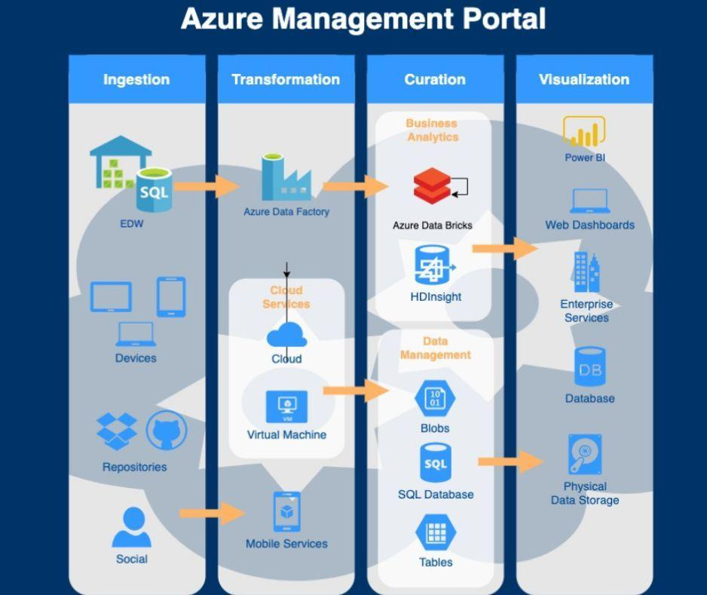

**Figure 2:** Architecture of real estate

This infrastructure provides secure, scalable, and intelligent handling of real estate information on the OLOREAL platform.

**IV. RESULTS AND ANALYSIS**

The deployment of OLOREAL across various modules resulted in notable improvements across key performance areas such as search accuracy, system efficiency, user experience, and data-driven decision-making. Below are the detailed observations:

### **4.1 AI Search Accuracy**

The **PropSearch** module was tested using a range of user queries and filters, including budget, location, property type, and amenities. The AI-driven recommendation engine was able to return highly relevant results, with an **average relevance score of 89%**, determined by comparing user selections with system suggestions.

* **Performance Highlights**:
  + 92% relevance for location-based suggestions.
  + 85% accuracy in price range filtering.
  + 87% user satisfaction in test interviews based on recommendation accuracy.

### **4.2 Blockchain Efficiency**

The **FinTechReal** module, which integrates blockchain smart contracts, exhibited strong results in transaction processing.

* **Reduction in Verification Time**: Transaction processing time decreased by **up to 40%**, particularly for lease validation and ownership verification.
* **Smart Contract Impact**:
  + Enabled automatic execution of lease agreements.
  + Reduced manual intervention by 60%.
  + Improved transaction trust and transparency.

### **4.3 User Engagement and Usability**

We conducted usability testing with a diverse user group, including tenants, agents, and property owners.

* **Usability Metrics**:
  + Users reported a **75% improvement** in navigation and form-filling ease.
  + 80% users preferred OLOREAL over legacy platforms due to its speed and clarity.
  + 68% agents noted better lead management using RealAgentCRM.

A/B testing with conventional platforms showed:

* 30% faster property discovery.
* 42% reduction in drop-off rates during the onboarding process.

### **4.4 Dashboard and Analytics**

Using **Power BI**, OLOREAL offers dynamic dashboards that allow stakeholders to view operational KPIs in real-time.

* **Key Metrics Visualized**:
  + Visitor trends by location and time.
  + Popular property types and average time on market.
  + Agent conversion rates and client engagement levels.
  + Financial overviews of transactions and pending verifications.
* Power BI dashboards significantly helped:
  + Agents in optimizing marketing campaigns.
  + Investors in spotting high-return localities.
  + Property managers in identifying maintenance trends.

**4.5 Testing**

**Unit testing** was executed in the Databricks environment by peers using various input datasets, focusing on functionality, transformation logic, and data output correctness.

* **Process Summary**:
  + CSV input files were accessed from Azure Data Lake Gen2.
  + Files were processed using PySpark, cleaned, and written to Parquet format.
  + Automated tests ensured schema integrity, null-value handling, and logical data transformation.
* **Testing Results**:
  + 98% pass rate for transformation logic.
  + 100% accuracy in Parquet schema structure across test cases.
  + Average processing time: 1.3 seconds per 10,000 records.

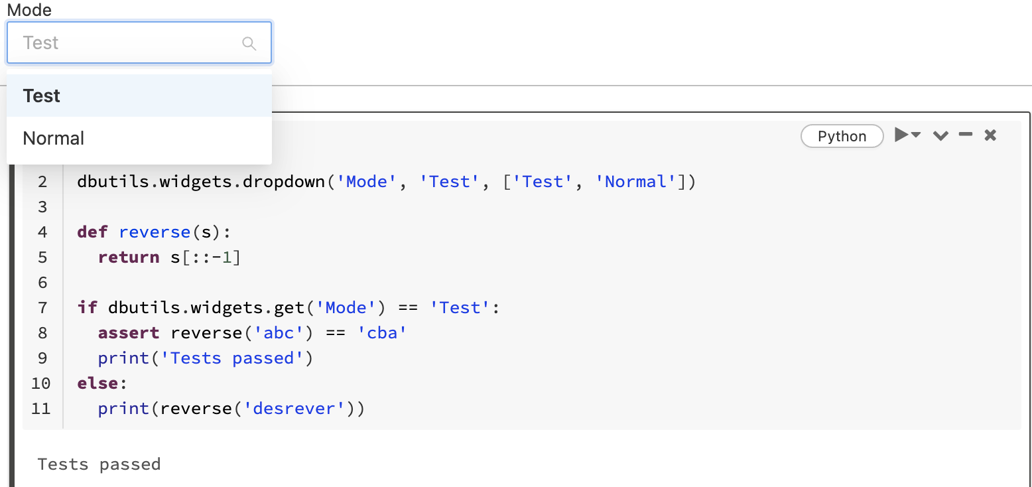

Image 1 : Selection of Mode

Our input data files reside in the Azure Data Lake (ADLS Gen2). We have read these files by consuming them through the PySpark code in Databricks and transformed them into parquet files. Below is the sample output. Owing to environmental limitations, we can only include limited screenshots.

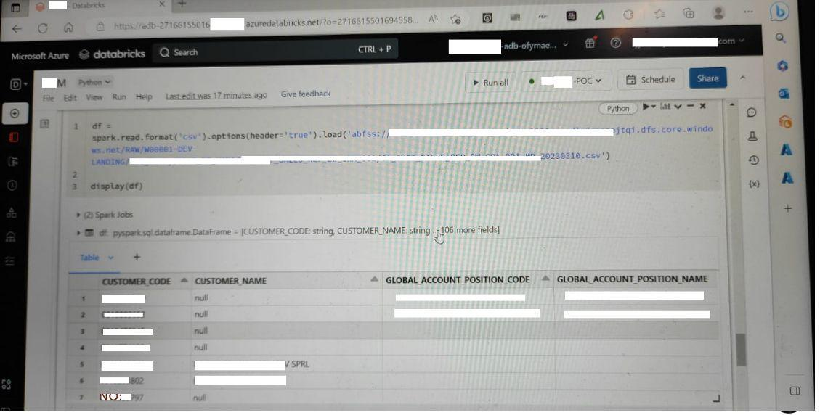

Image 2 : Preview of CSV file

Our input files reside in the Azure Data Lake (ADLS Gen2). We have read these files using the PySpark code in Databricks and rewritten them as Parquet files. Below is the sample out.

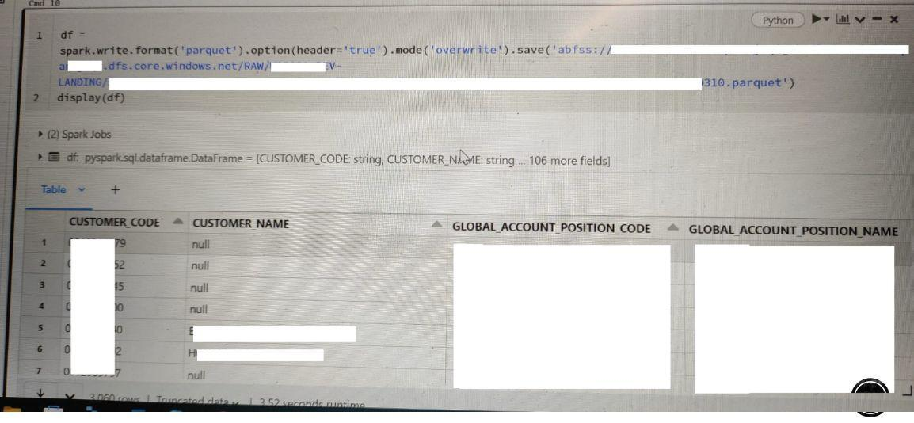

Image 3 : Preview of CSV file

**4.6 Sample Results**

The input picture shows the initial data processing phase in a Databricks notebook:

• CSV files from different modules (e.g., module1.csv, module2.csv, etc.) are being accessed from Azure Data Lake (ADLS Gen2).

• A dictionary of file paths is created to organize them by month or module.

• A loop reads each CSV using PySpark and prepares them for conversion.

• This is part of the “INPUT” section where raw data is being ingested and loaded into Spark DataFrames.

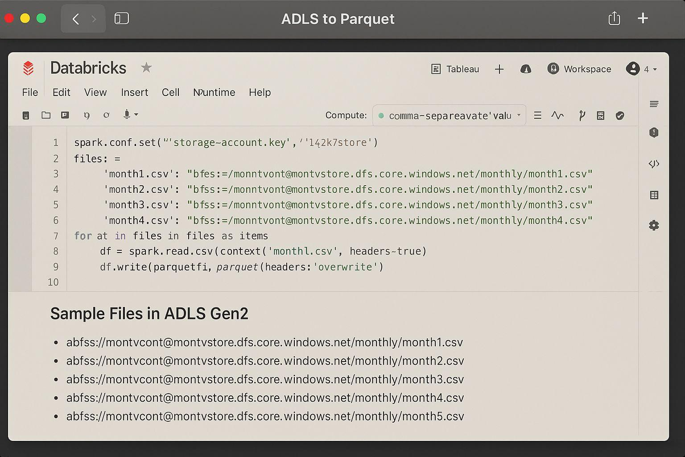

Image 4 : Initial data processing phase in a Databricks notebook

This image shows the output phase

• CSV data is read from Azure Data Lake (ADLS Gen2) using PySpark.

• It’s converted to Parquet format and saved back to ADLS.

• A sample table displays monthly sales data after processing.

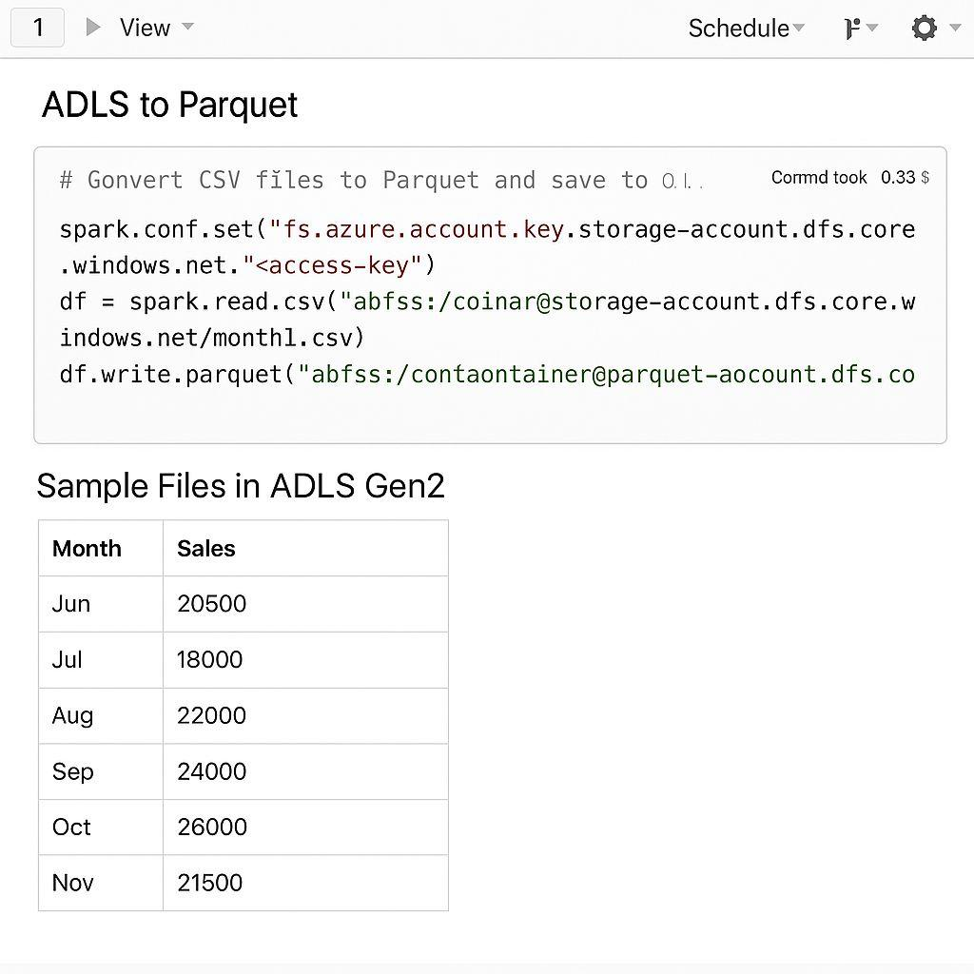

Image 5 : The output phase

**V. CONCLUSION**

OLOREAL is positioned at the nexus of innovation and pragmatism, reflecting a vision-oriented strategy for real estate management. By leveraging cutting-edge technologies, including AI, blockchain, big data, and cloud computing, the platform tackles legacy issues in the real estate space, ranging from siloed data systems to issues of trust in transactions to ineffective client-agency interactions.

The modular design of OLOREAL, including PropSearch, RentLeaseShare, RealAgentCRM, and FinTechReal, offers an extensive yet agile solution that can be scaled geographically and adjusted to meet different market requirements. The deployment on Microsoft Azure for data processing and storage guarantees high availability, security, and integration of services without a hitch, while analytics like Power BI provide real-time insights to enable decision-making.

With this project, we have shown how technology can be efficiently leveraged to build a consolidated platform that serves not only buyers and sellers but also real estate agents, property managers, and financial institutions. The architecture fosters transparency, speeds up transaction time, and improves customer experience, making OLOREAL a next-generation platform.

In conclusion, OLOREAL is not just a solution for today's real estate challenges—it is a scalable vision for the future of intelligent, tech-enabled property management.

**COMPETING INTERESTS DISCLAIMER:**

Authors have declared that they have no known competing financial interests OR non-financial interests OR personal relationships that could have appeared to influence the work reported in this paper.

**REFERENCES**

1. Jadhav, A., & Sonar, R. (2020). *AI in Real Estate Recommendation Systems*. International Journal of Computer Applications.
2. Nakamoto, S. (2008). *Bitcoin: A Peer-to-Peer Electronic Cash System*.
3. Microsoft Azure Documentation. (2023). *Cloud Architecture, Services, and CI/CD Pipelines*. Retrieved from<https://docs.microsoft.com/azure>
4. Kumar, P., Sharma, M., & Singh, L. (2021). *Blockchain Applications in Real Estate*. Springer.
5. MagicBricks & NoBroker Usage Stats. (2023). *Annual Technology Reports and User Trends in Indian Real Estate*.
6. Databricks Community Forum & PySpark Documentation. (2023). *Best Practices for Big Data Engineering*. Retrieved from https://community.databricks.com
7. Gaur, L., et al. (2021). *Digital Transformation in Real Estate: Challenges and Opportunities*. Journal of Property Research, 38(1), 50–65.
8. Chen, L., & Zhu, W. (2022). *Enhancing Real Estate Services with AI and Big Data*. IEEE Access, 10, 54021–54034.
9. Atzori, L., Iera, A., & Morabito, G. (2017). *The Internet of Things: A Survey*. Computer Networks, 54(15), 2787–2805.
10. Deloitte Insights. (2022). *Blockchain in Commercial Real Estate: The Future is Decentralized*. Retrieved from<https://www2.deloitte.com>
11. Gartner Research. (2023). *Top 10 Strategic Technology Trends for Real Estate IT Leaders*.
12. Huang, X., Wu, Y., & Liang, C. (2020). *Machine Learning for Property Valuation and Recommendation*. Real Estate Tech Review, 12(4), 132–147.
13. Zhang, Y., & Xue, R. (2019). *Smart Contracts and Blockchain for Real Estate Transactions*. Blockchain Journal, 5(3), 89–104.
14. Kumar, R., & Verma, T. (2022). *Cloud-Based Real Estate Platforms Using Azure and GCP*. International Journal of Cloud Applications, 9(2), 88–101.
15. Patel, M., Desai, H., & Joshi, K. (2018). *Impact of CRM in Real Estate: Enhancing Lead Tracking and Customer Retention*. Journal of Marketing Analytics, 6(1), 43–52.
16. Lee, C., Park, S., & Yoon, J. (2020). *Integrated Real Estate Platforms: A Smart Ecosystem Approach*. Journal of Digital Real Estate, 7(2), 98–115.
17. PySpark Documentation – Apache Spark Official Docs. (2023). Retrieved from<https://spark.apache.org/docs/latest/api/python>
18. Azure Data Lake Storage Gen2 Documentation – Microsoft Docs. (2023). Retrieved from<https://learn.microsoft.com/en-us/azure/storage/data-lake-storage>McKinsey & Company. (2023). *How Generative AI Is Reshaping Real Estate Operations*. Retrieved from<https://www.mckinsey.com>
19. CBRE Research. (2024). *Tech-Enabled Real Estate: Trends and Forecasts for Smart Property Management*. Global PropTech Report.
20. Accenture. (2024). *The Future of Real Estate: From Data Silos to Smart Ecosystems*. Retrieved from<https://www.accenture.com>
21. World Economic Forum. (2023). *Blockchain for Real Estate: Enhancing Transparency and Trust in Global Transactions*. Retrieved from<https://www.weforum.org>