*Original Research Article*

Early Detection for Congenital Heart Disease among Elementary School Students by Using a Simple Predictor Score Called Si-Biru

.

ABSTRACT

|  |
| --- |
| **Aims:** Screening for CHD in schoolchildren is not yet established in low-and-middle-income countries, particularly in Indonesia. The objective of this study is to establish simple CHD screening methods by using a questionnaire called Si-BIRU (Blue, Respiratory infection, failUre to thrive), among elementary students.  **Study design:** Descriptive-analytic using a retrospective observational study.  **Place and Duration of Study:** Four elementary schools in Kepanjen District, Malang, East Java, Indonesia. between January 2023 and December 2023.  **Methodology:** A total of 1.008 school students were screened within a month. Data management was carried out using the SPSS 25.0 program. Independent sample t-test was and chi-square were used to compare continuous data and categorical data between the two groups, respectively.  **Results:** As many as 26 (2.57%) students were detected to have cardiac abnormalities. Of which, 18 students (72 %) had abnormal valves, 12 students (24 %) had congenital septal defects consisting of 3 students (12%) with atrial septal defects, 2 students (8 %) with patent foramen ovale (PFO), and 1 cyanotic student (4 %) with transposition of a great artery (TGA). Male students had a significantly higher prevalence of abnormal electrocardiogram findings (64%) compared to female students (36%), p = 0.085.  **Conclusion:** This study shows that a questionnaire called “Si-BIRU” can be a simple and effective method for early screening and detection of CHD. The cut-off score of ≥2 had high sensitivity (96%) and specificity (92.1%) of Si-BIRU. |

*Keywords:* C*ongenital Heart Disease, Heart, Screening, Indonesia, Intervention.*

1. INTRODUCTION

Congenital heart disease (CHD) is an abnormality in the structure and function of the heart that has been present since birth. CHD is the congenital abnormality causing most of the infant mortality [1]. The prevalence of CHD worldwide is 8 per 1.000 newborns, with quite large geographic variations [2-4]. Although the prevalence of severe congenital heart defects is decreasing in many Western or developed countries due to fetal screening and termination of pregnancy, the overall prevalence on a global scale is increasing [5]. Owing to medical, surgical, and technological developments over the last few decades, more than 90% of individuals born with CHD may survive into adulthood [6]. As a result, the prevalence of CHD in society has increased and now far exceeds the number of children with CHD [7].

CHD can be detected as early as fetal age through routine pregnancy ultrasound or after delivery. Not all CHD show symptoms and sometimes the symptoms are vague. It depends on the severity of the heart abnormality. As a result, many parents including in Indonesia do not notice that their children are showing symptoms of CHD, which can result in delayed treatment. The symptoms include bluish or blackish lips, skin, or fingers (cyanosis), fatigue and difficulty breathing, stunted growth, recurrent lung infections, irregular heartbeat (arrhythmia), swelling of the extremities, and fainting easily [8].

Screening for CHD in schoolchildren is well-established in high-income countries. However, in low- and middle-income countries including in Indonesia, there are several limitations such as in health infrastructure, human resources, and facilities. The lack of properly trained health personnel to establish appropriate screening for CHD also plays a huge role. As a result, patients with CHD particularly in the middle-and low-income countries like Indonesia are commonly delayed in diagnosis. The majority CHD cases were found at school age in our country, Indonesia. Therefore, we conducted study for CHD screening in schoolchildren. A previous study reported that in low-and middle-income countries, the percentage of delayed diagnosis of CHD was 85.1% [9]. The proportion of delayed diagnosis was 8.9%, including cyanotic CHD at 10.4% and acyanotic CHD at 8.7% [10]. Another study revealed that the delayed diagnosis of critical CHD was 29.5%. Critical CHD and the presence of extracardiac defects are associated with a lower likelihood of delayed diagnosis [11]. A previous study from Murni *et al* (2021) found that in Indonesia, six out of ten children with CHD had delayed diagnosis. Delayed diagnosis due to medical or midwifery care, referral/ follow-up system, and financial and social factors were several reasons for the delay in establishing CHD diagnosis [12]. According to a study by Liu et al. (2020), research assessing the prevalence of congenital heart disease (CHD) in school-age children may help measure unmet medical needs for diagnosis and treatment, especially in low-income nations. More medical resources are needed for those born with congenital heart disease, especially in developing nations.

Factors contributing to delayed diagnosis of CHD in low and middle-income countries are inadequately trained healthcare professionals and socioeconomic barriers including limited healthcare facilities, for example, echocardiography availability. Although echocardiography is the gold standard in diagnosing CHD besides electrocardiogram, it is not widely available in primary healthcare facilities. Therefore, a health system with qualified and trained resources is needed.Screening and early detection for CHD must be emphasized to enable thorough early management, for example, corrective devices and surgery. Early disease recognition may reduce the number of delays in CHD diagnosis and improve the outcomes of CHD patients [13]. According to this background, researchers are interested in investigating the possibility of the "Si-BIRU (Blue, Respiratory infection, failUre to thrive)" questionnaire criteria application in early CHD screening tools in remote or rural areas.

2. material and methods

**2.1 Study Design**

The design of this study is descriptive-analytic using a retrospective observational study. The objective is to investigate whether "Si-BIRU" (Blue, Respiratory infection, failUre to thrive) criteria can be a simple and applicable CHD screening tool in establishing a diagnosis of CHD as well as measuring its sensitivity and specificity.

**2.2 Screening Procedure**

The screening program was conducted in 4 (four) elementary in the Kepanjen District, Malang, East Java, Indonesia where the number of stunting was about 14.1% [14]. Elementary students from Kepanjen District, Malang who met inclusion criteria in this study were explained the purpose and benefits of examination (screening). Before undergoing screening, every student was asked for approval to participate in the study by signing a written informed consent. Demographical data that was recorded were the participant's general data such as name, date of birth, age, gender, address, and school. Other data obtained from interviews were recorded according to the screening sheets. The participants were measured for weight, height, blood pressure, oxygen saturation, physical examination for murmurs, electrocardiogram, and confirmed by echocardiography. All of the screening results were recorded.

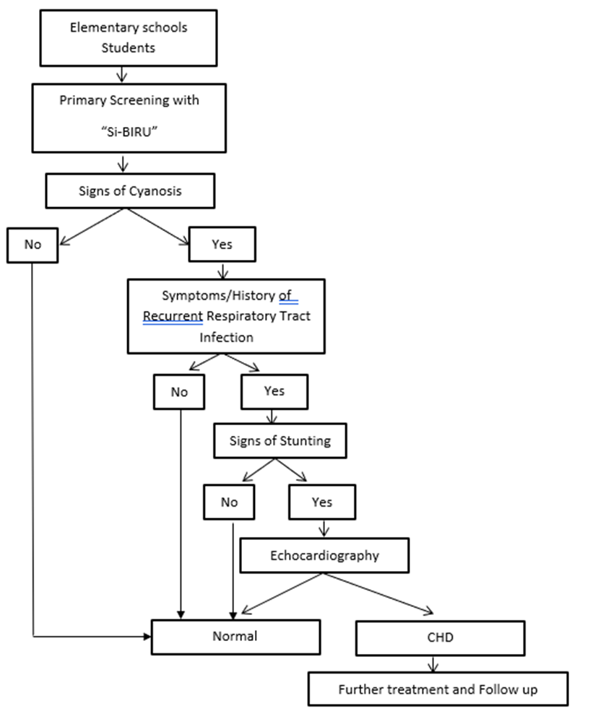

Figure 1. Workflow diagram for CHD screening program with Si-BIRU.

**2.3 Statistics Analysis**

Data management was carried out using the SPSS 25.0 program. The data are presented in the form of a sample characteristics distribution table. Continuous variables were expressed as means standard deviation (SD), 95% confidence intervals (CIs), frequency, and range. An independent sample t-test was used to compare continuous data between 2 groups. The chi-square test was used to compare the categorical data between the two groups. Sensitivity and specificity were calculated, and the receiver operating characteristic (ROC) curve was plotted to calculate the cutoff. Statistically significant data should have p values < 0.05. Afterward, the Si-BIRU scoring system was validated and underwent a reliability analysis using the Pearson instrument to assess whether this score was valid and reliable.

3. results

A total of 4 elementary schools were selected in the period of this screening. First-grade students, in total of 1.008 participants, were included in this screening. The characteristics of students who participated in the CHD screening are shown in Table 1.

In this study, 474 students were male and 525 students were female. There was no significant difference in mean age between the two groups. The average age of the normal student group was 8.6 years (SD = 1.5). The average age of those with CHD was 8.5 years (SD = 1.5, P = 0.715) (table 1).

Table 1. Baseline characteristics between two groups

|  |  |  |  |
| --- | --- | --- | --- |
| **Clinical Features** | **Echocardiography** | | **p-value** |
| **Normal (n=983)** | **CHD (n=25)** |
| Male/Female | 458/525 | 16/9 | 0.085 |
| Age (years+SD) | 8.6 + 1.5 | 8.5 + 1.5 | 0.715 |
| Symptoms |  |  |  |
| Cyanotic | 0 | 1 | 0.000 |
| Respiratory Infection | 389 | 24 | 0.000 |
| Stunting | 41 | 15 | 0.000 |
| Often absent from school | 64 | 7 | 0.000 |
| Cannot focus | 4 | 12 | 0.000 |
| Dyspnea | 13 | 7 | 0.000 |
| Nutrition Status |  |  | 0.000 |
| Poor nutrition | 22 | 3 |  |
| Underweight | 20 | 4 |  |
| Normal | 212 | 32 |  |
| Overweight | 53 | 3 |  |
| Obesity | 33 | 3 |  |

Among the 25 students (2.48%) with abnormal echocardiography findings, 18 students (72%) had functional regurgitation valves, consisting of 12 students with mild tricuspid regurgitation (TR), and 6 students with mild pulmonary regurgitation (PR). Only 6 students (24%) were confirmed with congenital septal defects, consisting of 3 students with atrial septal defect and 3 students with permanent foramen ovale. (Table 2.) Based on gender, male students had a significantly higher prevalence of abnormal electrocardiogram findings (64%) compared to female students (36%), p = 0.085.

The primary CHD screening took approximately 5–8 minutes per student, without combining other routine health examinations. The majority of the examined students were cooperative. The primary CHD screening is feasible to be performed yearly in first-grade elementary students and able to be integrated as a single activity with the mandatory annual health screening program. The secondary screening was performed using the gold standard tool in CHD screening, the transthoracic echocardiography, without any difficulties.

Traditional signs and symptoms associated with CHD analyses in this study include blue color in lips and fingers, respiratory infection, stunting, frequent absence from school, difficulty focusing, and fatigue or dyspnea. Statistically, the frequency of the 6 signs and symptoms analyses in the two study groups was significantly different (p < 0.05). In this study, patients with signs and symptoms above were more prevalent in the CHD population.

A scoring system has been created based on signs and symptoms in the previous validation phase including the previously mentioned 6 symptoms. This scoring system was then tested in the study population in the derivation phase, and it appears that students with CHD had experienced all symptoms more often compared to the normal students group (p < 0.05).

A final result from the receiver operating curve analysis obtained an area under the curve (AUC) of 0.972 (95% CI, 0.949-0.994). This scoring system provided a sensitivity of 96% and a specificity of 92.1% for subjects minimum of 2 symptoms positive (Figure 2).

Table 2. The Screening Results from Echocardiography Among Student

|  |  |  |  |  |  |  |  |  |  |  |  |  |  |  |  |  |
| --- | --- | --- | --- | --- | --- | --- | --- | --- | --- | --- | --- | --- | --- | --- | --- | --- |
|  | Sex | Age | Q1 | Q2 | Q3 | Q4 | Q5 | Q6 | BW | Height | Oxygen Saturation | | | | Murmur | Echo Screening  Results |
| No | Right Hand | Left Hand | Right Foot | Left Foot |
| 1 | P | 7 | No | yes | No | No | No | No | 23 | 124 | 97 | 99 | 97 | 99 | - | TR mild |
| 2 | L | 7 | No | yes | No | No | yes | No | 16 | 129 | 98 | 98 | 98 | 98 | - | Susp. PFO |
| 3 | P | 7 | No | yes | No | No | No | yes | 21 | 117 | 98 | 98 | 98 | 98 | - | TR Mild, PR Mild |
| 4 | L | 11 | No | yes | No | No | yes | No | 22 | 140 | 99 | 96 | 99 | 96 | - | PR Mild |
| 5 | L | 9 | No | yes | No | yes | No | No | 20 | 133 | 99 | 100 | 99 | 100 |  | TR mild |
| 6 | L | 10 | No | yes | No | No | yes | No | 24 | 122 | 99 | 98 | 99 | 98 |  | PR Mild, TR Mild |
| 7 | L | 10 | No | yes | No | No | No | yes | 23 | 132 | 98 | 98 | 98 | 98 | - | TR Mild |
| 8 | L | 7 | No | yes | No | No | yes | No | 23 | 122 | 98 | 99 | 98 | 99 |  | TR mild |
| 9 | P | 7 | No | yes | No | yes | No | No | 22 | 117 | 98 | 98 | 98 | 98 |  | Secundum ASD |
| 10 | L | 7 | No | yes | No | No | yes | No | 23 | 127 | 97 | 96 | 97 | 96 |  | TR mild |
| 11 | P | 7 | No | No | yes | yes | No | yes | 16 | 107 | 100 | 100 | 100 | 100 |  | TR mild |
| 12 | P | 7 | No | yes | yes | No | yes | No | 17 | 117 | 98 | 96 | 98 | 96 | yes | Secundum ASD |
| 13 | L | 8 | No | yes | yes | yes | No | No | 20 | 127 | 96 | 98 | 96 | 98 |  | PR Mild |
| 14 | P | 8 | No | yes | yes | No | yes | No | 21 | 119 | 99 | 98 | 99 | 98 |  | Secundum ASD |
| 15 | P | 8 | No | yes | yes | No | No | yes | 25 | 119 | 100 | 99 | 100 | 99 |  | TR mild |
| 16 | L | 8 | No | yes | yes | No | yes | No | 21 | 112 | 97 | 97 | 97 | 97 |  | TR mild |
| 17 | P | 8 | No | yes | yes | yes | No | No | 24 | 115 | 99 | 98 | 99 | 98 |  | PR Mild |
| 18 | P | 9 | No | yes | yes | No | yes | No | 23 | 130 | 98 | 97 | 98 | 97 | - | PR Mild |
| 19 | L | 9 | No | yes | yes | No | No | yes | 25 | 128 | 97 | 98 | 97 | 98 | - | TR Mild |
| 20 | P | 9 | No | yes | yes | No | yes | No | 24 | 131 | 99 | 100 | 99 | 100 | - | TR Mild, Patent Foramen Ovale |
| 21 | P | 9 | No | yes | yes | yes | No | No | 25 | 127 | 98 | 99 | 98 | 99 | - | TR Mild |
| 22 | L | 9 | No | yes | yes | No | yes | No | 24 | 122 | 99 | 99 | 99 | 99 | - | TR Mild |
| 23 | L | 11 | No | yes | yes | No | No | yes | 23 | 134 | 99 | 100 | 99 | 100 | - | TR Mild |
| 24 | L | 9 | No | yes | yes | No | yes | No | 23 | 140 | 99 | 100 | 99 | 100 | - | Susp. patent foramen ovale |
| 25 | L | 13 | yes | yes | yes | yes | No | yes | 22 | 132 | 73 | 75 | 73 | 75 |  | Pansystolic LLSB TGA VSD |

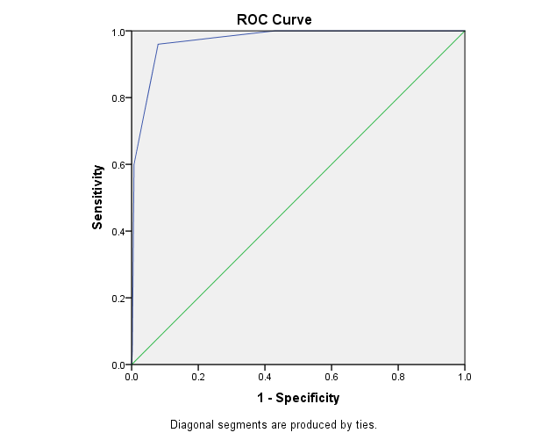

Figure 2. The Receiver Operating Curve (ROC) Analysis Result.

Lastly, the Si-BIRU score was validated and underwent a reliability analysis. Reliability Statistics showed Cronbach’s Alpha Based on Standardized Items was 0.486 (Table 3). Meanwhile, the R table score result was 0.0618.

Table 3. T

|  |  |  |
| --- | --- | --- |
| **Reliability Statistics** | | |
| Cronbach's Alpha | Cronbach's Alpha Based on Standardized Items | N of Items |
| .375 | .486 | 6 |

he Reliability Statistics Analysis Result

According to the comparison between Cronbach’s Alpha Based on Standardized Items and the R table score, the result was 0.486 > 0.0618. This indicates that overall scoring items of Si-BIRU were reliable.

**3.1 Discussion**

Abnormal structures in the heart chambers, valves, or large blood vessels in patients with congenital heart disease may change the normal blood flow pattern. Additionally, patients with congenital heart disease can experience cardiac complications such as arrhythmias, heart failure, and valvular insufficiency even after surgical correction of structural abnormalities [12]. Historically, most patients with congenital heart defects, especially with terminal conditions, experienced significantly reduced survival rates.

Our study found 3 students with permanent foramen ovale (PFO). We included the PFO into congenital septal defects according to a previous study from Romano et al. that stated a PFO is a common defect of the interatrial septum with the incidence of 15-35% in the adult population [15]. The aetiology of PFO was both environmental and genetic factors. However, it is still debatable because other studies involving PFO in carcinoid heart disease.

We also found 18 students (72%) had functional regurgitation valves consisting of 12 students with mild TR and 6 students with mild PR. Tricuspid regurgitation (TR) or pulmonary regurgitation (PR) was common and it can be functional. Therefore, it must be followed up routinely. The TR results from asymmetric dilatation of the tricuspid valve annulus secondary to left-sided heart failure due to myocardial or valvular disease. In turn, left heart dysfunction may lead to pulmonary hypertension. According to Sugiyama et al, the initial structure of the tricuspid valve leaflets is more complicated than the pulmonary valve leaflets [16]. The morphology of the tricuspid orifice was distorted, therefore, it is considered to be more vulnerable to regurgitation.

For many years, feasible methods for screening CHD patients for children have not yet been decided. A study by Vaidyanathan et al., from Kochi, Kerala, reported low sensitivity of clinical examination (9.26%) and pulse oximetry (11.4%), whereas specificity was high (97% and 91%, respectively) [17]. This study showed that neonatal screening may miss a few heart defects. Since the routine use of pulse oximetry in neonatal screening is still not universally implemented, it is important to do neonatal screening, particularly in our region. Besides, lots of studies have shown that even with neonatal screening programs, considerable CHDs are late detected. A study by Wren et al. reported that 82% of babies with CHD who had undergone routine examination at birth were discharged with no diagnosis and 54% remained undiagnosed at 6 weeks of age and 36% by 12 weeks of age [18]. A similar finding was reported by Meberg et al., from 35,218 screened newborns at birth by clinical examination, 269 of them were confirmed as CHD at birth by echo, and 84 were diagnosed with CHD on subsequent examination [19].

In a study by Shangfei He et al. (2020), social demographic data was gathered using a structured questionnaire. This was followed by a routine physical examination and echocardiogram for additional confirmation. 43,562 kids between the ages of 3 and 19 took part in the study. 80.0% were Tibetan, and 49.7% were boys. With an overall frequency of 6.73‰, 293 children were found to have a CHD. Of these, 239 had undiagnosed CHD, resulting in a 5.49 ‰ prevalence. 51.9% of CHD cases were caused by atrial septal defects, followed by ventricular septal defects (9.9%) and patent ductus arteriosus (31.1%).

Another study by Lucia K et al. (2020) assessed CHD using 12-lead ECG screening and cardiac auscultation during a 2-year period. They found that 6116 schoolchildren were checked during that time. A total of 329 (5.38%) pupils were found to have abnormalities. Of those, 45 students (13.68%) had heart murmurs, 6 students (1.82%) had both abnormalities, and 278 children (84.49%) had an abnormal ECG. The primary screening program was carried out with success. Out of the 260 students who had secondary screening, 18 (6.9%) had heart abnormalities, 7 (2.7%) had septal defects confirmed, and 11 (4.2%) had valve abnormalities. 0.29% was the overall prevalence (18 out of 6116)14.

For the youngsters, a second screening is necessary to identify these overlooked cases, which may later manifest as difficulties. The study aimed to create a new scoring system (si-BIRU) that is simple for parents, teachers, and other field workers to use when they suspect a kid has a heart issue and should be followed up with an early referral. The child can be referred sooner if the clinical score pro forma gives the staff a checklist to conveniently record the child's concerns. A score of two or above in this investigation indicated high sensitivity and specificity for the detection of CHD. To assess the score's validity, a sizable community-based investigation is necessary.

A second screening is warranted for the children to detect these missed cases which can later present with complications. The study attempted to design a new scoring system (si-BIRU) that can be easily utilized by various field workers, teachers, or parents suspected of heart defects in children and should be followed with an early referral. The clinical score pro forma can provide a checklist to the workers to easily note the child's complaints and therefore the child can be referred sooner. In this study, a score of 2 or more had a high sensitivity and specificity for CHD detection. However, a large community-based study is required to evaluate the validity of the score.

With high sensitivity and specificity, this scoring system is expected to be able to reduce the diagnostic delay of CHD. Accordingly, CHD morbidity and mortality rates might be reduced in the future. This scoring system is also expected to be used as a simple tool to help healthcare professionals with early detection and screening of CHD. For further research, this scoring system model should be validated on every clinical feature and in the general population, especially for primary healthcare patients, as a first-line screening tool before using more advanced diagnostic modalities.

4. Conclusion

This study indicates that a questionnaire called “Si-BIRU” can be a simple and effective method for early screening and detection of CHD. From analysis, we found a cut-off score of ≥2 that revealed high sensitivity (96%) and specificity (92.1%) of Si-BIRU. We hope it can be useful as a simple and applicable screener of CHD for either remote places or rural areas with limited healthcare facilities. This study as a pioneer, however, needs improvement with further study that conducted multicenter.

Consent

Written informed consent was obtained from the patient (or other approved parties) for publication of this research. A copy of the written consent is available for review by the Editorial office of this journal.

Ethical approval (where ever applicable)

All authors hereby declare that all experiments have been examined and approved by the appropriate ethics committee and have therefore been performed in accordance with the ethical standards laid down in the 1964 Declaration of Helsinki.

References

1. Rahajoe A, Roebiono P, Harimurti G. Panduan Tatalaksana Penyakit Jantung Bawaan Dewasa (PJBD). Kelompok Kerja Kardiologi Pediatrik dan Penyakit Jantung Bawaan Perhimpunan Dokter Spesialis Kardiovaskular Indonesia. 2020:44-55.

2. van der Linde D, Konings EE, Slager MA, et al. Birth prevalence of congenital heart disease worldwide: a systematic review and meta-analysis. J Am Coll Cardiol. 2011;58(21):2241-7.

3. Liu Y, Chen S, Zühlke L, et al. Global birth prevalence of congenital heart defects 1970-2017: updated systematic review and meta-analysis of 260 studies. Int J Epidemiol. 2019;48(2):455-63.

4. Paramita MIP, Gunawijaya E, Yantie NPVK, et al. Predictors of neonatal mortality with congenital heart disease. Bali Medical Journal. 2023;12(1):1114-9.

5. Lytzen R, Vejlstrup N, Bjerre J, et al. Live-Born Major Congenital Heart Disease in Denmark: Incidence, Detection Rate, and Termination of Pregnancy Rate From 1996 to 2013. JAMA Cardiol. 2018;3(9):829-37.

6. Moons P, Bovijn L, Budts W, et al. Temporal trends in survival to adulthood among patients born with congenital heart disease from 1970 to 1992 in Belgium. Circulation. 2010;122(22):2264-72.

7. Marelli AJ, Ionescu-Ittu R, Mackie AS, et al. Lifetime prevalence of congenital heart disease in the general population from 2000 to 2010. Circulation. 2014;130(9):749-56.

8. Kemenkes. Anak Saya Sakit Jantung Bawaan, Maksudnya? 2022. Available from: https://yankes.kemkes.go.id/view_artikel/724/anak-saya-sakit-jantung-bawaanmaksudnya.

9. Rashid U, Qureshi AU, Hyder SN, et al. Pattern of congenital heart disease in a developing country tertiary care center: Factors associated with delayed diagnosis. Ann Pediatr Cardiol. 2016;9(3):210-5.

10. Massin MM, Dessy H. Delayed recognition of congenital heart disease. Postgrad Med J. 2006;82(969):468-70.

11. Peterson C, Ailes E, Riehle-Colarusso T, et al. Late detection of critical congenital heart disease among US infants: estimation of the potential impact of proposed universal screening using pulse oximetry. JAMA Pediatr. 2014;168(4):361-70.

12. Murni IK, Wirawan MT, Patmasari L, et al. Delayed diagnosis in children with congenital heart disease: a mixed-method study. BMC Pediatr. 2021;21(1):191.

13. Mutluer FO, Çeliker A. General Concepts in Adult Congenital Heart Disease. Balkan Med J. 2018;35(1):18-29.

14. Agustino H, Widodo ERP. Analisis Implementasi Kebijakan Sosial Pencegahan Stunting di Kabupaten Malang. Sospol. 2022;8(2):241-52.

15. Romano V, Gallinoro CM, Mottola R, et al. Patent Foramen Ovale-A Not So Innocuous Septal Atrial Defect in Adults. J Cardiovasc Dev Dis. 2021;8(6).

16. Sugiyama H, Hoshiai M, Tan T, et al. Functional maturity of tricuspid and mitral valves in school children evaluated by echocardiography. Heart. 2005;91(11):1479-80.

17. Vaidyanathan B, Sathish G, Mohanan ST, et al. Clinical screening for Congenital heart disease at birth: a prospective study in a community hospital in Kerala. Indian Pediatr. 2011;48(1):25-30.

18. Wren C, Richmond S, Donaldson L. Presentation of congenital heart disease in infancy: implications for routine examination. Arch Dis Child Fetal Neonatal Ed. 1999;80(1):F49-53.

19. Meberg A, Otterstad JE, Frøland G, et al. Early clinical screening of neonates for congenital heart defects: the cases we miss. Cardiol Young. 1999;9(2):169-74