Determination of in vitro antifungal effect of capsaicin against Fusarium oxysporum
ABSTRACT
Aims: To evaluate the antifungal activity of capsaicin, a natural compound from hot peppers, against Fusarium oxysporum, and explore its potential as an alternative to synthetic fungicides in crop protection.
Study design: An in vitro experimental study was conducted to assess the concentration-dependent inhibitory effects of capsaicin on fungal growth.
Place and Duration of Study: Department of Plant Protection, Kocaeli University, in the year of 2024.
Methodology: Capsaicin was applied at three concentrations (125, 500, and 1000 ppm) to F. oxysporum cultures grown on Sabouraud Dextrose Agar. Fungal mycelial growth was monitored and measured over eight days. The percentage of inhibition was calculated by comparing treated groups with a control group without capsaicin.
Results: Capsaicin showed a clear concentration-dependent antifungal effect. At 1000 ppm, fungal growth was nearly completely inhibited, while 500 ppm caused significant suppression. The 125 ppm concentration resulted in mild inhibition compared to the control.
Conclusion: Capsaicin demonstrated strong antifungal activity against F. oxysporum, particularly at higher concentrations. These results highlight its potential as a sustainable, plant-derived alternative to synthetic fungicides for effective plant disease management.

Keywords: Natural antifungal agents, Fusarium oxysporum, Capsaicin, Antifungal activity

1. INTRODUCTION

Today, plant diseases continue to be one of the limiting factors in crop production, causing yield losses. This issue has become increasingly important as the world population continues to increase. Plant diseases are defined as any diseases that damage the normal structure, function, or economic value of the plant (Lucas et al., 1992). Factors that cause diseases in plants are divided into two categories: biotic and abiotic factors. Biotic factors, such as molds, can be extremely destructive for several reasons: they can multiply very quickly, complete their infection cycle in just a few days, mutate rapidly and develop resistance to fungicides, have spores that can be carried long distances by the wind, produce strong phytotoxic compounds and enzymes that damage plant structures, and even minor lesions like rust can reduce the economic value of the product (Strange, 1993).
Additionally, molds can contaminate agricultural products before or after harvest. Therefore, they are considered the most common cause of food spoilage, with some species, especially Aspergillus, Penicillium, and Fusarium, producing mycotoxins (Shuping & Eloff, 2017). Mycotoxins found in foods and feeds pose potential harm to both human and animal health.
The genus Fusarium is regarded as one of the most adaptive and versatile genera in Eumycota. It consists of soilborne, necrotrophic, plant pathogenic mold, with many species causing serious plant diseases worldwide. The mold can survive in soil as mycelium or spores without its hosts. In the presence of a host, mycelium from germinating spores penetrates the host roots, enters the vascular system (xylem), moves and multiplies within it, and causes the host to develop wilting symptoms. Fusarium oxysporum is an economically significant member of the Fusarium genus, primarily causing vascular wilts in many crops (Agrios, 2005).
Nowadays, the use of synthetic fungicides allows for quick and effective treatment of plant diseases and microbial contamination. Considering the undesirable qualities of synthetic fungicides, it is necessary to develop alternative applications that are less harmful to animals and humans and have a reduced environmental impact. In this context, plant-derived compounds are considered a potential source that is safer or more effective than synthetic antimicrobial agents (Sales et al., 2016; Samuel & Chaudhary, 2019). Various studies have shown the antimicrobial, anti-inflammatory, and antioxidant activities of extracts isolated from plants (El-Ghany M et al., 2015; Yusuf et al., 2001).
Capsaicin (8-methyl-N-vanillyl-6-nonenamide) is a nitrogen-containing substance belonging to the lipids group (Srinivasan, 2016). It is an alkaloid substance that gives red hot peppers their spiciness (Figure 1). Many studies have shown the antimicrobial activity of capsaicin and its analogs against microorganisms such as Bacillus subtilis (Nascimento et al., 2014), Helicobacter pylori (Tayseer et al., 2020; Yildiz Zeyrek & Oguz, 2005), Escherichia coli (Morrine et al., 2018), and Aspergillus parasiticus (Buitimea-Cantúa et al., 2020).

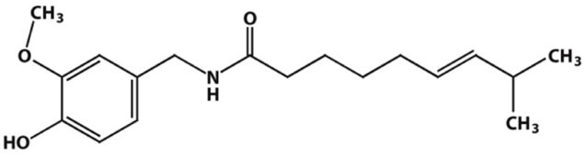

Fig. 1. Chemical structure of capsaicin
The long-term goal of this work is to develop new alternative control methods for plant pathogens that can replace synthetic fungicides. In this study, the fungicidal effects of capsaicin against F. oxysporum have been demonstrated in vitro.

2. material and methods

In this study, F. oxysporum was used. It was inoculated on Sabouraud Dextrose Agar (SDA; 40 g/L glucose, 20 g/L peptone, and 15 g/L agar) for five days at 30°C.
Capsaicin (Sigma Chemical C., St. Louis, MO, USA) was used as an antifungal compound dissolved in ethanol. Then, different concentrations of capsaicin (125, 500, and 1000 ppm) were prepared and added to SDA. About 20 ml of the growth medium was poured into each Petri dish and allowed to solidify. A six mm disc of 5-day-old culture of the test fungi was placed at the center of the Petri dish and incubated at 30°C for eight days, the growth was measured by “mycelial growth area” on the agar.
The mycelial growth area was determined via image analysis; pictures of Petri plates were taken daily (sample pictures are given in Figure 2), and the mycelial area was calculated by image and photo editing software (Paint.NET, Freeware).
For each treatment, three replicates were used. SDA medium without capsaicin served as a control. The fungitoxicity of capsaicin in terms of percentage inhibition of mycelial growth was calculated by using the formula (Samuel & Chaudhary, 2019):

$$\% Inhibition = \frac{dc-dt}{dc}×100$$
Where,
dc = average area increase in mycelial growth in control plates,
dt = average area increase at each treatment plate.

3. results and discussion

The following results provide a detailed analysis of the concentration-dependent antifungal effects of capsaicin on F. oxysporum mycelial growth, as observed through visual data and inhibition rate measurements over time. The data highlight how varying concentrations of capsaicin (0 ppm, 125 ppm, 500 ppm, and 1000 ppm) impact fungal growth, demonstrating that higher concentrations of capsaicin result in stronger and faster inhibition. The visual observations and corresponding inhibition rates confirm the potential of capsaicin as an effective antifungal agent, with its efficacy increasing with concentration and reaching a plateau after a certain period.
Figure 2 illustrates the concentration-dependent antifungal effect of capsaicin on F. oxysporum. In the control group (0 ppm), fungal growth is rapid, with significant growth visible by day 3 and full colonization of the plate by day 8. Moreover, a pinkish coloration appears, indicating sporulation or pigment production, confirming unhindered growth. At 125 ppm, the fungus grows more slowly than the control, with notable growth by day 3. By day 8, the fungus continues to spread, although the inhibition is slight. This suggests that 125 ppm has a mild inhibitory effect, delaying but not preventing growth. At 500 ppm, fungal growth is significantly restricted, with only small colonies visible by day 3. Throughout the experiment, the growth remains minimal, and the inhibition of fungal spread is much stronger than the lower concentrations. Finally, at 1000 ppm, the highest concentration, fungal growth is almost completely suppressed. Even by day 3, very little growth is visible, and by day 8, the fungus remains confined to the area around the inoculum, with no significant spread or sporulation. This demonstrates that capsaicin has a concentration-dependent effect, with higher concentrations showing stronger antifungal activity.

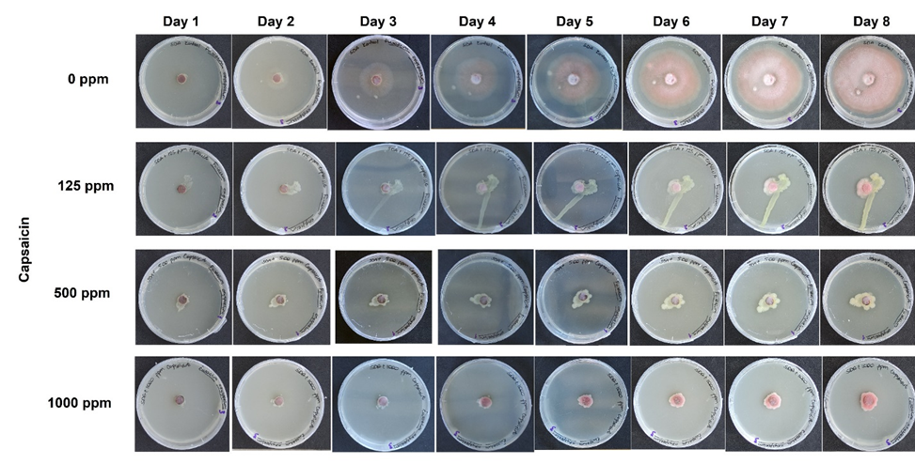
Fig. 2. The visual comparison of F. oxysporum mycelial growth over time on plates containing different concentrations of capsaicin (0 ppm, 125 ppm, 500 ppm, and 1000 ppm). Each row corresponds to a specific capsaicin concentration, while each column represents a time point (from day 1 to day 8).
According to Figure 3, the growth of F. oxysporum in the control group (without capsaicin) shows steady but gradual growth and is similar to the control in the early days (days 1-3) at 125 ppm capsaicin. However, after day 3, the growth rate accelerates more slowly than the control, and by day 8, the growth is still lower compared to the control group, likely indicating some inhibitory effect of capsaicin at this concentration. For the 500 ppm concentration, the growth pattern starts with very slow growth similar to the control but remains much lower. The highest concentration of capsaicin (1000 ppm) has the most inhibitory effect on the growth of F. oxysporum. Growth remains almost negligible throughout the first 6 days, with a slight increase towards the end. This suggests that the highest concentration of capsaicin significantly reduces growth, possibly causing a plateau effect in the fungal development. It can be concluded from Figure 3 that the growth of F. oxysporum is clearly inhibited by capsaicin, and the higher the concentration, the more significant the inhibitory effect.

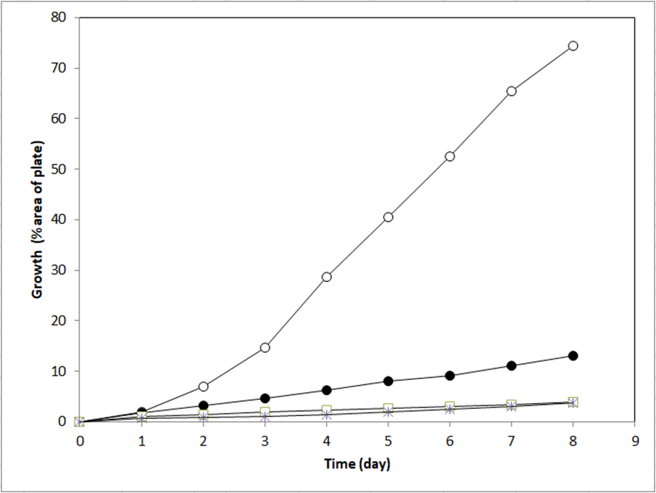
Fig. 3. Growth of F. oxysporum under different capsaicin concentrations (○: control, ●:125ppm, □: 500 ppm, *:1000ppm). Each data point represents the mean of three independent measurements.
Figure 4 illustrates the time- and concentration-dependent inhibitory effects of capsaicin on F. oxysporum mycelial growth. From day 1 to day 4, the inhibition rate steadily increases for all concentrations, with the rate stabilizing and plateauing after day 4, remaining nearly constant until day 8. Regarding the effect of concentration, 125 ppm shows the lowest inhibition rates throughout the experiment, starting at around 10% on day 1 and gradually increasing to approximately 70% by day 4, where it then stabilizes. The 500 ppm concentration exhibits a stronger inhibitory effect, starting at around 40% on day 1 and reaching about 90% by day 4, maintaining this level until day 8. The highest concentration, 1000 ppm, shows the most significant inhibition from the beginning, with around 60% inhibition on day 1 and nearly complete inhibition (~100%) by day 4, which is sustained through day 8. This concentration-dependent pattern clearly demonstrates that higher capsaicin concentrations result in faster and stronger inhibition of fungal growth, with 1000 ppm being the most effective, followed by 500 ppm and 125 ppm. These data and the visual data support the potential use of capsaicin as an antifungal agent, with higher concentrations leading to more rapid and complete inhibition. Additionally, the stabilization of the inhibition rate after day 4 suggests that capsaicin reaches its maximal antifungal effect at that point, beyond which no further enhancement occurs.
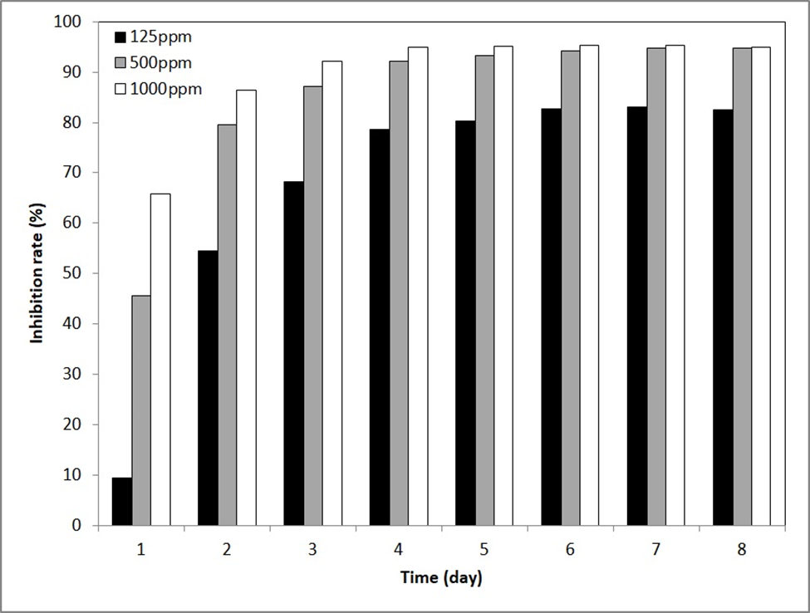
Fig. 4. The inhibition rate (%) of F. oxysporum mycelial growth over eight days when treated with capsaicin at three different concentrations: 125 ppm (black bars), 500 ppm (gray bars), and 1000 ppm (white bars). Each data point represents the mean of three independent measurements.
These findings align with previous studies on capsaicin’s antimicrobial properties. Tsuchiya (2001) conducted an experiment with liposomes that examined the effect of capsaicin on the membrane and showed that it changes membrane fluidity (Tsuchiya, 2001). Changing membrane fluidity gave capsaicin antimicrobial properties. Another study suggests that the inhibitory effect of capsaicin is related to the induction of osmotic stress and key genes for membrane biosynthesis (Kurita et al., 2002). Behbehani et al. (2023) showed that capsaicin reduces ergosterol in fungal cells, disrupting membranes, causing ion loss, and leading to cell death (Behbehani et al., 2023). These mechanisms likely explain the concentration-dependent inhibition observed in F. oxysporum.
Comparable antifungal activity has been reported against other fungal species. Xing et al. (2006) showed the antimicrobial activities of the capsaicin microcapsules on Botrytis cinerea and A. niger. They indicated that the antifungal activity of capsaicin at a concentration of 590 ppm (Xing et al., 2006). The minimum inhibitory concentration of capsaicin determined using the broth micro-dilution method was 122.16 ppm against Penicillium expansum. These results contribute to providing new options for using antifungal agents against P. expansum (Fieira et al., 2013). Another study explores capsaicin's role in inhibiting the germination of Colletotrichum capsici, a fungus causing anthracnose in chilies. Conidia were incubated on media with varying capsaicin concentrations. At 100 and 200 ppm, germination was completely inhibited, suggesting capsaicin's potential for fungal resistance (Kraikruan et al., 2008). Buitimea-Cantúa et al. (2018) found that capsaicin exhibited significant antifungal activity against A. parasiticus. The MIC₅₀ values were 39000 ppm for capsaicin, suggesting its potential as a natural antifungal agent (Buitimea-Cantúa et al., 2018). These studies support the effectiveness of capsaicin as a natural antifungal agent with broad-spectrum activity. The present findings confirm its strong inhibitory effects on F. oxysporum, particularly at higher concentrations. The stabilization of inhibition rates after day 4 suggests that capsaicin reaches its maximal antifungal effect within this timeframe.

4. Conclusion

The results of this study demonstrate the significant antifungal potential of capsaicin against F. oxysporum, a common and destructive plant pathogen. Plant diseases, particularly those caused by molds like Fusarium, continue to pose a major threat to global crop production, with molds responsible for not only yield loss but also food spoilage and mycotoxin contamination (Shuping & Eloff, 2017). As synthetic fungicides present health and environmental concerns, alternative solutions, such as plant-derived compounds, are being explored. Capsaicin, a compound found in hot peppers, has shown promising antimicrobial properties in previous studies (Nascimento et al., 2014; Tayseer et al., 2020). The findings of this study support capsaicin’s potential as an effective fungicide, with a concentration-dependent inhibition of Fusarium growth. At higher concentrations (500 and 1000 ppm), capsaicin demonstrated a strong, almost complete suppression of fungal growth, indicating its viability as an alternative to synthetic fungicides in the management of plant pathogens.

References

Agrios, G. N. (2005). Plant Pathology (5th Editio). Elsevier Academic Press.
Behbehani, J. M., Irshad, M., Shreaz, S., & Karched, M. (2023). Anticandidal Activity of Capsaicin and Its Effect on Ergosterol Biosynthesis and Membrane Integrity of Candida albicans. International Journal of Molecular Sciences, 24(2). https://doi.org/10.3390/ijms24021046
Buitimea-Cantúa, G. V., Buitimea-Cantúa, N. E., Rocha-Pizaña, M. del R., Hernández-Morales, A., Magaña-Barajas, E., & Molina-Torres, J. (2020). Inhibitory effect of Capsicum chinense and Piper nigrum fruits, capsaicin and piperine on aflatoxins production in Aspergillus parasiticus by downregulating the expression of aflD, aflM, aflR, and aflS genes of aflatoxins biosynthetic pathway. Journal of Environmental Science and Health - Part B Pesticides, Food Contaminants, and Agricultural Wastes, 0(0), 835–843. https://doi.org/10.1080/03601234.2020.1787758
Buitimea-Cantúa, G. V., Velez-Haro, J. M., Buitimea-Cantúa, N. E., Molina-Torres, J., & Rosas-Burgos, E. C. (2018). GC-EIMS analysis, antifungal and anti-aflatoxigenic activity of Capsicum chinense and Piper nigrum fruits and their bioactive compounds capsaicin and piperine upon Aspergillus parasiticus. Natural Product Research, 34(10), 1452–1455. https://doi.org/10.1080/14786419.2018.1514395
El-Ghany M, A. T., M, R. M., & Al Abboud, M. A. (2015). Efficacy of Certain Plant Extracts as Safe Fungicides Against Phytopathogenic and Mycotoxigenic Fungi. Agricultural and Biological Sciences Journal, 1(3), 71–75. http://www.publicscienceframework.org/journal/absjhttp://creativecommons.org/licenses/by-nc/4.0/
Fieira, C., Oliveira, F., Calegari, R. P., Machado, A., & Coelho, A. R. (2013). In vitro and in vivo antifungal activity of natural inhibitors against Penicillium expansum. Food Science and Technology, 33(SUPPL.1), 40–46. https://doi.org/10.1590/S0101-20612013000500007
Kraikruan, W., Sangchote, S., & Sukprakarn, S. (2008). Effect of capsaicin on germination of Colletotrichum capsici conidia. Kasetsart Journal - Natural Science, 42(3), 417–422.
Kurita, S., Kitagawa, E., Kim, C. H., Momose, Y., & Iwahashi, H. (2002). Studies on the antimicrobial mechanisms of capsaicin using yeast dna microarray. Bioscience, Biotechnology and Biochemistry, 66(3), 532–536. https://doi.org/10.1271/bbb.66.532
Lucas, G. B., Campbell, C. L., & Lucas, L. T. (1992). Introduction to plant diseases : identification and management (2nd ed.). Chapman & Hall.
Morrine, A. O., Zen-Zi, W., Weih, G. B., Grant, A. H., Kamal, D., & David, J. B. (2018). Comparative analysis of capsaicin in twenty nine varieties of unexplored Capsicum and its antimicrobial activity against bacterial and fungal pathogens. Journal of Medicinal Plants Research, 12(29), 544–556. https://doi.org/10.5897/jmpr2018.6667
Nascimento, P. L. A., Nascimento, T. C. E. S., Ramos, N. S. M., Silva, G. R., Gomes, J. E. G., Falcão, R. E. A., Moreira, K. A., Porto, A. L. F., & Silva, T. M. S. (2014). Quantification, Antioxidant and Antimicrobial Activity of Phenolics Isolated from Different Extracts of Capsicum frutescens (Pimenta Malagueta). Molecules, 19(4), 5434–5447. https://doi.org/10.3390/molecules19045434
Sales, M. D. C., Costa, H. B., Fernandes, P. M. B., Ventura, J. A., & Meira, D. D. (2016). Antifungal activity of plant extracts with potential to control plant pathogens in pineapple. Asian Pacific Journal of Tropical Biomedicine, 6(1), 26–31. https://doi.org/10.1016/j.apjtb.2015.09.026
Samuel, C. O., & Chaudhary, S. (2019). in vitro Antifungal Evaluation of Dendrophthoe Falcata Leaf Extract Against Phytopathogens. 5(624), 624–631. https://doi.org/10.26479/2019.0503.51
Shuping, D. S. S., & Eloff, J. N. (2017). the Use of Plants To Protect Plants and Food Against Fungal Pathogens: a Review. African Journal of Traditional, Complementary, and Alternative Medicines : AJTCAM, 14(4), 120–127. https://doi.org/10.21010/ajtcam.v14i4.14
Srinivasan, K. (2016). Biological Activities of Red Pepper (Capsicum annuum) and Its Pungent Principle Capsaicin: A Review. Critical Reviews in Food Science and Nutrition, 56(9), 1488–1500. https://doi.org/10.1080/10408398.2013.772090
Strange, R. N. (1993). Plant Disease Control Towards environmentally acceptable methods. Springer New York.
Tayseer, I., Aburjai, T., Abu-Qatouseh, L., AL-Karabieh, N., Ahmed, W., & Al-Samydai, A. (2020). In vitro anti-helicobacter pylori activity of capsaicin. Journal of Pure and Applied Microbiology, 14(1), 279–286. https://doi.org/10.22207/JPAM.14.1.29
Tsuchiya, H. (2001). Biphasic membrane effects of capsaicin, an active component in Capsicum species. Journal of Ethnopharmacology, 75(2–3), 295–299. https://doi.org/10.1016/S0378-8741(01)00200-8
Xing, F., Cheng, G., & Yi, K. (2006). Study on the antimicrobial activities of the capsaicin microcapsules. Journal of Applied Polymer Science, 102(2), 1318–1321. https://doi.org/10.1002/app.23766
Yildiz Zeyrek, F., & Oguz, E. (2005). In vitro activity of capsaicin against Helicobacter pylori. Annals of Microbiology, 55(2), 125–127.
Yusuf, N. A., Ibrahim, H., & Khalid, N. (2001). Antibacterial Evaluation and Tissue Culture Studies of Selected Medicinal Curcuma Species. National Science Foundation Workshop, Kuala Lumpur, Malaysia.

