Case Report
Beyond the Extra Digit: A Rare Case of Bardet-Biedl Syndrome in a 12-Year-Old with Polydactyly, Obesity and Vision Loss

Abstract
Bardet-Biedl Syndrome (BBS) is a rare multisystem ciliopathy with autosomal recessive inheritance and genetic heterogeneity, characterised by retinal degeneration, post axial polydactyly, renal disease, hypogonadism, central obesity, several dysmorphic features and variable degrees of cognitive impairment. Our proband a 12y old male child who had presented to our institute with signs of some dehydration as a result of non-bloody diarrhea and vomiting for 3 days, was found to be having horizontal nystagmus, post axial polydactyly in right foot, obesity, pigmentary retinopathy, micropenis and vesico-ureteric reflux on ultrasonography. Considering a probable diagnosis of Bardet-Biedl Syndrome, whole exome sequencing was done which confirmed the diagnosis by identifying a homozygous splice site donor variant c.1527+1G>A in intron12 of the BBS2 gene on chromosome 16q with autosomal recessive inheritance which was classified as Pathogenic as per ACMG guidelines. Patient is currently under management with a multidisciplinary team of consisting of Pediatricians, Nephrologists, Ophthalmologists, Endocrinologists, Speech Pathologists and Dieticians. Frequent regular follow-up plan with teaching of braille, admission to a special education school and follow up with fundoscopy and fibro scans is being undertake. Management of Bardet-Biedl syndrome requires a multidisciplinary holistic approach by a team consisting of pediatricians, nephrologists, orthopedic surgeons, ophthalmologists, cardiologists, endocrinologists, dental specialists, speech pathologists, audiologists and dieticians.

Introduction
Bardet-Biedl Syndrome (BBS) is a rare multisystem ciliopathy with autosomal recessive inheritance and genetic heterogeneity, characterised by retinal degeneration, post axial polydactyly, renal disease, hypogonadism, central obesity, several dysmorphic features and variable degrees of cognitive impairment [1,2]. Mutation in BBS2 gene located on chromosome 16q13 is the 3rd most frequent cause of BBS, accounting for approximately 8% of cases, following BBS1 and BBS10 mutations which are the two most frequent mutations associated with this condition [3]. It must be differentiated from a closely mimicking condition “Laurence-Moon syndrome (LMS)” which presents predominantly with spasticity, distal muscle weakness, ataxia and peripheral neuropathy [4].
We report a twelve year child who had presented to our institute with horizontal nystagmus and ataxia and was later confirmed to be a case of Bardet-Biedl Syndrome based upon clinical signs and a confirmatory genetic diagnosis was made.
Case Presentation
Our proband, a 12y old male child presented to our hospital with complaints of loose watery non-bloody stools and vomiting for last 3 days. Upon emergency assessment, the child was found to have features suggestive of “Some Dehydration” and was managed as per the WHO guidelines for management of diarrhoea and dehydration. A detailed history taking and clinical examination revealed gradually progressive decreased vision since childhood with current visual acuity being “finger counting present”, delayed developmental milestones in gross motor and speech domains with developmental quotient (DQ) being 50% and 66% respectively, a body mass index (BMI) of 24.99 kg/m2 (>27th adult equivalent) suggestive of obesity, micropenis indicated by a stretched penile length of 2cm, hypogonadism indicated by testicular volume of 4mL and absence of secondary sexual characters (no pubic or axillary hair), a hypomelanotic macule of size 8cm x 6cm with irregular margins on left shoulder and a post-axial polydactyly in right foot (Figure 1).
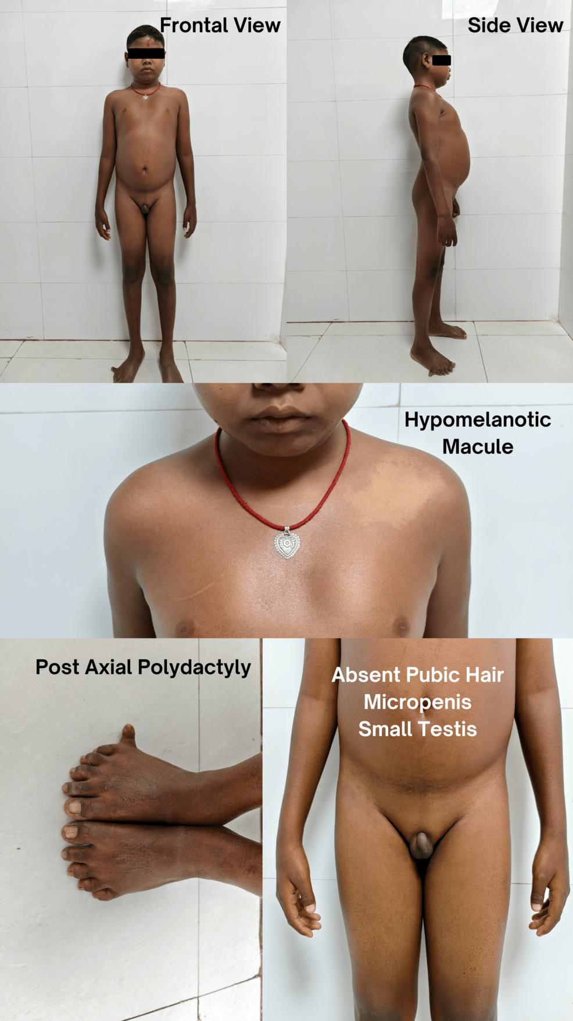
Figure 1: Morphological features of Patient in Frontal view and Side view demonstrating Hypomelanotic macule on left shoulder, Post axial polydactyly in right foot and micropenis and small testis with absent pubic hair
There was also presence of bilateral horizontal nystagmus in the child (Video-1).
The fundoscopy was suggestive of bilateral retinitis pigmentosa with macular degeneration (Figure 2).
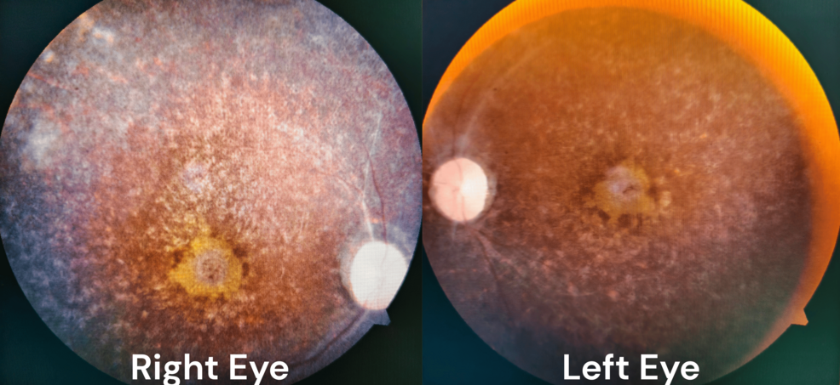
Figure 2: Fundoscopy picture demonstrating pigmentary retinopathy with macular degeneration of both eyes
An ultrasonographic examination of kidneys revealed presence of mild hydroureteronephrosis in right kidney. 2D echocardiography was normal, ruling out presence of any major structural or functional cardiac anomaly. (Figure 3)
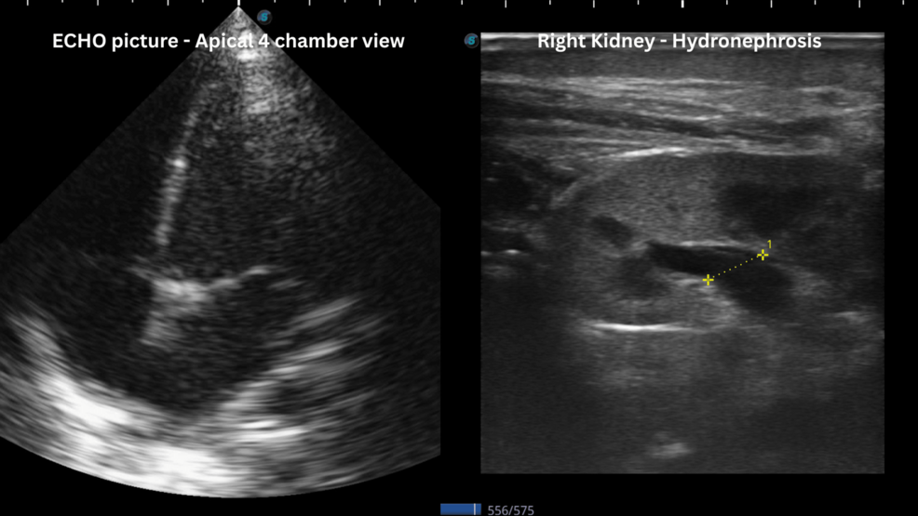
Figure 3: Echocardiographic picture of apical four chamber view; Ultrasound of Right Kidney demonstrating Hydronephrosis with dilated renal pelvis (anterior - posterior diameter 8mm)
Laboratory investigations revealed neutrophilic leukocytosis and raised levels of urea and creatinine, most probably caused by pre-renal acute kidney injury, which normalised after 2 days with supportive treatment (Table 1).
Laboratory parameter (unit) | Normal range | 12.02.2025 | 15.02.2025
Hemoglobin (g/dL) | 12-15 | 11.8 | 12.1
Total leukocyte count (per cu mm) | 4000-11000 | 29,921 | 14,120
Total platelet count (per cu mm) | 1,50,000-4,50,000 | 4,57,000 | 3,28,000
Neutrophil (%) | 40-70 | 95 | 68
Lymphocyte (%) | 10-40 | 3 | 20
Eosinophil (%) | 2-8 | 0 | 1
Serum Urea (mg/dL) | 10-40 | 76 | 32
Serum Creatinine (mg/dL) | 0.4-0.7 | 1.1 | 0.6
Serum Sodium (mmol/L) | 135-145 | 131 | 140
Serum Potassium (mmol/L) | 3.5-5.5 | 3.9 | 3.6
Serum Calcium (mmol/L) | 8-10.5 | 8.1 | 8.9
Serum Alanine Aminotransferase (IU/L) | 10-40 | 35 | 36
Serum Aspartate Aminotransferase (IU/L) | 10-40 | 33 | 30
Serum Alkaline Phosphatase (IU/) | 130-420 | 325 | 357
Serum Total Protein (g/dL) | 6.0-8.0 | 6.5 | 6.6
Serum Albumin (g/dL) | 3.5-5.0 | 3.9 | 3.8
Table 1: Laboratory parameters of the patient
Patient was stabilised by medical management, after which investigations were undertaken to ascertain the underlying cause of the above mentioned myriad of dysmorphic features in the child.
Considering all the above clinical features, a provisional clinical diagnosis of Bardet-Biedl syndrome was made and a whole exome sequencing was sent for confirmation. A homozygous splice site donor variant c.1527+1G>A in intron12 of the BBS2 gene on chromosome 16q with autosomal recessive inheritance was identified which is characteristic of Bardet-Biedl Syndrome 2 (OMIM: 615981) which was classified as Pathogenic as per ACMG classification [5].

Management and Outcome
Patient is currently under management with a multidisciplinary team of consisting of Pediatricians, Nephrologists, Ophthalmologists, Endocrinologists, Speech Pathologists and Dieticians. As this condition has no permanent cure currently, the plan of management for this child currently is frequent follow-up and trying to keep a check on worsening of symptoms. Patient is being taught the use of Braille and is currently taught in a school for Special Education. Annual screening by fundoscopy for retinal degeneration and fibro scans along with liver function tests (LFT) to look for emerging hepatic fibrosis. Informed consent form was signed by the patient's guardians giving permission for the use of patient's images and videos for the purpose of publication in scientific journal (a copy of the Informed Consent form has been sent to support@cureus.com)
Discussion
Bardet-Biedl Syndrome (BBS) was first described in literature independently by French Physician Georges Louis Bardet and Hungarian-Austrian Pathologist Artur Biedl in 1920 and 1922, respectively [6,7]. It is an extremely rare disorder with multisystem involvement which has an estimated prevalence of 1:1,60,000 [8]. It is an autosomal recessive condition which is included under the spectrum of “Ciliopathies” - a group of disorders associated with genetic mutations encoding defective proteins, which result in either abnormal formation or function of cilia [9,10]. It is a pleiotropic disorder with significant interfamilial and intrafamilial variation and has a higher prevalence among communities with higher rates of consanguinity, like Kuwait and Newfoundland [8]. The clinical phenotype of BBS evolves slowly throughout the first decade of life resulting in most patients getting diagnosed in the late childhood or adulthood [8].
Antenatal diagnosis can be suspected based upon ultrasonographic findings such as presence of polydactyly and structural renal abnormalities [8], but clinical diagnosis of BBS can be made on the basis of classical clinical manifestations which are considered as Primary features such as rod-cone dystrophy (93%), polydactyly (63-81%), central obesity (72-92%), learning disabilities (61%) and renal anomalies (53%). Several secondary features also aid in the diagnosis of this condition which includes speech disorder (54-81%), developmental delay (50-91%), brachydactyly (46-100%), diabetes mellitus (6-48%), ataxia (40-86%), dental defects (51%) and left ventricular hypertrophy (7%) on echocardiography [8,9,10]. Distinctive, but inconsistent, dysmorphic facial features include hypertelorism, midfacial hypoplasia and retrognathia, which can be subtle and difficult to appreciate [8]. The modified diagnostic criteria suggested by Beales et al in 1998 is as follows, in which presence of “4 primary” or “3 primary and 2 secondary” features are required to make a clinical diagnosis [11]. (Table 2)

Primary features | Secondary features
Rod cone dystrophy * | Speech disorder or delay *
Polydactyly * | Strabismus / Cataract / Astigmatism
Obesity * | Brachydactyly / Syndactyly
Learning disability * | Developmental delay *
hypogonadism (in males) * | Polyuria / Polydipsia
Renal anomalies * | Ataxia / Poor coordination / Imbalance *
 | Mild spasticity (especially Lower limbs)
 | Diabetes mellitus
 | Dental crowding / hypodontia / small roots / high arched palate
 | Left ventricular hypertrophy / congenital heart disease
 | Hepatic fibrosis
Table 2: Diagnostic Criteria for Bardet-Biedl Syndrome
* features present in our case
The clinical features of Bardet-Biedl syndrome can overlap with several conditions and hence the common differential diagnoses that should be thought of are as follows.
Laurence-Moon Syndrome: Historically considered related to BBS, this syndrome shares features like retinal degeneration and intellectual disability but is distinguished by the presence of spastic paraplegia and absence of polydactyly or obesity in some cases. The distinction is debated, as some experts view it as part of the BBS spectrum [12].
Alström Syndrome: This condition also presents with obesity, retinal dystrophy, and hearing loss, similar to BBS. However, polydactyly is absent, and patients often develop dilated cardiomyopathy and type 2 diabetes mellitus earlier and more consistently than in BBS [13].
McKusick-Kaufman Syndrome: This syndrome includes polydactyly, congenital heart defects, and hydrometrocolpos (in females), overlapping with BBS. However, it lacks the progressive retinal degeneration and obesity typically seen in BBS and is caused by mutations in the MKKS gene, which is also implicated in some BBS cases [14].
Prader-Willi Syndrome: Marked by obesity, hypotonia, intellectual disability, and hypogonadism, this condition can mimic BBS. However, it lacks polydactyly and retinal degeneration, and its genetic basis (chromosome 15q11-13 deletion or uniparental disomy) differs from BBS’s ciliary gene mutations [15].
Cohen Syndrome: This features obesity, intellectual disability, and retinal dystrophy, resembling BBS. Distinctive traits include prominent incisors, hypotonia, and neutropenia, with no polydactyly, and it’s linked to mutations in the VPS13B gene [16].
Joubert Syndrome: A ciliopathy like BBS, it shares features such as retinal dystrophy and kidney issues but is characterised by a “molar tooth sign” on brain imaging due to cerebellar vermis hypoplasia, which isn’t typical in BBS. Polydactyly can occur but is less common [17].
The genetic basis of BBS is related to at least 21 known mutations in BBS-causing genes known till now, including BBS gene family (BBS1-BBS20) and NPHP1 gene which encodes Nephrocystin1 protein, all of which contribute to the proper functioning of cilia [18]. The most common gene mutated in this syndrome is BBS1 (23%) followed by BBS10 (20%) [8,9]. BBS2 mutation, located on Chromosome 16q13, is the 3rd most common cause of BBS and accounts for 8% of cases affecting the BBSome protein function [8]. There is poor genotype-phenotype correlation in this disease although some studies have suggested that BBS2, BBS3 and BBS4 mutations may be linked to specific ocular phenotypes and more severe digital abnormalities [8].
A wide range of renal abnormalities such as Chronic Kidney Disease (CKD), Parenchymal cysts, calyceal clubbing, fetal lobulation, renal scarring, unilateral agenesis, renal dysplasia, renal calculi and vesicoureteric reflux are seen in children suffering from BBS [19]. Despite the variable renal involvement this condition, renal failure remains the leading cause of early death in this condition, accounting for 25% of deaths by age 41 [9,19]. Currently, there are no therapeutic options available to prevent the progressive deterioration in this condition [20].
Conclusions
Management of Bardet-Biedl syndrome requires a multidisciplinary holistic approach by a team consisting of pediatricians, nephrologists, orthopedic surgeons, ophthalmologists, cardiologists, endocrinologists, dental specialists, speech pathologists, audiologists and dieticians. Early educational plans must be made considering high incidence of rod cone dystrophy & the certainty of blindness and children must be trained in the use of Braille along with mobility training, adaptive living skills and computing skills. A healthy carbohydrate reduced diet in consultation with a dietician along with regular aerobic exercise must be undertaken to reduce the long term comorbidities associated with obesity. Special schools and educational programs will be needed to manage and circumvent the learning disabilities.
References
- Innes AM, Boycott KM, Puffenberger EG, et al.: A founder mutation in BBS2 is responsible for Bardet-Biedl syndrome in the Hutterite population: utility of SNP arrays in genetically heterogeneous disorders. Clin Genet. 2010, 78:424-431. 10.1111/j.1399-0004.2010.01481.x
- Alhamoud M, Alnosair G, Alhashim H: Bardet-Biedl Syndrome: A Rare Case From Ophthalmology Perspective. Cureus. 20221410, 29912-2022. 10.7759/cureus.29912
- Zaghloul NA, Katsanis N: Mechanistic insights into Bardet-Biedl syndrome, a model ciliopathy. J Clin Invest. 2009, 119:428-437. 10.1172/JCI37041
- Hufnagel RB, Arno G, Hein ND, et al.: Neuropathy target esterase impairments cause Oliver-McFarlane and Laurence-Moon syndromes. J Med Genet. 2015, 52:85-94. 10.1136/jmedgenet-2014-102856
- Richards S, Aziz N, Bale S, et al.: Standards and guidelines for the interpretation of sequence variants: a joint consensus recommendation of the American College of. Medical Genetics and Genomics and the Association for Molecular Pathology. Genet Med. 2015, 17:405-424. 10.1038/gim.2015.30
- Bardet G: On congenital obesity syndrome with polydactyly and retinitis pigmentosa (a contribution to the study of clinical forms of hypophyseal obesity) thesis, for the degree of doctor of medicine. Obes Res. 1995:387-99. 10.1002/j.1550-8528.1995.tb00165.x
- Biedl A. A pair of siblings with adiposo-genital dystrophy. Obes Res. 1995:404-404. 10.1002/j.1550-8528.1995.tb00167.x
- Forsythe E, Beales PL (2013: Bardet-Biedl syndrome. Eur J Hum Genet 21(1): 8-13. https://doi.org/10.1038/ejhg.2012.115. Epub. 2012, 20:22713813. 10.1038/ejhg.2012.115. Epub
- Rekhawar GR, Bhavana MP, Sawant VD, et al.: Bardet-Biedl Syndrome: a case report of delayed diagnosis with variable presentation and role of genetic testing in definitive diagnosis. Egypt Pediatric Association Gaz 71. 52:
- Waters AM, Beales PL: Ciliopathies: an expanding disease spectrum. Pediatr Nephrol. 2011, 26:1039-1056. 10.1007/s00467-010-1731-7
- Beales PL, Elcioglu N, Woolf AS, Parker D, Flinter FA: New criteria for improved diagnosis of Bardet-Biedl syndrome: results of a population survey. J Med Genet. 1999, 36:437-446.
- Khan BA, Shahid A, Bin Nazir M, Khan KS, Punshi A: Laurence-Moon-Bardet-Biedl Syndrome: A Case Report. Cureus. 2019119, 5618. 10.7759/cureus.5618
- Tahani N, Maffei P, Dollfus H, et al.: Consensus clinical management guidelines for Alström syndrome. Orphanet J Rare Dis. 2020151, 253-2020. 10.1186/s13023-020-01468-8
- 14. Ullah I, Rauf S, Ali S, et al.: A case of McKusick-Kaufman syndrome with perinatal diagnosis: case report and literature review. Ann Med Surg (Lond. 2022, 79:103926. 10.1016/j.amsu.2022.103926
- Belay KE, Ayalew BL, Amogne MT, Alemneh TA, Geletew TK: A 14-year-old male patient with diagnosis of Prader-Willi syndrome in Ethiopia: a case report. J Med Case Rep. 2023171, 530-2023. 10.1186/s13256-023-04282-5
- Taban M, Memoracion-Peralta DS, Wang H, Al-Gazali LI, Traboulsi EI: Cohen syndrome: report of nine cases and review of the literature, with emphasis on ophthalmic features. J AAPOS. 2007, 11:431-437. 10.1016/j.jaapos.2007.01.118
- Alam S, Khatoon F, Khan N: Joubert syndrome: a case report. Bull Fac Phys Ther 26. 18:
- Karmi HB, Abu Jwaid Y, Shehadeh MH, Njoom D, Awwad A and Eideh H (2024: Bardet-Biedl syndrome in a 19-year-old male: the first case report from Palestine. Front. Pediatr. 12:1420684. 10.3389/fped.2024.1420684
- Elawad OAMA, Dafallah MA, Ahmed MMM, et al.: Bardet-Biedl syndrome: a case series. J Med Case Rep. 2022161, 169-2022. 10.1186/s13256-022-03396-6
- Forsyth R, Gunay-Aygun M: Bardet-Biedl Syndrome Overview. In. Adam, MP, Feldman, J, Mirzaa, GM, Pagon, RA, Wallace, SE, Amemiya AGeneReviews®. Seattle (WA (ed): University of Washington, Seattle; July 14; 2003.

