**Correlation of Insulin Resistance and sensitivity in pregnancy with Obstetric and Neonatal outcomes: A Pilot Observational Study**

**Abstract:**

**Aims and objectives:** To assess insulin resistance and sensitivity during pregnancy and find its correlation with maternal and fetal outcomes.

**Materials and methods:** A two-year prospective observational study at All India Institute of Medical Sciences, New Delhi, enrolled 154 pregnant women, following 113 until delivery. Insulin resistance was assessed twice using HOMA IR and HOMA-β, and GDM was tested by OGTT.

**Results:** In our study, 17.7% of women were diagnosed with GDM. Significant correlations were found between BMI and insulin resistance (p=0.001), and family history of diabetes and insulin resistance (p=0.001). HOMA-IR ≥2.5 at 24-28 weeks increased the likelihood of GDM (p=0.014), preeclampsia (p=0.043), and caesarean sections (p=0.009). HOMA-IR <2.5 indicated healthier pregnancies (p=0.034). HOMA-β ≤184.1 was linked to adverse fetal outcomes and NICU admissions (p=0.012).

**Conclusions:** Optimizing BMI before pregnancy reduces risks like GDM, preeclampsia, NICU admissions, and neonatal hypoglycemia. Promote lifestyle, diet, exercise, and weight control awareness.

**Keywords:** insulin resistance, insulin sensitivity, HOMA-IR, HOMA- β, GDM

**INTRODUCTION:**

During pregnancy, insulin sensitivity in maternal tissues decreases by 50-60% (1)(2). Women with normal glucose tolerance compensate by increasing insulin secretion, but those with hyperglycemia cannot. In type 1 diabetes, insulin requirements rise by about 70% during pregnancy (3). This decreased sensitivity, due to a post-receptor defect, impairs the mobilization of GLUT4 and is influenced by elevated pregnancy hormones like estrogen, progesterone, prolactin, cortisol, and human placental lactogen. Insulin resistance is roughly three times higher in pregnancy than in non-pregnancy (6)(7).

Insulin resistance during pregnancy poses significant risks, the most common being gestational diabetes mellitus (GDM), which raises blood glucose levels and increases the risk of developing type 2 diabetes later (8)(9). This can adversely affect both mother and baby. Insulin resistance also predisposes women to preeclampsia, a potentially life-threatening hypertensive disorder. It contributes to abnormal vascular function and blood pressure dysregulation, leading to complications like preterm birth, fetal growth restriction, and long-term cardiovascular risks for the mother (10)(11). Impaired utero-placental circulation, another consequence, disrupts the supply of oxygen and nutrients to the fetus, causing growth restriction and other issues (12).

Despite extensive literature on hyperglycemia during pregnancy, comprehensive research on insulin resistance is lacking. This study aims to investigate pregnancy outcomes complicated by insulin resistance and assess its impact independently of hyperglycemia. It seeks to develop tailored interventions and strategies for better outcomes in this specific population, emphasizing the need for early detection and management of insulin resistance to mitigate adverse effects on maternal and fetal health. This study is aimed to assess insulin resistance and sensitivity during pregnancy and find its correlation with maternal and fetal outcomes.

**OBJECTIVES:**

**PRIMARY OBJECTIVE:**

1. To determine status of insulin resistance and sensitivity in pregnant women

**SECONDARY OBJECTIVES:**

1. To determine correlation of insulin resistance and sensitivity with obstetric outcome such as development of pre-eclampsia, gestational hypertension, chronic hypertension, polyhydramnios, postpartum hemorrhage, and puerperal sepsis.

2. To determine correlation of insulin resistance and sensitivity with perinatal outcome such as birth weight, occurrence of hypoglycemia, Transient tachypnoea of newborn, hyperbilirubinemia and NICU admissions.

**MATERIALS & METHODS:**

This Prospective Observational study was conducted between February 2022 to November 2023 in the Department of Obstetrics and Gynecology, All India Institute of Medical Sciences, New Delhi. The study was approved by the Institute Ethics Committee. Pregnant women above 18 years of age attending the outpatient antenatal clinic of the Department of Obstetrics and Gynaecology, and following the inclusion and exclusion criteria were recruited after taking informed consent. All the pregnant women underwent blood investigations at first antenatal visit. A blood sample for fasting plasma glucose and fasting serum insulin was taken after an overnight fasting of 8 hours. All enrolled women who were found to have FPG 92-125 mg/dl were labelled as GDM and were managed as per hospital protocol. All enrolled women were followed up and OGTT with 75 gm glucose was done at 24-28 weeks of gestation for women with normoglycaemia in early pregnancy. Repeat fasting serum insulin and fasting serum glucose was done in all pregnant women at 24-28 weeks.

Serum insulin estimation was performed using an electro chemiluminescent tracer-based immunometric assay (sandwich assay) using a Cobas e411 auto-analyzer (Roche Diagnostics). For plasma glucose, samples were collected in a fluoride vial, centrifuged immediately and were transported to the laboratory within 1 hour of collection in cool boxes. Glucose was analyzed using the hexokinase method with the Cobas Integra 400 plus auto-analyzer (Roche Diagnostics).

The Homeostasis model assessment (HOMA) was used to evaluate insulin resistance and beta cell function at the first antenatal visit

HOMA-IR = fasting plasma insulin concentration (μIU/mL) × fasting plasma glucose (mg/dl) / 405

HOMA-β = fasting plasma insulin concentration (μIU/mL) × 360/ fasting plasma glucose (mg/dl) -63

According to the HOMA-IR value, the cut-off value was set at 2.5 to denote insulin resistance (13). While median HOMA-β value at 12 weeks and 24-28 weeks were taken as cut-off for beta cell function.

All enrolled women were followed till delivery and maternal and fetal outcomes were noted.

Maternal outcomes such as development of pre-eclampsia, chronic hypertension, gestational hypertension, GDM, polyhydramnios, postpartum hemorrhage and puerperal sepsis were noted.

Fetal outcomes such as birth weight, occurrence of hypoglycemia, respiratory distress syndrome, hypocalcemia, hyperbilirubinemia, polycythemia and NICU admissions were noted.

  
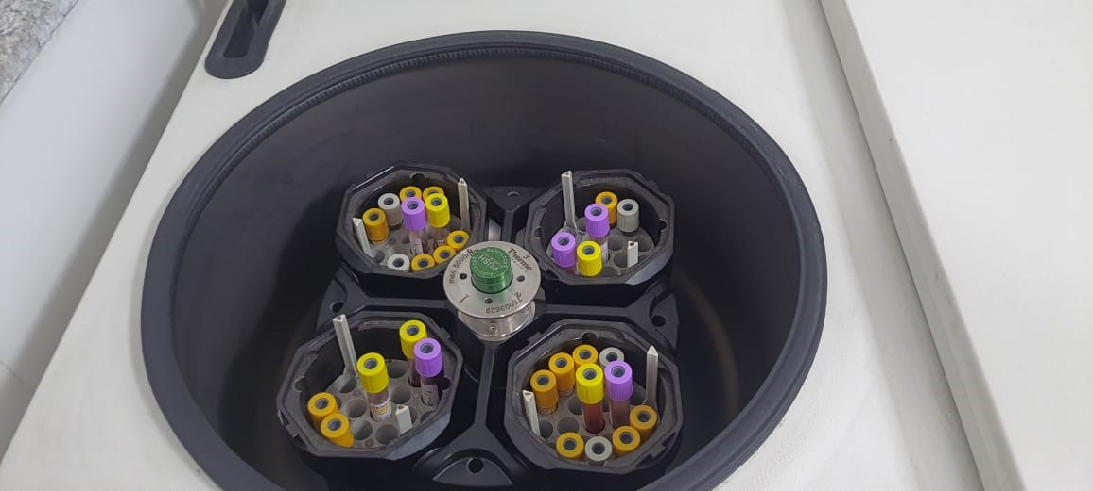

**picture 1-Centrifugation of fasting serum insulin using Multifuge X1R Centrifuge machine**

  
**picture 2-Cold boxes used to transport sample from outpatient department to the Lab**

**Statistical analysis*:*** Data analysis was carried out using SPSS, IBM version 20.0. Descriptive measures such as mean, standard deviation (SD) and range values were presented for normally distributed data. Comparison of mean values across categories were carried out using Student’s t- independent test/one way analysis of variance (ANOVA) test as appropriate. While carrying out ANOVA test, Changes in the HOMA-IR and HOMA-β between 12 weeks and 24-28 weeks were compared using independent paired sample-t test. Categorical data were presented as frequency and percentage values. Comparison of frequency data across categories were tested using Chi-square/Fishers Exact test as appropriate. Comparison of median within 2 groups done by Mann Whitney U test and median comparison between more than 2 groups done by Kruskal-walls 1 way ANOVA. Unadjusted odds ratio with 95% confidence intervals were presented. To decide the cut-off value of HOMA-IR and HOMA-β in predicting maternal and fetal outcome ROC analysis was carried out. A two- sided significant probability of p<0.05 was considered for statistical significance.

**Chart 1-WORKFLOW**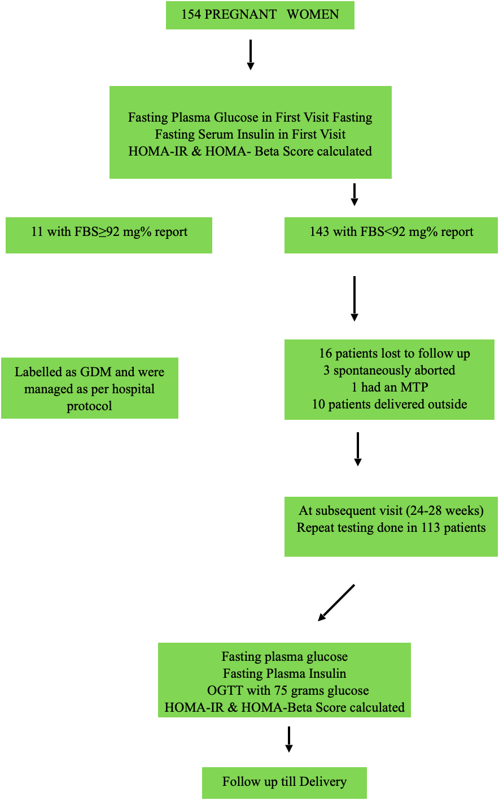

**OBSERVATION:**

A total of 154 pregnant women between 11+6 - 14 weeks of gestation, were screened from the antenatal clinic to participate in the study. Among them, 16 patients lost to follow-up, 3 spontaneously aborted, 1 had an MTP, and 10 patients delivered outside, so a total of 124 women were included in final analysis, and data on their maternal and fetal outcomes were analyzed.Out of a total of 124 women, we found a total of 22 women i.e., 17.7% were GDM. Out of 22 women, 11 women were diagnosed with GDM in early gestation and were excluded from analysis, and 11 were diagnosed with GDM in subsequent visit. Out of the 113, 3.5% (n=4) developed pre-eclampsia, 4.4% (n=5) developed gestational hypertension, 1.7%(n=2) developed chronic hypertension and 9.7% (n=11) developed gestational diabetes mellitus on OGTT. Out of 113 babies born 7.1% (n=8) were delivered preterm, 21.2% (n=24) were low birth weight, 12.3% (n=14) were small for date,13.2% (n=15) were large for date, and 6.2 % (n=7) had NICU admission.

**RESULTS:**

The comparison of HOMA-IR at 24-28 weeks in relation to 12 weeks revealed that among the participants, 80 individuals exhibited the same levels of insulin resistance (20 remained HOMA-IR ≥2.5 and 60 remained HOMA-IR<2.5), 19 individuals experienced an increase in insulin resistance, and 14 individuals demonstrated a decrease in insulin resistance.

***Figure 1: HOMA-IR trend at 24-28 weeks in comparison to 12 weeks***

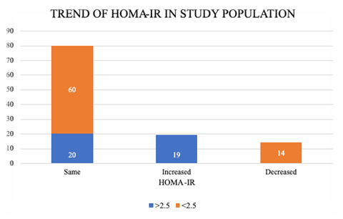

Insulin resistance was significantly increased with age (p <0.005). Significant associations were also found between BMI and HOMA-IR at both 12 weeks and 24-28 weeks period of gestation (p < 0.005), while HOMA-β showed a significant association only at 12 weeks (p = 0.0001).

Insulin resistance (HOMA-IR≥2.5) was found to be strongly associated with family history of diabetes mellitus at both 12 weeks and 24-28 weeks period of gestation. It was statistically significant with a p-value = 0.021 at 12 weeks and p-value = <0.0001 at 24-28 weeks.

Insulin resistance was divided into two groups <2.5 and ≥2.5. A total of 69.9% (n=79) of pregnant women had HOMA-IR < 2.5 and 30.1% (n=34) had ≥ 2.5. Maternal outcomes were equally distributed between two groups, with no statistically significant difference with respect to HOMA-IR at 12 weeks (p=0.060). However, it was noted that in patients who had HOMA-IR <2.5 at 12 weeks, majority had a healthy pregnancy (p=0.043).

We found that in the patients who had insulin resistance ≥2.5mg/dl at 24-28 weeks period of gestation were significantly more likely to have GDM (p=0.014), preeclampsia(p=0.043) and had significantly higher caesarean section rates (p=0.009). Also, it was noted that in patients who had HOMA-IR <2.5 at 24-28 weeks, majority had a healthy pregnancy (p=0.034).

We also noted that in the babies who required NICU admissions significant number of their mothers had HOMA-β value ≤184.1 at 24-28 weeks period of gestation(p=0.012).

We compared the demographic and clinical characteristics between patients with and without adverse composite pregnancy outcomes i.e., adverse maternal outcomes combined with adverse neonatal outcomes. It was found that in patients with adverse pregnancy outcomes majority had a family history of diabetes(p=0.014). Also, these patients had significantly increased fasting serum insulin and HOMA-IR at 12 weeks (p=0.031, 0.034 respectively). Birth weight, gestation age at delivery, and 1 minute Apgar score was also significantly lower in this group (p=0.009, <0.005 and 0.003 respectively).

On exploring the relationship between HOMA-IR levels at 12 weeks and the occurrence of adverse pregnancy outcomes, comprising both maternal and neonatal complications, significant association was found (p=0.032).

***Table 1: Association of HOMA-IR at*** ***12 weeks with Adverse pregnancy outcomes***

|  |  |  |  |  |
| --- | --- | --- | --- | --- |
|  | **HOMA-IR at 12 weeks** | |  | **p-value** |
| **Adverse Pregnancy outcomes** | **<2.5** | **≥2.5** | **n (%)** |
| No | 43 | 11 | 54 (47.8%) | 0.032 |
| Yes | 36 | 23 | 59 (52.2%) |
|  | 79 (69.9%) | 34 (30.1%) | 113 |

***Figure 2: Association of HOMA-IR at*** ***12 weeks with Adverse pregnancy outcomes***

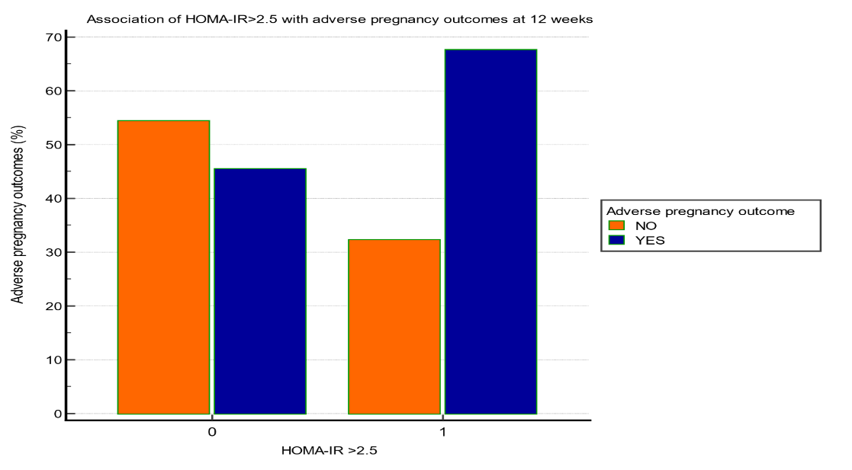

###### **Prediction of Adverse pregnancy outcomes at 12 weeks by ROC analysis:**

To decide the cut-off value of HOMA-IR and Fasting serum insulin levels at 12 weeks for predicting composite adverse pregnancy outcomes (including both adverse maternal and adverse fetal outcomes), ROC analysis was carried out. (figure 1) (Table 2)

## ***Table 2. ROC curve analysis for HOMA-IR and fasting serum insulin at 12 weeks***

|  |  |  |
| --- | --- | --- |
| **Variables** | **HOMA-IR** | **Fasting s. insulin** |
| Area under the ROC curve | 0.628 | 0.626 |
| Standard Error | 0.053 | 0.053 |
| 95% confidence interval | 0.524-0.732 | 0.522-0.730 |
| P value | 0.015 | 0.017 |
| Cut off | >2.14 | >9.59 |
| Sensitivity | 54% | 59% |
| Specificity | 74% | 66% |

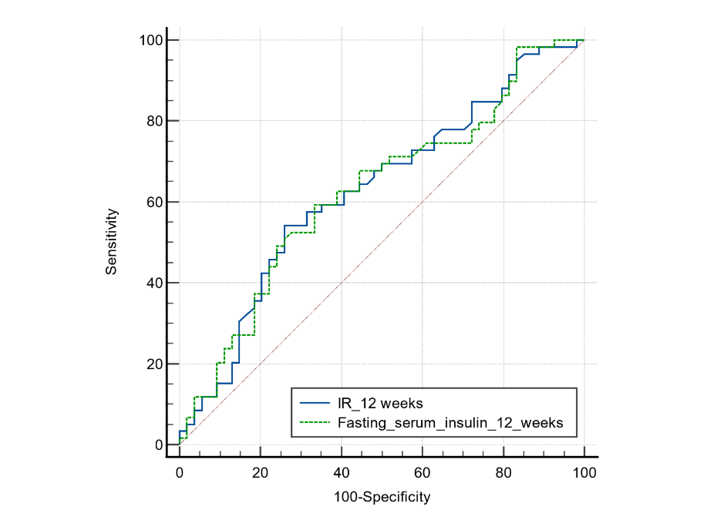

***Figure 3. ROC curve of HOMA-IR and fasting serum insulin in prediction of adverse pregnancy outcomes***

In the ROC curve analysis for HOMA-IR and fasting serum insulin, the area under the curve (AUC) was determined to be 0.628 and 0.626, respectively. The p-values associated with these analyses were 0.015 and 0.017, indicating statistical significance. The determined cut-off values for categorization were >2.14 for HOMA-IR and >9.59 for fasting serum insulin. Sensitivity and specificity for each variable were also computed, with HOMA-IR demonstrating a sensitivity of 54% and specificity of 74% and fasting serum insulin exhibiting a sensitivity of 59% and specificity of 66%. These findings provide valuable insights into the diagnostic performance of these variables.

**DISCUSSION:**

This study conducted on 124 pregnant women provides valuable insights into the prevalence and implications of gestational diabetes mellitus (GDM) and its association with maternal and fetal outcomes, alongside factors influencing insulin resistance during pregnancy. Comparing these findings with existing literature underscores the significance of the study's contributions and sheds light on potential avenues for further research and clinical intervention.

The observed prevalence of GDM (17.7%) aligns with previous studies documenting a rising trend in GDM rates globally, suggesting a consistent epidemiological pattern across different populations (14). This highlights the ongoing importance of GDM screening and management strategies in antenatal care to address its substantial impact on maternal and fetal health.

Furthermore, the identified associations between insulin resistance, demographic factors, and adverse pregnancy outcomes corroborate findings from prior research. Age and BMI emerged as significant predictors of insulin resistance, consistent with established literature indicating their role in modulating metabolic health during pregnancy (15). Additionally, the observed association between a family history of diabetes and insulin resistance echoes previous studies highlighting genetic predispositions to metabolic disturbances in pregnancy (16).

The division of participants based on HOMA-IR levels (<2.5 and ≥2.5) revealed differential risks for adverse outcomes, echoing similar findings in the literature. While the lack of significant differences in maternal outcomes at 12 weeks mirrors some previous studies (17), the association between elevated HOMA-IR levels at 24-28 weeks and increased risks of GDM, pre-eclampsia, and higher rates of caesarean section aligns with existing evidence implicating insulin resistance in adverse pregnancy outcomes (14)

Moreover, the study's investigation of the relationship between HOMA-IR levels and neonatal outcomes adds to a growing body of literature highlighting the potential implications of maternal metabolic health on fetal development and health outcomes (14). The significant differences observed in demographic and clinical characteristics between patients with and without adverse composite pregnancy outcomes further emphasize the multifactorial nature of pregnancy-related complications and underscore the importance of targeted interventions aimed at mitigating metabolic risks during gestation (18).

A major strength of this study lies in its use of established equations that offer valuable insights into the correlation of insulin sensitivity, β-cell function, and adverse pregnancy outcomes in women with GDM. Early lifestyle interventions are essential to increase insulin sensitivity and preserve β cell function. Inevitably, there are several limitations in this study. First, a percentage of pregnant women failed follow-up until delivery, possibly due to the coronavirus pandemic limiting regular follow-up. Also, the limited sample size in one single centre may bias external generalizability, which requires validation in a wider population with larger samples and a more representative prevalence of results. Due to the strong relationship between obesity and insulin resistance, it is advisable for individuals to optimize their weight before planning pregnancy to reduce the risk. Promoting awareness of a healthy lifestyle, balanced diet, regular exercise, and weight control is essential for the well-being of expectant parents.

This study's findings contribute valuable insights into the complex interplay between insulin resistance, maternal factors, and pregnancy outcomes. By contextualizing these results within existing literature, the study underscores the need for continued research and clinical interventions aimed at addressing metabolic disturbances during pregnancy to optimize maternal and neonatal health outcomes.

**CONCLUSION:**

In conclusion, the present study focused on insulin sensitivity and resistance in the first and second trimester of gestation. HOMA-IR and the quantitative insulin sensitivity check have been recommended in many institutions, but there is no commonly accepted HOMA-IR cutoff value. The standardized insulin assay was not available in the past few years; however, the technique of serum insulin test has become increasingly popular for clinical use in recent year. We demonstrated that increased HOMA-IR and decreased HOMA-β in early pregnancy is a risk factor for adverse pregnancy outcomes and is significantly influenced by body weight. If the HOMA-IR of a pregnant woman was higher than the cutoff point in early pregnancy, appropriate strategies should be taken to reduce adverse pregnancy outcomes. We have provided new evidence on the early identification of adverse pregnancy outcomes independent of the glycaemic values.

**REFERENCES:**

1. Catalano PM. Obesity, insulin resistance, and pregnancy outcome. REPRODUCTION. 2010 Sep;140(3):365–71.

2. Catalano PM. Trying to understand gestational diabetes. Diabet Med. 2014 Mar;31(3):273–81.

3. Skajaa GØ, Fuglsang J, Kampmann U, Ovesen PG. Parity Increases Insulin Requirements in Pregnant Women With Type 1 Diabetes. J Clin Endocrinol Metab. 2018 Jun 1;103(6):2302–8.

4. García-Patterson A, Gich I, Amini SB, Catalano PM, De Leiva A, Corcoy R. Insulin requirements throughout pregnancy in women with type 1 diabetes mellitus: three changes of direction. Diabetologia. 2010 Mar;53(3):446–51.

5. Padmanabhan S, Jiang S, Mclean M, Cheung NW. Effect of pregnancy on insulin requirements differs between type 1 and type 2 diabetes: A cohort study of 222 pregnancies. Aust N Z J Obstet Gynaecol. 2016 Aug;56(4):352–7.

6. Plows J, Stanley J, Baker P, Reynolds C, Vickers M. The Pathophysiology of Gestational Diabetes Mellitus. Int J Mol Sci. 2018 Oct 26;19(11):3342.

7. Bhograj A, Suryanarayana K, Nayak A, Murthy N, Dharmalingam M, Kalra P. Serum adiponectin levels in gestational diabetes mellitus. Indian J Endocrinol Metab. 2016;20(6):752.

8. Hedblad B, Nilsson P, Janzon L, Berglund G. Relation between insulin resistance and carotid intima‐media thickness and stenosis in non‐diabetic subjects. Results from a cross‐sectional study in Malmö, Sweden. Diabet Med. 2000 Apr;17(4):299–307.

9. Sonagra AD. Normal Pregnancy- A State of Insulin Resistance. J Clin Diagn Res [Internet]. 2014 [cited 2023 Dec 9].

10. Bano S, Agrawal A, Asnani M, Das V, Singh R, Pandey A, et al. Correlation of Insulin Resistance in Pregnancy with Obstetric Outcome. J Obstet Gynecol India. 2021 Oct;71(5):495–500.

11. Kaaja R. Insulin Resistance Syndrome in Preeclampsia. Semin Reprod Med. 1998 Mar;16(01):41–6.

12. Vega M, Mauro M, Williams Z. Direct toxicity of insulin on the human placenta and protection by metformin. Fertil Steril. 2019 Mar;111(3):489-496.e5.

13. Singh C, Gupta Y, Goyal A, Kalaivani M, Garg V, Bharti J, et al. Glycemic profile of women with normoglycemia and gestational diabetes mellitus during early pregnancy using continuous glucose monitoring system. Diabetes Res Clin Pract. 2020 Nov;169:108409.

14. HAPO Study Cooperative Research Group et al. “Hyperglycemia and adverse pregnancy outcomes.” The New England journal of medicine vol. 358,19 (2008): 1991-2002.

15. Thaker VV, Leduc CA, Salem R. 178-LB: Association of Pregnancy Oral Glucose Tolerance Test (OGTT) Glucose Response with Metabolic Profile in Mother and Child—Hyperglycemia and Adverse Pregnancy Outcomes Follow-up Study (HAPO-FUS). Diabetes. 2023 Jun 20;72(Supplement_1):178-LB.

16. Lee KW, Ching SM, Ramachandran V, Yee A, Hoo FK, Chia YC, et al. Prevalence and risk factors of gestational diabetes mellitus in Asia: a systematic review and meta-analysis. BMC Pregnancy Childbirth. 2018 Dec;18(1):494.

17. Landon, Mark B et al. “A multicenter, randomized trial of treatment for mild gestational diabetes.” The New England journal of medicine vol. 361,14 (2009): 1339-48.

18. Nohr, Ellen A et al. “Combined associations of prepregnancy body mass index and gestational weight gain with the outcome of pregnancy.” The American journal of clinical nutrition vol. 87,6 (2008): 1750-9.