Abundance and Partial Harmfulness Index (PHI) of weeds in plantain (Musa paradisiaca L., Musaceae) in Mé region, South-East Côte d'Ivoire

ABSTRACT
Poor weed management can result in additional costs that can be estimated at over 35%. Determining of the most troublesome weeds is becoming an essential part of effective weed control. A study was therefore carried out in the south-east of Côte d'Ivoire, in plantain plantations, to identify abundant weeds and assess their potential for causing damage. Two approaches were used. The first one consisted in carrying out a survey of plantain growers and the second in carrying out floristic surveys in plantain fields. To do this, the degree of infestation and the Partial Harmfulness Index of the major weeds in these works were analysed. Growers have identified 19 weeds that are difficult to control. In terms of weed flora, 152 species divided into 115 genera belonging to 47 families were recorded. The infestation diagram distinguished 20 major weeds, of which Panicum laxum is the most aggressive (FC = 80.28 % ; ADaverage= 1.55). The Partial Harmfulness Index (PHI) determined five (5) potentially harmful weeds (PHI ≥ 1000). After cross-referencing the two lists of constraining and major weeds (survey and floristic survey), there is floristic homogeneity, with 25 constraining and major weeds in this study. With a view to better weed control in banana cultivation in the Mé region, growers should take into account the most abundant and constraining weeds in order to reduce yield losses.

Keywords : Major weeds, degree of harmfulness, Plantain, South-East Côte d'Ivoire

- INTRODUCTION
Plantain is one of the main foodstuffs consumed in Central and West Africa (Tetang 2013). The entire value chain of this speculation contributes to reducing food insecurity, from which many dishes derive, to create jobs and to fight against poverty in rural and urban areas (Nkendah 2001). In Côte d'Ivoire, there are five main food crops with significant production, including plantain (preceded by yam and cassava) with an estimated annual production of 1.8 million tons, 40-50% of which is consumed directly (Thiemele et al., 2017). Côte d'Ivoire is the leading exporter of plantain in West Africa, with part of its production exported to the sub-region (Mali, Burkina Faso, Ghana, Liberia, etc.) and to Europe (Traoré et al., 2009). However, plantain production in Côte d'Ivoire is still inadequate. These productivity losses are due to climatic factors and bio-aggressors, including weeds. Weeds are among the leading causes of crop production losses worldwide (Basu et al., 2004 ; Rao et al., 2007). Weeds cause yield losses estimated at between 15 and 97% (Arslan et al., 2016). Poor weed control in an agrosystem can increase farm labour costs by 35% (Kumar et al., 2013). In addition, the scarcity and high cost of labour mean that growers have to maximise their weeding time. It is in this sense that the identification of the most troublesome weeds will enable them to facilitate weed control. The aim of this study is to determine which weeds are most abundant and which could be potentially harmful in banana plantations.
Through this study, knowledge of these weeds could guide weed control in order of priority, i.e. first eliminate the most harmful to the least harmful. Knowledge of these weeds will also enable farmers to use appropriate control methods and adapted technical itineraries.
2. MATERIALS AND METHODS
2.1. Study site
The study area is located in the south-east of Côte d'Ivoire, specifically in the departments of Adzope, Akoupe and Alepe. These three departments are the main plantain production areas in the Mé Region. Mé region is one of the main banana-producing areas in Côte d’Ivoire (Figure 1).

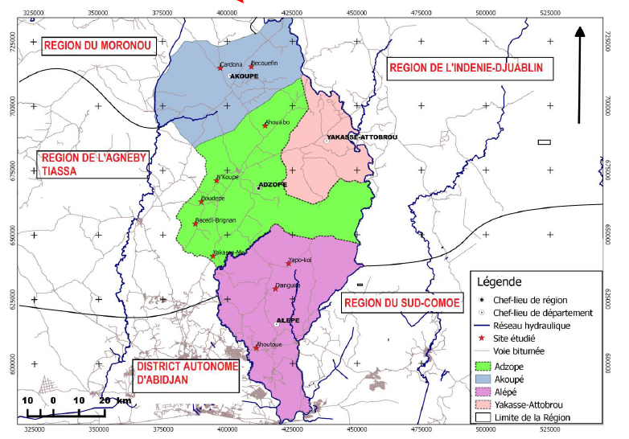
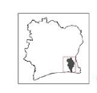

Figure 1. Location of study sites in the study area (Yapi et al., 2021)
2.2. Data collection
Data collection consisted of carrying out a seriee of floristic surveys, coupled with a survey of growers. A questionnaire was drawn up, including an inventory of the most difficult weeds to weed and the most abundant or major weeds on the farm. For the floristic survey, the itinerant survey method coupled with a tour of the fields was used. The size of plantain plantation plots varied from 0.25 to 1 ha, but the elementary plot sampled was 0.25 ha (Traoré 1991 ; Le Bourgeois 1993). The relative importance of each weed was defined using the abundance-dominance score assigned (Table 1). This scale combines the indices + and 1 in the same class 1 so as to assign the same coefficient to species which, due to their low cover or density, do not represent a direct nuisance for the crop.
Table 1. Transformation of abundance-dominance into percentage of average cover (Gounot 1969)
Abundance-dominance index | Recovery class | Average coverage (%)
5 | 75-100 | 87,5
4 | 50-75 | 67,5
3 | 25-50 | 37,5
2 | 10-25 | 17,5
1 | 1-10 | 5,5

2.3. Data analysis
Two analytical approaches were used : qualitative and quantitative analysis of the weed flora.
2.3.1. Qualitative aspect of the flora
Qualitative floristic analysis was used to describe the composition of the weed flora (Lebreton and Le Bourgeois 2005), floristic richness, the spectrum of biological types, morphological types and the similarity coefficient.Richesse and floristic composition : the number of weed species, genera and families recorded in the study were determined. The nomenclature adopted for the identification of the inventoried species is that of APG IV (2016).
- Biological type spectrum : the species identified were classified according to their biological types. The model used in this work is that of several authors (Aké-Assi 2001 and 2002 ; Mbayngone et al., 2008), adapted from Raunkiaer (1905).
- Morphological type : the weed species surveyed were classified according to three main morphological types : arborescent (trees and shrubs), lianascent and herbaceous. The proportions of the different morphological types were used to construct a histogram.
- Coefficient of similarity : the degree of similarity between two lists of flora is called the coefficient of similarity (Cs). The formula used, as presented below, is that of Sørensen (1948), reported by Gounot (1969), Daget and Poissonet (1969) :
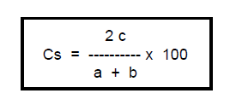
When Cs is greater than or equal to 50%, this means that the two lists being compared are so close to each other that they can be considered to be identical environments. In our study, the two lists will be merged to obtain the list of major and constraining weeds. If the Cs is less than 50%, the two environments concerned can be considered as floristically different. Thus, he species common to both lists will be retained and will constitute the list of major and constraining weeds.
2.3.2. Quantitative aspect of the flora
The quantitative aspect of the flora concerned the frequency and abundance-dominance of weeds. These two variables were used to determine the degree of infestation of each weed and the partial harmfulness index.
- Weed frequencies : frequency is a measure of the regularity of the distribution of a species in a plant community (Ipou, 2005). Absolute and centesimal frequencies, as defined by Daget and Poissonet (1969), are taken into account in this study. It is defined by the following formula :

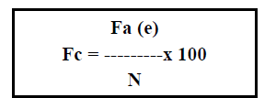
Where, Fc - centesimal frequency, N - total number of readings, Fa - absolute frequency
- The average abundance-dominance index [AD avg (e)] defines the ratio of the sum of the species' abundance-dominance scores [Σ AD of species (e)] to the total number of surveys (N).
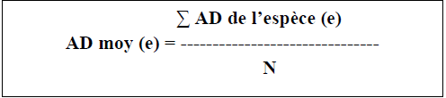
- Infestation diagram : this consists of a scatter plot based on centesimal frequencies on the abscissa and average abundance-dominance indices on the ordinate. Several groups of weeds are differentiated according to the Le Bourgeois (1993) classification, from the least to the most infesting.In this study, weeds with a centesimal frequency greater than 40% and an abundance-dominance greater than or equal to 0.25 will be considered infesting (Yapi et al., 2021).
- Partial Harmfullness Index (PHI) : to assess the potential harmfulness of weeds, the Partial Pest Index (PPI) was also determined using the following formula : PHI = Sum of the average cover of the species x 100 / Absolute frequency of the species (Bouhache and Boulet 1984 ; Zidane et al., 2010).
According to Ka et al. (2020), species with a centesimal frequency of less than 20% are considered to be non-noxious weeds.

3. RESULTS
3.1 Flora of constraining weeds identified by growers
The 71 plantain growers identified 19 weed species grouped into 17 genera and 8 botanical families (Table 2). Asteraceae (4 species), Euphorbiaceae (3 species), Poaceae (3 species) and Fabaceae (3 species) are the best represented families. Six species have centesimal frequencies greater than 25%. These are : Croton hirtus L'Hérit (Euphorbiaceae), Panicum laxum Sw. (Poaceae), Centrosema pubescens Benth (Fabaceae), Porophyllum ruderale Jacq. (Asteraceae), Panicum maximum Jacq. (Poaceae) and Chromolaena odorata (L.) R. King. (Asteraceae). Most of these weeds are Therophytes (31.58 %), Microphanerophytes (21.05 %) and Nanophanerophytes (21.05 %) (Figure 2). In terms of morphological types, herbaceous species are the most represented, with an estimated proportion of 47.37 % (Figure 3).
3.2 Weed flora from floristic surveys
3.2.1. Floristic analysis
The surveys identified 152 weeds. This weed flora comprises 115 genera belonging to 47 families. The best represented families are Poaceae (23), Asteraceae (15), Fabaceae (14), Euphorbiaceae (13), Rubiaceae (10) and Cyperaceae (9). Of the biological types represented, Therophytes (32 %), Microphanerophytes (22 %) and Nanophanerophytes (18.67 %) are the most abundant, whatever the locality (Figure 4). In terms of morphological types, grasses and shrubs/shrubs are the most abundant, with 54 % and 27 % respectively (Figure 5). Although the proportion of lianescent species is low (15 %), their presence causes disadvantages because they can hinder weeding and can slow down the growth of young banana trees by curling up.
Table 2. Constraining weeds identified by plantain growers, by locality
 |  |  |  |  | Localities
N° | Species | Families | FC | Class | Adzopé | Akoupé | Alépé
1 | Ageratum conyzoides | Asteraceae | 18,31 | D | + | + | -
2 | Alchornia cordifolia | Euphorbiaceae | 15,49 | D | + | + | -
3 | Calopogonium mucunoides | Fabaceae | 19,72 | D | + | - | +
4 | Centrosema pubescens | Fabaceae | 35,21 | D | - | + | -
5 | Chromolaena odorata | Asteraceae | 56,34 | D | + | + | +
6 | Commelina benghalensis | Commelinaceae | 12,68 | M | - | - | +
7 | Commelina diffusa | Commelinaceae | 14,08 | M | - | + | -
8 | Croton hirtus | Euphorbiaceae | 32,39 | D | + | + | -
9 | Diodia rubricosa | Rubiaceae | 12,68 | D | - | - | +
10 | Dissotis rotundifolia | Melastomataceae | 11,27 | D | + | - | -
11 | Mallotus oppositifolius | Euphorbiaceae | 14,08 | D | + | - | +
12 | Mitracarpus villosus | Rubiaceae | 14,08 | D | - | + | -
13 | Panicum laxum | Poaceae | 53,52 | M | + | + | +
14 | Panicum maximum | Poaceae | 43,66 | M | + | + | +
15 | Porophyllum ruderale | Asteraceae | 42,25 | D | + | - | +
16 | Pueraria phasoeloides | Fabaceae | 18,31 | D | - | - | +
17 | Rottboelia cochinchinensis | Poaceae | 12,68 | M | + | + | -
18 | Sida acuta | Malvaceae | 11,27 | D | + | - | -
19 | Synedrella nodiflora | Asteraceae | 22,54 | D | + | + | +
+: Present; -: Absent; D: Dicotyledonous; M: Monocotyledonous; CF: Centesimal frequency; In bold: the most frequently cited constraining weeds.
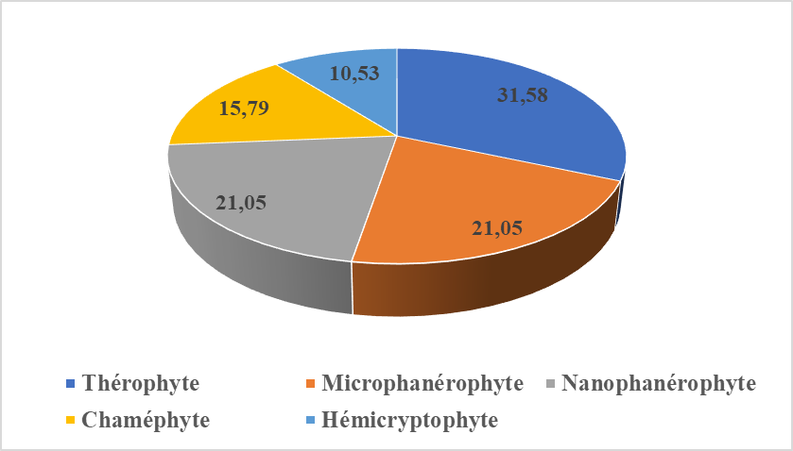
Figure 2. Biological types of constraining weeds in plantain cultivation, recorded during the survey

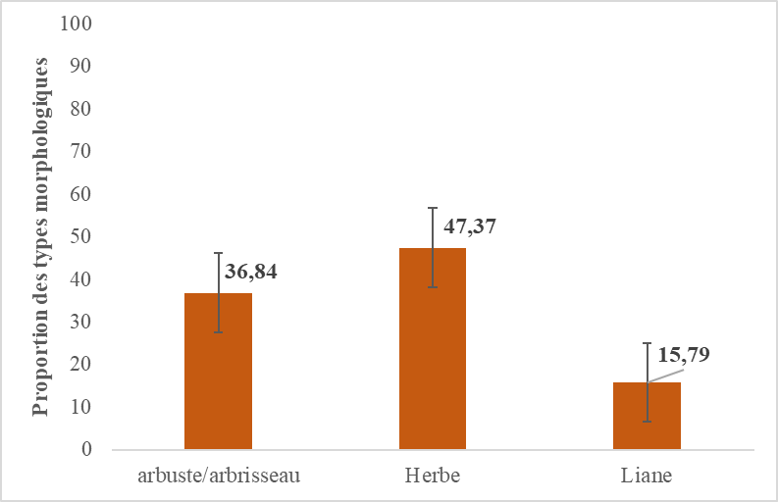
Figure 3. Histogram of morphological types of constraining weeds in plantain cultivation, recorded during the survey

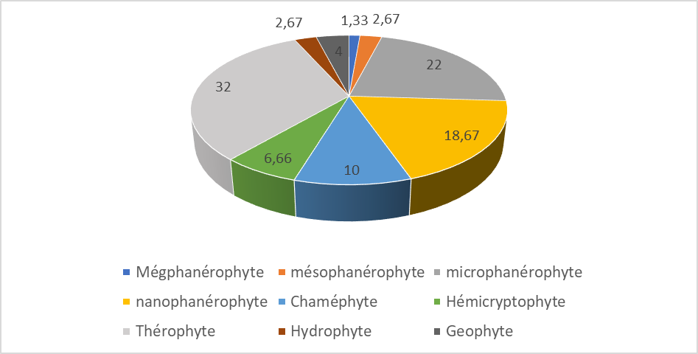
Figure 4. Histogram of biological types of weeds in plantain crops recorded during the floristic inventory.

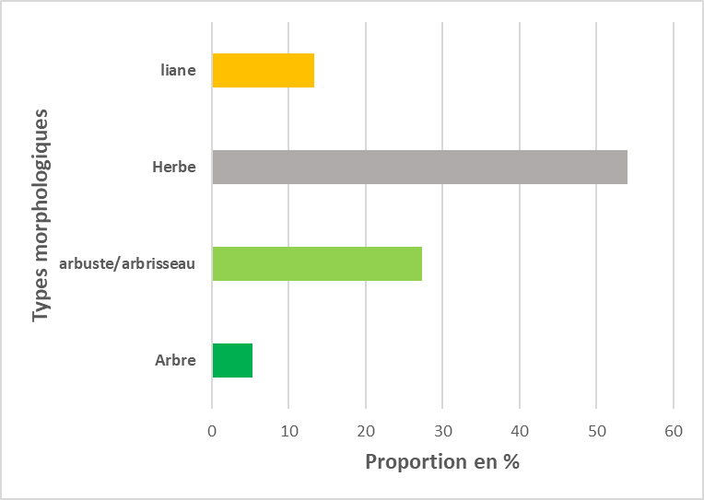
Figure 5. Histogram of morphological types of weeds in plantain crops recorded during the floristic inventory.

3.2.2. Degree of weed infestation
Data Analysis reveals that 20 species have a centesimal frequency greater than or equal to 40% and an average dominance abundance greater than or equal to 0.25. Figure 6 shows the potential harmfulness of the weeds inventoried. Five groups of species are represented. General major weeds (G1), are represented by a single species (Panicum laxum), general potential weeds (G2), with three species (Porophyllum ruderale, Croton hirtus and Synedrella nodiflora) and general weeds (G3), with seven species (Ageratum conyzoides, Chromolaena odorata, Calopogonium mucunoides, Panicum maximum, Mitracarpus villosus, Centrosema pubescens and Pueraria phasoeloides). Major regional weeds (G6) and minor plantain weeds (G9) make up all the other weeds.
3.2.3. Partial Harm Index (PHI)
Calculation of the Partial Harm Index revealed the existence of 41 potentially harmful weeds in plantain cultivation in the study area (Table 3). These species are divided into two groups and represent 26.97% of the general flora inventoried. The first group contains five species with an PHI greater than 1000. These are, in descending order, Synedrella nodiflora (PHI = 2488.46), Croton hirtus (PHI = 2345.88), Porophyllum ruderale (PHI = 1919.23), Panicum laxum (PHI = 1890.35) and Ageratum conyzoides (PHI = 1536.67). These species make up 3.29% of the flora. These species are considered as the most harmful in plantain fields. The second group, with an estimated proportion of 23.68% of the species of flora inventoried, includes 36 species with an PHI of between 500 and 1000. These species are moderately harmful.
3.2.4. Floristic similarity of flora
Comparison of the two floristic inventories showed that the list of constraining weeds cited by the growers is floristically homogeneous with that of the major weeds from the floristic surveys. The similarity coefficient was 71.79%. The species common to both lists are 14 weeds. Analysis of the calculation of the similarity coefficient (Cs>50%) reveals that 25 weeds are constraining and major in plantain cultivation in the study area (Table 4).
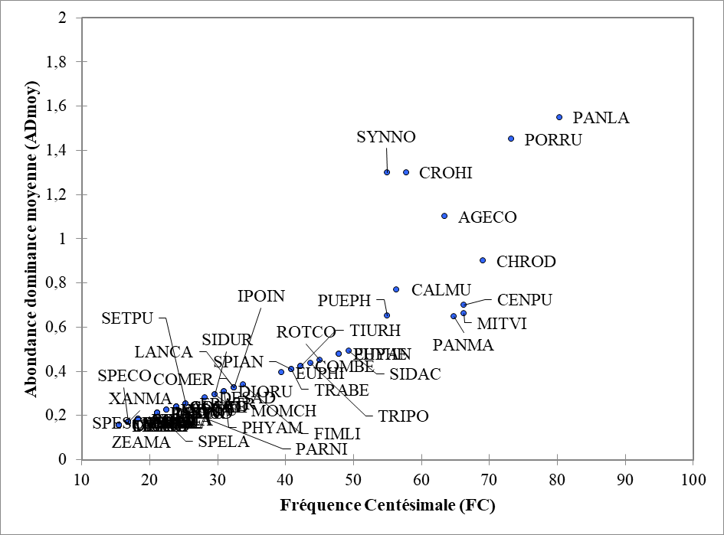
G 9
G 7
G 5
G 2
G 1
G 8
G 6
G 4
G 3
Figure 6. Weed infestation diagram for plantain crops in the study area

Table 3. Partial Harm Index for species
N° | Species | Relative frequency | Centesimal frequency | PHI
1 | Synedrella nodiflora | 39 | 54,93 | 2488,46
2 | Croton hirtus | 41 | 57,75 | 2354,88
3 | Porophyllum ruderale | 52 | 73,24 | 1919,23
4 | Panicum laxum | 57 | 80,28 | 1890,35
5 | Ageratum conyzoides | 45 | 63,38 | 1536,67
6 | Calopogonium mucunoides | 40 | 56,34 | 1000,00
7 | Chromolaena odorata | 49 | 69,01 | 933,67
8 | Pueraria phasoeloides | 39 | 54,93 | 765,38
9 | Centrosema pubescens | 47 | 66,20 | 643,62
10 | Alchornea cordifolia | 17 | 23,94 | 550,00
11 | Axonopus compressus | 15 | 21,13 | 550,00
12 | Commelina benghalensis | 30 | 42,25 | 550,00
13 | Commelina diffusa | 17 | 23,94 | 550,00
14 | Commelina erecta | 23 | 32,39 | 550,00
15 | Costus afer | 17 | 23,94 | 550,00
16 | Desmodium adscendens | 20 | 28,17 | 550,00
17 | Desmodium triflorum | 15 | 21,13 | 550,00
18 | Diodia rubricosa | 22 | 30,99 | 550,00
19 | Eragrostis tremula | 18 | 25,35 | 550,00
20 | Euphorbia heterophylla | 34 | 47,89 | 550,00
21 | Euphorbia hirta | 28 | 39,44 | 550,00
22 | Fimbristylis littoralis | 24 | 33,80 | 550,00
23 | Imperata cylindrica | 16 | 22,54 | 550,00
24 | Ipomoea involucrata | 23 | 32,39 | 550,00
25 | Lantana camara | 23 | 32,39 | 550,00
26 | Mimosa pudica | 16 | 22,54 | 550,00
27 | Mitracarpus villosus | 47 | 66,20 | 550,00
28 | Momordica charantia | 21 | 29,58 | 550,00
29 | Panicum maximum | 46 | 64,79 | 550,00
30 | Parquetina nigrescens | 17 | 23,94 | 550,00
31 | Passiflora foetida | 15 | 21,13 | 550,00
32 | Phyllanthus amarus | 22 | 30,99 | 550,00
33 | Physalis angulata | 34 | 47,89 | 550,00
34 | Rottboelia cochinchinensis | 32 | 45,07 | 550,00
35 | Setaria pumila | 18 | 25,35 | 550,00
36 | Sida acuta | 35 | 49,30 | 550,00
37 | Sida urens | 21 | 29,58 | 550,00
38 | Spigelia anthelmia | 29 | 40,85 | 550,00
39 | Triumfetta rhomboidea | 30 | 42,25 | 550,00
40 | Tragia benthamii | 29 | 40,85 | 550,00
41 | Trianthema portulacastrum | 31 | 43,66 | 550,00

Table 4. List of major and constraining weeds in plantain crops according to the two investigations
N° | Species | Family
1 | Ageratum conyzoides | Asteraceae
2 | Alchornia cordifolia | Euphorbiaceae
3 | Calopogonium mucunoides | Fabaceae
4 | Centrosema pubescens | Fabaceae
5 | Chromolaena odorata | Asteraceae
6 | Commelina benghalensis | Commelinaceae
7 | Commelina diffusa | Commelinaceae
8 | Croton hirtus | Euphorbiaceae
9 | Diodia rubricosa | Rubiaceae
10 | Dissotis rotundifolia | Melastomataceae
11 | Euphorbia heterophylla | Euphorbiaceae
12 | Mallotus oppositifolius | Euphorbiaceae
13 | Mitracarpus villosus | Rubiaceae
14 | Panicum laxum | Poaceae
15 | Panicum maximum | Poaceae
16 | Physalis angulata | Solanaceae
17 | Porophyllum ruderale | Asteraceae
18 | Pueraria phasoeloides | Fabaceae
19 | Rottboelia cochinchinensis | Poaceae
20 | Sida acuta | Malvaceae
21 | Spigelia anthelmia | Loganiaceae
22 | Synedrella nodiflora | Asteraceae
23 | Tragia benthamii | Euphorbiaceae
24 | Trianthema portulacastrum | Aizoaceae
25 | Triumfetta rhomboidea | Tiliaceae

4. DISCUSSION
This study identified 19 weeds cited as difficult to weed by growers. These species belong to the Asteraceae, Poaceae, Euphorbiaceae and Fabaceae families. The relative importance of these four (4) families could be justified by their dominance in the characteristic flora of this environment (Akobundu, 1987 ; Kouamé, 2014). Weeds such as Ageratum conyzoides, Panicum laxum, Panicum maximum, Rottboelia cochinchinensis, Porophyllum ruderale, Chromolaena odorata, Calopogonium mucunoides, Centrosema pubescens, Pueraria phasoeloides are the most abundant in this crop because they have a high seed production capacity, easy germination and potential for rapid colonisation of the environment (Aboh et al., 2008 ; Touré, 2009, and Kpla et al., 2017). Floristic surveys revealed 152 weeds divided into 115 genera and 47 botanical families. This floristic richness is relatively diversified in banana plantations in the Mé region. Tano et al., (2016) also obtained good floristic diversity with 161 species in banana plantations in the Lagunes region at Azaguié-Abbè (Abidjan District). The best represented families are Poaceae (23), Asteraceae (15), Fabaceae (14), Euphorbiaceae (13), Rubiaceae (10) and Cyperaceae (9). These families are characteristic of tropical environments and have been observed in several studies, including those by Akobundu (1987), Mangara (2009) and Yapi et al., (2021). Therophytes (32%), Microphanerophytes (22%) and Nanophanerophytes (18.67%) are the most abundant biological types. These biological types appeared dominant in the work of Kouadio et al. (2013) in Dabou in the south of Côte d'Ivoire in banana crops. The work of Yapi et al., (2021) in cassava cultivation in the Mé region showed that therophytes and nanophanerophytes are the most representative, accounting for more than 57% of the weed flora. Therophytes and nanophanerophytes are generally favoured by tillage through ploughing and weeding (Maillet 1992). Herbaceous species and shrubs/shrubs are the most abundant, with 54% and 27% respectively. In the Mé region, plantain is grown on fallow land of varying lengths and in open areas. These 2 factors could justify the high presence of these biomorphological types (Touré 2009 ; Kouamé 2014). The infestation diagram showed that Panicum laxum is the only infesting weed belonging to the group of general major weeds. In fact, the abundance-dominance of P. laxum is due to its high seed production and its adaptation to cultivation practices. Calculation of the potential harmfulness index for weeds revealed that Croton hirtus, Synedrella nodiflora, Panicum laxum, Porophyllum ruderale and Ageratum conyzoides are the weeds with a PHI greater than 1000. These five species produce large quantities of seeds (Gué 2017 ; Kpla 2017). The concordance of the two lists of weeds (according to the survey and the inventory) shows, firstly, that the floristic surveys confirm the farmers' observations and, secondly, that these weeds are very abundant, making weeding difficult.
5. CONCLUSION
Research on plantain weeds in Mé Region has made it possible to extract the most abundant and potentially harmful weeds of this crop. Croton hirtus L'Hérit (Euphorbiaceae), Panicum laxum Sw. (Poaceae), Centrosema pubescens Benth (Fabaceae), Porophyllum ruderale Jacq. (Asteraceae), Panicum maximum Jacq. (Poaceae) and Chromolaena odorata (L.) R. King. (Asteraceae) are the most remarkable weed species, regular and potentially harmful to the crop. These species have the advantage of producing a considerable quantity of seeds with a wide and rapid distribution so that they can colonise open environments as well as agrosystems. Among the abundant and frequent weeds, Panicum laxum Sw., belonging to general major weed group in this study, presents the highest degree of infestation in plantain plantations in Mé Region. Weeds such as Synedrella nodiflora, Croton hirtus, Porophyllum ruderale, Panicum laxum and Ageratum conyzoides have the highest Partial Harm Index (PHI) (PHI ≥ 1000). This study revealed that 25 weeds are a major constraint to plantain cultivation in the Mé region. These weeds will therefore be given priority for weed control by growers.

REFERENCES
Aké Assi, L., 2001. Flora of the Ivory Coast: Systematic Catalog, Biogeography, and Ecology. Systematic Botany Memoir. Published by the Conservatories and Botanical Garden of Geneva, Volume 1, Boissiera: 57, 396 p.
Aké Assi, L., 2002. Flora of the Ivory Coast: Systematic Catalog, Biogeography, and Ecology. Systematic Botany Memoir. Published by the Conservatories and Botanical Garden of Geneva, Volume 2, Boissiera: 58, 441 p.
Aboh B. A., Houinato M., Oumorou M., and Sinsin B. (2008) Invasive capacities of two exotic species, Chromolaena odorata (Asteraceae) and Hyptis suaveolens (Lamiaceae), in relation to land use in the Bétécoucou region (Benin), Belgian Journal of Botany, vol. 141, no. 2, pp. 125-140.
Akobundu, IO., 1987. Weed science in the Tropics. Principles and practices. Chichester, J. Wiley & Sons Editions. 522 p.
APG IV., 2016. An update of the Angiosperm Phylogeny Group classification for the orders and families of flowering plants. Botanical Journal of the Linnean Society 2016, 181: 1-20.
Arslan, MP., Hafiz, HA., Bhagirath SSC., 2016. Weed management in sorghum [Sorghum bicolor (L.) Moench] using crop competition: A review. Crop Prot. 1-7.
Basu, C., Halfhill, DM., Mueller, CT., Stewart, JrNC., 2004. Weed genomics: new tools to understand weed biology. TRENDS in Plant Science. 9, 391-398. DOI: 10.1016/j.tplants.2004.06.003
Bouhache, M., and Boulet, C., 1984. Floristic study of tomato weeds in the Souss. Hommes Terre Eaux, 14: 37-49. Daget, P., and Poissonnet, J., 1969. Phycological Analysis of Grasslands: Agronomic Applications. Docum. C.N.R.S-C.E.P.E.-Montpellier, France. 67 p.
Gounot, M., 1969. Quantitative Vegetation Study Methods. Masson et Cie. Ed., Paris (France), 314 p.
Gué, A., 2017. Study of the Biological Characteristics of Some Major Weeds of Food Crops in West-Central Côte d'Ivoire. Doctoral Thesis, Félix Houphouët-Boigny University, Abidjan, Côte d'Ivoire. 176.
Ipou Ipou J., 2005. Biology and Ecology of Euphorbia heterophylla L. (Euphorbiaceae) in Cotton Crops in Northern Côte d'Ivoire. Thesis from the University of Cocody, Abidjan, UFR Biosciences. 195 pages.
Ka, SL., Mokho, SARR., GUEYE, M., MBAYE, MS., Kandioura, NOBA., 2020. Infestation level and potential harmfulness of sorghum (Sorghum bicolor) weeds in Upper Casamance, Senegal. Moroccan Journal of Agronomic and Veterinary Sciences, 8(3). https://www.agrimaroc.org/index.php/Actes_IAVH2/article/view/884
Kouamé KF., 2014. Constraints related to rice production: study of the weed flora and vegetation of rice cultivation in the Bélier region (Central Côte d'Ivoire). Doctoral Thesis, Félix Houphouët-Boigny University, Abidjan, Côte d’Ivoire, 137 p., 2014.
Kouadio, YP., Tiébré MS., Kassi, NJ., N’Guessan, KE., 2013. Floristic Diversity and Determinants of Weed Coverage in Dabou Industrial Banana Plantations in Southern Côte d’Ivoire. Journal of Applied Biosciences 68: 13 p. https://dx.doi.org/10.4314/jab.v68i0.95066
Kumar V., Singh S., Rajender, C., S., Malik, RK., Brainard, DC., Ladha, JK., 2013. Weed Management Strategies to Reduce Herbicide Use in Zero-Till Rice-Wheat Cropping Systems of the Indo-Gangetic Plains. Weed Technol., 27, 241-254.
Kpla, C. F., Touré, A., Ipou Ipou, J., (2017). Germination Capacity of Porophyllum ruderale (Jacq.) Cass (Asteraceae) A Food Crop Weed in Côte d’Ivoire; Journal of Agriculture and Environmental Sciences, Vol. 6, No. 2, pp. 114-120.
Le Bourgeois, T., 1993. Weeds in the Cotton Rotation in Northern Cameroon (Africa). Doctoral Thesis, University of Montpellier II Sciences and Technology of Languedoc, Montpellier, France. 249 p.
Lebreton, G., Le Bourgeois T., 2005. Analysis of the Weed Flora of Lentil in Cilaos-Réunion. CIRAD Report. 19 p.
Maillet, J., 1992. Constitution and dynamics of weed communities in French vineyards and Camargue rice paddies. Doctoral thesis, USTL Montpellier. 209 p.
Mangara, A., 2009. Weeds in pineapple cultivation: Ananas comosus L. Merr. (Bromeliaceae), in the localities of Anguédédou, Bonoua, and N'Douci, in lower Côte d'Ivoire: inventory and control trial. Doctoral thesis, University of Cocody, Abidjan, Côte d'Ivoire. 197 p.
Mbayngone, E., Thiombiano, A., Hahn-Hadjali, K., Guinko, S., 2008. Structure of woody plants in the Pama Reserve (southeastern Burkina Faso, West Africa). Flora et Vegetatio Sudano-Sambesica. 11, 25-34. file:///C:/Users/lenovo/Downloads/admin,+Directeur+de+la+revue,+FVSS_03.pdf
Nkendah, R., 2001. Collection and analysis of secondary data on the banana and plantain sector in Gabon. Technical mission report. 25 pp.
Rao, AN., Johnson, DE., Sivaprasad, B., Ladha, JK., Mortimer, AM., 2007. Weed management in direct-seeded rice. Advances in Agronomy. 93, 153-255 https://doi.org/10.1016/S0065-2113(06)9 3004-1
Raunkiaer S., 1905. Biological types for botanical geography. Bull. Acad. R. Sc. Denmark, 5:347-437.
Sorensen, T., 1948. A method of establishing groups of equal amplitude in plant sociology based on similarity of species content. Det Kongelige Danske Videnskabernes Selskabs Kopenhagen, Biologiske Skrifter, 5; 4, 1-34.
Tano, EJ., Kouadio, YP., Gnonhouy, GP., N’guessan, KE., 2016. Floristic inventory and effect of crop density on weed cover in plantain (Musa paradisiaca l.) banana plantations in two production areas (Azaguié-Abbè, Agnéby-tiassa region and Eboissué, Indenié-djuablin region) of Côte d’Ivoire. African Agronomy, 28 (3): 53-67.
Tetang, J., 2013. Plantain: Production of healthy seeds using the PIF technique, Management of a plantain farm and the most productive varieties. La voix du paysan 260. 6-14.
Thiemelé, S. Traore, N. Aby, P. Gnonhouri, N. Yao, K. Kobenan, E. Konan, A. Adiko, and N. Zakra, 2017. Diversity and participatory selection of productive local plantain varieties in Côte d'Ivoire, Journal of Applied Biosciences, 114 pp. 11324-1133
Touré, A., 2009. Flora and weed vegetation of crops planted in the Sanaimbo classified forest and surrounding agroecosystems in the N'Zi Comoé region; Central-Eastern Côte d'Ivoire. Doctoral thesis, University of Cocody, Abidjan, Côte d'Ivoire, 172 p.
Traoré, H., 1991. Influence of agroecological factors on the formation of weed communities of the main cereal crops (sorghum, millet, maize) in Burkina Faso. Doctoral Thesis, University of Montpellier II, France, 180 p.
Traoré, K. Kobenan, S. K. Kouassi, and G. P. Gnonhouri, 2009. Plantain Cropping Systems and Pest and Pest Control Methods in Smallholder Agriculture in Côte d'Ivoire, Journal of Applied Biosciences, 19 pp. 1094-1101
Yapi, AF., Kouamé, KF., and Tialou OF., 2021. Harmful Weeds of Manihot esculenta Crantz (Euphorbiaceae) in Southeast Côte d'Ivoire. International Journal of Innovation and Applied Studies, Vol. 34 No. 4, 878-887. https://ijias.issr-journals.org/abstract.php?article=IJIAS-21-274-02
Zidane, L., Salhi, S., Fadli M., El, A.M., Taleb, A., Douira, A., 2010. Study of weed groups in western Morocco. Biotechnol. Agron. Soc. Environ. 14, 153-166. https://popups.uliege.be/1780-4507/index.php?id=17096&file=1&pid=5130

