Case report

Snake Bite in Cross breed Goat: A Case Report

Abstract
Snake bite is an important and common cause of accidental death in domestic and wild animals of India. The most affected farmers are from the rural region where the encounter with venomous snake is very common and access to the antivenom is very limited. We report a case study of two-year-old cross bred male (Sirohi x Assam Hill Goat) kept at Instructional Livestock Farm Complex, Lakhimpur College of Veterinary Science, Assam Agricultural University Assam. The reproductive organ area of the goat was swollen with edematous whitish discharges. The skin of the animal was discoloured and it appeared to be bluish in colour; the eye pupil was dilated. Fang marks were observed after retraction of skin with accumulation of sero sanguineous fluid and blood clots at the site corresponding to the fang marks. The victim of the snake bite had multiple fang marks which may be due to the cobra snake habit and it also has the capability of delivering multiple bites in single attack. The occurrence of several fang marks on the carcass may also be due to the defensive or vigorous movements of the animal. An amount of about200–500 mg of venom on an average can be delivered by the snakes of Cobra species and their bites are very common in the morning and evening than during night which happened in this reported case as well. One of the most effective methods of controlling snake numbers is to reduce their food supply (rodents) and shelter. Concerned forest officials should be contacted on presence of snakes in farms or human households.

Keywords: Snake bite, antivenom, male crossbred goat, sero sanguineous fluid

Introduction
Snake bite is an important and common cause of accidental death in domestic and wild animals of India. The most affected farmers are from the rural region where the encounter with venomous snake is very common and access to the antivenom is very limited. India records highest number of cases in the world which is 1.4 to 2.8 million snake bites and about 46000 fatalities of humans each year occurs (Mohapatra et al.,2011). However, precise data on snake bite in livestock is not available in the country. Out of the many snakes two commonly available snakes having nueurotoxic venoms are two sub–species of cobras found in India, the Indian or spectacled cobra (Naja naja) and the monocled cobra ((Naja kaouthia).
The size and shape of both the sub-species of cobras are same with an average length of about 1.9 meters and maximum length up to 2.4 meters. Body colour of both these species are observed to have yellow to dark brown and black body colour in both the sexes. Female snakes are generally longer but lighter in comparison to male due to longer tail. The Indian Cobra inhabits area which are generally associated with water, such as the areas under paddy fields, swamps, and mangroves, but can also be found in grasslands, shrublands, and forests. The species also occurs in agricultural land and nearby to human settlements including cities but are mostly found in rural areas. These snakes belong to Elapidae family. Venom of Indian Cobra predominantly contains neurotoxins, but it also contains cardiotoxin (Behler, 1989). Proteins and polypeptides are main toxic constituents (Roy et al., 2010). This clinical article reports a case of cobra envenomation in a male crossbred goat.
Case presentation
A two-year-old cross bred male (Sirohi x Assam Hill Goat) kept at Instructional Livestock Farm Complex, Lakhimpur College of Veterinary Science, Assam Agricultural University Assam was reported to be healthy at around 4.00 PM of summer of 2024. The death of the animal was reported at around 4.55 PM. The goat was healthy with no previous history of any clinical illness. The goat was free ranged in the vicinity of ILFC, mainly on grasses in fields. The goat had reached the farm around 4.05 PM and started showing nervine symptoms of stretching legs, progressive weakeness and flaccid paralysis with discharge from mouth. The tongue became cyanotic within 5-10 minutes. Heavy respiratory distress gradually developed in the animal. On post-mortem examination, multiple snake bite marks were observed on right side of the mouth region. The reproductive organ area of the goat was swollen with edematous whitish discharges. The skin of the animal was discoloured and it appeared to be bluish in colour; the eye pupil was dilated. Fang marks were observed after retraction of skin with accumulation of sero sanguineous fluid and blood clots at the site corresponding to the fang marks.
Post mortem examination of the carcass was carried out after death of the animal and revealed no abnormalities except congestion in heart and oedematous condition of the right lobe of heart with frothy discharges. The intestines appeared to be normal, liver had no any changes and the right chamber of heart was dilated. The thorough examination of the kidneys showed little discolouration with inflammation. The post mortem examination showed no other gross lesions. On the manifestation of clinical signs, postmortem lesions, fang marks and history, it was concluded that the animal died of Snake Bite.

Discussion
Non-specific clinical and post-mortem findings except the respiratory distress, neurological symptoms and cyanotic colouration of tongue and presence of multiple fangs marking and sudden death of the goat was indicative of Snake Bite. Snakes including cobra have been observed in grazing fields especially during the spring monsoon season in and around ILFC as well as whole campus of Lakhimpur College of Veterinary Science. The victim of the snake bite had multiple fang marks which may be due to the cobra snake habit and it also has the capability of delivering multiple bites in single attack. Similar observation was reported by (Carswell, 2010). The occurrence of several fang marks on the carcass may also be due to the defensive or vigorous movements of the animal. An amount of about200–500 mg of venom on an average can be delivered by the snakes of Cobra species (Shea, 2005) and their bites are very common in the morning and evening than during night (Punde, 2008) which happened in this reported case as well. The composition of snake venom is highly complex containing many proteins, enzymes and strongly basic polypeptides (JiminezPorras, 1968). The snakes’ venoms are often characterized as either neurotoxic, hemotoxic, or both (Jiminez–Porras, 1968; Greene, 1997).Neurotoxins are rich in basic amino acids (Lee, 1972) and disrupt neuromuscular junctions (Jiminez–Porras, 1968; Greene, 1997). Neurotoxins present in the snake venom attack the central nervous system and results in cardiovascular collapse and the victim falls into a coma. Death soon follows due to respiratory failure. Oedema, erythema, haemolytic anemia, hemoglobinuria, and swelling of facial and laryngeal tissues, cardiac irregularities, and fall in blood pressure, shock and neurotoxicity occurs which is caused due to the presence of phosphodiesterase, hyaluronidase and peptidasein cobra venom (Chauhan, 2010). Similar observation was made in this case on post–mortem examination. Plant poisoning, allergic reaction and other venomous insect bites also shows respiratory distress and restlessness which leads complication in diagnosis with snake bite. However, in this case, the history and presence of snake bitemarks (Figure 2) with respiratory distress, restlessness and sudden death were clearly indicative of snake bite (Farooq et al, 2014)

Conclusion
It was concluded on the basis of history andnecropsy findings, that the animal died of snake bite, which most of the time is not diagnosed and reported. It is suggested that some precautionary measures should be adopted to control the snake population near animal sheds. One of the most effective methods of controlling snake numbers is to reduce their food supply (rodents) and shelter. Concerned forest officials should be contacted on presence of snakes in farms or human households. If live snakes are captured then they should be rehabilated to protected areas away from human habitats.
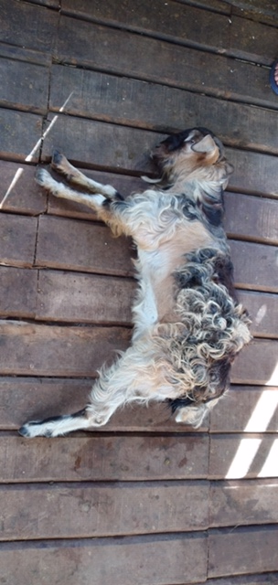
Figure 1: Dead cross bred Goat (vicitim)
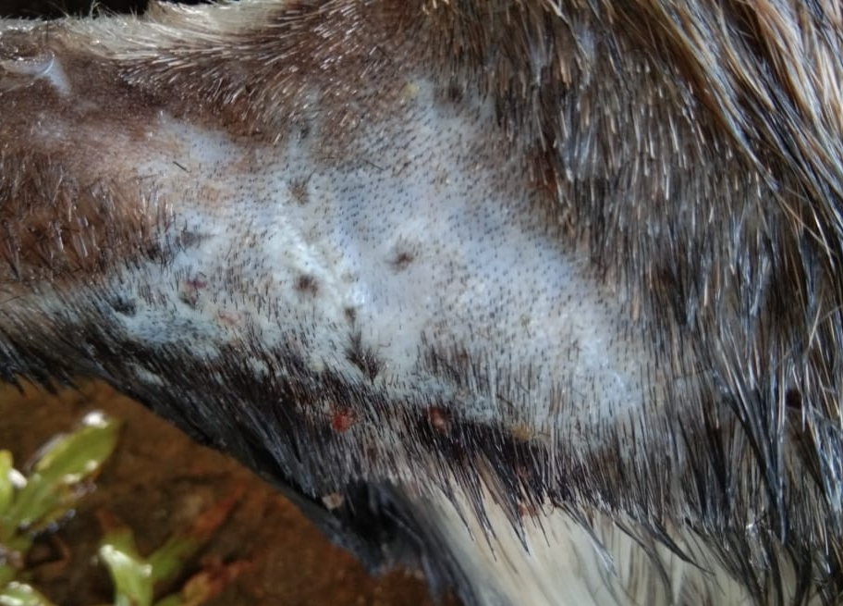
Figure2: Spot of snake bite in the Cross bred Goat
Reference
Mohapatra B, Warrell DA, Suraweera W, Bhatia P, Dhingra N, Jotkar RM ,Rodriguez PS, Mishra K, Whitaker R, Jha P. Snakebite mortality in India: A nationally representative mortality survey : PLoSNegl. Trop. Dis. 5, e1018; 2011.
Behler CM. Simon and Schuster's guide to reptiles and amphibians of the world :Simon and Schuster fireside Publishers, New York, 256 ;1989.
Roy A, Zhou XD, Chong MZ, Foo CS, Rajagopalan N, Nirthanam S, Bertrand D, Sivaraman J, Kini RM. Structural and functional characterisation of a novel homodimeric 3–finger neurotoxin from the venom of Ophiophagushannah(King Cobra): J. Biol. Chem, 285: 8302–8315; 2010.
Carswell D King Cobras can be found in many places in Thailand, majority being in the Khaosok: Cited in http://www.articlesalley.com; 2010.
Shea MO. Venomous snakes of the world: Princeton University Press. New Jersey, 160; 2005.
Punde DP. Snake bite (perspective of elapidae bites in rural Maharashtra) :Proceedings of SNA–CON 2008 at Little Flower Hospital, Angamaly Kerala ;2008.
Greene HW. Snakes: The Evolution of Mystery in Nature: Berkeley, California: University of Berkeley Press. 351;1997.
Jiminez–Porras JM. Pharmacology of peptides and proteins in snake venoms: Annual Review of Pharmacology, 8: 299–318; 1968.
Lee CY. Chemistry and pharmacology of polypeptide toxins in snake venoms : Annu Rev Pharmacol, 12: 265–286;1972.
Chauhan RS: Textbook of Veterinary Pathology. IBDC publishers. Lucknow, 651;2010.
Farooq U, Irshad H, Ullah RW, Ullah A, Afzal M, Latif A, Zahur AB.. Snake Bite in Jersey Cattle; a Case Report: Research Journal for Veterinary Practitioners, 2 (5): 82 – 83; 2014.

