Original Research Article

Evaluation of Bixa orellana and Dianella nigra as Natural Alternatives to Hematoxylin and Eosin for cytosmear.

Abstract
Introduction: Conventional cytological staining methods such as hematoxylin and eosin (H&E) involve toxic, expensive, and environmentally hazardous chemicals. In light of growing interest in sustainable laboratory practices, this study evaluates the staining efficacy of plant-based alternatives—Dianella nigra for nuclear staining and Bixa orellana (sindoor) for cytoplasmic staining.
Materials and Methods: Buccal smear samples (n = 15) were collected and fixed in 95% ethanol. A nuclear stain was prepared from freshly extracted juice of Dianella nigra, while the cytoplasmic stain was derived by dissolving Bixa orellana in ethanol. Staining quality was assessed using three parameters: nuclear clarity, cytoplasmic contrast, and overall staining quality, and compared with smears stained using standard H&E. Statistical analysis included interobserver reliability (Cohen’s κ), Shapiro-Wilk test for normality, and Pearson correlation.
Results: Natural stains demonstrated high efficacy in cytoplasmic contrast (mean ± SD: 2.80 ± 0.41) and overall staining quality (2.87 ± 0.35), with slightly reduced nuclear clarity (2.07 ± 0.59) compared to H&E (3.00 ± 0.00 for all parameters). Interobserver reliability was substantial to almost perfect for both stains (κ = 0.86–0.88 for natural stains; κ = 0.91–0.95 for H&E). A strong positive correlation was observed between nuclear clarity and overall staining quality in both groups (r = 0.91 for natural stains, r = 0.93 for H&E; p < 0.001).
Conclusion: Natural dyes such as Dianella nigra and Bixa orellana offer promising alternatives to conventional H&E staining, combining diagnostic clarity with eco-friendliness and cost-effectiveness. While slight variability in staining intensity persists, their high interobserver reliability and strong correlation metrics support their potential utility in routine cytological evaluations. Further standardization may enable broader application in clinical and educational settings.

INTRODUCTION:
Cytology involves the microscopic examination of cells, typically after they have been sectioned. Standard staining agents like hematoxylin, eosin, gram stains, silver nitrate are used and it contains toxicity materials, hazardous chemicals and also high in cost [1]. So having these concerns in society we developed natural alternatives like turmeric, kumkum, ginger, henna, beetroot, wood rust, and sindoor are being used.
Dianella nigra is rich in anthocyanins, a plant pigments known for producing blue hues, making it promising natural substitute for hematoxylin. Sindoor, a traditional herbal preparation commonly associated with cultural and medicinal practices in South India so it often includes a mix of herbs such as turmeric, cinnamon, clove, and camphor [2,3]. This investigation focuses on the effectiveness of these extracts as viable alternatives to standard H&E stains in cytological samples. The aim of this study is to evaluate non-toxic, eco-friendly, and cost-effective staining options
MATERIALS AND METHODS
Sterilized cotton swabs were used to obtain a total of 15 buccal smear samples from randomly chosen participants. Using coupling jars, these obtained smears were promptly stored in 95% ethanol to maintain cellular integrity. The cytoplasmic stain was made by dissolving 7.5 grams of commercially available sindoor powder (Bixa orellana) in 50 milliliters of ethanol, stirring the mixture well with a glass rod, and then storing it in a dark room covered with foil paper to keep out light. The solution was filtered and stored for later use after settling for 48 hours. Using a mortar and pestle, about 250 grams of fresh Dianella nigra fruits were hand smashed. The nuclear stain was directly applied to the resultant juice. To obtain nuclear contrast, the fixed cytological smears were first stained for 30 minutes using the Dianella nigra extract. The slides were stained with the prepared sindoor stain for 20 minutes to target the cytoplasm after being gently rinsed under running water. The slides were properly air-dried after being gently rinsed once more. To preserve the results for microscopic inspection, the stained smears were then mounted using a common mounting media. Specifically, we examined staining potential of Dianella nigra (commonly referred as ink fruit) as nuclear components and Bixa orellana (sindoor) for cytoplasmic staining.

RESULTS
On Analysis the stained cytosmear stained with Bixa orellana & Dianella nigra Stain
compared with Hematoxylin and Eosin exhibited.
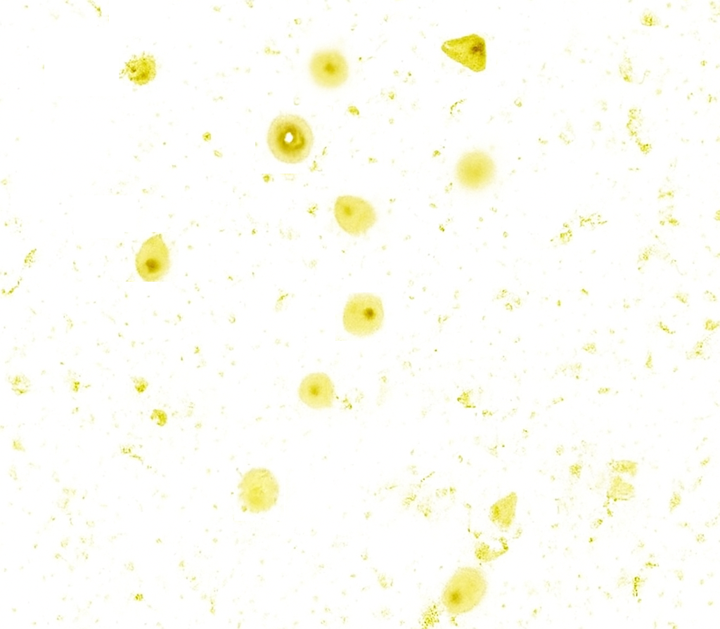
Fig-1 Stained cytosmear of Bixa orellana and Dianella nigra

Parameter | Bixa orellana & Dianella nigra Stain (n=15) | H&E Stain (n=15)
Nuclear Clarity | 3/15 (20%) scored 3 | 15/15 (100%) scored 3
Nuclear Clarity | 10/15 (66.7%) scored 2 | –
Nuclear Clarity | 2/15 (13.3%) scored 1 | –
Nuclear Clarity | Mean ± SD: 2.07 ± 0.59 | Mean ± SD: 3.00 ± 0.00
Cytoplasmic Contrast | 12/15 (80%) scored 3 | 14/15 (93.3%) scored 3
Cytoplasmic Contrast | 3/15 (20%) scored 2 | 1/15 (6.7%) scored 2
Cytoplasmic Contrast | Mean ± SD: 2.80 ± 0.41 | Mean ± SD: 2.93 ± 0.25
Overall Staining Quality | 13/15 (86.7%) scored 3 | 15/15 (100%) scored 3
Overall Staining Quality | 2/15 (13.3%) scored 2 | –
Overall Staining Quality | Mean ± SD: 2.87 ± 0.35 | Mean ± SD: 3.00 ± 0.00
Table 1: Comparison of Natural Stain and H&E stain in Nuclear clarity, cytoplasmic contrast, overall staining quality.
Metric | Bixa orellana & Dianella nigra Stain (n=15) | H&E Stain
Interobserver Reliability (κ) | 0.86–0.88 (Almost perfect) | 0.91–0.95 (Almost perfect)
Normality (Shapiro-Wilk test) | p > 0.05 (Normal distribution) | p > 0.05 (Normal distribution)
Pearson Correlation (Nuclear vs. Overall clarity) | r = 0.91, p < 0.001 | r = 0.93, p < 0.001
Table 2: Statistical comparison of staining parameters
Nuclear Clarity:
In the natural stain group, 10 out of 15 samples (66.7%) exhibited good nuclear clarity (score 2), while 3 samples (20%) showed excellent clarity (score 3) and 2 samples (13.3%) demonstrated mild clarity (score 1). The mean score for nuclear clarity was 2.07 ± 0.59. In contrast, the H&E-stained group achieved a score of 3 in all 15 samples (100%), yielding a perfect mean of 3.00 ± 0.00.
Cytoplasmic Contrast:
Cytoplasmic staining with the natural stain was found to be strong in 12 samples (80%) and moderate in 3 samples (20%), resulting in a mean score of 2.80 ± 0.41. In the H&E group, 14 samples (93.3%) showed excellent contrast (score 3), and one sample (6.7%) scored 2, with a slightly higher mean of 2.93 ± 0.25.
Overall Staining Quality:
The overall quality of staining using the natural method was rated as excellent in 13 out of 15 cases (86.7%) and good in the remaining 2 (13.3%). The mean overall quality score was 2.87 ± 0.35. All 15 smears stained with H&E scored 3, with a mean of 3.00 ± 0.00.All 15 smears stained with H&E scored 3, with a mean of 3.00 ± 0.00 (Figure 1), (Table 1).
Numerous colored substances, including flavonoids, anthocyanins, tannins, saponins, alkaloids, and curcumin, are naturally produced by plants. These materials are appropriate for staining because they can bind to tissue components selectively. However, a number of variables, including concentration, staining time, solvent type, and pH level, affect how well they work. Interobserver reliability remained substantial to almost perfect for both stains (κ = 0.78–0.82 for natural stain; 0.91–0.95 for H&E). Data showed normal distribution in both groups (Shapiro-Wilk test, p > 0.05). A strong positive correlation was still observed between nuclear clarity and overall staining quality in both groups (r = 0.84 for natural stain and r = 0.93 for H&E, p < 0.001) (Table 2).
DISCUSSION:
This study investigated the utilization of sindoor (Bixa orellana) and Dianella nigra as natural substitutes for traditional hematoxylin and eosin (H&E) stains. The findings were encouraging: sindoor, which has a bright red pigment, sufficiently stained the cytoplasm, while diella nigra, which is high in anthocyanins, successfully stained cell nuclei with a characteristic blue tint.
When combined, these agents provided a basic cytological examination that was safe, affordable, and environmentally friendly. Though it is not a novel concept, the use of plant-based dyes in histology is becoming increasingly popular as people become more conscious of the drawbacks of synthetic dyes. Even while hematoxylin and eosin are dependable, they have drawbacks, including the use of hazardous chemicals, potential cost, and environmental issues. Because of these disadvantages, researchers and educators are now looking for natural, biodegradable substitutes [4,5,6]. Particularly, anthocyanins have demonstrated a lot of promise as natural colors. Known for their vivid red, purple, and blue hues, they can be seen in fruits, vegetables, and flowers. They are safer for lab workers and the environment because they not only provide brilliant color but also have nutritional and medicinal qualities [7].
According to literature, effective staining occurred in over 90% of experiments utilizing extracts rich in anthocyanins. Most commonly used sources include onion peel, red poppy, butterfly pea, black plum, and hibiscus [8]. In general, water-based extracts outperformed alcohol-based ones, particularly when combined with binding-enhancing mordants like iron or alum. Other natural ingredients have also been investigated as possible eosin substitutes, including henna, ginger, beetroot, and rose petals. Phenolic pigments found in ginger, for example, can give cytoplasmic components yellow to brown tints [9,10]. Balaji et al. explored the use of turmeric (curcumin) as a histological and cytological stain and demonstrated its potential as a natural, non-toxic alternative that offers satisfactory nuclear visualization in exfoliated buccal smears [11].
Our research contributes to the increasing amount of data demonstrating the value of plant-derived stain. These natural dyes have the potential to be useful instruments in diagnostic and educational contexts with more standardization and improvement, providing a more hygienic and environmentally friendly future for histology research [12].

Despite their eco-friendly and non-toxic nature, natural stains exhibit certain limitations that may affect their widespread adoption in diagnostic cytology. Priyadarshini et al. noted that natural stains often lack consistency in staining intensity and reproducibility, which can lead to variable interpretation of cellular morphology [13]. Mathur et al. observed that natural extracts such as beetroot and papaya have limited shelf life and are prone to microbial contamination if not stored properly, making long-term use challenging in clinical settings [14]. Furthermore, Balaji et al. reported that turmeric-based staining, while effective, may produce background staining and reduced nuclear-cytoplasmic contrast compared to standard synthetic dyes like hematoxylin [11]. These drawbacks highlight the need for further refinement in preparation, preservation, and standardization of natural stains before they can be reliably used in routine cytological evaluations.
Despite slight variations in staining intensity and consistency, the natural dyes used in this study produced results comparable to H&E in terms of diagnostic clarity. The high interobserver reliability and the strong positive correlation between nuclear clarity and overall staining quality further support their potential utility in cytological evaluations. These findings suggest that natural dyes, though subject to minor variations in staining parameters, offer promising potential for use in diagnostic staining procedures.

CONCLUSION
Our research shows that natural plant-based dyes like sindoor (Bixa orellana) and Dianella nigra have a lot of potential as substitutes for conventional hematoxylin and eosin stains. They offer a safer, more economical, and environmentally friendly alternative to H&E, even though they might not completely replace it in all diagnostic situations—particularly for simple cytological examination. These natural stains are especially useful in places with limited resources, where non-toxic techniques are valued. They could significantly contribute to the global promotion of more accessible and sustainable histology techniques with additional study and improvement.

REFERENCES
1. Mulla SA, Ansari A, Shrivastava S, Bhattacharjee M, Panchmahalkar A. Natural Alternatives to Chemical Staining in Routine Histopathology - A Narrative Review. Oral & Maxillofacial Pathology Journal. 2024;15(1).
2. Alturkistani HA, Tashkandi FM, Mohammedsaleh ZM. Histological stains: a literature review and case study. Global Journal of Health Science. 2015;8(3):72.
3. Horobin RW. Theory of histological staining. In: Bancroft’s Theory and Practice of Histological Techniques. 2018:114–123.
4. Latonen L, Koivukoski S, Khan U, Ruusuvuori P. Virtual staining for histology by deep learning. Trends in Biotechnology. 2024 Mar 13.
5. Hartika G, Zulharmita Z, Asra R. Utilization of natural dye substances for histological staining: A review. Asian J Pharm Res Dev. 2021;9(1):149–158.
6. Jing P, Giusti MM. Analysis of anthocyanins in biological samples. In: Anthocyanins in Health and Disease. 2013:115.
7. Jasphin S, Raghavendra AP, Solomon MC, Amuthan A, Singh BM, Kairanna NV. Anthocyanins: A hue for histology - systematic review. Malaysian Journal of Science. 2023;106–125.
8. Aly Dyab AK, Yones DA, Mohamed YM, Bayoumi SA, Elossily NA. Alternative staining of Fasciola gigantica using natural herbal dyes. J Egypt Soc Parasitol. 2020;50(1):127–134.
9. Prajapati MR, Agarwal P, Jadav B. Exploring the staining potential of Zingiber officinale extracts (Ginger) as a natural alternative to eosin in hematoxylin & eosin staining: A cross-sectional study. J Clin Diagn Res. 2023;17(10).
10. Kar S, Kumar H, Sangamesh NC, Mishra S, Bajoria AA, Saha M. Safe food coloring agent as an alternative to eosin stain. Cureus. 2024;16(9).
11. Balaji N, Ranganathan K, Ramesh A, Raj AT. Use of turmeric as a natural dye in histology and cytology – An eco-friendly approach. J Oral Maxillofac Pathol. 2018;22(3):378–81.
12. Patel NK. Natural Dye Based Sindoor. Life Sciences Leaflets. 2011;11:355.
13. Priyadarshini SR, Uma K, Meenakshi S. Efficacy of natural stains in comparison with routine Papanicolaou stain in exfoliative cytology. J Clin Diagn Res. 2015;9(8):ZC48–ZC50.
14. Mathur S, Singh M, Jha A, Goyal R. Comparison of natural (beetroot and papaya) and synthetic stains in exfoliative cytology. J Oral Maxillofac Pathol. 2020;24(1):140.

