EVALUATION OF SKELETAL MUSCLE RELAXANT ACTIVITY BY USING PIPER NIGRUM SEEDS

ABSTRACT
Treating muscle-related pain and spasms, which are commonly linked to conditions like multiple sclerosis, spinal cord injury, and stroke, requires the use of skeletal muscle relaxants. Despite the widespread use of synthetic muscle relaxants, there has been a lot of interest in studying plant-based substitutes because of their possible effectiveness and less severe adverse effects. With an emphasis on the phytochemical components and pharmacological characteristics of Piper nigrum (black pepper) seeds, this study evaluates the skeletal muscle relaxant action of these seeds. After being verified, the seeds, which came from Annaram, Telangana, were extracted using ethanol maceration. Alkaloids, flavonoids, tannins, steroids, and carbohydrates were detected by phytochemical screening; these substances are known to support a variety of biological processes, including muscle relaxation.
Experimental assessments were used to determine the ethanolic extract’s bioactive potential. Significant muscle relaxant activity was found in the results, most likely as a result of piperine, the main alkaloid in Piper nigrum that is known to have neuroactive and anti-inflammatory properties. In addition to stressing the need for additional research, including in vivo and clinical trials, to ascertain its therapeutic feasibility, the study highlights Piper nigrum’s potential as a natural alternative for skeletal muscle relaxation. This study highlights the significance of phytochemical research in muscle relaxant therapy, given the growing preference for herbal therapies over synthetic drugs. The results suggest that Piper nigrum could be a promising candidate for the development of safer and more potent muscle relaxants, offering a natural remedy for musculoskeletal issues.
INTRODUCTION
Skeletal muscle relaxants function either centrally within the cerebrospinal axis or peripherally at the neuromuscular junction (NMJ), which causes paralysis or inhibits muscle tone (1). The motor neuron stops supplying the synapses with acetylcholine (Ach), its chemical messenger, at the NMJ. The NMJ is thereby relaxed by the skeletal muscle and fibres. Muscle fibre repolarization causes the sarcoplasmic reticulum (SR) gates to close, which stops calcium (Ca2+) from being released. Furthermore, adenosine triphosphate (ATP)-powered pumps will replenish the sarcoplasm with Ca2+. Consequently, thin filament actin-binding sites are “shielded.” In the absence of a cross-bridge between the thin and thick filaments, the muscle fiber relaxes and releases tension (2).
Chronic pain patients frequently experience myogenic pain or pain originating in the muscles with a 30% frequency of myofascial pain in the practice of general internal medicine (3) and a 65%, 74%, and 67% number of patients with multiple sclerosis, stroke, or spinal cord injuries who experience muscle pain related to spasticity, respectively (4-6). Myogenic pain can be treated with a range of pharmacologic medications. These substances are commonly known as antispastic drugs, muscle relaxants, or muscle relaxants. According to one study, approximately 35% of patients who visit a primary care doctor complaining of pain in the lower back receive a prescription for a muscle relaxant, and up to 91% of doctors report using them (7-8). The two main categories of this pharmacologic class are central and peripheral muscle relaxants, which are either depolarizing or non-depolarizing. While the latter is used to induce muscle paralysis as part of perioperative general anaesthesia, the former is typically utilized to treat myogenic pain.
One aspect of the syndrome of upper motor neurones is muscle spasms, which are motor disorders marked by increased excessive tendon jerks and muscle tone brought on by the stretch reflex being overly excited.
Eg: Back spasms, calf spasms, upper leg spasms, and abdominal cramps.
The naturally occurring chemical substances known as phytochemicals are found in plants and can improve or worsen health [9]. The most important ones are alkaloids, flavonoids, tannins, phenolic compounds, and other bioactive components of plants [10]. These phytochemicals, which have a defence mechanism and provide defence against a number of ailments, are found naturally in the stems, bark, leaves, fruits, and roots of medicinal plants [11]. Asthma, arthritis, cancer, and other illnesses are all significantly aided by phytochemicals. Phytochemicals can also be regarded as “man-medicine friendly” because they treat illnesses without endangering humans [12]. The phytochemicals are generally classed as primary or secondary metabolites. The sugars, proteins, nucleic acids, amino acids, chlorophyll, and other primary metabolites are in charge of the plant’s fundamental growth. Secondary metabolites are those which are needed for the survival of the plants in a hostile environment [13]. Phytochemicals can be extracted from plant materials using extraction techniques. The most common techniques are maceration, percolation, infusion, digestion, decoction, Soxhlet extraction, and others.
Eco-friendly techniques like Supercritical Fluid Extraction (SFE), Accelerated Solvent Extraction (ASE), Microwave-Assisted Extraction (MAE), and Ultrasound-Assisted Extraction (UAE) have also been introduced more recently. Some of these solvents include water, ethanol, methanol, acetone, ether, benzene, and chloroform [9]. According to the World Health Organisation, medicinal plants are the best source of a variety of medications. Almost 80% of people in developed nations use traditional medicine, which is made up of substances derived from medicinal plants [14]. A few chemically active compounds that affect the human body in a particular way are responsible for the therapeutic benefits of plants [15]. Numerous natural chemicals from various molecular families that have a range of biological activities in humans can be found in plants. With around 80% of the global population relying mostly on traditional remedies for their initial medical care, plant-based, traditional medicines are still important in the medical field [16]. The screening of plant materials for phytochemicals and standard techniques for identifying the biologically active components qualitatively are the main topics of this examination.
2. RESOURCES AND ADVANCES
2.1 THE STUDY AREA:
The Pulla Reddy Institute of Pharmacy’s Department of Pharmacology in Dundigal, Hyderabad, is where the study was carried out.
2.2 PLANT MATERIAL:
Piper nigrum seeds were collected in November 2024 from Annaram, Telangana, India. After collection, authentication was carried out by the Botanical Survey of India, Room No. 228-238, Sultan Bazar, Koti, Hyderabad – 500001.
2.3 PREPARATION OF CRUDE EXTRACT:
Large quantities of fresh Piper nigrum seeds were gathered, shade-dried, and ground in a grinder. For additional research, the coarse powder was utilised. The extraction process, known as maceration, was carried out using ethanol as the solvent. After filtering, the extract was kept for later examination.
3. PHYTOCHEMICAL TESTS FOR PIPER NIGRUM BY USING ETHANOLIC EXTRACT
3.1 ALKALOIDS TEST
- MAYER’S TEST: After adding two millilitres of plant extract, add two to three droplets of Mayer's reagent onto the test tube's side walls.
OBSERVATION: The presence of alkaloids is indicated by a white, creamy precipitate (17, 24).
- WAGNER’S TEST: Along the sides of the test tube, a few millilitres of plant extract are mixed with a few drops of Wagner's reagent.
OBSERVATION: The test is positive if the precipitate is reddish-brown (17).
- DRAGENDROFF’S TEST: The test tube holding two milliliters of crude pepper extract was mixed with two to three drops of Dragendroff’s reagent.
OBSERVATION: Alkaloids were detected by the appearance of a turbid, orange-red precipitate (18).
- HAGER’S TEST: A few drops of Picric acid that has been saturated, also known as Hager's reagent, were mixed with two millilitres of sample solution.
OBSERVATION: Alkaloids are present in the Piper nigrum extract when a yellow precipitate forms.
3.2 FLAVONOIDS TEST
- FERRIC CHLORIDE TEST: In addition to two to three millilitres of the sample solution, a few drops of a neutral 5% ferric chloride solution are added.
OBSERVATION: A dark green colour indicates the presence of a phenolic component.
- ALKALINE REAGENT TEST: A 10% sodium hydroxide solution is used to treat an ethanolic extract solution.
OBSERVATION: Flavonoids are indicated by their yellow colour (17).
3.3 CARBOHYDRATES TEST
- MOLISCH’S TEST: Mix two millilitres of plant extract with two drops of α-α-naphthol alcoholic solution. The mixture is thoroughly shaken before gradually adding a few drops of strong sulphuric acid along the test tube's walls.
OBSERVATION: The presence of carbohydrates is indicated by a violet ring (24).
- BENEDICT’S TEST: Benedict's reagent by volume (0.5 ml). A boiling water bath is used to heat the mixture for two minutes.
OBSERVATION: A distinctively coloured precipitation (green, orange, or red) forms when sugar is present (17).
- FEHLING’S TEST: Fehling’s test was performed on the hydrolysed extract after a small amount of the extract was hydrolysed in a water bath for a few hours with five millilitres of hydrochloric acid. Two millilitres of extract were added to two millilitres of Fehling’s solution (1 ml each of Fehling’s A and B solutions), thoroughly mixed, and then brought to a boil.
OBSERVATION: When reducing sugars are present, the precipitate will appear red or yellow (19).

3.4 PROTEIN TEST
- NINHYDRIN TEST: Two drops of ethanolic filtrate are mixed with a ninhydrin solution (10 milligrams in 200 millilitres of acetone).
OBSERVATION: The presence of proteins is indicated by a purple appearance.
- BIURET TEST: Add the biuret reagent and a few drops of the ethanolic extract.
OBSERVATION: A pink ethanolic layer shows the presence of protein (17, 24).

3.5 GLYCOSIDES TEST
- BORNTRAGER’S TEST: Glycosides were detected by adding 3 ml of chloroform to 2 ml of filtered hydrolysate and shaking the mixture.
OBSERVATION: Glycosides are indicated by colours such as red, yellow, and orange (17).
- KELLER KILIANI TEST: The extraction was combined with 2 droplets of 2% FeCl3 in two millilitres of glacial acetic acid solution. Two millilitres of pure sulfuric acid were added to a different tube containing the solution.
OBSERVATION: When the interface is treated with a 10% ammonia solution after the chloroform layer has been separated, the presence of glycosides can be detected by looking for a brown ring (20).
- LIEBERMANN BURCHARD'S TEST: 2 millilitres of acetic anhydride are used to dissolve the 3-millilitre extract. Along the test tube’s sidewalls, a drop or two of sulphuric acid concentrate is added gradually.
OBSERVATION: Glycosides are indicated by a green or blue-green colour (21).
3.6 TANNINS TEST
- FERRIC CHLORIDE TEST: Three millilitres of extract are mixed with five millilitres of distilled water. This is combined with a small quantity of a neutral 5% FeCl3 solution.
OBSERVATION: Phenolic compounds are indicated by a brownish-green colour.
- LEAD ACETATE TEST: Add 3 millilitres of a 10% lead acetate solution after the extract (2 millilitres) has been dissolved in distilled water.
OBSERVATION: Phenolic chemicals are indicated by a large, white precipitate (17).
3.7 STARCH TEST
- IODINE TEST: Approximately 2-3 ml of the extract was mixed with 0.01 g of iodine and 0.075 g of potassium iodide in approximately 5 ml of distilled water.
OBSERVATION: The formation of a blue colour indicates the presence of starch (22).
  - STEROIDS TEST
- WAGNER’S TEST: A few drops of Wagner's reagent are combined with a few millilitres of plant extract along the sides of the test tube.
OBSERVATION: The test is confirmed as positive by a reddish-brown precipitate (17).
- SALKOWSKI TEST: After adding 2 ml of the solution to 3 ml of chloroform and gently shaking the mixture, 2 ml of concentrated sulphuric acid is added down the test tube's side to create a layer on top of the sample solution. Don't shake the test tube after adding sulphuric acid.
OBSERVATION: A reddish brown or golden yellow colour is formed (23).
3.9 SAPONINS TEST
- FOAM TEST: Five millilitres of extract and five millilitres of distilled water were rapidly combined in a test tube before being heated.
OBSERVATION: Stable foam formation was interpreted as a sign that saponins were present (17, 24).
- SALKOWSKI TEST: To form a layer on top of the solution, 2 ml of concentrated sulphuric acid is added down the side of the test tube after 2 ml of the sample solution and 3 ml of chloroform have been added and gently shaken. After adding sulfuric acid to the test tube, do not shake it.
OBSERVATION: A reddish brown or golden yellow colour is formed (23).

RESULTS
Table 1- List of Chemical Tests for Piper Nigrum by Using Ethanolic And Aqueous
S.NO | NAME OF THE CHEMICAL TEST | ETHANOLIC EXTRACT | AQUEOUS EXTRACT
1. | ALKALOIDS TEST  - Hager’s Test  - Wagner’s Test  - Mayer’s Test  - Dragendroff’s Test | Positive  Positive  Positive  Positive | Positive  Positive  Positive  Positive
2. | FLAVONOIDS TEST  - Ferric Chloride Test  - Alkaline Reagent Test | Positive  Positive | Positive  Positive
3. | CARBOHYDRATES TEST  - Molisch Test  - Benedict’s Test  - Fehling’s Test | Positive  Positive  Positive | Positive  Positive  Positive
4. | PROTEINS TEST  - Ninhydrin Test  - Biuret Test | Negative  Negative | Negative  Negative
5. | SAPONINS TEST  - Foam Test  - Salkowski Test | Negative  Negative | Negative  Negative
6. | TANNINS TEST  - Ferric Chloride Test  - Lead Acetate Test | Positive  Positive | Positive  Positive
7. | STARCH TEST  - Iodine Test | Negative | Negative
8. | STEROIDS TSET  - Salkowski Test  - Wagner’s Test | Positive  Positive | Positive  Positive
9. | GLYCOSIDES TEST  - Borntrager’s Test  - Keller-Kiliani Test  - Liebermann Burchard Test | Negative  Positive  Positive | Negative  Positive  Positive

DISCUSSION
Evaluation of muscle relaxant activity by using the Piper nigrum seeds.
The purpose of this research was to look into the pharmacological and phytochemical activity of muscle relaxants. Before choosing the plant, we reviewed several literatures to learn more about the activity. Then we chose a plant seed called ‘PIPER NIGRUM’, also known as black pepper. Piper nigrum seeds were collected in November 2024 from Annaram, Telangana, India. After collecting the seeds, we have done our authentication processes. Next, we took fresh seeds in bulk amounts, dried them in the shade, and pulverized them in a grinder. The course powder was used for further studies. We have done extraction methods like maceration by using solvents like methanol and aqueous. By using the above extract, we performed certain phytochemical tests for the identification test for alkaloids, flavonoids, tannins, steroids, glycosides, carbohydrates, proteins, saponins, and starch. From the above identification test, we got positive results for alkaloids, flavonoids, carbohydrates, tannins, and steroids and negative results for proteins, starch, and saponins. Numerous plant-derived compounds have demonstrated significant therapeutic potential. Among the plants studied thus far, the Piperaceae family, commonly known as the pepper family, exhibits remarkable promise. Piperine, a naturally occurring alkaloid in plants of the trans stereoisomer is the pyridine group found in Piperaceae family, which includes P. nigrum and P. longum of 1-piperoylpiperidine. It is also known as (E, E)-1-piperoylpiperidine or (E, E)-1-[5-(1, 3-benzodioxol-5-yl)-1-oxo-2, 4-pentadienyl] piperidine. Piperine is the alkaloid that gives black and long pepper their pungency, along with chavicine, a piperine isomer. It has also been used in various traditional medical practices and as an insecticide. Ethanol extract from Piper nigrum seeds was used throughout the entire investigation. Several bioactive chemicals were discovered in the ethanol extract of Piper nigrum seeds during the initial phytochemical screening tests. These substances may be the cause of the plant’s various therapeutic benefits. The plant extract was found to contain alkaloids, flavonoids, tannins, carbohydrates, and steroids.
CONCLUSION
Herbal and botanical uses of natural chemicals, particularly those derived from plants, have drawn a lot of attention recently because they have been thoroughly evaluated for effectiveness and are usually thought to be safe for humans. Compared to synthetic pharmaceuticals, herbal remedies have several benefits, such as their natural source, effects, and affordability. Herbal remedies are said to be more palatable to the human body and are produced using readily available, reasonably priced, and renewable basic materials. Maceration is the extraction process that produces superior outcomes. We concluded that the chosen plant extract had been correctly identified by phytochemical analysis. Several bioactive substances are suggestive of their medicinal potential, including alkaloids, flavonoids, tannins, steroids, and glycosides. Future research will concentrate on in vivo experiments to assess the extract’s safety and biological efficacy in greater detail.
REFERENCES
- Akash Devi, Chitra Khanwelka, ‘A Comparative Study of Skeletal Muscle Relaxant Effects of Thiocolchicoside, Diazepam and their Combination in Wistar Rats Using the Rotarod Apparatus’, Journal of Medical Sciences, published date: 09.16.2024, DOI: 10.7759/cureus.69513
- Gordon J, Kelly A, James A, et al., Muscle fibre contraction and relaxation. Anatomy and Physiology, OpenStax, Houston, Texas; 2022. 1:1336.
- Skootsky SA, Jaeger B, Oye RK, Prevalence of myofascial pain in general internal medicine practice, Journal of Clinical Medicine, West J Med 1989;151:157–60.
- McGuire JR, Harvey KL, The prevention and management of complications after stroke, Journal of National Library of Medicine, 1999 Nov; DOI: 10:857–74.
- MS Society. MS symptom management survey, Journal of National Multiple Sclerosis Society, London: MS Society; 1997.
- Maynard FM, Karunas RS, Waring WP., Epidemiology of spasticity following traumatic spinal cord injury, Journal of National Library of Medicine, 1990 July; DOI: 71:566–9.
- Di Iorio D, Henley E, Doughty A. A survey of primary care physician practice patterns and adherence to acute low back problem guidelines, Journal of National Library of Medicine, 2000 Nov-Dec; DOI: 10.1001/archfami.9.10.1015.
- Cherkin DC, Wheeler KJ, Barlow W, et al., Medication use for low back pain in primary care spine, Journal of National Library of Medicine, 1998 March; DOI:10.1097/00007632-199803010-00015.
- Junaid R Shaikh and MK Patil, International Journal of Chemical Studies 2020; 8(2): 603-608DOI: https://doi.org/10.22271/chemi.2020.v8.i2i.8834
- Manjulika Yadav, Sanjukta Chatterji, Harad Kumar Gupta and Geeta Watal, International Journal of Pharmacy and Pharmaceutical Sciences ISSN- 0975-1491 Vol 6, Issue 5, 2014
- Rohit Kumar Bargah, Journal of Pharmacognosy and Phytochemistry 2015; 4(1): 07-09.
- K. Sahira Banu, Dr. L. Cathrine International Journal of Advanced Research in Chemical Science (IJARCS) Volume 2, Issue 4, April 2015, PP 25-32 ISSN 2349-039X (Print) & ISSN 2349-0403 (Online) www.arcjournals.org.
- Vishnu Balamurugan*, Sheerin Fatima. M.A, Sreenithi Velurajan, IJARIIE-ISSN(O)-2395-4396.
- R.S. Sawant and A.G. Godghate*, International Journal of Science, Environment ISSN 2278-3687 (O) and Technology, Vol. 2, No 4, 2013, 634 – 641.
- PradeepA1, DineshM1, Govindaraj A1, Vinothkumar D2, Ramesh Babu NG3 Pradeep A. et al. / International Journal of Biological Pharmaceutical Research. 2014; 5(1): 4 e- ISSN 0976 – 3651.
- Nagy Morsya, Phytochemical analysis of biologically active constituents of medicinal plants Main Group Chemistry 13 (2014) 7–21DOI 10.3233/MGC-130117IOS Press.
- 17) K. Sahira Banu, Dr. L. Cathrine, General Techniques Involved in Phytochemical Analysis, International Journal of Advanced Research in Chemical Science (IJARCS) Volume 2, Issue 4, April 2015, PP 25-32 ISSN 2349-039X (Print) & ISSN 2349-0403 (Online) www.arcjournals.org.
- Snigdha Shubham1*, Ravish Mishra2, Narayan Gautam3, Manisha Nepal1, Nilotpol Kashyap4 and Kishore Dutta5, Phytochemical Analysis of Papaya Leaf Extract: Screening Test
- Ayush Tomar, Ujjwal, Shalu Choudhary, Nisha Dhillon, PHYTOCHEMICAL SCREENING OF LEAF AND FLOWER EXTRACT OF TAGETES ERECTA L. AND THEIR ANTIMICROBIAL EFFICIENCY AGAINST SOME MICROBIAL STRAINS, 10.20959/wjpr20255-35149
- Ruth Afunwa, Chisom Marycynthia Okafor, Chukwunonso Anthony Igboko, Martin Chukwunonso Nwofia, PHYTOCHEMICAL AND ANTIMICROBIAL PROPERTIES OF COCONUT WATER (Cocos nucifera L.) AGAINST BACTERIA ISOLATES FROM STUDENTS URINE SAMPLES IN A UNIVERSITY COMMUITY, Journal of Clinical Medicine and Research, 10.5281/zenodo.14583834
- Junaid R Shaikh and MK Patil, Qualitative tests for preliminary phytochemical Screening: An overview DOI: https://doi.org/10.22271/chemi.2020.v8.i2i.8834
- Vishnu Balamurugan*, Sheerin Fatima. M.A, Sreenithi Velurajan, A GUIDE TO PHYTOCHEMICAL ANALYSIS
- Rohit Kumar Bargah, Preliminary test of phytochemical screening of crude ethanolic and aqueous extract of Moringa pterygosperma Gaertn
- Pillalamarri Madhavi, Kothmiri Swathika, Kunta Akhil, Palladi Naresh Kumar, Jamagani Anusri, Faruque Ahmed and Rahul Sarkar, EVALUATION OF ANTI-INFLAMMATORY ACTIVITY USING PLANTS BRASSICA OLERACEA VAR. CAPITA, BRASSICA OLERACEA VAR. ITALICA, DOI: 10.20959/wjpr20239-28252.

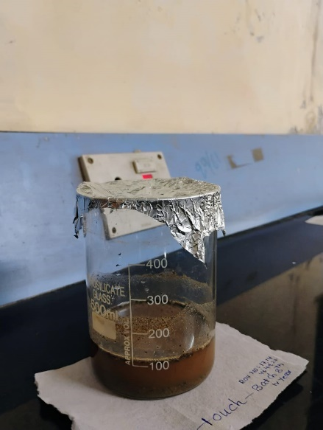
Fig.1 PROCESS OF MACERATION

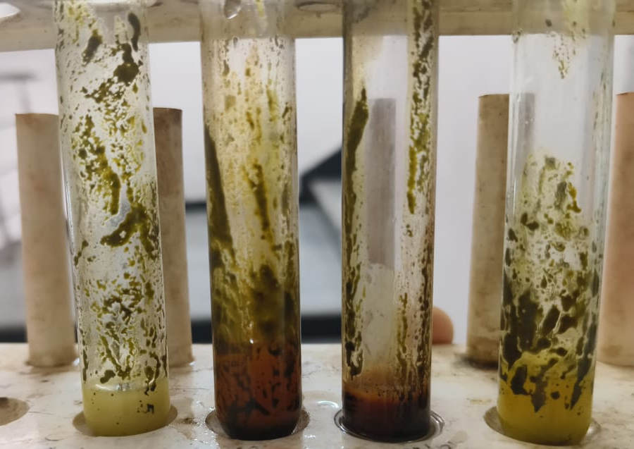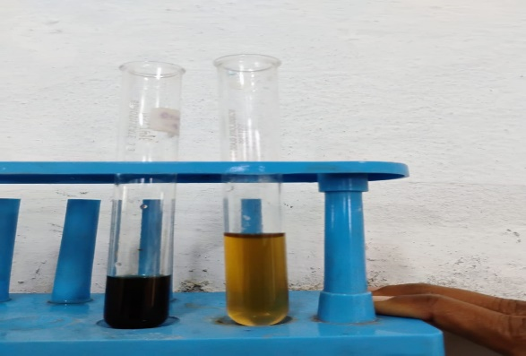
Fig.2 ALKALOIDS Fig.3 FLAVONOIDS
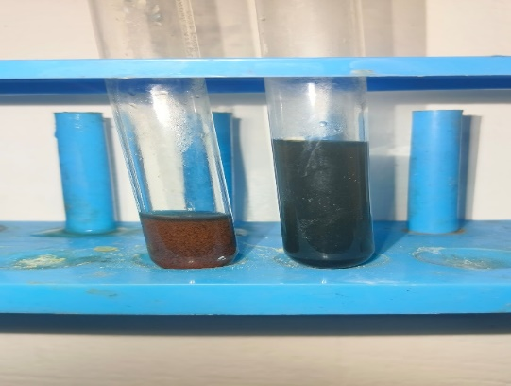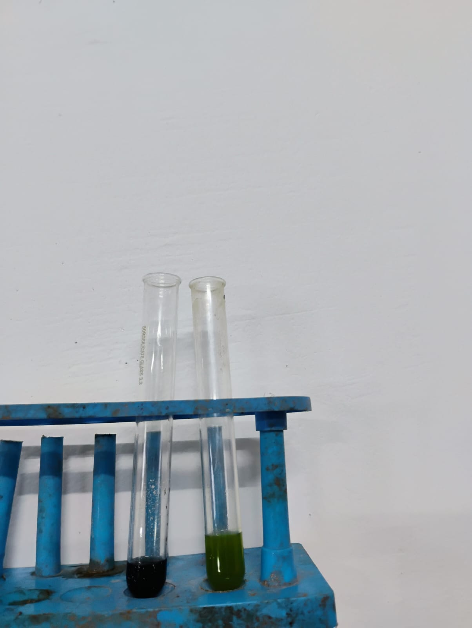
Fig.4 CARBOHYDRATES Fig.5 PROTEINS
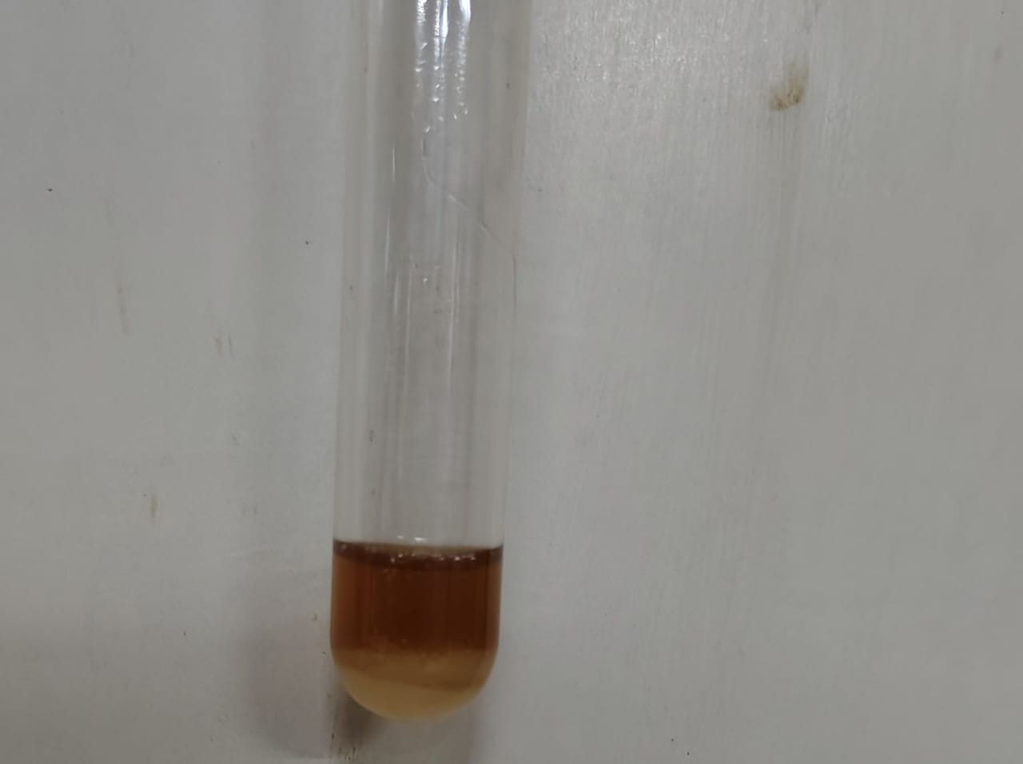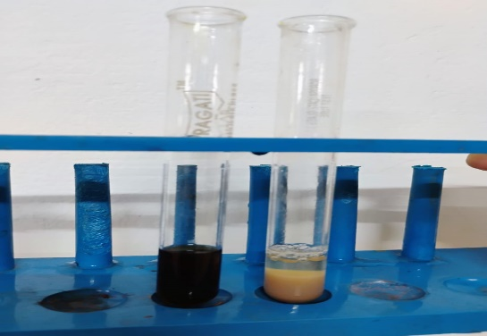
Fig. 6 GLYCOSIDES Fig.7 TANNINS

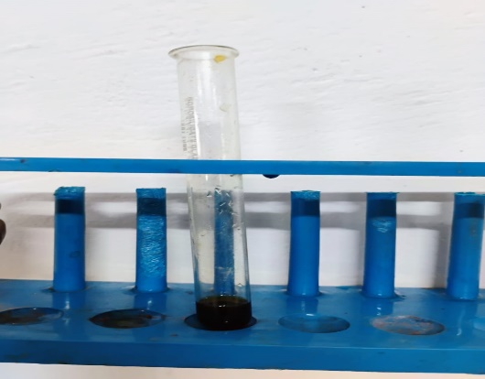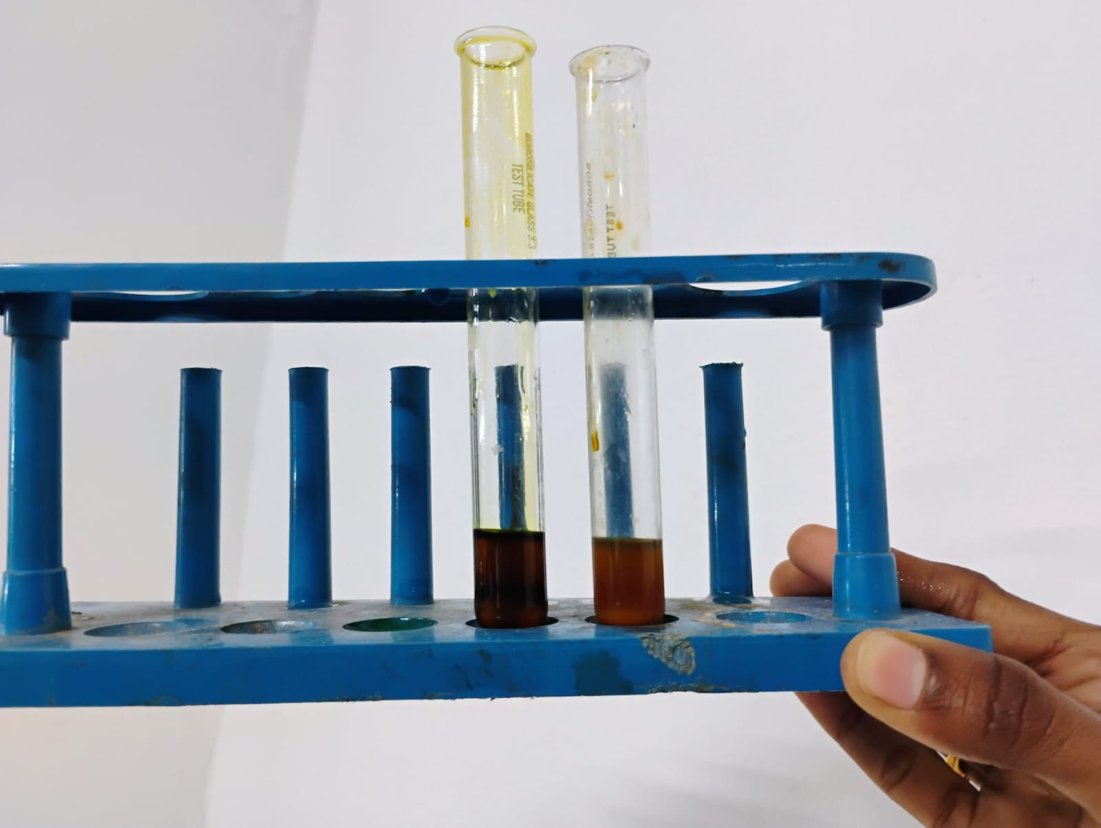
Fig.8 STARCH Fig.9 STEROIDS

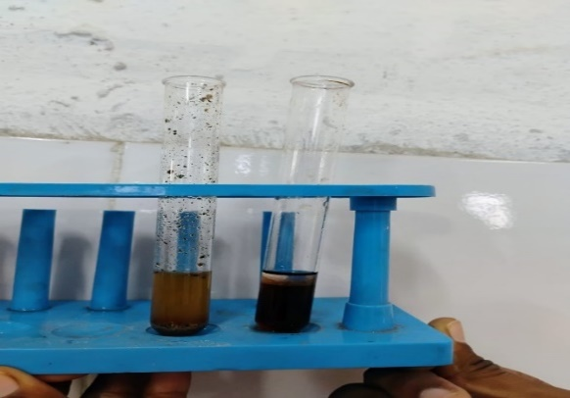
Fig.10 SAPONINS

