INNOVATIVE APPROACHES TO ADDRESS HOSPITAL-ACQUIRED INFECTIONS: PREVENTION, MANAGEMENT, AND EMERGING TECHNOLOGIES

ABSTRACT
Hospital-acquired infections (HAIs) remain a significant global healthcare challenge, leading to increased morbidity, mortality, and financial burdens. These infections are monitored by organizations like the CDC’s National Healthcare Safety Network (NHSN) to improve patient safety. Beyond individual harm, HAIs contribute to the spread of multidrug-resistant pathogens, including MRSA, VRE, and carbapenem-resistant bacteria, complicating treatment efforts. Common types of HAIs include bloodstream infections, urinary tract infections, surgical site infections, pneumonia, and Clostridium difficile infections, highlighting the critical need for effective infection control measures in healthcare settings, as reported in a multistate point-prevalence survey conducted in acute care hospitals in the United States (USA). This review explores the latest advancements in the prevention, management, and technological interventions targeting HAIs.
Furthermore, we delve into enhanced sterilization protocols, the role of antimicrobial coatings, and behavioral interventions for improved compliance with hygiene practices. In prevention, novel antimicrobial therapies, such as bacteriophage therapy and nanoparticle-based drug delivery systems, offer promising avenues to combat drug resistance effectively. Advanced diagnostic tools, including next-generation sequencing and point-of-care testing, facilitate rapid pathogen identification and personalized therapeutic strategies. Collaborative efforts between researchers, healthcare professionals, and policymakers are emphasized as essential in fostering an integrated framework for HAI management. By leveraging state-of-the-art technologies and evidence-based practices, healthcare systems can advance towards a future with significantly reduced infection rates, enhanced patient safety, and optimized resource utilization.
Keywords: Nosocomial Infection,vancomycin-resistant enterococci (VRE), Clostridium difficile, Acinetobacter spp., methicillin-resistant Staphylococcusaureus (MRSA),Klebsiella pneumoniae
- INTRODUCTION
There has been significant discussion regarding the risk of infection to patients from contaminated healthcare surfaces.Hospital-acquired infections, also known as nosocomial infections, remain a significant global health concern, affecting patient outcomes, healthcare costs, and overall hospital safety. These infections occur during a patient's stay in a healthcare facility and are not present or incubating at the time of admission [1]. Infections such as central line-associated bloodstream infections (CLABSI), catheter-associated urinary tract infections (CAUTI), and ventilator-associated pneumonia (VAP) are commonly linked to HAI [2]. The emergence of antibiotic-resistant pathogens has further complicated the management of HAIs.Hospital-acquired infections are increasingly associated with multidrug-resistant (MDR) pathogens, posing significant challenges to effective treatment and infection control.Multi-drug-resistant organisms (MDROs), such as carbapenem-resistant Enterobacteriaceae (CRE) and methicillin-resistant Staphylococcus aureus (MRSA), have become increasingly prevalent, making traditional antibiotic treatments less effective[3]. This rising challenge has led to the exploration of alternative therapies, such as bacteriophage therapy and faecal microbiota transplantation, which show promise in combating these resistant infections [4.Methicillin-resistant Staphylococcus aureus (MRSA), carbapenem-resistant Enterobacteriaceae, and other MDROs are now commonly implicated in HAIs, demanding alternative therapeutic strategies, such as bacteriophage therapy and advanced antibiotic stewardship [5].
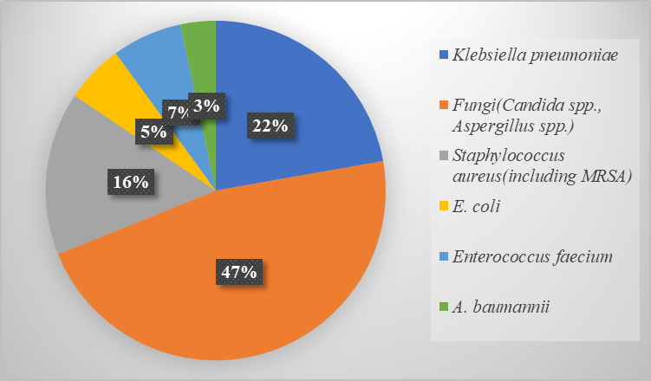
Figure1. Distribution of Microorganisms Causing Nosocomial Infections
This pie chart illustrates the prevalence of key microorganisms responsible for hospital-acquired infections, highlighting the proportional representation of Staphylococcus aureus, Klebsiella pneumoniae, Escherichia coli, Pseudomonas aeruginosa, Acinetobacter baumannii, and Enterococcus species. Understanding these proportions helps in formulating targeted infection control strategies to reduce healthcare-associated infections.
Emerging technologies and predictive modelling have provided new avenues to combat HAIs. For example, machine learning algorithms are being employed to predict and detect early signs of nosocomial infections, enabling timely intervention [5]. Additionally, probabilistic frameworks for estimating infection risks in healthcare personnel and patients, such as those developed for COVID-19, demonstrate the utility of innovative approaches in managing outbreaks within healthcare settings [6]. The prevalence of HAIs is alarming, with over 648,000 patients in U.S. hospitals developing these infections annually, leading to approximately 75,000 deaths [7]. It is now widely acknowledged that the healthcare environment can facilitate the transmission of several key pathogens, including vancomycin-resistant enterococci (VRE), Clostridium difficile, Acinetobacter spp., methicillin-resistant Staphylococcusaureus (MRSA), and norovirus[6].A study indicates that Gram-negative bacteria account for over 30% of hospital-acquired infections. These bacteria are particularly prevalent in specific types of infections, comprising 47% of ventilator-associated pneumonia cases and 45% of urinary tract infections. They are also the dominant pathogens in intensive care units (ICUs) [8].
Despite these advancements, the global prevalence of HAIs underscores the need for a multifaceted approach. Strategies integrating rigorous hygiene protocols, continuous surveillance, and advanced diagnostic tools are essential to minimize the incidence and impact of HAIs. This review examines the epidemiology, pathogenesis, and risk factors associated with HAIs while exploring innovative prevention and treatment strategies to address this enduring challenge in modern healthcare.

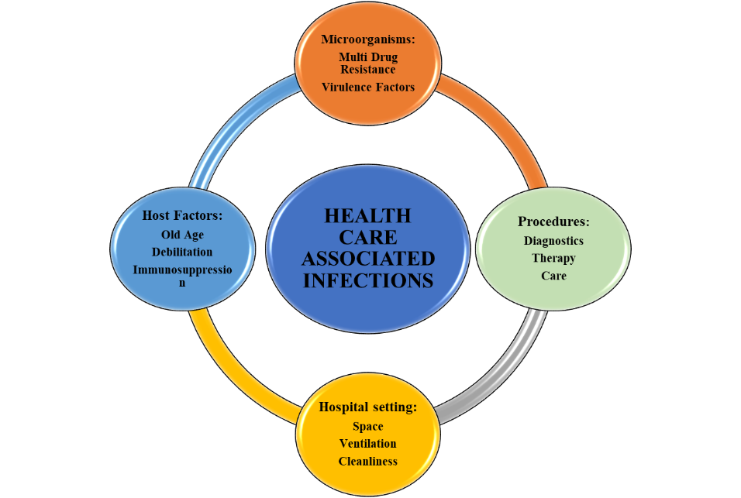
Figure 2. Factors Determining health care associated infections

  - DISEASES ASSOCIATED WITH HOSPITAL-ACQUIRED INFECTIONS
1.1.1 Pneumonia
In ICU patients, pneumonia is predominantly caused by the aspiration of microorganisms from nasal, oro-pharyngeal, or gastric flora [9]. These infections can occur either before ICU admission, particularly in patients with compromised upper airway functions due to coma, trauma, or surgery, or following intubation and ICU admission. Given this, the term “ventilator-associated pneumonia" may be misleading and could be replaced with more precise terminology. For instance, "intubation-associated pneumonia" could be used for early-onset cases, and "tube-associated pneumonia" for late-onset cases. Nevertheless, to maintain simplicity and preserve the acronym, VAP remains a practical term [10].
According to a case-control study at a 600-bed hospital from January 2006 to April 2008. Each case of hospital-acquired pneumonia (HAP) was randomly matched with two controls. Data were collected on risk factors, patient characteristics, and outcomes were recorded, the study included 119 patients with HAP and 238 controls. The incidence of HAP outside the ICU was 2.45 cases per 1,000 discharges. Multivariate analysis identified several significant risk factors for HAP: malnutrition, chronic renal failure, anaemia, impaired consciousness, a Charlson comorbidity index greater than 3, previous hospitalization, and thoracic surgery. Complications occurred in 57.1% of patients, and the mortality rate attributable to HAP was 27.7%[11]. From these results it was concluded that HAP outside the ICU is prevalent among patients with malnutrition, chronic renal failure, anaemia, impaired consciousness, significant comorbidity, recent hospitalization, and thoracic surgery. It is associated with higher illness rates, increased death risks, prolonged hospitalization, and an elevated likelihood of transfer to specialized care facilities.
Next, focusing on other hospital-acquired infections, this review examines bloodstream infections and urinary tract infections based on various case studies and data, highlighting the associated risks, causative agents, and the effectiveness of treatments globally.
    - Blood Stream Infection
Bloodstream infections (BSIs) occur when the immune system fails to contain an infection at a local site, leading to widespread disease. These infections are a significant cause of disease prevalence and mortality. The frequency, epidemiology, and pathogens involved in BSIs have evolved alongside advancements in medical care. This is particularly evident with the rise of increasingly ill and immunocompromised hospitalized patients who rely heavily on medical support and indwelling devices [12].
From March 1995 to September 2002, a study in 49 US hospitals identified 24,179 cases of nosocomial bloodstream infections (BSIs), with an incidence of 60 cases per 10,000 admissions. Most BSIs were monomicrobial, with Gram-positive organisms causing 65% of cases, Gram-negative organisms 25%, and fungi 9.5%. The crude mortality rate was 27%. Common pathogens included coagulase-negative staphylococci (31%), Staphylococcus aureus (20%), enterococci (9%), and Candida species (9%). Methicillin resistance in S. aureus rose from 22% in 1995 to 57% in 2001. Vancomycin resistance was found in 2% of Enterococcus faecalis and 60% of Enterococcus faecium isolates [13]. In this study, one of the largest multicentre investigations conducted to date, we observed a growing proportion of nosocomial bloodstream infections (BSIs) caused by antibiotic-resistant organisms in hospitals.
    - Urinary Tract Infection
Urinary tract infections are the most common healthcare-associated infections, leading to significant costs and morbidity [14]. A retrospective study across 43 acute-care hospitals examined catheter-associated urinary tract infections and non-CAUTI hospital-onset urinary tract infections (HOUTIs). Among 549,433 admissions, there were 434 CAUTIs and 3,177 non-CAUTI HOUTIs. Non-CAUTI HOUTIs were more frequent and led to more secondary bloodstream infections (HOB) than CAUTIs. Both CAUTI and non-CAUTI HOUTI were linked to poor outcomes, highlighting the need for enhanced surveillance and prevention, especially outside the ICU area in the hospitals [15].
1.2 CHALLENGES OF ANTIMICROBIAL RESISTANCE IN SELECTED NOSOCOMIAL PATHOGENS
The rate of infections at various anatomical sites and the associated infection risk differs depending on the type of ICU, with the prevalence of specific pathogens varying according to the site of infection [16]. Prevention and control efforts have primarily targeted methicillin-resistant Staphylococcus aureus, vancomycin-resistant Enterococcus, and Gram-negative bacilli that produce extended-spectrum β-lactamase, among other pathogens.
    - Staphylococcus aureus
S. aureus is one of the most severe gram-positive bacterial infections found in both hospital and community settings [17]. These organisms have been detected in patients who lack the traditional risk factors for MRSA infection, such as recent hospitalization, intensive care unit treatment, surgery, nursing home residence, or recent antimicrobial therapy [18]. According to a clinical trial data conducted, gram-positive bacteria, such as methicillin-resistant Staphylococcus aureus (MRSA), are responsible for many of the infections, MRSA contributes to 10%–40% of cases of healthcare-associated (HCAP), hospital-acquired pneumonia, and ventilator-associated pneumonia. In certain centres, MRSA pneumonia occurs as frequently in HCAP as it does in HAP and is more common than in VAP [19].
    - Vancomycin-Resistant Enterococci
Enterococcus species have become the third most common pathogen in hospitalized patients, responsible for nearly 12% of hospital-acquired infections [20]. While vancomycin-resistant enterococci (VRE) are organisms with low virulence and pathogenicity, they often cause hospital-acquired infections [21]. In the USA, surveillance data from the National Healthcare Safety Network indicate that 3% of all reported hospital-acquired infections were caused by VRE [22].
    - Gram-negative bacilli
The definition of nosocomial infections is somewhat arbitrary; in recent studies, infections like bacteraemia are classified as nosocomial, meaning acquired in the hospital, if the first samples showing microorganisms are collected on or after the third day of hospitalization [23]. Gram-negative bacilli differ in how often they cause the four most common types of hospital-acquired infections: pneumonia, surgical site infections (SSI), urinary tract infections (UTI), and bloodstream infections (BSI)[24]. Among the Gram-negative aerobic bacteria, E. coli was the most common, followed by K. pneumoniae, P. aeruginosa, and Enterobacter cloacae [25]. E. coli is linked to various diseases, including urinary tract infections, septicemia, pneumonia, neonatal meningitis, peritonitis, and gastroenteritis.
1.3 PARAMETERS
The risk factors for nosocomial infections are influenced by the care environment, the patient's susceptibility and condition, and the lack of awareness of these infections among staff and healthcare providers [26]. Hospital patients are vulnerable to infections due to underlying health conditions and medical procedures like surgery, intubation, or antibiotic use, as well as exposure to microorganisms from other patients, the hospital environment, or healthcare staff [27]. As depicted in Table 1 there are various causes or parameters of HAI’s.

Table 1. Different causes responsible for infections acquired in hospitals.
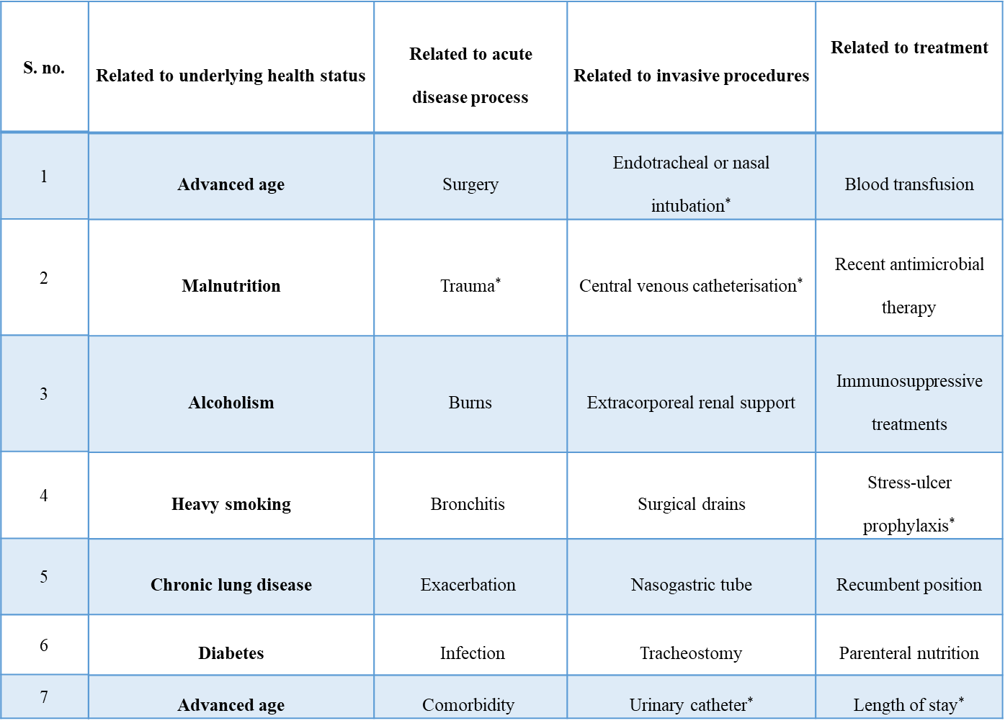
1.4 MODES OF TRANSMISSION OF HOSPITAL ACQUIRED INFECTION
The primary mode of organism transmission between patients is through indirect contact via healthcare staff's hands, often due to neglect or inadequate hand hygiene practices [28].Multiple lines of evidence indicate that environmental contamination contributes to the development of hospital-acquired infections. Studies have demonstrated an increased risk of patients contracting the same pathogen as the previous room occupant[29]. In a large retrospective cohort study, Huang and colleagues aimed to quantify the risk of acquiring two common nosocomial pathogens, MRSA and VRE, from contaminated hospital rooms [30].Patients with diarrhea are common means of transmission. Their room items such as surfaces and equipment act as reservoirs. Vancomycin-resistant enterococcii can survive on theses surfaces for days or weeks and become a source of contamination for healthcare individuals and other patients [31].Respiratory machines, catheters, and exposed wounds can serve as sources for transmission. K. pneumoniae and has been reported to spread through stool (77%), patients' hands (42%), and the pharynx (19%)[32].Common reservoirs for P. aeruginosa contamination include breast pumps, incubators, sinks, hospital staff's hands, and even hand soaps [34]. In contrast, C. difficile spores can survive for months, posing challenges for disinfectants and cleaning agents. Infected patients and inanimate objects serve as major reservoirs. Additionally, hospital staff and the overall healthcare environment significantly contribute to the spread of these pathogens [35].
1.5 MODERN APPROACHES TO INFECTION DIAGNOSIS
The diagnosis of hospital-acquired pneumonia (HAP) remains a topic of debate, with no definitive method established as the gold standard. Numerous factors can account for new fevers and elevated white blood cell counts, and using radiological imaging alone to diagnose pneumonia is often unreliable. As a result, clinical guidelines have been developed to help clinicians decide which patients likely have pneumonia and which do not[36].The bacteriologic diagnosis of pneumonia requires obtaining samples from the lower airways for quantitative culture analysis.MDR nosocomial pathogens complicate the treatment of infections and negatively impact clinical outcomes, while also increasing treatment costs for patients [37].Microbiological surveillance plays a vital role in infection control programs, supplying data on the types and quantities of microbial flora present at various sites within healthcare facilities [38].Quantitative culture results may be influenced by sampling variability, and there is no evidence to suggest that quantitative cultures, compared to qualitative ones, lead to reductions in mortality, ICU stay duration, length of mechanical ventilation, or the need for antibiotic adjustments. However, quantitative cultures are more effective at distinguishing between colonization and actual infection, reducing the likelihood of unnecessary antibiotic use. To further enhance this distinction in patients with ventilator-associated pneumonia, promising biomarkers, such as procalcitonin, C-reactive protein, and soluble triggering receptor expressed on myeloid cells (sTREM-1), are being studied in conjunction with clinical and microbiological factors [39].
1.6 STRATEGIES FOR THE PREVENTION AND CONTROL OF HOSPITAL-ACQUIRED INFECTIONS
    - Hospital Maintenance
Environmental cleaning and disinfection play a crucial role in infection control programs, ensuring that patient rooms and equipment are safe. While hand hygiene has rightfully garnered significant attention, cleaning practices are equally important [40].
Hospital-acquired infections are a significant safety concern for both healthcare providers and patients. Considering the related health complications, fatality risks, extended hospitalization, and heightened expenses, it is crucial to adopt strategies that ensure hospitals remain as safe as possible by preventing such infections [41].Patients admitted to rooms previously occupied by carriers of VRE or MRSA face a two- to three-fold increased risk of acquiring these pathogens[42]. Similar elevated risks are observed for infections with A. baumannii, Pseudomonas aeruginosa, and C. difficile. Molecular typing in MRO outbreaks has linked contamination of the environment, healthcare workers' hands, and patient isolates. While healthcare workers play a primary role in transmission, they can acquire MROs from the environment or inadequately cleaned equipment such as monitors, blood pressure cuffs, and tourniquets[43]. Enhanced terminal cleaning methods have been shown to significantly reduce the acquisition rates of MRSA, VRE, and C. difficile[44].
    - Barrier Precautions for Infection Control
Contact precautions involve the use of single-patient rooms, dedicated equipment, and require healthcare workers (HCWs) to wear gowns and gloves during patient care. The optimal implementation of these precautions to reduce hospital-acquired infections, particularly for vancomycin-resistant Enterococcus (VRE), remains uncertain[45]. The routine use of gowns and gloves for each patient interaction demands considerable effort from HCWs, consumes large quantities of supplies, and results in notable financial and environmental costs. Moreover, studies have shown that these measures can inadvertently negatively impact the quality of patient care[40].
    - Effective Hospital Waste Management
Hospital waste can serve as a potential reservoir for pathogens, necessitating proper handling. Around 10–25% of the waste generated by healthcare facilities is classified as hazardous. Infectious healthcare waste should be stored in restricted-access areas. Waste containing high levels of heavy metals, as well as waste from surgeries, infected individuals, blood- and sputum-contaminated materials, and diagnostic laboratories, must be disposed of separately. It's crucial to educate healthcare staff and cleaners on the risks associated with hospital waste and the importance of proper waste management practices[25].
These findings align with previously reported inefficacy of other strategies involving the administration of specific antistaphylococcal immunoglobulins, whether pooled from donors or enriched[46].

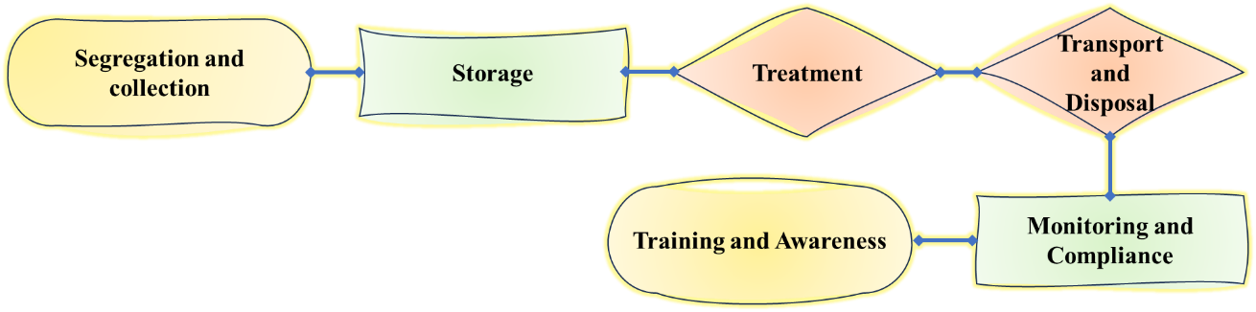
Figure3. Flowchart depicting Comprehensive Approach to Effective Hospital Waste Management for Minimizing Hospital Acquired Infections
This flowchart outlines the systematic process of hospital waste management, essential for minimizing the risk of hospital-acquired infections. The steps include waste segregation, collection, storage, treatment, transport, and disposal, ensuring compliance with regulatory standards and promoting a safe healthcare environment. Additionally, it emphasizes the importance of continuous monitoring, training, and improvement in waste management practices to mitigate infection risks.
  - TREATMENT
1.7.1 Antimicrobial Use and Resistance: A Growing Concern
Microbes, though invisible to the naked eye, are ubiquitous across the planet. Antimicrobial drugs are employed to combat pathogenic microbes that threaten the health of living organisms. However, antimicrobial resistance arises when microbes evolve the capacity to withstand the effects of these drugs, allowing them to survive and continue growing despite treatment[25].Nosocomial infections, or healthcare-associated infections, are a critical challenge within hospitals due to their high prevalence, potential severity, and increasing antibiotic resistance. Effective treatment strategies target both the prevention of infection and addressing established infections through a combination of antibiotic therapy, bacteriophage therapy, and innovative approaches like microbiome-based treatments.
    - Antibiotic Therapy
The cornerstone of nosocomial infection treatment is the use of antibiotics. However, the rise of multidrug-resistant organisms such as Methicillin-resistant Staphylococcus aureus(MRSA), Vancomycin-resistant Enterococci (VRE), and Extended-spectrum beta-lactamase (ESBL)-producing bacteria has limited the efficacy of traditional antibiotics. Targeted therapy based on microbial susceptibility testing is therefore essential [47].
    - MRSA Treatment
For infections caused by MRSA, glycopeptides such as vancomycin have been the gold standard. However, the emergence of vancomycin-intermediate strains has necessitated the use of alternative treatments. Daptomycin, an antibiotic from the lipopeptide class, has been shown to be effective in cases of bacteremia and endocarditis caused by MRSA [48]. Studies indicate that daptomycin has a high clinical success rate in patients unresponsive to vancomycin. Linezolid, an oxazolidinone, is another alternative for MRSA infections, particularly in pneumonia and soft tissue infections [48].
1.7.4 VRETreatment
Vancomycin-resistant Enterococci (VRE) represent another major nosocomial threat. Linezolid and daptomycin are among the preferred agents for treating VRE infections. A study by Boucher et al. (2019) reported that the use of high-dose daptomycin, often in combination with other agents like ampicillin or ceftaroline, yielded positive outcomes in VRE bacteremia [49].
    - Gram-negative MDROs Treatment
The treatment of Gram-negative MDRO infections, such as those caused by ESBL-producing Escherichia coli and Klebsiella pneumoniae, often requires the use of carbapenems, including meropenem and imipenem [50]. However, the increasing prevalence of carbapenem-resistant organisms (CRE) has driven the use of novel agents like ceftazidime-avibactam and meropenem-vaborbactam[51]. These agents restore some activity against resistant strains by inhibiting beta-lactamase enzymes.
    - Bacteriophage Therapy
With antibiotic resistance on the rise, bacteriophage therapy is being revisited as a potential alternative for nosocomial infections. Phages are viruses that specifically infect and lyse bacteria, offering a targeted approach with fewer side effects compared to broad-spectrum antibiotics. Research has shown that bacteriophages can be highly effective against biofilm-associated infections, which are common in catheter-related bloodstream infections and ventilator-associated pneumonia [52].
A clinical case study in Belgium demonstrated the efficacy of bacteriophage therapy in treating a Pseudomonas aeruginosa infection resistant to conventional antibiotics. After phage application, the patient’s infection was eradicated without recurrence [53].
1.7.7 Microbiome-based Approaches
Restoring the balance of the microbiota is an emerging strategy for preventing and treating nosocomial infections. This is particularly relevant in cases of Clostridioides difficile infection (CDI), which is associated with antibiotic-induced dysbiosis. Fecal microbiota transplantation (FMT) has been shown to be highly effective in treating recurrent CDI by reintroducing healthy gut bacteria to outcompete the pathogenic strain [54].
Additionally, incorporating probiotics alongside antibiotic treatment is drawing interest, particularly for infection prevention in vulnerable patients.Probiotics have demonstrated efficacy in reducing the incidence of ventilator-associated pneumonia in critically ill patients [55]. The significance of infection prevention measures and antibiotic stewardship programs should be highlighted, particularly until more dependable treatment options for multidrug-resistant Gram-negative bacteria (GNB) and advanced rapid diagnostic tools become available[56].
- CONCLUSIONS
Hospitals and healthcare facilities worldwide have historically had inadequate strategies for preventing and controlling hospital-acquired infections. This has resulted in delayed responses, significant cross-contamination, increased mortality rates, and financial losses during disease outbreaks. Even in the age of antibiotics, these infections remain difficult to control. However, the transmission of such infections through healthcare workers can be mitigated by adhering to strict infection control practices.
The improper and frequent use of antibiotics has also contributed to the rise of drug-resistant organisms, making them harder to treat. Hospitals must establish infection control programs that allow for the monitoring, comparison, and control of infection rates. A well-managed surveillance system, in line with CDC guidelines, is crucial. Additionally, sharing best practices between hospitals is essential to curbing the spread of nosocomial infections.
To prevent post-operative infections, especially in type II and III incisions, strict protocols should be followed, including meticulous pre-operative care. Shortcomings in technology, such as poor infrastructure and inadequate ventilation, have hindered efforts to isolate patients and prevent the spread of HAIs. Improving the quality of disinfection is also necessary for better infection control. Effective strategies for managing hospital-acquired infections must be implemented in hospitals, with healthcare workers (HCWs) acknowledging the critical role they play in preventing HAIs. Nosocomial infections present complex challenges in treatment due to the rise of antibiotic resistance. While antibiotics remain the mainstay of treatment, alternative strategies such as bacteriophage therapy and microbiome-based approaches are promising avenues for managing these infections. Future research should focus on optimizing the use of these treatments, potentially combining them with conventional antibiotic therapies to improve outcomes in hospital settings.
Achieving success in these efforts will require a cultural shift that highlights both institutional and individual accountability. This includes adherence to infection control guidelines and the responsible use of antimicrobials to ensure optimal prevention and management practices.

Ethics statement
This study did not involve human or animal experiments; therefore, ethical review was not required.

REFERENCES
- Abdidizaji, Sina, Ali Khodabandeh Yalabadi, Mehdi Yazdani-Jahromi, Ozlem Ozmen Garibay, and Ivan Garibay. "Agent-based modeling of C. difficile spread in hospitals: assessing contribution of high-touch vs. Low-touch surfaces and inoculations’ containment Impact." In Conference of the Computational Social Science Society of the Americas, pp. Cham: Springer Nature Switzerland, (2023):173-188.
- Tacconelli, Evelina, Elena Carrara, Alessia Savoldi, Stephan Harbarth, Marc Mendelson, Dominique L. Monnet, Céline Pulcini et al. "Discovery, research, and development of new antibiotics: the WHO priority list of antibiotic-resistant bacteria and tuberculosis." The Lancet infectious diseases 18, no. 3 (2018): 318-327.
- Halikov, Maksim R., Vasily E. Ekushov, Alexei V. Totmenin, Natalya M. Gashnikova, Mariya E. Antonets, Tatyana V. Tregubchak, Lidiia P. Skliar, Natalia P. Solovyova, Irina S. Gorelova, and Svetlana N. Beniova. "Identification of a novel HIV-1 circulating recombinant form CRF157_A6C in Primorsky Territory, Russia." Journal of Infection 88, no. 2 (2024): 180-182.
- Bruno, Antonia, Farida Tripodi, Alice Armanni, Linda Barbieri, Alessandro Colombo, Sara Fumagalli, Hind Moukham et al. "Advancements in nanosensors for detecting pathogens in healthcare environments." Environmental Science: Nano (2024).
- Ebnöther, Corina, Beate Tanner, Flavia Schmid, Vittoria La Rocca, Ivo Heinzer, and Thomas Bregenzer. "Impact of an infection control program on the prevalence of nosocomial infections at a tertiary care center in Switzerland." Infection Control & Hospital Epidemiology 29, no. 1 (2008): 38-43.
- Dancer, Stephanie J. "Importance of the environment in methicillin-resistant Staphylococcus aureus acquisition: the case for hospital cleaning." The Lancet infectious diseases 8, no. 2 (2008): 101-113.
- Agarwal, Mansi, Stephanie Shiau, and Elaine L. Larson. "Repeat gram-negative hospital-acquired infections and antibiotic susceptibility: a systematic review." Journal of Infection and Public Health 11, no. 4 (2018): 455-462.
- Hidron, Alicia I., Jonathan R. Edwards, Jean Patel, Teresa C. Horan, Dawn M. Sievert, Daniel A. Pollock, and Scott K. Fridkin. "Antimicrobial-resistant pathogens associated with healthcare-associated infections: annual summary of data reported to the National Healthcare Safety Network at the Centres for Disease Control and Prevention, 2006–2007." Infection Control & Hospital Epidemiology 29, no. 11 (2008): 996-1011.
- Wg, Johanson. "Changing pharyngeal bacterial flora of hospitalized patients. Emergence of Gram-negative bacilli." N Engl J Med 281 (1969): 1137-1140.
- Torres, Antoni, Santiago Ewig, Harmut Lode, Jean Carlet, and European HAP Working Group. "Defining, treating and preventing hospital acquired pneumonia: European perspective." Intensive care medicine 35 (2009): 9-29.
- Sopena, Nieves, Eva Heras, Irma Casas, Jordi Bechini, Ignasi Guasch, Maria Luisa Pedro-Botet, Silvia Roure, and Miquel Sabrià. "Risk factors for hospital-acquired pneumonia outside the intensive care unit: a case-control study." American journal of infection control 42, no. 1 (2014): 38-42.
- Karchmer, Adolf W. "Nosocomial bloodstream infections: organisms, risk factors, and implications." Clinical infectious diseases 31, no. Supplement_4 (2000): S139-S143.
- Wisplinghoff, Hilmar, Tammy Bischoff, Sandra M. Tallent, Harald Seifert, Richard P. Wenzel, and Michael B. Edmond. "Nosocomial bloodstream infections in US hospitals: analysis of 24,179 cases from a prospective nationwide surveillance study." Clinical infectious diseases 39, no. 3 (2004): 309-317.
- Lobão, Maria João, and Paulo Sousa. "Hospital-acquired urinary tract infections: results of a cohort study performed in an internal medicine department." Acta medica portuguesa 30, no. 9 (2017): 608-614.
- Kelly, Timothy, ChinEn Ai, Molly Jung, and Kalvin Yu. "Catheter-associated urinary tract infections and non-CAUTI hospital-onset urinary tract infections: Relative burden, cost, outcomes and related hospital-onset bacteremia and fungemia infections." Infection Control & Hospital Epidemiology (2024): 1-8.
- Weber, David J., Ralph Raasch, and William A. Rutala. "Nosocomial infections in the ICU: the growing importance of antibiotic-resistant pathogens." Chest 115, no. 3 (1999): 34S-41S.
- Valaperta, Rea, Milvana Rosa Tejada, Marcello Frigerio, Alessandra Moroni, Elisa Ciulla, Sara Cioffi, Paolo Capelli, and Elena Costa. "Staphylococcus aureus nosocomial infections: the role of a rapid and low-cost characterization for the establishment of a surveillance system." New Microbiologica 33, no. 3 (2010): 223-232.
- David, M. D., A. M. Kearns, S. Gossain, M. Ganner, and A. Holmes. "Community-associated meticillin-resistant Staphylococcus aureus: nosocomial transmission in a neonatal unit." Journal of Hospital Infection 64, no. 3 (2006): 244-250.
- Wunderink, Richard G., Michael S. Niederman, Marin H. Kollef, Andrew F. Shorr, Mark J. Kunkel, Alice Baruch, William T. McGee, Arlene Reisman, and Jean Chastre. "Linezolid in methicillin-resistant Staphylococcus aureus nosocomial pneumonia: a randomized, controlled study." Clinical Infectious Diseases 54, no. 5 (2012): 621-629.
- Linden, PeterK, and CaroleB Miller. "Vancomycin-resistant enterococci: the clinical effect of a common nosocomial pathogen." Diagnostic microbiology and infectious disease 33, no. 2 (1999): 113-120.
- Gastmeier, Petra, Christin Schröder, Michael Behnke, Elisabeth Meyer, and Christine Geffers. "Dramatic increase in vancomycin-resistant enterococci in Germany." Journal of Antimicrobial Chemotherapy 69, no. 6 (2014): 1660-1664.
- Puchter, Laura, Iris Freya Chaberny, Frank Schwab, Ralf-Peter Vonberg, Franz-Christoph Bange, and Ella Ebadi. "Economic burden of nosocomial infections caused by vancomycin-resistant enterococci." Antimicrobial Resistance & Infection Control 7 (2018): 1-7.
- Klastersky, J. "Nosocomial infections due to Gram-negative bacilli in compromised hosts: Considerations for prevention and therapy." Reviews of Infectious Diseases (1985): S552-S558.
- Weinstein, Robert A. "Epidemiology and control of nosocomial infections in adult intensive care units." The American journal of medicine 91, no. 3 (1991): S179-S184.
- Khan, Hassan Ahmed, Aftab Ahmad, and Riffat Mehboob. "Nosocomial infections and their control strategies." Asian pacific journal of tropical biomedicine 5, no. 7 (2015): 509-514.
- Breathnach, Aodhán S. "Nosocomial infections and infection control." Medicine 41, no. 11 (2013): 649-653.
- Breathnach, Aodhán S. "Nosocomial infections." Medicine 33, no. 3 (2005): 22-26.
- Kolmos, Hans Jørn. "Health care associated infections: sources and routes of transmission." Infection Control–Updates 22 (2012): 21-38.
- Steinberg, James P., Megan E. Denham, Craig Zimring, Altug Kasali, Kendall K. Hall, and Jesse T. Jacob. "The role of the hospital environment in the prevention of healthcare-associated infections by contact transmission." HERD: Health Environments Research & Design Journal 7, no. 1_suppl (2013): 46-73.
- Datta, Rupak, Richard Platt, Deborah S. Yokoe, and Susan S. Huang. "Environmental cleaning intervention and risk of acquiring multidrug-resistant organisms from prior room occupants." Archives of internal medicine 171, no. 6 (2011): 491-494.
- Sood, Seema, Meenakshi Malhotra, B. K. Das, and Arti Kapil. "Enterococcal infections & antimicrobial resistance." Indian journal of medical research 128, no. 2 (2008): 111-121.
- Lin, Yi-Tsung, Yu-Ping Wang, Fu-Der Wang, and Chang-Phone Fung. "Community-onset Klebsiella pneumoniae pneumonia in Taiwan: clinical features of the disease and associated microbiological characteristics of isolates from pneumonia and nasopharynx." Frontiers in microbiology 6 (2015): 122.
- Jones, B. L., L. J. Gorman, J. Simpson, E. T. Curran, S. McNamee, C. Lucas, J. Michie, D. J. Platt, and B. Thakker. "An outbreak of Serratia marcescens in two neonatal intensive care units." Journal of Hospital Infection 46, no. 4 (2000): 314-319.Rabier, V., S. Bataillon, A. Jolivet‐Gougeon, J‐M. Chapplain, A. Beuchée, and
- P. Bétrémieux. "Hand washing soap as a source of neonatal Serratia marcescens outbreak." Acta Paediatrica 97, no. 10 (2008): 1381-1385.
- Rabier, V., S. Bataillon, A. Jolivet‐Gougeon, J‐M. Chapplain, A. Beuchée, and P. Bétrémieux. "Hand washing soap as a source of neonatal Serratia marcescens outbreak." Acta Paediatrica 97, no. 10 (2008): 1381-1385.
- Kieninger, Alicia N., and Pamela A. Lipsett. "Hospital-acquired pneumonia: pathophysiology, diagnosis, and treatment." Surgical Clinics of North America 89, no. 2 (2009): 439-461.
- Solomon, FithamlakBisetegen, Fiseha Wadilo, Efrata Girma Tufa, and Meseret Mitiku. "Extended spectrum and metalo beta-lactamase producing airborne Pseudomonas aeruginosa and Acinetobacter baumanii in restricted settings of a referral hospital: a neglected condition." Antimicrobial Resistance & Infection Control 6 (2017): 1-7.
- Bohra, Shweta, and Ritu Bhatnagar. "Bacteriological profile in microbiology surveillance of operation theatres: a retrospective study at a tertiary care teaching hospital in Rajsamand district." Rajasthan IP Int J Med Microbiol Trop Dis 6 (2020): 120-122.
- Peleg, Anton Y., and David C. Hooper. "Hospital-acquired infections due to gram-negative bacteria." New England Journal of Medicine 362, no. 19 (2010): 1804-1813.
- Fernando, Shelanah A., Timothy J. Gray, and Thomas Gottlieb. "Healthcare‐acquired infections: prevention strategies." Internal medicine journal 47, no. 12 (2017): 1341-1351.
- Mehta, Yatin, Abhinav Gupta, Subhash Todi, S. N. Myatra, D. P. Samaddar, Vijaya Patil, Pradip Kumar Bhattacharya, and Suresh Ramasubban. "Guidelines for prevention of hospital acquired infections." Indian journal of critical care medicine: peer-reviewed, official publication of Indian Society of Critical Care Medicine 18, no. 3 (2014): 149.
- Chemaly, Roy F., Sarah Simmons, Charles Dale Jr, Shashank S. Ghantoji, Maria Rodriguez, Julie Gubb, Julie Stachowiak, and Mark Stibich. "The role of the healthcare environment in the spread of multidrug-resistant organisms: update on current best practices for containment." Therapeutic advances in infectious disease 2, no. 3-4 (2014): 79-90.
- Dancer, Stephanie J. "Dos and don’ts for hospital cleaning." Current opinion in infectious diseases 29, no. 4 (2016): 415-423.
- Pinto, Angie N., Thuy Phan, Gabriela Sala, Elaine YL Cheong, Steven Siarakas, and Thomas Gottlieb. "Reusable venesection tourniquets: a potential source of hospital transmission of multiresistant organisms." Medical journal of Australia 195, no. 5 (2011): 276-279.
- Dhar, Sorabh, Dror Marchaim, Ryan Tansek, Teena Chopra, Adnan Yousuf, Ashish Bhargava, Emily T. Martin et al. "Contact precautions more is not necessarily better." Infection control & hospital epidemiology 35, no. 3 (2014): 213-219.
- Manzoni, Paolo, Daniele De Luca, Mauro Stronati, Evelyne Jacqz-Aigrain, Giulia Ruffinazzi, Martina Luparia, Elena Tavella et al. "Prevention of nosocomial infections in neonatal intensive care units." American journal of perinatology 30, no. 02 (2013): 081-088.
- Liu, Catherine, Arnold Bayer, Sara E. Cosgrove, Robert S. Daum, Scott K. Fridkin, Rachel J. Gorwitz, Sheldon L. Kaplan et al. "Clinical practice guidelines by the Infectious Diseases Society of America for the treatment of methicillin-resistant Staphylococcus aureus infections in adults and children." Clinical infectious diseases 52, no. 3 (2011): e18-e55.
- Boucher, Helen W., George H. Talbot, John S. Bradley, John E. Edwards, David Gilbert, Louis B. Rice, Michael Scheld, Brad Spellberg, and John Bartlett. "Bad bugs, no drugs: no ESKAPE! An update from the Infectious Diseases Society of America." Clinical infectious diseases 48, no. 1 (2009): 1-12.
- Miller, William R., Barbara E. Murray, Louis B. Rice, and Cesar A. Arias. "Vancomycin-resistant enterococci: therapeutic challenges in the 21st century." Infectious Disease Clinics 30, no. 2 (2016): 415-439.
- Hareza, Dariusz, Patricia J. Simner, Yehudit Bergman, Emily Jacobs, Sara E. Cosgrove, and Pranita D. Tamma. "The frequency of extended-spectrum β-lactamase genes harbored by Enterobacterales isolates at high risk for clinically significant chromosomal ampC expression." In Open Forum Infectious Diseases, vol. 10, no. 4, p. ofad175. US: Oxford University Press, 2023.
- Falagas, Matthew E., Giannoula S. Tansarli, Drosos E. Karageorgopoulos, and Konstantinos Z. Vardakas. "Deaths attributable to carbapenem-resistant Enterobacteriaceae infections." Emerging infectious diseases 20, no. 7 (2014): 1170.
- Kortright, Kaitlyn E., Benjamin K. Chan, Jonathan L. Koff, and Paul E. Turner. "Phage therapy: a renewed approach to combat antibiotic-resistant bacteria." Cell host & microbe 25, no. 2 (2019): 219-232.
- Schooley, Robert T., Biswajit Biswas, Jason J. Gill, Adriana Hernandez-Morales, Jacob Lancaster, Lauren Lessor, Jeremy J. Barr et al. "Development and use of personalized bacteriophage-based therapeutic cocktails to treat a patient with a disseminated resistant Acinetobacter baumannii infection." Antimicrobial agents and chemotherapy 61, no. 10 (2017): 10-1128.
- Van Nood, Els, Anne Vrieze, Max Nieuwdorp, Susana Fuentes, Erwin G. Zoetendal, Willem M. de Vos, Caroline E. Visser et al. "Duodenal infusion of donor feces for recurrent Clostridium difficile." New England Journal of Medicine 368, no. 5 (2013): 407-415.
- Caselli, E., L. Arnoldo, C. Rognoni, M. D’Accolti, I. Soffritti, L. Lanzoni, M. Bisi et al. "Impact of a probiotic-based hospital sanitation on antimicrobial resistance and HAI-associated antimicrobial consumption and costs: A multicenter study. Infect Drug Resist. 2019; 12: 501–510." DOI: https://doi. org/10.2147/IDR. S 194670: 501-510.
- Mun, Seok Jun, Si-Ho Kim, Hyoung-Tae Kim, Chisook Moon, and Yu Mi Wi. "The epidemiology of bloodstream infection contributing to mortality: the difference between community-acquired, healthcare-associated, and hospital-acquired infections." BMC Infectious Diseases 22, no. 1 (2022): 336.

