LEARNING OF ENGLISH AND SATISFACTION OF ESL LEARNERS WITH SPEAKING CLASSES: THE MEDIATING ROLDE OF THE USE OF ENGLISH ONLINE DURING LEISURE TIME

ABSTRACT
This study determined the mediating role of the use of English online during leisure time between learning of English and the satisfaction of ESL learners with speaking classes anchored on the theory of Metacognition. The data were gathered from Grade 12 Senior High School students enrolled in the first semester of the academic year 2024-2025 at school 304366, using an adapted survey questionnaire implemented face-to-face. Utilizing quantitative research design, data were collected and analyzed using correlation and mediation analyses. The findings revealed a significant positive correlation between learning English and satisfaction with speaking classes; learning of English and the Use of English online during leisure time; and the Use of English online to the satisfaction with speaking classes. Mediation analysis showed that English online use partially mediated the link between learning English and satisfaction with speaking classes, accounting for 21.1% of the total effect. Path analysis revealed both direct and indirect effects of online engagement. The study concluded that integrating metacognitive strategies within practical context enhances ESL learners' skills and satisfaction, highlighting the benefits of incidental learning. These findings can improve educational quality and promote equitable lifelong learning opportunities in line with United Nation Sustainable Development Goal 4: Quality Education.

Keywords: education, English learning, satisfaction of ESL learners with speaking classes, online usage, mediating effect, Philippines

- INTRODUCTION

The increasing importance of English as a global lingua franca has made it essential for non-native speakers, particularly ESL (English as a Second Language) learners, to attain proficiency in speaking. In the Philippines, despite a significant emphasis on English in the education system, many learners express dissatisfaction with their speaking classes. Traditional teaching methods, prevalent in ESL classrooms, often hinder authentic language usage and reduce opportunities for practical speaking experience. This disconnect between learners' expectations and classroom practices can lead to a lack of engagement and lower satisfaction levels in speaking tasks. The central problem addressed in this study is the low satisfaction of ESL learners with speaking classes, stemming from inadequate teaching practices, particularly the reliance on traditional instructional approaches. These methods limit real-life language application and fail to motivate learners, resulting in low engagement and self-confidence during speaking activities. Understanding how to enhance satisfaction levels in speaking classes is crucial for improving learner outcomes and fostering effective communication skills. To mitigate the issues faced by ESL learners, the study proposes integrating metacognitive strategies and promoting the use of English during leisure time to enhance speaking skills and the overall satisfaction of learners with their courses. By leveraging online resources and opportunities for incidental learning, learners can develop their speaking abilities in a more engaging and practical context. This approach emphasizes proactive engagement with the language outside the classroom and encourages exploration and self-directed learning, potentially transforming the ESL learning experience and improving satisfaction levels.

A review of relevant literature highlights the persistent shortcomings of traditional ESL teaching methodologies. Rustan et al. and Kashinathan et al. identify that scripted dialogues and teacher-centered approaches inhibit authentic language use, resulting in decreased learner motivation (Kashinathan et al.). Widiati et al. and Yahaya et al. emphasize the negative impact these traditional practices have on learners' self-confidence and satisfaction levels in speaking classes. Additionally, studies by Zhang et al. and Asakereh and Dehghannezhad point to the significant role that student engagement and the environment play in fostering satisfaction, while Manan et al. note that reliance on instructional practices limits opportunities for practical language application. This body of research underscores the need for innovative strategies that cater to modern learners in a digital landscape.

The scope of this study centers on Grade 12 Senior High School ESL learners in the Philippines, focusing on their satisfaction with speaking classes and the impact of online English usage during leisure time. The research encompasses both quantitative data collection and analysis, employing correlation and mediation analyses to explore the relationships among learning of English, online English use, and learner satisfaction. The justification for this research lies in the pressing need to address the dissatisfaction among ESL learners in the Philippines, which, if left unaddressed, could hinder their language acquisition and future opportunities. By investigating the mediating effects of online English use, the study aims to provide actionable insights that can enhance classroom practices and empower learners, thereby contributing to the goals of achieving quality education as outlined in the United Nations Sustainable Development Goal 4.

- METHOD

Research Respondents
The study targeted senior high school students at school 304366, involving 250 respondents selected through random sampling to ensure a representative sample reflective of the student population. The sample included Grade 12 students from various strands: Technical-Vocational Livelihood (sections Masigasig, Magalang, Masipag), Humanities and Social Sciences (Sanghaya, Masiglahi, Masidlak, Marangal), and Administration and Business Management (Mapitagan). Only Grade 12 respondents enrolled in relevant English-speaking courses were included, while those who withdrew or didn't meet inclusion criteria were excluded. The research considered potential psychological risks, like language anxiety, implementing strategies to mitigate them, including clear guidelines and access to counseling services. An informed consent form outlined the potential risks, with participants receiving direct benefits such as tokens of appreciation and indirect benefits like contributions to their language learning and self-esteem. Conducted at school 304366 in Davao City, the study aimed to assess ESL learners' satisfaction with speaking classes in a diverse educational context. In compliance with the Data Privacy Act of 2012, all data were anonymized and securely archived, with deletion following the study’s completion.

Material and Instrument
The questionnaires used in the study were adapted and modified from prior research to fit the specific needs of ESL learners. Language education experts reviewed the tools, and revisions were made based on their feedback to ensure clarity and relevance. The final questionnaire achieved a mean validity score of 4.17, indicating strong content validity (Varathan et al., pp. 22–27). The tools were grouped into three categories: (1) Learning of English (IV), (2) ESL Learners' Satisfaction with Speaking Classes (DV), and (3) Use of English Online During Leisure Time (MV).

The Learning of English Questionnaire (Tragant et al., pp. 95–108) assessed learners' efforts to study English inside and outside the classroom. It covered six areas: general English improvement, vocabulary learning, grammar study, reading, and writing. A five-point Likert scale measured frequency: 4.21–5.00 ("Always") to 1.00–1.80 ("Never"), helping interpret how consistently students engaged in English learning. The Speaking Class Satisfaction Questionnaire (Asakereh & Dehghannezhad, pp. 345–363) contained 38 items rated from 1 ("Very Unsatisfactory") to 5 ("Very Satisfactory") across five domains, such as linguistic, psychological, and instructional aspects. It gauged learner satisfaction using a five-point interpretation scale similar to the first questionnaire.The third tool, Use of English Online During Leisure Time (Geoffrey Sockket), explored learners' informal English use online, measured on a scale from 1 ("I do not do it") to 4 ("I do it very often"). Frequency interpretations were based on monthly engagement levels, from "Always" (6+ times/month) to "Never."

All instruments were revised based on literature reviews, pilot-tested, translated when needed, and aligned with participants' context. The questionnaires showed high reliability with Cronbach’s alpha scores of 0.928 (English learning), 0.969 (speaking class satisfaction), and 0.928 (online English use), confirming their suitability and consistency for data collection.

Design and Procedure
This study employed mediation analysis to examine the relationships among three variables: Learning English (independent variable), Satisfaction with ESL Speaking Classes (dependent variable), and Use of English Online During Leisure Time (mediating variable). Mediation analysis, a statistical method used to understand how one variable influences another through a mediator, has become widely used across disciplines such as psychology, health, and education (Yu et al.; Zeng et al.; Wang et al.). It uses regression path analysis to assess indirect effects and has evolved significantly since Baron and Kenny’s foundational work.Descriptive and correlation analyses were conducted prior to mediation testing to explore associations among variables. Regression coefficients and significance levels were reported to determine the mediating effect of online English use on learners’ satisfaction. Updated methodologies, including multiple regression, structural equation modeling, and sensitivity testing, were followed to ensure validity and reliability (Valente et al.; Toni et al.).

The researcher collaborated with a statistician for data collection, analysis, and manuscript writing. The tools, validated with a mean score of 4.17, were pilot-tested and deemed reliable. Permissions were obtained from relevant education authorities, including the University of Mindanao, school division offices, principals, and supervisors. Respondents included Grade 12 students from the HUMSS, TVL, and ABM strands. Informed consent and assent were obtained, and participants were oriented on confidentiality, voluntary participation, and their right to withdraw (Skelton et al.; Adewale et al.).

Ethical standards were strictly observed. The study was approved by the University of Mindanao Ethics Review Committee (UMERC No. 2024-285). The researcher personally administered the surveys and completed data collection within two weeks. Academic integrity was maintained using proper citation, paraphrasing, and plagiarism detection tools (e.g., Grammarly, Quillbot). No data was fabricated or misrepresented. Expert consultation and transparency throughout the research process ensured ethical conduct and credible findings aligned with current literature in language education.

- RESULTS AND DISCUSSION
Frequency of Learning English
Revealed in Table 1 is the frequency of using English strategies among Senior High School students revealed that they often utilize English strategies with an overall mean score of 3.56 and a standard deviation of 0.56. Five strategies in learning English were also often, namely, the general level of English with a mean of 3.75, studying grammar with a mean of 3.58, reading in English with a mean of 3.88, writing English with a mean of 4.00, and speaking in English with the mean of 3.67. At the same time, students in vocabulary learning which means sometimes had a mean score of 3.04. These findings suggest that while students actively engage with various English learning strategies, vocabulary acquisition remains an area with relatively lower usage. This indicates a potential need for targeted interventions or instructional strategies to enhance vocabulary learning among Senior High School students.

Table 1
Frequency of the Learning of English
Indicators | SD | Mean | Descriptive Level
General Level of English | 0.65 | 3.75 | Often
Vocabulary Learning | 0.79 | 3.04 | Sometimes
Studying Grammar | 0.89 | 3.58 | Often
Reading English | 0.66 | 3.88 | Often
Writing in English | 0.73 | 4.00 | Often
Speaking in English | 0.53 | 3.67 | Often
Overall | 0.56 | 3.65 | Often

Writing in English emerged as the most frequently used learning strategy, emphasizing its vital role in language acquisition. Research supports that writing enhances expressive skills and helps learners better articulate their understanding (Sasmita et al., 11). Therefore, educators should integrate structured writing tasks—such as journals, essays, and reaction papers—into instruction to bridge passive exposure and active use, boosting confidence and proficiency. In contrast, the low frequency of vocabulary learning is concerning. Despite its importance for comprehension and academic performance, students often overlook vocabulary strategies (Habók et al.; Bangkam et al.). This suggests a need for more engaging and context-rich vocabulary instruction to promote deeper learning and motivation. Overall, the data highlights the importance of reforming English language teaching to address both emotional and academic dimensions. Focusing on writing as a core communication skill and improving vocabulary instruction through interactive methods can significantly enhance students' English proficiency and readiness for global communication (Lu et al.; Febriyanti et al.; Mohamed).

Satisfaction of ESL Learners with Speaking Classes
The table illustrates the level of satisfaction among ESL learners with their speaking classes, using various indicators such as linguistics, psychological, social, course book, instructor, and the educational system and faculty. All indicators show mean satisfaction levels above 3.5, except for the course book, which remains close to 3.49. The overall mean satisfaction level is 3.59, categorized as "Satisfied," with a relatively low standard deviation of 0.61, indicating consistency in responses. These results suggest that while learners generally express satisfaction with their speaking classes, improvements in course materials may further enhance their learning experience.
Table 2
Satisfaction of ESL Learners with Speaking Classes
Indicators | SD | Mean | Descriptive Level
Linguistics | 0.71 | 3.66 | Satisfied
Psychological | 0.80 | 3.50 | Satisfied
Social | 0.62 | 3.52 | Satisfied
Course Book | 0.78 | 3.49 | Satisfied
Instructor | 0.70 | 3.67 | Satisfied
Educational System and Faculty | 0.71 | 3.62 | Satisfied
Overall | 0.61 | 3.59 | Satisfied

ESL learners reported the highest satisfaction with instructors (mean score: 3.67), highlighting their vital role in motivating and engaging students, which improves language learning outcomes (Aliyu et al.; Ibrahim et al.; Kashinathan et al.). Personalized feedback and adaptive teaching foster a supportive environment. Institutions should invest in professional development to enhance teaching strategies and maintain learner satisfaction. Students are also encouraged to actively seek feedback and engage in their learning.
In contrast, coursebooks received lower satisfaction, suggesting they may lack relevance or engagement. When materials don’t align with learners’ needs, they are seen as less useful (Abduljawad et al.; Ying et al.). To address this, instructors should enrich content with interactive, real-world resources—like multimedia, texts, and communicative tasks—to better support diverse learning styles (Ramzan et al.; Baber). Overall, teacher quality and dynamic materials are key to enhancing satisfaction and speaking proficiency in ESL classes.

The Use of English Online During Leisure Time
Shown in Table 3 is the English use in online leisure activities occurs moderately, with respondents indicating "sometimes." The mean score of 3.31 falls in the middle of the Likert scale, and a standard deviation of 0.71 indicates some variability in individual responses despite a general consensus among participants.
Table 3
The Use of English Online During Leisure Time
Statements | SD | Mean | Descriptive Level
1. I read written documents in English on the internet. | 0.92 | 3.88 | Often
2. I listen to English on the internet | 0.98 | 3.98 | Often
3. I contribute to forums in English | 0.95 | 3.33 | Sometimes
4. I use an instant Messenger text service to chat in English with friends. | 1.17 | 3.47 | Often
5. I chat online in English with people I have never met. | 1.20 | 3.35 | Sometimes
6. I use voice services, such as Skype, Messenger, WeChat, Kakao Talk, etc., to talk to people in English | 1.19 | 3.21 | Sometimes
7. I participate in a virtual world where I use English. | 1.16 | 3.23 | Sometimes
8. I use English pseudonyms (not real names) and avatars. | 1.27 | 3.06 | Sometimes
9. I exchange e-mails with friends in English. | 1.26 | 2.89 | Sometimes
10. I write a blog post in English. | 1.25 | 2.70 | Sometimes
11. I leave comments on other people’s posts in English. | 1.22 | 3.12 | Sometimes
12. I use social networking sites to communicate with English-speaking friends. | 1.19 | 3.49 | Often
Overall | 0.71 | 3.31 | Sometimes

Online English use during leisure time showed high engagement in listening activities, with a mean score of 3.98. This suggests that the passive and enjoyable nature of listening—such as through podcasts or audiobooks—effectively supports language learning (Toomnan). Educators should incorporate these tools to strengthen listening comprehension.Conversely, writing blog posts scored lowest (mean: 2.70), likely due to the higher cognitive demand and intimidation it presents outside classroom settings (Huzairin et al.; Jugo et al.). To address this, teachers can encourage writing through collaborative tasks, guided prompts, or interactive platforms like forums and social media to build confidence and motivation (Strauß et al.; Salah et al.).

The Relationship between Learning of English and Satisfaction of ESL Learners with Speaking Classes

The strong correlation between English learning and ESL learners' satisfaction with speaking classes (r = 0.737, p = 0.00) suggests that effective learning strategies boost satisfaction, supporting findings by Shawaqfeh et al. High satisfaction across indicators highlights the value of interactive, structured learning environments, while lower satisfaction with course materials points to a need for ongoing improvement (Shawaqfeh et al.; Palma et al.).

Among specific skills, overall English proficiency showed the strongest link to satisfaction (r = 0.648), followed by speaking (r = 0.633), reading (r = 0.595), writing (r = 0.570), grammar (r = 0.543), and vocabulary (r = 0.525)—all with p-values of 0.00, indicating significant relationships.

Table 4
Significance of the Relationship between Learning of English and Satisfaction of ESL Learners with Speaking Classes

Learning of English | Satisfaction of ESL Learners with Speaking Classes
Learning of English | Lin | Psy | Soc | CB | Ins | ESF | Overall
Gen | 0.660** | 0.478** | 0.550** | 0.491** | 0.567** | 0.551** | 0.648**
Gen | 0.000 | 0.000 | 0.000 | 0.000 | 0.000 | 0.000 | 0.000
Voc | 0.504** | 0.383** | 0.452** | 0.395** | 0.470** | 0.462** | 0.525**
Voc | 0.000 | 0.000 | 0.000 | 0.000 | 0.000 | 0.000 | 0.000
Gram | 0.533** | 0.407** | 0.465** | 0.407** | 0.478** | 0.481** | 0.543**
Gram | 0.000 | 0.000 | 0.000 | 0.000 | 0.000 | 0.000 | 0.000
Read | 0.607** | 0.404** | 0.516** | 0.392** | 0.572** | 0.511** | 0.595**
Read | 0.000 | 0.000 | 0.000 | 0.000 | 0.000 | 0.000 | 0.000
Write | 0.626** | 0.377** | 0.445** | 0.367** | 0.551** | 0.493** | 0.570**
Write | 0.000 | 0.000 | 0.000 | 0.000 | 0.000 | 0.000 | 0.000
Speak | 0.599** | 0.461** | 0.604** | 0.417** | 0.597** | 0.548** | 0.633**
Speak | 0.000 | 0.000 | 0.000 | 0.000 | 0.000 | 0.000 | 0.000
Overall | 0.742** | 0.527** | 0.633** | 0.521** | 0.677** | 0.640** | 0.737**
Overall | 0.000 | 0.000 | 0.000 | 0.000 | 0.000 | 0.000 | 0.000
Legend:
Gen – Improving General Level of English | Gram- Studying Grammar | CB- Course Book
Voc – Vocabulary Learning | Soc- Social | Write – Writing in English
Lin – Linguistic | Read- Reading in English | Psy- Psychological
Speak- Speaking in English | Ins- Instructor | ESF – Educational System & Facility

The strong correlation between overall English proficiency and ESL learners' satisfaction with speaking classes suggests that improved language skills enhance class satisfaction. Studies show that communicative competence boosts motivation and positive attitudes (Manogaran et al.). Approaches like the Flipped Classroom and metacognitive strategies promote self-directed learning, leading to better engagement and satisfaction (Majid et al.; Dayag-Tungpalan et al.; John et al.). Educators should adopt innovative methods—such as flipped learning or collaborative tools—to improve proficiency and create engaging speaking environments. Conversely, vocabulary learning showed the weakest but still moderate correlation with satisfaction. While important, vocabulary may have less direct impact on speaking class satisfaction. As noted by Zakaria et al., low vocabulary usage among ESL learners highlights the need for explicit, engaging instruction. Tools like Kahoot and gamification can boost vocabulary retention, confidence, and motivation, supporting more satisfying learning experiences (Ahmed et al.).

The Relationship between Learning of English and the Use of English Online During Leisure Time.

The association between learning of English and using it online during free time is displayed in Table 5. The overall outcome demonstrated a favorable connection with an r-value of 0.473 and a p-value of 0.00. With reference to the findings, it also implies that people are more likely to become more proficient in English as they use the language in informal, non-academic contexts like social media, watching movies, or online chat (Yulia et al. 322-336). This moderate correlation implies that frequent exposure to English in a natural and engaging context reinforces learning by providing opportunities to practice reading, writing, listening, and speaking in real-life scenarios.

Table 5
The Relationship Between Learning of English and the Use of English Online During Leisure Time.
Learning of English | Use of English Online During Leisure Time
Improving the General Level of English | 0.0432**
Improving the General Level of English | 0.000
Vocabulary learning | 0.368**
Vocabulary learning | 0.000
Studying grammar | 0.362**
Studying grammar | 0.000
Reading in English | 0.385**
Reading in English | 0.000
Writing in English | 0.314**
Writing in English | 0.000
Speaking in English | 0.385**
Speaking in English | 0.000
Overall | 0.473**
Overall | 0.000

Among the five constructs of English learning, using English online during leisure time showed the strongest correlation with speaking and reading (r = 0.385), followed by vocabulary (r = 0.368), grammar (r = 0.362), writing (r = 0.314), and lastly, overall English proficiency (r = 0.0432). These results highlight that online engagement is especially beneficial for speaking and reading but has limited impact on writing and overall proficiency. This suggests that informal online activities, such as reading articles or joining discussions, enhance communicative skills by offering authentic contexts for language use (Huzairin et al.; Abuosbeh et al.). Educators should integrate reading and speaking-focused tasks—like article summaries or forum participation—into lessons to leverage these benefits and foster digital literacy. However, the weak link between online use and general English proficiency implies that informal learning alone is insufficient for comprehensive language development (Widyaningrum et al.; Lee et al.). Therefore, a balanced approach that combines informal online engagement with structured instruction is essential to support well-rounded language growth.

The Relationship between the Use of English Online During Leisure Time and Satisfaction of ESL learners with speaking classes.

Presented in Table 6 is the positive correlation between the use of English online during leisure time and the satisfaction of ESL learners with speaking classes based on the overall result with a p-value of 0.00 and an R-value of 0.737. Utilizing English online during leisure time is likely to enhance the satisfaction of learners in their speaking sessions. This finding suggests that informal exposure to English through online platforms contributes to improved language confidence and overall speaking proficiency (Ramzan et al.; Chen et al.). Therefore, integrating more interactive and digital learning opportunities in formal education may further support ESL learners' speaking development.

Table 6.
The Relationship between the Use of English Online During Leisure Time and Satisfaction of ESL learners with speaking classes.

Use of English Online During Leisure Time | Satisfaction
Use of English Online During Leisure Time | Linguistics | Psychological | Social | Course  Book | Instructor | Educational System and Facility | Overall
Use of English Online During Leisure Time | 0.742** | 0.527** | 0.633** | 0.521** | 0.677** | 0.640** | 0.737**
Use of English Online During Leisure Time | 0.000 | 0.000 | 0.000 | 0.000 | 0.000 | 0.000 | 0.000

Linguistics and ESL learners’ satisfaction with speaking classes showed the strongest correlation (r = 0.742), highlighting the value of integrating linguistic instruction with speaking practice. This aligns with Majid et al., who found that approaches like the Flipped Classroom boost motivation by offering practice beyond the classroom. The findings underscore the need for curricula that combine linguistic skills with engaging speaking opportunities. Conversely, psychological satisfaction and the use of English online during leisure time had the weakest correlation (r = 0.527). While online English use can support social interaction, it may lack the depth needed to foster strong psychological satisfaction. As Khatiwada et al. note, social support plays a key role in learner well-being. Overall, engaging in online English activities—such as conversations, films, or forums—can enhance fluency and classroom enjoyment (Rashid et al.). These activities reinforce language use and increase satisfaction with speaking classes.

Mediating Analysis of Three Variables
Demonstrate in the table below is the mediating influence of utilizing English online during leisure on the correlation between English learning (LE) and satisfaction with speaking classes among ESL learners (SF).
The direct impact (LE → SF) is estimated at 0.637, signifying a robust and statistically significant correlation between English learning and satisfaction with speaking lessons, irrespective of the mediating variable (online English usage during leisure time). The indirect effect (LE → UE → SF) is estimated at 0.171, showing that part of the influence of learning English on satisfaction is mediated by using English online during leisure time. This mediation is also statistically significant, as indicated by a p-value of less than 0.001. The cumulative effect (LE → SF), encompassing direct and indirect effects, is 0.808. The overall impact of learning English on satisfaction with speaking lessons is substantial, with 21.1% of this effect mediated by online English usage and the remaining 78.9% by the direct impact.

Table 7
Significance of Mediation of Using English Online during Leisure Time Between Learning English and Satisfaction with Speaking Classes among ESL Learners
 |  |  |  |  |  |  |  |  | 95% C.I. (a)
Type |  | Effect | Estimate |  |  | SE |  |  | Lower |  |  | Upper |  |  | Β |  |  | z |  |  | P
Indirect |  | LE ⇒ UE ⇒ SF |  |  | 0.171 |  |  | 0.0303 |  |  | 0.111 |  |  | 0.230 |  |  | 0.156 |  |  | 5.64 |  |  | < .001
Component |  | LE ⇒ UE |  |  | 0.605 |  |  | 0.0711 |  |  | 0.466 |  |  | 0.745 |  |  | 0.473 |  |  | 8.51 |  |  | < .001
 |  | UE ⇒ SF |  |  | 0.282 |  |  | 0.0374 |  |  | 0.209 |  |  | 0.355 |  |  | 0.329 |  |  | 7.54 |  |  | < .001
Direct |  | LE ⇒ SF |  |  | 0.637 |  |  | 0.0479 |  |  | 0.543 |  |  | 0.731 |  |  | 0.582 |  |  | 13.31 |  |  | < .001
Total |  | LE ⇒ SF |  |  | 0.808 |  |  | 0.0468 |  |  | 0.716 |  |  | 0.900 |  |  | 0.737 |  |  | 17.26 |  |  | < .001
Percent of Mediation= 21.1%
Legends: LE – Learning of English UE- Use of English online During Leisure time
SF- Satisfaction of ESL Learners with Speaking Classes

This result illustrates partial mediation, where the use of English online during leisure time accounts for 21.1% of the relationship between English learning and satisfaction with speaking classes, with the remaining 78.9% directly tied to English learning itself. A strong positive correlation was found between learning English and using English online (LE → UE, r = 0.605), and using English online positively influenced satisfaction with speaking lessons (UE → SF, r = 0.282). The findings align with Metacognition theory, which suggests that self-regulated activities, like online English use, enhance satisfaction (Momdjian et al.). The English Achievement Model also supports this, showing that self-regulation increases motivation and satisfaction (Dayag-Tungpalan). Flavell’s metacognition theory emphasizes that awareness of learning strategies boosts learner effectiveness, impacting satisfaction (Drigas et al.).Alshammari’s study and the Virtual Flipped Classroom Model highlight that online English use outside the classroom improves satisfaction. Similarly, Ramzan's research supports the idea that engaging in enjoyable online activities, like social media, fosters positive attitudes and boosts satisfaction in speaking classes.

In summary, both direct English learning and online English activities contribute to satisfaction with speaking classes. Online practice offers additional opportunities for skill development, enhancing classroom learning and satisfaction. This combination of formal instruction and informal online practice provides a more immersive and fulfilling learning experience, improving proficiency and confidence in spoken English.

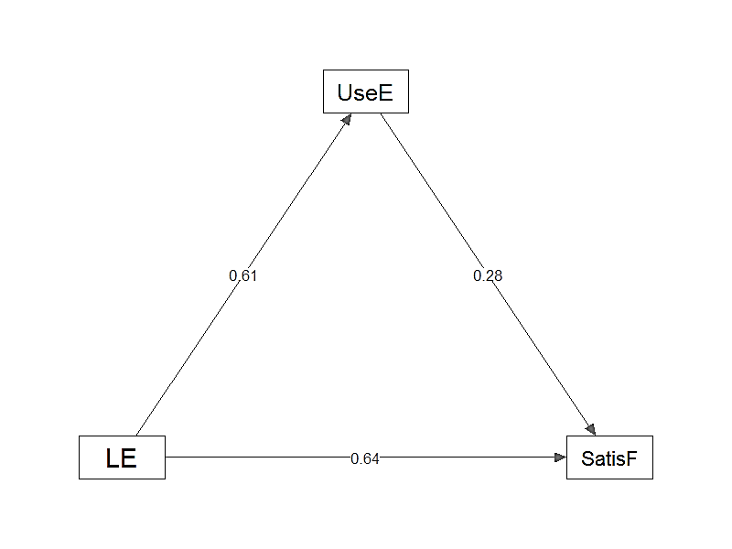
Figure 1. The Path Model of the Mediating Analysis of the use of English online during leisure time, learning of English, and satisfaction of ESL learners with Speaking classes

Legends: LE – Learning of English UseE- Use of English online During Leisure time
SatisF- Satisfaction of ESL Learners with Speaking Classes.

The path model in Figure 1 shows the mediating effect of using English online during leisure time (UseE) on the relationship between learning English (LE) and satisfaction with speaking classes (SatisF). The model's direct path (LE → SatisF) has a coefficient of 0.64, indicating a strong positive correlation between learning English and satisfaction. This highlights that satisfaction is largely driven by English learning efforts, regardless of the mediating factor.The mediating path (LE → UseE → SatisF) includes two stages: the correlation between learning English and online use (LE → UseE) has a coefficient of 0.61, and the relationship between online use and satisfaction (UseE → SatisF) has a coefficient of 0.28. This suggests that casual online practice enhances satisfaction by providing additional opportunities for language use.

The model indicates that learning English directly impacts satisfaction with speaking classes, with online English use reinforcing this relationship. Casual practice outside the classroom boosts skills and confidence, increasing satisfaction with speaking lessons. Research by Parcon supports this, showing that informal practice improves engagement and satisfaction. Iino's study further highlights how online peer interaction enhances speaking abilities and satisfaction. In conclusion, while learning English significantly influences satisfaction, integrating informal online practice strengthens this effect. The findings emphasize the importance of providing opportunities for practical language use outside the classroom to enhance student satisfaction and success in language learning.

- CONCLUSION AND RECOMMENDATIONS

This study shows that ESL learners’ satisfaction with speaking classes improves significantly when using English online during leisure time. Informal language practice beyond the classroom boosts learners' confidence and engagement, enhancing their overall classroom experience. The study finds a partial mediation effect, with 21.1% of the correlation between English learning and satisfaction linked to online participation, highlighting the importance of both formal learning and online practice.
The results align with research showing that online platforms can improve language skills and foster positive attitudes toward language learning. Educators should integrate informal online learning experiences into traditional curricula, promoting English use in casual settings to reinforce classroom skills.
The study recommends that educational institutions encourage informal learning through online forums, blogs, and social media for peer interaction and language practice. Incorporating technology-based tools like podcasts and gamified elements can keep students engaged and help with vocabulary and grammar acquisition. Learners should also use writing applications and grammar tutorials, engage in language exchange programs, and participate in community events for real-time speaking practice.
Policy and curriculum developers should create inclusive curricula that integrate informal and formal learning, while also training educators to incorporate technology into lessons. Future research should explore additional mediators such as socio-cultural influences and emerging technologies like AI, VR, and gamified environments for ESL education.
In conclusion, this study underscores the importance of using English online during leisure time to improve language learning and increase satisfaction in ESL speaking classes, offering valuable insights for educators, learners, and researchers to enhance language education.
REFERENCES:
Abduljawad, Samah, et al. "Teachers to learners: portfolio, please! new techniques of portfolio assessment in esl classrooms". International Journal of Learning Teaching and Educational Research, vol. 23, no. 4, 2024, p. 34-51. https://doi.org/10.26803/ijlter.23.4.3

Abuosbeh, Zein, et al. "The impact of online learning during the pandemic on language and reading performance in english–french bilingual children". Journal of Research in Reading, 2024. https://doi.org/10.1111/1467-9817.12450

Adewale, Babatunde, et al. "Assessing participants understanding and voluntariness of informed consent in a clinical trial in Nigeria." Journal of Clinical Research &Amp; Bioethics, vol. 7, no. 4, 2016. https://doi.org/10.4172/2155-9627.1000279

Ahmed, Alim, et al. "An empirical study on the effects of using kahoot as a game-based learning tool on efl learners’ vocabulary recall and retention". Education Research International, vol. 2022, 2022, p. 1-10. https://doi.org/10.1155/2022/9739147

Aliyu, Muhammad M., et al. "Reducing undergraduates speaking anxiety through class interactions and oral presentations". Asian Journal of Contemporary Education, vol. 3, no. 1, 2019, p. 36-43. https://doi.org/10.18488/journal.137.2019.31.36.43
Alshammari, Muteerah, et al. "The effect of online learning in developing english speaking skills: أثر التعلم عن بعد في تطوير مهارة التحدث باللغة الإنجليزية". مجلة العلوم التربوية و النفسية, vol. 6, no. 8, 2022, p. 149-157. https://doi.org/10.26389/ajsrp.r020821

Altam, Saleh, et al. "Influence of social media on efl yemeni learners in indian universities during covid-19 pandemic". Linguistics and Culture Review, vol. 4, no. 1, 2020, p. 35-47. https://doi.org/10.21744/lingcure.v4n1.19uxyg

Asakereh, A., & Dehghannezhad, M. (2015). Student satisfaction with EFL speaking classes: Relating speaking self-efficacy and skills achievement. Issues in Educational Research, 25(4), 345-363

Bangkam, Sofena, et al. "Identifying writing strategies applied by esl primary school pupils in a rural school". International Journal of Academic Research in Business and Social Sciences, vol. 10, no. 3, 2020. https://doi.org/10.6007/ijarbss/v10-i3/7040

Chen, et al. "Investigating the impact of online language exchanges on second language speaking and willingness to communicate of chinese efl learners: a mixed methods study". Frontiers in Psychology, vol. 14, 2023. https://doi.org/10.3389/fpsyg.2023.1177922

Chen, Huaruo, et al. "Be perfect in every respect”: the mediating role of career adaptability in the relationship between perfectionism and career decision-making difficulties of college students." BMC Psychology, vol. 10, no. 1, 2022. https://doi.org/10.1186/s40359-022-00845-1

Chen, Weina, et al. "Leveraging flip, a video discussion platform, to support the needs of international esl pre-service teachers". Relc Journal, vol. 54, no. 2, 2023, p. 489-499. https://doi.org/10.1177/00336882231175510

Chen, Xiuwen, et al. "Language learning as investment or consumption? a case study of chinese university students’ beliefs about the learning of languages other than english". Sustainability, vol. 12, no. 6, 2020, p. 2156. https://doi.org/10.3390/su12062156

Dayag-Tungpalan, Maricel, et al. "Metacognitive strategies and perceived factors affecting the speaking performance of esl learners". JETT, vol. 14, no. 2, 2023. https://doi.org/10.47750/jett.2023.14.02.049

Drigas, Athanasios, et al. "8 pillars x 8 layers model of metacognition: educational strategies, exercises &amp;trainings". International Journal of Online and Biomedical Engineering (Ijoe), vol. 17, no. 08, 2021, p. 115-134. https://doi.org/10.3991/ijoe.v17i08.23563

Febriyanti, Nani, et al. "The impact of tenth grade students’ grammar mastery and anxiety on their english achievement". Journal of Social Work and Science Education, vol. 4, no. 3, 2023, p. 733-746. https://doi.org/10.52690/jswse.v4i3.613

Fidyati et al. "Autonomous EFL Learners’ Ways of Practicing Speaking Skills During Pandemic of COVID-19." Proceedings Of the International Conference on Social Science, Political Science, And Humanities (ICOSPOLHUM 2020).2021. https://doi.org/10.2991/assehr.k.210125.038

Habók, Anita, et al. "Investigating the relationship among english language learning strategies, language achievement, and attitude". Frontiers in Psychology, vol. 13, 2022. https://doi.org/10.3389/fpsyg.2022.867714

Huzairin, Huzairin, et al. "Technology and language learning". Texto Livre Linguagem E Tecnologia, vol. 13, no. 3, 2020, p. 103-120. https://doi.org/10.35699/1983-3652.2020.24657

John, Emily, et al. "A systematic review of social media integration to teach speaking." Sustainability, vol. 13, no. 16, 2021, p. 9047. https://doi.org/10.3390/su13169047

John, Emily, et al. "Language learning strategies used by form 4 esl learners to develop speaking skills". International Journal of Academic Research in Business and Social Sciences, vol. 11, no. 6, 2021. https://doi.org/10.6007/ijarbss/v11-i6/10040

Kashinathan, Saraswathy, et al. "Esl learners’ challenges in speaking english in malaysian classroom". International Journal of Academic Research in Progressive Education and Development, vol. 10, no. 2, 2021. https://doi.org/10.6007/ijarped/v10-i2/10355

Khatiwada, Januka, et al. "The effect of perceived social support on psychological distress and life satisfaction among nepalese migrants in japan". Plos One, vol. 16, no. 2, 2021, p. e0246271. https://doi.org/10.1371/journal.pone.0246271

Küfeoğlu, Sinan, et al. "Sdg-4 quality education"., 2022, p. 255-275. https://doi.org/10.1007/978-3-031-07127-0_6

Le, Thi M., et al. "Factors affecting learner’s satisfaction towards online learning during covid-19 pandemic: a case study of vietnam". International Journal of Evaluation and Research in Education (IJERE), vol. 12, no. 1, 2023, p. 274. https://doi.org/10.11591/ijere.v12i1.23539

Lee, Ju S., et al. "The role of informal digital learning of english in korean and swedish efl learners’ communication behaviour". British Journal of Educational Technology, vol. 52, no. 3, 2021, p. 1279-1296. https://doi.org/10.1111/bjet.13082

Lu, Keqi, et al. "A study of emotion regulation in learning english for high school students: taking the affiliated high school to hangzhou normal university students as a case study". Communications in Humanities Research, vol. 33, no. 1, 2024, p. 65-73. https://doi.org/10.54254/2753-7064/33/20240050

Majid, Nur, et al. "The effects of flipped classroom on form 4 esl learners’ speaking performance in a malaysian secondary school". SHS Web of Conferences, vol. 182, 2024, p. 01008. https://doi.org/10.1051/shsconf/202418201008

Manan, Nor, et al. "Vlogging as an assessment tool in elt: a study among adult learners in a distance learning program." Elsya Journal of English Language Studies, vol. 4, no. 2, 2022, p. 109-123. https://doi.org/10.31849/elsya.v4i2.8160
Manogaran, Darushana, et al. "Systematic review: effectiveness of social media in improving speaking skills of ESL learners." International Journal of Academic Research in Progressive Education and Development, vol. 11, no. 3, 2022. https://doi.org/10.6007/ijarped/v11-i3/14722

Mohamed, Zahra, et al. "Exploring effective factors of enhancing the english language skills for undergraduate students at universities in mogadishu, somalia". Serdec Educational Journal, vol. 5, no. 5, 2024, p. 1-32. https://doi.org/10.70595/sej105

Othman, Khairunnisa B., et al. "Virtual flipped classroom: English as a second language (ESL) learners’ decision-making styles in academic reading." International Journal of Academic Research in Business and Social Sciences, vol. 13, no. 3, 2023. https://doi.org/10.6007/ijarbss/v13-i3/16501

Palma, Carmen, et al. "The use of a virtual environment to improve students’ listening skills: a learning analytics approach". Ciencia Latina Revista Científica Multidisciplinar, vol. 7, no. 2, 2023, p. 2937-2953. https://doi.org/10.37811/cl_rcm.v7i2.5537

Parcon, Richard, et al. "Task-based instruction in teaching 21st century literature from the philippines and the world: learners’ views and reflections". Elt Forum Journal of English Language Teaching, vol. 11, no. 1, 2022, p. 41-51. https://doi.org/10.15294/elt.v11i1.52493

Pešić, Dragana, et al. "Cognitive and metacognitive strategies in foreign language listening comprehension at the studies of tourism – students’ preference and university lecturers’ utility rating." Vol. 10, No. 2 of the International Journal of Cognitive Research in Science, Engineering, and Education (IJCRSEE), 2022, p. 89–99. https://doi.org/10.23947/2334-8496-2022-10-2-89-99

Prasetya, Rizky E., et al. "The interplay between self-regulated learning behavioral factors and students’ performance in english language learning through moodle". ELT Forum: Journal of English Language Teaching, vol. 12, no. 3, 2023, p. 145-156. https://doi.org/10.15294/elt.v12i3.66613

Ramzan, Muhammad, et al. "Amplifying classroom enjoyment and cultivating positive learning attitudes among esl learners". Pakistan Journal of Humanities and Social Sciences, vol. 11, no. 2, 2023, p. 2298-2308. https://doi.org/10.52131/pjhss.2023.1102.0522
Rashid, Aneesa A., et al. "Using pallet for collaborative writing among ESL learners." Creative Education, vol. 10, no. 03, 2019, p. 610–620. https://doi.org/10.4236/ce.2019.103044

Salah, Mohamed, et al. "The impact of english extracurricular activities on pre-service teachers at the higher institute of social sciences and education of gafsa". Studies in Applied Linguistics and TESOL, vol. 23, no. 2, 2023. https://doi.org/10.52214/salt.v23i2.12082
Sasmita, Yeni, et al. "Problems faced by efl students in learning to write". Linguista Jurnal Ilmiah Bahasa Sastra Dan Pembelajarannya, vol. 5, no. 1, 2021, p. 11. https://doi.org/10.25273/linguista.v5i1.9404

Shawaqfeh, Adawiya, et al. "Interaction as a mechanism to enhance english language proficiency in the classroom". Journal of Language Teaching and Research, vol. 15, no. 1, 2023, p. 229-234. https://doi.org/10.17507/jltr.1501.25

Sockett, G. “The Online Informal Learning of English”. Springer, 2014.
Strauß, Sebastian, et al. "Promoting interaction in online distance education: designing, implementing and supporting collaborative learning". Information and Learning Sciences, vol. 121, no. 5/6, 2020, p. 251-260. https://doi.org/10.1108/ils-04-2020-0090

Suk, William A., et al. "Benefits of basic research from the superfund research program." Reviews on Environmental Health, vol. 35, no. 2, 2020, p. 85–109. https://doi.org/10.1515/reveh-2019-0104

Toomnan, Parichart, et al. "The impact of online learning during the covid-19 pandemic on language learning strategies, proficiency, and enjoyment among thai efl students". International Journal of Emerging Technologies in Learning (Ijet), vol. 19, no. 01, 2024, p. 131-146. https://doi.org/10.3991/ijet.v19i01.46401

Tragant, Elsa, et al. “Understanding Foreign Language Learning Strategies: A Validation Study.” System, vol. 41, no. 1, Mar. 2013, pp. 95–108, doi:10.1016/j.system.2013.01.007.
Valente, Matthew, et al. "Causal mediation effects in single case experimental designs.". Psychological Methods, vol. 28, no. 2, 2023, p. 488-506. https://doi.org/10.1037/met0000497

Wang, Ruoran, et al. "Serum cystatin c is correlated with mortality of traumatic brain injury patients partially mediated by acute kidney injury." Acta Neurologica Belgica, vol. 123, no. 6, 2023, p. 2235-2241. https://doi.org/10.1007/s13760-023-02282-2

Wei, Yuhan, et al. "Comparing the effectiveness of traditional and flipped classrooms in helping high school students second language oral acquisition". Lecture Notes in Education Psychology and Public Media, vol. 29, no. 1, 2023, p. 259-265. https://doi.org/10.54254/2753-7048/29/20231528

Widiati, Utami, et al. "Exploring strategies of teaching speaking among indonesian and malaysian secondary english teachers". Register Journal, vol. 16, no. 2, 2023, p. 286-300. https://doi.org/10.18326/register.v16i2.286-300

Widyaningrum, Lulut, et al. "Shaping the way to teach? exploring the adoption of digital multimodal texts as instructional tools in efl teaching practicum". Language Circle Journal of Language and Literature, vol. 18, no. 2, 2024, p. 248-254. https://doi.org/10.15294/lc.v18i2.49256
Wilski, Maciej, et al. "The perceived impact of multiple sclerosis and self-management: the mediating role of coping strategies." Plos One, vol. 16, no. 3, 2021, p. 248135. https://doi.org/10.1371/journal.pon e.0248135

Xuan, Zhang, et al. "Enhancing english education through the integration of text, audio, and video for enriched learning experiences". Advances in Social Science, Education and Humanities Research, 2024, p. 4-10. https://doi.org/10.2991/978-2-38476-263-7_2

Yahaya, Rose S., et al. "Esl learners’ obstacles in learning speaking skills". The English Teacher, vol. 50, no. 3, 2021, p. 173-181. https://doi.org/10.52696/wyzy7207

Ying, Yong, et al. "The challenges of learning english skills and the integration of social media and video conferencing tools to help esl learners coping with the challenges during covid-19 pandemic: a literature review". Creative Education, vol. 12, no. 07, 2021, p. 1503-1516. https://doi.org/10.4236/ce.2021.127115

Yu, Qingzhao, et al. "Multiple mediation analysis with survival outcomes: with an application to explore racial disparity in breast cancer survival." Statistics in Medicine, vol. 38, no. 3, 2018, p. 398–412. https://doi.org/10.1002/sim.7977

Yulia, Astri, et al. "Enhancing english proficiency through social circle and vocabulary among malaysian adult learners". Studies in English Language and Education, vol. 10, no. 1, 2023, p. 322-336. https://doi.org/10.24815/siele.v10i1.25740

Zakaria, Noorfatin, et al. "The needs analysis of esl learners’ expository writing challenges: perspectives of esl teachers". International Journal of Academic Research in Business and Social Sciences, vol. 14, no. 5, 2024. https://doi.org/10.6007/ijarbss/v14-i5/21387

Zeng, Ping, et al. "Statistical methods for mediation analysis in the era of high-throughput genomics: current successes and future challenges." Computational and Structural Biotechnology Journal, vol. 19, 2021, p. 3209–3224. https://doi.org/10.1016/j.csbj.2021.05.04
Zhang, Weiwei, et al. "Supporting learner success: revisiting strategic competence through developing an inventory for computer-assisted speaking assessment". Frontiers in Psychology, vol. 12, 2021. https://doi.org/10.3389/fpsyg.2021.689581
Zhen, Ling, et al. "The usage of mall in learners’ readiness to speak english". Sustainability, vol. 14, no. 23, 2022, p. 16227. https://doi.org/10.3390/su142316227

APPENDIX- A

Descriptive Results

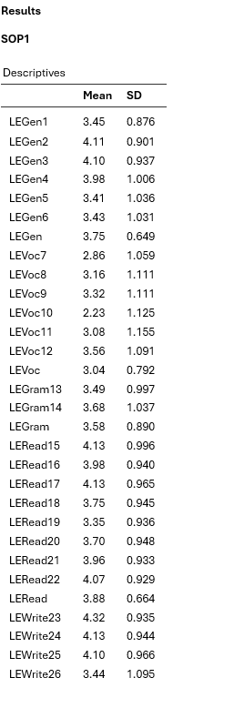
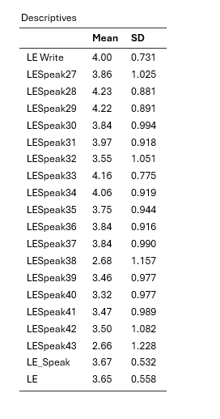

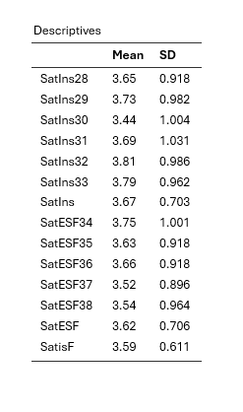
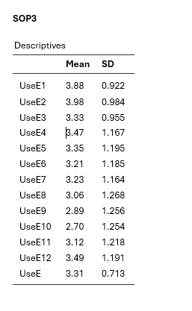
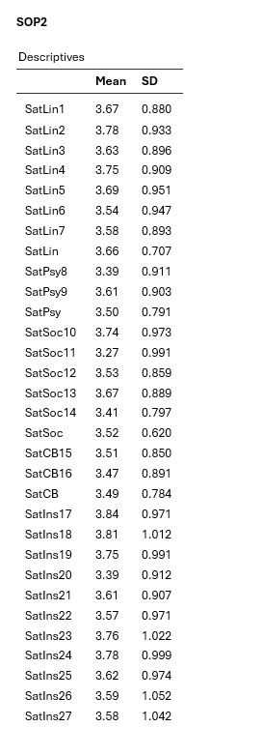

APPENDIX B
Correlational Results
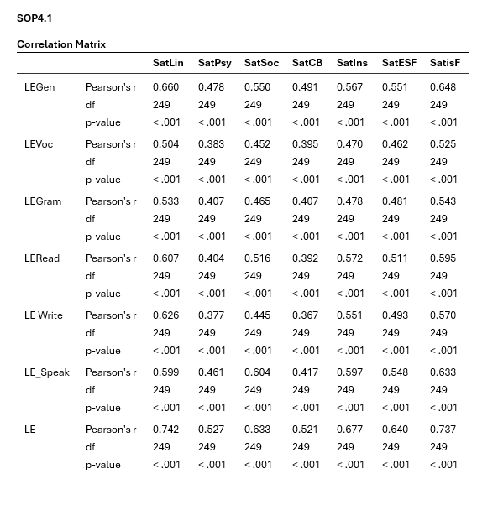

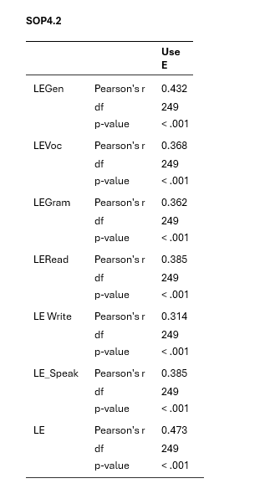
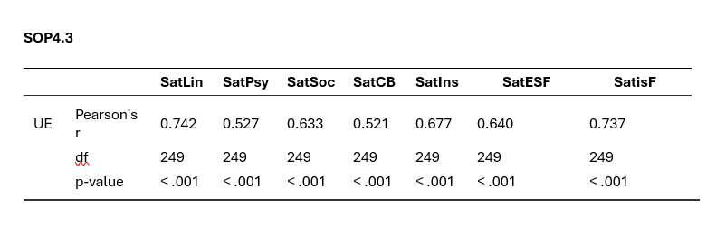

APPENDIX C
Mediating Analysis
