**A Multimodal Discourse Study of and Discursive Functions in Online Cartoon Reportage of ASUU Strike**

**Abstract**

This work focuses on the semiotic study of some selected online cartoons reporting issues on the recent ASUU strike Language basically is seen as a tool for communication and the visual modes of communication have been employed in online media as a veritable means of communicating very serious issues metaphorically. It aims to analyze the significant linguistic features associated with the selected themes, assess the visual components and describe the functional relationship. The data for the study were purposively selected based on the theme ‘ASUU strike’. Ten cartoons were randomly selected from Facebook and X (formerly known as Twitter). Analysis of the research relied on O’Halloran’s (2008) Systemic Functional Multimodal Discourse Analysis. The theory helped to critically explore how Nigerian social media users deploy verbal-visual communication to portray some societal issues. The study shows that cartoons are used to criticize underlying critical societal issues and draw the attention of stakeholders to effect necessary changes. The study emphasizes the vitality of visual elements as important devices in understanding a text. It also underscores the place of linguistic and literary devices, such as imagery, metaphor, sarcasm and irony in communication. Finally, the study unveils the potentials of visual images to convey meaning beyond the verbal language in any human society.

**Keywords**: *Multimodal, Discourse, Cartoon, Online, Functions.*

**Background to the study**

All over the world, tertiary education, also known as the ivory tower, is regarded as the bedrock of knowledge and intellectualism and most the appropriate ground for incubation of future leaders. However, over the last twenty years in Nigeria, the University system has witnessed an unprecedented industrial unrest and so many official assaults than other social institutions. Many have argued that those in authority see the university as a burden and as an institution to be exploited and left desolated.

This study focuses on the use of cartoon as a medium of communication. Communication is a means through which social integration is fostered in the society. One of the powerful modes of visual communication which has become famous in Nigerian Newspapers is the cartoon. Cartoons are simplified drawings, representational or symbolic, which make satirical, witty or humorous points. Cartoons play prominent role in correcting societal ills, entertainment etc( Oyedeji, 2013). Among the genres of visual art that prove potent in putting checks on the political class in the contemporary society is political cartooning. Cartoonists are like traditional palace jesters who lampoon the political class using satire as a tool (Akinloye, 2014).

Language use varies as it is used to perform different functions: we communicate ideas, thoughts and opinions through language; we use language to warn of danger, to advice, to arouse emotions and to make people accept our point of view. The use of language for these purposes is dictated by the context and they have their own unique form. The expressive use of language with its unique features is captured by cartoonists’ use of language in their cartoons.

This study is therefore significant in exploring how reality maintenance, as Kress (1998) puts it, is a multimodal negotiates meanings in a conversation that requires average readers to fix the meaning(s) of and ascribe evaluative character of cartoons. In this regard Fowler (1998) argues that “the greater part of reality maintenance in conversation is implicit, not explicit. Most conversations do not in so many words define the nature of the words. Rather they take place against the background of a world that is silently taken for granted. It is against this backdrop that this paper tries to investigate on ‘A multimodal Discourse Study and Discursive Functions of online Cartoon Reportage of ASUU Strike.”

**Multimodal**

Multimodality attempts to identify how different semiotic modes or resources are combined within a particular socio-cultural domain in order to create a semiotic event (Kress & Van Leeuwen 2001). This explanation is based on the concept that verbal communication can never be completed or thorough without mentioning the non-verbal communications like painting, images and colors etc. Ariyo(2007) opines that Multimodal discourse analysis is essentially concerned with the theory and analysis of semantic resources at the semantic expansion which occur as semiotic choices combined in multimodal phenomena. In other words, Multimodal Discourse analysis is the combination of words with other modalities such as pictures, films, visual images and sounds to make meaning. It considers how multimodal texts are designed and how semiotic tools such as color, framing, focus and position of elements contribute to the making meaning of these texts.

**Cartoon**

Cartoons are also designed to stand alone as works of arts, needing no guidance from an interpreter to be understood. The public wants to know hidden truths. They are classified as cartoon of opinion and cartoon of jokes. Cartoon of opinion focuses on domestic politics and social themes while cartoons of jokes are designed to communicate humor (Adejuwon 2009). The cartoon of opinion is synonymous to an editorial or political cartoon. An editorial cartoon can be defined as an illustration containing a commentary that usually relates to current events or personalities. This type of cartoon serves as a visual commentary on current events or personalities. Editorial cartoons are usually satirical rather than merely humorous in nature as they may communicate the political viewpoint of the cartoonist or add depth to an opinion article in a newspaper or magazine.

Cartoons often use caricature which is a deliberate distortion or exaggeration of a person’s features in order to make fun of well-known figures who are often politicians. They typically combine artistic skill, hyperbole and biting humor in order to question authority and draw attention to corruption and other social ills in the society. The presentation of cartoons in this manner is an avenue for cartoonists to effectively express their thought about any event in the society in a comical manner. Cartoons are illustrations usually in a single panel with visual symbolic elements to express the cartoonist’s views on societal issues in humorous or subtle ways. Most commonly, cartoons address current political issues or events, social trends, or famous personalities in a way that takes a stand or presents a particular point of view. Although cartoons are mostly humorous, they do generally contain elements of irony.

**Text Discourse**

The term text usually refers to a message which has been recorded in some way (writing, audio and video recording) so that it is physically independent of its sender or receiver (Chandler: 9). A sequence of cohesive and coherent sentences realizing a set of mutual irrelevant intentions. Discourse is modes of speaking and writing which involve participants in adopting a particular attitude towards areas of sociocultural activity. So, text discourse is a message which may be written or recorded that demands its participants to adopt a particular attitude towards areas of sociocultural-activities.  
**Theoretical Framework**

This research adopted O’Halloran’s (2008) Systemic Functional Multimodal Discourse Analysis. O’Halloran’s (2008) framework is an approach which shows that the Systemic Functional (SF) approach to multimodal discourse analysis (MDA) is concerned with the theory and practice of analyzing meaning arising from the use of multiple semiotic resources in discourses which range from written, printed and electronic texts to material lived in reality. It extends the study of language in combination with other resources, such images, colors, scientific symbolism, gestures, actions, music and sound (O’Halloran, 1). Multimodal discourse analysis is the study of the intersection and interdependence of various modalities of communication within a given context (Synder, 1). Researchers in this area seek to identify the influence of mode on meaning within a given context, focusing on co-occurrence interaction between multiple semiotic systems (Baldry and Thibault, 31). The Multimodal discourse is essentially concerned with the theory and analysis of semiotic resources and the semantic expressions which occur as semiotic choices combined in multi-cultural phenomena. The ‘intersemiotic’ relations arising from the interaction of semiotic choice known as intersemiosis is a central area of multimodal research (Jewitt, 14). Multimodal discourse analysis is also concerned with the design, production and distribution of multimodal resources in social settings (Van Leeuwen, 32)

However, Multimodal discourse is faced with some challenges as O’Halloran notes: the major challenges facing multimodal discourse analysis include the development of theories and frameworks for semiotic resources other than language, the modeling of social semiotic processes (in particular, intersemiosis and resioticisation), and the interpretation of the complex semantic space which unfolds within and across multimodal phenomena.

Nevertheless, in an era of multimodality, semiotic mode rather than language is treated as fully capable of serving for the representation and communication. Prior to this time, language had been studies alone. But recently, there has been a paradigmatic shift from studying language alone. O’Halloran identifies reasons for this shift as, there are several reasons for the paradigmatic shift away from the study of language alone to the study of the integration of language with other resources. First, discourse analysts attempting to interpret the wide range of human discourse practices have found the need to account for the meaning arising from multiple semiotic resources deployed in various media. Second, technologies to develop new methodological approach for multimodal discourse analysis, for example multimodal annotation tools (Rohfing et al) have become available and affordable. Lastly, interdisciplinary research has been more common as scientist from various disciplines seek to solve to solve similar problems.

**Methodology**

The data for this study were purposively selected from Twitter and Facebook. In the first instance, the data were purposively selected based on the visual modes employed by the cartoonist. In the second instance, ten cartoons were randomly selected from the purposively selected one from Twitter and Facebook. These cartoons were selected because they generate so much reaction online. The data were subjected to a multimodal discourse analysis to show how societal realities are portrayed through visual modes.

The analysis of the selected cartoons was done in close reference to the issue of industrial action – attention is paid particularly on the use of color, gaze, posture symbols and icons. Also, the functional relationship between the visual components and meanings of the signs is examined. Therefore, the discussions for the study were tailored towards some issues that vividly mirror the realities of the society.

**Data Analysis**

**Datum One**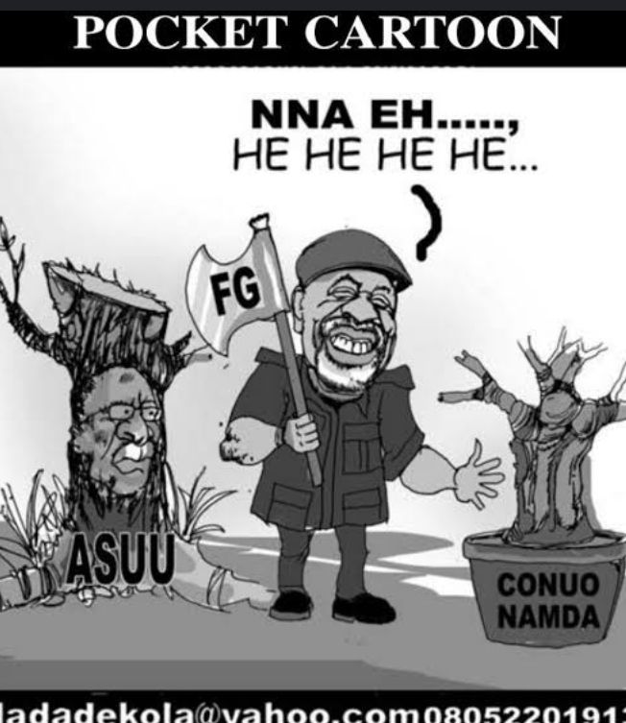

The text here which can be seen to be brutally dehumanizing, shows the cartoonist using a semiotic imagery to depict the minister of Labour and Productivity Dr Chris Nwabueze Ngige with an axe, smiling cheerfully to show satisfaction for a job well-done. The image of ASUU is depicted in the mold of the National President Prof EmmanuelOsodeke carrying a remnant of a big tree slashed halfway. On the left is a new plant placed in basin lettered by the cartoonist CONUA and NAMDA. These are breakaway factions of ASUU. The discursive function of the cartoonist is to depict a tussle between the Federal Government and the Academic Staff Union of Universities. It is designed to show that the Federal Government agents led by the Minister of Labour and Productivity is engaging in a divide and rule approach amongst members of the union by approving the registration of rival unions.

**Datum Two**

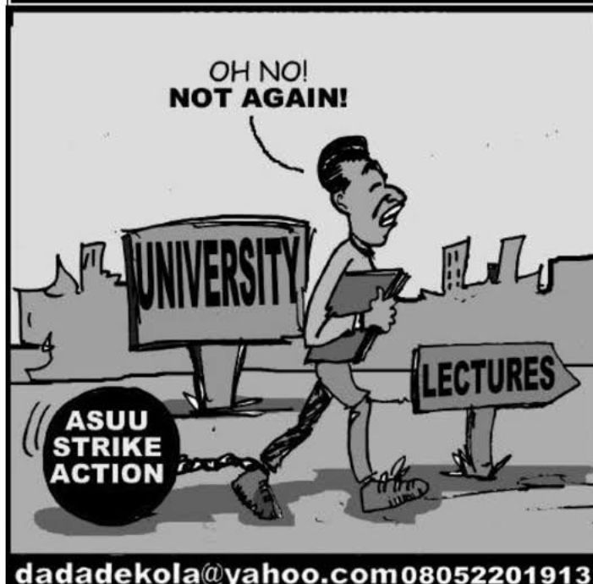

This text paints the picture of students’ dilemma during the strike action. The cartoonist presents a picture of a male student tied on the foot, which represents ASUU industrial action. The student is presently in the university but cannot attend lectures. It is a picture portraying newly admitted students who, after tortuously labouring to gain admission, are frustrated by the strike. Incidentally, most universities joined the strike at the beginning of the session. The discursive function of the text is to paint an entanglement of students in the impasse between the Government and the Academic Staff Union of Universities (ASUU)

**Datum Three**

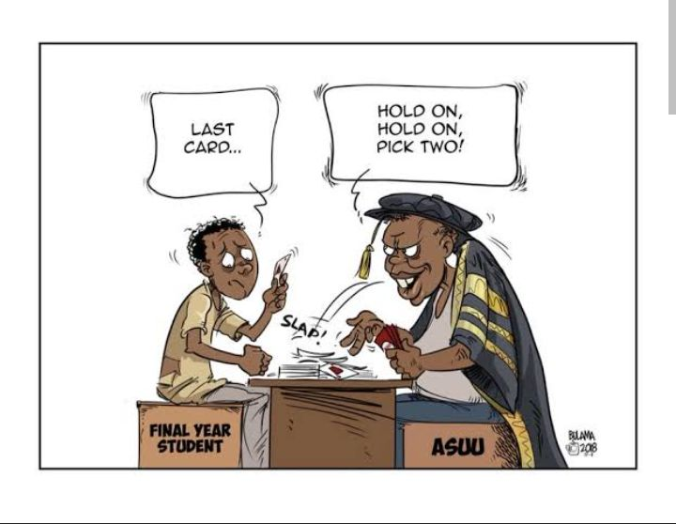

This text presents the picture of a struggling student sitting in a game position with someone dressed in ceremonial gown. The cartoonist labeled the student as a final year student and the man with the ceremonial dress as ASUU. The cartoonist using language of ‘whot’ game, while the student is eager to graduate, the union is telling the student to ‘hold on’ signifying a delay in next action (graduation) twice and the word ‘pick two’ denotes additional burden of two cards in the game. Also worthy of note is the sound made while dropping the card ‘slap’. The discursive function is to paint ASUU as not being considerate to graduate students on time.

**Datum Four**

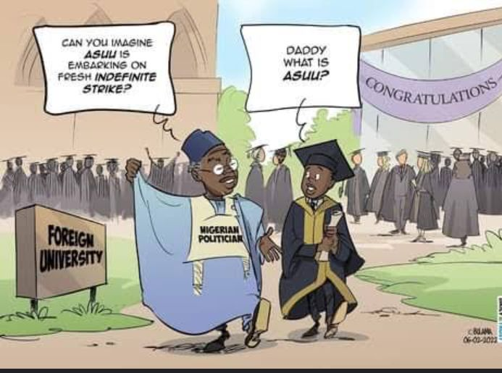

The text humorously paints the picture of a flamboyant Nigerian Politician with his son in a foreign university celebrating an occasion which is not stated. There seems to be the use of what can be regarded as semiotic innuendo and euphemism. The discursive function of the texts is to show the lackadaisical attitude of the ruling class to the education of the masses. This is someone elected to provide quality education but who ended up sending his child to a foreign institution and even sarcastically lampooning ASUU for embarking on industrial action. To make matters worse, the child in the picture does not know what ASUU is even though ASUU is a foremost trade union in Nigeria.

**Datum Five**

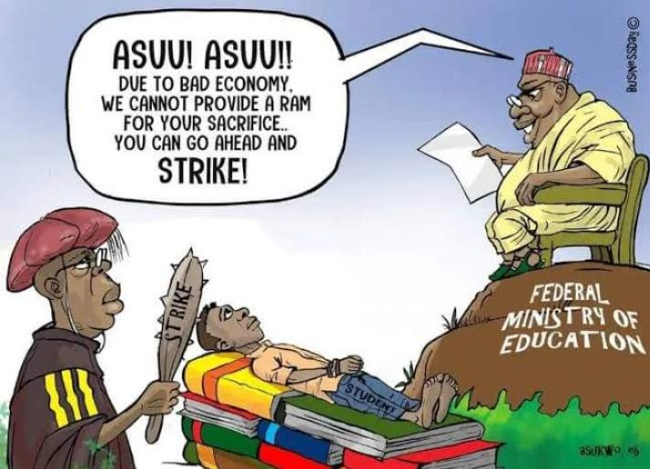

The text sarcastically captures a tensed situation; the cartoonist through the use of semiotic imagery shows someone sitting on a chair on top a rock. Where this man is seated is tagged Federal Ministry of Education. Facing the man directly is someone dressed in ceremonial gown of an academe, holding a baton which ‘strike’ inscribed on it. A young man is lying down on his books, with his hands tied; that is, the student. By linguistic extension, the image of the rock is also a form of semiotic metaphor to show that the man dishing out instruction is sitting on huge resources. Also, the image of the student tied down is a form of exaggeration. Worthy of note is the ironical expression made that ‘due to bad economy’. The speaker is painted as a representative of the Federal government who constitutionally is in charge of overseeing the nation’s education. The discursive function is to show that the Federal government has what it takes to end the industrial action, if it wishes; but rather chooses to be arrogant; insisting it does not have the ram for ASUU’s sacrifice and so is daring the consequences.

**Datum Six** 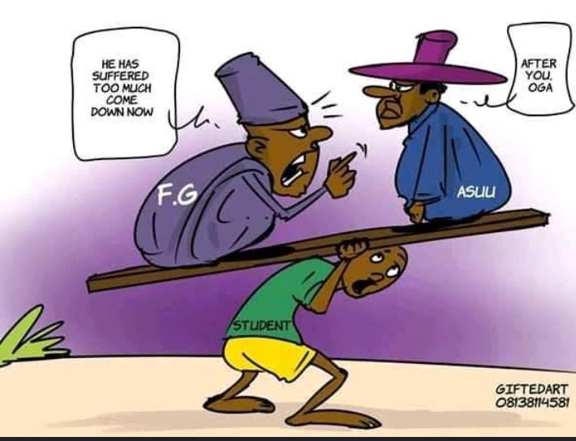

In the text, we see an image of a helpless young man carrying two men. It is instructive to note that the weight is so heavy that the student is tired and weary. The cartoonist paints the baggage as Federal Government (FG) and ASUU. The man who represents the Federal Government is admonishing ASUU to come down, that the student has suffered so much. ASUU on the other hand is insisting that the Federal Government must come down first. The discursive function is to tell the world that both ASUU and Federal Government are the causative agents in the student’s plight.

**Datum Seven**

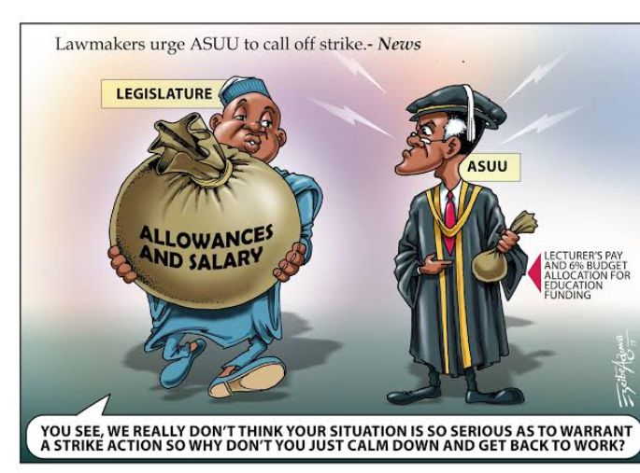

The Cartoonist unveils a picture of the legislative arm. He paints the legislature as a selfish and an over bloated individual with outrageous allowances and salary at the same time, while the ASUU is going home with peanuts. On top of the picture is an inscription ‘lawmaker’s *urge ASUU to call off strike’* and beside the image of the ASUU member is another inscription ‘*lecturer’s pay and 6% budget allocation for education funding’.* The Cartoonist employs the use of sarcasm and irony. The legislature as an independent arm of government which is expected to checkmate the excesses of the executive arm, is rather working in connivance with them and directing ASUU members to return to classroom without paying attention to their demands.

The union is praying for increase in education funding, checkmating of the proliferation of universities and enhancing the welfare of its members. These and other issues raised by ASUU are not seen by the lawmakers as serious enough to warrant strike action. The discursive function of this image is that it portrays lawmakers as selfish, bereft of problem solving capability and incapable of performing their constitutional obligation.

**Datum 8**

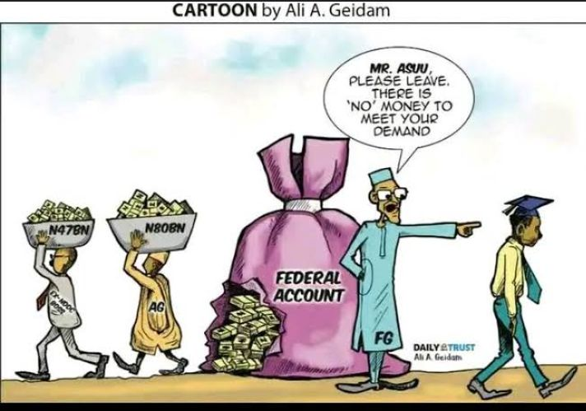

The text mirrors the reality in the Nigerian political corridor. The cartoonist employs the linguistic tool of imagery to depict the Federal Government as yelling at ASUU that the government account is empty as ‘*there is no money to meet their demand’* while behind the scene a notorious looting is taking place by senior government officials. Those identified by the cartoonist are the former Niger Delta Development Commission (NNDC) staff carting away forty-seven billion naira and the nation’s Accountant General enriching himself illegally with the sum of eighty billion naira. The discursive function of this picture is to expose the decadence in the Nigerian government’s accountability system. Those who are in charge of the country’s treasury cannot give proper account but choose instead to embezzle what is meant to take care of the entire citizenry.

**Datum Nine**

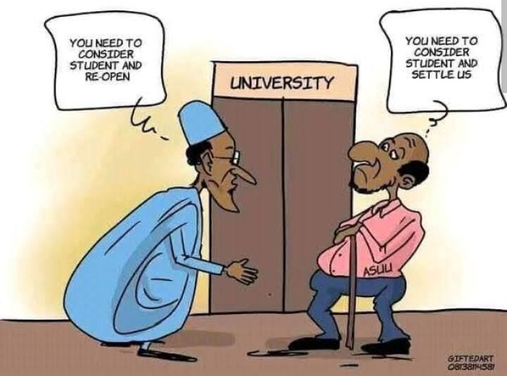

In the text presented in a form of gentle interpersonal discussion, the cartoonist depicts a closed university and a turn-taking scenario. An individual is seen with a physique similar to that of the former President of the Federal Republic of Nigeria, President Muhammadu Buhari insinuating that the union needs to consider students and re-open while the interlocutor stands facing the President and folding his arms insists on being settled before re-opening. The discursive function of this picture is to inform the general public that the industrial action undertaken by the members of ASUU is as a result of disagreement with the Federal government. While the head of the federal government is not pro-active enough to settle the dispute, he relies solely on rhetoric to seek sympathy from the populace and paint ASUU bad light.

**Datum 10**

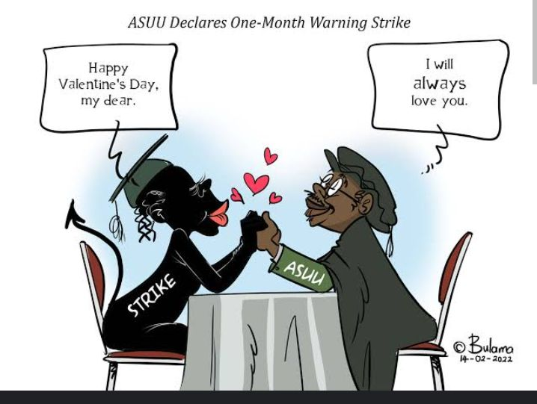

The texts paint a romantic picture of two individuals-a man who is in love with a lady. The man is portrayed as ASUU and the Lady is ‘Strike’. The picture shows ASUU telling the lady ‘I will always love you’. The use of the word ‘always’ signals a promise that seems to be everlasting. Similarly, the sitting posture and the gesture of holding each other also shows a as strong connection. The discursive function of this picture is extending narratives from other peoples opinion that ASUU for long, has chosen not to change its tactics in addressing its demands. For over thirty years, it has always employed the instrumentality of strike in pressing home its demands. ASUU on the other hand, has argued that strike is the only language understood by government.

**Conclusion**

Multimodal discourse analysis has made it possible to account for visual components of the study. The lexical choices employed by the authors have also been identified. This is made possible by the theoretical framework we have used in this study. However, it is instructive to note that interpretation of images is, by its very nature, subjective and an image can carry multiple messages depending upon the nature of the interpreting culture.

This study has shown through discussion that cartoons are made to express underlying critical societal issues and draw attention of stakeholders to effect necessary changes. The study has been able to additionally show that social media is not only an avenue to establish social relationships and interactions but a medium for discussing national issues.

The study emphasizes the vitality of visual elements as important devices in understanding a text, the use of linguistic and literary devices such as imagery, metaphor, sarcasm, irony, allusion, etc. Also, this study reveals the potentials of visual images to convey meaning beyond the verbal language in any human society.

REFERENCES

Abraham, Messaris P &. "The role of images in framing news stories." SD Reese, O.H Grandy and A.E Grant. *Annual Review of Antropology*. London: Social World London, 2018. 26-39.

David, Chandler. *Semiotics*. London: Routledge, 2002.

David, Crystal & David. "Investigating Emglish Style." *Daily Christian Life Ministry* (2016): 17-29.

John, Bignell. *Media Semiotics*. Manchester: Manchester University Press, 1997.

Lewin, Rappoport. *Punch lines: the case for racial, ethnic and gender humour*. Westport: Praeger, 2005.

O'Halloran, Smith B.A & K L. *Multimodal Studies: Exploring Issues and Domains*. Newyork: Routledge, 2014.

Paul, Simpson. *On the Discourse of Satire* . Amsterdam: John Benjamins, 2003.

Vin, Raskin. *Semantic Mechanism of Humour*. Dordretch: Reidel, 1985.

Webb, Keane. *Religious Language*. London: Longman, 2018.

Taiwo, R. 'Forms and Functions of Interrogation in Christian Pulpit Discourse .Nebula 2.4 117-131. 2005. Print.

Taiwo, R. "Response Elicitation in English- medium Christian Discourse" Linguistic online 127- 143. 2006. Print.

Taiwo, R. "Language, Ideology and Power Relations in Nigeria Newspaper Headlines" Nebula, vol. 4 (l). 2007. Print.

Taiwo, R. "Satirizing Politicians and Public Officers in Nigerian Newspapers",The International Journal of Language Society and culture, Issue 22, 19-28. 2007.

Taiwo, R. Emerging Trends in English Language in the New Media: A Case Study of Satire in Nigerian Text Messages, a paper at the 281) International Nigeria English Studies Association (NESA) Conference, University of Benin. 2011.