**Effect of Climate Variability on ­­­­­­­­­­­­­­­­­­ Malaria Prevalence among Children in Elgeyo Marakwet West Sub County, Kenya**

**Abstract**

Malaria remains an issue of great public health concern and, in developing nations, children under five years old are particularly susceptible due to hygiene and poverty. It’s caused by the parasite Plasmodium falciparum spread by female Anopheles mosquitoes and is affected by climate change, especially temperature and rainfall. The purpose of this research was to evaluate these climatic impacts on the malaria incidence in children in Elgeyo Marakwet West Sub-County through spatio-temporal spatial distribution and relationship between climate and malaria prevalence.

The study applied purposive and systematic random sampling with mathematical models to show the correlation between malaria incidence and climate using R-studio and SPSS. Results showed that climate was highly correlated with malaria prevalence, with hotter weather and more frequent rains leading to more cases of malaria. The results imply that climate change might further worsen malaria in this area, thus the necessity for an effective surveillance system using Geographic Information Systems (GIS) for real-time monitoring. There should also be a local education campaign to increase prevention, use insecticide-treated nets (ITNs), and eradicate mosquito nests.

**KEY Words:** *Climate variability, Malaria, Rainfall, Temperature, Children, Spatio-temporal distribution,*

**Introduction**

Climate change, as defined by Hussien (2019), encompasses long-term shifts in mean climate states and variability due to anthropogenic factors, significantly impacting malaria transmission dynamics. Key climate variables such as temperature, rainfall patterns, and humidity influence mosquito longevity and malaria prevalence, with recent studies indicating a troubling increase in malaria cases in Kenya's highland regions despite established links between temperature and mosquito activity (Nkiruka, Prasad, & Clement, 2021; Kogan, 2020). In 2020 alone, there were 241 million malaria cases globally, resulting in 627,000 deaths, with the pandemic exacerbating prevention efforts.

Kenya's diverse eco-climate zones contribute to a significant malaria burden, particularly in Elgeyo Marakwet County where prevalence rates range from 1-5% (Kim, Choi, & Lee, 2019). Insufficient understanding of environmental determinants of malaria vectors may partly explain this high prevalence. Therefore, it is crucial to study the influence of eco-hydrological conditions on malaria vectors among children to integrate effective prevention measures. Investigating climate variability's impact on malaria prevalence in Marakwet West Sub-County is essential for developing targeted interventions that address the challenges posed by changing climatic conditions on public health.

The study’s main objective was to determine the effect of climate variability on malaria prevalence among children in Marakwet West Sub-County.

**Literature Review**

In 2018, the World Health Organization (WHO) estimated 405,000 malaria-related deaths globally, a slight decrease from 416,000 in 2017 and 585,000 in 2016 (WHO, 2019). The burden of malaria is predominantly felt in Sub-Saharan Africa and India, which account for over 90% of cases. In 2018 alone, Sub-Saharan Africa reported approximately 213 million malaria cases, highlighting the region's severe disease burden. Kenya's malaria epidemiology is categorized into four zones: endemic areas, highland and epidemic-prone areas, seasonal transmission zones, and low-risk regions. Seasonal transmission of P. falciparum leads to prevalence rates of 5-20% in highland areas.

Environmental factors significantly influence mosquito vector dynamics. Temperature is a crucial abiotic factor affecting mosquito growth and survival; Anopheles mosquitoes thrive at temperatures between 15°C and 34°C (Hussien, 2019). Rainfall and standing water also play vital roles in mosquito development, although excessive rainfall can reduce mosquito density by flushing larvae from breeding sites (Zhao et al., 2020). Among children under five years old, malaria remains a leading cause of morbidity and mortality. Long-Lasting Insecticide Nets (LLIN) are recommended for pregnant women and infants in semi-arid regions (Kogan, 2020). Understanding these dynamics is essential for effective malaria prevention strategies tailored to specific environmental conditions.

**Research and Methodology**

This study was conducted in Elgeyo-Marakwet West Sub-County (Figure 1), in Kenya. Elgeyo-Marakwet West Sub-County covers approximately 804.60 km² with a population of 108,374 Persons and 26,740 households (KNBS, 2019).

The study used a combination of research designs. These research designs included; descriptive research design, empirical research design and survey research design. Descriptive research design was critical in giving identities or characteristics of the target population. The empirical design aided the study with appropriateness to sample of the key informants of the study.

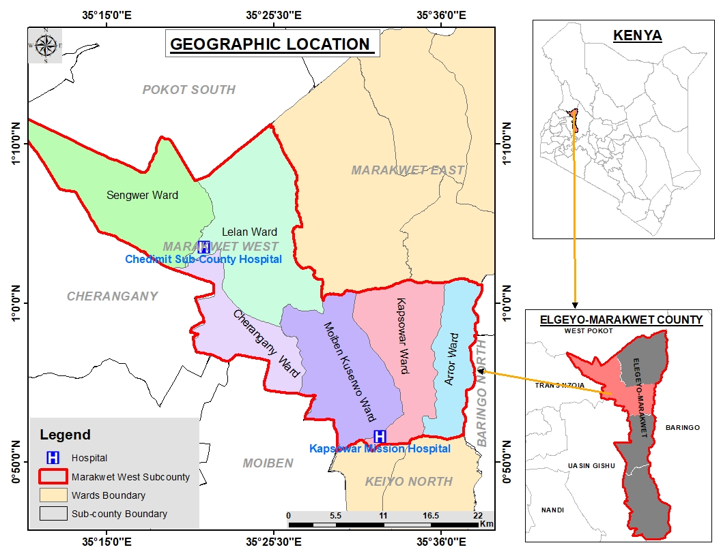

*Figure 1: Area of study; Elgeyo-Marakwet West Sub-County*

The study targeted 26,740 households, selecting 200 participants from Elgeyo-Marakwet County Meteorological Department and three hospitals to collect records of malaria outbreaks in the area during the past 10 years. Purposive sampling technique was used in this study to obtain data from the participants. The study also applied random sampling technique which was used in obtaining data from the residents around the two sub county hospitals as identified from Marakwet West Sub-County.

The study used semi-structured questionnaires to obtain raw quantitative data from the field of study. Mann-Kendall test and Principal Component Analysis (PCA) were used for data analysis. Also, propensity score model was used for analysis and presentation of the results.

**Findings and Discussions**

## The study sought to determine selected profile of the children, which was gender, age range and weight. The profile of the children is shown in Table 1.

Table 1: Profile of the children

|  |  |  |  |  |  |  |
| --- | --- | --- | --- | --- | --- | --- |
| Child Gender | | | | | | |
|  | | | Frequency | | | Percent |
|  | Female | | 66 | | | 34.9 |
| Male | | 123 | | | 65.1 |
| Total | | 189 | | | 100.0 |
| Child’s Age Range | | | | | | | |
|  | Below 1 year | | | 58 | | 30.7 | |
| 1-2 years | | | 85 | | 45.0 | |
| 3-5 years | | | 46 | | 24.3 | |
| Total | | | 189 | | 100.0 | |
| Child’s Weight | | | | | | |
|  | | 1-5Kg | | | 83 | 43.9 |
| 6-10 Kg | | | 67 | 35.4 |
| 11-15 Kg | | | 15 | 8.0 |
| 16-20 Kg | | | 24 | 12.7 |
|  | |  | | | 189 | 100 |

(Author, 2024)

Results (Table 1) indicates that more than half (65.1%) of the children were male and (34.9%) were female. Even though the gender distribution might not directly affect the research topic, it is crucial to identify any imbalances in the sample in order to comprehend how the study's demographics are represented. Majority of the children within the survey area were below 2 years old (75.4%) with an average weight of below 10kg (79.3%).

This study analyzed the prevalence of malaria among children in Elgeyo Marakwet West Sub-County from 2012-2022 through the use of Mann-Kendall trend test which indicated a decreasing trend in the prevalence of malaria in the sub-county during the specified period (Table 2). The plot (Figure 2) shows the average monthly malaria cases with a trendline, indicating seasonal patterns and overall trends.

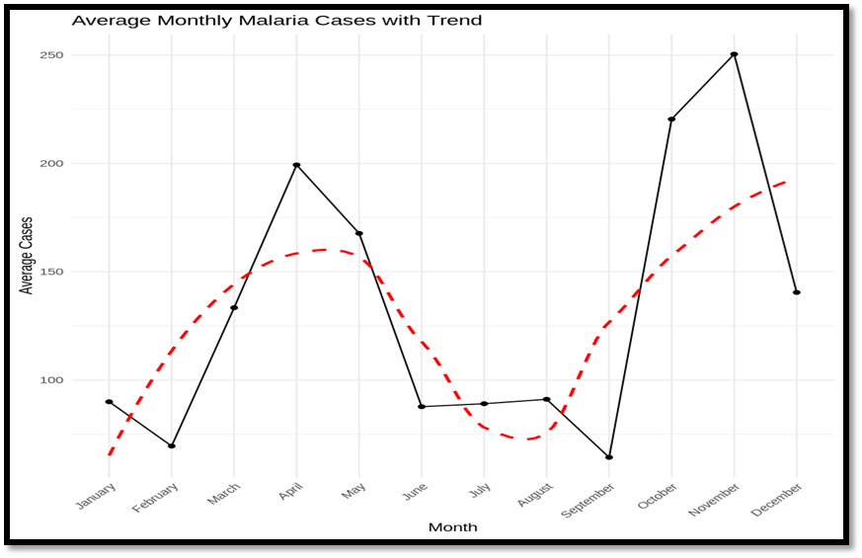

*Figure 2: Average Monthly Malaria Cases with Trendline*

The figure (2) depicts different seasonality in malaria incidence with highs in April and November. The peaks coincide with high rainfall, which provides breeding habitat for mosquitoes and thereby increases the spread of malaria. The trendline shows a steady drop in average malaria cases during the measured years.

**Table 2: Summary of monthly average Malaria cases Mann-Kendal test and Sen’s Slope**

|  | **Mann-Kendal Test** | | **Sen's Slope** | |  |
| --- | --- | --- | --- | --- | --- |
| **Month** | **Tau** | **P-value** | **Slope** | **P-value (95%)** | **Trend** |
| January | 3.1042 | 0.0019 | 4.69 | 0.0002* | Increasing |
| February | -2.8544 | 0.0043 | 3.75 | 0.0002* | Increasing |
| March | -0.5080 | 0.6115 | -1.39 | 0.410 | Decreasing |
| April | 0.4231 | 0.6722 | 2.50 | 0.562 | Decreasing |
| May | -0.3667 | 0.7138 | -3.68 | 0.728 | Decreasing |
| June | 3.3335 | 0.0009 | 5.00 | 0.0001* | Increasing |
| July | 3.4818 | 0.0005 | 5.00 | 0.0001* | Increasing |
| August | 3.3005 | 0.0010 | 5.00 | 0.0001* | Increasing |
| September | -0.3667 | 0.3647 | 0.83 | 0.0002* | Increasing |
| October | -0.3667 | 0.7138 | -5.53 | 0.068 | Decreasing |
| November | 0.9064 | 0.7138 | 7.63 | 0.100 | Increasing |
| December | -1.2437 | 0.2136 | -1.75 | 0.220 | Decreasing |

*5% Significance Level

(Author, 2024)

This study establishes that there are marked seasonal differences in the rates of malaria in Elgeyo Marakwet West Sub-County. Third, the number of cases increased sharply in January, with the Mann-Kendall Tau of 3.1042 (P = 0.0019) and the Sen’s Slope of 4.69 (P = 0.0002). The mean of Tau coefficient emerged significant in February (- 2.8544; P <0.05) depicting the number of early months showing an increasing trend in malaria. During March, there was a slight increase in trends with Tau equal to -0.5080 (P = 0.6115) from which trends were and remained stable until May. April as well as May also had non-significant Tau value of 0.4231 and - 0.3667 respectively. A sharp rise was evident in June with Tau =3.3335, P = 0.0009 and remained raised through July and August, with Tau = 3.4818 P = 0.001 and Tau = 3.3005 P = 0.001 respectively.

On the other hand, September still steady (Tau = -0.3667, P = 0.3647); and a slight decrease of October (Tau = -0.3667, P = 0.7138). November also showed an inclination towards positive correlation (Tau = 0.9064) but the results did not achieve statistical significance (P = 0.100). December presented a negative value or direction according to Tau = -1.2437 P = 0.2136. In general, the results of percentage increase in confirmed malaria cases show that malaria epidemic escalates seasonally, especially during the early and end of the dry season, and the early rainy season.

The trend graph of Elgeyo-Marakwet West sub-County hospitals (Figure 3) indicates the highest malaria peak was recorded in 2016. In this case, in 2016 there were more malaria cases recorded in the county which was approximately 2800 children diagnosed with malaria. The depicted malaria trend (Figure 3) as recorded across the 3 hospitals depicted by the blue line, indicates a slow and constant reduction in malaria cases.

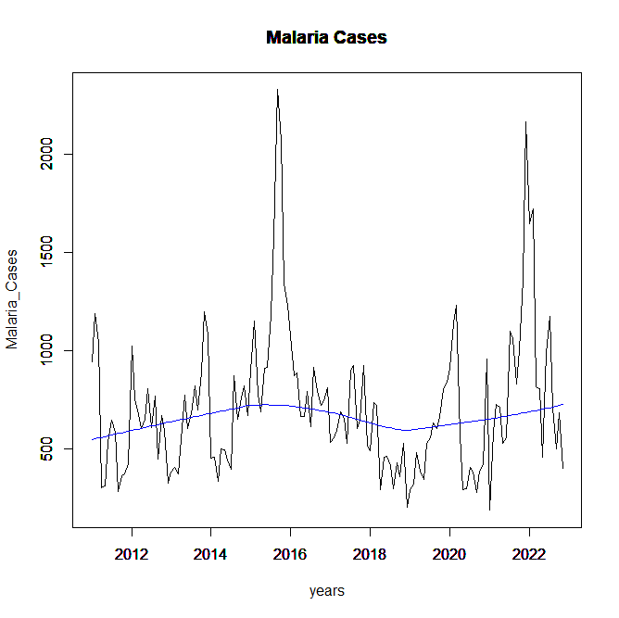

*Figure 3: Depicted Malaria trend across hospitals in Elgeyo-Marakwet West Sub-County*

The seasonal trend of malaria cases from 2012 to 2022 is depicted in the visualization (Figure 4 and 5). October through December seems to be the peak season, with November having the greatest average number of cases. The months of June and July have the lowest occurrence.

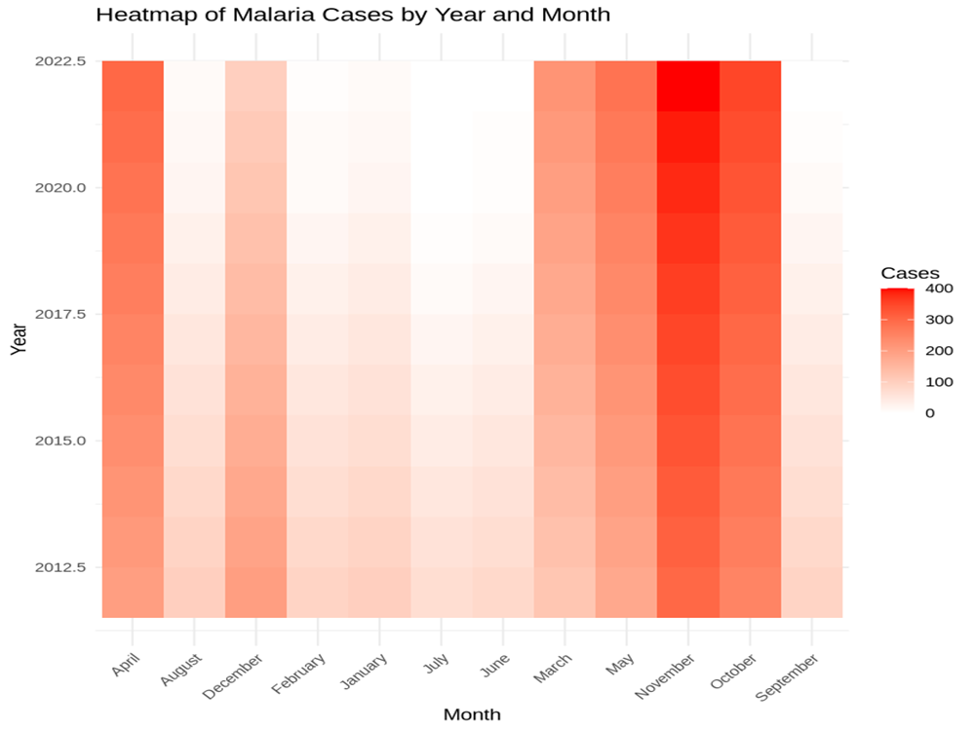

*Figure 4: Heatmap of Malaria cases annually and Monthly in Elgeyo-Marakwet West Sub-County*

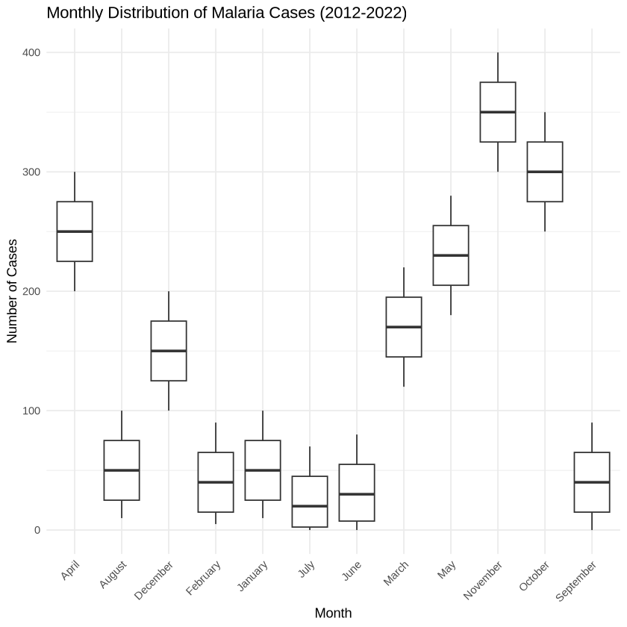

*Figure 5: Monthly distribution of Malaria cases in Elgeyo-Marakwet West Sub-County*

According to the data (table 2), the highest average number of malaria cases occurred in October, November, and December, followed by March, April, and May, while the lowest average number occurs in June, July and August. The standard deviation is represented by the error bars, which show variation within each season.

From 2012 to 2022, malaria cases in Elgeyo-Marakwet West Sub-County showed clear peaks in March-April-May (MAM) and October-November-December (OND) seasons. Most of the average monthly cases occurred during the OND season (Cases 267, M=92.08), which had greater variability due to post-rainy season transmission occurring in semi-arid areas in Kenya. MAM had an average of 217 cases (M=47.15) cases due to the impact of rainfall on vector breeding cycles. Low transmission generally occurred during the June-July-August (JJA) period (M=39.55), as drier conditions reduce mosquito breeding habitats.

Principal component analysis showed that malaria prevalence is associated with rainfall in MAM/OND and temperature. Anopheles mosquitoes breed in rainy places, while temperature speed time of parasite development. Although malaria trends have declined over time (Figure 5), annual rainfall and maximum temperatures do not appear to show significant directional trends. It is possible that bed nets or health programs are reducing transmission. Changing patterns of rainfall are enlarging the zones of malaria and climate suitability models emphasize the need for seasonal vector control at peak incidence.

|  |  |
| --- | --- |
|  |  |
|  |  |

*Figure 6: Long-term trends in malaria cases, annual rainfall, and maximum temperature between the years 2012-2022*

In figure 7, the prevalence of malaria (shown by the red line) has been declining over time. The Sen's slope, or linear trend, for malaria prevalence is shown by the dashed blue line. The Sen's slope (-0.1) and p-value (0.0002) for the malaria prevalence trend are displayed in the annotation in the upper-left corner. The annual rainfall is represented by the blue line, which fluctuates throughout time but lacks a distinct trend. Take note that the rainfall data have been divided by 1000 to accommodate the malaria prevalence on the same axis.

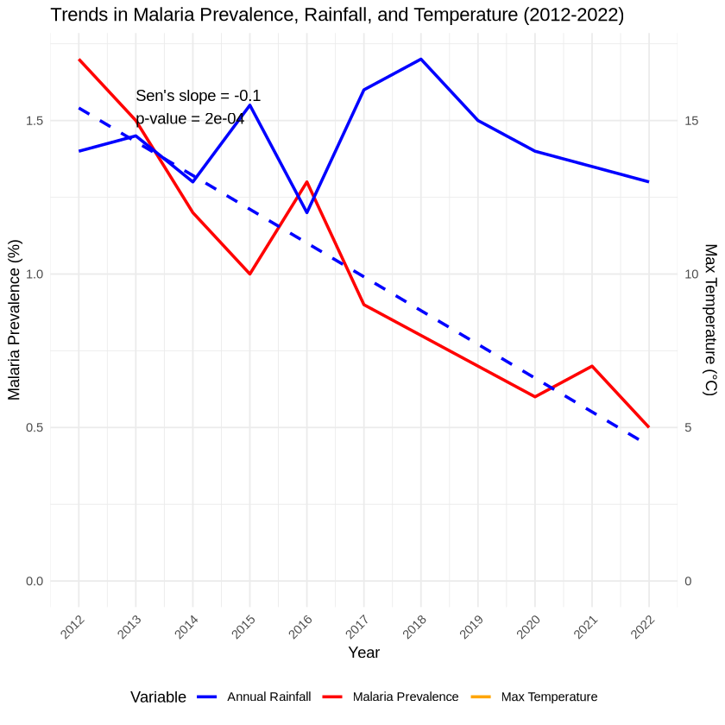

*Figure 7: Trends in Malaria Prevalence*

The article explores the role of temperature in malaria transmission, particularly the impact on mosquito metabolism, egg production and blood meal rates. Ideal temperatures of 22-23°C promote such activities, which increase mosquitoes and malaria. On the other hand, below 10°C lowers metabolic processes and mosquito production, so fewer eggs and blood meals are eaten (Murdock et al., 2016).

Further explanations are provided by Principal Component Analysis (PCA) of connections between climate conditions and malaria prevalence. Component 1 relates age of children to temperature profiles favoring vector abundance (young children may be susceptible to malaria). Component 2 is about the relationship between annual precipitation and the influence of temperature on parasite and vector abundance — higher precipitation can boost transmission capacity. Part 3 is focused on seasonal variability of parasite and vector growth: extreme temperatures also negatively affect vector populations. And finally, Component 4: seasonal rainfall patterns which, as we saw, are highly relevant to malaria dynamics. In general, the results show that temperature, rain and malaria are intricately interconnected, and environmental context is important for understanding and controlling malaria outbreaks.

*Table 3: Component Matrix*

|  |  |  |  |  |
| --- | --- | --- | --- | --- |
| **Component Matrixa** | | | | |
|  | Component | | | |
| 1 | 2 | 3 | 4 |
| Age of your child | .483 | .083 | .668 | -.132 |
| Temp influence thriving of vectors & parasites | .312 | -.052 | -.605 | .303 |
| Range of Temp that causes high vector N | -.707 | .010 | .168 | -.060 |
| Do rain influence malaria transmission | .169 | .493 | .169 | -.319 |
| Annual rain & permanent absence of water bodies contribute to recorded low but varying malaria cases | .226 | .646 | .072 | .226 |
| Other variables associated with climate variability and malaria | -.130 | .584 | -.142 | .478 |
| Rainfall pattern during MAM, OND, JJA | .392 | -.437 | .308 | .549 |
| Variation in mean temp during MAM, OND, JJA | .452 | .001 | -.441 | -.494 |
| Extraction Method: Principal Component Analysis. | | | | |
| a. 4 components extracted. | | | | |

The graph (Figure 8) reveals the eigenvalue distribution across eight components in the PCA analysis. The first four components have eigenvalues above 1.0 (specifically 1.286, 1.202, 1.184, and 1.041), suggesting they are significant according to Kaiser's criterion

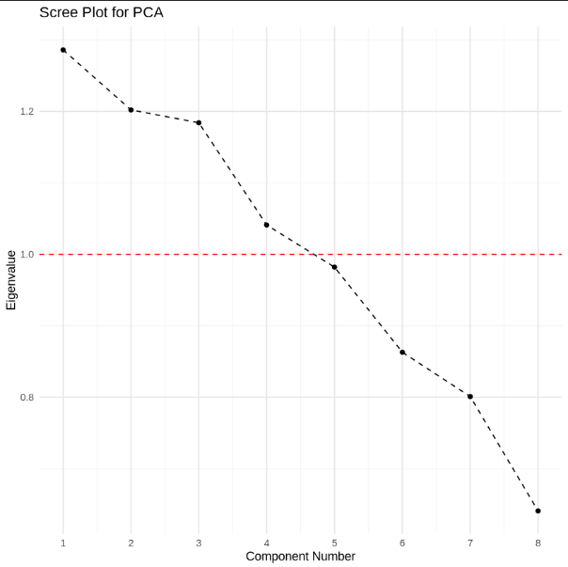

*Figure 8: Scree Plot*

Further, the study also analyzed the effect of climate variables on malaria prevalence among children in Elgeyo-Marakwet West Sub- County.

The results presented in Table 4 indicate the marginal effects of annual rainfall and maximum temperature on malaria prevalence among children in Elgeyo Marakwet West Sub-County. The model can be specified as follows:

Malaria Cases (Y) = β0 +β1(Annual Rainfall) + β2(Max Temperature) + ϵ

In this case: β0​ is the intercept, β1 represents the effect of annual rainfall, β2 represents the effect of maximum temperature, and ϵ is the error term.

**Table 4: Coefficient Marginal Effects**

| Variable | Coeff. | Std. Error | P-Value | Marginal Effect |
| --- | --- | --- | --- | --- |
| Annual Rainfall (mm) | 0.000 | 0.001 | 0.033 | 0.000 |
| Maximum Temperature (°C) | 0.157 | 0.177 | 0.004 | 0.157 |

(Author, 2024)

The B-coefficient analysis reveals significant relationships between climate factors and malaria rates. Annual rainfall has a coefficient of 0.000484, indicating that each additional millimeter of rainfall correlates with an increase of approximately 0.000484 malaria cases, supported by a p-value of 0.033, which confirms statistical significance at the 0.05 level. This suggests that increased rainfall fosters mosquito breeding, enhancing malaria transmission. Conversely, the maximum temperature's B-coefficient is 0.157194, implying that each degree Celsius rise corresponds to an additional 0.157194 malaria cases. The strong correlation is further validated by a p-value of 0.004, indicating a close association between higher temperatures and increased malaria incidence. Overall, these findings underscore the critical role of climate in malaria dynamics, highlighting the need for public health strategies to consider environmental factors such as rainfall and temperature to mitigate potential outbreaks in vulnerable populations.

The linear regression between the number of cases (y) and the dependent variables (annual rains, maximum temperature) could be formulated as follows:

Y = β0 + 0.000484 X1 + 0.157194 X2 + ϵ

Where:

* Y= Number of malaria cases
* β0= Constant term (intercept)
* β1, β2 = Coefficient for independent variables
* X1, X2 = Annual rainfall & maximum temperature
* ϵ= Error term

**Malaria seasonality**

Elgeyo-Marakwet west Sub County experiences seasonal malaria transmission. The availability of several seasonal and permanent water bodies provides suitable breeding microhabitats for malaria vector at specific periods of the year. The relatively low annual rainfall and the general absence of permanent water bodies summed up to the witnessed low but varying numbers of recorded malaria cases giving in weighted option of varying climatic conditions as the possible cause.

Results agrees with study findings by Nyawanda *et al.,* (2023) that between 2008 and 2010, the incidence of malaria rose by 50%; from 2010 to 2015, it decreased by 73%. Despite widespread usage of bed nets, there was a recurrence in cases after 2016. While rainfall was linked to an increase in incidence. In contrast to SES, which was not linked to malaria incidence in this cohort, bed net use was associated with a decrease in the incidence of malaria among children aged 6 to 59 months (IRR = 0.78, 95% BCI: 0.70–0.87) but not in other age groups.

According to the model summary (table 5) results, Cox & Snell results shows that only 17.9% of the data are explained by the model and to the Nagelkerke its 23.8% of the data which is explained by this logistic regression model.

**Table 5: Model Summary**

|  |  |  |  |
| --- | --- | --- | --- |
| **Model Summary** | | | |
| Step | -2 Log likelihood | Cox & Snell R Square | Nagelkerke R Square |
| 1 | 105.761a | .179 | .238 |
| a. Estimation terminated at iteration number 4 because parameter estimates changed by less than .001. | | | |

In table 6, the correlation between annual rainfall, maximum temperature and malaria cases provide useful insights into how these climatic conditions impact the incidence of malaria.

**Table 6: Correlation coefficient for Annual rainfall, Temperature and Malaria Prevalence**

|  |  |  |  |  |
| --- | --- | --- | --- | --- |
|  | | Malaria Prevalence Rate | Rainfall (mm) | Max. Temp. (C) |
| Malaria Prevalence Rate | Correlation | 1 |  |  |
|  | Sig. (2-tailed) |  |  |  |
| Rainfall | Correlation | -0.1694 | 1 |  |
|  | Sig. (2-tailed) | 0.6184 |  |  |
| Max. Temp | Correlation | 0.3193 | .246** | 1 |
|  | Sig. (2-tailed) | 0.3386 | .043 |  |

(Author, 2024)

The relationship between malaria prevalence and climate had the weakest negative correlation with rainfall (r=0.1694r=0.1694), suggesting that a larger amount of rainfall actually reduces malaria cases slightly, although it is statistically insignificant (p = 0.6184). The relationship with maximum temperature, on the other hand, is positive and moderate (r=0.3193r=0.3193), meaning that, as temperatures rise, more people get malaria, because the mosquitoes are more prone to survive and breed. But neither was this correlation statistically significant (p = 0.3386). On the whole, there are correlations between rainfall, temperature and malaria prevalence, but none is statistically significant in this dataset.

Table 7 shows that more than half of the children 61.4% contracted malaria in the last three months prior to the survey period. Majority also indicated the presence of stagnant waters (ponds) near their homes (63.5%) as well as shrubs and thickets present (68.3%). This implies the presence of potential breeding grounds for the malaria causing vectors.

**Table 7: Malaria Prevalence in Elgeyo-Marakwet West Sub-County**

|  |  |  |  |  |  |
| --- | --- | --- | --- | --- | --- |
| Child contracted malaria in last 3months | | | | | |
|  | | Frequency | | Percent | |
|  | Yes | 116 | | 61.4 | |
| No | 73 | | 38.6 | |
| Total | 189 | | 100.0 | |
| Any Pond or stagnant water near your home | | | | | | |
|  | Yes | | 120 | | 63.5 | |
| No | | 69 | | 36.5 | |
| Total | | 189 | | 100.0 | |
| Any shrubs and thicket near your home | | | | | |
|  | Yes | | 129 | 68.3 | |
| No | | 60 | 31.7 | |
|  |  | | 189 | 100 | |

The estimated propensity score model revealed that children living around ponds and dense vegetation were more likely to contract malaria in the previous three months than children living in regions where there was no stagnant water. That’s because ponds and thickets act as nesting grounds for malaria vectors. Children in Chebiemit Sub-County Hospital were less likely to be in the treated group than in Kapsowar (AIC) Mission Hospital and Iten County Referral Hospital. Malaria transmission was not much affected by age or gender. This model was the best fit for the data, as it had an AIC value of 59.615, suggesting that environment (especially close to breeding grounds) determines the prevalence of malaria in children.

**Intervention Measures using Mosquito Nets (Observation Before and After Intervention)**

On the average malaria cases on the control group, the observation was that the use of mosquito nets lowered malaria cases by -0.39241. The critical value 0.22282 was greater than the p value (0.05) hence the test was statistically significant. The understanding from the analysis was that the original number of the observations were 189 and the number of treated observations were 179.

The use of mosquito nets is connected with an average decrease in malaria cases of -0.39241. This negative estimate implies that mosquito nets are successful in lowering the malaria incidence in the group under control. The test was statistically significant since the critical value of 0.22282 was higher than the p-value of 0.05. This implies that it is unlikely that the observed decline in malaria cases linked to mosquito net use is the result of chance.

**Table 8: Malaria Cases in Control Group**

| **Statistic** | **Value** |
| --- | --- |
| Standard Error | 0.32189 |
| T-statistic | -1.2191 |
| P-value | 0.22282 |
| N | 189 |

The t-statistic and standard error (Table 8) shows that mosquito nets reduced the prevalence of malaria to a modest degree (t-statistic = -1.2191, standard error = 0.32189). The p-value of 0.22282 does not prove the null hypothesis that mosquito nets are not associated with malaria prevalence at the 0.05 level, but it suggests a possibility of impact worth studying.

In addition, the study measured balancing property of propensity scores, and found a strong correlation between malaria patients and tested cases at Kapsowar Hospital before matching (p = 0.0038337). The p-value after matching came to 2.22e-16, suggesting that thickets were a significant factor leading to higher levels of malaria in the area. These observations show that environmental influences in malaria transmission dynamics play a critical role and that these associations must be further investigated in detail.

**Discussion**

The discussion examines the interplay between climatic factors and malaria prevalence in Elgeyo-Marakwet West Sub-County from 2012 to 2022, highlighting declining malaria rates despite non-significant climatic trends. Key findings reveal a statistically significant reduction in malaria cases, attributed to improved control measures and potential environmental shifts. The Mann-Kendall test demonstrated a strong negative correlation (tau value) and significant p-value, with Sen’s slope quantifying the rate of decline. However, a 2016 malaria surge suggested localized environmental or healthcare challenges, possibly linked to temperature/rainfall variations or diagnostic gaps. Temperature exhibits a nonlinear relationship with malaria transmission. Optimal transmission occurs at 25°C, as temperatures outside the 16–30°C range disrupt mosquito physiology and *Plasmodium* parasite development. Murdock et al. (2016) noted that minor temperature fluctuations within this range significantly alter transmission potential, with warming potentially reducing risk in high-transmission areas. Rainfall influences mosquito breeding habitats. Moderate rainfall creates stagnant water for Anopheles breeding, while excessive rainfall may wash away larvae. Kim et al. (2019) observed that heavy precipitation increased malaria rates by expanding breeding sites, though this effect varies geographically. In Elgeyo-Marakwet, annual rainfall averaged 1300 mm, but its impact on malaria trends remained statistically insignificant.

Studies in Southeast Asia and Africa corroborate these patterns. Rahmani et al. (2022) linked malaria incidence to temperature, humidity, and rainfall variability, while Mafwele and Lee (2022) identified climate networks driving malaria surges in 43 African nations. In South America, Ayanlade et al. (2020) reported a 35% malaria increase during El Niño-induced droughts in Colombia and Venezuela, underscoring rainfall’s dual role. Similarly, Hussien (2019) emphasized warm temperatures and rainfall as critical drivers in East African highlands. The Elgeyo-Marakwet findings align with global evidence, stressing the need for climate-integrated malaria control. Effective interventions must account for local ecological conditions, such as optimizing insecticide-treated nets during peak rainfall or adjusting surveillance in temperature-sensitive zones. Additionally, improving diagnostic access could mitigate underreporting, as seen in the 2016 surge.

**Conclusions and Recommendations**

The study demonstrated a strong correlation between Marakwet West Sub-County's climate fluctuation and the frequency of malaria in children. The findings showed that variations in climate-related parameters, like temperature and precipitation patterns, directly affect the prevalence of malaria in children in the area. In particular, the study found a significant correlation between rising temperatures and a rise in pediatric malaria incidence. Elevated temperatures provide ideal circumstances for malaria-carrying mosquito reproduction and survival, thereby augmenting the likelihood of transmission to offspring. Additionally, the study found a connection between the incidence of malaria and rainfall patterns. Moderate rainfall episodes were found to be linked to an increased risk of malaria in youngsters. The results of this study highlight how crucial climate variables are to the frequency and spread of malaria amongst children. It emphasizes the requirement for efficient malaria prevention plans that consider the impact of climate variability.

**REFERENCES**

Ayanlade, A., Nwayor, I. J., Sergi, C., Ayanlade, O. S., Di Carlo, P., Jeje, O. D., &Jegede, M. O. (2020). Early warning climate indices for malaria and meningitis in tropical ecological zones. *Scientific Reports*, *10*(1), 1-13.

Baghbanzadeh, M., Kumar, D., Yavasoglu, S. I., Manning, S., Hanafi-Bojd, A. A., Ghasemzadeh, H., &Haque, U. (2020). Malaria epidemics in India: Role of climatic condition and control measures. *Science of the Total Environment*, *712*, 136368.

Harp, R. D., Colborn, J. M., Candrinho, B., Colborn, K. L., Zhang, L., & Karnauskas, K. B. (2021). Interannual Climate Variability and Malaria in Mozambique. *GeoHealth*, *5*(2), e2020GH000322.

Hussien, H. H. (2019). Malaria's association with climatic variables and an epidemic early warning system using historical data from Gezira State, Sudan. *Heliyon*, *5*(3), e01375.

Hussien, H. H. (2019). Malaria's association with climatic variables and an epidemic early warning system using historical data from Gezira State, Sudan. *Heliyon*, *5*(3), e01375.

Kim, J. E., Choi, Y., & Lee, C. H. (2019). Effects of climate change on Plasmodium vivax malaria transmission dynamics: a mathematical modeling approach. *Applied Mathematics and Computation*, *347*, 616-630.

Kogan, F. (2020). *Remote sensing for malaria: Monitoring and predicting malaria from operational satellites*. Cham, Switzerland: Springer Nature Switzerland AG.

McNeish, D. (2018). Thanks coefficient alpha, we’ll take it from here. *Psychological methods*, *23*(3), 412.

Nkiruka, O., Prasad, R., & Clement, O. (2021). Prediction of malaria incidence using climate variability and machine learning. *Informatics in Medicine Unlocked*, *22*, 100508.

Segun, O. E., Shohaimi, S., Nallapan, M., Lamidi-Sarumoh, A. A., &Salari, N. (2020). Statistical modelling of the effects of weather factors on malaria occurrence in Abuja, Nigeria. *International journal of environmental research and public health*, *17*(10), 3474.

Segun, O. E., Shohaimi, S., Nallapan, M., Lamidi-Sarumoh, A. A., &Salari, N. (2020). Statistical modelling of the effects of weather factors on malaria occurrence in Abuja, Nigeria. *International journal of environmental research and public health*, *17*(10), 3474.

World Health Organization. (2019). *Compendium of WHO malaria guidance: prevention, diagnosis, treatment, surveillance and elimination* (No. WHO/CDS/GMP/2019.03). World Health Organization.

Yi, L., Xu, X., Ge, W., Xue, H., Li, J., Li, D., ...& Li, J. (2019). The impact of climate variability on infectious disease transmission in China: Current knowledge and further directions. *Environmental research*, *173*, 255-261.

Zhao, H., Lai, Z., Leung, H., & Zhang, X. (2020). *Feature learning and understanding: Algorithms and applications*. Cham: Springer.