**Urban Development and Population Growth in Bhopal: Challenges and Opportunities**

**Abstract**

The accelerating pace of urbanization globally has ushered in profound transformations in cities, particularly in developing nations like India. Bhopal, the capital of Madhya Pradesh, exemplifies this rapid urban evolution, driven by population growth, rural-to-urban migration, and industrial expansion. This study critically examines the demographic trends, spatial growth patterns, and the multifaceted challenges and opportunities arising from urban development in Bhopal. Utilizing secondary data sources, census reports, government planning documents, and satellite imagery, the research employs both quantitative and spatial analysis to map the city's transformation from a historical town into a dynamic urban center.

The findings reveal a significant population increase of over 380% from 1961 to 2011, accompanied by spatial expansion from 26.3 sq. km in 1975 to 185.19 sq. km in 2024. The city’s growth is influenced by infrastructural development corridors, natural constraints, and industrial hubs like Mandideep. Despite these developments, Bhopal faces acute urban challenges, including inadequate water supply infrastructure, high urban poverty rates, proliferation of slums, and uneven spatial development. The study highlights that 36.2% of Bhopal's population resides in slums and the city has seen a sharp decline in its Ease of Living Index ranking, underscoring governance and service delivery issues.

The research identifies key opportunities presented by integrated urban planning frameworks like the Bhopal Development Plan 2031, which advocates for sustainable growth through enhanced green cover, efficient land use, infrastructure development, and public participation. The study concludes that sustainable urbanization, when well-managed, can transform Bhopal into a more inclusive, resilient, and livable city, contributing positively to India’s broader urban development goals and Sustainable Development Goal 11.

Keywords: Population growth, Urban sprawl, Spatial, City, Development, sustainable

**Introduction**

The world is increasingly becoming urbanized as humans have become more of an urban species. The sole purpose of human migration to urban areas is for better living. According to Yiran et al., (2020), urbanization is a complex phenomenon that varies significantly across different parts of the world, impacting individuals and families in numerous ways. Unplanned urbanization is heating hard in underdeveloped and developing countries. The rapid rise in homeless people, slum proliferation, inhuman living conditions, environmental degradation, etc. are indications of how city resources are not able to accommodate the increasing inflow of population.

Urbanization facilitates the centralization of services, that lead to greater access to employment, education, and leisure activities, which attract many individuals to move into cities. However, rapid urban growth also brings significant challenges, particularly in underdeveloped and developing countries, where urban areas often struggle with diminishing access to fresh water, escalating sewage and sanitation issues, lack of green space and recreation centers, and declining public health. Access to fresh water is important for the economic growth and the health of its citizens. According to UNEP, “the urban population without sanitation doubled from 88 million in 1990 to 175 million in 2008 and people without access to fresh water increased from 29 million in 1990 to 57 million in 2008 in African countries.”

Cities worldwide have become a powerful catalyst for sustainable economic growth, development, and prosperity, driving innovation, consumption, and investment in developed and developing nations. This significant shift toward urban living has far-reaching impacts on energy consumption, food security, and human progress. Although the outcome of this change is positive, poorly planned urbanization can potentially generate economic disorder, congestion, pollution, and civil unrest (UN-Habitat 2016). According to the United Nations, Department of Economic and Social Affairs. Population Division (2019) “Urbanization is closely related to the three dimensions of sustainable development: economic, social, and environmental. The well-managed urbanization can help maximize the benefits of agglomeration and minimize environmental degradation and potential adverse impacts of a growing number of city dwellers. As the world continues to urbanize, sustainable development depends increasingly on the successful management of urban growth, especially in low-income and lower–middle–income countries where the most rapid urbanization is expected between now and 2050.”

The World Urbanization Prospects (2018) report stated that “about 55 percent of the global population lived in urban areas in 2018 as compared to 30 percent in 1950.” By 2050, approximately 70 percent of the global population will reside in urban areas, making sustainable urban planning crucial (Singh et al., 2024). India is witnessing rapid urbanization and population growth in the last few decades. As per the Census 2011, the urban population in the country stood at 37.7 crores, which accounted for 31 percent of the country’s population. This is projected to increase to 60 crores (40 percent) by 2030 and over 80 crores (50 percent) by 2050 (Ease of Living Index 2019). Urbanization brings great opportunities and benefits to industrialization, modernization, and sociological rationalization, that is the reason why the trend of rapid urbanization is predicted.

“Urban areas worldwide continue to expand giving rise to an increase in both vertical and horizontal dimensions. With cities growing beyond their administrative and physical boundaries, conventional governing structures and institutions become outdated. This trend has led to expansion not just in terms of population settlement and spatial sprawl but has altered the social and economic sphere of influence of urban residents” (UN-Habitat 2016). Urban spatial expansion results mainly from three powerful forces: a growing population, rising incomes, and falling commuting costs (Brueckner, J. K 2000). “Bhopal City has experienced significant population influx in recent decades, leading to the expansion of its urban footprint and the emergence of unplanned settlements on the periphery” (Brush 1968). “A key factor driving this phenomenon is the migration of people from rural areas to the city in search of economic opportunities and a better quality of life. This influx has put a strain on the city’s infrastructure and resources, leading to the development of informal settlements and the loss of valuable agricultural and natural lands to urban sprawl” (Ramachandra et. al., 2015).

Sustainable urbanization is key to successful development, as the world continues to urbanize. Integrated policies to improve the lives of both urban and rural dwellers are needed, strengthening the linkages between urban and rural areas and building on their existing economic, social, and environmental ties (World Urbanization Prospects: The 2018 Revision, 2019). Poorly managed urbanization can be detrimental to sustainable development. However, with vision and commitment, sustainable urbanization is one of the solutions to our ever-growing global population.

**Objectives**

1. To analyze the patterns and trends of population growth in Bhopal
2. To identify key challenges and opportunities for sustainable urban development

**Methodology**

The present study adopts a secondary data-based research methodology, incorporating both quantitative and spatial analysis techniques.

Data were primarily collected from secondary sources such as government reports, statistical handbooks, research publications, and policy documents relevant to the study area and topic.

To complement and enhance the analysis, satellite imagery was utilized for visual interpretation and spatial assessment of the region.

**Study area**

Bhopal city, located in Huzur sub-district is situated in 23º15’35.75” N latitude and 77º 24’45” E longitude (Figure 1). The city is one of the oldest cities in the country established by Raja Bhoj, the famous Parmar king of Dhar in the 11th century. In the 18th century, the city was again fortified by Dost Mohammed Khan, a chieftain of Aurangzeb. The city remained the capital of a feudal state till it was merged into the Indian Union in 1948. In 1956 Bhopal became the capital of the reorganized State of Madhya Pradesh. Bhopal city is the social, economic, and political life of Madhya Pradesh with the legacy of rich historical past and future aspirations. The city is not only an administrative capital but also serves as a center of commercial, cultural, educational, and industrial activities. This potential of Bhopal city attracts an inflow of population across the country. Owning to this phenomenon, the development of the city’s physical infrastructure, transportation, ecological, environmental, housing, social, economic, and institutional framework needs to be strengthened.

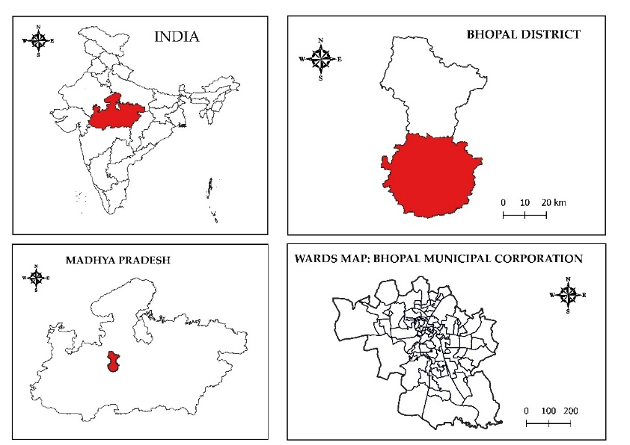

**Figure 1: Study Area**

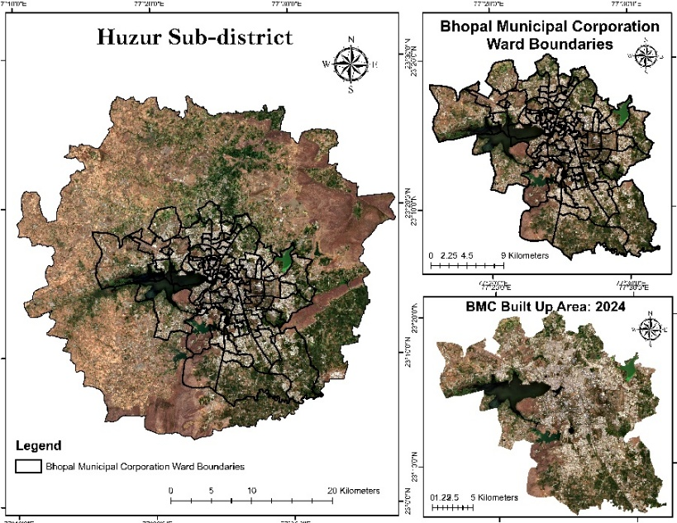

Figure 2: Sentinel -2 image of Bhopal (True color image) of the study area

**Results & Discussion**

**Demographic scenario of Bhopal city**

The population growth in Bhopal city is primarily driven by its status as the state capital, its educational facilities, better healthcare, and job opportunities, as the city houses several large and medium industries. The city experienced rapid population growth, recording a 117.87% decadal increase between 1951 and 1961, primarily due to the establishment of a major public

Source: Census of India

sector manufacturing unit, Bharat Heavy Electricals Limited (BHEL). During 1971-1981, the city's boundary was expanded to include BHEL Township and Bairagarh within the Bhopal Municipal Corporation. The establishment of the Mandideep Industrial Area further boosted population growth, resulting in a 73.66% decadal increase. However, the growth rate gradually declined in subsequent decades—55.98% in 1981-1991, 37.12% in 1991-2001, and 29.3% in 2001-2011. The gradual population growth trend is illustrated in Figure3 and 4.

Source: Census of India

The population growth in Bhopal appears to be significantly driven by both natural growth and migration. This increase in population has led to rising population density issues. According to the 2001 Census, the population density of Bhopal (Municipal Corporation) was 4,886 people per sq km, which increased to 6,290 people per sq km in the 2011 Census. The wards in the old city are the most densely populated areas of Bhopal, with Shahjahanabad, Aishbagh, Islampura, and Moti Masjid being among the densest.

**Growth pattern of the city**

Bhopal city's spatial expansion has accelerated in nearly all directions, driven largely by geographical factors. Natural barriers such as Bhojtal (Upper Lake) and Lower Lake have influenced its growth, while major development corridors like Indore Road, Hoshangabad Road, and Kolar Road have facilitated expansion into new areas. The southern region, particularly along Honshangabad road, has seen the most intensive growth due to the presence of transit corridors, strong connectivity, and available land unimpeded by physical barriers. This growth is also driven by the conversion of rural land to urban, especially near the major work center and industrial town of Mandideep (Development Plan 2031) Figure 5.

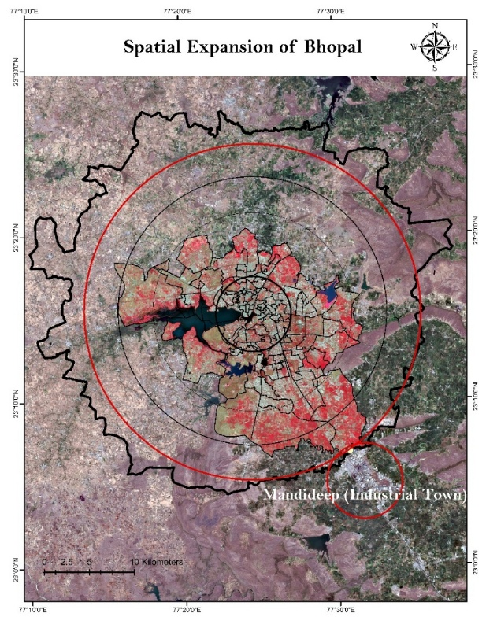

Figure 5: Spatial expansion of Bhopal

Table 1: Growth of city in different direction from the center

|  |  |
| --- | --- |
| Direction | Growth in KM. |
| North | 4.5 |
| Northeast | 4 |
| East | 8 |
| Southeast | 10 |
| South | 6 |
| Southwest | 5 |
| West | 1 |
| Northwest | 6 |

Source: Bhopal Development Plan 2005

**Challenges**

As mentioned in the above discussion, population of the city is increasing and more areas has been brought under the municipal to accommodate the growing need of the city. Two sectors of the urban have been taken into considered for the studies.

**Water supply**

Ensuring a sustainable water supply of adequate quantity and desired quality to meet the growing needs is one of the major challenges facing Bhopal city. The population of Bhopal city has increased from 371715 in 1961 to 1798218 in 2011 indicating an increase of 383.7% over the period of 50 years. The present water supply to Bhopal City is 530 MLD, consisting of 126 MLD from Bhojtal lake, 155 MLD from Kolar, 185 MLD from the Narmada, 29 MLD from Kerwa and 35 MLD from groundwater.

Table 2: Source wise water availability

|  |  |  |  |  |
| --- | --- | --- | --- | --- |
| Sl.No | Source | Million Liters Per Day | | |
|  |  | Present capacity | Proposed augmentation | Total available water |
| 1 | Bhojtal lake | 126 | - | 126 |
| 2 | Kolar | 155 | - | 155 |
| 3 | Ground Water Sources | 35 | - | 35 |
| 4 | Narmada Scheme | 185 | - | 185 |
| 5 | Kerwa, Hathaikheda, Ghodapachhad | 29(existing Kerwa) | 92.8 | 121.8 |
|  | Total | 495 | 31 | 526 |

Source: Bhopal Development Plan 2031

Despite the availability of adequate water sources, Bhopal faces several critical challenges in ensuring efficient and equitable water supply across the city:

1. Inadequate Treatment Capacity: Although water sources are sufficient, treatment facilities cannot meet current demand.
2. Limited Storage Infrastructure: Existing storage capacity is only half of the daily water requirement.
3. Insufficient Distribution Network: The water supply network is underdeveloped and fails to cover the entire city.
4. Overburdened Stand Posts: Each community stand post serves around 95 people, exceeding the Environment Improvement in Urban Sector norms.
5. Network Inefficiencies: The system suffers from high water losses due to leakages and outdated infrastructure.
6. Lack of Accountability: There is no proper monitoring of water quantities at the source, treatment plants, or consumer end.

**Growth of slum**

Urbanization also brings a challenge in housing and the growth of slum areas. “Bhopal city has historically had a high incidence of population living without adequate housing and infrastructure, which has grown over the years” (Bhopal Municipal Corporation and UN-Habitat India 2023). “Bhopal city has recorded the highest urban poverty ratio of 48. 4 percent among all the Indian states” (UN-Habitat 2006). The city has 209 locations as slums (Figure 7), and as per the census 2011, 36.20 percent of the total urban population of Bhopal Municipal Corporation lives in slum areas.

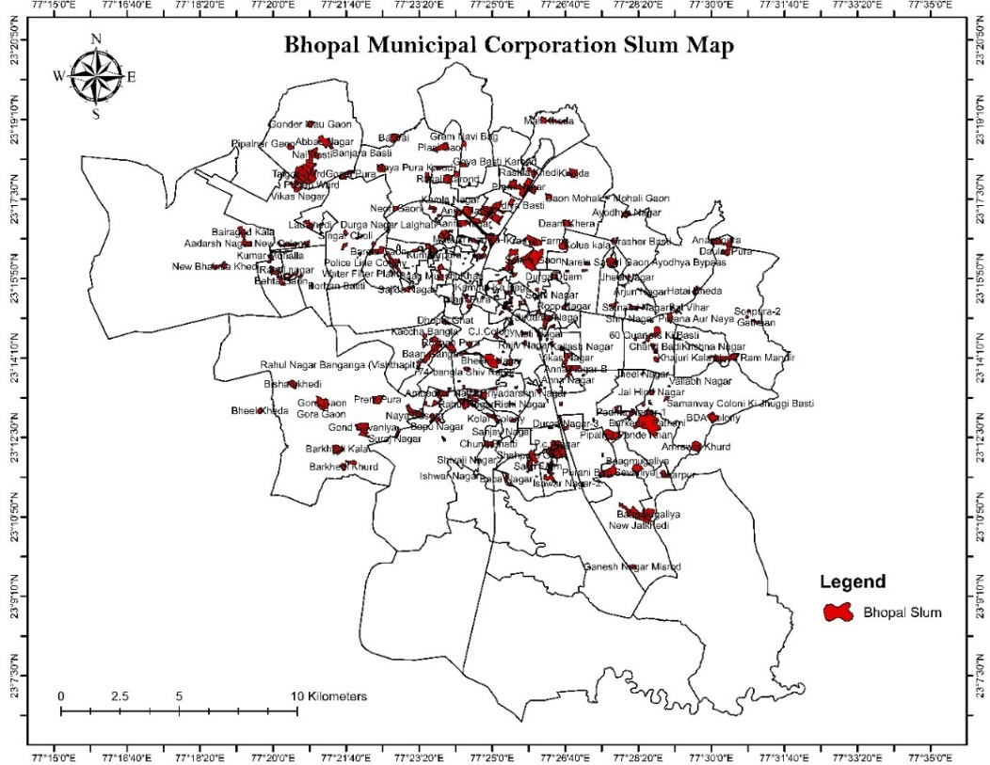

Figure 6: Bhopal Slum

As the population continues to grow, it not only drives the spatial expansion of urban areas but also presents challenges to sustainable development. In the Ease of Living Index published by the Ministry of Housing and Urban Affairs, Bhopal dropped from 10th place in 2018 to 19th position in 2021. The index evaluates cities based on three pillars: Quality of life, Economic Ability, and Sustainability. Additionally, a significant challenge is meeting the goals of Sustainable Development Goals, specifically Sustainable Development Goal -11, which aims to “Make cities and human settlements inclusive, safe, resilient, and sustainable.”

**Spatial** **analyst**: According to the Bhopal Municipal Corporation and UN-Habitat India (2023), the city's built-up area was 26.3 sq. km in 1975, with a population of 3.84 lakh, which expanded to 68.6 sq. km by 2000. To further analyze Bhopal's spatial growth, a spatial change analysis was conducted using Sentinel-2 imagery for the period between 2016 and 2024. The results indicate a significant increase in the built-up area, from 152.5 sq km in 2016 to 185.19 sq km in 2024. This growth suggests a 21.4 percent expansion over the period, pointing to factors such as population growth, economic development, and infrastructure improvements during the city’s expansion (Figure 7).

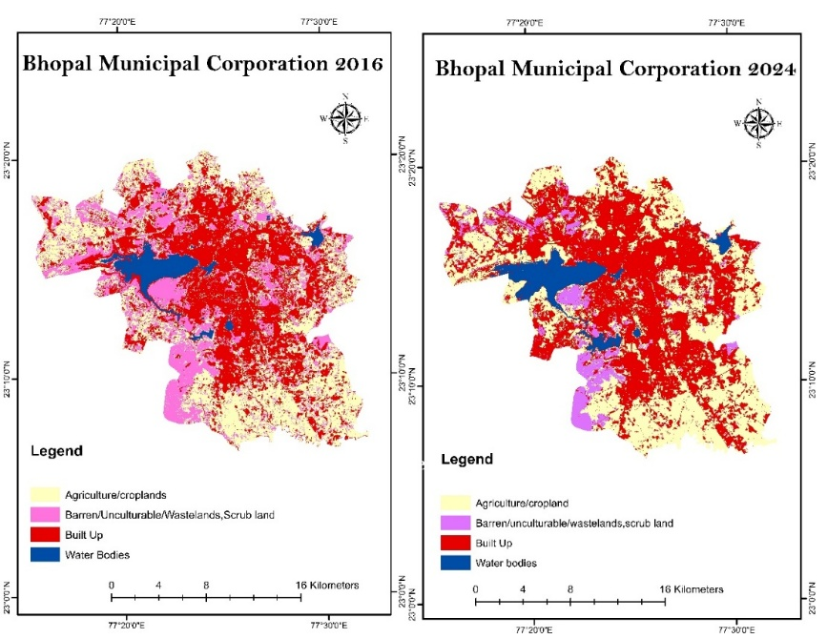

Figure 7: Change detection from 2016 to 2024

**A brief overview of urban development in Bhopal city**

Bhopal's urban governance began in 1907 with the establishment of *Majlis-e-Intezamia*. Until 1956, the city covered a small area, gradually expanding to 71.23 sq. km by 1975, and further including BHEL Township and Bairagarh by 1981. In 1983, Bhopal was upgraded to a Municipal Corporation with 56 wards, increasing to 66 in 1994 without expanding the city limits. However, the city evolved as a collection of distinct townships rather than a unified whole.

The Bhopal Development Plan (BDP) 1991 aimed for integrated development over 240.87 sq. km, focusing on efficient land use, compact city growth, and improved transport. The BDP 1995–2005 expanded the planning area to 601.06 sq. km, incorporating 146 villages and emphasizing organized urban growth, informal settlement planning, and enhanced transport networks.

By the 2001 Census, Bhopal had 14.35 lakh urban residents across 66 wards in 285 sq. km. In 2015, the Kolar municipality was merged, increasing BMC’s area to 463 sq. km across 85 wards and 17 zones.

The BDP 2021 expanded planning to 813.92 sq. km, focusing on future population growth, natural resource conservation, and sustainable infrastructure development.

**Towards sustainable urban**

To make city liveable and sustainable, the Bhopal Development Plan 2031, aligned with AMRUT, emphasizes structured land use, environmental protection (especially around Bhojtal Lake), robust transport infrastructure (including a Fourth Ring Road and metro extension to Sehore), minimum 18m-wide roads, 40% green cover, and community participation in planning.

As the city expanded, its planning boundaries were progressively extended. The Development Plan classifies land use into categories such as Residential, Commercial, Industrial, Public-Semi-Public and Utilities, Recreational, Transportation, Agriculture, Wasteland, Forest, and Water Bodies. The city's development across various land uses is presented in Table 3.

Table 3: Growth pattern of Bhopal

|  |  |  |  |  |
| --- | --- | --- | --- | --- |
| Spatial growth trends and patterns of different land uses | | | | |
| Development plan | BDP 1991 | BDP 2005 | In the year 2018 | Draft BDP 2031 |
| Land use | Existing landuse (In HA.) | Existing landuse (In HA.) | Existing landuse (In HA.) | Existing landuse (In HA.) |
| Residential | 1534 | 3660 | 10169 | 36579 |
| Commercial | 65 | 243 | 405 | 5081 |
| PSP and PUF | 542 | 1178 | 3060 | 10160 |
| Industrial | 348 | 806 | 956 | 7113 |
| Transportation | 542 | 1062 | 2769 | 12194 |
| Recreational | 203 | 902 | 14226 | 14225 |

Source: Bhopal Development Plan (BDP)-2031

**Conclusion**

The urban development of Bhopal presents a vivid narrative of a city grappling with the dualities of growth and sustainability. As highlighted in this study, Bhopal has undergone significant demographic and spatial transformations, primarily driven by population growth, rural-urban migration, and economic expansion. From a modest town to a sprawling urban center, Bhopal’s growth trajectory mirrors the broader urbanization trends seen across many Indian cities.

The analysis reveals that while the city has made notable progress in expanding its infrastructure, industrial base, and residential zones, this growth has also brought forth a complex array of challenges. The rapid and often unplanned urban sprawl has strained the city’s water supply systems, led to the proliferation of slums, and placed enormous pressure on existing public utilities and infrastructure. The spatial analysis using satellite imagery between 2016 and 2024 illustrates a considerable expansion in built-up areas, emphasizing the urgent need for sustainable land management and planned development.

Bhopal's current urban landscape reflects both achievements and gaps. On one hand, it boasts a diversified economic base, educational and healthcare institutions, and historical significance that continues to attract inward migration. On the other hand, the inequities in resource distribution, the burgeoning number of informal settlements, and environmental stressors such as water scarcity and land degradation raise serious concerns about the city’s long-term sustainability.

The city’s planning initiatives, particularly the Bhopal Development Plans (1991, 2005, and the draft 2031), provide a roadmap for organized growth, infrastructure enhancement, and environmental preservation. The 2031 plan, in alignment with national missions like AMRUT, advocates for increased green cover, structured land use, community participation, and improved connectivity through ring roads and metro expansions. However, successful implementation will require robust institutional mechanisms, inter-agency coordination, and participatory governance.

As Bhopal continues to urbanize, the city must strive to balance its developmental goals with environmental stewardship and social equity. Sustainable urban development is not just a policy aspiration but a necessary course of action to ensure that the city remains livable, inclusive, and resilient for future generations. The challenges of population pressure, infrastructure demand, and ecological degradation must be met with innovative planning, integrated policy approaches, and active community involvement. Only through such efforts can Bhopal transform into a model of sustainable urbanization in India’s heartland.

**Reference**

Agnieszka, Kozera., Aldona, Standar. (2024). 1. Energy independent cities? Investment activity of cities in the implementation of eu co-financed projects in renewable energy sources and its conditions in Poland. Acta Scientiarum Polonorum, doi: 10.22630/aspe.2024.23.2.8

Bhopal Development Plan (BDP)-2031. Volume-I(draft) Existing conditions studies and analysis. Directorate of Town and Country Planning, Government of Madhya Pradesh

Bhopal Municipal Corporation and UN-Habitat India (2023). Bhopal Voluntary Local Review-An Agenda for Action: Sustainable Urban Transformation in Bhopal

Bhopal city development plan under JNNURM. Bhopal Municipal Corporation.

Brueckner, J. K. (2000). Urban Sprawl: Diagnosis and Remedies. International Regional Science Review, 23(2), 160-171. <https://doi.org/10.1177/016001700761012710>

Brush E J (1968). Spatial patterns of population in Indian cities. Geographical review. Vol. 58, No3 (July 1968. Pp. 362-391, Taylar and Francis.Ltd.

District Census Handbook Bhopal. Village and Town directory. Series-24, part XII-A, Census of India 2011, Madhya Pradesh. Directorate of Census Operations Madhya Pradesh

District Census Handbook part -A &B. Bhopal district. Village and Town directory. Series-24, Census of India 2001, Madhya Pradesh. Directorate of Census Operations Madhya Pradesh

District ground water information booklet, Bhopal district. Central Ground Water Board, North Centrral Region, Bhopal(2013). Ministry of Water Resources

https://www.cgwb.gov.in/old_website/District_Profile/MP/Bhopal.pdf

Ismail et al., (2018). [Delineating urban growth limit for managing urbanization in Iskandar Malaysia](https://doi.org/10.1088/1755-1315/169/1/012042). IOP Conference Series Earth and Environmental Science, 2018

Muh., Ade, Kurnia, Harahap., Jeffriansyah, Dwi, Sahputra, Amory., Muh., Ilhamuddin, Dahri. (2024). 2. Transforming Cities Through Renewable Energy: Analyzing the Role of Green Infrastructure in Driving Urban Economic Growth. Indo-Fintech Intellectuals, doi: 10.54373/ifijeb.v4i2.1280

Ngossaha JM, Ngouna RH, Archimède B, Negulescu M-H, Petrişor A-I. Toward Sustainable Urban Mobility: A Multidimensional Ontology-Based Framework for Assessment and Consensus Decision-Making Using DS-AHP. *Sustainability*. 2024; 16(11):4458. <https://doi.org/10.3390/su16114458>

T.V. Ramachandra, A.H. Bharath, M.V. Sowmyashree, (2015) Monitoring urbanization and its implications in a mega city from space: Spatiotemporal patterns and its indicators, Journal of Environmental Management, Volume 148, 2015, Pages 67-81, ISSN 0301-4797

Yiran et la (2020). [Urban Sprawl in sub-Saharan Africa: A review of the literature in selected countries](https://doi.org/10.4314/gjg.v12i1.1). Ghana Journal of Geography, 2020

[United Nations Department of Economic and Social Affairs](https://www.un-ilibrary.org/search?value1=United+Nations+Department+of+Economic+and+Social+Affairs&option1=author&noRedirect=true) (2022) “[The Sustainable Development Goals Report 2022](https://www.un-ilibrary.org/content/books/9789210018098)”, pp 48-49 July 2022. <https://doi.org/10.18356/9789210018098c015>

UN-Habitat. (2016) "Urbanization and Development: Emerging Futures." World Cities Report 2016.

United Nations, Department of Economic and Social Affairs, Population Division (2019). *World Population Prospects 2019: Highlights* (ST/ESA/SER.A/423).

United Nations (2018). *World Urbanization Prospects: The 2018 Revision: key facts*. Available at <https://population.un.org/wup/Publications/Files/WUP2018-KeyFacts.pdf>.

United Nations Department of Economic and Social Affairs. World Urbanisation Prospects: The 2018 Revision.

UNEP (United Nations Environment Programme) Water and Sanitation. <https://www.unep.org/explore-topics/resource-efficiency/what-we-do/cities/water-and-sanitation>

United Nations Human Settlement Programme (UN-HABITAT) 2006, UN-HABITAT report on poverty mapping: A situation analysis of poverty pockets in Bhopal

UN-HABITAT (2021) Bhopal city profile and diagnostic report. Sustainable Cities Integrated Approach Pilot (SCIAP)

United nations, department of Economic and Social Affairs, Population Division (2019), World Urbanization Prospects: The 2018 Revision (ST/ESA/SER-A/4200. New York; United Nations.