*Original Research Article*

Assessing Urban Green Infrastructure Transformation in Delhi (1991–2021): A Landscape Ecology and Remote Sensing Approach

.

ABSTRACT

|  |
| --- |
| Urban green spaces (UGS) play a crucial role in ensuring ecological stability and improving the quality of life in rapidly urbanizing regions. This study investigates the long-term transformation of UGS in the National Capital Territory of Delhi (NCTD), India, over a three decades (1991–2021), a time marked by unprecedented urban expansion. Multi-temporal Landsat satellite imagery was used for analysis, including Landsat 5 TM (1991, 2001), Landsat 8 OLI (2011), and Landsat 9 OLI-2 (2021). Unsupervised classification using the maximum likelihood algorithm was performed in ArcGIS 10.8 to classify six major land use/land cover (LULC) categories. Change detection matrices were also constructed to analyze land transitions across three decadal intervals and cumulatively over the entire study period. Landscape and class-level metrics (PLAND, PD, LPI, LSI, COHESION, CONTAG, SHDI, and SHEI) were computed to assess changes in landscape structure and spatial configuration. Results show a significant increase in built-up area (from 263.18 to 570.56 km²) primarily at the expense of agricultural land, vegetation, and open space. Forest cover demonstrated a net gain in the final decade, likely reflecting restoration efforts and reclassification, while vegetation showed consistent fragmentation and loss. The CONTAG index revealed increasing spatial aggregation, while SHDI and SHEI declined, indicating reduced landscape diversity and evenness. Class-level metrics revealed rising patch density and geometric irregularity in vegetation and forest classes, suggesting ecological fragmentation. The findings highlight the urgent need for integrated urban planning, policy reform, and proactive monitoring strategies to mitigate the ecological consequences of unbalanced urban growth. This research provides valuable insight for sustainable green space management in megacities undergoing intense land transformation. |

*Keywords: [Urban green space (UGS); Landscape Metrics; Urbanization; Remote Sensing & GIS]*

1. INTRODUCTION

Urbanization is rapidly transforming landscapes worldwide, particularly in developing countries like India. By 2030, nearly 60% of the global population is expected to reside in cities **(Ramaiah & Avtar, 2019)**. With Asia and Africa currently home to 90% of the world's rural population, these regions are experiencing urbanization at an unprecedented pace, projected to reach urbanization levels of 56% and 64%, respectively, by 2050 **(Kookana et al., 2020)**. This rapid expansion of urban areas has resulted in the continuous spread of built-up infrastructure at the expense of urban green spaces (UGS), leading to significant ecological and environmental challenges **(Li et al., 2022)**. As a crucial component of urban ecosystems, UGS plays a vital role in maintaining ecological balance. Its degradation not only alters urban ecosystem structures and processes but also threatens urban sustainability (F. Zhang & Qian, 2024). Consequently, there is growing recognition of ecosystem services provided through UGS, including microclimate regulation, mitigation of the urban heat island effect, air pollution reduction, aesthetic enhancement, recreational opportunities, and the promotion of both physical and psychological well-being.

Many countries and cities across the world have actively formulated greening policies and urban green space planning to safeguard urban ecosystems and improve quality of life for their citizens. For example, Brazil and United Kingdom incorporated UGS planning into urban planning system and issued corresponding planning policies since the 1990s **(Momm-Schult et al., 2013)**. Same as in Maryland State Government of United States of America established land protection programs to protect natural resources and developed Green Infrastructure Assessment to identify important ecological areas **(Weber et al., 2006)**. Countless efforts by Indian government also have been made in recent years to protect ecosystems. Such as the National Urban Green Policy emphasizes the preservation and expansion of green spaces in cities **(Govindarajulu, 2014)**, while AMRUT (Atal Mission for Rejuvenation and Urban Transformation) aims to enhance urban greenery and create sustainable urban infrastructure **(Biswas et al., 2024)**. Additionally, the Smart Cities Mission incorporates green and blue infrastructure planning to promote climate resilience **(García Sánchez & Govindarajulu, 2023)**. Furthermore, the National Green Tribunal (NGT) plays a crucial role in enforcing environmental laws and safeguarding green spaces **(Tripathi & Sinha, 2024)**. These policies and regulatory frameworks have contributed to urban afforestation, improved air quality, and better ecosystem management. However, challenges such as rapid urbanization, land-use conflicts, and weak policy implementation continue to threaten urban green spaces, necessitating more comprehensive and enforceable strategies for sustainable urban development.

To evaluate the impact of rapid growing urbanization & various land-use policies on UGS dynamics, extensive research has been conducted on its spatiotemporal variations and long-term trends. Such studies seek to optimize the spatial distribution of UGS and support informed decision making for urban ecosystem conservation. Remote sensing techniques and geographic information systems (GIS) have been widely employed to monitor land-use transformations over time **(Balogun et al., 2011; Das & Angadi, 2022; Rogan & Chen, 2004)**. Commonly utilized analytical approaches include land-use transition matrices, which depict changes among different land-use categories within a given period **(Noszczyk, 2019)**, and landscape metrics, which assess spatial modifications in landscape composition and configuration **(Machado et al., 2018)**.

In recent decades, India has experienced rapid urbanization, leading to significant transformations in its urban landscapes **(Bharath et al., 2018)**. The National Capital Territory of Delhi (NCTD), one of the world's largest metropolitan areas, has undergone unprecedented urban growth alongside its economic development **(Mookherjee et al., 2015)**. The built-up area in Delhi expanded from approximately 263.18 km² in 1991 to 570.56 km² in 2021, reflecting a substantial increase in urban infrastructure. This rapid development has exerted pressure on Urban Green Spaces (UGS), altering landscape patterns and prompting concerns about ecological services **(Pulighe et al., 2016)**.​ Recognizing these challenges, the Delhi Development Authority (DDA) has formulated and updated Master Plans to guide the city's development. The Master Plan for Delhi (MPD) has undergone several revisions, including MPD-2021 and the forthcoming MPD-2041. These plans emphasize environmental sustainability, the enhancement of green-blue infrastructure, and the integration of green spaces within urban planning frameworks. Additionally, the DDA has introduced the Green Development Area Policy to protect natural resources and promote sustainable development practices. ​These strategic planning initiatives aim to balance urban growth with ecological preservation, ensuring that the expansion of built environments does not compromise the quality and availability of green spaces essential for urban sustainability and residents' well-being.

In this study, land use data for NCTD was utilized to analyze the spatiotemporal dynamics of urban green spaces (UGS) from 1991 to 2021. The study examines spatio-temporal pattern of UGS and change in terms of land-use transitions along with landscape configurations. The primary objectives of this research are: (1) to assess the spatiotemporal transformation of urban green spaces in Delhi from 1991 to 2021 using remote sensing, LULC change detection, and transition matrices. (2) to evaluate the structural and ecological dynamics of green space classes through landscape and class-level metrics for guiding sustainable urban planning. Understanding these changes and their driving factors can contribute to sustainable urban development and the effective conservation of UGS in NCTD.

2. material and methods

**2.1 Study area**

The study focuses on Delhi, an India's administrative capital and one of the country's most populous metropolitan areas. Delhi is world's second most populous capital city having density of 11,320 persons per km² and the world's largest in terms of total area (1484 Km2) **(Census, 2011)**. NCTD is located between latitudes 28.61°N and longitude 77.23°E in Northern part of India, bordering the states Haryana is to the north, west, and south of Delhi, while Uttar Pradesh is to the east. Administratively, the NCTD is divided into 11 districts and thirty-three tehsils or sub-divisions. Delhi is located in plains with its elevation ranging from 213 to 290 m and the highest point in study area is the Delhi Ridge, a remnant of the Aravalli ranges, which boasts rich biodiversity and lush green vegetation that shields the city from the hot winds blowing in from the deserts of Rajasthan to the west. The region is characterized by a subtropical semi-arid climate, with mainly three seasons hot summers (March-June), monsoonal rains (July-Sept), and cool winters (Nov-Feb) **(Chaudhuri & Sharma, 2020)**. Delhi exhibits extreme seasonal variations in temperature typically ranging from 2°C in winter to over 48°C in summer **(Roy, 2019)**. The monsoon season brings moderate to heavy rainfall, averaging 700–800 mm annually, with approximately 80% of precipitation occurring between July and September **(Chalakkal & Mohan, 2022)**. For this research, NCTD has been selected as a study area because of its unprecedent growth of rapid urbanization, expansion of huge population, and encroachment of green areas for new development since the last few decades. NCTD is an important location for studying the dynamics of LULC. In addition, the environmental susceptibility of NCTD, which is categorized by a reduction in vegetation and growth in built-up land, highlights the requirement of sustainable urban planning to reduce the undesirable effects on natural world.

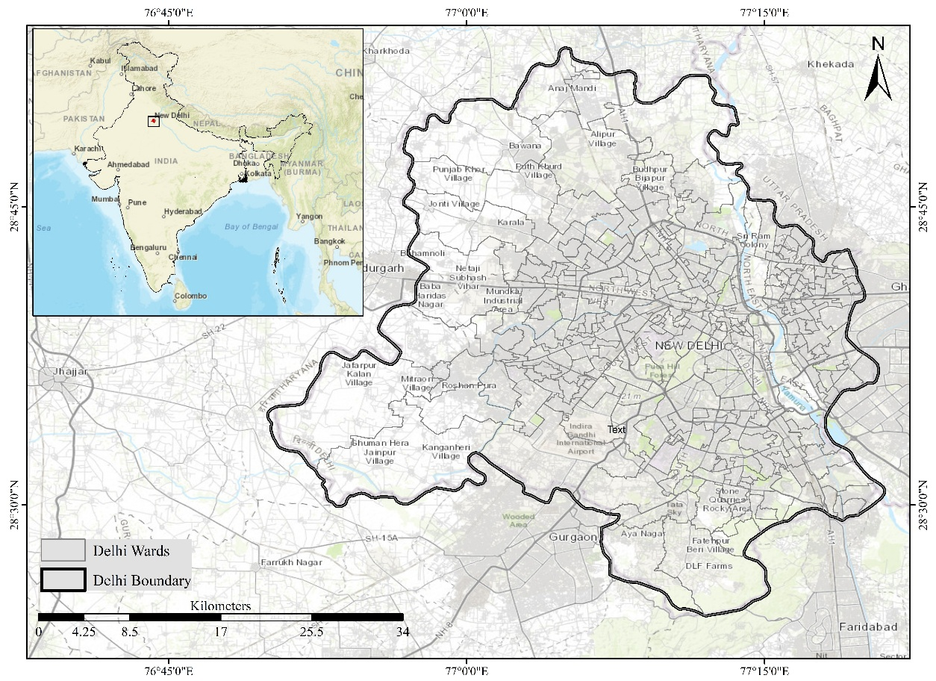

Fig. 1. Study area map.

**2.2 Data Sources**

This study employed a systematic, multi-step approach to analyze the changes in urban green spaces in NCTD over the past three decades (1991–2021). This research utilized satellite data, Google Earth images, government published reports. The LULC change maps were created with the help of Landsat satellites images from Landsat-5, Landsat- 8, and Landsat-9, all with a same spatial resolution of 30 mtr for reflecting bands. The satellite images that is extracted from Landsat mission were classified using an un-supervised maximum likelihood classification method in Arc GIS 10.8 Software to produce land-use patterns for four different time periods and then overall accuracies of the classified land use data were calculated. Although collected from various satellite missions, these datasets maintain identical spatial resolution, hence providing uniformity in LULC classification across multiple years. In addition to satellite data, Survey of India topographic sheets at a 1:50,000 scale were utilized to delineate the administrative boundary of NCT Delhi. Detailed specifications of these datasets are provided in **Table 1.**

**Table 1. Overview of the Data Collection**

|  |  |  |  |  |  |  |
| --- | --- | --- | --- | --- | --- | --- |
| **Satellite** | **Sensor type** | **No. of bands** | **Spatial resolution** | **Radiometric resolution** | **Acquisition date** | **Data source** |
| Landsat 5 | TM | 7 | 30 mtr | 8 bits | 1991 and 2001 | <https://ers.cr.usgs.gov/>. |
| Landsat 8 | OLI/TIRS | 11 | 30 mtr | 12 bits | 2011 |
| Landsat 9 | OLI-2/TIRS-2 | 11 | 30 mtr | 14 bits | 2021 |

**2.3 Methods**

The importance of the methodology stems from its role in ensuring that study is directed in an organized and systematic way, making results more consistent, precise, and simple to replicate. In this study, the task-based methodology has been adopted and applied.

**2.3.1 LULC Classification**

To analyze the spatiotemporal variations in land use and land cover (LULC), satellite imagery for the years 1991, 2001, 2011, and 2021 was processed using an unsupervised classification technique within the Arc GIS 10.8 software environment. This approach was adopted to detect natural spectral groupings in the imagery without requiring predefined training data, making it particularly suitable for long-term land cover monitoring. Satellite datasets were sourced from the United States Geological Survey (USGS), specifically using Landsat 5 TM for 1991 and 2001, Landsat 8 OLI for 2011, and Landsat 9 OLI for 2021. All imagery was selected from the dry season (January–March) to minimize atmospheric variation and cloud interference. Each image has a spatial resolution of 30 meters, which is sufficient for regional-scale LULC analysis. Initial preprocessing steps included layer stacking of spectral bands, radiometric correction, and subsetting of the Area of Interest (AoI). These steps ensured spatial consistency across the time series and prepared the imagery for accurate classification. The unsupervised classification was conducted using maximum likelihood classification method in Arc GIS 10.8 Software. This algorithm automatically groups pixels into spectral clusters based on their reflectance characteristics by iteratively adjusting class means and reallocating pixel membership. A higher number of initial clusters (100) was chosen to allow for sufficient spectral differentiation. Once classification was complete, the spectral classes were recoded into six meaningful LULC categories based on visual interpretation, expert knowledge, and cross-referencing with ESRI base maps and Google Earth imagery data. The final LULC categories are presented in **Table 2.**

**Table 2. Land Use Land Cover Classes**

|  |  |  |
| --- | --- | --- |
| **S. No.** | **LULC Class** | **Description** |
| 1 | Water Body | Rivers, lakes, ponds, and other water features |
| 2 | Vegetation | Grassy areas, shrubs, and scattered green cover |
| 3 | Forest | Dense tree-covered areas |
| 4 | Agriculture | Cropland and agricultural fields |
| 5 | Built-up | Residential, commercial, and industrial areas |
| 6 | Open Space | Barren land, fallow plots, and open grounds |

**2.3.2 Accuracy Assessment**

Accuracy assessment is a critical component of any land use/land cover (LULC) classification process, as it provides a quantitative measure of reliability and thematic correctness of generated maps. In the present study, accuracy of unsupervised classification outputs was evaluated using a stratified random sampling technique, supported by the Fishnet tool in ArcGIS to generate spatially distributed validation points across all six LULC classes **(Anees et al., 2020**). For each classified map (1991, 2001, 2011, and 2021), an error matrix (confusion matrix) was constructed by comparing the classified pixels with reference data extracted from high-resolution imagery, and Google Earth datasets. From this matrix, three standard accuracy metrics were calculated: User’s Accuracy (UA), Producer’s Accuracy (PA), and Overall Accuracy (OA).

The User’s Accuracy (UA), which reflects probability that a pixel classified into a certain category actually represents that category on ground (i.e., commission error), was computed using equation (1):

$α = \frac{n}{N}×100$ (1)

Where ‘α’ is UA, ‘n’ denotes number of corrected points classified on image, and ‘N’ is the number of points verified in field **(Brovelli et al., 2015)**. The Producer’s Accuracy (PA), indicating probability that a reference pixel is correctly classified (i.e., omission error), was calculated in equation (2):

$β = \frac{∑D_{ij}}{R_{j}}$ (2)

Where ‘𝛽’ is PA, ‘ $D_{ij}$’ denotes the number of correctly classified pixels in class 𝑖 (diagonal value of the error matrix) and ‘ $R_{j}$’ is total number of pixels in row j **(Morales-Barquero et al., 2019)**. The Overall Accuracy (OA), representing proportion of total number of correctly classified pixels to total number of validation points, was computed using the following equation (3):

$γ = \frac{∑D_{ij}}{C_{j}}$ (3)

Where ‘𝛾’ is OA, ‘ $D_{ij}$’ denotes the number of correctly classified pixel (diagonal sum) and $C_{j}$ is total number of validation samples (across all classes). In addition to above metrics, the Kappa coefficient was calculated to provide a more robust measure of classification accuracy by accounting for the possibility of chance agreement. The Kappa statistic was computed as follows in equation (4):

$k = \frac{\sum_{i-1}^{r}{X_{ii}-\sum_{i=1}^{r}{(X_{i+}{×X}_{+i})}}}{N^{2}-\sum_{i=1}^{r}{(X_{i+}{×X}_{+i})}}$ (4)

Where ‘k’ represents kappa coefficient, ‘N’ is the total number of observations, ‘r’ denotes total number of rows present in error matrix, Xii is number of observations present in row and column ‘i’ respectively, Xi+ is total number observations in row ‘i’ and ‘X+i is total number of observations in column ‘i’ **(Foody, 2020).**

**2.3.3 LULC change Detection Analysis (1991-2021)**

To investigate spatial and temporal dynamics of land use and land cover (LULC), with particular attention to green spaces in NCTD, a post-classification comparison method was employed using decadal Landsat satellite imagery for the years 1991, 2001, 2011, and 2021. The classified raster datasets for each year were generated using un-supervised classification and subsequently converted to vector format to enable polygon-based geospatial operations **(Viana et al., 2019)**. The change detection analysis was structured in four stages: three decadal transitions 1991–2001, 2001–2011, and 2011–2021 and one long-term transition for the entire study period, i.e., 1991–2021. This staged comparison facilitated the assessment of both short-term and long-term land transformation trends. The 'Intersection' geoprocessing tool was applied between successive time periods to overlay the vector layers and extract areas of land cover transition. For each temporal interval, a transformation matrix was constructed to quantify changes between land cover categories. The transformation matrix (also referred to as a transition or change matrix) presents the area of land that transitioned from one class to another **(Asokan & Anitha, 2019).** The rows in the matrix represent land cover classes in the initial year of comparison, while the columns indicate classes in the subsequent year. Diagonal elements represent stable classes with no change, whereas off-diagonal elements reveal conversions between different land cover types. This matrix-based approach offers a detailed understanding of land conversion dynamics, particularly highlighting the loss, persistence, and gain of green spaces.

To measure the extent of change, two metrics were calculated: absolute change and percentage change. The absolute change (*Ci*) in area for a given class 𝑖 was computed using the equation (5):

${ C}_{i}= L_{i }⎯B_{i}$ (5)

Similarly, the percentage change (Pi) was derived as:

$P_{i} = \left({L_{i} ⎯ B_{i}}/{B_{i}}\right) × 100$ (6)

where ${ C}_{i}$ denotes the change in area (in km²), $P_{i}$ represents the percentage change, $B_{i}$ is the area of class 𝑖 in the base year, and $L_{i }$ is the area of the same class in the target year. These computations were applied for each transition period to capture class-specific trends in land transformation, especially for green spaces.

**2.3.4 Landscape Matrix**

To evaluate spatial structure and temporal dynamics of landscape patterns particularly those associated with green spaces a suite of quantitative landscape metrics was employed. These metrics are widely used in landscape ecology to characterize changes in the composition and configuration of land use and land cover across time and space. In this study, a total of eight landscape metrics were selected based on their relevance and frequent use in previous peer-reviewed literature. These include five class-level metrics and three landscape-level metrics, each serving to capture specific dimensions of landscape structure, such as fragmentation, connectivity, and diversity. At the class level, the selected metrics include: Percentage of Landscape (PLAND), which measures the proportional area occupied by a specific land use class; Patch Density (PD), which indicates the degree of fragmentation by quantifying number of patches per unit area; Largest Patch Index (LPI), reflecting dominance of largest patch within landscape; Landscape Shape Index (LSI), which accounts for geometric complexity of patches; and Patch Cohesion Index (COHESION), which evaluates the physical connectedness of patches within the same land cover type **(Sertel et al., 2018)**. At the broader landscape scale, three integrative indices were applied: Contagion Index (CONTAG), which reflects degree of spatial aggregation among different land cover types; Shannon’s Diversity Index (SHDI), which captures the overall richness and heterogeneity of the landscape **(Y. Zhang et al., 2023)**; and Shannon’s Evenness Index (SHEI), which describes uniformity in the distribution of patch types across the landscape **(Plexida et al., 2014)**. Functionally, PLAND, PD, LPI, and LSI were employed to assess the extent and pattern of fragmentation within the green space class. COHESION and CONTAG served to examine the spatial continuity of vegetated patches, while SHDI and SHEI provided insight into the compositional complexity and evenness of the landscape as a whole. The computation of these metrics was carried out using specialized spatial analysis tools, and their interpretation facilitated a nuanced understanding of green space dynamics in the context of urban expansion in NCT Delhi.

**Table 3. Landscape metrics used in this study** (Turner & Gardner, 2015)

|  |  |  |  |  |
| --- | --- | --- | --- | --- |
|  | **Metrics** | **Equations** | **Unit** | **Justification** |
| Class- level | (PLAND) | ${PLAND =P}_{i} = \frac{\sum_{j=1}^{n}{a_{ij }}}{A}$**(100)**  Pi = proportion of landscape occupied by patch type (class)i.  aij = area (m2) of patchij.  A = total landscape area (m2 ). | Percent | General index |
| (PD) | $PD = \frac{n_{i}}{A}$**(10,000) (100) $n_{i}$**  = number of patches in the landscape of patch type (class)i.  A = total landscape area (m2 ). | Number per 100 hectares | Fragmentation index |
| (LPI) | $$LPI = \left(\frac{γ_{max}}{A}\right)× 100$$ $γ_{max}$ ​ = area of largest patch in a given class ( square meters or hectares)  A = total landscape area (in the same unit as $γ_{max}$ ​) | Percent | Fragmentation and dominance index |
| (LSI) | $$LSI = \frac{0.25\sum_{k=1}^{m}{e_{ik}^{*}}}{\sqrt{A}}$$ $e_{ik}^{*}$ = total length (m) of edge in the landscape between patch types (classes) i and k; includes entire landscape boundary and some or all background edge segments involving class i  A = total landscape area (m2 ). | None | Shape index |
| (COHESION) | $$COHESION = \left[1 ⎯\frac{\sum_{j=1}^{n}{p_{ij}^{*}}}{\sum_{j=1}^{n}{p_{ij}^{*}}\sqrt{a_{ij}^{*}}}\right]{\left[1⎯\frac{1}{\sqrt{Z}}\right]}^{-1}$$ $p_{ij}^{*}$ = perimeter of patchij in terms of the number of cell surfaces. $a_{ij}^{*}$ = area of patchij in terms of the number of cells.  Z = total number of cells in the landscape. | Percent | Connectivity index |
| Landscape - level | (CONTAG) | $$CONTAG = \left[1+ \frac{\sum_{i=1}^{m}{\sum_{k=1}^{m}{\left[P_{i }\frac{g_{ik}}{\sum_{k=1}^{m}{g_{ik}}}\right]\left[ln\left(P_{i }\frac{g_{ik}}{\sum_{k=1}^{m}{g_{ik}}}\right)\right]}}}{2ln(m)}\right]× 100$$ Pi = prop. of landscape occupied by patch type (class)i.  = number of adjacencies (joins) between pixels of patch types (classes) i and k based on the double-count method.  m = number of patch types (classes) present in landscape, including the landscape border if present. | Percent | Connectivity and fragmentation index |
| (SHDI) | $$SHDI = \sum_{i=1}^{m}{\left(p_{i}^{*}ln p_{i} \right)}$$ $P_{i }$ = prop. of landscape occupied by patch type (class)i. | None | Diversity index |
| (SHEI) | $$SHEI = \frac{\sum_{i=1}^{m}{\left(p_{i}^{*}ln p_{i} \right)} }{ln m}$$ $P_{i }$ = prop. of landscape occupied by patch type (class)i.  m = the number of patch types (classes) present in landscape, excluding the landscape border if present. | None | Diversity index |

3. results and discussion

**3.1 LULC pattern change (1991-2021)**

**3.1.1 LULC pattern of NCT Delhi in 1991**

In 1991, as shown in **table 4** the land use and land cover of NCT Delhi was predominantly agricultural, with agriculture accounting for 35.18% (528.7 sq. km) of the total area. Barren land was also significant, occupying 23.37% (351.23 sq. km), while vegetation and forest areas comprised 12.55% (188.55 sq. km) and 10.19% (153.17 sq. km), respectively. The built-up area covered 17.51% (263.18 sq. km), reflecting the early stages of urban expansion. Water bodies constituted only 1.20% (17.96 sq. km) of the landscape. The LULC map of 1991 as shown in **figure 2** depicts a semi-rural landscape dominated by agriculture and natural cover, with urbanization mostly confined to central regions. The limited built-up area suggests that urban sprawl was still in its nascent stage, aligning with the population trends and infrastructural development of the time.

**3.1.2 LULC pattern of NCT Delhi in 2001**

As shown in **table 4** by 2001, significant changes had taken place. Built-up areas increased drastically to 28.07% (421.84 sq. km), reflecting rapid urban growth. The share of agriculture dropped slightly to 33.45%, while vegetation and forest cover declined to 10.38% and 7.45%, respectively. Barren land also reduced to 19.55%, possibly due to conversion into construction zones. The extent of water bodies remained low at 1.10%. The expansion of built-up areas suggests accelerated urbanization due to population pressure and infrastructure development (L. Wang et al., 2020), particularly following Delhi's designation as the National Capital Territory and associated economic growth. The decline in vegetation and forest highlights the 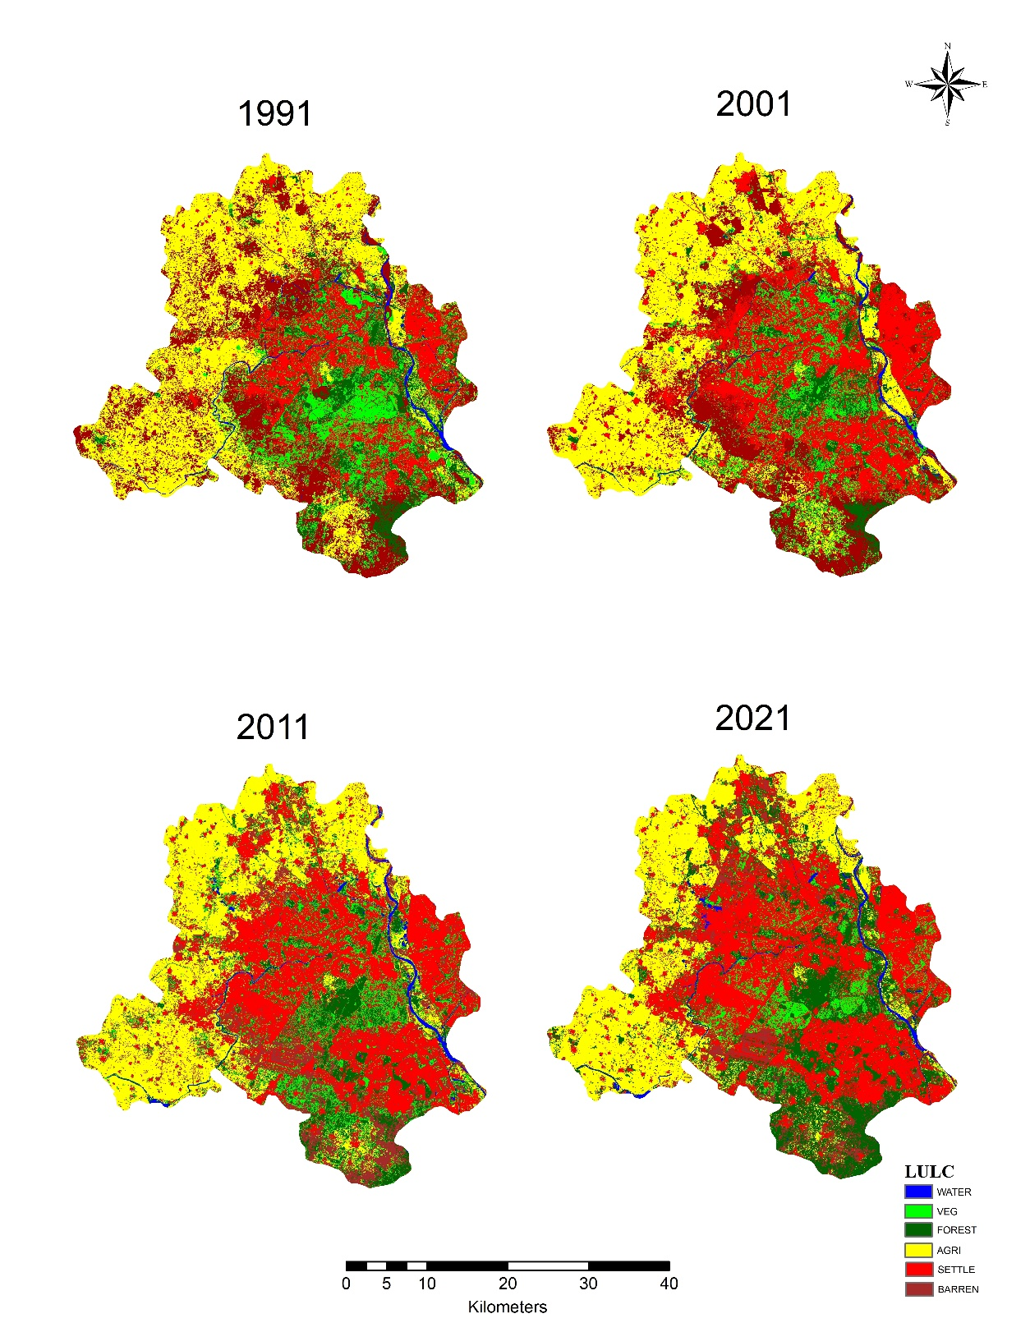cost of urban expansion on ecological assets.

Fig. 2. Spatial distribution of Land Use/Land Cover (1991, 2001, 2011 & 2021).

**3.1.3 LULC pattern of NCT Delhi in 2011**

In 2011, as **table 4** shows that the trend of increasing urbanization continued with built-up land covering 31.73% (476.85 sq. km). The agricultural area shrank further to 29.53%, while vegetation showed a marginal improvement (11.06%), possibly due to urban greening projects. Interestingly, forest cover slightly recovered to 8.86%. Barren land continued to decrease, reaching 17.21%, and water bodies slightly increased to 1.61% (24.26 sq. km). The increase in built-up areas correlates with Delhi’s growing housing and commercial demands. Initiatives like the Master Plan for Delhi (MPD-2021) may have contributed to forest and vegetation recovery through afforestation and park development. However, the continuing reduction in agricultural land remains a concern for peri-urban sustainability.

**3.1.4 LULC pattern of NCT Delhi in 2021**

By 2021, the dominance of built-up land became even more pronounced, expanding to 38.01% (570.56 sq. km). Agriculture dropped to 26.31%, and vegetation declined sharply to 7.35%, the lowest in three decades. Conversely, forest cover experienced a significant rise to 17.73% (266.23 sq. km) a surprising reversal, potentially linked to both improved satellite classification techniques and forest area restoration projects. Barren land reduced to 9.24%, while water bodies decreased slightly to 1.36%. The sharp rise in forest cover may be attributed to large-scale afforestation efforts under schemes like the Delhi Green Action Plan and plantation drives, along with reclassification of some former vegetated or open spaces as forested under new definitions **(Randhawa et al., 2024)**. The alarming drop in vegetation, however, suggests that while forest zones were protected, general urban green spaces like parks and tree-lined streets have diminished due to infrastructure growth.

**3.1.5 Comparative Discussion (1991-2021)**

Over the three decades (1991–2021), NCT Delhi witnessed a clear and consistent trend toward urbanization, with built-up areas increasing by over 117% (from 263.18 to 570.56 sq. km). This expansion occurred at the cost of agriculture (reduced by 133.72 sq. km) and barren land (reduced by 212.5 sq. km). While forest cover grew significantly in 2021, possibly due to policy-level interventions and stricter environmental regulations, the loss of vegetation indicates a decline in urban green infrastructure, which plays a crucial role in air pollution mitigation, microclimatic regulation, and public health **(Kumar et al., 2019)**. The shifting land dynamics reflect Delhi’s rapid urban sprawl driven by population growth, housing demand, infrastructural development, and policy shifts. The continuous reduction in open and vegetated lands may exacerbate urban environmental challenges such as the Urban Heat Island (UHI) effect, reduced biodiversity, and increased air pollution levels. This analysis underscores the urgent need for integrated urban planning that balances development with ecological preservation. Strategies like green infrastructure integration, sustainable zoning policies, and citizen-participatory greening programs are vital for mitigating the long-term socio-environmental risks posed by such LULC transformations.

**Table 4. LULCC pattern and change in NCT Delhi (1991 - 2021)**

|  |  |  |  |  |  |  |  |  |
| --- | --- | --- | --- | --- | --- | --- | --- | --- |
|  | **1991** | | **2001** | | **2011** | | **2021** | |
| **LULC Class** | Area (sq. km) | Percentage | Area (sq. km) | Percentage | Area (sq. km) | Percentage | Area (sq. km) | Percentage |
| **Water body** | 17.96 | 1.20 | 16.59 | 1.10 | 24.26 | 1.61 | 20.48 | 1.36 |
| **Vegetation** | 188.55 | 12.55 | 155.99 | 10.38 | 166.16 | 11.06 | 110.28 | 7.35 |
| **Forest** | 153.17 | 10.19 | 111.92 | 7.45 | 133.13 | 8.86 | 266.23 | 17.73 |
| **Agriculture** | 528.7 | 35.18 | 502.72 | 33.45 | 443.81 | 29.53 | 394.98 | 26.31 |
| **Built-up** | 263.18 | 17.51 | 421.84 | 28.07 | 476.85 | 31.73 | 570.56 | 38.01 |
| **Open space** | 351.23 | 23.37 | 293.84 | 19.55 | 258.57 | 17.21 | 138.73 | 9.24 |
| **Total** | 1502.79 | 100.00 | 1502.9 | 100.00 | 1502.78 | 100.00 | 1501.26 | 100.00 |

**3.2 Accuracy assessment**

Table 5 presents the classification accuracy assessment of land use/land cover (LULC) maps for the years 1991, 2001, 2011, and 2021 using user’s accuracy (UA), producer’s accuracy (PA), overall accuracy (OA), and the Kappa coefficient as standard performance metrics. The overall accuracy ranged from 86.73% to 93.09% across the four temporal datasets, with the highest classification accuracy observed in 2021 (OA = 93.09%; Kappa = 0.9158), indicating substantial agreement between classified and reference data. The lowest accuracy was recorded in 2011 (OA = 86.73%; Kappa = 0.846), potentially due to increased heterogeneity in land cover and urban expansion during that period. Among the LULC classes, Water Body consistently achieved high UA and PA across all years, with perfect or near-perfect classification in 2001 and 2021 (PA = 100% in 2021), reflecting the distinct spectral signature and minimal confusion with other classes. Vegetation and Open space classes showed moderate variation in accuracy, with noticeable improvement in 2021 (UA = 93.67% and 94.27%, respectively), attributed to better spatial resolution and classification techniques. The Forest class demonstrated relatively lower accuracies in earlier years (UA = 77.92% in 2001), but improved significantly by 2021 (UA = 83.54%, PA = 94.28%) due to refined training data and reduced confusion with dense vegetation. The Agriculture and Built-up classes showed considerable improvement over the years, with Agriculture rising from PA = 77.91% in 2011 to 90.12% in 2021, while Built-up areas achieved the highest accuracy in 2021 (UA = 94.94%, PA = 94.93%), indicative of increasingly accurate identification of urban features, likely due to increased separability of spectral characteristics of impervious surfaces. Overall, the results demonstrate a temporal improvement in classification performance, highlighting the advancement of classification methods and data preprocessing strategies adopted in recent years **(Fotso Kamga et al., 2021**).

**Table 5. Accuracy assessment using error metrics and kappa coefficient (1991 - 2021)**

|  |  |  |  |
| --- | --- | --- | --- |
| **Time period** | **Land use class** | **User accuracy (%)** | **Producer accuracy (%)** |
| **1991** | Water Body | 91.03 | 98.61 |
| Vegetation | 91.14 | 91.14 |
| Forest | 92.4 | 89.02 |
| Agriculture | 90.91 | 90.91 |
| Built-up | 92.4 | 93.59 |
| Open space | 93.58 | 91.82 |
| **Overall accuracy** | | 91.82 | |
| **Kappa coefficient** | | 0.9047 | |
| **2001** | Water Body | 100 | 98.75 |
| Vegetation | 86.07 | 89.47 |
| Forest | 77.92 | 84.5 |
| Agriculture | 88.61 | 79.55 |
| Built-up | 89.74 | 87.5 |
| Open space | 88.46 | 91.39 |
| **Overall accuracy** | | 88.18 | |
| **Kappa coefficient** | | 0.86 | |
| **2011** | Water Body | 98.71 | 98.71 |
| Vegetation | 82.05 | 87.67 |
| Forest | 78.2 | 82.43 |
| Agriculture | 85.9 | 77.91 |
| Built-up | 92.4 | 85.88 |
| Open space | 85.99 | 90.6 |
| **Overall accuracy** | | 86.73 | |
| **Kappa coefficient** | | 0.846 | |
| **2021** | Water Body | 97.43 | 100 |
| Vegetation | 93.67 | 92.5 |
| Forest | 83.54 | 94.28 |
| Agriculture | 92.4 | 90.12 |
| Built-up | 94.94 | 94.93 |
| Open space | 94.27 | 91.92 |
| **Overall accuracy** | | 93.09 | |
| **Kappa coefficient** | | 0.9158 | |

**3.3 Change detection analysis and Transformation of LULC (1991-2021)**

The spatial and temporal analysis of land use/land cover (LULC) dynamics in the National Capital Territory of Delhi from 1991 to 2021 reveals a complex and evolving pattern of land transformation driven primarily by urbanization. As shown in **Table 6** and **Figure 3(a)**, the decade between 1991 and 2001 was marked by a sharp surge in built-up areas, with significant conversions from vegetation (56.25 sq.km), open space (64.10 sq.km), and agriculture (34.82 sq.km), highlighting the early phases of unregulated urban expansion. Vegetation and forest classes showed substantial mutual exchanges, suggesting unstable green cover and possible classification shifts or seasonal influences. Between 2001 and 2011 (**Table 7 and Figure 4**), this urban growth trajectory intensified, with built-up land expanding by 418.16 sq.km mostly at the expense of vegetation, agriculture, and open spaces. Notably, vegetation continued to serve as a transitional class, with 43.91 sq.km retained and nearly equal amounts flowing into forest (24.24 sq.km) and agriculture (35.13 sq.km), while forest cover showed signs of fragmentation and increasing transitions to other classes.

**Table 6. Change area matrix of 1991 - 2001 (Km2).**

|  |  |  |  |  |  |  |  |
| --- | --- | --- | --- | --- | --- | --- | --- |
| 2001 | 1991 | | | | | | |
| **LULC** | **Water** | **Vegetation** | **Forest** | **Agriculture** | **Built-up** | **Open Space** |
| **Water** | 8.5302 | 1.035 | 2.7657 | 2.4633 | 0 | 1.8261 |
| **Vegetation** | 1.3869 | 53.9919 | 31.1139 | 26.8443 | 0 | 31.1175 |
| **Forest** | 3.168 | 30.3453 | 51.4962 | 16.8561 | 0 | 12.3363 |
| **Agriculture** | 1.7604 | 14.1768 | 20.2941 | 373.17 | 0 | 86.0463 |
| **Built-up** | 1.2429 | 56.2464 | 29.34 | 34.8282 | 259.6875 | 64.1025 |
| **Open Space** | 1.8162 | 38.1807 | 20.6091 | 68.085 | 0 | 158.101 |

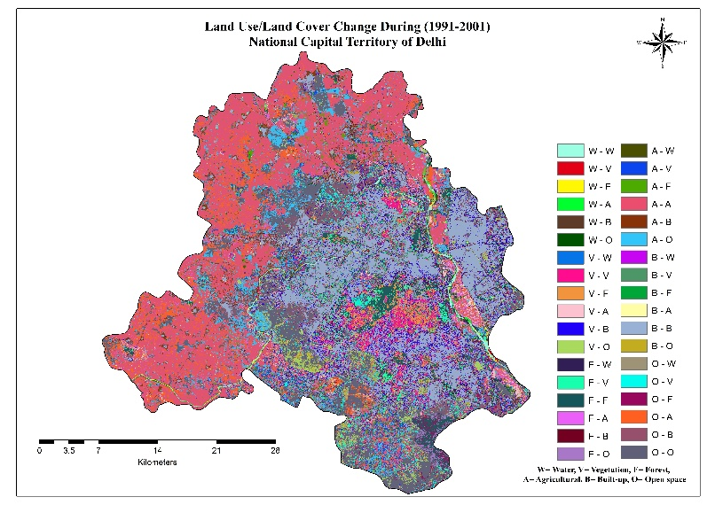

**Fig. 3** LULC change detection during (1991-2001);

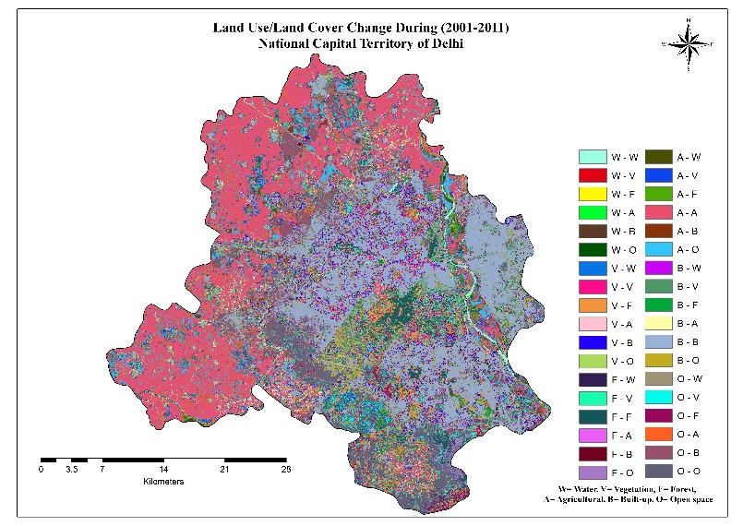

**Fig. 4** LULC change detection during (2001-2011)

**Table 7. Change area matrix of 2001 - 2011 (Km2).**

|  |  |  |  |  |  |  |  |
| --- | --- | --- | --- | --- | --- | --- | --- |
| 2011 | 2001 | | | | | | |
| **LULC** | **Water** | **Vegetation** | **Forest** | **Agriculture** | **Built-up** | **Open Space** |
| **Water** | 10.5696 | 1.413 | 3.3435 | 4.2516 | 0 | 2.8476 |
| **Vegetation** | 1.116 | 43.9083 | 24.2424 | 35.1279 | 0 | 35.5212 |
| **Forest** | 1.5678 | 35.019 | 48.4506 | 19.1277 | 0 | 17.1378 |
| **Agriculture** | 1.1223 | 12.1644 | 8.2782 | 360.916 | 0 | 41.3919 |
| **Built-up** | 0.6255 | 38.0628 | 15.1533 | 23.6565 | 418.1642 | 86.409 |
| **Open Space** | 1.6965 | 28.6551 | 15.9057 | 55.1781 | 0 | 111.94 |

The 2011–2021 period, represented in **Table 8 and Figure 5**, witnessed a shift from outward sprawl to densification, where built-up land increased to 467.39 sq.km, converting large portions of vegetation (37.67 sq.km) and agricultural land (31.41 sq.km). Interestingly, this decade also saw a significant gain in forest cover, with 90.97 sq.km retained and additional inflow from vegetation (59.97 sq.km) and agriculture (33.30 sq.km), suggesting successful afforestation and landscape restoration programs. Vegetation again remained highly dynamic, losing area to forest and built-up classes while feeding into open space (26.89 sq.km). Agriculture retained a considerable portion of its area (319.94 sq.km) but continued to be encroached upon by urban development.

|  |  |  |  |  |  |  |  |
| --- | --- | --- | --- | --- | --- | --- | --- |
| 2021 | 2011 | | | | | | |
| **LULC** | **Water** | **Vegetation** | **Forest** | **Agriculture** | **Built-up** | **Open Space** |
| **Water** | 11.8989 | 1.56172 | 2.18475 | 2.81565 | 0 | 1.60155 |
| **Vegetation** | 1.22265 | 35.0408 | 18.6595 | 14.9108 | 0 | 26.8873 |
| **Forest** | 4.2012 | 59.9672 | 90.9715 | 33.2978 | 0 | 63.1366 |
| **Agriculture** | 2.40367 | 19.5467 | 9.13612 | 319.943 | 0 | 33.0424 |
| **Built-up** | 2.66985 | 37.6668 | 6.91222 | 31.4091 | 467.3904 | 76.6552 |
| **Open Space** | 1.81778 | 16.9168 | 5.46705 | 35.5966 | 0 | 65.9376 |

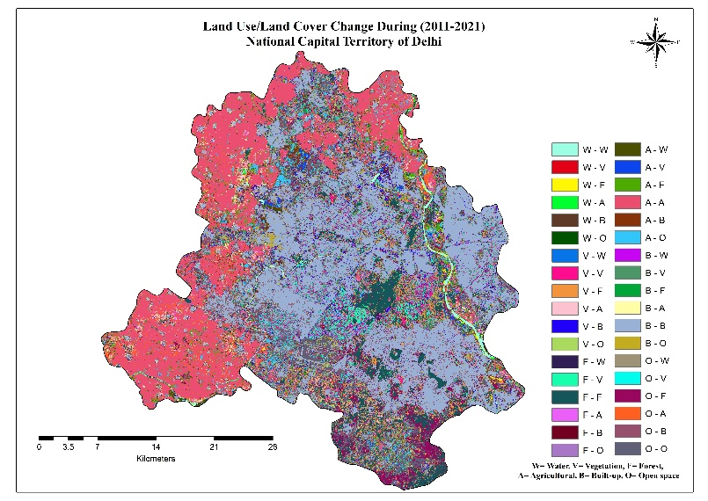**Table 8. Change area matrix of 2011 - 2021 (Km2).**

**Fig. 5** LULC change detection during (2011-2021);

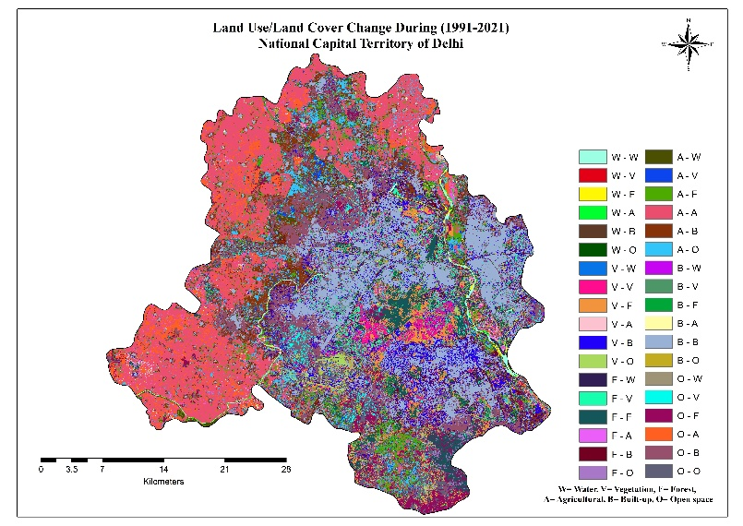

**Fig. 6** LULC change detection during (1991-2021)

Cumulatively, over the entire three decades (1991–2021) (**Table 9 and Figure 6),** built-up land exhibited the most dramatic increase, from 0 to 259.59 sq.km, absorbing substantial areas from all other classes especially vegetation (80.43 sq.km), agriculture (91.31 sq.km), forest (40.33 sq.km), and open space (130.47 sq.km). Forest cover, in contrast, experienced a net gain, with 67.05 sq.km retained and additional conversion from vegetation (53.41 sq.km) and agriculture (61.04 sq.km), reflecting positive ecological trends. Vegetation and open space acted primarily as transitional categories, experiencing high flux and significant loss to built-up and forest classes. Agricultural land, although relatively stable (292.39 sq.km retained), lost more than 300 sq.km to other land cover types, indicating ongoing peri-urban conversion and shrinking cultivation zones. Overall, the transformation landscape across the four decades reflects a trajectory of rapid urban expansion, fluctuating green cover, and only partial ecological compensation demanding urgent integration of landscape-level planning, ecological restoration, and sustainable land governance frameworks in Delhi’s urban future.

**Table 9. Change area matrix of 1991 - 2021 (Km2)**

|  |  |  |  |  |  |  |  |
| --- | --- | --- | --- | --- | --- | --- | --- |
| 2021 | 1991 | | | | | | |
| **LULC** | **Water** | **Vegetation** | **Forest** | **Agriculture** | **Built-up** | **Open Space** |
| **Water** | 8.00168 | 1.1196 | 3.06337 | 5.32665 | 0 | 2.58548 |
| **Vegetation** | 1.01385 | 33.1276 | 20.0318 | 21.0674 | 0 | 26.3754 |
| **Forest** | 3.62452 | 53.4064 | 67.0527 | 61.0402 | 0 | 67.7644 |
| **Agriculture** | 2.04098 | 5.64772 | 12.8047 | 292.392 | 0 | 75.0116 |
| **Built-up** | 2.10713 | 80.4314 | 40.3259 | 91.3126 | 259.5928 | 130.468 |
| **Open Space** | 1.05908 | 20.1362 | 12.193 | 50.0573 | 0 | 50.6891 |

**3.4 Green Space Changes in Landscape Patterns (1991-2021)**

We applied Fragstats 4.2 to calculate the landscape-level metrics of the green space landscape, that is, three land - use types (Vegetation, forest, and Agriculture). The temporal analysis of landscape metrics CONTAG in (%), SHDI, and SHEI from 1991 to 2021 reveals significant shifts in the spatial configuration and composition of the landscape, likely driven by rapid urbanization and land use transformation. The CONTAG index as shown in fig 7 (a), which measures the degree of clumping or aggregation of similar land cover types, shows a moderate increasing trend over the three decades (1991–2021) (R² = 0.63). This suggests that the landscape has become more spatially aggregated, potentially due to the expansion and consolidation of built-up areas. As urban infrastructure such as residential, commercial, and industrial zones expanded, formerly fragmented patches of green and agricultural land were replaced by more continuous urban surfaces **(La Rosa, 2014)**. This pattern aligns with observed urban sprawl and centralized urban development strategies adopted in many parts of the National Capital Territory (NCT) of Delhi. In contrast, the Shannon’s Diversity Index (SHDI), shown in fig 7 (b) which captures the richness and distribution of different land cover types, shows a mild but consistent decline (R² = 0.42). This indicates a reduction in the heterogeneity of the landscape, where a few dominant land use categories most likely urban or built-up classes have increasingly overshadowed others such as vegetation, agriculture, and water bodies. This loss of diversity reflects a homogenizing landscape, a common consequence of unregulated urban expansion that diminishes ecological variety and reduces the adaptive capacity of urban ecosystems. Similarly, the Shannon’s Evenness Index (SHEI), in fig 7 (c) quantifies the uniformity in the distribution of land cover categories, also displays a declining trend (R² = 0.36). This suggests a growing imbalance in the landscape structure, where certain classes are becoming disproportionately dominant. The reduction in evenness is likely a result of disproportionate land conversion into urban or impervious surfaces, with little attention given to maintaining equilibrium across different land cover types. The dominance of built-up areas at the expense of ecological land uses such as open spaces and vegetation patches poses serious concerns for landscape sustainability, biodiversity conservation, and environmental resilience **(D. Wang & Xu, 2024).** Collectively, these trends highlight a progressive shift towards landscape homogenization, reduced ecological diversity, and increased spatial dominance of urban land cover types. The findings underscore the urgent need for integrated land use planning and policy interventions that prioritize the preservation of landscape heterogeneity and spatial balance. Maintaining a diverse and evenly distributed landscape is essential for enhancing ecosystem services, mitigating urban heat island effects, and promoting long-term urban sustainability.

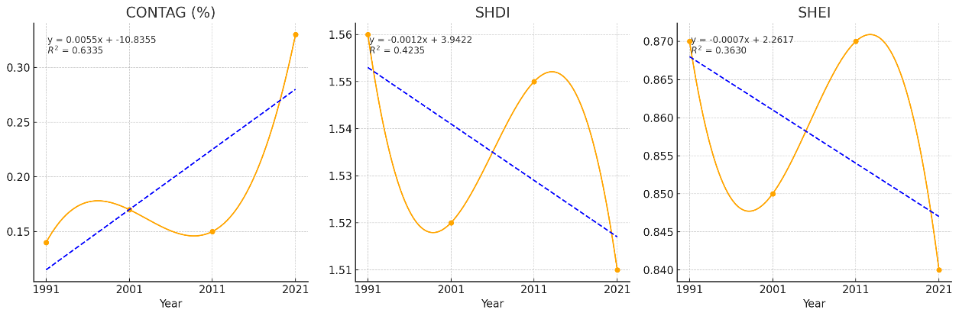**Fig 7.** The landscape-level metrics of the land use pattern of NCT Delhi from 1991 to 2021. (a) Contagion index (CONTAG); (b) Shannon’s evenness index (SHDI); (c) Shannon’s evenness index (SHEI).

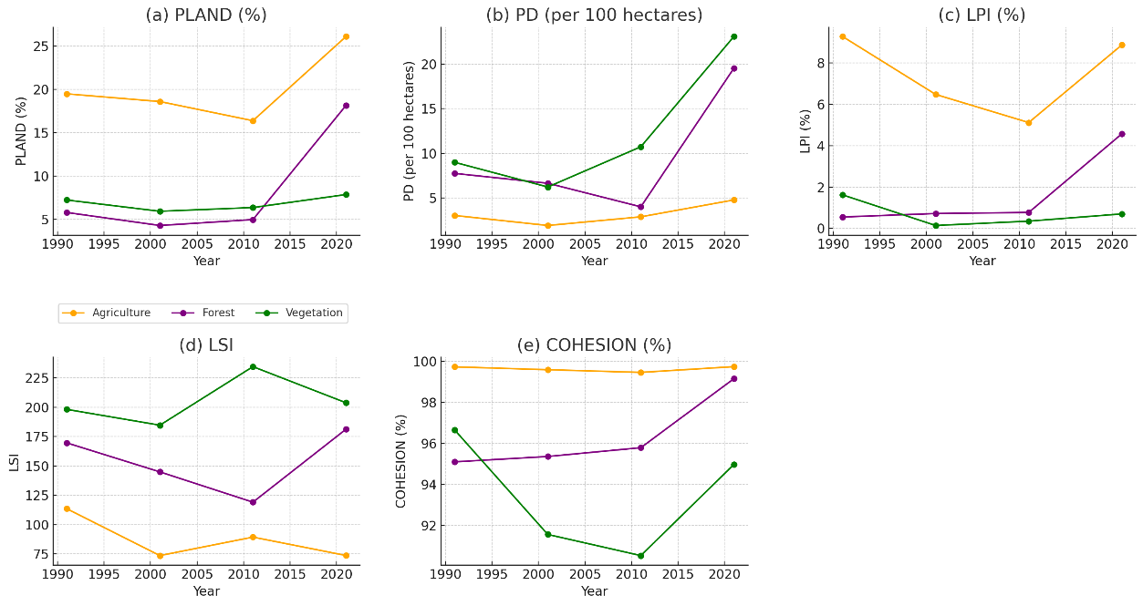Class-level metrics offer further insight into the specific behavior of key land cover types vegetation, forest, and agriculture. Fig 8. Shows that Percentage of Landscape (PLAND) values show that agriculture remained the dominant class, particularly increasing from 2011 to 2021, while vegetation exhibited only minor fluctuations. Interestingly, the forest class showed a substantial increase in PLAND and cohesion in 2021, possibly reflecting afforestation programs or a shift in classification policies. Despite this, earlier decades saw low forest presence and high fragmentation, as indicated by low LPI and moderate patch density. Vegetation, while relatively stable in area coverage, showed significant increases in patch density (PD) and Landscape Shape Index (LSI), especially from 2011 to 2021. This suggests rising fragmentation and spatial irregularity, likely due to ongoing urban development. Cohesion values for vegetation decreased through 2011, before recovering slightly in 2021 implying temporary disconnection of green patches with modest recovery efforts later. The agriculture class, on the other hand, maintained consistently high cohesion and low PD across all years, reflecting large, contiguous and relatively undisturbed agricultural blocks.

**Fig. 8** The class-level metrics of the Urban green space of NCT Delhi from 1991 to 2021. (a) PLAND; (b) PD; (c) LPI; (d) LSI; (e) COHESION

Additionally, the LPI (Largest Patch Index) reveals that agriculture consistently contained the largest patches throughout the study period. The significant increase in forest LPI and cohesion in 2021, however, indicates that restoration and reforestation programs may have begun to yield spatially contiguous forest patches. The vegetation class remained dominated by small, fragmented patches with minimal large-patch presence, reinforcing its vulnerability within the broader land use system. Collectively, these metrics suggest a landscape under increasing anthropogenic pressure particularly from urban expansion which has altered the configuration and function of both natural and semi-natural land cover types. The trends underscore the need for integrated planning strategies that account for spatial cohesion, diversity, and resilience at both the landscape and class levels. Metrics such as CONTAG, SHDI, LPI, and cohesion should be institutionalized as diagnostic tools in land-use monitoring and urban planning frameworks, enabling a shift from reactive to proactive environmental governance.

4. Conclusion

This study presents an integrated assessment of long-term urban green space (UGS) transformation in the National Capital Territory of Delhi (NCTD) from 1991 to 2021, combining remote sensing analysis, landscape metrics, and change detection matrices to reveal the underlying patterns and processes of land use dynamics. The findings clearly illustrate a sustained and substantial expansion of built-up areas growing by over 117% in three decades which has occurred predominantly at the cost of agricultural land, vegetation, and open spaces. The spatial configuration of the landscape has been markedly altered, with built-up areas becoming increasingly aggregated (as reflected by a rising CONTAG index), while the richness and evenness of land cover types have declined steadily (as indicated by decreasing SHDI and SHEI values). At the class level, the analysis reveals a nuanced picture: while agricultural land remains the dominant green space category in terms of spatial extent, it has undergone significant internal shrinkage and edge fragmentation. Vegetation areas exhibited high levels of patch density and geometric complexity, pointing to increased fragmentation and disconnection, particularly in peri-urban and transitional zones. In contrast, forest areas displayed a marked improvement in spatial cohesion and PLAND in the final decade, suggesting positive outcomes of afforestation policies and land reclassification. However, the vegetated landscape remains vulnerable, with green space patches increasingly fragmented and isolated due to the unrelenting expansion of impervious surfaces. These trends underscore the urgent need for an ecosystem-based, spatially-informed urban policy framework. Urban planning authorities, such as the Delhi Development Authority (DDA), must incorporate the findings of landscape metrics particularly LPI, COHESION, and CONTAG into master planning and zoning policies to prevent ecological disintegration. Green buffers, ecological corridors, and continuous green belts should be mandated in land use policy to maintain functional connectivity across urban green spaces. Furthermore, a minimum per capita green space threshold, aligned with WHO’s recommendation of 9 m² per person, should be institutionalized and enforced **(Przewoźna et al., 2024)**. In conclusion, safeguarding urban green spaces in a megacity like Delhi requires a confluence of evidence-based planning, robust regulatory frameworks, and citizen participation. Without strategic intervention, the ongoing landscape homogenization and ecological fragmentation may pose irreversible threats to environmental sustainability, public health, and climate resilience. The methodology and findings of this study provide a replicable framework for other rapidly urbanizing cities in the other part of the world, emphasizing the need for spatially explicit, data-driven strategies for sustainable urban development.

References

1. Anees, M. M., Mann, D., Sharma, M., Banzhaf, E., & Joshi, P. K. (2020). Assessment of Urban Dynamics to Understand Spatiotemporal Differentiation at Various Scales Using Remote Sensing and Geospatial Tools. *Remote Sensing*, *12*(8), Article 8. https://doi.org/10.3390/rs12081306
2. Asokan, A., & Anitha, J. (2019). Change detection techniques for remote sensing applications: A survey. *Earth Science Informatics*, *12*(2), 143–160. https://doi.org/10.1007/s12145-019-00380-5
3. Balogun, I. A., Adeyewa, D. Z., Balogun, A. A., & Morakinyo, T. E. (2011). *Analysis of urban expansion and land use changes in Akure, Nigeria, using remote sensing and geographic information system (GIS) techniques*.
4. Bharath, H. A., Chandan, M. C., Vinay, S., & Ramachandra, T. V. (2018). Modelling urban dynamics in rapidly urbanising Indian cities. *The Egyptian Journal of Remote Sensing and Space Science*, *21*(3), 201–210. https://doi.org/10.1016/j.ejrs.2017.08.002
5. Biswas, J., Ray, K. K., Biswas, M. B., & Panda, A. (2024). *Evaluating the Transformation of City Facilities under AMRUT: A Conceptual Model* (13:718). F1000Research. https://doi.org/10.12688/f1000research.151245.1
6. Brovelli, M. A., Molinari, M. E., Hussein, E., Chen, J., & Li, R. (2015). The First Comprehensive Accuracy Assessment of GlobeLand30 at a National Level: Methodology and Results. *Remote Sensing*, *7*(4), Article 4. https://doi.org/10.3390/rs70404191
7. Census, I. (2011). *Census, 2011*. Government of India. https://censusindia.gov.in/census.website/data
8. Chalakkal, J. B., & Mohan, M. (2022). Is the Monsoon climatology observed over the National Capital Region, Delhi indicative of an Urban -Monsoon linkage on rainfall modification? *Urban Climate*, *46*, 101289. https://doi.org/10.1016/j.uclim.2022.101289
9. Chaudhuri, R. R., & Sharma, P. (2020). Addressing uncertainty in extreme rainfall intensity for semi-arid urban regions: Case study of Delhi, India. *Natural Hazards*, *104*(3), 2307–2324. https://doi.org/10.1007/s11069-020-04273-5
10. Das, S., & Angadi, D. P. (2022). Land use land cover change detection and monitoring of urban growth using remote sensing and GIS techniques: A micro-level study. *GeoJournal*, *87*(3), 2101–2123. https://doi.org/10.1007/s10708-020-10359-1
11. Foody, G. M. (2020). Explaining the unsuitability of the kappa coefficient in the assessment and comparison of the accuracy of thematic maps obtained by image classification. *Remote Sensing of Environment*, *239*, 111630. https://doi.org/10.1016/j.rse.2019.111630
12. Fotso Kamga, G. A., Bitjoka ,L, Akram ,T., Mengue Mbom ,A., Rameez Naqvi ,S., & and Bouroubi, Y. (2021). Advancements in satellite image classification: Methodologies, techniques, approaches and applications. *International Journal of Remote Sensing*, *42*(20), 7662–7722. https://doi.org/10.1080/01431161.2021.1954261
13. García Sánchez, F., & Govindarajulu, D. (2023). Integrating blue-green infrastructure in urban planning for climate adaptation: Lessons from Chennai and Kochi, India. *Land Use Policy*, *124*, 106455. https://doi.org/10.1016/j.landusepol.2022.106455
14. Govindarajulu, D. (2014). Urban green space planning for climate adaptation in Indian cities. *Urban Climate*, *10*, 35–41. https://doi.org/10.1016/j.uclim.2014.09.006
15. Kookana, R. S., Drechsel, P., Jamwal, P., & Vanderzalm, J. (2020). Urbanisation and emerging economies: Issues and potential solutions for water and food security. *Science of The Total Environment*, *732*, 139057. https://doi.org/10.1016/j.scitotenv.2020.139057
16. Kumar, P., Druckman, A., Gallagher, J., Gatersleben, B., Allison, S., Eisenman, T. S., Hoang, U., Hama, S., Tiwari, A., Sharma, A., Abhijith, K. V., Adlakha, D., McNabola, A., Astell-Burt, T., Feng, X., Skeldon, A. C., de Lusignan, S., & Morawska, L. (2019). The nexus between air pollution, green infrastructure and human health. *Environment International*, *133*, 105181. https://doi.org/10.1016/j.envint.2019.105181
17. La Rosa, D. (2014). Accessibility to greenspaces: GIS based indicators for sustainable planning in a dense urban context. *Ecological Indicators*, *42*, 122–134. https://doi.org/10.1016/j.ecolind.2013.11.011
18. Li, Q., Thapa, S., Hu, X., Luo, Z., & Gibson, D. J. (2022). The Relationship between Urban Green Space and Urban Expansion Based on Gravity Methods. *Sustainability*, *14*(9), Article 9. https://doi.org/10.3390/su14095396
19. Machado, R., Godinho ,Sérgio, Pirnat ,Janez, Neves ,Nuno, & and Santos, P. (2018). Assessment of landscape composition and configuration via spatial metrics combination: Conceptual framework proposal and method improvement. *Landscape Research*, *43*(5), 652–664. https://doi.org/10.1080/01426397.2017.1336757
20. Momm-Schult, S. I., Piper ,Jake, Denaldi ,Rosana, Freitas ,Simone Rodrigues, Fonseca ,Maria de Lourdes Pereira, & and Oliveira, V. E. de. (2013). Integration of urban and environmental policies in the metropolitan area of São Paulo and in Greater London: The value of establishing and protecting green open spaces. *International Journal of Urban Sustainable Development*, *5*(1), 89–104. https://doi.org/10.1080/19463138.2013.777671
21. Mookherjee, D., Geyer ,H.S., & and Hoerauf, E. (2015). Dynamics of an Evolving City-Region in the Developing World: The National Capital Region of Delhi Revisited. *International Planning Studies*, *20*(1–2), 146–160. https://doi.org/10.1080/13563475.2014.942515
22. Morales-Barquero, L., Lyons, M. B., Phinn, S. R., & Roelfsema, C. M. (2019). Trends in Remote Sensing Accuracy Assessment Approaches in the Context of Natural Resources. *Remote Sensing*, *11*(19), Article 19. https://doi.org/10.3390/rs11192305
23. Noszczyk, T. (2019). A review of approaches to land use changes modeling. *Human and Ecological Risk Assessment: An International Journal*, *25*(6), 1377–1405. https://doi.org/10.1080/10807039.2018.1468994
24. Plexida, S. G., Sfougaris, A. I., Ispikoudis, I. P., & Papanastasis, V. P. (2014). Selecting landscape metrics as indicators of spatial heterogeneity—A comparison among Greek landscapes. *International Journal of Applied Earth Observation and Geoinformation*, *26*, 26–35. https://doi.org/10.1016/j.jag.2013.05.001
25. Przewoźna, P., Inglot, A., Mielewczyk, M., Maczka, K., & Matczak, P. (2024). Accessibility to urban green spaces: A critical review of WHO recommendations in the light of tree-covered areas assessment. *Ecological Indicators*, *166*, 112548. https://doi.org/10.1016/j.ecolind.2024.112548
26. Pulighe, G., Fava, F., & Lupia, F. (2016). Insights and opportunities from mapping ecosystem services of urban green spaces and potentials in planning. *Ecosystem Services*, *22*, 1–10. https://doi.org/10.1016/j.ecoser.2016.09.004
27. Ramaiah, M., & Avtar, R. (2019). Urban green spaces and their need in cities of rapidly urbanizing India: A review. *Urban Science*, *3*(3), 94.
28. Randhawa, K., Bhattacharya, P., & Shimrah, T. (2024). Spatio-temporal analysis of urban forest fragmentation in Delhi, India, using Landscape Fragmentation Tool v2.0. *Environmental Monitoring and Assessment*, *196*(12), 1273. https://doi.org/10.1007/s10661-024-13386-4
29. Rogan, J., & Chen, D. (2004). Remote sensing technology for mapping and monitoring land-cover and land-use change. *Progress in Planning*, *61*(4), 301–325. https://doi.org/10.1016/S0305-9006(03)00066-7
30. Roy, S. S. (2019). Spatial patterns of trends in seasonal extreme temperatures in India during 1980–2010. *Weather and Climate Extremes*, *24*, 100203. https://doi.org/10.1016/j.wace.2019.100203
31. Sertel, E., Topaloğlu, R. H., Şallı, B., Yay Algan, I., & Aksu, G. A. (2018). Comparison of Landscape Metrics for Three Different Level Land Cover/Land Use Maps. *ISPRS International Journal of Geo-Information*, *7*(10), Article 10. https://doi.org/10.3390/ijgi7100408
32. Tripathi, U., & Sinha, D. R. (2024). *The Role of National Green Tribunal in Safeguarding of Environment with Respect to Constitution of India*. *6*(2).
33. Turner, M. G., & Gardner, R. H. (2015). Landscape Metrics. In M. G. Turner & R. H. Gardner (Eds.), *Landscape Ecology in Theory and Practice: Pattern and Process* (pp. 97–142). Springer. https://doi.org/10.1007/978-1-4939-2794-4_4
34. Viana, C. M., Oliveira, S., Oliveira, S. C., & Rocha, J. (2019). 29—Land Use/Land Cover Change Detection and Urban Sprawl Analysis. In H. R. Pourghasemi & C. Gokceoglu (Eds.), *Spatial Modeling in GIS and R for Earth and Environmental Sciences* (pp. 621–651). Elsevier. https://doi.org/10.1016/B978-0-12-815226-3.00029-6
35. Wang, D., & Xu, P.-Y. (2024). Urban green infrastructure: Bridging biodiversity conservation and sustainable urban development through adaptive management approach. *Frontiers in Ecology and Evolution*, *12*, 1440477. https://doi.org/10.3389/fevo.2024.1440477
36. Wang, L., Jia, Y., Li, X., & Gong, P. (2020). Analysing the Driving Forces and Environmental Effects of Urban Expansion by Mapping the Speed and Acceleration of Built-Up Areas in China between 1978 and 2017. *Remote Sensing*, *12*(23), Article 23. https://doi.org/10.3390/rs12233929
37. Weber, T., Sloan, A., & Wolf, J. (2006). Maryland’s Green Infrastructure Assessment: Development of a comprehensive approach to land conservation. *Landscape and Urban Planning*, *77*(1), 94–110. https://doi.org/10.1016/j.landurbplan.2005.02.002
38. Zhang, F., & Qian, H. (2024). A comprehensive review of the environmental benefits of urban green spaces. *Environmental Research*, *252*, 118837. https://doi.org/10.1016/j.envres.2024.118837
39. Zhang, Y., Zhao, Y., Zhang, H., Cao, J., Chen, J., Su, C., & Chen, Y. (2023). The Impact of Land—Use Composition and Landscape Pattern on Water Quality at Different Spatial Scales in the Dan River Basin, Qin Ling Mountains. *Water*, *15*(18), Article 18. https://doi.org/10.3390/w15183276