A GIS-based Identification of spatial analysis of road density and Understanding the pattern of Road Network in Ahilyanagar District of Maharashtra State, India.

**Abstract:**

The transportation system contributes to the socio-economic and political development of any geographical area. This factor is the most important factor for urbanization and market development. Transportation is the means of transporting any goods and people from one place to another. Although there are various types of transportation systems such as international, national, state, district, village roads, the main types of transportation systems are air, water, land, pipelines. Mean and Standard Division have been used with the help of statistical techniques to study the road traffic pattern and road density in Ahilyanagar district using GIS. With the help of statistical methods, four main types of road levels in Ahilyanagar district have been identified Very Low, Low, Moderate, and High Density or Level. For this, the calculation is done according to the index value for Mean and S.D. The overall condition of the roads density in Shrirampur Tehsil of Ahilyanagar district is excellent. Also, if we consider rural roads, the density of rural roads in Ahilyanagar district is not very low in any tehsil and it is not very high either, which means that rural roads have been developed in this study area. District roads have also been developed accordingly. But even so, if we consider according to the State Highway, the tehsils of Nevasa, Shevgaon, Pathardi, Rahuri and Parner have very low road density.

**Key words**: Road Network, Road density, GIS-based Identification, Spatial Analysis, Pattern.

**Introduction:**

The economic, social, cultural and industrial progress of any country depends on the transport system. The origin of transport trade is for the distribution of the country's agricultural and industrial products, for the distribution of raw and finished goods to the market, for the supply of all the necessary power resources to the rural and urban sectors, for helping in times of crisis, for the improvement of the backward areas, for the timely delivery of material to the local and foreign markets, for the supply of products as per the requirements of the country. Transport routes act as a lifeline during the defense of the country during times of drought, earthquake, storm, natural calamity. Due to transport routes, people from different parts of the country come into contact with each other, exchange of values, thoughts and culture occurs. By increasing mutual cooperation, a sense of selfless help to each other is created. Transport routes are useful for fulfilling the various needs of people. (Jadhav M. S. 2022) he studied Graph Theory Based Assessment of State Road Transportation Network among the Tehsil Towns of Ahmednagar District, has calculated network connectivity for transportation in Ahmednagar district using Alpha, Beta, Gamma Index and Cyclomatic number. (Devidas Dhondiram Dabhade 2022) The natural and man-made resources available in any geographical area are important or necessary for the socio-economic and political development of that area. Natural factors primarily affect transport connectivity and structure. The topographical structure of any geographical region is considered important, as are climatic factors.

In general, transportation is defined as the means of moving people and goods from one place to another. There are various aspects of transportation, which mainly include the concepts of time, space, cost, effort, etc. From a geographical point of view, natural factors are responsible for the type of transportation. In short, natural factors have given different types of transportation their characteristics. From this point of view, it is necessary to study transportation from the perspective of study and development. (H. M. Saxena , 2005) Transportation is a measure of relations between different areas and is, therefore, an essential aspect of geography.

(Mhaske, P. H., et al. 2001 and Gadekar D J 2009). The mobility of passengers and freight is fundamental to economic and social activities such as commuting, manufacturing, distributing goods, or supplying energy. Each movement has a purpose, an origin, a potential set of intermediate locations, and a destination. Mobility is supported and driven by transport systems composed of infrastructures, modes, and terminals. They enable individuals, institutions, corporations, regions, and nations to interact and undertake economic, social, cultural, or political activities. The development of transportation systems takes place in a socioeconomic context. While development policies and strategies focus on physical capital, recent years have seen a better balance by including human capital issues. Irrespective of the relative importance of physical versus human capital, development cannot occur without both interacting as infrastructures cannot remain effective without proper operations and maintenance. At the same time, economic activities cannot take place without an infrastructure base. The highly transactional and service-oriented functions of many transport activities underline the complex relationship between its physical and human capital needs. For instance, effective logistics rely on infrastructures and managerial expertise. The development of transportation systems is embedded within the scale and context in which they take place, from the local to the global and from environmental, historical, technological, and economic perspectives. (Chakor, B. R., et al. 2024, Sampat, M. R 2024) The transportation system helps in large-scale urbanization and also contributes significantly to land use change. This system is the reason for socio-economic development. Transportation is literally described as a means of carrying people as well as goods and animals from one location to another. It has been in existence since the earliest times where wooden carts and animals like horses, donkeys, and bulls were used exclusively. As tines changed we saw numerous inventions taking place and the changes resulted in the invention of cars, buses, trucks, spacecraft, helicopters, ships, airplanes, etc. taking the place of earlier transports. The importance of transportation is that it enables trade, commerce, and communication that establish civilization. It is good planning that manages traffic flows and enables the undisturbed and steady movement from one place to another. It is transportation that acts as a link between manufacturing facilities and consumer markets. Transportation is a reality of our life and without effective and affordable transportation it becomes impossible for any kind of movement from one place to another. (Gadekar D J 2009 and Mhaske, P. H. 2009), The development of various cities has been due to the transport sector, mainly Shirdi, Mumbai, Delhi, etc. The development of agriculture in India has been due to the transport system. Road network of district is plays a significant role in the development of agriculture, tourism, industry and trade sectors of district economy. Rural roads are larger in the length compare to national and major state highway roads. In the present study focus on the assessment of major state and state highway road network connectivity and accessibility assessment with respect to tehsil centres and increasing road connectivity and quality. According to the above study, it is necessary to study the traffic of Ahilyanagar district from a geographical point of view. It is also advisable to study in which geographical area the traffic density is higher or lower and what factors have affected that area.

**Study area:**

The present study Ahilyanagar district has been selected as a study area. It extends between 18° 20´ and 19° 59´ north latitudes and 73° 40´ to 75° 43´ east longitudes (Map.1) located in part in the upper Godavari basin. The district is very dense in shape and length of 200 km. a width of 210 km. Ahilyanagar district is bounded by Beed district to the west and Chhatrapati Sambhajinagar district to the north-east. Also, Nashik district is bounded by Mumbai to the west and Pune district to the south-west. Also, mainly Nashik district and some parts of Dhule district are bounded by Ahilyanagar district to the north. This study region is divided into there are three physical divisions namely, first Sahyadri moutons ranges i.e. Kalsubai, Adula, Baleshwar and Harishchandragad, second Plateau third plains area. This topographical structure has had an impact on the transportation system and transport network here. Various types of roads such as National Highway, State Highway, District Highway, and Rural Roads pass through this Ahilyanagar district and all these roads exist in this Ahilyanagar district. Ahilyanagar district occupies 17,048 square km geographical area the administratively there are divided into 14 tehsils. The topographical structure of these 14 tehsils is different and this has affected the available transport system here. The entire Akole tehsil, some parts of Sangamner tehsil mainly fall in the mountainous area, while some tehsils fall in the plains, mainly Rahta, Shrampur, Kopargaon, Nevasa etc. tehsils fall in the plains. The drought-affected areas include the tehsils of Shrigonda, Karjat, Jamkhed, Shevgaon and Pathardi. In study region 71.10 % area under cultivation area out of them 32.40% is irrigated and 67.60 % rain fed or rain shadow area. The average annual rainfalls is 578.8 mm. (22.79”) and mean daily maximum temperatures is 39°C and mean daily minimum temperature is 11.7° C. According to 2011 census population is 45, 43,083 in which male and female are 2,348,802 and 2,194,281 correspondingly and density of population was 266 per sons per square kilometres.

**Map no 01: Location map study area**

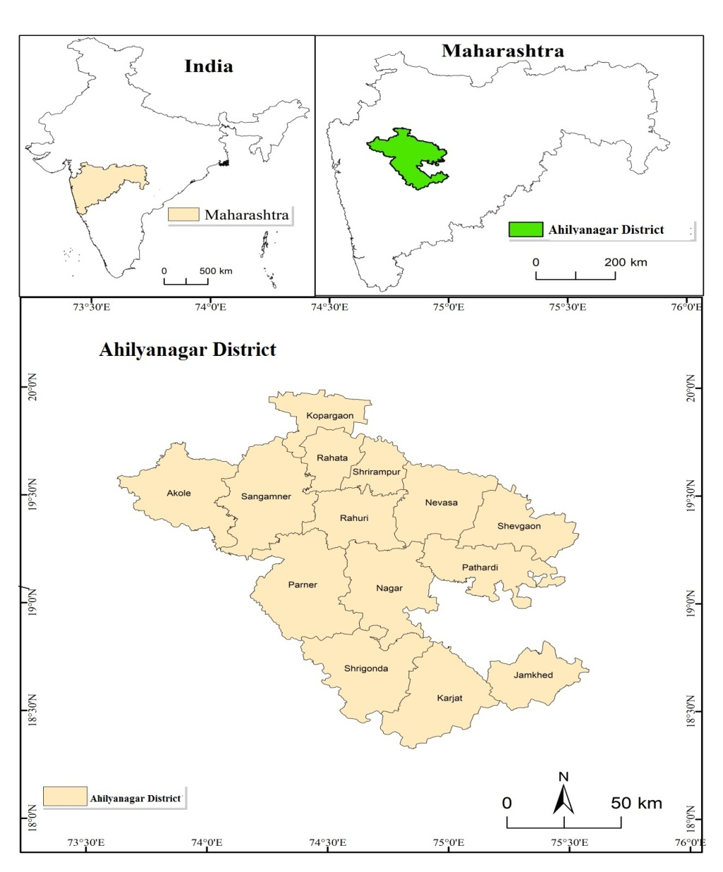

**Aims and objectives:**

The main objective of this research is to geographically study density of roads and the pattern of the road network in Ahilyanagar district. The following objectives have been considered to complete this aim:

1. GIS-based Identification of spatial analysis and Pattern of Road and Road density.
2. To study the level of development of Rural, District, State and overall Roads in Ahilyanagar district.

**Research Methodology:**

The following research methodology has been used to fulfill the above aim and object of this research. The study methods for this research paper are based on secondary data. Also, the length of the roads in the study area is from the Socio-economic Abstract of Ahilyanagar district (2023-24) period. Also, reference book, research Journal and various websites have been used in secondary data. Based on this statistical factor, the roads were converted into density and the Mean and Standard Division (S.D) were used to calculate the level of road density in Ahilyanagar district. Table No. 01 (Use of statistical technique Mean and Standard Division) and Table No. 02 (Level of Road Density) provide complete information on how statistical techniques are used. The entire research methodology and Stage is shown in Chart No. 1.

**Chart 01: Research Methodology**

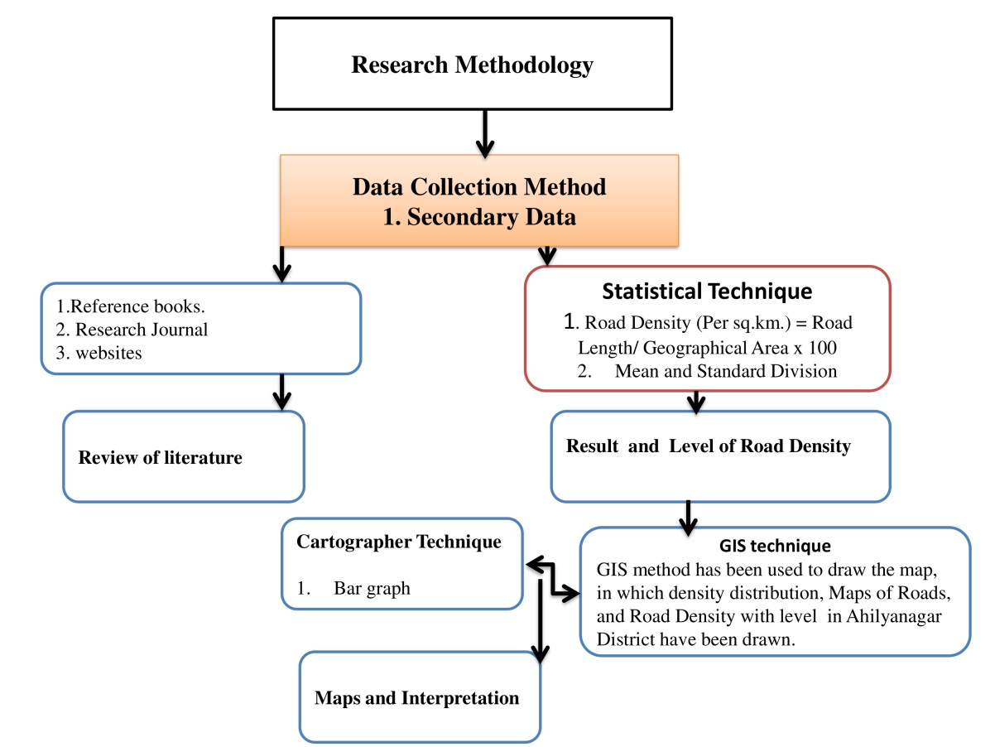

**Table no 01: Use of Statistical Technique Mean and Standard Division (S.D)**

|  |  |  |  |  |
| --- | --- | --- | --- | --- |
| Level | Total Road  Density | Rural Road  Density | District Road Density | **State highway** Road Density |
| Mean | 141.070714 | 72.48486 | 77.41727 | 13.97851 |
| S.D | 32.7636104 | 21.96479 | 24.92235 | 6.315785 |
| Mean - S.D | 108.307104 | 50.52006 | 52.49492 | 7.662721 |
| Mean-S.D-S.D | 75.5434936 | 28.55527 | 27.57257 | 1.346936 |
| Mean-S.D-S.D-S.D | 42.7798832 | 6.590472 | 2.650225 | -4.96885 |
| Mean + S.D | 173.834325 | 94.44965 | 102.3396 | 20.29429 |
| Mean+S.D+S.D | 206.597935 | 116.4144 | 127.262 | 26.61008 |
| Mean+S.D+S.D+S.D | 239.361545 | 138.3792 | 152.1843 | 32.92586 |

**Table no 02: Level of Road Density**

|  |  |  |  |  |
| --- | --- | --- | --- | --- |
| Index Value Formula (Difference) | Total Road Density | Rural Road Density | District Road Density | **State highway** Road Density |
| Mean+S.D –Mean-S.D | 65.5272207 | 43.92959 | 49.84469 | 12.63157 |
| Mean+S.D+S.D- Mean-S.D-S.D | 131.054441 | 87.85918 | 99.68939 | 25.26314 |
| Mean+S.D+S.D+S.D- Mean-S.D-S.D-S.D | 196.581662 | 131.7888 | 149.5341 | 37.89471 |

To calculate the road density in Ahilyanagar district, four types of density have been calculated using Table No. 02, namely Very Low, Low Moderate and High Density. The level value has been calculated using Table No. 02 to calculate the road density of the study area in 04 type’s namely rural road density, district road density, state highway road density and total road density Table no 03 and 04.

**Table No. 03: Level and Category of Road density**

|  |  |  |  |  |
| --- | --- | --- | --- | --- |
| Sr.no | **Rural Road Density** | | **District Road Density** | |
| Level of Value | **Category** | Level of Value | **Category** |
|  | Less Than 43 | Very low | Less Than 49 | Very low |
|  | 43.92 to 87 | Low | 49.84 to 99 | Low |
|  | 87.85 to 131 | Moderated | 99.68 to 149 | Moderated |
|  | More than 131.78 | High | More than 149.53 | High |

**Table No. 04**: Level and Category of Road density

|  |  |  |  |  |
| --- | --- | --- | --- | --- |
| Sr.no | **State highway Road Density** | | **Total Road Density** | |
| Level of Value | **Category** | Level of Value | **Category** |
|  | Less Than 12 | Very low | Less Than 65 | Very low |
|  | 12.63 to 25 | Low | 65.52 to 131 | Low |
|  | 25.26 to 37 | Moderated | 131.05 to 196 | Moderated |
|  | More than 37.89 | High | More than 196.58 | High |

The density level of roads has been determined using statistical data. With the help of this and GIS, the distribution of roads in terms of density has been shown. The following formula has been used to calculate the road density. The road density is mainly calculated as the number of roads per 100 square kilometers.

|  |
| --- |
| Road Density (Per sq.km.) = Road Length/ Geographical Area x 100 |

**Result and Discussion:**

Various factors such as geographical, economic, social, political and technological factors affect the transport system. Also, the topographic structure and location of the area are important for which geographical regions can develop which type of transport. In Ahilyanagar district, the topographic situation is not the same everywhere if we consider it according to the tehsil. This has an impact on the road transport density and pattern here.

1. **Total Length of roads in study area:**

Table No 05 and Graph 01 show the total geographical area and total length of roads in Ahilyanagar district. It mainly shows the length of rural roads, district roads, state and total roads. In total roads, rural roads, unpaved roads, paved roads, gravel roads, and paved roads have been considered. The largest geographical area in Ahilyanagar district is of Shrigonda tehsil followed by Nagar, Karjat, Sangamner, Nevasa tehsils. This geographical area has an impact on the density and length of road transport here. In terms of the length of rural roads in Ahilyanagar district, the longest rural road length is in Parner tehsil, followed by Shrigonda tehsil and Rahuri tehsil with a total length of more than a thousand kilometers. Also, the shortest rural road length is in Jamkhed tehsil with 416 kilometers, followed by Kopargaon tehsil with 529 kilometers. In short, it is clear that the rural areas in tehsils where the length of rural roads is short have very low road connectivity, and the rural transport connectivity in tehsils where the length of rural roads is long has high connectivity. However, the length of district roads varies from tehsil. The longest length of district roads is in Nevasa tehsil with 1390 kilometers. Also, in Nagar Parner, Karjat and Sangamner tehsils, the length of district roads is more than 1000 kilometers. In short, it is clear that in tehsils where the length of rural roads is less, the length of district roads (Tarmac roads) is more and in tehsils where the length of rural districts is more, the length of district roads is less. In short, in some districts in rural areas, the length of roads is less on the contrary the length of district roads is more than in rural areas. At the same time, in terms of state highways in Ahilyanagar district, the longest state highway length is in Shrigonda (493.4 kilometres), followed by Karjat tehsil, which is mainly 267 kilometres. After this, Nagar tehsil (233 kilometres), Shrigonda tehsil, this tehsil generally has the longest state highway length. The shortest state highway length is in Shrirampur tehsil, where the total length of state highway is 91 kilometres, followed by Rahuri tehsil, Nevasa, Shevgaon, Pathardi tehsils, where the length of state highway is within 100 kilometres. This makes it clear that the connectivity of state highways in this tehsil is very poor. Considering the total length of roads in Ahilyanagar district, this total length of roads mainly includes unpaved roads, paved roads, gravel roads, as well as rural, district, state and national highways. In terms of total length of districts, firstly, the total length of roads is highest in Shrigonda Tehsil, followed by Sangamner, Parner and these three Tehsils have the highest proportion of total length of roads exceeding two thousand kilometers. Then comes Nagar Tehsil, Akole Tehsil and the lowest proportion of total length of roads is mainly in Jamkhed Tehsil, where the total length is less than 1000 kilometres.

**Table no 05**: Total Length of roads in study area (Road Length in KM)

|  |  |  |  |  |  |  |  |
| --- | --- | --- | --- | --- | --- | --- | --- |
| **Sr. No.** | **Name of the Tehsil** | **Geographical in Sq km** | **Total Length of Rural Road** | **Total Length of District Road** | **Total Length of State Highway** | **Total Length of Road in Km** |  |
| 1 | Akola | 1504 | 839.86 | 993.06 | 200 | 1785.33 |  |
| 2 | Sangamner | 1357.8 | 964.65 | 1351.1 | 213.6 | 2111.51 |  |
| 3 | Kopargaon | 706.13 | 529.59 | 604.44 | 101.7 | 1061.32 |  |
| 4 | Rahata | 687.86 | 705.97 | 756.61 | 86.33 | 1262.43 |  |
| 5 | Shrirampur | 506.02 | 619.6 | 644.35 | 91.5 | 1155.45 |  |
| 6 | Nevasa | 1292.04 | 898.31 | 1390.23 | 73.18 | 1844.99 |  |
| 7 | Shevgaon | 1087.13 | 625.5 | 761.9 | 99.12 | 1228.32 |  |
| 8 | Pathardi | 1177.84 | 686.39 | 878.06 | 76.36 | 1386.99 |  |
| 9 | Nagar | 1502.72 | 956.66 | 1027.65 | 233.52 | 1896.76 |  |
| 10 | Rahuri | 1016.85 | 1101.3 | 661.4 | 92.2 | 1671.45 |  |
| 11 | Parner | 1867.92 | 1182.23 | 1106.9 | 147.93 | 2066.21 |  |
| 12 | Shrigonda | 1604.81 | 1137.1 | 835.6 | 493.4 | 2268.1 |  |
| 13 | Karjat | 1491.52 | 728.29 | 1069.53 | 267.6 | 1694.87 |  |
| 14 | Jamkhed | 875.24 | 416.11 | 536.3 | 167.67 | 952.86 |  |
|  | **Total** | **16677.88** | **11391.6** | **12617.13** | 2344.11 | **22386.59** |  |

**Sources:** Socio-economic Abstract of Ahilyanagar district (2023-24) & Calculated by Researcher

**Graph no 01: Total Length of roads in study area**

1. **Road Density per 100 Sq. Km:**

There is various state highways in the state of Maharashtra, a total of 21 highways pass through Ahilyanaga district. Along with this, the following National Highways pass through Ahilyanagar district, mainly National Highway 61, National Highway 160, National Highway 561 and National Highway 561 A and B. Tables 06 and 07 provide a detailed description of which state highways and which national highways pass through the Nagar district. Table No. 08 shows the density of rural roads, district roads, state highways and total road density in Ahilyanagar district. The density of these roads is shown in 100 Sq. Km. The highest rural road density in Ahilyanagar district is in Shrirampur, Rahuri and Rahata Tehsil. Here the rural road density is more than 100 per 100 square kilometers. Also, the lowest density of rural roads is in Jamkhed Karjat tehsil, where the density is less than 50 square kilometers. In Ahilyanagar district, the highest density of state highways is seen in Shrigonda (30.74507 Per Sq. Km) tehsil. This is followed by Jamkhed tehsil, Karjat tehsil, Nagar tehsil Shrirampur, tehsil. On the other hand, the lowest density of state highways is in Nevasa tehsil with 5.66 km², followed by Parner tehsil with 7.9 Per Sq. Km and Rahuri tehsil with 9.06 Per Sq. Km (Map no 02 and 03) .

Table no 06: Passes through State Highway in Ahilyanagar District

|  |  |  |
| --- | --- | --- |
| Sr.No | Number of State Highway | Passes Through |
|  | Maharashtra State  Highway 2 | This highway, also known as the Malegaon-Manmad Road, runs through Ahmednagar, Nashik, and Pune districts |
|  | MH SH 10 | Manmad-Daund Road: This highway, also known as the Malegaon-Manmad Road, runs through Ahmednagar, Nashik, and Pune districts |
|  | MH SH 21 | Akole – Dhamangaon Pat – Bota |
|  | [MH SH 27](https://en.wikipedia.org/wiki/Maharashtra_State_Highway_27) | [Pune](https://en.wikipedia.org/wiki/Pune) – [Shirur](https://en.wikipedia.org/wiki/Shirur,_Maharashtra" \o "Shirur, Maharashtra) – [Ahmednagar](https://en.wikipedia.org/wiki/Ahmednagar) |
|  | MH SH 44 | Shahapur – Kalsubai – Akole – Sangamner – Shrirampur – Nevasa – Gevrai |
|  | MH SH 45 | [Sinnar](https://en.wikipedia.org/wiki/Sinnar) – [Loni](https://en.wikipedia.org/w/index.php?title=Loni,_Maharashtra&action=edit&redlink=1" \o "Loni, Maharashtra (page does not exist)) – Kolhar |
|  | MH SH 46 | Malshejghat – [Sangamner](https://en.wikipedia.org/wiki/Sangamner" \o "Sangamner) |
|  | MH SH 49 | (Rahuri-Sakur-Shreerampur): This highway connects Rahuri, Sakur, and Shreerampur, passing through Ahmednagar and Solapur districts. |
|  | MH SH 50 | (Shrigonda-Shirur-Parner):This highway connects Shrigonda, Shirur, Parner, Takli Dhokeshwar, and Sakur, all within Ahmednagar district. |
|  | MH SH 51 | Shirur-Nighoj-Alkuti-Belhe): This highway connects Shirur, Nighoj, Alkuti, and Belhe, passing through Ahmednagar and Pune districts |
|  | MH SH 55 | [Shirur](https://en.wikipedia.org/wiki/Shirur,_Maharashtra) – [Shrigonda](https://en.wikipedia.org/wiki/Shrigonda" \o "Shrigonda) – [Jamkhed](https://en.wikipedia.org/wiki/Jamkhed" \o "Jamkhed) |
|  | MH SH 60 | [Ahmednagar](https://en.wikipedia.org/wiki/Ahmednagar) – Jeur – Ghodegaon – Handinimgaon – Newasa Fata |
|  | MH SH 67 | [Daund](https://en.wikipedia.org/wiki/Daund) – [Siddhatek](https://en.wikipedia.org/wiki/Siddhatek" \o "Siddhatek) – Rashin – [Karmala](https://en.wikipedia.org/wiki/Karmala" \o "Karmala) – Paranda – [Barshi](https://en.wikipedia.org/wiki/Barshi" \o "Barshi) – [Osmanabad](https://en.wikipedia.org/wiki/Osmanabad) – [Ausa](https://en.wikipedia.org/wiki/Ausa_(town)" \o "Ausa (town)) |
|  | MH SH 68 | [Shevgaon](https://en.wikipedia.org/wiki/Shevgaon) – [Pathardi](https://en.wikipedia.org/wiki/Pathardi" \o "Pathardi) – [Kada](https://en.wikipedia.org/wiki/Kada,_Maharashtra_state,_India" \o "Kada, Maharashtra state, India) – Mirajgaon – Karjat – Rashin |
|  | MH SH 141 | [Solapur](https://en.wikipedia.org/wiki/Solapur) – Khandeshwar – Mirajgaon – [Ahmednagar](https://en.wikipedia.org/wiki/Ahmednagar) |
|  | MH SH 142 | [Ahmednagar](https://en.wikipedia.org/wiki/Ahmednagar) – Kada – [Jamkhed](https://en.wikipedia.org/wiki/Jamkhed" \o "Jamkhed) |
|  | MH SH 148 | [Ahmednagar](https://en.wikipedia.org/wiki/Ahmednagar) – [Amrapur](https://en.wikipedia.org/wiki/Shevgaon_tehsil" \o "Shevgaon tehsil) – [Shevgaon](https://en.wikipedia.org/wiki/Shevgaon" \o "Shevgaon) – [Paithan](https://en.wikipedia.org/wiki/Paithan" \o "Paithan) |
|  | MH SH 157 | [Pathardi](https://en.wikipedia.org/wiki/Pathardi) – [Kada](https://en.wikipedia.org/wiki/Kada,_Maharashtra" \o "Kada, Maharashtra) – [Ashti](https://en.wikipedia.org/wiki/Ashti,_Beed" \o "Ashti, Beed) – [Jamkhed](https://en.wikipedia.org/wiki/Jamkhed" \o "Jamkhed) – [Bhum](https://en.wikipedia.org/wiki/Bhum" \o "Bhum) |
|  | MH SH 143 | [Pathardi](https://en.wikipedia.org/wiki/Pathardi) – [Solapur](https://en.wikipedia.org/wiki/Solapur_district), [Ahmednagar](https://en.wikipedia.org/wiki/Ahmednagar_district) |
|  | MH SH 144 | [Pathardi](https://en.wikipedia.org/wiki/Pathardi) [Ahmednagar](https://en.wikipedia.org/wiki/Ahmednagar_district) |
|  | [MH SH 368](https://en.wikipedia.org/w/index.php?title=MH_SH_368&action=edit&redlink=1) | Bhorwadi - Nagadawadi - Kandali - Bori - Belhe - Khandeshwar Nagar - Garkhindi - Pimpalgaon Rotha - Kanhoor |

**Sources:** [**https://en.wikipedia.org/wiki/List_of_state_highways_in_Maharashtra**](https://en.wikipedia.org/wiki/List_of_state_highways_in_Maharashtra)

**.** Table no 07: Passes through National Highway in Ahilyanagar District

|  |  |  |
| --- | --- | --- |
| Sr.No | Number of National Highway | Passes Through |
|  | **NH 61** | This highway passes through Kalyan, Ahmednagar, Parbhani, Nanded, Nirmal, and Jagtial. |
|  | **NH 160** | **Specifically the stretch from Savali Vihir to the start of the Ahmednagar bypass, is located in Ahmednagar district** |
|  | **NH 561** | **Starts from its junction with NH-61 near Ahmednagar and ends at Beed.** |
|  | **NH 561A** | **Terminal near Ahmednagar** |

**Sources:** [**https://en.wikipedia.org/wiki**](https://en.wikipedia.org/wiki)

**Table no 08: Road density in study area (Density per 100 Sq. Km)**

|  |  |  |  |  |  |
| --- | --- | --- | --- | --- | --- |
| **Name of the Tehsil** | **Rural Road Density** | **District Road Density** | **State highway Road Density** | **Total Road Density** |  |
| Akola | 55.84175532 | 66.02792553 | 13.29787 | 118.71 |  |
| Sangamner | 71.04507291 | 99.50655472 | 15.73133 | 155.51 |  |
| Kopargaon | 74.99893787 | 85.59896903 | 14.40245 | 150.30 |  |
| Rahata | 102.6328032 | 109.9947664 | 12.55052 | 183.53 |  |
| Shrirampur | 122.4457531 | 127.3368642 | 18.08229 | 228.34 |  |
| Nevasa | 69.52648525 | 107.5996099 | 5.663911 | 142.80 |  |
| Shevgaon | 57.53681712 | 70.08361466 | 9.117585 | 112.99 |  |
| Pathardi | 58.27531753 | 74.54832575 | 6.483054 | 117.76 |  |
| Nagar | 63.6618931 | 68.3859934 | 15.53982 | 126.22 |  |
| Rahuri | 108.3050597 | 65.04400846 | 9.067217 | 164.38 |  |
| Parner | 63.29125444 | 59.25842649 | 7.919504 | 110.62 |  |
| Shrigonda | 70.85573993 | 52.06846916 | 30.74507 | 141.33 |  |
| Karjat | 48.82871165 | 71.70738575 | 17.94143 | 113.63 |  |
| Jamkhed | 47.54238837 | 61.27462182 | 19.15703 | 108.87 |  |
| Total | 68.30340547 | 75.65188141 | 14.0552 | 134.23 |  |

**Sources:** Calculated by Researcher (2023-24)

According to Map No. 04 and Table No. 9, if we consider the density of rural roads, the level of development in Ahilyanagar district is divided into four types: Less Than 43 Very low density, 43.92 to 87 Low densities, 87.85 to 131 Moderate and More than 131.78 Level of Value is High Density. There are a total of 14 tehsils in Ahilya Nagar district, out of which the rural density includes Kopargaon, Sanganmer, Akole, Newasa, Shevgaon, Pathardi Nagar, Parner, Shrigonda, Karjat and Jamkhed tehsils, while the moderate rural road density includes Rahat Shrampur Rahuri tehsils. But the density of rural roads does not include the most developed tehsil in Ahilyanagar. This means that the development of rural roads in Ahilyanagar district has decreased in terms of geographical area according to each tehsil. In short, if we consider this density, the connectivity of rural areas is very low. Accordingly, it is seen that the connectivity of roads in rural areas needs to be increased. The tehsils in which the density of rural roads is low are affected by natural factors. This is mainly because Akole tehsil is completely a tribal region and a mountain/hilly region, which has an impact on the roads here. Also, Nevasa, Shevgaon, Pathardi, Parner, Shrigonda, Karjat, Jamkhed, which are included in the drought-affected districts of Ahilyanagar district, have an impact on the economic development here. Due to this, the connectivity of rural roads in this area is low and due to the sparse population here, rural roads have not been developed in this area. The density of district roads is shown in Table No. 10 and Map No. 05. If we consider district roads, the density of district roads is low in Akole Kopargaon, Nevasa, Shevgaon Pathardi, Nagar, Rahuri, Parner, Shrigonda, Karjat, Jamkhed. Also, if we consider the development of medium district roads, Sangamner, Rahata, Shrampur, Nevasa have moderate development or are at a moderate level. Which tehsil is not included in the high development district roads means that the connectivity of district roads is low and their connectivity needs. When it comes to the density of state highways, the lowest density is in Nevasa, Shevgaon, Pathardi, Rahuri and Parner tehsils, followed by low density Akole, Sangamner, Kopargaon, Rahat, Shrirampur Nagar, Karjat, Jamkhed tehsils and moderate state highway road density is in Shrigonda tehsil. A total of 21 state highways pass through Ahilyanagar district and the highest state highway connectivity is in Shrigonda tehsil.

Table no 09: **Level of Rural Road Density**

|  |  |  |  |
| --- | --- | --- | --- |
| **Sr.no** | **Level of Value** | **Category** | **Name of the Tehsil** |
|  | Less Than 43 | Very low | Nil |
|  | 43.92 to 87 | Low | Kopargaon,Sangamner, Akola,  Nevasa,Shevgaon,Pathard,Nagar,  Parner,Shrigonda,Karjat,Jamkhed. |
|  | 87.85 to 131 | Moderated | Rahata, Shrirampur,Rahuri. |
|  | More than 131.78 | High | Nil |

**Sources:** Calculated by Researcher (2023-24)

Table no 10: **Level of District Road Density**

|  |  |  |  |
| --- | --- | --- | --- |
| **Sr.no** | **Level of Value** | **Category** | **Name of the Tehsil** |
|  | Less than 49 | Very low | Nil |
|  | 49.84 to 99 | Low | Akola,Kopargaon,Nevasa,Shevgaon,  Pathardi,Nagar,Rahuri,Parner,Shrigonda,  Karjat,Jamkhed, |
|  | 99.68 to 149 | Moderated | Sangamner,Rahata,Shrirampur, Nevasa |
|  | More than 149.53 | High | Nil |

**Sources:** Calculated by Researcher (2023-24)

Table no 11: **Level of State highway Road Density**

|  |  |  |  |
| --- | --- | --- | --- |
| **Sr.no** | **Level of Value** | **Category** | **Name of the Tehsil** |
|  | Less Than 12 | Very low | Nevasa,Shevgaon,Pathardi,Rahuri,Parner. |
|  | 12.63 to 25 | Low | Akola,Sangamner,Kopargaon,Rahata,Shrirampur,  Nagar,Karjat,Jamkhed. |
|  | 25.26 to 37 | Moderated | Shrigonda |
|  | More than 37.89 | High | Nil |

**Sources:** Calculated by Researcher (2023-24)

Table no 12: **Level of Total Road Density**

|  |  |  |  |
| --- | --- | --- | --- |
| **Sr.no** | **Level of Value** | **Category** | **Name of the Tehsil** |
|  | Less Than 65 | Very low | Nil |
|  | 65.52 to 131 | Low | Akola, Shevgaon,Pathardi,Nagar,  Parner, Karjat, Jamkhed. |
|  | 131.05 to 196 | Moderated | Sangamner, Kopargaon, Rahata, Nevasa, Rahuri,Shrigonda. |
|  | More than 196.58 | High | Shrirampur |

**Sources:** Calculated by Researcher (2023-24)

**Graph no 02: Road density in study area**

The total length of roads in Ahilyanagar district is not uniform everywhere, nor is the total density of roads uniform. The total road density includes rural roads, district roads, national highways, other gravel roads in the district, and unpaved roads. In Ahilyanagar district, the low density of total roads includes Akole, Shevgaon, Pathardi, Nagar, Parner, Karjat, Jamkhed tehsils. The moderate includes Sanganmer, Kopargaon, Rahata, Nevasa, Rahuri and Shrigonda tehsils and the high road density level includes Shrirampur tehsil. It is clear from this that road connectivity is very poor in Ahilyanagar district. Considering the total geographical area and population, the road density is very low here. In short, to increase the road density in the study area, it is necessary to convert unpaved or gravel roads into tar roads, which will increase the road density and boost economic development. According to the above study, it is observed that the impact of natural factors on the construction of roads and road density in Ahilyanagar district is seen. The road density is very low only in the areas like the mountain/ hill area and drought-affected tehsils.

Map no 02: Pattern of Transport network (National, State Roads)

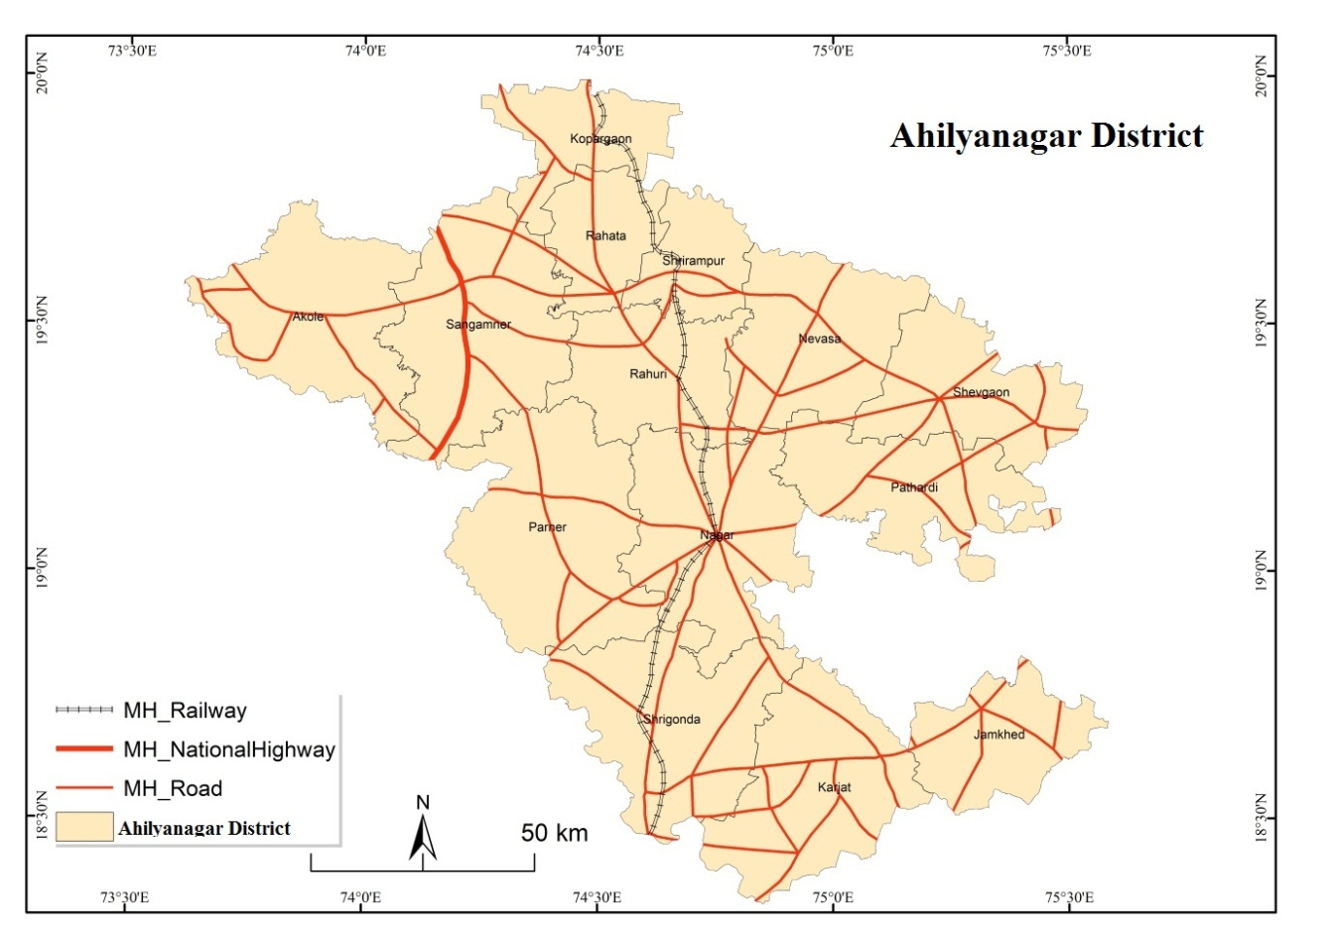

Map no 03: Spatial Pattern of Transport network in the Study area

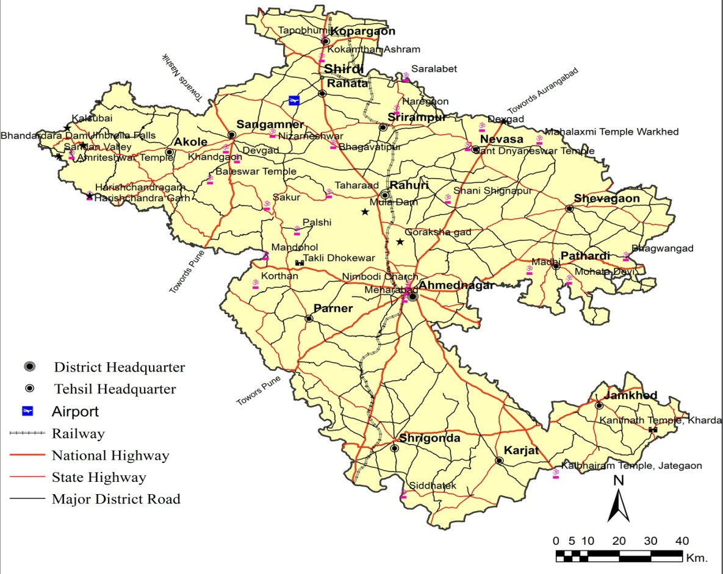

Map No 04: Level of Rural Road Density

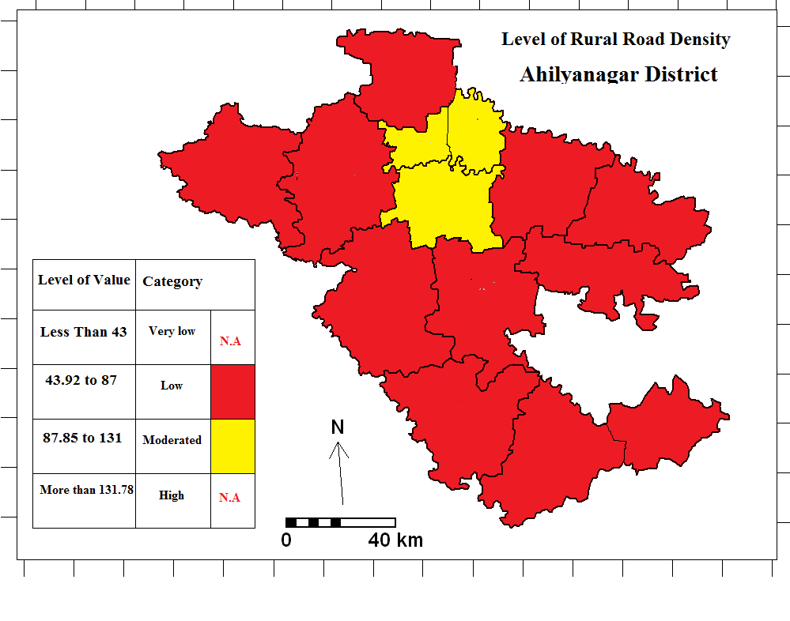

Map no 05: Level of District Road Density

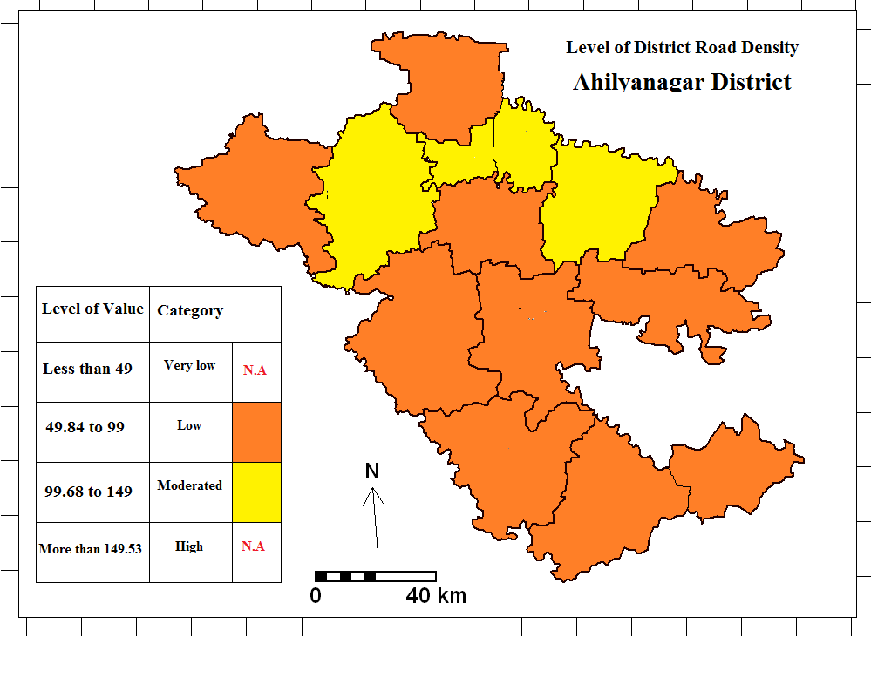

**Map No 06: Level of State Highway Road Density**

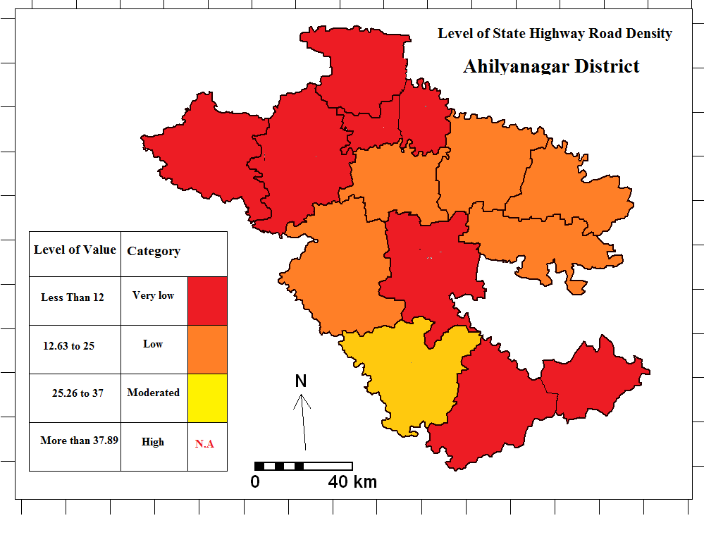

**Map no 07: Total Road Density** 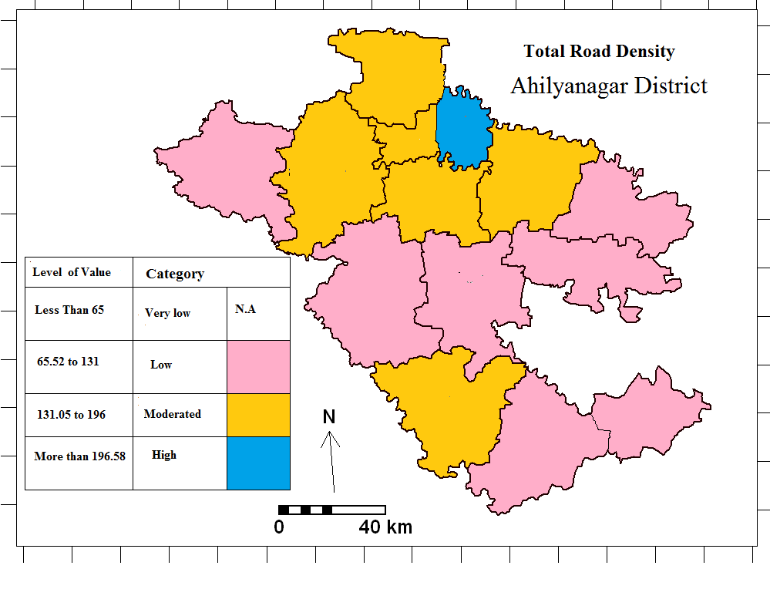

**CONCLUSION:**

Transportation is defined as the means of moving people and goods from one place to another. Among the natural factors, topographic and climatic factors are important in the development of transportation. Along with this, socio-economic, cultural, political and technological factors also affect it. The transportation system of a geographical region is considered important for the economic development of that region. The backbone of the economic development of any country is its transportation system. Road density levels have been calculated using mean and standard division to determine the density of road in Ahilyanagar district. The largest geographical area in Ahilyanagar district is of Shrigonda tehsil followed by Nagar, Karjat, Sangamner, Nevasa tehsils. The longest rural road length is in Parner tehsil, followed by Shrigonda tehsil and Rahuri tehsil with a total length of more than a thousand kilometers. Also, the shortest rural road length is in Jamkhed tehsil with 416 kilometers, followed by Kopargaon tehsil with 529 kilometers. The longest length of district roads is in Nevasa tehsil with 1390 kilometers. Also, in Nagar Parner, Karjat and Sangamner tehsils, the length of district roads is more than 1000 kilometers. At the same time, in terms of state highways in Ahilyanagar district, the longest state highway length is in Shrigonda (493.4 kilometres), followed by Karjat tehsil, which is mainly 267 kilometres. After this, Nagar tehsil (233 kilometres), Shrigonda tehsil, this tehsil generally has the longest state highway length. The shortest state highway length is in Shrirampur tehsil, where the total length of state highway is 91 kilometres, followed by Rahuri tehsil, Nevasa, Shevgaon, Pathardi tehsils. The total length of roads is highest in Shrigonda Tehsil, followed by Sangamner, Parner and these three Tehsils have the highest proportion of total length of roads exceeding two thousand kilometers. Then comes Nagar Tehsil, Akole Tehsil and the lowest proportion of total length of roads is mainly in Jamkhed Tehsil, where the total length is less than 1000 kilometres. National Highways pass through Ahilyanagar district, mainly National Highway 61, National Highway 160, National Highway 561 and National Highway 561 A and B. Tables 06 and 07 provide a detailed description of which state highways and which national highways pass through the Nagar district. The highest rural road density in Ahilyanagar district is in Shrirampur, Rahuri and Rahata Tehsil. The lowest density of rural roads is in Jamkhed Karjat tehsil. state highways, the lowest density is in Nevasa, Shevgaon, Pathardi, Rahuri and Parner tehsils, followed by low density Akole, Sangamner, Kopargaon, Rahat, Shrirampur Nagar, Karjat, Jamkhed tehsils and moderate state highway road density is in Shrigonda tehsil.

**DISCLAIMER (ARTIFICIAL INTELLIGENCE)**

Author hereby declare that NO generative AI technologies such as Large Language Models (ChatGPT, COPILOT, etc) and text-to-image generators have been used during writing or editing of this manuscript.

**Reference:**

1. Chakor, B. R., et al. (2024). Prognostication of urbanisation growth and level in Pune district of Maharashtra state using GIS technique. *Journal of Computational Analysis and Applications*, *33*(8), 473–482.
2. Devidas Dhondiram Dabhade andDeepak Janardhan Gadekar (2022) Transport Network Analysis Of Ahmednagar District, Maharashtra State, India, International Journal of Food and Nutritional Sciences , 11(08) 2088- 2095.
3. Eknath, S. M. (2020). Level of human resources development: A conceptual and review exposition. *International Journal for Research in Applied Science & Engineering Technology*, *8*(03), 687–691. <https://doi.org/10.22214/ijraset.2020.3130>
4. Eknath, S. M. (2020). Temporal analysis of human resources development (HRD) in Pathardi Tehsil of Ahmednagar District, Maharashtra State, India. *International Journal of Scientific Research in Multidisciplinary Studies*, *6*(8), 36–45.
5. Eknath, S. M., et al. (2020). A geographical study of human resources development in Ahmednagar District, Maharashtra, India. *EPRA International Journal of Multidisciplinary Research*, *6*(3), 86–93. <https://doi.org/10.36713/epra4116>
6. Gadekar D J (2009) Analysis of Roads Network Connectivity in Ahmednagar District, Research Analysis and evaluation International 18 (2) Pp 26-27.
7. Gadekar, D. J. (2024). A study of tourist satisfaction index (TSI) of heritage tourist place of Ajanta Cave in Chatrapati Sambhaji Nagar district of Maharashtra state in India. *Heritage: Journal of Multidisciplinary Studies in Archaeology*, *11*(2), 1195–1199.
8. Gadekar, D. J., & Eknath, S. M. (2025). *Impact of tourism: A success story of Shirdi tourism centre*. Crown Publishing. ISBN 978-93-6426-547-8.
9. [H. M. Saxena](https://www.google.co.in/search?sca_esv=5e2063ff01afdbfd&hl=en&q=inauthor:%22H.+M.+Saxena%22&udm=36) · (2005) Transport Geography, Rawat Publications, ISBN:9788170339458
10. Jadhav M. S. (2022) Graph Theory Based Assessment of State Road Transportation Network among the Tehsil Towns of Ahmednagar District, Maharashtra, Journal of Emerging Technologies and Innovative Research ,9(1) Pp 222-229.
11. Mhaske, P. H. (2009). Analysis of roads network connectivity in Ahmednagar District. *Research Analysis and Evaluation International*, *2*(18), 26–27.
12. Mhaske, P. H., et al. (2001). Land use & economic activity in Shirdi, Rahata Taluka, District Ahmednagar M.H. *International Refereed Research Journal*, *2*(18), 75–76.
13. Neelam Pal (2015) Transport Network in Varanasi city, Uttar Pradesh, the Deccan Geographer, 53 (2) Pp41-51
14. Sampat, M. R., et al. (2024). Estimate the rate of change in forest cover and its impact on soil by using GIS and remote sensing: A case study of Gadchiroli District, Maharashtra. *The Bioscan*, *19*(3), 8–18.
15. Sampat, M. R., et al. (2024). Land use and land cover mapping using digital classification technique in Dindori Tehsil of Nashik District, Maharashtra State, India using remote sensing. *Journal of Computational Analysis and Applications*, *33*(6), 604–617
16. Tupe, B. K., & Gadekar, D. J. (2010). Agricultural land use and crop pattern in Rahata Tahsil of Ahmadnagar District in Maharashtra State. *Maharashtra Bhugolshastra Sanshodhan Patrika*, *27*(01), 30–37.

1. <https://transportgeography.org/contents/chapter3/transportation-and-economic-development/>

2. <https://transportgeography.org>

3. <https://www.marketing91.com>

4. <https://pangeography.com/introduction-to-transport-geography/>