GROWTH AND SURVIVAL OF Sargassum sp. WITH DIFFERENT UREA FERTILIZATION DOSES

.
ABSTRACT
Seaweed is one of the most abundant biological resources in Indonesian waters. One type of seaweed that is abundant in the waters is the brown algae (Phaeophyta). Sargassum sp. It is a seaweed that is included in the macro category of brown algae that has not been cultivated and has not been optimally utilized in Indonesia. Sargassum sp contains bioactive compounds such as alginate, fucoidan, fucosanthin, and florotanin. This study was conducted to analyze survival and growth in Sargassum sp. with different doses of urea fertilizer (TAN). This research method uses an experimental method with a Complete Random Design (RAL) consisting of 5 treatments and 3 replicates, so that there are 15 total experiments, namely (P0): Without the administration of urea fertilizer; (P1): Urea fertilizer dose 0.010 ppm; (P2): Urea fertilizer dose 0.025 ppm; (P3): Urea fertilizer dose 0.050 ppm; (P4): Urea fertilizer dose 0.075 ppm. Sargassum maintenance was carried out for 15 days at the aquaculture environment laboratory, University of Mataram. The parameters observed included survival rate, absolute weight growth, specific weight growth rate, thalus length, number of leaf blades and water quality. The results showed that the highest survival rate was found in P4 (57%), the lowest weight reduction in P4 (-25 g), the lowest specific weight reduction in P4 (-3.75%), the lowest thalus reduction in P4 (5 cm) and the lowest reduction in the number of leaves in P4 (49 leaves). Based on the results of the insignificant one-way anova test of Sargassum sp. seaweed growth, the results of the order 2 polynomial regression test with a determination value of R2 (70-80%) revealed a strong relationship between fertilizer dose and seaweed growth, but did not provide an increase in weight, thalus length and leaf strands. This is suspected to be the beauty of N absorption into seaweed. The absorbed nutrients are utilized as a source of energy to survive in the environment so it is recommended to use higher doses for subsequent experiments and use dead corals as a substrate.
Keywords: Sargassum sp., growth, survival, dosage of urea fertilizer.
- INTRODUCTION
Seaweed is one of the most abundant biological resources in Indonesian waters. One type of seaweed that is abundant in waters is the brown algae (Phaeophyta) which consists of 400 species which is known to be the most abundant type of other types of seaweed. one of them is Sargassum sp. Sargassum sp is still used as an indicator that has a biofilter ability that can absorb compounds in waters, including heavy metals that are toxic (Azizah et al., 2018).
One of the pigments that helps the photosynthesis process is carotenoid pigments. The amount of carotenoid pigment content in seaweed will affect as it grows, namely the availability of nutrients such as nitrogen, phosphorus and environmental conditions such as optimal water quality (Febriani et al., 2022). Sargassum sp contains bioactive compounds such as alginate, fucoidan, fucosanthin, and florotanin (Nuraini et al., 2021). Bioactive compounds that can be used as extracts or as key components in the food and pharmaceutical industries. Fukoidan has been studied to function as an anti-tumor, anti-proliferation, and anti-inflammatory in laboratory experiments (Muslimin & Sari, 2017).
Nitrogen elements can be added through fertilization. The fertilizer used is urea fertilizer. Urea fertilizer contains 45-46% nitrogen, so it is good for plant growth. Urea fertilizer is a single type of fertilizer whose nitrogen element functions to accelerate the growth of thalus (Rendiansyah et al., 2024). Seaweed is not able to absorb nitrogen directly, plants absorb nitrogen elements in the form of nitrate or ammonium ions which are both water-soluble ions (Miarti & Legasari, 2022). Based on the description above, it is necessary to conduct research to analyze the extent of growth and survival of Sargassum sp. by administering different doses of urea fertilization.

- Research methods
  - Research Materials
This study uses material consisting of primary and secondary data. Perimeter data is the main data in the study and is obtained directly when conducting sampling activities during the study. The primary data used were water samples and seaweed Sargassum sp. while the secondary data is complementary data in the research and the data used in this study is water quality (light, temperature, salinity, pH, Nitrate, orthophosphate and TAN).

2.2 Metode penelitian
This research will be carried out for 15 days in January – February 2025 at the Aquatic Environment Laboratory, Aquatic Aquaculture Study Program, Department of Fisheries and Marine Sciences, Faculty of Agriculture, University of Mataram. Nitrate, Orthophosphate and TAN testing was carried out at the Analytical Chemistry Laboratory, Faculty of Mathematics and Natural Sciences, University of Mataram. The tools used are containers, aeration, refactometers, pH meters, lux meters, rulers, analytical scales, scissors, aquades, urea fertilizers.
The method of this study is experimental using a Complete Random Design (RAL) consisting of 5 treatments and 3 replicas, so that there are 15 total experiments, namely (P0): Without the administration of urea fertilizer; (P1): Urea fertilizer dose 0.010 ppm; (P2): Urea fertilizer dose 0.025 ppm; (P3): Urea fertilizer dose 0.050 ppm; (P4): Urea fertilizer dose 0.075 ppm. The research procedures carried out are as follows:
Seaweed culture procedure Sargassum sp. starting with the preparation of culture containers using multi-level shelves equipped with LED lights with an intensity of 1,300.6-4,160.5 Lux (Fitriani et al., (2023) equipped with the installation of oxygen channel pipes for aeration devices. Seaweed seedlings Ulva sp. Adapted for 7 days in a floating net cage, Ekis Bay, after 7 days of adaptation, transferred to the laboratory, weighed 50 g/sample and tied to the substrate. Culture maintenance lasted for 15 days with daily monitoring of water quality including temperature, salinity, pH, and light, as well as the addition of urea fertilizer based on fertilizer dose. Growth observations include the weight, length and number of leaf strands of Sargassum sp.
3. RESULTS AND DISCUSSION
3.1 Seaweed Survival Sargassum sp.
Based on the results of the study conducted for 15 days, the administration of different doses of urea fertilizer in each treatment had a different effect (P>0.05) on the survival of Sargassum sp. in P4 with a fertilizer dose of 0.075 ppm, the highest survival rate of 57% was obtained, and P2 with a fertilizer dose of 0.025 ppm obtained the lowest survival value of 41.6%. Results of 2nd order polynomial regression in Figure 1. It can be seen that the result of the determination value is 70% of the relationship between TAN concentration and survival of Sargassum sp. At the time of maintenance is very strong and 30% of the survival rate is affected by other factors such as the environment and so on. The presence of TAN in cultivation containers is very important because it is a nutrient for the growth and survival of Sargassum.
Sargassum does not provide growth such as weight gain, increase in thalus, leaves and length, it is suspected that Sargassum absorbs nutrients in cultivation containers to be used as a source of energy to survive in the environment. This is in line with the results of the research Rendiansyah et al., (2024) which states that urea fertilizer applied to the type of seaweed (Caulerpa lentillifera) is not used for growth but as a source of energy to adapt to its environment.
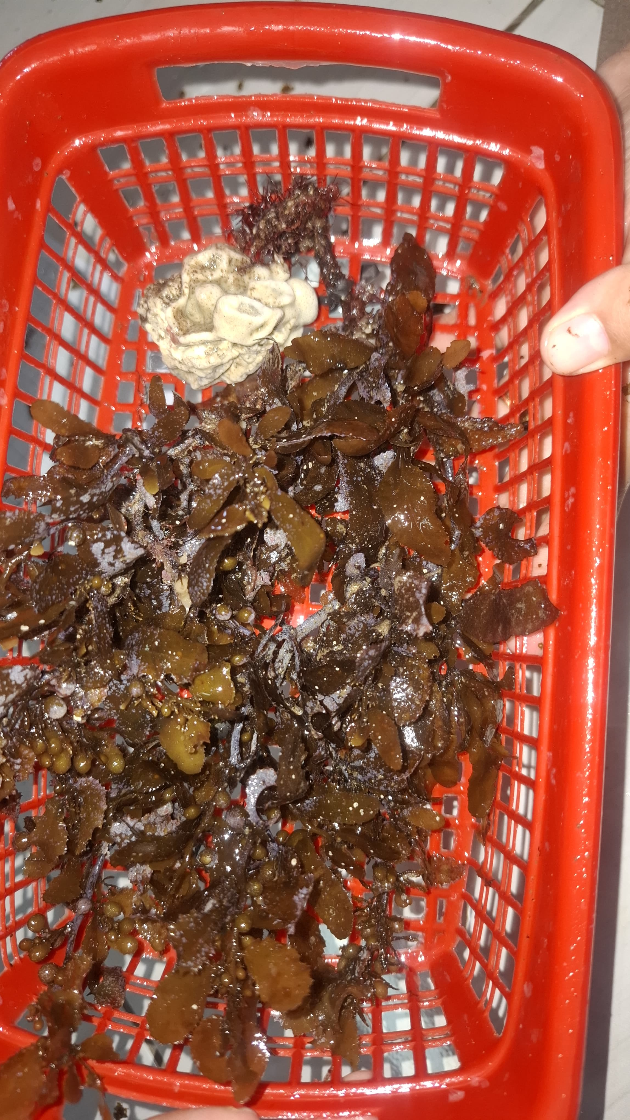
Figure.1 Sargassum sp. root Sticking to Dead Corals
Sargassum maintenance in this study uses baskets as a substrate by tying thalus to keep it upright in the maintenance container and to overcome the shaky nature of dead corals are given as a weight. This is done so that the Sargassum that is kept is able to survive and grow in its maintenance container. Figure 2. presented above it is known that the root of Sargassum sp. It does not attach to the basket but rather attaches to the dead coral. This is in line with the opinion Fitriani et al., (2023) which states that Sargassum sp. It should be cultivated on hard substrates such as dead corals, gravel and mollusk shells.

Figure. 2 Survival Of Sargassum sp. At Different Urea Fertilizer Dosages.
  - Absolute Weight and Growth Rate of Specific Weight of Sargassum sp.
Based on the results of the research that has been carried out, the administration of different doses of urea fertilizer in each treatment has a non-significant difference (P>0.05) on the absolute weight growth of Sargassum sp. in P4 there was the lowest weight reduction with an average value of -25 g with a fertilizer dose of 0.075 ppm and P2 there was the most weight reduction with an average value of -35 g with a fertilizer dose of 0.025 ppm. Results of 2nd order polynomial regression in Figure 3. The results of the determination value of 79% were found that the relationship between TAN and absolute weight growth had a very strong relationship. The relationship between TAN and seaweed growth is said to be very strong because it is a nutrient for seaweed. The presence of TAN in the cultivation container and the addition of N at the time of maintenance given from fertilizer are not optimally absorbed so that it does not provide growth, this is known at the time of TAN testing.
The first TAN test was carried out on day 0 there was a amount of TAN in the maintenance water so that urea fertilizer had not been given until the amount of TAN in the maintenance container was absorbed by seaweed, followed by the TAN test on the third day it was known that the amount of TAN was still not absorbed by Sargassum to the maximum. The test was carried out again on the fifth day, it was found that the amount of TAN in the aquaculture water container had been absorbed so, on the fifth day, N began to be added by applying urea fertilizer to the maintenance container in accordance with the amount of treatment dose.
Testing of the amount of TAN is carried out every 5 days, on the 10th day it is continued to test the amount of TAN in the maintenance water container, it is known that the amount of TAN in the water container increases from the number of treatment doses given so that no increase in urea fertilizer is given, it is suspected that Sargassum does not absorb the existing TAN but Sargassum has started to release N until the end of maintenance, The release of N in the aquaculture water container indicates that Sargassum has entered the death phase. This is in line with the results of the research Rendiansyah et al., (2024) tested on seaweed (Caulerpa lentillifera) stated that the decrease in the growth of seaweed (Caulerpa lentillifera) in each treatment was due to seaweed stocked after 3-10 days of seaweed already showing signs of death such as turning white, over time the thallus, stolons, ramuli, and rhizoids turned mushy and easily destroyed, this is suspected to be high nitrogen concentrations and lack of phosphate elements at the beginning research so as to affect the growth of seaweed.

Figure 3. The Absolute Weight of Seaweed Sargassum sp. at different Urea Fertilizer Dosages.

Based on the results of the research that has been carried out, the administration of different doses of urea fertilizer in each treatment has a non>differential effect (P0.05) on the daily growth of Sargassum sp. in P4 there was the lowest rate of weight reduction/day with an average value of 3.75% with a fertilizer dose of 0.075 ppm and P2 there was the most weight reduction rate/day with an average value of -6.05% with a fertilizer dose of 0.025 ppm. Results of 2nd order polynomial regression in Figure 5. The results of the determination value of 81% were found that the relationship between TAN and SGR or specific weight growth had a very strong relationship. The relationship between TAN and seaweed growth is said to be very strong because it is a nutrient for seaweed.
Specific growth results are known that there is no growth per day at the time of this maintenance, it is known that the N given is not optimally absorbed by the seaweed for growth, but as energy to survive in the environment so that it does not provide a specific growth value for Sargassum sp. This is in line with the opinion Hutabarat et al., (2024) which states that the low specific growth rate is due to the low absorption of nutrients and light penetration by the process of photosynthesis. Seaweed does not experience significant growth but gradually dies as fertilizer is used as an energy source to adapt to the new environment. Cokrowati, et al., (2024) which states that this low daily growth is suspected that seaweed does not absorb the nutrients that exist for its daily growth.
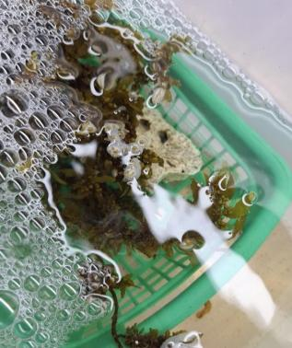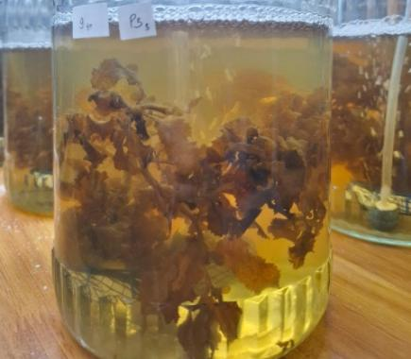
Figure 4. The difference between fresh Sargassum and wilted Sargassum
The difference between fresh Sargassum and withered Sargassum in the maintenance container can be seen in figure 4. It is known that the color of the water is still clear in the fresh Sargassum maintenance container while the Sargassum has withered, the water in the container will be dirty or called depigmentation. The results of the study found that there was an SGR value in P2 treatment with a fertilizer dose of 0.025 ppm, it was known that the highest thalus reduction with a value of -6.05 grams and the lowest thalus reduction was found in the P4 treatment at a dose of 0.075 ppm with a value of -3.75 grams. This is different from the results of the research obtained Muktiniati et al., (2022) which states that it is known that with a nitrogen absorption value of 46.9 x 10-7 mg/m2/day, the best absolute weight growth with a value of 195.58 grams and the highest specific growth rate (200 cm) with a specific growth value reaches 4.35%/day while the results of the research obtained Maryunus & Hussein, (2018) daily specific growth (SGR) ranges from 6.58 – 6.76%. Hulpa et al., (2021) stating that a good specific weight rate is also caused by the influence of nutrients contained in waters, the presence of nutrients from the abundant levels of nitrate and phosphate can affect algae reproduction.

Figure 5. Specific weight growth of Sargassum sp. with different urea fertilization doses
The results of the research that have been carried out on the administration of different doses of urea fertilizer in each treatment are obtained from the value of the difference in the reduction in thalus length during the maintenance of Sargassum sp can be seen in figure 7. in P4 with a fertilizer dose of 0.075 ppm, the lowest reduction difference value of 3 cm was obtained and P1 obtained the highest difference value or not much different from (P0, P2, and P3) less than 1 cm 5-6 cm. The growth of Sargassum seaweed is known by increasing weight, thalus length and number of leaves obtained during maintenance, thalus serves as the main factor to absorb N so that when thalus is disturbed, Sargassum cannot absorb N optimally. This is in line with the opinion Sari et al., (2021) which states that seaweed absorbs or obtains food through the cells contained in its thallus by diffusion through the surface of the body. Nutrients greatly affect the abundance of seaweed, good nutrition will provide good growth in cultivated seaweed.
Based on the results of the research, it was found that there was no growth but a reduction in weight and number of leaves. Reduction of thalus and number of leaves of Sargassum sp. the highest is found in P2 while the reduction in thalus and the lowest number of leaves is found in P4. This reduction occurs because the Sargassum thalus breaks and the leaves attached to the thalus will fall along with it and some leaves fall off on their own every day. It is suspected that Sargassum sp. experiencing stress on the new environment.
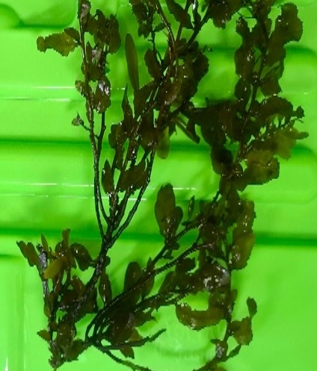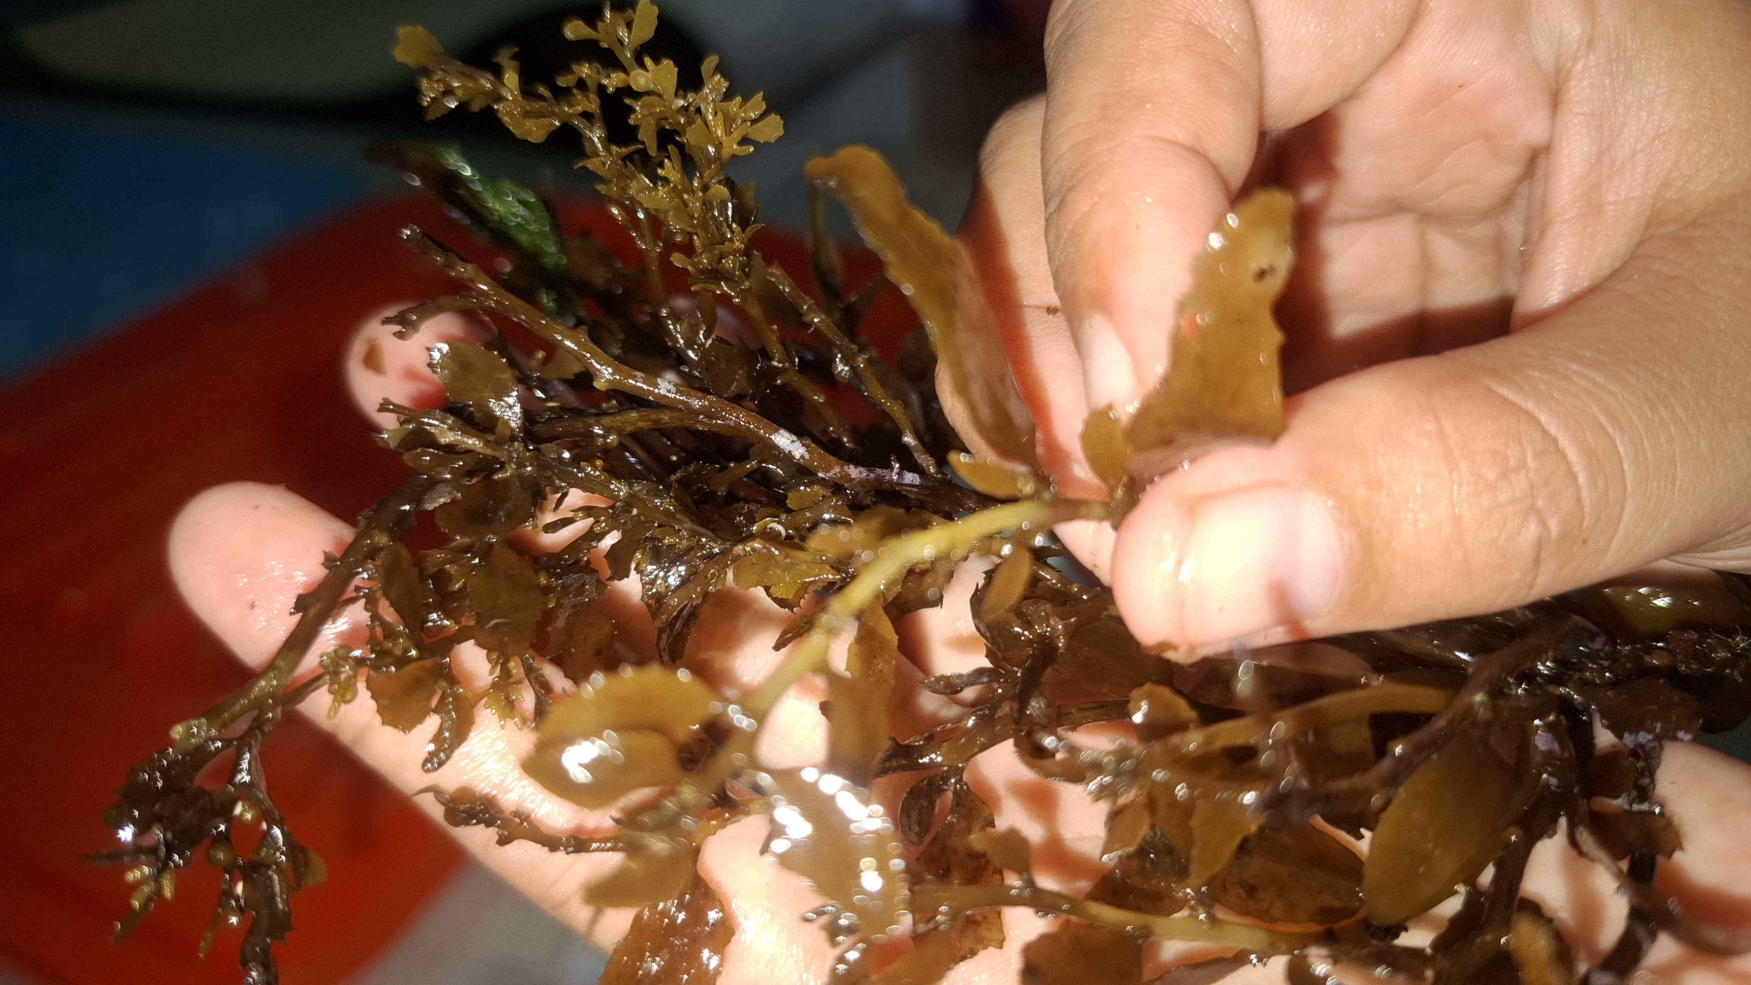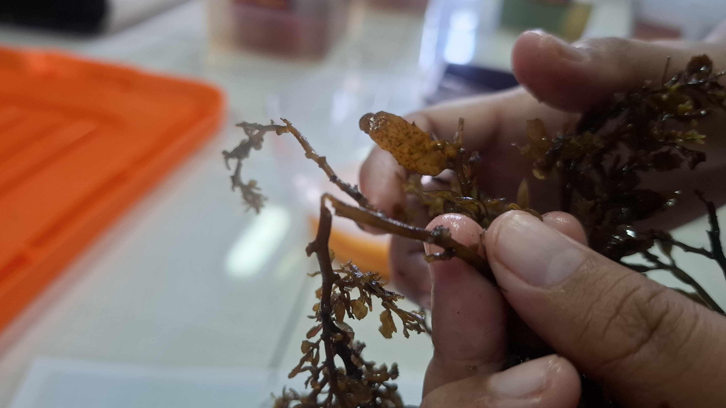
Thalus, who is still healthy Thalus who are suspected of being affected/infected with ice-ice disease
Figure 6. The difference between healthy thalus and thalus suspected of being infected with ice-ice disease
The results of the research that have been carried out by applying different doses of urea fertilizer in each treatment were obtained in each treatment the value of the difference in the number of leaves (leaves) that fell during the maintenance of Sargassum sp. in P4 with a fertilizer dose of 0.075 ppm, the number of leaves that fell the least was 49 leaves and the number of leaves that fell the most was found in P2 as many as 112 leaves with a fertilizer dose of 0.025 ppm. The number of leaf strands will decrease with the presence of weakened thalus so that the leaf strands on the attached thalus will also weaken and will fall off in the maintenance container. Thalus and leaves have a strong relationship because with the increase in the growth of seaweed, the number of leaves that will grow along with the increase in the length of thalus. Figure 6. It can be seen that the fallen leaves will be destroyed so that depigmentation occurs in the cultivation water marked by a water color such as brownish yellow. This is in line with the opinion Supiandi et al., (2023) which states that leaf growth occurs due to the presence of active cells that undergo randomly distributed division and cause an increase in leaf size that will be followed by growth. The factors that affect the leaves are environmental factors, namely nutrients, temperature, pH and nitrogen. These factors can stimulate leaf growth, the availability of sufficient nitrogen will increase the leaf area, since nitrogen can stimulate the growth of shoots and leaves especially in the vegetative growth phase.

Figure 7. Total length of the initial thalus and the late
4. Water Quality
The water quality parameters observed during the research activities, namely pH, temperature, salinity and light intensity, were measured every day for 15 days of the cultivation period while orthophosphate, nitrates and TAN tests were carried out on days 0, 3, 5, 10 and 15. The results obtained during the study of all parameters are optimal. Data on water quality results can be seen in Table 1.
Table 1 Water Quality During Research
No | Parameters | Unit | Result | Optimal | Literature
1 | pH | - | 7,8 | 7-8,5 | (Cokrowati et al., 2021)
2 | Suhu | ^{O}C | 27-27,1 | 24-35 | (Ruslaini, 2016)
3 | Salinitas | Ppt | 36,5-36,6 | 30-31 | (Supiandi et al., 2023)
4 | Cahaya | Lux | 1,460 | 1.300,6- 4.160,5 | (Fitriani et al., 2023)
5 | Nitrat | mg/L | 0,59-07 | 0,200-0,420 | (Safitri et al., 2021)
6 | Ortofosfat | mg/L | 1,01-1,77 | 1,0-3,5 | (Marlin et al., 2022)
7 | TAN | mg/L | 0,10-0,23 | <0.3 | (Neisila et al., 2020)

Water quality is one of the main factors that must be considered in cultivation activities in a controlled scope. The value of water quality must be in accordance with the standards of cultivated seaweed cultivation as one of the supporting factors for its growth. The intensity of light obtained during this study was 1460 lux. This is in line with Fitriani et al., (2023) which states that the optimum light intensity ranges from 1300.6-4160.5 lux. An unoptimal temperature will cause the metabolism of seaweed to be disrupted, causing the seaweed to become stressed. The average temperature value obtained during seaweed cultivation ranges from 27-27.1ºC. The temperature value obtained is optimal for seaweed cultivation. This is in line with Ruslaini, (2016) which states that the optimal temperature for seaweed growth is in the range of 25-30ºC. The growth of seaweed in the cultivation environment is determined by the salinity and pressure between the seaweed and its scope of cultivation. The salinity value obtained during cultivation is in the range of 36.5 ppt, this value is still relatively good for seaweed cultivation. This is in line with Supiandi et al., (2023) which states that the salinity of water functions to regulate the osmotic pressure present in the body of marine organisms and their environment. good salinity range for the cultivation of Sargassum sp. is 30-37 ppt. The degree of acidity or pH is a chemical factor that determines the growth of seaweed. pH is affected by compounds or content in aquaculture water such as CO2, the concentration of carbonate salts and the composition of organic matter in the waters. The pH value obtained during the study ranged from 7.8. This is in line with the opinion Cokrowati et al., (2021) states that the pH of the waters affects the toxicity of a water. Aquatic organisms are mostly sensitive to changes in pH. Suitable water pH values for Sargassum sp. ranges from 6.9-8.
Seaweed needs nutrients to help with growth. The nutrients needed by seaweed for growth are nitrates, orthophosphates and TANs. The nitrate test results obtained are known that the amount of nitrates in the water of the cultivation container on day 0 is around 0.04 mg/L and the results of the N test on days 3-10 range from 0.92-1.23 mg/L from the results of the N test it can be concluded that the amount of nitrates in the maintenance container is increasing, this is suspected that the thalus is damaged so that there is an increase in nitrates. This is in line with the opinion Desanti et al., (2023) which states that the decomposition process of dead seaweed results in high concentrations of nitrates in the waters. The nitrate value obtained during maintenance exceeds the optimal value for the growth of Sargassum seaweed. This is in line with Safitri et al., (2021) which states that the optimal value of nitrates for the growth of Sargassum sp. is 0.200-0.420 ppm. Excess and lack of nitrates in cultivation containers will inhibit the growth of seaweed. This is in line with Desanti et al., (2023) which states that too high a concentration of Nitrate, too high a concentration of Nitrate will cause damage to seaweed. Orthophosphate is a nutrient that affects the metabolism of plant cells. The phosphate content in the waters will affect the fertility of the waters for the growth of seaweed. The results of the orthophosphate test obtained during maintenance are 1.01-1.77 mg/L, the amount of orthophosphate content is optimal but the Sargassum that is maintained is still not optimally absorbed so it does not use orthophosphate as a nutrient for its growth. This is in line with the opinion Marlin et al., (2022) which states that phosphorus is necessary for the growth of seaweed. The range of suitable phosphate content values for seaweed fertility is 0.1–3.5 ppm.
Total Ammonia Nitrogen is the amount of ammonia obtained from nitrogen derived from fertilizers that are nitrified by aquatic bacteria so that they become nitrates. Nitrate is a nutrient that is absorbed by seaweed for its growth but nutrients that are not absorbed by seaweed will be ammonia in the cultivation container. This is in line with the opinion Lastriana et al., (2023) stated that ammonia is a form of nitrogen as a nutrient needed by seaweed. This nitrogen will then be used by seaweed as an ingredient in the synthesis of amino acids and proteins. This compound is produced from the decomposition process of dead organisms that occurs in the waters. The TAN value obtained during the study was 0.10-0.23 mg/L. This is in line with Neisila et al., (2020) which states that the range of ammonia values is still within the limit set by the 2004 Ministry of Environment and Forestry, which is <0.3. The high availability of N values in the waters will store the N in its tissues, but when the N value is low in cultivated waters, the N stored in the thalus is used as growth.
4. CONCLUSION
Based on the results of the research that has been carried out, it is known that the difference in the dose of urea fertilizer given does not have a real effect on the growth and survival of Sargassum, it is suspected that the low absorption of N in cultivation containers and seaweed is suspected of being infected with ice-ice disease. The nutrients absorbed by seaweed are used as a source of energy to survive in the environment so that it does not provide an increase in weight, length and number of leaves during maintenance.

REFERENCES
Azizah, R., Malau, R., Susanto, A. B., Santosa, G. W., & Hartati, R. (2018). Lead Content in Water, Sediment, and Seaweed Sargassum sp. in Jepara Waters, Indonesia. Tropical Oceanology, 21(23), 155–166.
Cokrowati, N., Nur, D., & Lumbessy, S. Y. (2021). Journal of Tropical Biology Growth Performance of Sargassum sp. Cultivated in Labuan Ijuk, Moyo Hilir Sumbawa Besar Regency, West Nusa Tenggara. 21, 783–791.
Cokrowati, N., Prasedya, E. S., Raihanun, B., Putra, D. P., Astuti1, N. K. P., Ilhami, B. T. K., Hariadi1, H., Jumat, M., Jayusri, Padmi, H., Waang, D. C., & Kurniawan3, N. S. H. (2024). Growth Performance of Sargassum cristaefolium Seaweed in Gerupuk Bay, Central Lombok. Scientific Journal of Aquaculture Department, 9(1), 24–34.
Desanti, I. A., Pramesti, R., & Sunaryo. (2023). Growth of Gracilaria sp. with Different Densities in Intensive Shrimp Farming Wastewater. Journal of Marine Research, 12(1), 103–109.
Febriani, A., Diniarti, N., & Setyono, B. D. H. (2022). The Effect of Different Depths on Chlorophyll-A and Carotenoid Content of Kappaphycus alvarezii Seaweed in Ekas Bay Waters, East Lombok. Unram Fisheries Journal, 12(4), 493–503.
Fitriani, Cokrowati, N., & Mukhlis, A. (2023). The Effect of Sargassum sp. Seaweed Cultivation with Different Substrates on a Laboratory Scale. Indonesian Journal of Aquaculture Medium, 3(3), 162–171.
Hulpa, W. L., Cokrowati, N., Dinarti, N., (2021). Growth of Sargassum sp. Seaweed Cultivated at Different Depths in Ekas Bay, East Lombok. 14(2), 185–191.
Hutabarat, A., Irawan, H., & Putri, D. S. (2024). Growth Rate of Kappaphycus alvarezii Seaweed Seedlings with Different Fertilizer Applications Scientific Journal of Aquaculture Department, 9(4), 32–42.
Lastriana, B. H., Cokrowati, N., & Putra, A. P. (2023). Analysis of Water Pollution Levels at Seaweed Cultivation Locations, Labuhan Sangoro, Saleh Bay, Sumbawa Regency. Fisheries Journal, 13(3), 744–754.
Marlin, Kasim, M., & Munier, T. (2022). Study of Physical and Chemical Conditions of Waters in Relation to Neosiphonia Density on Kappaphycus alvarezii Thalus on Lakeba Bau-Bau Beach. Journal of Aquatic Resources Management, 7(4), 273–287.
Maryunus, R. P., & Hussein, R. (2018). Growth Performance of Seaweed Tissue Culture Seedlings Kotoni (Kappaphycus alvarezii) in Vid Bangir Bay Waters. Indonesian Aquatics Journal, 3(2), 91–95.
Miarti, A., & Legasari, L. (2022). Uncertainty in Measurement of Biuret Content, Nitrogen Content, and Oil Content Analysis in Urea Fertilizer in the Production Control Laboratory of PT Pupuk Sriwidjaja Palembang. Scientific Horizon Journal, 2(3), 861–874.
Muktiniati, M., Junaidi, M., Dwi, B., & Setyono, H. (2022). Nitrogen Absorption Rate in Kappaphycus alvarezii with a Longline System in the IMTA (Integrated MultiTrophic Aquaculture) Area at Ekas Bay. Journal of Tropical Biology, 22((3)), 815–823.
Muslimin, & Sari, W. K. P. (2017). Cultivation of Sargassum sp. Seaweed Using the Bag Method at Several Depth Levels in Two Different Water Areas. Journal of Aquaculture Research, 12(3), 221–230.
Neisila, R. I., Junaidi, M., & Scabra, A. R. (2020). The Effect of Seaweed Types on Nitrogen Absorption Rates in Ekas Bay Waters, East Lombok. Journal of Fisheries Sciences and Aquaculture, 15(1), 1–5.
Nuraini, D., Amin Alamsjah, M., & Eka Saputra (2021). Application of Fucoxanthin Pigment Extract from Sargassum sp. on the Physical Quality of Blusher Preparation. Journal of Marine and Coastal Science, 10(2), 74–84.
Rendiansyah, Arbit, N. I. S., & Sahruddin. (2024). The Effect of Urea Fertilizer Application with Different Doses on the Growth of Seaweed (Caulerpa lentillifera). Journal of Fisheries and Marine Technology, 15(1), 11–20.
Ruslaini. (2016). Study of Water Quality on the Growth of Seaweed (Gracilaria verrucosa) in Ponds Using the Vertical Culture Method. OCTOPUS Journal, 5(2), 522–527.
Safitri, W., Cokrowati, N., & Diniarti, N. (2021). The Growth of Sargassum sp. with Different Seed Weights in Floating Raft Cultivation System in Ekas Bay, East Lombok. JOURNAL OF FISHERIES AND MARINE AFFAIRS, 26(3), 147–153.
Sari, R. R., Cokrowati, N., & Diniarti, N. (2021). Growth of Sargassum sp. with Different Seed Weights in Cultivation with the Basic Stakes Method. Airaha Journal, 10(02), 213–221.
Supiandi, Cokrowati, N., & Lestari, D. P. (2023). Effect of Different Harvest Ages on Alginate Content in Sargassum sp. Seaweed Using Longline. Indonesion Journal of Aquaculture Medium, 3(3), 149–161.

