CAUSES AND EFFECTS OF POOR HEALTH AMONG LEARNERS AT ANNINIPAN ELEMENTARY SCHOOL: BASIS FOR INTERVENTION

Abstract
Health education is an ongoing process aimed at improving the health and quality of life of individuals and communities. Children suffering from health issues are at an increased risk of academic difficulties compared to their healthier peers. This study seeks to investigate the causes and effects of poor health faced by learners at Anninipan Elementary School. The study employed a qualitative design, utilising a Problem Tree Analysis using a focus group discussion (FGD) approach. Purposive sampling was used, and a total of 13 participants, including parents, teachers, and students, were recruited to ensure diverse perspectives on the health issues discussed. Transcriptions of the discussions were analysed using thematic analysis, with a focus on categorising the identified causes and effects of poor health. The results revealed that the health challenges faced by learners at Anninipan Elementary School arise from a mix of socio-economic, behavioural, and environmental factors. Socio-economic problems such as poverty, lack of education, family issues, and the low prioritisation of health contribute significantly to poor health among learners. Environmental issues like climate change further aggravate these conditions by increasing exposure to disease-causing environmental risks. Moreover, poor sanitation, nutritional deficiencies, and hygiene issues create conditions conducive to the spread of infections, malnutrition, and overall poor health. The study concluded that addressing these challenges requires comprehensive, multi-sectoral interventions that improve nutrition, sanitation, health education, and community engagement.

Introduction
Education serves as a vital driver for the development of a country, and a strong education system enhances the prospects for nationwide progress. The quality of education depends not only on state initiatives but also on collective efforts from various stakeholders, including businesses, educational institutions, and community organizations. Among these critical sectors is health education, which plays a pivotal role in enhancing public health and raising awareness of diverse health issues. Health education is an ongoing process aimed at improving the health and quality of life of individuals and communities [1].
Children suffering from health issues are at an increased risk for academic difficulties compared to their healthier peers. Research indicates that students with poor health are more likely to experience school failure, repeated grade retention, and higher dropout rates[2]. Globally, school-aged children are particularly vulnerable to communicable diseases, partly due to inadequate hygiene practices, insufficient sanitation, and nutrient-deficient diets, all of which contribute to absenteeism and negative influence academic performance due to illness [3]. Personal hygiene, defined as a set of practices that help maintain health and prevent illness, involves regular washing of the body, hands, and clothes, as well as dental hygiene [4]. Due to their developing immune systems and limited awareness of basic hygiene, children often contract and spread illnesses within school environments, which elevates absenteeism rates among students [5].
In the Philippines, initiatives such as “Oplan Kalusugan sa DepEd” (OK sa DepEd) have been launched by the Department of Education (DepEd) and the Department of Health (DOH) to promote holistic health and nutrition programs in schools. One of the key challenges faced by schools, particularly in geographically isolated and disadvantaged areas (GIDAs), is the prevalence of health-related issues that significantly impede academic performance and overall well-being among students. This initiative adopts a whole-of-government and whole-of-society approach to bolster school health programs and is currently being trialed in selected schools for potential wider implementation [6].
Anninipan, located in Flora, Apayao, is classified as a Geographically Isolated and Disadvantaged Area (GIDA) where residents face unique challenges, including limited access to essential health services caused by socio-economic barriers and geographic remoteness. GIDAs often struggle with high poverty rates, resulting in adverse health outcomes for children, including malnutrition and a heightened vulnerability to diseases (Department of Health, 2023) [7]. These issues often manifest in forms such as poor sanitation, nutritional deficiencies, and inadequate hygiene practices, all of which contribute to higher rates of absenteeism and lower academic achievement.
Given these challenges, this study seeks to investigate the causes and effects of poor health faced by learners at Anninipan Elementary School. The primary goal is to identify causes and effects as a basis for crafting effective interventions.

Statement of the Problem
This study generally determined the causes and effects of poor health among learners of Anninipan Elementary School as basis for interventions.
Specifically, it sought to answer the following questions:
- What are the causes of poor health among learners of Anninipan Elementary School?
- What are the effects of poor health among learners of Anninipan Elementary School?
- What interventions can be crafted to address the health-related issues?

Theoretical Framework

This thesis is grounded in the Social Determinants of Health (SDH) and the Health Belief Model (HBM), both of which play critical roles in understanding the causes and effects of poor health faced by learners at Anninipan Elementary School. The SDH framework posits that health outcomes are significantly influenced by socio-economic factors, education levels, and community resources [8]. As such, students from lower socioeconomic backgrounds often experience barriers to accessing nutritious food, quality health care, and proper sanitation, leading to poor health outcomes that can negatively impact their academic performance. The HBM complements this by suggesting that health behaviors are largely motivated by individuals' beliefs regarding the severity of health risks and their perceived benefits of engaging in health-promoting actions [9].
In the context of the study, students’ awareness and attitudes towards hygiene practices will be explored, as these beliefs directly correlate with their likelihood of practicing healthy behaviors, which in turn affects their school attendance and performance. Furthermore, the interrelationship between health and academic success is evidenced by research indicating that unhealthy children are more likely to experience higher rates of absenteeism and lower academic achievement [10].
This highlights the necessity for early interventions within schools to promote health. Finally, community engagement and policy frameworks are emphasized as crucial components in implementing effective school health programs. Studies have shown that collaborative efforts between schools, communities, and policymakers can significantly enhance the success of health initiatives in schools [11].
By integrating these theoretical foundations, this research aims to identify the multifaceted causes and effects contributing to health challenges among students and to propose comprehensive interventions that address these issues holistically.

Research Paradigm

Process
Output
Input

Poor Health Issue

Problem Tree Analysis using Focus Group Discussion (FGD)
Propose targeted interventions.

Figure 1. A figure showing the flow of the study.

RESEARCH METHODOLOGY

This section outlines the research methods and procedures utilized in the study, detailing the research design, study locale, participants, research instruments, and data collection procedures.

Research Design
The research study employed qualitative design, utilizing a Problem Tree Analysis using a focus group discussion (FGD) approach. This methodology was selected for its capacity to provide rich, contextual insights into the causes and effects of poor health experienced by learners of Anninipan Elementary School. FGDs allow participants—namely, parents, teachers, and students—to share their experiences and perspectives in an open, interactive setting. This approach contrasts with structured interviews, facilitating a more dynamic exploration of participants’ views and allowing for deeper understanding of the nuanced factors contributing to the health challenges faced by the community [12].

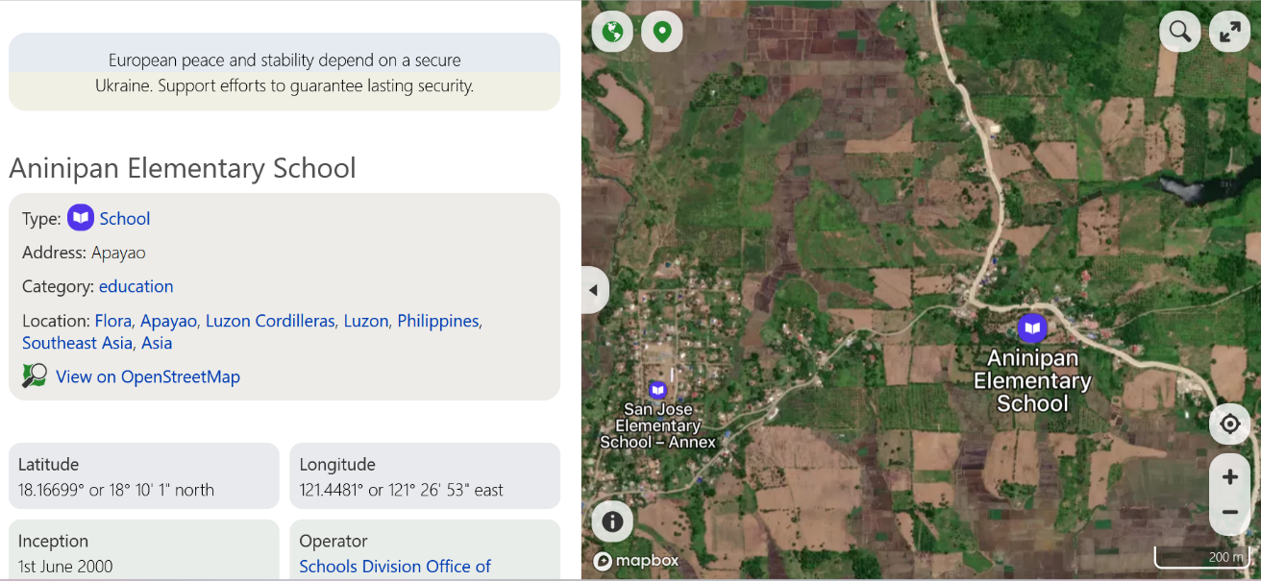
fig 2-Locale of the Study

Respondents of the Study
In identifying the respondent of the study for the FGDs, purposive sampling was employed. This technique is widely utilized in qualitative research to select individuals who can provide rich, relevant insights on the subject matter [13]. A total of [13] participants, which included parents, teachers, and students, were recruited to ensure diverse perspectives on the health issues discussed.

Research Instruments
The Problem Tree Analysis (PTA) is a valuable participatory research tool employed in my study to identify and analyze the root causes and effects of poor health among learners at Anninipan Elementary School. By starting with a core problem—poor health among students—PTA facilitates group discussions among various stakeholders, including parents, teachers, and community health workers, who share their insights and experiences.
Simultaneously, the PTA maps out the "branches," illustrating the effects of these causes, such as increased absenteeism and decreased academic performance. This visual representation not only clarifies the relationships between causes and effects but also enhances understanding of the complex interconnections involved. The participatory nature of PTA fosters productive discussions and consensus-building among diverse stakeholders, igniting a sense of ownership in addressing identified health issues. Moreover, the insights gained through PTA inform the development of targeted interventions that are tailored to the specific needs of the community, enabling comprehensive approaches to improve student health and wellbeing. Ultimately, PTA serves as a potent tool that enriches qualitative data collection, providing both a structured framework for analysis and a means to foster community collaboration in promoting health among learners.

Data Gathering Procedure

To obtain comprehensive and meaningful data relevant to the study’s objectives, the researcher employed a multi-method qualitative approach anchored on Focus Group Discussion (FGD) utilizing the Problem Tree Analysis (PTA) as the primary data gathering tool. This method was selected for its participatory and exploratory nature, allowing participants to share insights in a structured yet open environment.

- Coordination & Ethical: Prior to data collection, the researcher sought approval from the school head of Anninipan Elementary School and coordinated with local education and health officials to gain permission to engage teachers, parents, and community health workers. Informed consent was obtained from all participants, ensuring ethical compliance in accordance with research standards involving human subjects.

- Participants Selection: Participants were purposively selected to ensure relevant perspectives and first-hand experiences regarding the health conditions of learners.

- Focus Group Discussion with Problem Tree Analysis: The core data gathering activity was the Focus Group Discussion (FGD), during which the Problem Tree Analysis tool was used to identify, visualize, and analyze the causes and effects of poor health among learners. The process followed these steps:
- Introduction and warm-up: The researcher explained the purpose of the activity, set ground rules, and created a safe, inclusive environment.
- Identification of the core problem: Participants were asked to agree on the central problem (e.g., "Poor Health Among Learners").
- Determining root causes: Participants discussed and listed various underlying causes (e.g., poor hygiene, lack of access to clean water, malnutrition), which were written and positioned as the "roots" of the tree.
- Exploring the effects: The group then identified observable and long-term effects of poor health on learners (e.g., absenteeism, poor academic performance, low energy), which were placed as the "branches" of the tree.
- Validation and prioritization: The tree was reviewed collectively to validate the relevance and accuracy of each cause and effect, and key points were highlighted for further analysis.

This participatory method encouraged stakeholders to express local knowledge and personal experiences, which enriched the qualitative data and provided contextual depth.

- Documentation and Analysis: Notes were taken to ensure accuracy. Visual outputs such as the drawn problem trees were photographed and included in the data set. Transcriptions of the discussions were later analyzed using thematic analysis, with a focus on categorizing the identified causes and effects of poor health.

RESULTS AND DISCUSSION

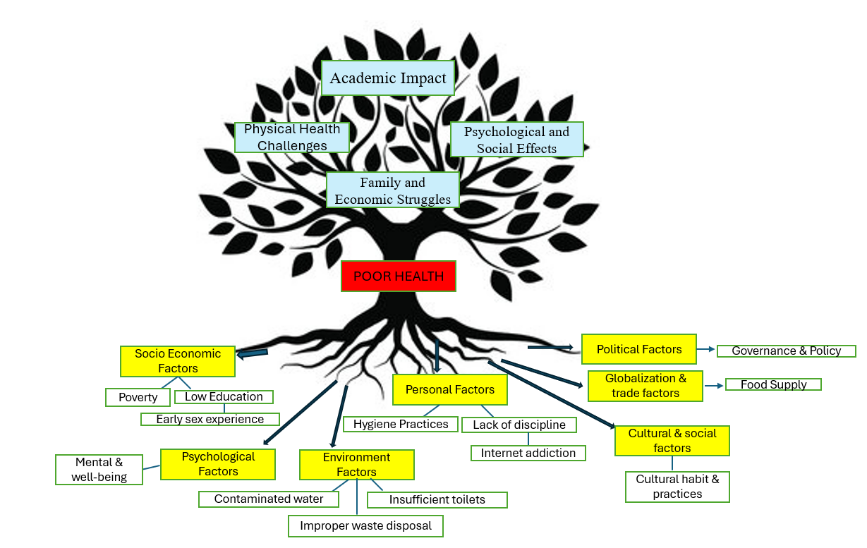
In view of the thorough analysis of data, the hereunder findings emerged from this research journey:

Diagram 1. Problem Tree Diagram illustrates the root causes and effects of poor health among learners at Anninipan Elementary School.
The health challenges faced by learners at Anninipan Elementary School arise from a mix of socio-economic, behavioral, and environmental factors. Socio-economic problems such as poverty, lack of education, family issues, and the low prioritization of health contribute significantly to poor health among learners [14]. Poverty limits access to proper nutrition, healthcare, and hygienic living conditions, making children more vulnerable to diseases [15]. Environmental issues like climate change further aggravate these conditions by increasing exposure to disease-causing environmental risks [16]. In addition, social media addiction, noted as a behavioral concern among the learners, is associated with increased risks of mental health problems and poor academic performance [17].

Table 1. Themes and Core Ideas Identified as Causes of Poor Health Among Learners
Major Themes | Core Ideas
Socioeconomic Factors | - Poverty limits access to nutritious food, clean water, and healthcare.  - Low parental education reduces health literacy.  - Limited access to government support programs worsens health outcomes.  -Household priorities sometimes favor non-essential spending over food.
Environmental Factors | - Inadequate sanitation infrastructure (lack of proper toilets, poor waste management).  - Limited access to clean and safe water.  - Water shortages force unsanitary practices.
Personal Factors | - Irregular hygiene and inconsistent health practices.  - Exposure to inappropriate content via social media.  - Food insecurity affects nutrition and school attendance.
Cultural & Social Factors | -Cultural beliefs restrict certain hygiene practices (e.g., prohibitions on hair cutting).  -Traditional beliefs influence perceptions of cleanliness and health.  - Disciplinary issues at home affect health education.
Political Factors | -Insufficient government support and prioritization for community health.  - Limited access to social welfare programs.
Globalization & Trade Factors | - Imported foods with unclear or hard-to-understand labels.  - Nutritional concerns due to unfamiliar food products.
Psychological Factors | - Feelings of shame and embarrassment linked to food insecurity.  - Lack of social support negatively impacts mental and physical health.

Causes of poor health among learners are due to the following factors:
These root causes lead directly to immediate health problems observed in the school community. Poor sanitation, nutritional deficiencies, and hygiene issues create conditions conducive to the spread of infections, malnutrition, and overall poor health [18]. Early sexual experiences, another identified issue, are linked to insufficient education and lack of guidance, resulting in increased risks of teenage pregnancy and sexually transmitted diseases [19]. Anninipan is a barangay in the municipality of Flora, Apayao province. Its population in the 2020 Census was 1,033, representing 5.76% of Flora's total population. Flora's poverty incidence was 17.30% in the latest census, compared to 17.78% in the previous one, it is stated that the poverty rate in Flora has decreased; however, it remains a significant factor contributing to the poor health of the learners.

Socioeconomic Factors
It indicates that socioeconomic factors, particularly poverty and low income, significantly hinder children's access to essential health resources such as nutritious food, clean water, and adequate healthcare, leading to poor health outcomes and increased absenteeism at Anninipan Elementary School. Furthermore, the lack of health education and limited health literacy among families exacerbate these issues, highlighting the need for targeted interventions to address these disparities and promote better health practices among students.
One respondent mentioned that, “Nu dadduma, digwan mi ti adu diay maysa supot nga payless tapnus iti kasta ket makaiwaras kanyami amin, nu maipanggep iti danum, danum iti bubun ti in-inomen mi.”
“Sometimes, we struggle a lot with just one plastic bag from Payless so that it can be shared among all of us. When it comes to water, the water we drink comes from the well.”
Another respondent mentioned that, “Most parents have limited education, and their knowledge about health education, including hygiene and sanitation practices, is inadequate. As a result, this is what children are learning,”
Another respondent mentioned that, “Kasano met ngamin, nu siasinno pay ti narigat ti panagbiagna, it is those who cannot access government programs like TUPAD, 4Ps, and other potential income-generating initiatives.”
“How could it be otherwise, when those who have the hardest life are the ones who cannot access government programs like TUPAD, 4Ps, and other potential income-generating initiatives.”
Another respondent mentioned that, “Adu ngamin iti maiparit nga mabuybuya iti mobile phone isu nga nacurious nak ket tinulad ko met.”
“There are many things that are prohibited from being viewed on a mobile phone, so I became curious and tried it too.
Another respondent mentioned that, “iyun una ngamin ni nanang nga gumatang ti sigarilyo na ngem tay gumatang ti makan mi, isu nga kaadwan na, awan karga ti buksit mi nga sumrek ti pagadalan.”
“Mom always buys her cigarettes first before buying our food, which is why most of the time, we go to school with empty stomachs.”

Environmental Factors
It indicates that inadequate sanitation infrastructure, such as poor waste management systems and losing access to clean water because the mountains no longer have trees; instead, they have been replaced with corn and banana plantations because deforestation disrupts natural water cycles and increases soil erosion, leading to water pollution and reduced water availability. Respondents highlighted difficulties in implementing proper hygiene practices due to a lack of resources, such as functional sanitation facilities, which exacerbate health-related challenges and impact on students' overall well-being and academic performance.
One respondent mentioned that, “Awanan kami iti nasudi nga kasilyas ken nadalos nga danum, makius usar kami laeng iti karrubami.”
“We no longer have access to a proper toilet and clean water, so we rely on our neighbors for these needs.”
Another respondent mentioned that, “Nu karigaten iti danum, maibaonen dagiti ubbing iti kasabaan nga umisbo agsipud ta awanen pagsibog kadagiti banyo.”
“If there is a water shortage, children will be forced to urinate in the kasabaan because there is no longer water to flush the toilets.”
Personal Factors
It reveals that Personal factors, particularly inconsistent hygiene practices and lack of discipline, significantly contribute to health issues among students at Anninipan Elementary School.
One respondent mentioned that, “Nu ania ti kaalistwan nga maluto, isu ti balonen dagiti annak.”
“Whatever is the most urgent to be cooked, that is what the children will be served.”
Another respondent mentioned that, “gapu iti social media world, adun ti makitkita dagiti ubbing iti mobile phones da, kasla gagangay payen kanayada iti agbuya dagiti maiparit a mabauya.”
“Because of the social media world, many children are seen on their mobile phones, as if they are very young but already watching forbidden or inappropriate content.”

Cultural & Social Factors
It indicates that cultural and social factors significantly influence health behaviors among students at Anninipan Elementary School, often leading to practices that hinder proper hygiene and nutrition. Respondents expressed that cultural beliefs and disciplinary issues at home contribute to poor Health and inadequate health education, which ultimately affects children’s health outcomes.
One respondent said, “bawal wenno maiparit nga ipapukis ti buok nu saan pay nga nalpas ti panagani ti pagay.”
“It is forbidden or not allowed to cut the hair before the harvest is finished.”
Another respondent said, “kuna dagiti babbaket di ugma, awan matay ti rugit ngem adda matay ti sobra dalus.”
“The old women say, no one will die from a sudden illness, but some will die from excessive cleanliness.”

Political Factors
It reveals that political factors, particularly the lack of governmental support, is severely hinder the health outcomes of students at Anninipan Elementary School. Respondents indicated that inadequate government response to health issues contributes to ongoing health challenges within the community.
One respondent said, “kurang ti suporta ti gobierno”.
“Lack of support from the government.”
Another responded said, “We are of low priority.”

Globalization and Trade Factors
It indicates that globalization and trade contribute to health-related challenges by introducing a variety of food products from different countries, which often come with labels that are difficult for the local population to understand. Respondents expressed concerns about the accessibility and nutritional value of these imported foods, highlighting a disconnect between available food products and community health literacy.
One respondent said, “adun iti agsasabali a makmakan nga aggapu naduma duma nga country, agalalo ket haan maawatan dagiti label na.”
“There are many kinds of food that come from various countries, especially since their labels are not easily understood.

Psychological Factors.

The impact of depression or unwanted and lack of social support further underscores the deep connection between mental and emotional states and overall physical health, highlighting the need for a holistic approach to wellness.
One respondent said, “mabain nak nga sumrek pagadalan nu awan ti balunen mi nga makan.”
“I feel embarrassed to go to school when I have no food to bring with me.”

Table 2. The effects of poor health among learners of Anninipan Elementary School.
Core Idea | Major Themes | Effect of Poor Health Among Learners
Poor health undermines learners’ well-being, academic achievement, and social experiences. | Physical Health Challenges | - Increased absenteeism due to frequent illness and weak immune systems  - Poor hygiene (body odor, dental issues)
 | Academic Impact | - Lower academic proficiency and test scores  - Difficulty concentrating and participating in class
 | Psychological and Social Effects | - Feelings of isolation, low self-esteem, and depression  - Stigma and exclusion from peers due to poverty or hygiene
 | Family and Economic Struggles | - Lack of resources for nutritious food, healthcare, and school needs  - Parental illness limits family support
The effects of poor health among learners of Anninipan Elementary School.

The resulting effects among learners are highly detrimental. Many students develop weak immune systems, leading to frequent absenteeism [20]. Malnutrition and poor health contribute to cognitive challenges, reflected in a low level of academic proficiency [21]. Psychological effects such as depression and feelings of being unwanted are also significant concerns, potentially leading to long-term mental health issues [22].
Addressing these challenges calls for comprehensive school-based interventions focusing on improving nutrition, sanitation, health education, and mental health support. Collaborative efforts involving families, communities, and health authorities are essential to break the cycle of poor health and academic underachievement among the learners.

In the course of discussion done to participants, the following responses on the effect of Poor Health among learners emerged:
One respondent said, “Kanayun nak nga makaturturog, agsipud ta saan kami pay nangrabii, nammigat ken awan naited nga kwarta mi igatang meriendami, saan kamin nga nakadigos a simrek ditoy pagadalan ta naladaw kami a nagriing”
“I'm sleepy because we haven't eaten dinner yet, we skipped lunch, and we weren't given any money to buy a snack. We also couldn’t take a bath before coming to school because we woke up late.
Another respondent mentioned that,“Managsakit dagiti ubbing aglalo agalen da sakit ti tiyan ken ngipen, nu sinno pay iti nakapsot iti uneg ti klase, isu pay met ti kanayon nga agabsent”.
“Children often get sick, especially with stomachaches and toothaches, and the weakest one in the class is usually the one who is always absent”.
Another respondent said that, “Kaadwan dagiti agad-adal ditoy Anninipan Elementary School ket addaan ti body odor aglalo nu kasta nga mabayagan da iti outdoor activities da, masumrunan nak pay nu dadduma nga agpabasa ti one-on-one agsipud ta adda madi nga angot dagiti ngiwat da”.
“Many students at Anninipan Elementary School have body odor, especially when they spend a lot of time in outdoor activities. It is also unpleasant when some ask for one-on-one reading because their mouths smell bad”.
Another respondent mentioned that, “Gagangay ti nabobre, awan gaygayyemna.”
“It's just that we are poor, that's why no one likes us.”.
Another respondent mentioned that, “Haan nga makaubra ni tatang ngamin haan nga kabaelan ti bagi na, adda highblood na ken diabetic pay. Awan met ngarud ti umanay nga kwarta tapno maipakita mi diay hospital ta maikkan ti umiso nga agas”.
“My father is unable to work because of his poor health; he has high blood pressure and diabetes. Unfortunately, we don’t have enough money to bring him to the hospital for proper treatment and medication.”
Another respondent mentioned that, “Dakkel nga epekto na ti Regional Achievement Test (RAT), National Achievement Test (NAT) ken overall nga proficiency level iti pagadalan tayo makagapu ti salun-at dagiti ubbing ket saan nga makapagfunction a nalaing ti overall nga bagi da.”
“The Regional Achievement Test (RAT), National Achievement Test (NAT), and overall proficiency level in our school have a significant impact on the well-being of the children, as their overall physical functioning is affected when they are not performing well.”

Recommended Interventions

Issues | Intervention
Malnutrition and hunger | Implement a school meal program that provides daily balanced meals to ensure children receive adequate nutrition, addressing issues like malnutrition and hunger.
Socioeconomic Barriers | - Introduce scholarship initiatives that provide financial support for students from low-income families to pursue higher education, creating long-term educational opportunities.  - . Host fundraising events to raise money for families in need, which can help alleviate financial burdens related to school supplies, meals, and other essential costs.
Poor sanitation facilities | Upgrade existing sanitation facilities to provide clean and functional restrooms with adequate supplies and maintenance, promoting hygiene and comfort.
Low Health Literacy and Poor Hygiene Practices | Engage the local community in supporting school health initiatives through partnerships with local health organizations to provide resources and support.
Limited Access to Healthcare and Health Services | Organize periodic health check-ups for students to identify and address health issues early, including vision and dental assessments.
Sedentary lifestyles and lack of opportunities for physical activity | Introduce after-school programs that promote physical activity, such as sports and fitness clubs, to enhance children's physical health and well-being.
Lack of proper education on sexual health and relationships | Organizing a series of informative and interactive workshops in collaboration with local health agencies, schools, and community organizations. The focus will be on educating adolescents about sexual health, consent, relationships, and the implications of early sexual activity.
Social Media Influences | Develop guidelines and educate students and parents on responsible use of mobile devices and the internet to encourage healthy media consumption and online safety.

SUMMARY, CONCLUSION, AND RECOMMENDATIONS
This presents the summary, conclusions and recommendations of the study.

Summary
The study examined the causes and effects of poor health among students at Anninipan Elementary School. It was found that many learners suffer from frequent illnesses, poor hygiene, and malnutrition due to poverty, limited health education, inadequate sanitation facilities, and cultural beliefs. These health problems negatively affect students’ attendance, academic performance, and social well-being. The findings highlight the need for coordinated efforts from the school, families, and local health agencies to address these issues holistically.

Conclusion
Poor health among learners at Anninipan Elementary School is a complex issue influenced by socioeconomic, environmental, behavioral, and cultural factors. It directly impacts students’ well-being and learning outcomes. Addressing these challenges requires comprehensive, multi-sectoral interventions that improve nutrition, sanitation, health education, and community engagement. Such efforts are essential to enhance students’ health, reduce absenteeism, and improve academic performance for long-term educational success.

Recommendations

Based on the foregoing findings and conclusions, the following are strongly recommended:
- The School Administration should develop and integrate health education into the school curriculum that focuses on hygiene, nutrition, and preventive health measures to raise awareness among students about the importance of these practices.
- The School Administration should collaborate with local health agencies and non-governmental organizations to provide nutritious meals and snacks at school, ensuring that students have access to regular and balanced nutrition.
- The School Administration should upgrade the sanitation infrastructure within the school, including access to clean water, functional toilets, and proper waste management systems to promote a healthier school environment.
- The School Administration should involve the parents, local communities, and health professionals in health initiatives to create a supportive environment for students, promoting healthy behaviors both at home and in school.
- The School Administration should supply students with necessary hygiene materials, such as soap, hand sanitizers, and sanitary products, to encourage consistent hygiene practices and reduce the spread of communicable diseases.
- The School Administration should implement routine health screenings and check-ups for students to identify health issues early and provide necessary interventions, fostering a proactive approach to health.
- The School Administration should Engage with local government and educational authorities to advocate for policies and funding that address health and nutrition challenges in GIDA areas, emphasizing the importance of education and health equity.
- The School Administration should work with parents and the community to promote responsible use of technology. Schools can implement guidelines for students regarding the use of mobile devices and the internet, focusing on monitoring online activities and encouraging healthy media consumption.

REFERENCES

[1] Bugshan A, Alhazmi A, Ali M. Health Education and Its Impacts on Public Health: A Review. Journal of Health Education Research & Development. 2022;40(2):101-112.

[2] Sriyono M. Health Problems and Academic Performance of Children: A Systematic Review. International Journal of Public Health Science. 2015;4(1):1-10.

[3] Abdelrahman M. Importance of Personal Hygiene for Students: Implications for Educational Outcomes. Global Journal of Health Science. 2022;14(3):134-142.

[4] Motakpalli R, Tashkin L, Gida A. Role of Hygiene in Preventing Communicable Diseases in Schools. Archives of Public Health. 2013;71(1):15-22.

[5] Adnane M. The Impact of Hygiene Practices on Students’ Health. Journal of School Health. 2014;84(9):564-570.

[6] Schwager S, Ruel M, Mofijur M. Health and Nutrition Initiatives in Schools: Evidence from the Philippines. Nutrition Reviews. 2019;77(11):798-807.

[7] Department of Health, Philippines. Geographically Isolated and Disadvantaged Areas: Health Challenges and Interventions. Manila: DOH; 2023.

[8] Marmot M. Social determinants of health inequalities. Lancet. 2022;384(9945):1015-1023.

[9] Carpenter CJ, Hagger MS. A meta-analysis of the Health Belief Model variables in sexual health: Evidence for the role of attitudes. Health Psychology Review. 2022;16(2):444-465.

[10] Nabbuye R, Mulindwa J, Okello D. The Role of School Health Interventions in Reducing Absenteeism: Evidence from Uganda. BMC Public Health. 2023;23(1):55.

[11] Siddiqi M, Carella B, Awan A. Community Engagement in School Health Initiatives: A Framework for Collaboration. Journal of Community Health. 2023;48(2):171-180.

[12] Creswell JW. Qualitative Inquiry and Research Design: Choosing Among Five Approaches. 4th ed. Thousand Oaks: Sage Publications; 2017.

[13] Kvale S. Doing Interviews. London: Sage Publications; 2009.

[14] Bradley RH, Corwyn RF. Socioeconomic status and child development. Annual Review of Psychology. 2002;53(1):371-399.

[15] Gupta RP-S, de Wit ML, McKeown D. The impact of poverty on the current and future health status of children. Paediatr Child Health. 2007

[16] Watts N, Adger WN, Agnolucci P, et al. Health and climate change: policy responses to protect public health. The Lancet. 2015;386(10006):1861–1914.

[17] Twenge JM, Campbell WK. Media use is linked to lower psychological well- being: Evidence from three datasets. Psychiatry Quarterly. 2019;90(2):311– 331

[18] World Health Organization. Water, sanitation and hygiene in schools: Global baseline report 2018. Geneva: World Health Organization; 2018.

[19] Bearinger LH, Sieving RE, Ferguson J, Sharma V. Global perspectives on the
sexual and reproductive health of adolescents: patterns, prevention, and
potential. The Lancet. 2007;369(9568):1220–1231

[20] World Health Organization. Water, sanitation and hygiene in schools: Global
baseline report 2018. Geneva: World Health Organization; 2018

[21] Grantham-McGregor S, Cheung YB, Cueto S, Glewwe P, Richter L, Strupp B.
Developmental potential in the first 5 years for children in developing countries.
The Lancet. 2007;369(9555):60–70.

[22] Twenge JM, Campbell WK. Media use is linked to lower psychological well-
being: Evidence from three datasets. Psychiatry Quarterly. 2019;90(2):311–331.
Available from: https://doi.org/10.1007/s11126-018-9610-0

APPENDICES

APPENDIX A

Background Information Form
Please complete this background information form.
- Role:
  - [ ] Teacher
  - [ ] Parent
  - [ ] Student

- If Teacher:
  - Grade Level(s) Currently Teaching: _________________________
  - Subject Area(s) Currently Teaching: _________________________
  - Number of Years Teaching Experience: _______

- If Parent:
  - Number of Children Currently Enrolled in School: _______
  - Grade Level(s) of Your Child(ren): _________________________

- If Student:
  - Grade Level: _______
  - Age: _______

- Gender:
  - [ ] Male
  - [ ] Female
  - [ ] Prefer not to say

- Age Group (for Teachers & Parents):
  - [ ] 20-29
  - [ ] 30-39
  - [ ] 40-49
  - [ ] 50 and above

Section B: Contextual Information (Optional but Helpful)
- (For Teachers): What is one thing you find most rewarding about your teaching experience?

- (For Parents): What is one thing you hope your child(ren) will gain most from their education?

- (For Students): What is one thing you enjoy most about being a student?

Thank you again for your participation!
APPENDIX B

REFLECTIVE JOURNAL

Researcher: _______________________ Date: ________________________
Informant No. : ____________________ Time: ________________________

- What are the causes of Poor Health among learners of Anninipan Elementary School?
__________________________________________________________________________________________________________________________________________________________________________________________________________________________________________________________________________________________________________________________________________________________________________________________________________________________.

- What are the effects of Poor Health among learners of Anninipan Elementary School?
__________________________________________________________________________________________________________________________________________________________________________________________________________________________________________________________________________________________________________________________________________________________________________________________________________________________.

Appendix C

Letter to the Respondents

February 15, 2024

Dear Respondents:

Good day!

I am conducting a study in line with my research study titled “CAUSES AND EFFECTS OF POOR HEALTH AMONG LEARNERS OF ANNINIPAN ELEMENTARY SCHOOL”. This study aims to determine the Causes and effects of poor health among learners of Anninipan Elementary School as basis for crafting an intervention.

I would like to invite you to participate in a valuable Focus Group Discussion (FGD) about the topic. Your perspective as a participant is highly valued and will contribute significantly to our understanding of the issues.

Your participation in this FGD is entirely voluntary, and all information you share will be kept confidential and used for research purposes only. Your identity will be protected in any reports or publications resulting from this study.

Thank you.

Sincerely,

Author

Appendix D

Photo Documentation

