EFFECTIVENESS OF GAME-BASED LEARNING IN THE LANGUAGE AND LITERACY OF THE KINDERGATEN IN BALASI ELEMENTARY SCHOOL

Abstract
This study seeks to contribute to this growing body of regional literature by evaluating the effectiveness of game-based learning in the context of Balasi Elementary School. Game-based learning, which includes both self-directed and teacher-guided play, creates low-stress, engaging environments that foster deeper understanding and enhance educational outcomes. This study is anchored on the concept that structured game-based learning can significantly enhance the language and literacy development of kindergarten pupils. The conceptual framework highlights the relationship between game-based learning strategies (as the independent variable) and the pupils' performance in language and literacy (as the dependent variable). This finding supports the idea that young learners thrive in settings where learning is associated with play, interaction, and enjoyment. Through games, pupils were able to develop their vocabulary, comprehension, oral communication, and critical thinking skills in a manner that traditional instruction could not achieve as effectively. The integration of games into classroom instruction not only increased pupil participation and enthusiasm but also promoted deeper understanding and retention of language concepts.

Keywords: vocabulary, Game-based learning, language concepts, kindergarten classrooms

Introduction
In recent years, there has been a growing recognition of the importance of integrating game-based learning strategies within early childhood education (1,2). A substantial body of research supports the idea that play is foundational in promoting children’s linguistic, social, and cognitive development (3). Game-based learning, which includes both self-directed and teacher-guided play, creates low-stress, engaging environments that foster deeper understanding and enhance educational outcomes (4). These strategies align well with the developmental needs of young learners, making them especially relevant in kindergarten classrooms.
Globally, the adoption of game-based learning has gained traction, supported by research in child development and learning theory (5). Countries such as Finland, Norway, and Sweden have pioneered child-led educational models emphasizing exploration, discovery, and inquiry within supportive learning environments (6). Although the implementation in the United States has been more gradual, game-based learning is increasingly being integrated into early childhood education programs (7,8). In response to these global developments, this study aims to examine the effectiveness of game-based learning in enhancing the language and literacy skills of kindergarten pupils at Balasi Elementary School. The results are expected to offer evidence-based insights to inform and improve local pedagogical practices.
The Department of Education (DepEd) in the Philippines recognizes the value of play in early childhood education by embedding play-based learning into the kindergarten curriculum (9). The Kindergarten Education Act of 2012 (Republic Act No. 10157) mandates kindergarten for five-year-olds, promoting holistic development through age-appropriate, inclusive, and child-centered practices (10,11). The 2015 Kindergarten Curriculum Guide and the K–12 Basic Education Program emphasize play's role in developing literacy, numeracy, and social skills (12). DepEd Order No. 47, s. 2016 supports a balanced approach between child-initiated and teacher-guided activities and encourages the use of storytelling, music, and arts for holistic learning (13–16). Furthermore, partnerships with organizations like UNICEF have improved access to game-based learning tools and teacher training, reflecting a national commitment to developmentally appropriate education (17). These initiatives underscore the potential of game-based learning to enhance young learners' cognitive and language development (18). In the Cordillera Administrative Region (CAR), there is a rising interest in play-based education to improve young learners’ cognitive and language skills. Studies conducted in Benguet and Ifugao provinces report improvements in problem-solving and language development through play-based learning (19,20), while research in Mountain Province emphasizes its positive effects on creativity and critical thinking (21).
In Apayao Province, though limited, research also supports the benefits of game-based learning. Studies show it enhances creativity, social interaction, reading comprehension, and vocabulary development (22,23). This study seeks to contribute to this growing body of regional literature by evaluating the effectiveness of game-based learning in the context of Balasi Elementary School.
In Balasi Elementary School supports game-based learning in kindergarten through interactive lessons that include storytelling, role-playing, and group games, which promote cognitive, language, and social development (19). These practices align with DepEd’s play-based learning policies and show grassroots commitment to progressive teaching methods. Despite challenges such as limited resources and inconsistent teacher training, strong support from educators and parents sustains these efforts. Teachers also engage in community events like storytelling and cultural games, strengthening the link between education and local heritage (19).
Statement of the Problem
This study aims to explore the effectiveness of game-based learning in the language and literacy of the kindergarten in Balasi Elementary School. Specifically, it seeks to answer the following questions:
- What is the language and literacy performance of the kindergarten during the control period and experimental period?
- Is there a significant difference in the language and literacy performance of the kindergarten during the control period and experimental period?
Research Hypotheses
Null Hypothesis (H₀): There is no significant difference between the performance of kindergarten in game-based learning.
Alternative Hypothesis (H₁): Kindergarten students who undergo game-based learning will exhibit significantly higher levels of language and literacy development compared to those who do not.
Theoretical Framework
Vygotsky’s Sociocultural Theory (24) and Piaget’s Cognitive Development Theory (25), emphasizing the critical role of play and social interaction in children's learning. Game-based learning serves as a foundational educational approach, aligning with the principle that meaningful learning occurs when children actively engage in hands-on, playful activities that foster both cognitive and language development.
According to Vygotsky, social interaction is fundamental to cognitive development, with language serving as a crucial tool for constructing thought. He introduced the concept of the Zone of Proximal Development (ZPD), which suggests that children learn best when guided by more knowledgeable peers or adults within their potential developmental range. In the context of Balasi Elementary School, game-based learning provides opportunities for social interaction where children communicate, negotiate roles, and practice vocabulary through structured play, thereby enhancing their language and literacy skills [24].
Piaget, on the other hand, emphasized the significance of active exploration in cognitive development. He proposed that children construct knowledge through experiences and interaction with their environment. Game-based activities such as storytelling, role-playing, and language games allow learners to engage with concepts at their developmental level, promoting critical thinking, problem-solving, and self-regulation [25].
These theoretical foundations are supported by contemporary research. Boyer [26] asserted that play-based learning promotes holistic development and is directly linked to improved language and literacy outcomes. Valiquette and Sutton [27,28] emphasized that structured play significantly enhances vocabulary acquisition, phonemic awareness, and narrative abilities. Wickstrom [29] further demonstrated that language-rich games support cognitive flexibility and early literacy competencies.
Together, these theories and findings validate the implementation of game-based learning as a developmentally appropriate strategy to improve language and literacy among kindergarten pupils.
Conceptual Framework
This study is anchored on the concept that structured game-based learning can significantly enhance the language and literacy development of kindergarten pupils. The conceptual framework highlights the relationship between game-based learning strategies (as the independent variable) and the pupils' performance in language and literacy (as the dependent variable). Game-based learning includes activities such as storytelling, role-playing, puppetry, language games, and interactive reading, which are designed to create engaging, developmentally appropriate learning experiences. These strategies aim to support vocabulary growth, phonemic awareness, comprehension, and communication skills in young learners. The study compares two instructional approaches: the control period, which uses traditional teaching methods, and the experimental period, where game-based learning is implemented. The framework operates under the assumption that the introduction of game-based learning will result in a measurable improvement in the academic performance of kindergarten pupils in language and literacy. This conceptual structure serves as a guide for analyzing the effectiveness of innovative instructional strategies in early childhood education and supports the development of data-driven recommendations for classroom practice.

Figure 1. Research Paradigm
Independent Variables Dependent Variables

Academic achievement
-Control Period
-Experimental Period

Implementation of Game-Based Learning

Based on the paradigm, the independent variable is the implementation of game-based learning, which refers to the use of structured educational games to enhance language and literacy skills. The dependent variable is the academic achievement of kindergarten pupils, as measured during the control period (without game-based learning) and experimental period (with game-based learning).
The relationship between the variables is that the implementation of game-based learning (independent variable) is expected to improve the academic achievement (dependent variable) of the pupils.
The paradigm illustrates that as game-based learning is introduced and implemented, it is hypothesized to have a positive impact on the academic achievement in language and literacy among kindergarten pupils.

RESEARCH METHODOLOGY
This chapter presents the research methods and procedures used in the study. It includes the research design, locale of the study, respondents and sampling procedures, research instrument, data gathering procedure, and data analysis.
Research Design
The study used a repeated measures design. A repeated measures design is a type of research design where the same participants are involved in each condition or level of the dependent variable. The researcher exposed the same group of people to all the treatments or conditions. It allowed the researcher to observe and measure changes in academic achievement by comparing pupil performance before and after the intervention, ensuring a clear understanding of the impact of game-based learning.
In this study, the researcher determined the relationship between game-based learning and language and literacy development by employing a pretest-posttest design. Standardized assessments were administered before and after the intervention. This repeated-measures approach allowed the comparison of learners' academic achievement during the control and experimental periods, providing data on the effectiveness of game-based learning in a real-world classroom setting.
The study was conducted in two distinct periods: Control Period: Pupils underwent regular classroom instruction using traditional teaching methods without the integration of game-based learning strategies. This served as the baseline for assessing their language and literacy performance under conventional teaching.: The same group of pupils experienced lessons enhanced with various game-based learning activities specifically designed to improve their language and literacy skills.
To measure the pupils’ progress and the impact of the intervention: A pre-test was administered before the control period to assess the pupils' initial language and literacy skills. A post test was given at the end of the control period to identify any improvements from traditional teaching alone. A second pre-test was conducted before the experimental period to re-establish the pupils' starting point. A final post test was administered after the implementation of game-based learning strategies to determine the effectiveness of the intervention.
The process of conducting the study began with the preparation phase, where pre-test and post test assessment tools were developed based on the kindergarten curriculum in language and literacy. During the control period implementation, regular language and literacy lessons were delivered without the use of games, and a pre-test was administered at the beginning while a posttest was given at the end of the period to measure academic achievement under traditional instruction. This was followed by the transition and orientation phase, where pupils were introduced to the concept of game-based learning to ensure their familiarity and comfort with the new instructional approach. The experimental period implementation then commenced, during which language and literacy lessons were integrated with game-based activities. Similar to the control period, a pre-test was administered before and a post test after the experimental period. Finally, in the data collection and analysis phase, the pre-test and post test scores from both periods were gathered and compared, and statistical analysis was conducted to determine if there was a significant difference in academic achievement attributed to the implementation of game-based learning.
Locale of the Study
This study was conducted at Balasi Elementary School, located in the municipality of Flora, Apayao, within the Cordillera Administrative Region. The school caters to a diverse population of kindergarten pupils, including those from the indigenous Aeta community. The Aeta are a distinct ethnic group known for their rich cultural heritage and traditional way of life, primarily residing in the mountainous regions of the Cordillera. These children represent a community that has maintained its traditional practices while increasingly integrating into mainstream Filipino society.
At Balasi Elementary School, Aeta pupils, along with children from other cultural backgrounds, receive education that acknowledges and respects their cultural identity. The school promotes an inclusive learning environment where age-appropriate educational activities are designed to address the developmental needs of young learners, including the fostering of cognitive and language skills. The local community, including parents and leaders, is actively involved in the educational process, emphasizing the importance of balancing cultural preservation with academic growth.
The respondents come from the Aeta community, an indigenous group in the Philippines known for their distinct cultural identity and close-knit community values. These children bring with them a unique cultural perspective, shaped by oral traditions, storytelling, and hands-on learning, which aligns naturally with the principles of play-based education. Their inclusion in the study provides a culturally rich context for examining the effectiveness of game-based learning strategies.
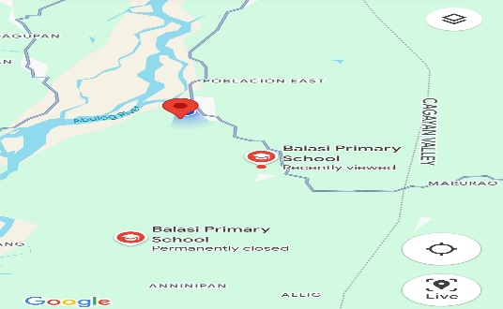
The integration of the Aeta community into the school setting provides a unique context for this research. It offers a valuable opportunity to study the effectiveness of game-based learning in enhancing the language and literacy development of kindergarten pupils, particularly in a culturally diverse environment.

picture 1- Map showing study location
Respondents of the Study
picture 2- Balasi Elementary School
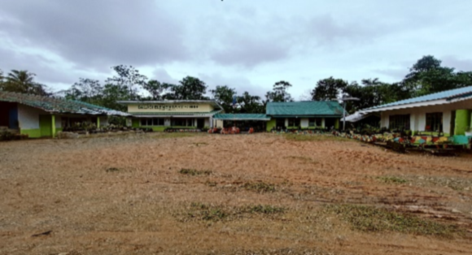
The respondents of this study are kindergarten pupils enrolled at Balasi Elementary School during the School Year 2024–2025. These learners, aged five to six years old, are at a critical stage of development where foundational skills in language and literacy are formed. The total number of
respondents consists of approximately six (6) children who are actively participating in the school’s regular kindergarten class.
The selection of respondents was done using total enumeration, all kindergarten pupils currently enrolled in the school were included in the study. This method was deemed appropriate due to the small population size and the intent to capture a comprehensive understanding of the impact of game-based learning on the entire kindergarten cohort.
The teacher-researcher, ensured that all respondents participated in both the pre-test and post test assessments, which served as tools for measuring changes in language and literacy development.
Ethical considerations were strictly observed in dealing with the respondents. Informed consent was obtained from the parents or guardians of all participating pupils. The study was conducted in a manner that ensured the safety, privacy, and well-being of the children at all times. Participation was voluntary, and the children were treated with respect, kindness, and understanding throughout the course of the research.
list 1: Control Group
Respondents | Frequency | Percentage
Male | 3 | 50%
Female | 3 | 50%
Total | 6 | 100%
list 2: Experimental Group
Respondents | Frequency | Percentage
Male | 3 | 50%
Female | 3 | 50%
Total | 6 | 100%

Research Instrument
In this study, the researcher determined the relationship between game-based learning and language and literacy development by employing a pre-test-post test design. Standardized assessments were administered before and after the intervention. This repeated-measures approach allowed the comparison of learners' academic achievement during the control and experimental periods, providing data on the effectiveness of game-based learning in a real-world classroom setting.
This study used a repeated measures design to evaluate the effectiveness of game-based learning on the language and literacy development of kindergarten pupils. The main research instrument was a teacher-made assessment tool composed of 20 items, which measured key language and literacy competencies. These tools were adapted from Department of Education learning modules and evaluated summative tests, ensuring alignment with the Most Essential Learning Competencies (MELCs) under the Kindergarten Curriculum Guide.
The test covered areas such as letter-sound recognition, oral language, vocabulary, listening comprehension, and emergent reading. Each correct response was awarded 1 point, with a maximum possible score of 20.
The same 20-item test was administered as both the pre-test and post-test. The pre-test was given before the implementation of the game-based learning activities to establish baseline levels. The post-test was conducted after the intervention to assess changes in performance.
To interpret the results of the pre-test and post test, the following descriptive scale adapted from the Department of Education's K to 12 grading guidelines was used (DepEd, 2015):
Percentage Score | Description | Interpretation
90–100% | Outstanding | Demonstrates advanced understanding and skill mastery
85–89% | Very Satisfactory | Demonstrates thorough understanding and skill proficiency
80–84% | Satisfactory | Adequate understanding; meets expected competencies
75–79% | Fairly Satisfactory | Developing understanding; needs guidance
Below 75% | Did Not Meet Expectations | Needs significant improvement and intervention
Data Gathering Procedure
This study, which employed a repeated measures design to evaluate the effectiveness of game-based learning on the language and literacy development of kindergarten pupils at Balasi Elementary School, was conducted over the course of the second and third grading quarters. The second quarter, which served as the control period, spanned 8–10 weeks and focused on traditional instruction, while the third quarter, the experimental period, also lasted 8–10 weeks and implemented game-based learning strategies.
The data gathering process for this study followed three distinct phases: pre-data gathering, data gathering, and post-data gathering. During the pre-data gathering phase, the researcher secured the necessary permissions from school administrators and obtained informed consent from the parents or guardians of the participating kindergarten pupils. An orientation session was conducted with the teachers to explain the study’s objectives, methods, and their roles in facilitating the game-based learning activities aligned with language and literacy assessments. Preparations for collecting baseline data, including preliminary assessments of each child’s language and literacy abilities, were also completed during this stage.
In the data gathering phase, the researcher conducted structured observations and administered assessments. This phase focused on tracking language and literacy development through repeated measures. The researcher documented structured observations of the children as they engaged in various game-based learning activities such as storytelling, role-playing, and nature-inspired games to capture behavioral and developmental changes. Pre-tests and post tests were administered at planned intervals to measure progress in language and literacy development throughout the study period.
During the post-data gathering phase, the researcher analyzed and interpreted the collected data to assess the effectiveness of game-based learning. The findings were synthesized to compare results from the control period (traditional approach) and the experimental period (game-based approach), while also taking into consideration any cultural factors that may have influenced play-based learning outcomes. This phase concluded with the preparation of a comprehensive report that highlighted key findings and implications for early childhood education. The researcher then presented these findings to the administration and teaching staff of Balasi Elementary School, offering actionable recommendations for enhancing game-based learning in their kindergarten program.
Statistical Treatment of Data
The data gathered in this study, which investigates the effectiveness of game-based learning on the language and literacy development of kindergarten pupils at Balasi Elementary School, were analyzed using repeated measures. The following statistical procedures were employed:
Weighted Mean
This was used to assess the effectiveness of game-based learning on the language and literacy development of kindergarten pupils.
Wherein:
∑X = sum of the quantitative variable
N = total sample size
X̄ = ∑X / N
Mean Percentage Score (MPS)
MPS was used to evaluate the level of mastery of pupils as a percentage of the total possible score.
Wherein:
MPS = (Total Score ÷ [Number of Items × Number of Pupils]) × 100
These methods are commonly used in educational research for evaluating learning outcomes and mastery levels among students (20).
RESULTS AND DISCUSSION
This chapter presents and discusses the findings of the study on the effectiveness of game-based learning in improving the language and literacy performance of kindergarten pupils at Balasi Elementary School. The results are presented according to the sequence of the Statement of the Problem (SOP).
The study began by assessing the language and literacy performance of kindergarten pupils during the control period, where traditional instruction methods were applied. The control period aimed to establish a baseline measurement of the pupils’ academic achievement in language and literacy, using pre-test and post test assessments. As shown in Table 1, the results indicated an improvement in the pupils’ performance from the pre-test to the post-test.
In table 1, the pre-test mean score was 15.17, with a Mean Percentage Score (MPS) of 75.85%, reflecting the initial language and literacy proficiency of the pupils prior to any instructional intervention. After the implementation of regular language and literacy lessons, the post-test scores showed a mean of 16.0 and an MPS of 80%. This represents a 4.15% increase in the MPS, demonstrating a positive improvement in academic achievement under the traditional teaching methods.
These results suggest that the pupils made progress in their language and literacy skills through the regular delivery of lessons, highlighting the effectiveness of consistent, structured instruction in early childhood education. However, while traditional methods proved beneficial, the improvements observed were limited when compared to the potential effects of more engaging, interactive teaching methods such as game-based learning.
The findings of this study are consistent with the work of Boyer (28), who argued that even without innovative approaches, traditional instructional methods could lead to improvements in early literacy development. Boyer’s research supports the notion that structured teaching remains valuable in promoting language acquisition. Similarly, Wickstrom (31) noted that while traditional approaches have their merits, they often lack the engaging elements necessary to foster deeper learning and motivation among young learners.

Table 1. Language and Literacy Performance during the Control Period
Pupil | Pre-test Score (Out of 20) | Post-test Score (Out of 20)
Pupil 1 | 14 | 15
Pupil 2 | 15 | 17
Pupil 3 | 14 | 15
Pupil 4 | 16 | 16
Pupil 5 | 15 | 16
Pupil 6 | 17 | 17
Total | 91 | 96
Mean | 15.17 | 16.0
MPS | 75.85% | 80%
Interpretation | Fairly Satisfactory | Satisfactory
The results presented in Table 2 demonstrate a notable improvement in the language and literacy performance of the pupils during the experimental period, where game-based learning was integrated into the language and literacy lessons. The pre-test mean score was 16.5 (MPS = 82.5%), and after the introduction of game-based learning, the post test mean score increased to 19.0 (MPS = 95%). This represents a significant improvement of 12.5% in the MPS, suggesting that the game-based learning intervention had a substantial positive impact on the pupils' academic achievement in language and literacy.
In the pre-test, the pupils already displayed a good understanding of language and literacy concepts, as evidenced by the 16.5 mean score. However, after experiencing the interactive and engaging nature of game-based learning, the pupils demonstrated a higher level of mastery, as reflected in the post-test scores. The 95% MPS in the post-test suggests that the pupils were not only more motivated but also able to apply their knowledge and skills in a more effective and meaningful way.
These results align with previous research that has highlighted the positive effects of game-based learning on language development in early childhood education. For example, Boyer (28) found that game-based learning environments foster increased engagement and motivation, which in turn leads to better retention and mastery of academic content, particularly in language and literacy. Boyer’s study emphasized the role of interactive, play-based methods in creating a more engaging and dynamic learning environment for young children, which is consistent with the findings of this research.
Similarly, Wickstrom (31) reported that incorporating games into the classroom enhances cognitive development and language acquisition among young learners. According to Wickstrom, game-based learning encourages active participation and problem-solving, which are essential for the development of literacy skills. This aligns with the significant improvement in the pupils' post-test results, suggesting that the hands-on, interactive nature of games positively influenced their academic performance.
Additionally, Valiquette (29) discussed the importance of providing children with opportunities for playful, collaborative learning through games. Valiquette found that game-based learning helps children develop both cognitive and social skills, which are critical for language development. By fostering a sense of achievement and teamwork, games enhance children’s ability to communicate effectively and understand language in a more contextually rich manner.
Table 2. Language and Literacy Performance during the Experimental Period
Pupil | Pre-test Score (Out of 20) | Post-test Score (Out of 20)
Pupil 1 | 15 | 18
Pupil 2 | 17 | 19
Pupil 3 | 16 | 18
Pupil 4 | 17 | 20
Pupil 5 | 16 | 19
Pupil 6 | 18 | 20
Total | 99 | 114
Mean | 16.5 | 19.0
MPS | 82.5% | 95%
Interpretation | Satisfactory | Outstanding
A comparison of the language and literacy performance of the kindergarten pupils during the control period and the experimental period was conducted to determine if there was a significant difference in their academic achievement. The pre- test and post test scores from both periods were analyzed, and the results showed a noticeable improvement in the pupils' performance during the experimental period, where game-based learning was implemented.
During the control period, the pre-test mean score was 15.17, with a Mean Percentage Score (MPS) of 75.85%. At the end of the control period, the post-test mean score increased slightly to 16, with an MPS of 80%. This demonstrates a modest improvement of 4.15% in the pupils' language and literacy performance, indicating that traditional instruction had some impact, but the progress was relatively limited.
In contrast, during the experimental period, where game-based learning was integrated into the curriculum, the pre-test mean score was 16.5 (MPS = 82.5%). After the implementation of game-based learning, the post-test mean score increased significantly to 19, with an MPS of 95%. This represents a remarkable improvement of 12.5% in the pupils' performance during the experimental period, showing that the game-based approach led to a much greater enhancement in language and literacy skills.
The difference in MPS between the two periods is striking: the experimental period exhibited an 8.35% greater increase in MPS compared to the control period. This substantial improvement suggests that game-based learning created a more engaging, motivating, and effective environment for the pupils to develop their language and literacy skills. Games likely provided a more interactive and hands-on approach to learning, which could have been more appealing to the pupils, enhancing their ability to retain information and apply their knowledge in meaningful ways.
Statistical analysis of the data revealed a significant difference in the language and literacy performance between the control and experimental periods. The introduction of game-based learning resulted in a notable increase in the pupils' academic achievement, suggesting that the interactive and engaging nature of games contributed to better language acquisition, retention, and literacy skills compared to the traditional teaching methods used during the control period.
These findings are consistent with research by Boyer (28), who found that game-based learning significantly enhances students' language skills by promoting active engagement, motivation, and improved cognitive processing. Similarly, Wickstrom (31) and Valiquette (29) reported similar improvements in language and literacy outcomes when games were integrated into early childhood education, supporting the notion that game-based learning is an effective instructional strategy for enhancing academic achievement in young learners.
Table 3: Comparison of Language and Literacy Performance Between the Control Period and Experimental Period
Period | Pre-test Mean Score | Post-test Mean Score | Mean Percentage Score (MPS) | Difference in MPS | Descriptive Interpretation
Control Period | 15.17 | 16 | 75.85% | 4.15% | Fairly Satisfactory
Experimental Period | 16.5 | 19 | 82.5% | 12.5% | Satisfactory
Difference | +1.33 | +3 | +6.65% | +8.35%
Overall, the data in this study confirms that game-based learning is an effective strategy to enhance the language and literacy skills of kindergarten pupils. The use of interactive, engaging, and play-oriented activities provided a more stimulating learning environment, which significantly contributed to the improvement of the pupils' academic performance.
SUMMARY OF FINDINGS, CONCLUSION, AND RECOMMENDATION
This chapter presents a summary of the key findings from the study, highlighting the significant improvements in the language and literacy performance of kindergarten students following the game-based learning intervention. Based on these findings, the chapter draws conclusions regarding the effectiveness of game-based learning in early childhood education. Additionally, it offers recommendations for educators and policymakers on how to integrate game-based learning strategies into the curriculum to enhance language development and literacy skills in young learners. The chapter aims to provide actionable insights for improving educational practices and promoting more engaging learning environments for students.
Summary of Findings
The study determined the effectiveness of game-based learning on the language and literacy development of kindergarten pupils at Balasi Elementary School. Based on the results, during the control period where traditional instruction was used, the pupils achieved a pre-test mean score of 15.17 (MPS = 75.85%) and a post-test mean score of 16 (MPS = 80%), showing a modest improvement. In contrast, during the experimental period where game-based learning strategies were implemented, the pupils' pre-test mean score was 16.5 (MPS = 82.5%), and their post-test mean score significantly increased to 19 MPS = 95%). This demonstrates a greater improvement in language and literacy performance during the experimental period compared to the control period. Furthermore, a significant difference was observed between the two periods, with a 4.15% increase in MPS during the control period and a 12.5% increase during the experimental period. The findings clearly indicate that game-based learning had a stronger positive impact on the pupils’ language and literacy development compared to traditional teaching methods.
Statistical analysis revealed a significant difference between the two instructional approaches. Therefore, the null hypothesis stating that "there is no significant difference between the performance of kindergarten pupils in game-based learning" is rejected. This result confirms that game-based learning is a more effective instructional approach for enhancing the language and literacy development of young learners compared to conventional teaching methods.
Conclusions
Based on the results of the study, it is concluded that game-based learning significantly enhances the language and literacy development of kindergarten pupils. During the control period, where traditional teaching methods were employed, pupils demonstrated only a slight improvement in their academic performance, as reflected by the small increase in their Mean Percentage Scores (MPS). However, during the experimental period, where game-based learning strategies were integrated into the lessons, a substantial improvement in pupils’ language and literacy performance was observed. The remarkable increase in both the mean scores and MPS indicates that game-based activities provided a more engaging, interactive, and motivating learning environment, which allowed pupils to better grasp and apply literacy skills.
This finding supports the idea that young learners thrive in settings where learning is associated with play, interaction, and enjoyment. Through games, pupils were able to develop their vocabulary, comprehension, oral communication, and critical thinking skills in a manner that traditional instruction could not achieve as effectively. The integration of games into classroom instruction not only increased pupil participation and enthusiasm but also promoted deeper understanding and retention of language concepts. Thus, it can be concluded that game-based learning is a powerful and effective approach in early childhood education, and its use in the classroom should be encouraged to foster greater academic growth among young learners.
Recommendations
Based on the findings and conclusion of the study, the following recommendations are proposed:
- Integrate Game-Based Learning into Kindergarten Instruction
The Department of Education, particularly at the school level, is encouraged to integrate game-based learning strategies into the regular kindergarten curriculum. The significant improvement in pupils’ language and literacy performance demonstrates the effectiveness of interactive and play-based methods.
- Provide Professional Development for Teachers
Regular training and workshops should be conducted to equip kindergarten teachers with the skills and knowledge to effectively implement game-based learning. Emphasis should be placed on designing age-appropriate, engaging, and culturally relevant games that promote literacy and language development.
- Develop and Distribute Game-Based Learning Materials
Schools and educational stakeholders should invest in the development and distribution of instructional materials that support game-based learning. These materials may include story-based games, word and phonics games, and culturally grounded activities that align with the learning competencies.
- Engage Parents and the Community
Strengthening the partnership between schools, parents, and the community is essential. Activities such as storytelling sessions and traditional games can be incorporated to promote learning beyond the classroom and reinforce local heritage, as demonstrated at Balasi Elementary School.
- Conduct Further Research
Future studies may explore the long-term impact of game-based learning on other developmental domains such as numeracy, socio-emotional skills, and critical thinking. Comparative studies involving other schools or grade levels could also enrich the understanding of its broader applicability.

REFERENCES
[1] Boyer W. Playing with metaphors: The role of play and metaphor in early childhood development. Early Child Dev Care. 2019;189(8):1353–63.
[2] Wickstrom H. Learning through play: The impact of play-based learning on language acquisition. J Early Child Res. 2020;18(2):105–18.
[3] Valiquette T. Storytelling and literacy: Play-based approaches in early childhood education. Childhood Education. 2020;96(3):50–6.
[4] Hirsh-Pasek K, Golinkoff RM, Berk L, Singer D. A mandate for playful learning in preschool: Presenting the evidence. New York: Oxford University Press; 2009.
[5] Whitebread D, Coltman P, Jameson H, Lander R. Play, cognition and self-regulation: What exactly are children learning when they learn through play? Educ Psychol. 2009;29(3):269–82.
[6] Broström S. A dynamic learning concept in early years education: A possible way to prevent schoolification. Int J Early Years Educ. 2017;25(1):3–15.
[7] Weisberg DS, Hirsh-Pasek K, Golinkoff RM, Kittredge AK, Klahr D. Guided play: Principles and practices. Curr Dir Psychol Sci. 2016;25(3):177–82.
[8] Zosh JM, Hopkins EJ, Jensen H, Liu C, Neale D, Hirsh-Pasek K, et al. Learning through play: A review of the evidence. LEGO Foundation. 2018.
[9] Department of Education (Philippines). Kindergarten Curriculum Guide. Pasig City: DepEd; 2015.
[10] Republic of the Philippines. Republic Act No. 10157: Kindergarten Education Act [Internet]. 2012 [cited 2025 Apr 30]. Available from: https://www.officialgazette.gov.ph/2012/01/20/republic-act-no-10157/
[11] Department of Education (Philippines). K to 12 Basic Education Program. Pasig City: DepEd; 2012.
[12] Department of Education (Philippines). Kindergarten Curriculum Guide. Pasig City: DepEd; 2015.
[13] Department of Education (Philippines). DepEd Order No. 47, s. 2016: Policy on Kindergarten Education. Pasig City: DepEd; 2016.
[14] Department of Education (Philippines). Guidelines on the Implementation of the Mother Tongue-Based Multilingual Education. DepEd Order No. 16, s. 2012.
[15] Department of Education (Philippines). Implementation of the Music, Arts, PE, and Health Curriculum in K–12. DepEd Order No. 31, s. 2012.
[16] Department of Education (Philippines). Daily Lesson Log Guidelines for Kindergarten. DepEd Memorandum; 2017.
[17] United Nations Children’s Fund (UNICEF). Strengthening early learning through play in the Philippines. Manila: UNICEF Philippines; 2020.
[18] Zosh JM, Hirsh-Pasek K, Hopkins E, Jensen H, Liu C, Solis SL, Whitebread D. Accessing the inaccessible: Redefining play as a spectrum. Front Psychol. 2021;12:609302.
[19] Balasi Elementary School. Language and literacy performance scores of kindergarten pupils (Control and Experimental Periods). Flora, Apayao: Unpublished data; 2025.
[20] Benguet State University. The effectiveness of play-based learning in improving early literacy: A study in Benguet. La Trinidad: BSU Research Office; 2021.
[21] Ifugao State University. Promoting cognitive development through play: Evidence from Ifugao classrooms. Ifugao: IFSU Research Journal; 2020.
[22] Mountain Province State Polytechnic College. Creativity and critical thinking in early learners through play. Bontoc: MPSPC Journal of Education; 2022.
[23] Apayao State College. Enhancing reading and vocabulary skills through game-based strategies: A study in Apayao. Conner: ASC Research Office; 2023.
[24] Vygotsky LS. Mind in society: The development of higher psychological processes. Cambridge, MA: Harvard University Press; 1978.
[25] Piaget J. The origins of intelligence in children. New York: International Universities Press; 1952.
[26] Bodrova E, Leong DJ. Tools of the mind: The Vygotskian approach to early childhood education. Young Children. 2007;62(5):56–61.
[27] Berk LE, Winsler A. Scaffolding children’s learning: Vygotsky and early childhood education. Washington, DC: National Association for the Education of Young Children; 1995.
[28] Boyer W. Playing with metaphors: The role of play and metaphor in early childhood development. Early Child Dev Care. 2019;189(8):1353–63.
[29] Valiquette T. Storytelling and literacy: Play-based approaches in early childhood education. Childhood Education. 2020;96(3):50–6.
[30] Sutton A. The impact of structured play on phonemic awareness in preschool children. Int J Early Years Educ. 2021;29(1):15–28.
[31] Wickstrom H. Learning through play: The impact of play-based learning on language acquisition. J Early Child Res. 2020;18(2):105–18.
[32] Rogoff B. Apprenticeship in thinking: Cognitive development in social context. New York: Oxford University Press; 1990.
[33] Chomsky N. Aspects of the theory of syntax. Cambridge, MA: MIT Press; 1965
[34] Bruner J. Child’s talk: Learning to use language. New York: Norton; 1983.

Appendix A

Letter to the Public Schools District Supervisor
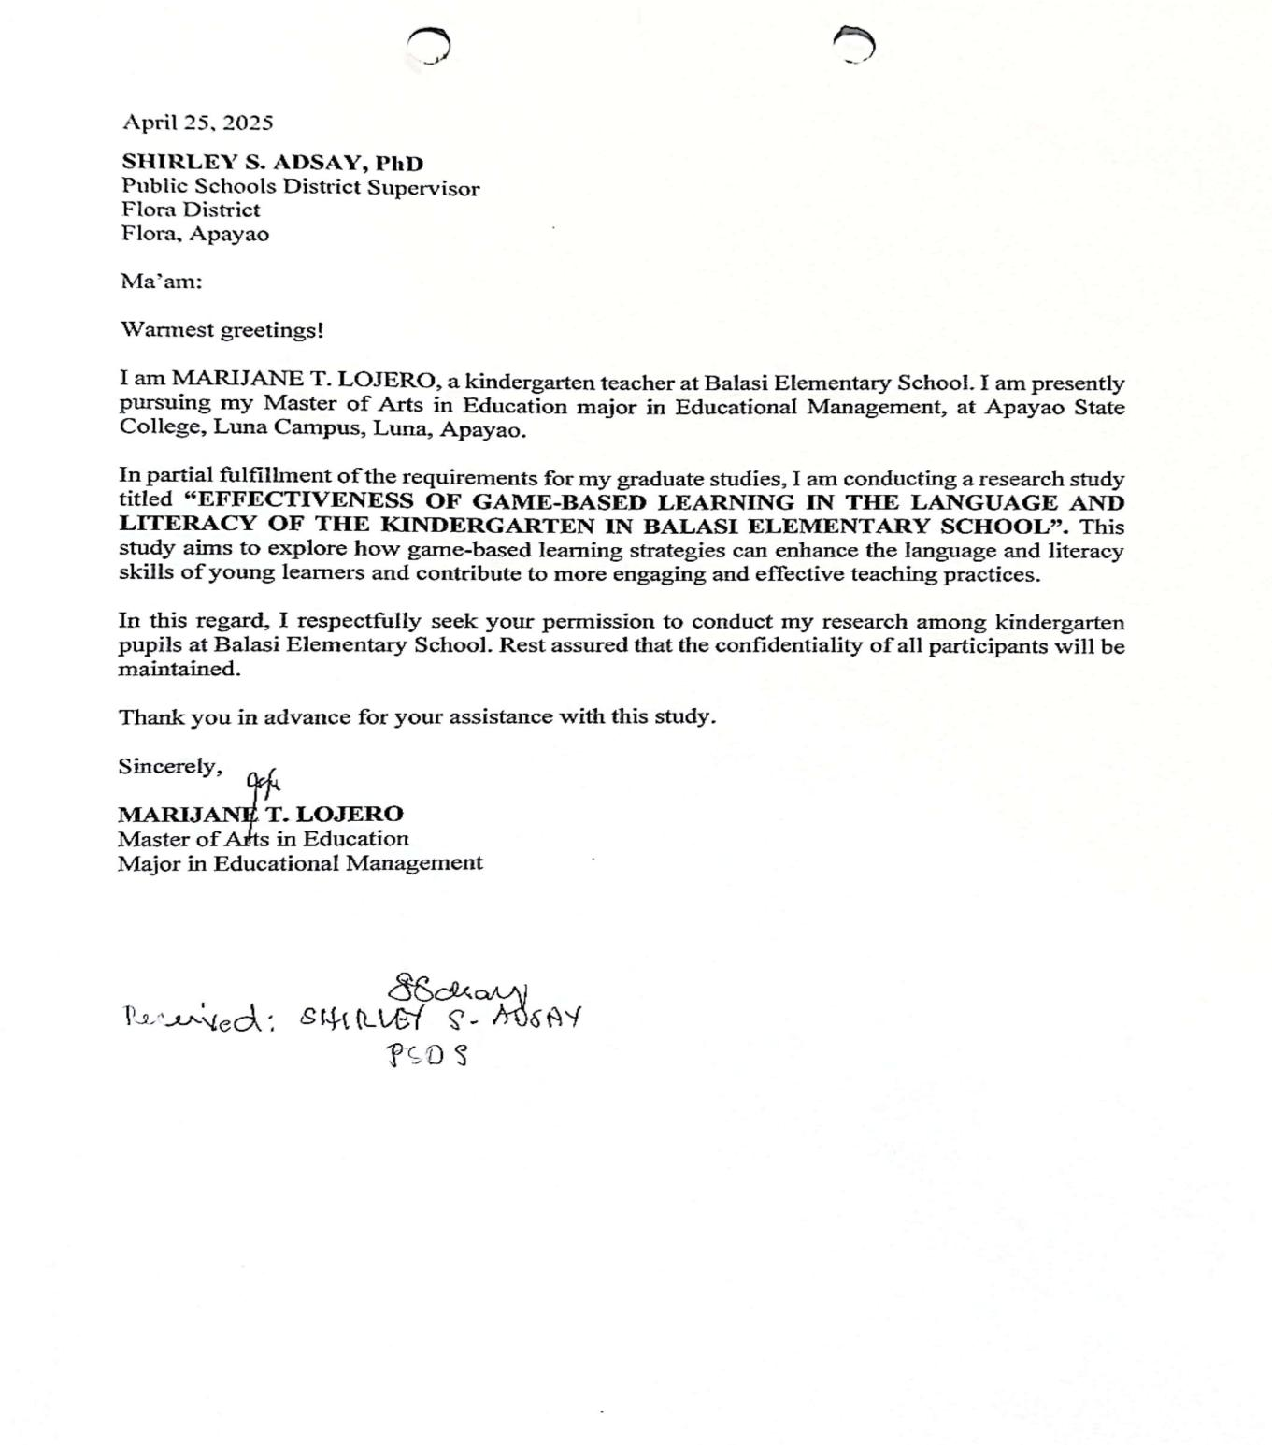

Appendix B

Letter to the School Head


Appendix C

Letter to the Parents


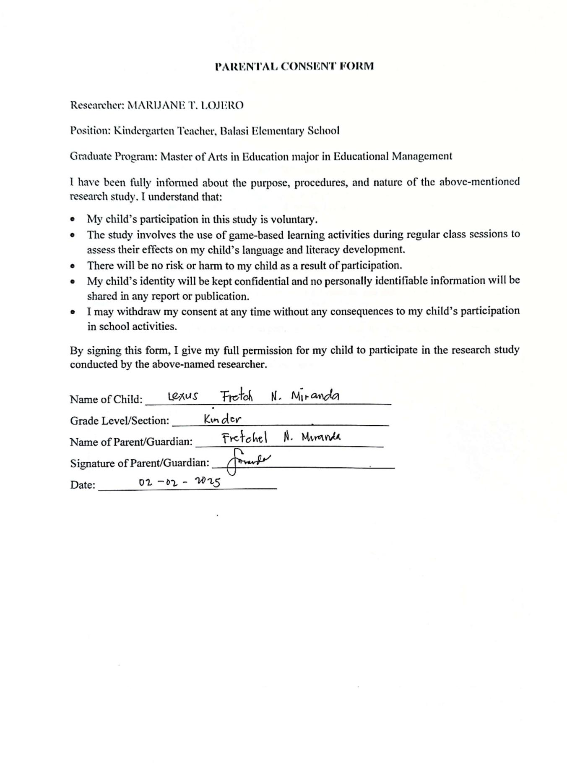

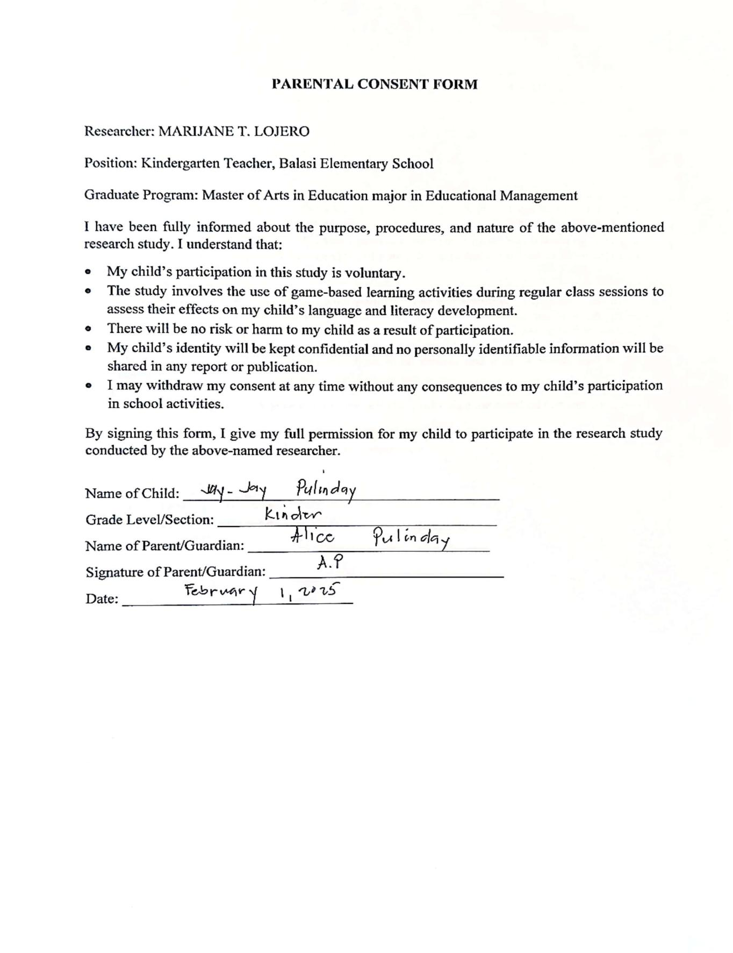

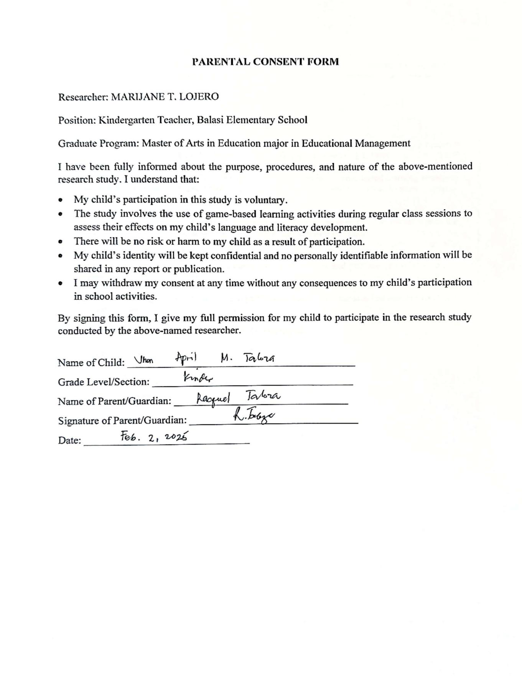

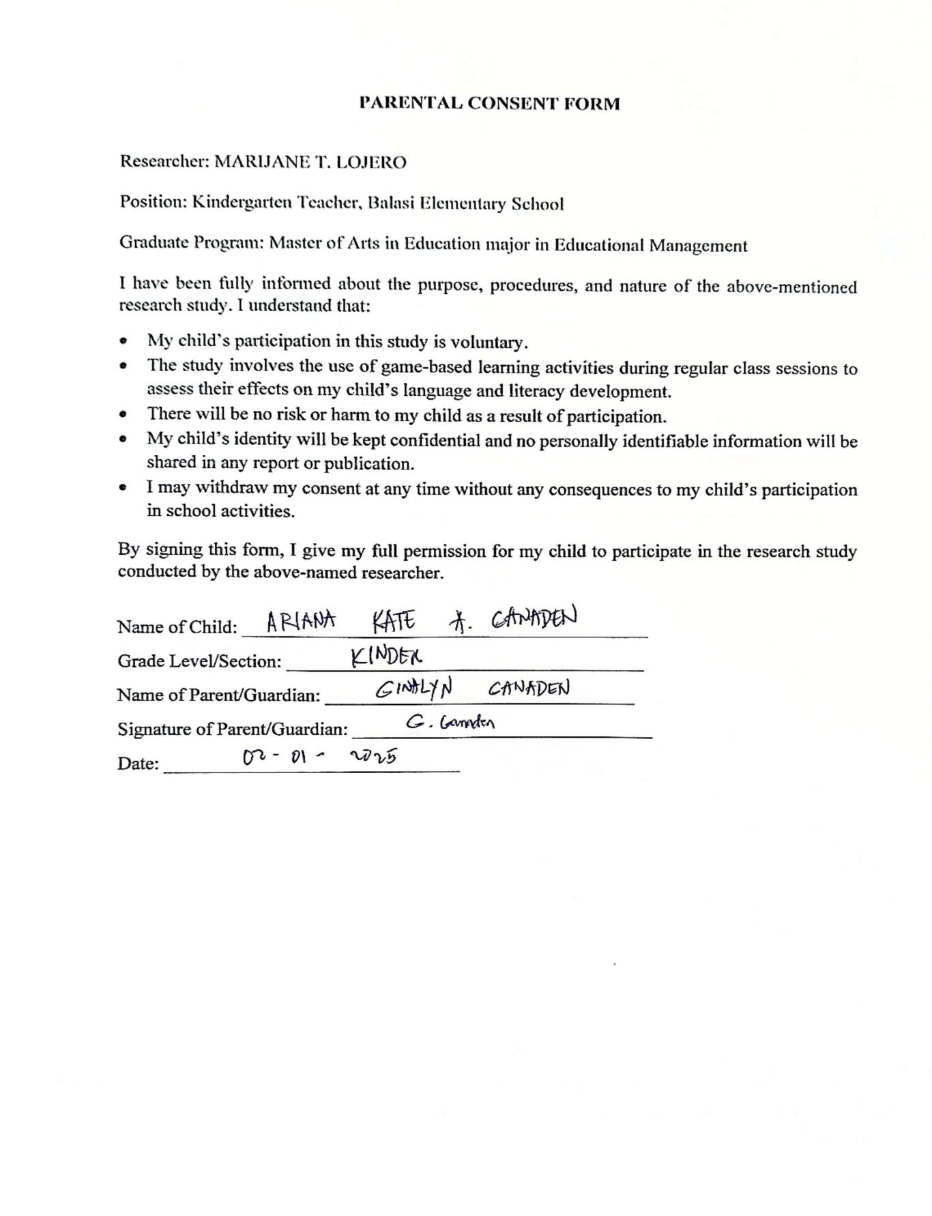

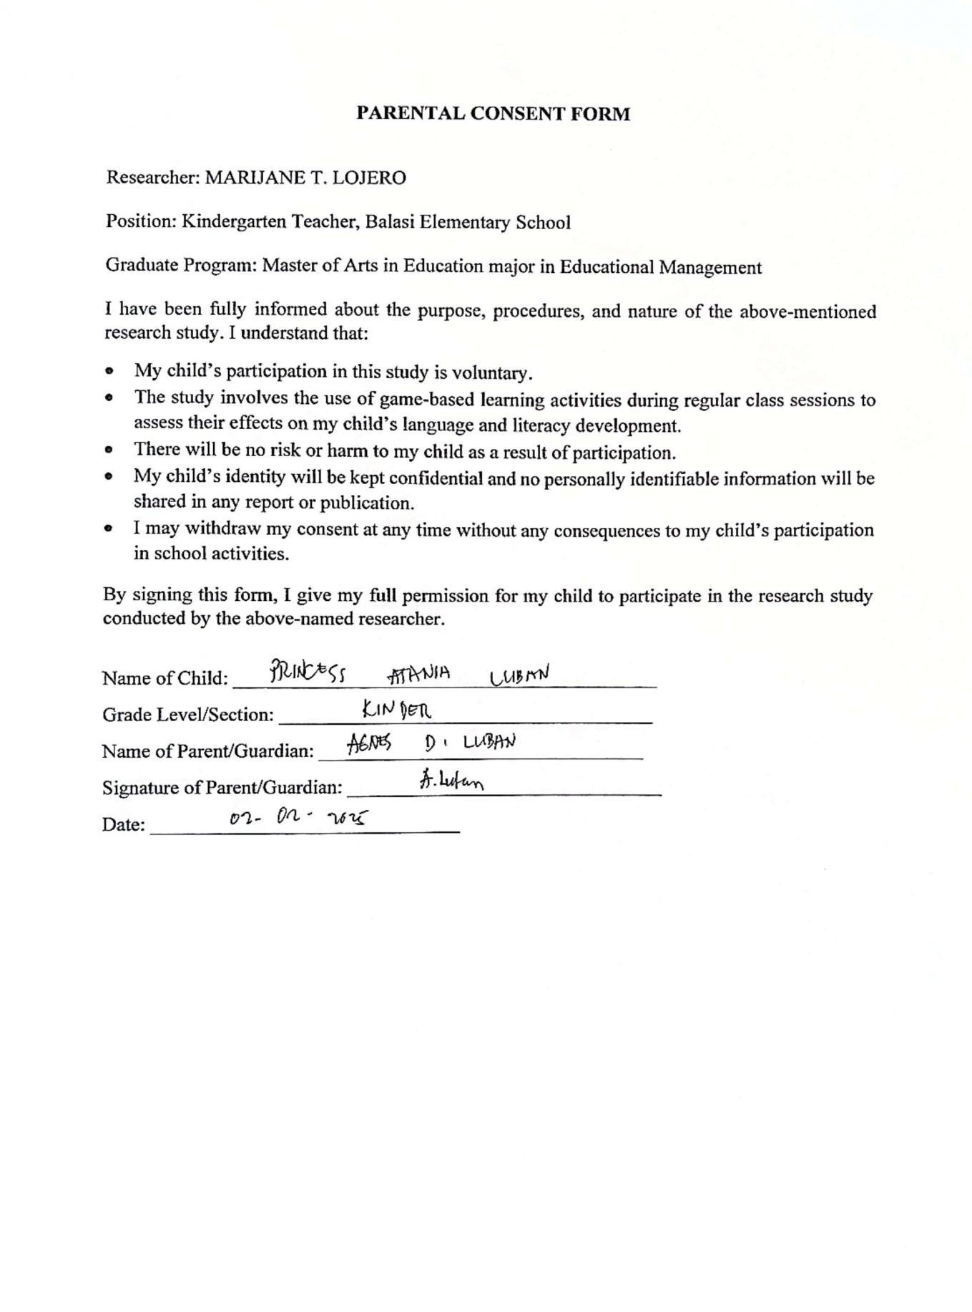

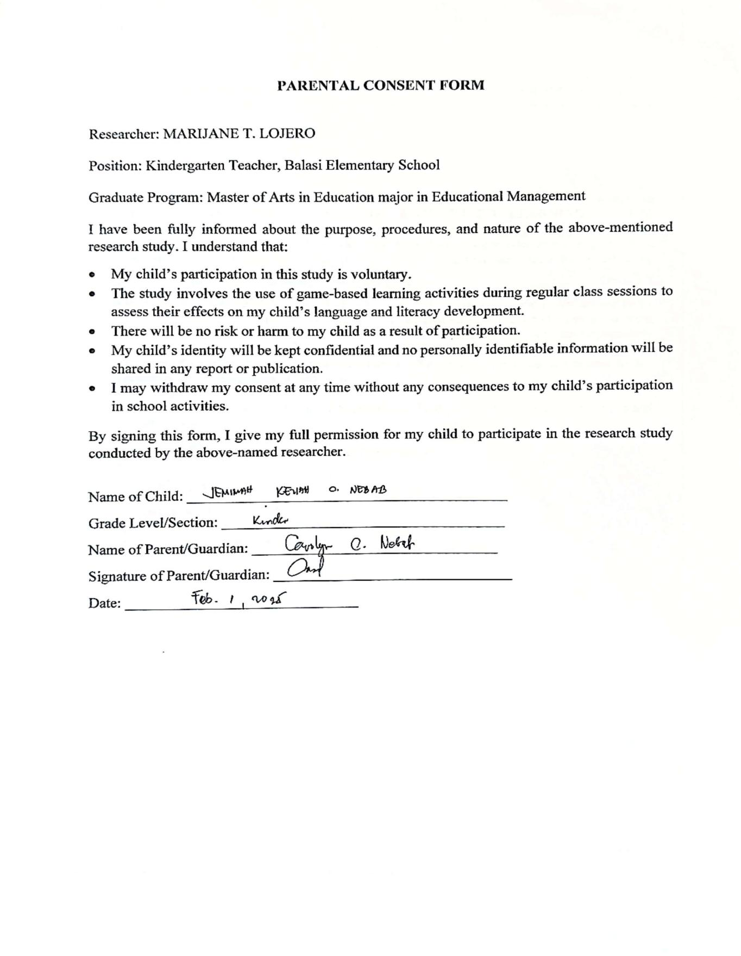

Appendix D

Pre-Test and Post Test

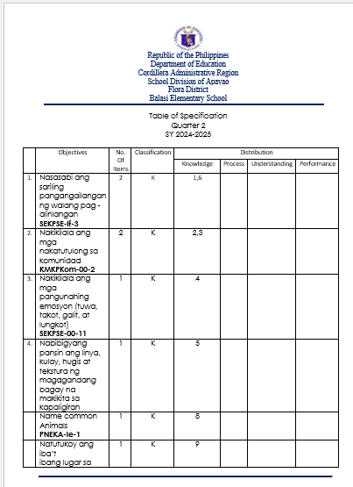

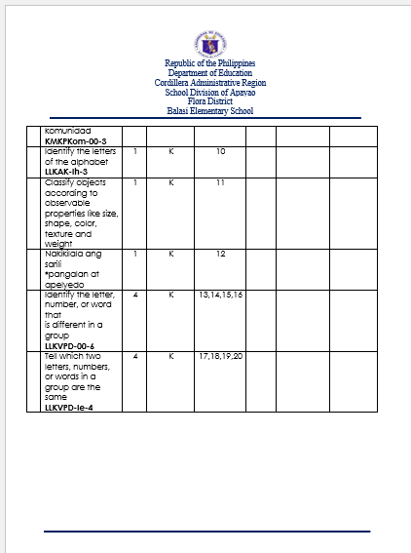

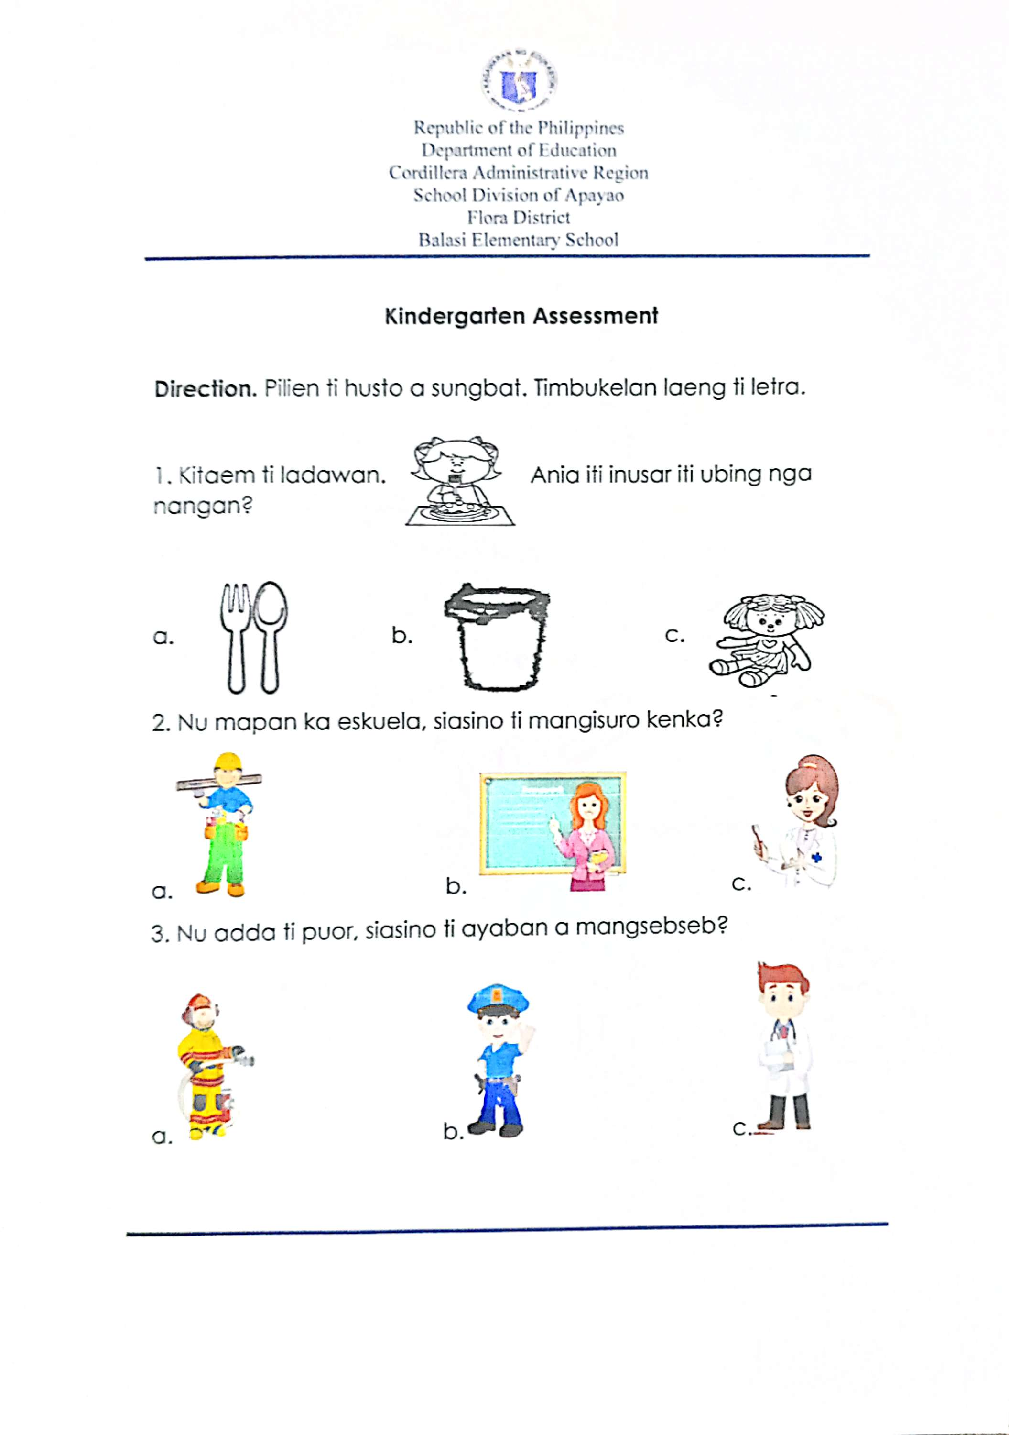
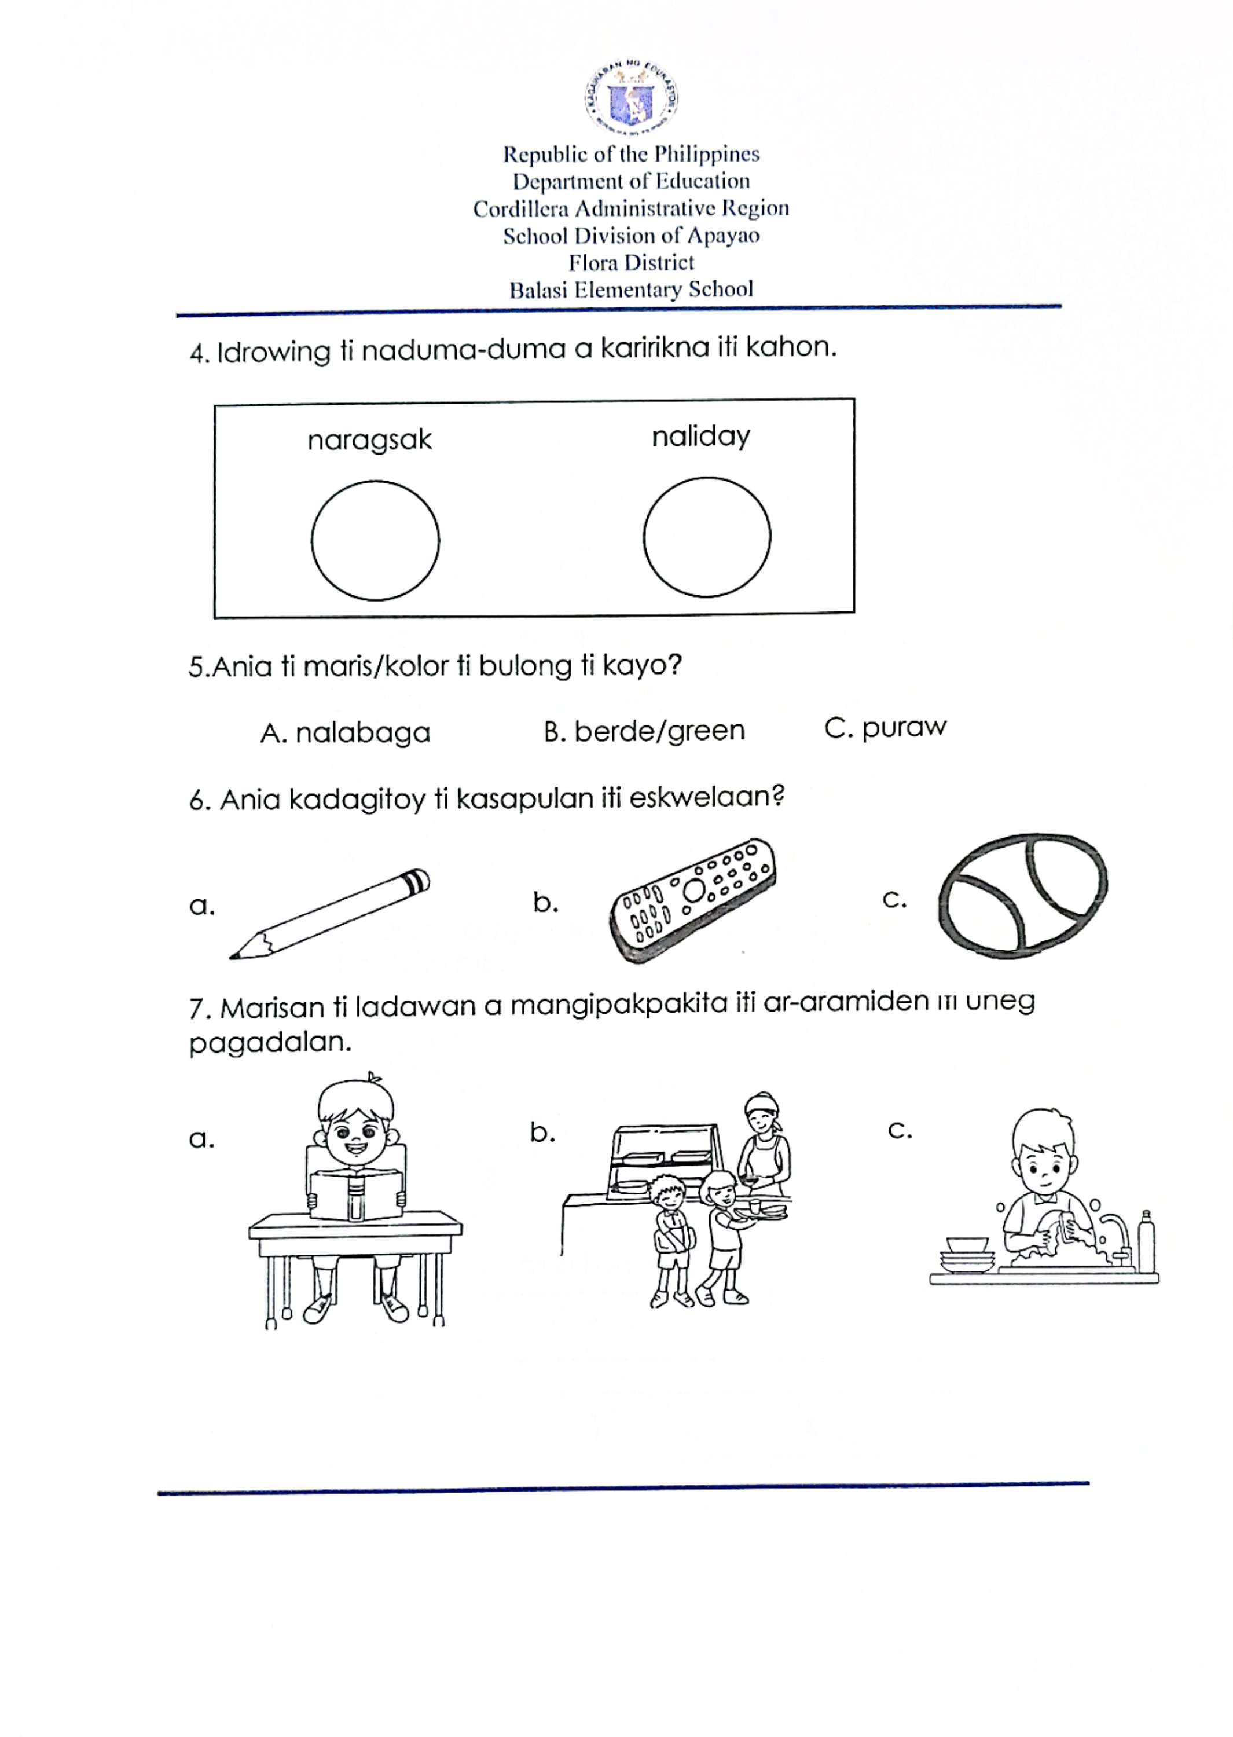
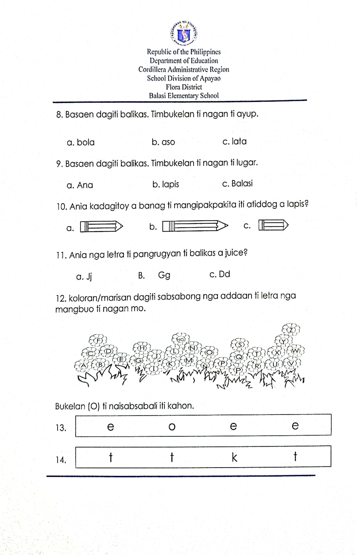
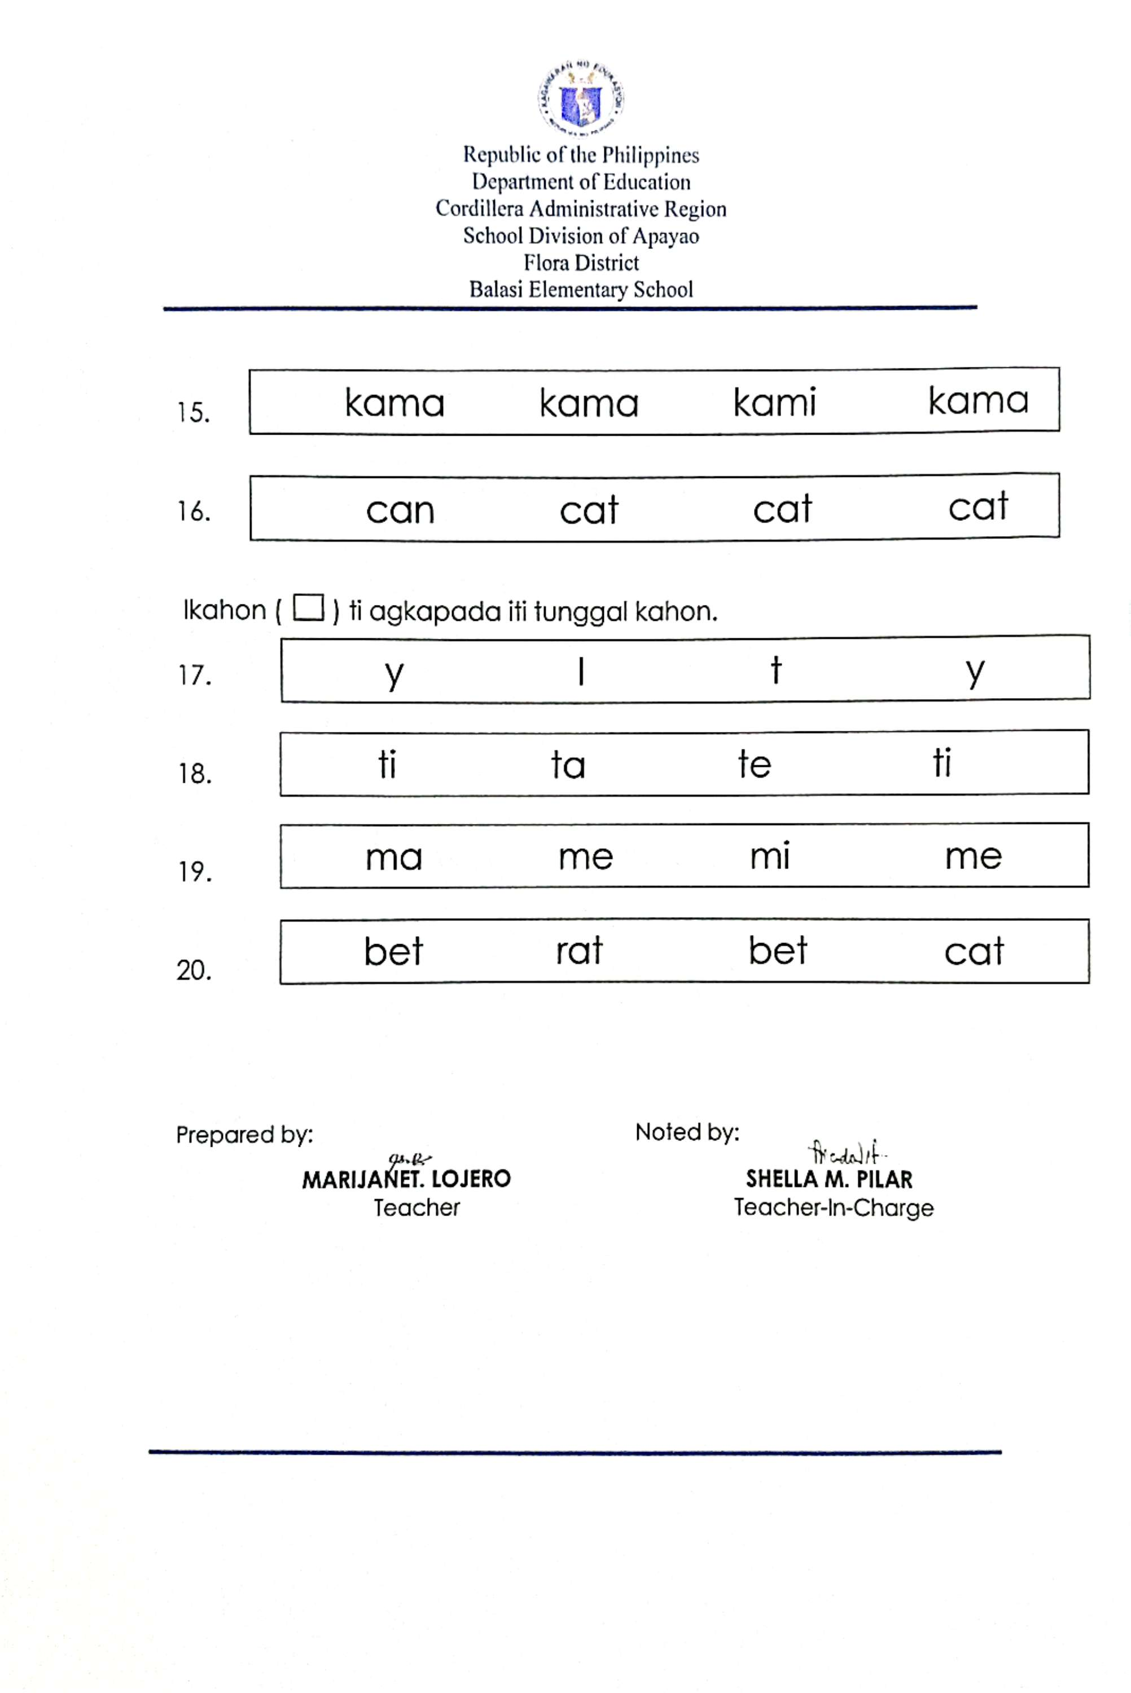
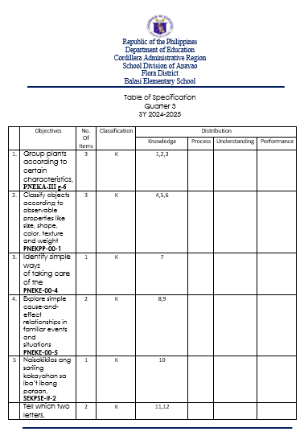

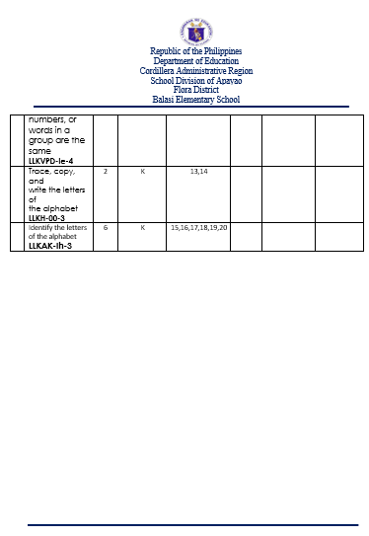

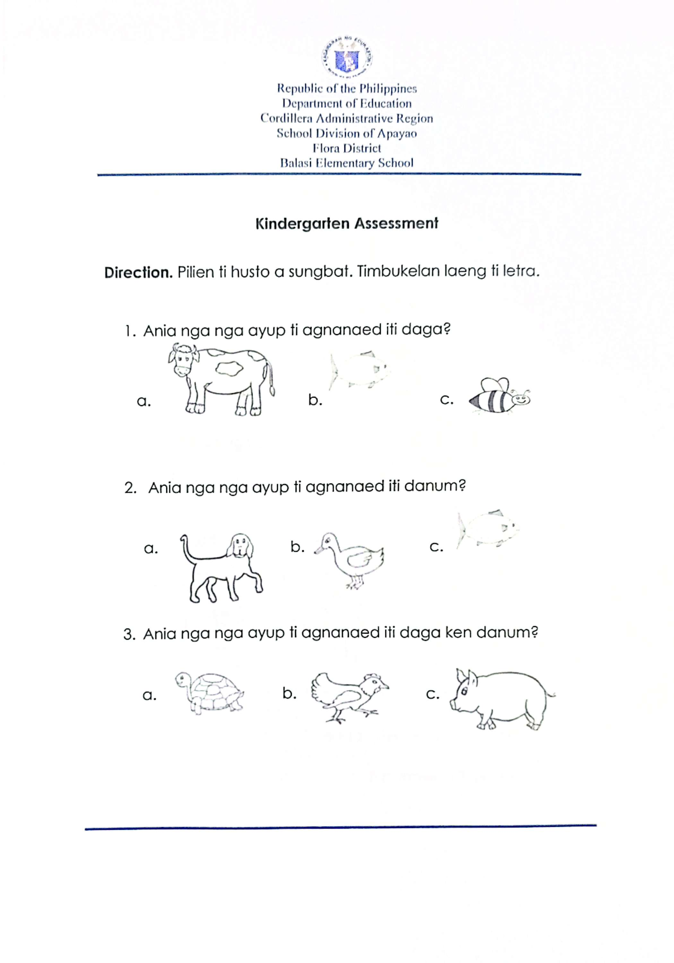
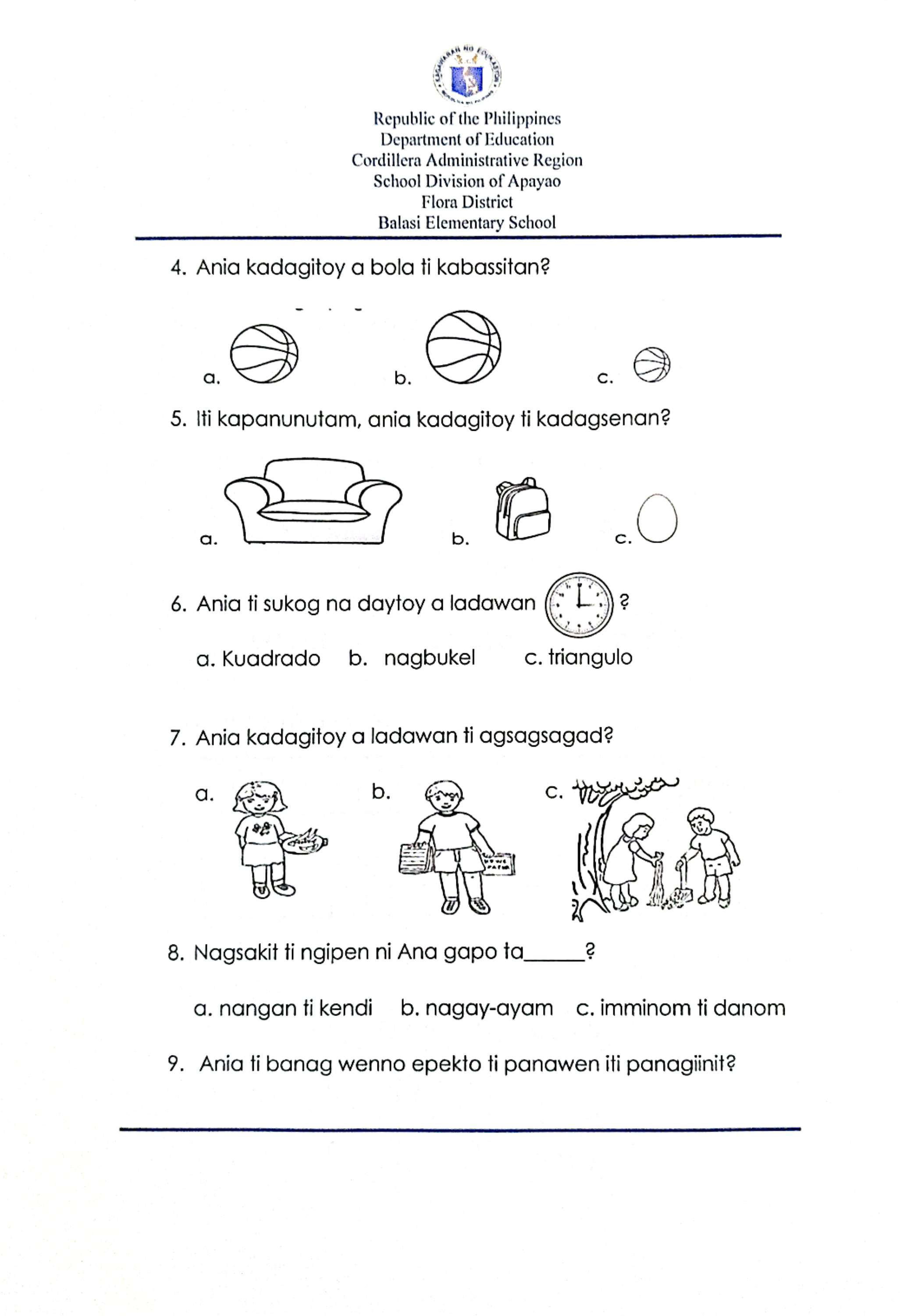
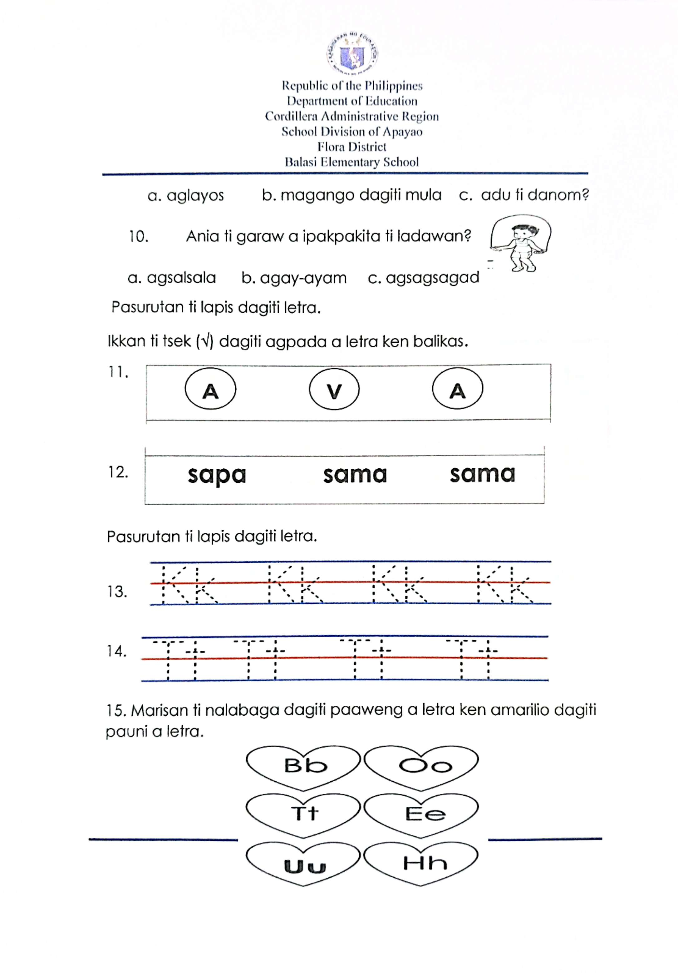
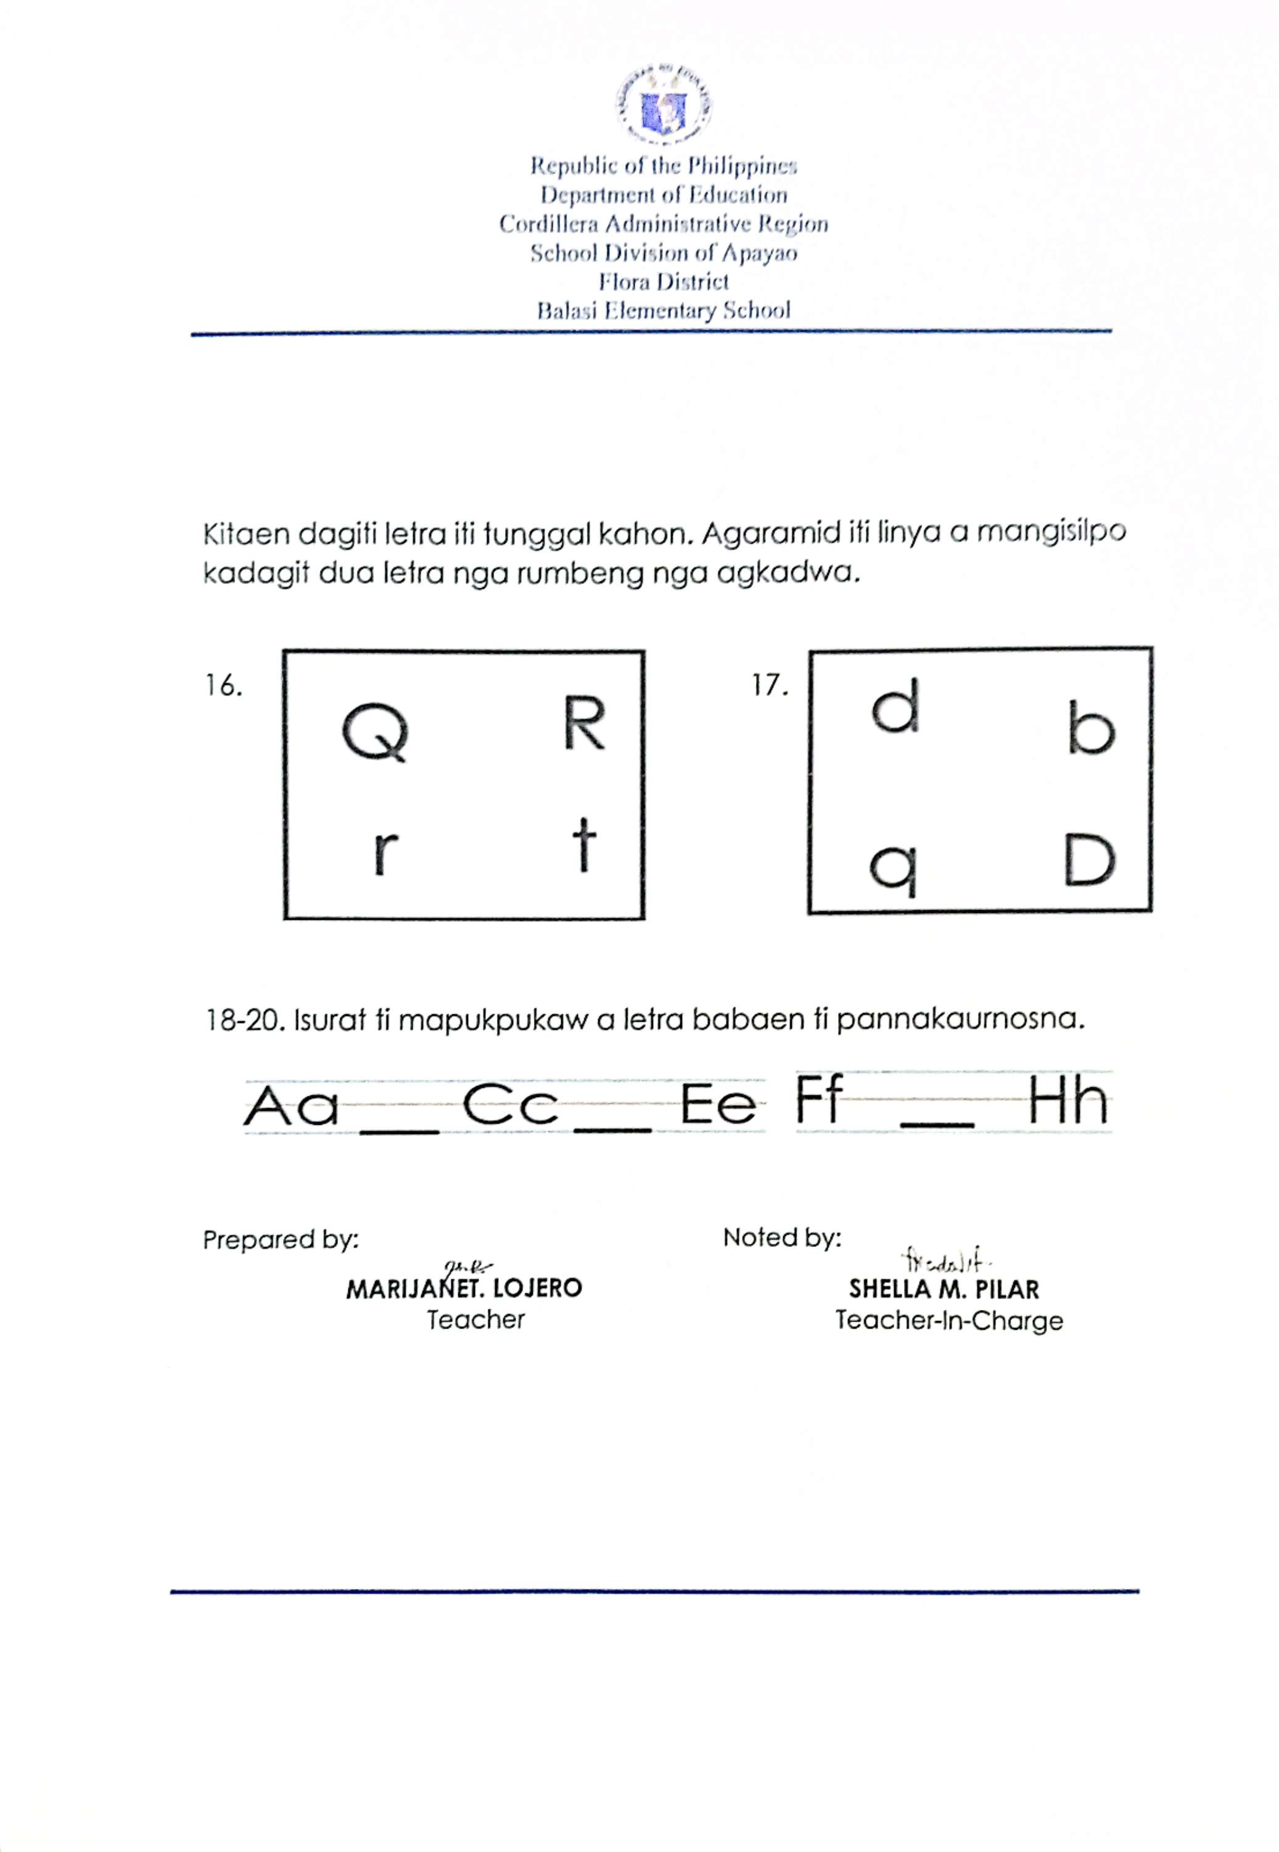
Appendix E

Daily Lesson Log ( DLL )

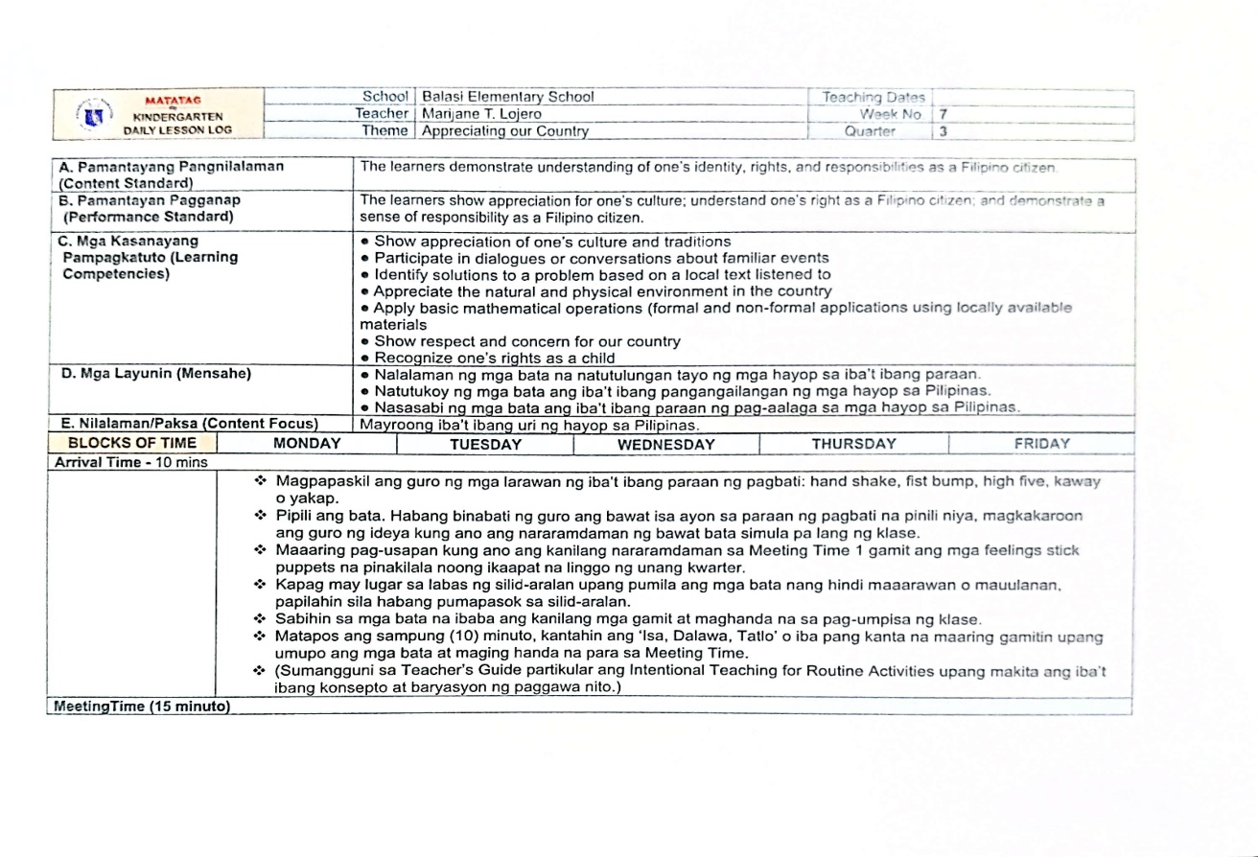

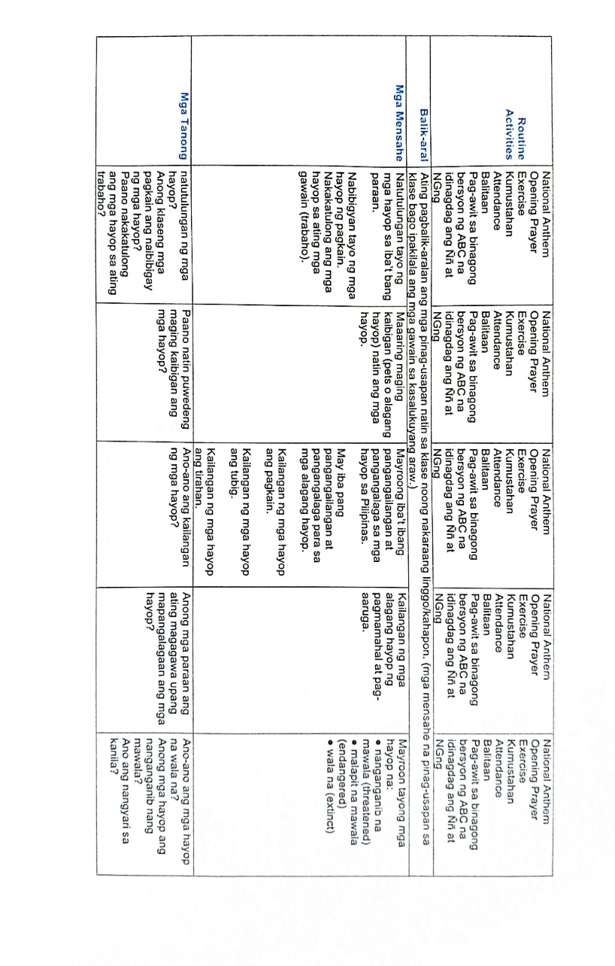

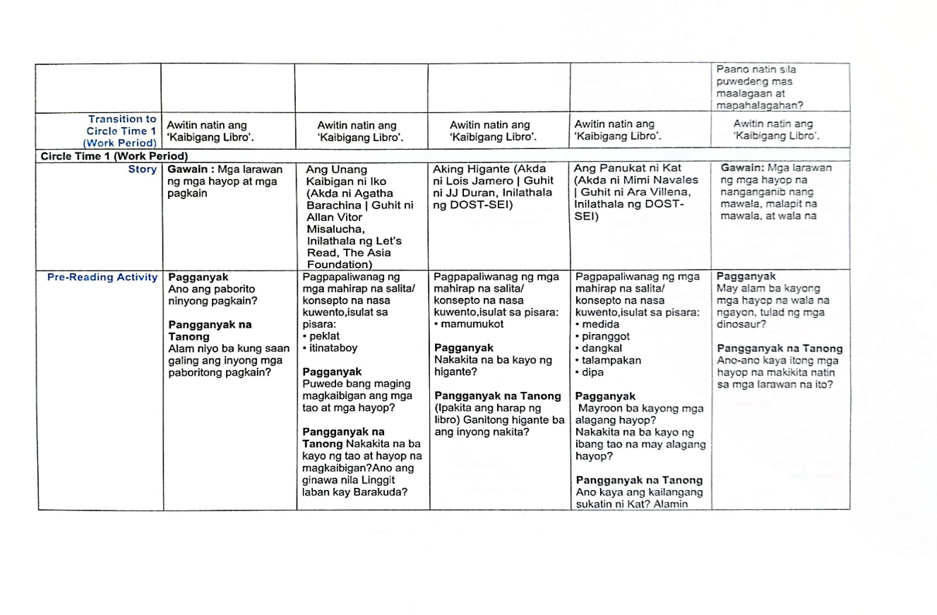

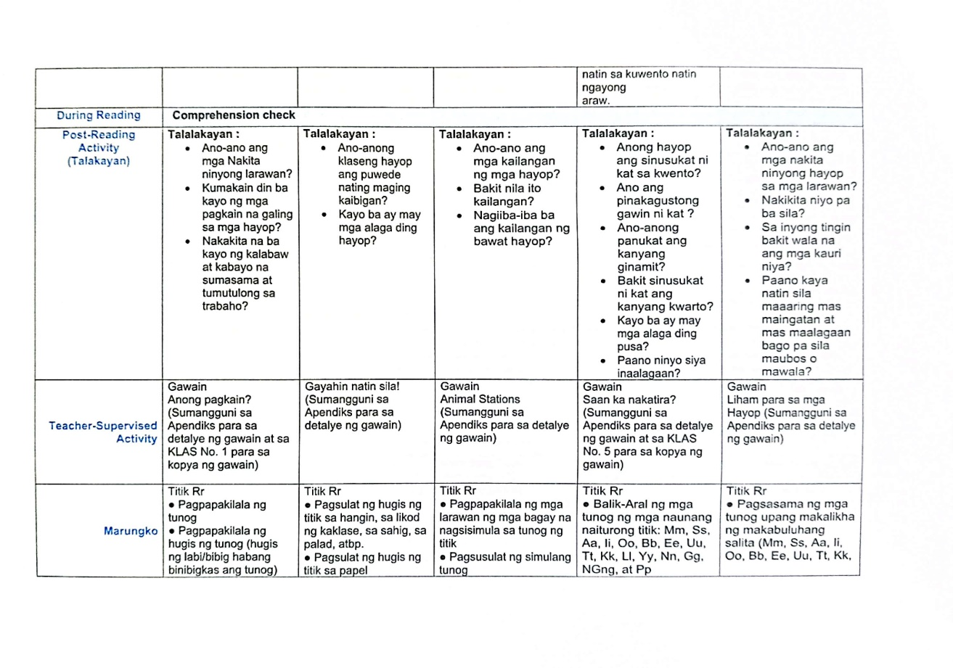

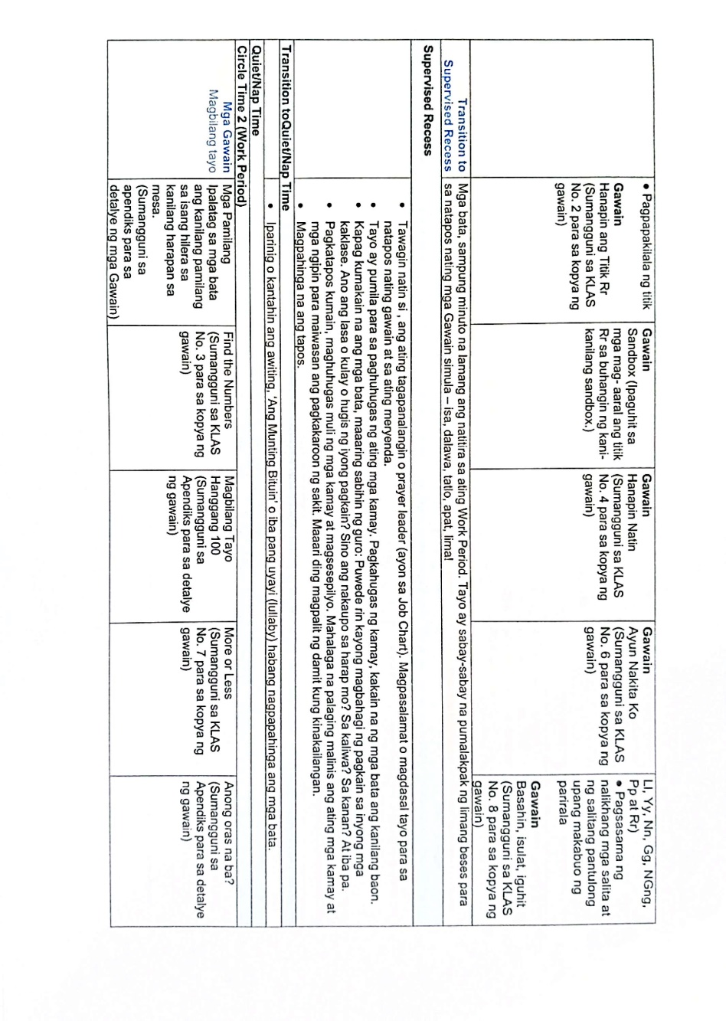

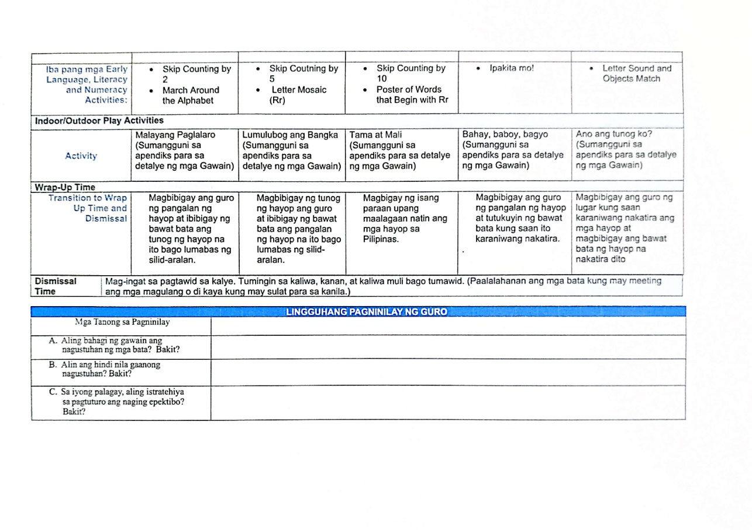

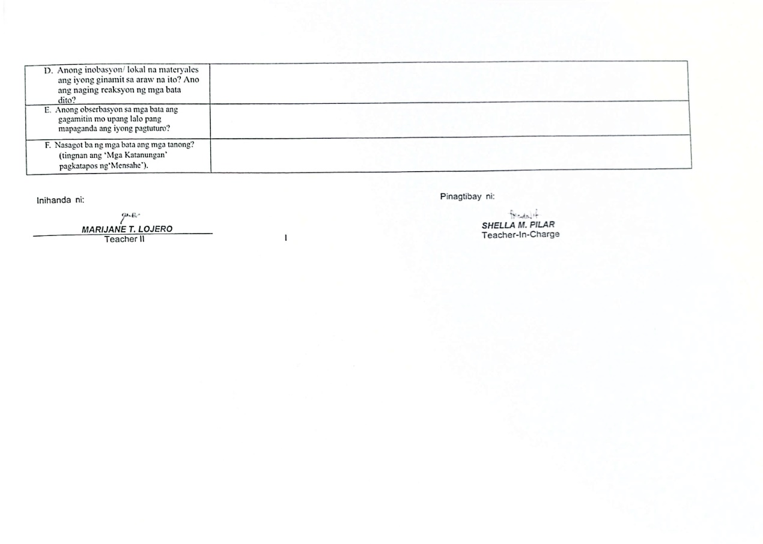

Appendix F

Documentation
